WAVELET TRANSFORM BASED RESTORATION OF DAMAGED CHINESE PAINTING
Author and Co-Authors Name: Shivam Mandlekar, [Co-author 2 Name Surname], [Co-author 3 Name Surname]
[Mentor Name Surname] – Teacher / Guide as Co-Author
Department of Electronics and Computer Science, Ramdeobaba University, Nagpur, Maharashtra, India
Email ID: shivxmonthemix@gmail.com

CASE STUDY ABSTRACT
Traditional Chinese paintings on paper and silk suffer tears, cracks, scratches and losses as they age, and their digitised copies also carry acquisition noise. This case study examines how the wavelet transform can be used to restore such a degraded digital image. A traditional-style Chinese landscape painting (720 × 768 pixels) served as the reference, and a reproducible damage model removed 10.76% of it through torn patches, cracks and scratches and added Gaussian noise (σ = 0.05). The adopted approach is an eight-stage pipeline implemented in Python on Google Colab: pre-processing, colour- and morphology-based damage detection, segmentation of a damage mask, three-level db4 discrete wavelet decomposition, BayesShrink soft thresholding of the detail coefficients, inverse transform, Telea inpainting of the missing regions and seam smoothing. Damage was detected with a recall of 1.000 and a Dice coefficient of 0.895, and wavelet thresholding removed 53.4% of the noise on intact areas. Compared with the original painting, the restored image reached a PSNR of 24.77 dB, an SSIM of 0.835 and an MSE of 217.0, against 16.12 dB, 0.565 and 1589.6 for the damaged input and 22.94 dB, 0.612 and 330.3 for conventional inpainting alone. Region-wise analysis showed that the gain over inpainting came almost entirely from denoising intact areas, while quality inside large missing regions stayed near 16.8 dB for every method. Soft BayesShrink outperformed hard and universal thresholds, smooth Daubechies-type wavelets outperformed the Haar wavelet, and the advantage of the wavelet stage grew with noise, from 0.26 dB at σ = 0.02 to 4.62 dB at σ = 0.10. The case shows that wavelet denoising and inpainting are complementary, that detection accuracy and region-wise evaluation matter as much as the restoration algorithm, and that low-cost open-source tools can support non-invasive digital preservation of cultural heritage.

KEYWORDS
Wavelet transform; Discrete wavelet transform (DWT); BayesShrink; Image denoising; Image inpainting; Damage detection; Digital restoration; Cultural heritage; Chinese painting; PSNR and SSIM

I. CASE BACKGROUND AND CONTEXT
Chinese painting is traditionally executed in ink and mineral or vegetable pigments on xuan paper or silk, and mounted as hanging scrolls, handscrolls or album leaves. These supports are thin, hygroscopic and mechanically weak. Repeated rolling and unrolling, insect and mould attack, abrasion, light exposure and changing humidity gradually produce tears along creases, losses of paper or silk, cracks, scratches, flaking pigment, stains and overall yellowing. Because the painted layer is only a fraction of a millimetre thick, every loss removes part of the artist’s original brushwork.
Physical conservation of such works — cleaning, remounting, infilling losses and retouching — is skilled, slow and partly irreversible, and modern conservation ethics require minimal intervention, reversibility and full documentation. At the same time, museums, libraries and archives are digitising their collections at scale. A digital copy can be studied, published and exhibited without handling the object, and it allows virtual restoration: a plausible recovered appearance can be computed, discussed and corrected without touching the original.
Digital Image Processing (DIP) provides two classical families of tools for this purpose. The first is multiresolution analysis by the wavelet transform [1], [2], which separates an image into low-frequency structure and high-frequency detail, together with wavelet shrinkage, which suppresses noise by thresholding small detail coefficients [3]–[5]. The second is image inpainting, which fills missing regions by propagating information from their surroundings [6]–[8]. Restoration quality is commonly reported with the Mean Squared Error (MSE), the Peak Signal-to-Noise Ratio (PSNR) and the Structural Similarity index (SSIM) [9], [10].
This case study was carried out as part of the Digital Image Processing course (RBU, EN, 2026–27). It applies these tools to a digital image of a traditional-style Chinese landscape (shan shui) painting showing mountains, pine trees, two pavilions, a river, flowering trees and a vertical calligraphic inscription with red seals on warm, aged-looking paper (Fig. 1). The complete method was implemented as a reproducible Google Colab notebook using open-source Python libraries [11]–[13].

II. CASE PROBLEM / CHALLENGE
A digitised damaged painting suffers from two different kinds of degradation at the same time. Missing information occurs where the paint layer is physically gone — torn and missing patches, cracks and scratches, which in this case appear as bright exposed backing paper. Corrupted information occurs across the remaining intact area in the form of random noise introduced by ageing and digital acquisition. The two require different remedies: noise must be reduced without blurring brush strokes, missing regions must be filled with plausible content where no data exist, and, before either step, the damage must be located automatically and accurately.
The problem matters because errors are costly. Over-smoothing erases the brush texture that carries the painter’s style; false detections overwrite authentic paint with invented content; and a method that is judged only visually may look convincing while being unfaithful to the original. The case was constrained to a single image with no training data, a CPU-only cloud notebook, freely available libraries and fully reproducible processing. Objective evaluation needs a ground truth, so the evidence was generated by applying a controlled, recorded damage model to an undamaged reference image: the exact damage mask (10.76% of the image) and the exact noise level (σ = 0.05) are known.
The case-study questions were:
Q1. Can the damaged regions be detected and segmented automatically, and how accurately?
Q2. Does wavelet decomposition and coefficient thresholding reduce noise while preserving detail?
Q3. Does combining wavelet restoration with inpainting outperform conventional inpainting in terms of MSE, PSNR and SSIM?
Q4. How sensitive are the results to the wavelet family, decomposition level, threshold rule, noise level and extent of damage?
Accordingly, the objective was to study and implement the wavelet transform for digital image processing, to reduce noise and restore the degraded painting by decomposing it into different frequency components, and to evaluate the reconstructed image with MSE, PSNR and SSIM.

III. CASE SETTING AND STAKEHOLDERS
Setting. The case is an academic laboratory study conducted in the Department of Electronics and Computer Science, Ramdeobaba University, Nagpur. All processing ran in a Google Colab notebook on a standard CPU runtime using Python 3 with NumPy, OpenCV [12], PyWavelets [11], scikit-image [13], pandas and Matplotlib. Every random step used a fixed seed (42), so each run reproduces the same damage pattern and the same numbers; the complete notebook, including all experiments, executed in about 46 s end to end. The source image (302 × 316 pixels) was resized to a working size of 720 × 768 pixels, divisible by 2³ for a three-level wavelet decomposition. Table I lists the damage model and Fig. 1 shows its effect.
Table I. Simulated damage applied to the reference painting
Damage type | Model | Setting
Torn / missing patches | Smoothed random field thresholded into irregular blobs with jagged, paper-like edges | ≈ 10% target coverage
Cracks and tears | Curved random walks drawn as lines | 4 tears, 4 px wide
Scratches | Nearly straight random walks | 6 scratches, 2 px wide
Exposed backing | Lost pixels set to paper colour | RGB (0.965, 0.955, 0.930)
Acquisition noise | Additive white Gaussian noise on all pixels | σ = 0.05 (≈ 12.8 grey levels)
Fading / yellowing | Global blend towards a yellow tint (optional) | Disabled in this evaluation
Total damaged area | Union of patches, tears and scratches (ground truth) | 10.76% of the image

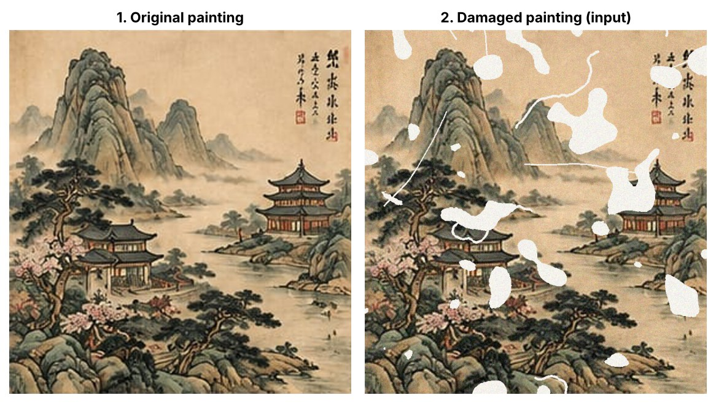
Fig. 1. Reference painting (left) and the damaged digital image used as input (right), showing missing patches, tears, scratches and noise.
Stakeholders. Although this is a laboratory case, the problem it models involves several groups with different interests, summarised in Table II.
Table II. Stakeholders, roles and interests
Stakeholder | Role and interest | Interaction with this case
Museums, archives and libraries | Own and digitise collections; need faithful, well-documented digital copies | Users of damage maps and virtual restoration previews
Conservators and restorers | Plan physical treatment; value non-invasive previews, reversibility and documentation | Interpret the detected damage mask and judge whether fills are plausible
Art historians and researchers | Study style, inscriptions and seals; require authentic detail, not invented content | Depend on restored areas being clearly identified
Students and faculty (DIP course) | Learn, implement and evaluate DIP techniques | Authors and mentor who designed, built and analysed the pipeline
Open-source developers | Maintain PyWavelets, OpenCV, scikit-image and related tools | Provide the algorithms and implementations used
General public and cultural communities | Access heritage through exhibitions and online collections | Final viewers of digitally restored images

Several contextual factors shape the case. Technically, results depend on image resolution, on the noise characteristics of the capture process and on the colour of exposed losses. Economically, the approach needs no special hardware or paid software. Ethically and culturally, any restored content is a computed hypothesis rather than recovered history; this is especially important for inscriptions and seals, where a fill could suggest characters the artist never wrote.

IV. INTERVENTION / APPROACH AND METHOD ADOPTED WITH BLOCK DIAGRAM
The intervention is an eight-stage restoration pipeline with two parallel branches (Fig. 2). The damage detection branch (stages 3.1–3.3) produces a binary mask of damaged pixels. The wavelet restoration branch (stages 3.4–3.6) removes noise from the colour image in the wavelet domain. The two meet in stage 3.7, where missing regions are reconstructed, followed by post-processing (3.8) and objective evaluation against the undamaged original. Fig. 3 shows the output of every stage.

A. 3.1 Pre-processing
The damaged RGB image is converted to grayscale (Y = 0.299R + 0.587G + 0.114B). Two smoothed copies are created only for detection: a Gaussian-filtered copy (σ = 1.2) that suppresses noise inside large regions, and a 3 × 3 median-filtered copy that removes impulsive noise while keeping thin scratches. The restoration itself always works on the unsmoothed colour image.

B. 3.2 Damage detection
Exposed backing paper is bright and almost colourless, whereas the painting is darker and warmer. Large losses are therefore detected in the HSV colour space of the Gaussian-smoothed image:
D_{r}(x, y) = [ V(x, y) ≥ 225 ] ∧ [ S(x, y) ≤ 40 ] (1)
Thin scratches and cracks are blurred by smoothing, so they are found with a morphological white top-hat transform on the median-filtered grayscale image g, using a 9 × 9 elliptical structuring element B:
TH = g − (g ∘ B), D_{l} = [ TH > 28 ] ∧ [ V > 200 ] ∧ [ S < 70 ] (2)
where g ∘ B denotes morphological opening. Line candidates smaller than 15 pixels are discarded, and the raw damage map is their union, D = D_{r} ∪ D_{l}.

C. 3.3 Segmentation
The raw map is cleaned with a 3 × 3 morphological closing, connected components smaller than 30 pixels are removed, and the remaining regions are dilated by a 2-pixel safety margin so that anti-aliased edges of each loss are included. Connected-component labelling then yields the final damage mask M, the number of damaged regions and their areas; damaged regions are shown in red over the image for documentation (Fig. 3, panel 3.3).
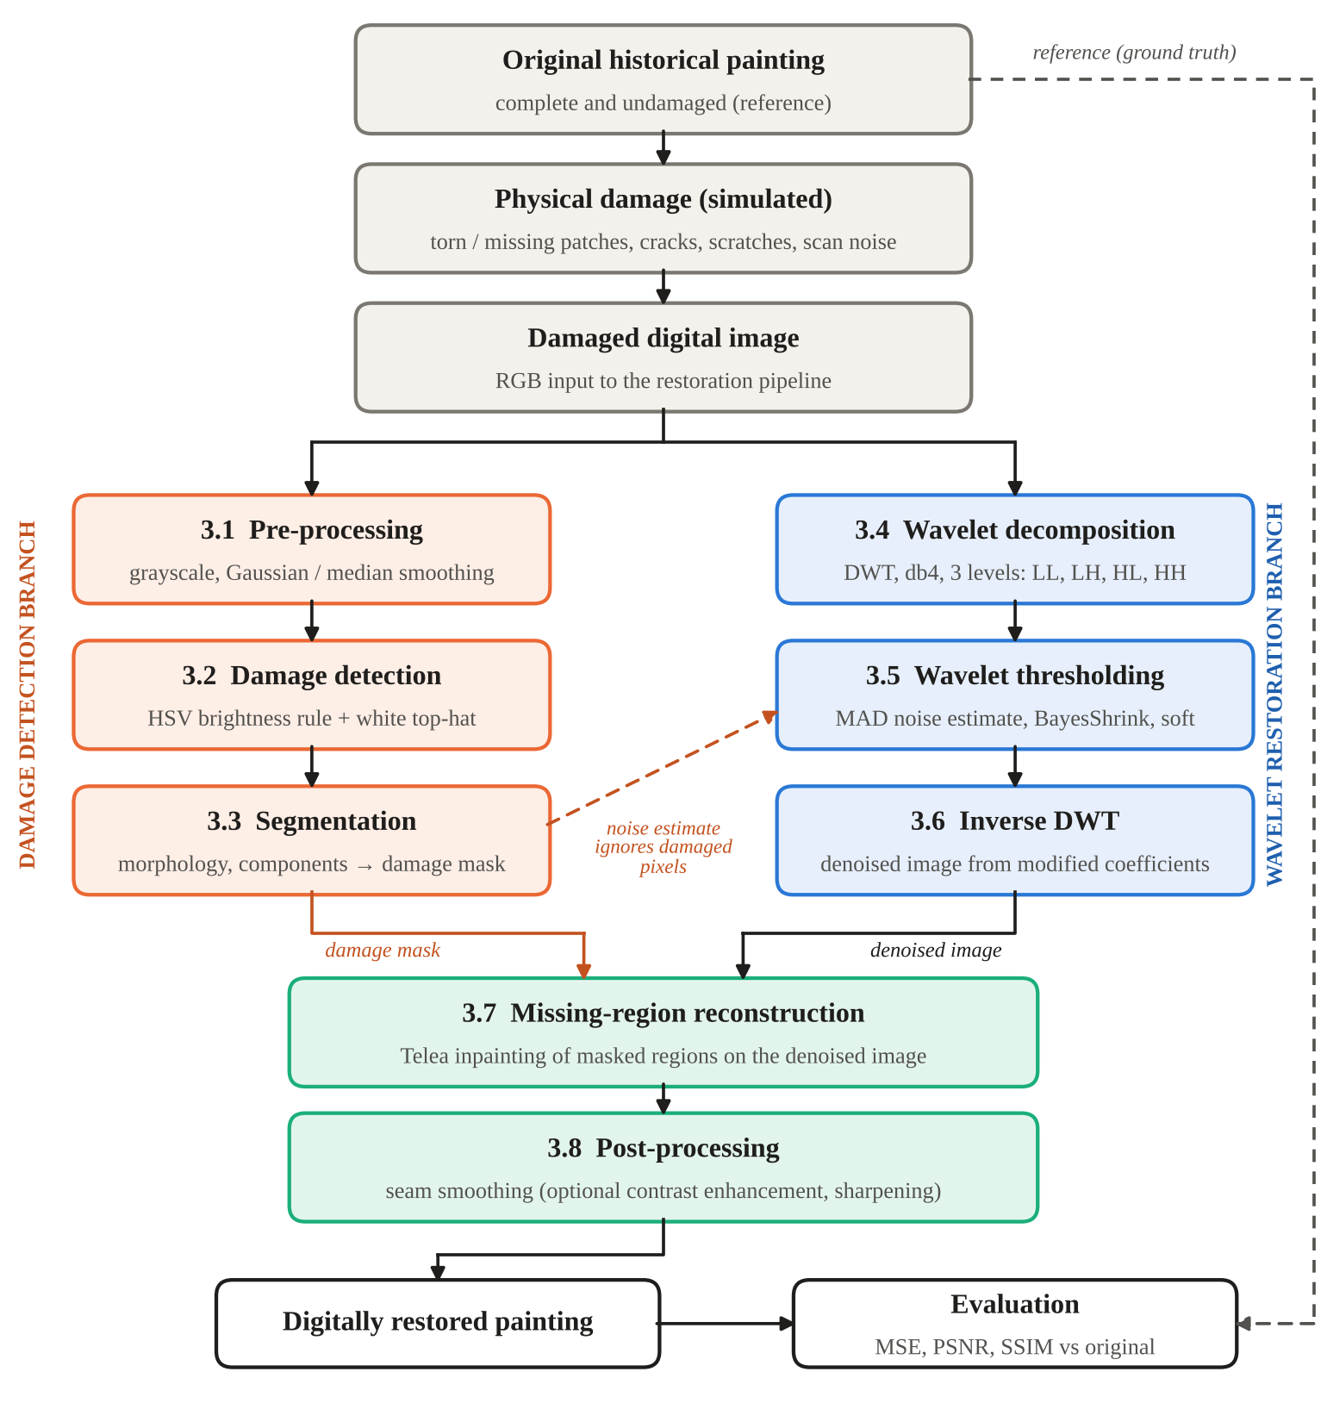
Fig. 2. Block diagram of the proposed wavelet transform based restoration pipeline.

D. 3.4 Wavelet decomposition (DWT)
Each colour channel f is decomposed with a separable two-dimensional discrete wavelet transform [1]. One level splits the image into an approximation sub-band LL and three detail sub-bands — LH (horizontal detail), HL (vertical detail) and HH (diagonal detail) — each a quarter of the size; the decomposition is repeated on LL:
f → { LL₃ ; ( LH_{j} , HL_{j} , HH_{j} ), j = 1, 2, 3 } (3)
The Daubechies db4 wavelet (eight filter taps, four vanishing moments) [2] was used with three levels and periodic boundary extension, so that each sub-band has exactly half the size of its parent and reconstruction is perfect.

E. 3.5 Wavelet based restoration: thresholding of coefficients
Noise spreads evenly over all coefficients, while image structure concentrates in a few large ones. The noise standard deviation σ_{n} is estimated robustly from the finest diagonal sub-band, excluding coefficients that fall inside the damage mask:
σ_{n} = median( | HH₁ | ) / 0.6745 (4)
For every detail sub-band the BayesShrink threshold [5] is computed from the variance of its coefficients, σ_{Y}² = mean(d²):
T_{B} = σ_{n}² / σ_{X} , σ_{X} = √[ max( σ_{Y}² − σ_{n}² , 0 ) ] (5)
and each detail coefficient d is soft-thresholded [4]:
η(d) = sign(d) · max( | d | − T_{B} , 0 ) (6)
Coefficients smaller than T_{B} are set to zero and larger ones are shrunk towards zero. The approximation sub-band LL₃ is left unchanged because it holds the overall shapes and colour washes.

F. 3.6 Inverse DWT
The image is reconstructed channel by channel from the unchanged approximation and the thresholded detail coefficients by the inverse DWT, giving a denoised colour image in which the missing regions are still present.

G. 3.7 Missing-region reconstruction (inpainting)
Thresholding cannot create content where paint is physically missing. Each region in M is therefore filled using the fast-marching inpainting method of Telea [6] with a radius of 5 pixels: unknown pixels are processed from the region boundary inwards, and each is estimated as a weighted average of nearby known pixels, with weights favouring close pixels lying along the local image gradient. Inpainting is applied to the denoised image so that noise is not propagated into the filled areas. In the implementation the inverse DWT (3.6) therefore precedes reconstruction (3.7); filling the holes directly in the wavelet domain was also tested as a baseline (Section V).

H. 3.8 Post-processing
To hide visible seams, an edge-preserving bilateral filter is blended into the image only on a thin ring around each filled region. As an optional display enhancement, contrast-limited adaptive histogram equalisation (CLAHE, clip limit 1.0) on the lightness channel and mild unsharp masking (amount 0.3) were also applied; this version is reported separately because it deliberately changes pixel values.
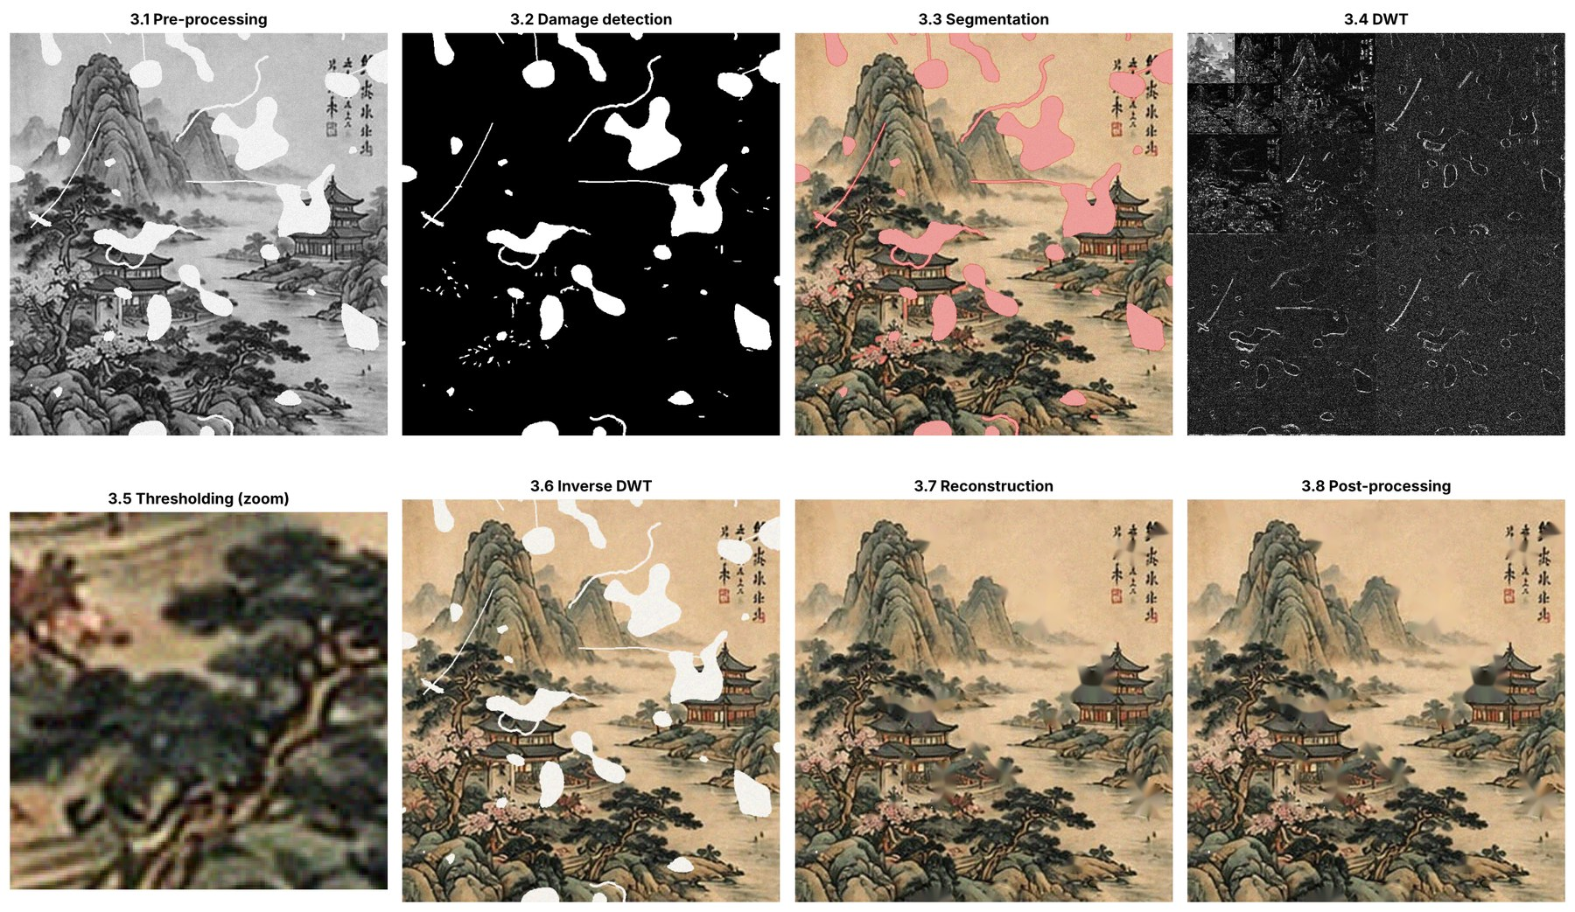
Fig. 3. Output of each pipeline stage, 3.1 to 3.8 (the 3.5 panel is a zoomed crop showing the denoised texture).

I. Evaluation method
The restored image K is compared with the undamaged original I (both M × N × 3, 8-bit) using:
MSE = (1 / 3MN) Σ [ I(x, y, c) − K(x, y, c) ]² , PSNR = 10 log₁₀ ( 255² / MSE ) (7)
SSIM(x, y) = [ (2μ_{x}μ_{y} + C₁)(2σ_{xy} + C₂) ] / [ (μ_{x}² + μ_{y}² + C₁)(σ_{x}² + σ_{y}² + C₂) ] (8)
SSIM [9] is averaged over local windows and colour channels. PSNR was additionally computed separately inside the true damaged area and on the intact area. Detection was scored against the ground-truth mask with precision, recall, intersection over union (IoU) and the Dice coefficient. Eight variants were compared on the same detected mask: the damaged input; Telea inpainting [6] and Navier–Stokes inpainting [7] without denoising; wavelet denoising without inpainting; an iterative wavelet-domain inpainting baseline in which holes are refined by repeated soft thresholding with decreasing thresholds while known pixels are held fixed [14]; and the proposed pipeline with and without the optional display enhancement. Four one-factor-at-a-time experiments then varied the wavelet family and level (E1), the threshold rule (E2), the noise level (E3) and the amount of damage (E4).

V. EVIDENCE, OBSERVATIONS AND ANALYSIS

A. Damage detection and segmentation (Q1)
Table III. Damage detection performance against the ground-truth mask
Measure | Value
Damaged area — ground truth | 10.76%
Damaged area — detected (after 2-px margin) | 13.26%
Damaged regions found | 54
Precision / Recall | 0.811 / 1.000
IoU / Dice coefficient | 0.811 / 0.895
Precision / Recall without the 2-px margin | 0.977 / 0.950
False alarm on the undamaged original | 0.88% of pixels

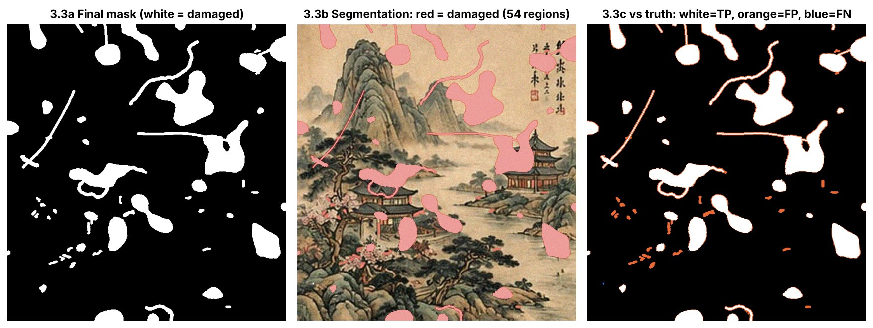
Fig. 4. Final damage mask (left), segmentation overlay (centre) and comparison with ground truth (right: white = correct, orange = false positive, blue = missed).
Every damaged pixel was detected (recall 1.000), giving a Dice coefficient of 0.895. The 2.51 percentage points of over-detection have two causes: 1.94 points come from the deliberate 2-pixel safety margin around true losses, and only 0.57 points are isolated false detections of small bright details such as blossoms and highlights (orange specks in Fig. 4). Without the margin, precision rises to 0.977 but recall falls to 0.950, so the margin trades a small amount of intact paint for complete coverage of every loss. Run on the undamaged original, the detector flagged only 0.88% of pixels.

B. Wavelet decomposition (Q2)
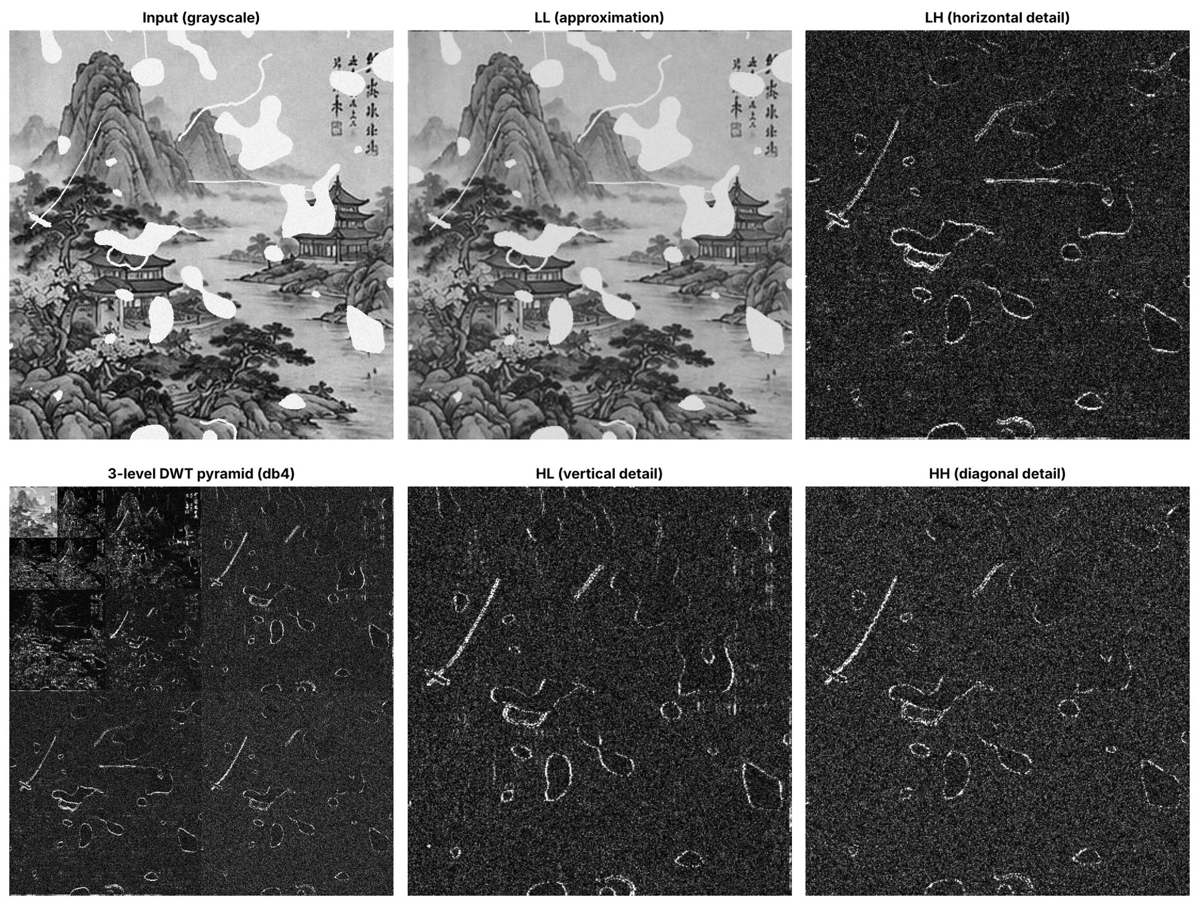
Fig. 5. One-level DWT of the damaged image: LL approximation and LH, HL, HH detail sub-bands, with the three-level db4 pyramid (bottom left).
The decomposition shows strong energy compaction: at level 1 the LL sub-band holds 99.66% of the image energy, while LH, HL and HH together hold only 0.34% (0.13%, 0.12% and 0.09%). The detail sub-bands in Fig. 5 are dominated by fine-grained noise; the clearest structures in them are the sharp boundaries of tears and scratches. This confirms the rationale of the method: modifying only the small detail coefficients can remove much of the noise while leaving the main structure in LL untouched.

C. Wavelet thresholding and denoising (Q2)
The MAD estimator of equation (4) gave σ_{n} = 0.0498, 0.0501 and 0.0496 for the R, G and B channels against a true value of 0.050, an error below 1%. Table IV shows how BayesShrink adapted the threshold to each sub-band.
Table IV. BayesShrink thresholds and fraction of coefficients set to zero (green channel)
Level | Sub-band | Threshold T_{B} | Coefficients zeroed
1 (finest) | LH / HL / HH | 0.0873 / 0.0968 / 0.1355 | 89.8% / 93.0% / 98.8%
2 | LH / HL / HH | 0.0204 / 0.0217 / 0.0566 | 19.9% / 22.6% / 68.0%
3 (coarsest) | LH / HL / HH | 0.0065 / 0.0071 / 0.0109 | 3.5% / 4.0% / 7.7%

At the finest level, where noise dominates, almost all coefficients were removed (98.8% in HH₁). At the coarsest level, where coefficients mainly describe real structure, fewer than 8% were removed. The histogram in Fig. 6 shows the noise-dominated central peak eliminated while the large-magnitude tails that carry edges survive. On the intact area, the standard deviation of the error relative to the original fell from 0.0498 to 0.0232, a 53.4% reduction in noise, with brush strokes and foliage edges preserved (Fig. 7).
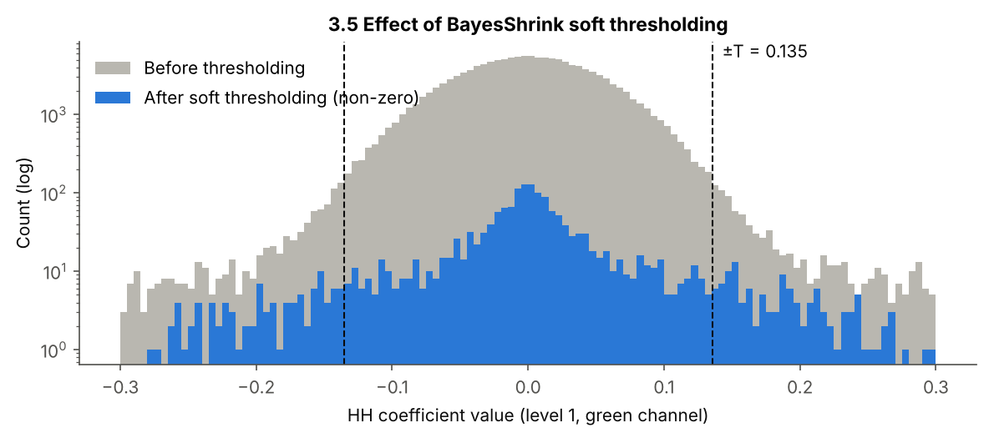
Fig. 6. Distribution of level-1 HH coefficients before and after BayesShrink soft thresholding (log scale); dashed lines mark ±T_{B}.
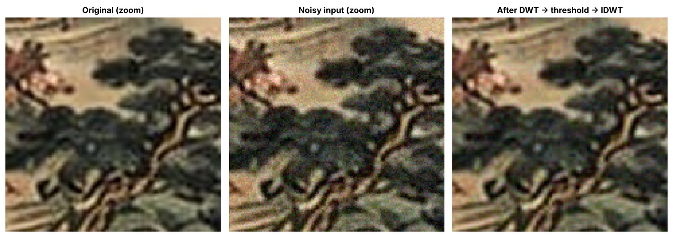
Fig. 7. Zoomed intact area: original, noisy input and result after DWT, thresholding and inverse DWT.

D. Comparison of restoration methods (Q3)
Table V. Objective comparison with the original painting (same detected mask for all methods)
Method | MSE ↓ | PSNR (dB) ↑ | SSIM ↑ | PSNR damaged area (dB) | PSNR intact area (dB)
Damaged image (input) | 1589.63 | 16.12 | 0.565 | 6.85 | 26.06
Telea inpainting (no denoising) | 330.27 | 22.94 | 0.612 | 16.78 | 25.00
Navier–Stokes inpainting (no denoising) | 337.83 | 22.84 | 0.611 | 16.52 | 25.04
Wavelet denoising only (no inpainting) | 1436.84 | 16.56 | 0.793 | 6.98 | 32.13
Wavelet-domain iterative inpainting | 284.93 | 23.58 | 0.817 | 15.16 | 29.08
Wavelet + inpainting (proposed) | 218.34 | 24.74 | 0.830 | 16.83 | 29.00
Proposed + seam smoothing (final) | 217.00 | 24.77 | 0.835 | 16.83 | 29.08
Proposed + display enhancement | 491.08 | 21.22 | 0.760 | 16.05 | 22.62

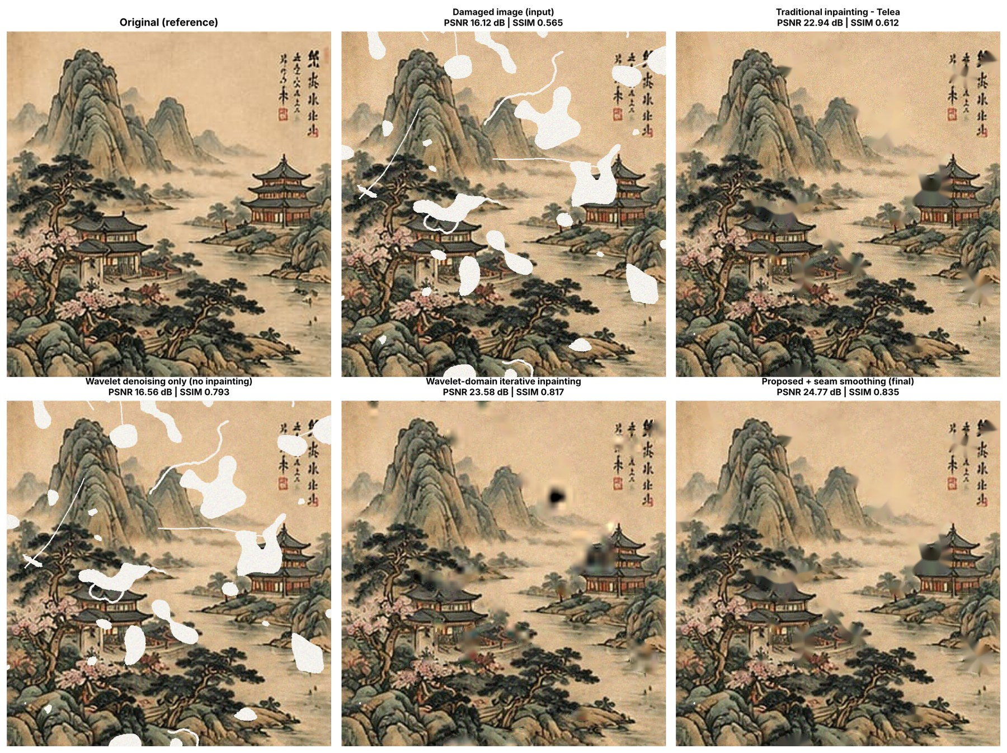
Fig. 8. Visual comparison of the original, the damaged input and four restoration methods, with PSNR and SSIM for each.
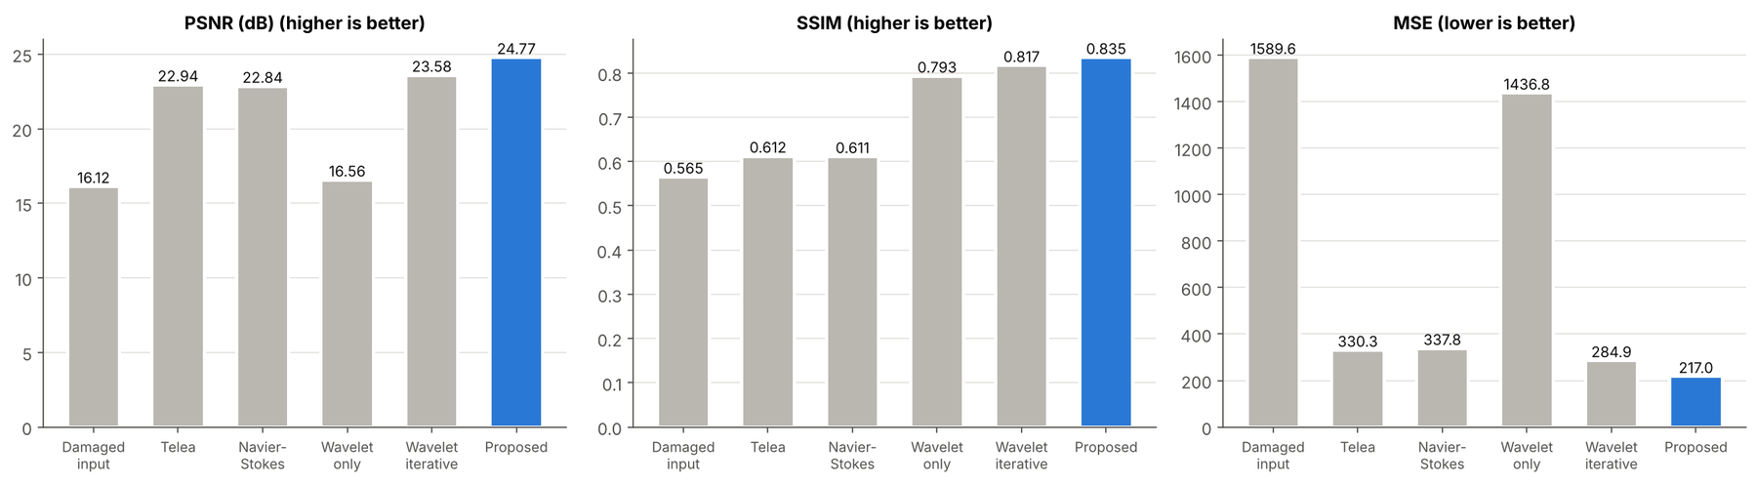
Fig. 9. PSNR, SSIM and MSE of the main methods; the proposed method is highlighted.
Table V and Figs. 8–9 answer Q3. Conventional inpainting filled the losses and raised PSNR from 16.12 dB to 22.94 dB (Telea) and 22.84 dB (Navier–Stokes), but because the noise remained, SSIM improved only from 0.565 to about 0.61. Wavelet denoising alone raised SSIM to 0.793 but left PSNR at 16.56 dB because the white losses were untouched. The combination achieved the best value on all three metrics: PSNR 24.77 dB, SSIM 0.835 and MSE 217.00 — 1.83 dB, 0.223 and 34.3% better than Telea inpainting alone. Seam smoothing added a small further gain (+0.03 dB, +0.005 SSIM). The pure wavelet-domain iterative inpainting was the second-best method overall (23.58 dB, 0.817), but it was clearly weaker inside the holes. The optional display enhancement looked crisper yet reduced PSNR by 3.55 dB and SSIM by 0.075, because contrast equalisation and sharpening move pixel values away from the original.

E. Where the improvement comes from: region-wise analysis
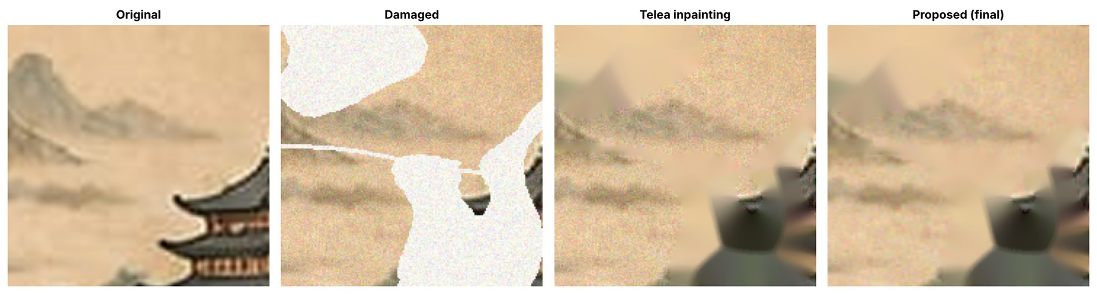
Fig. 10. The most damaged area: original, damaged input, Telea inpainting and the proposed result.
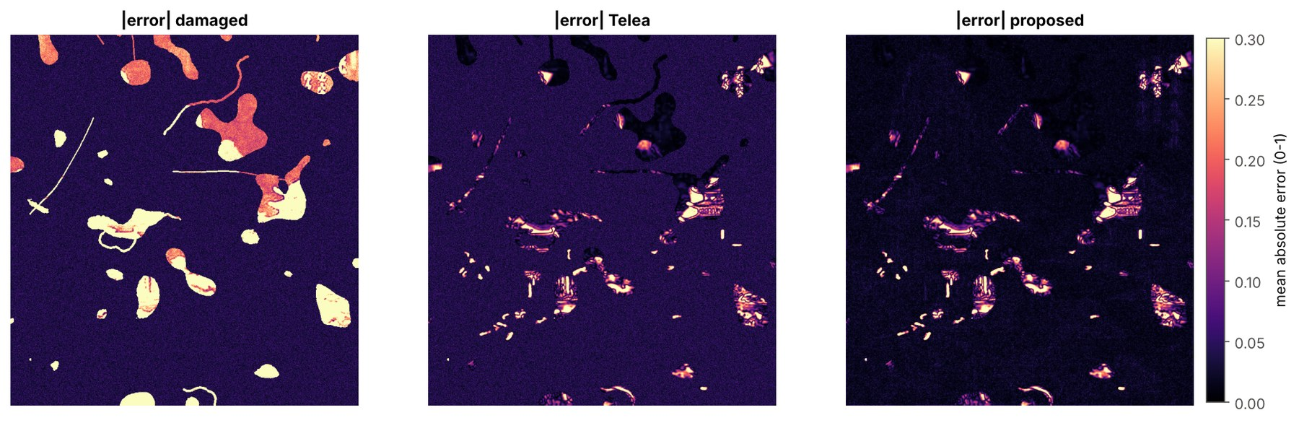
Fig. 11. Absolute error maps (mean over RGB) for the damaged input, Telea inpainting and the proposed method.
The last two columns of Table V separate the two degradations. Inside the true damaged area, Telea (16.78 dB), Navier–Stokes (16.52 dB) and the proposed method (16.83 dB) are practically equal, and the iterative wavelet-domain fill is lower (15.16 dB). On the intact area, the proposed method reaches 29.08 dB against 25.00 dB for Telea, a gain of 4.08 dB. The overall advantage of the proposed method therefore comes almost entirely from wavelet denoising of the intact painting, not from better filling of the holes. The error maps in Fig. 11 confirm this: the uniform noise floor visible for Telea disappears in the proposed result, while the bright errors inside large holes over structured content — the pavilion roofs, pine foliage and inscription — remain similar. Wavelet denoising alone scores even higher on the intact area (32.13 dB) because the “intact area” as defined by ground truth includes the 2.51% of over-detected pixels, which the proposed method replaces by inpainting; this quantifies the cost of imperfect detection precision.

F. Sensitivity experiments (Q4)
Table VI. E1 — PSNR (dB) of the proposed method by wavelet family and decomposition level
Wavelet | Level 1 | Level 2 | Level 3 | Level 4
Haar | 24.16 | 24.31 | 24.33 | 24.33
db2 | 24.39 | 24.59 | 24.61 | 24.61
db4 (used) | 24.51 | 24.75 | 24.77 | 24.77
sym4 | 24.52 | 24.76 | 24.77 | 24.78
coif2 | 24.52 | 24.77 | 24.78 | 24.79
bior2.2 | 24.43 | 24.60 | 24.61 | 24.61

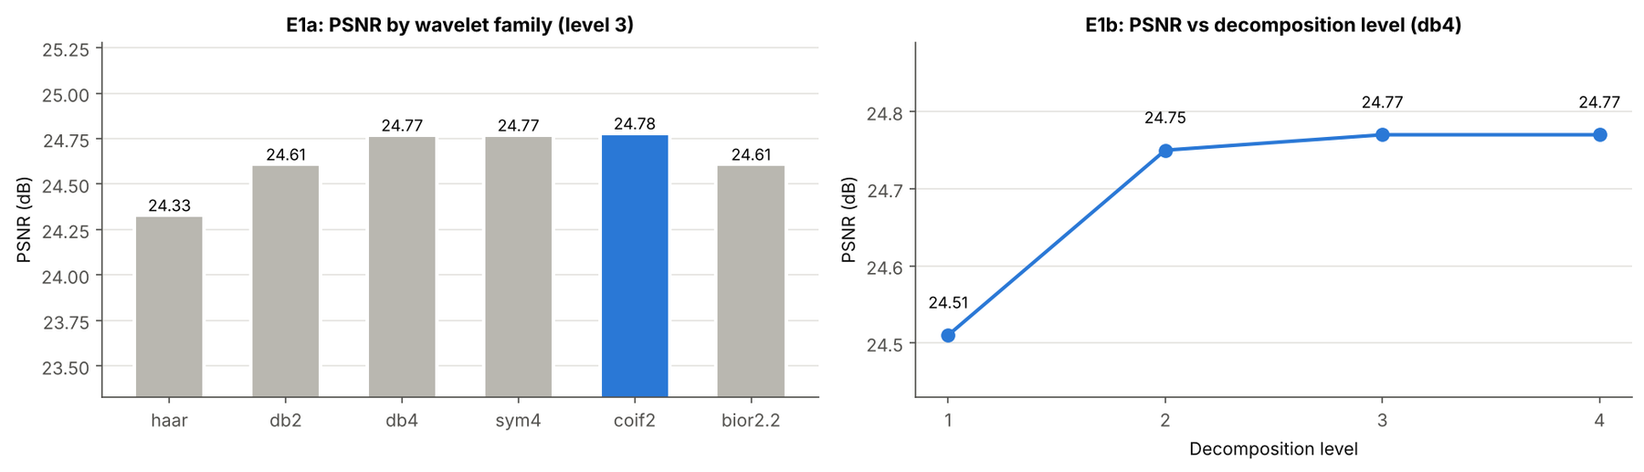
Fig. 12. E1: PSNR by wavelet family at level 3 (left) and by decomposition level for db4 (right).
E1 – wavelet family and level. Smooth wavelets with more vanishing moments (db4, sym4, coif2: 24.77–24.79 dB, SSIM 0.835–0.836) outperformed the Haar wavelet (24.33 dB, SSIM 0.781), whose blocky basis leaves staircase artefacts, and the biorthogonal bior2.2 (24.61 dB). Going from one to two decomposition levels added about 0.24 dB; further levels changed PSNR by at most 0.02 dB, because at coarse scales few coefficients fall below the threshold (Table IV). The chosen db4 at level 3 is within 0.02 dB of the best configuration.
Table VII. E2 — Effect of the thresholding rule and of detail enhancement
Setting | PSNR (dB) | SSIM
Soft thresholding, BayesShrink (used) | 24.77 | 0.835
Soft thresholding, VisuShrink (universal threshold) | 23.01 | 0.719
Hard thresholding, BayesShrink | 24.06 | 0.733
Hard thresholding, VisuShrink | 23.95 | 0.785
Soft BayesShrink + detail gain 1.1 | 24.54 | 0.824
Soft BayesShrink + detail gain 1.2 | 24.18 | 0.809

E2 – thresholding rule. The sub-band-adaptive BayesShrink threshold beat the single universal VisuShrink threshold σ_{n}√(2 ln N) [3] by 1.76 dB, because the universal threshold is too large for coarse sub-bands and over-smooths the image. Soft thresholding beat hard thresholding by 0.71 dB and 0.102 SSIM; hard thresholding keeps isolated noisy coefficients that appear as speckle. Amplifying the surviving detail coefficients (“detail enhancement”) consistently lowered fidelity.
Table VIII. E3 and E4 — PSNR (dB) as noise level and amount of damage increase
Noise σ (E3, 10% damage) | 0.02 | 0.04 | 0.06 | 0.08 | 0.10
Damaged input | 16.42 | 16.24 | 15.98 | 15.64 | 15.24
Telea inpainting | 24.78 | 23.63 | 22.26 | 20.76 | 19.49
Proposed | 25.04 | 24.85 | 24.73 | 24.32 | 24.11
Hole coverage (E4, σ = 0.05) | 5% | 10% | 15% | 20% | 25%
Damaged input | 18.62 | 16.12 | 14.53 | 13.31 | 12.34
Telea inpainting | 23.58 | 22.94 | 22.31 | 21.40 | 20.93
Proposed | 26.01 | 24.77 | 23.76 | 22.48 | 21.81

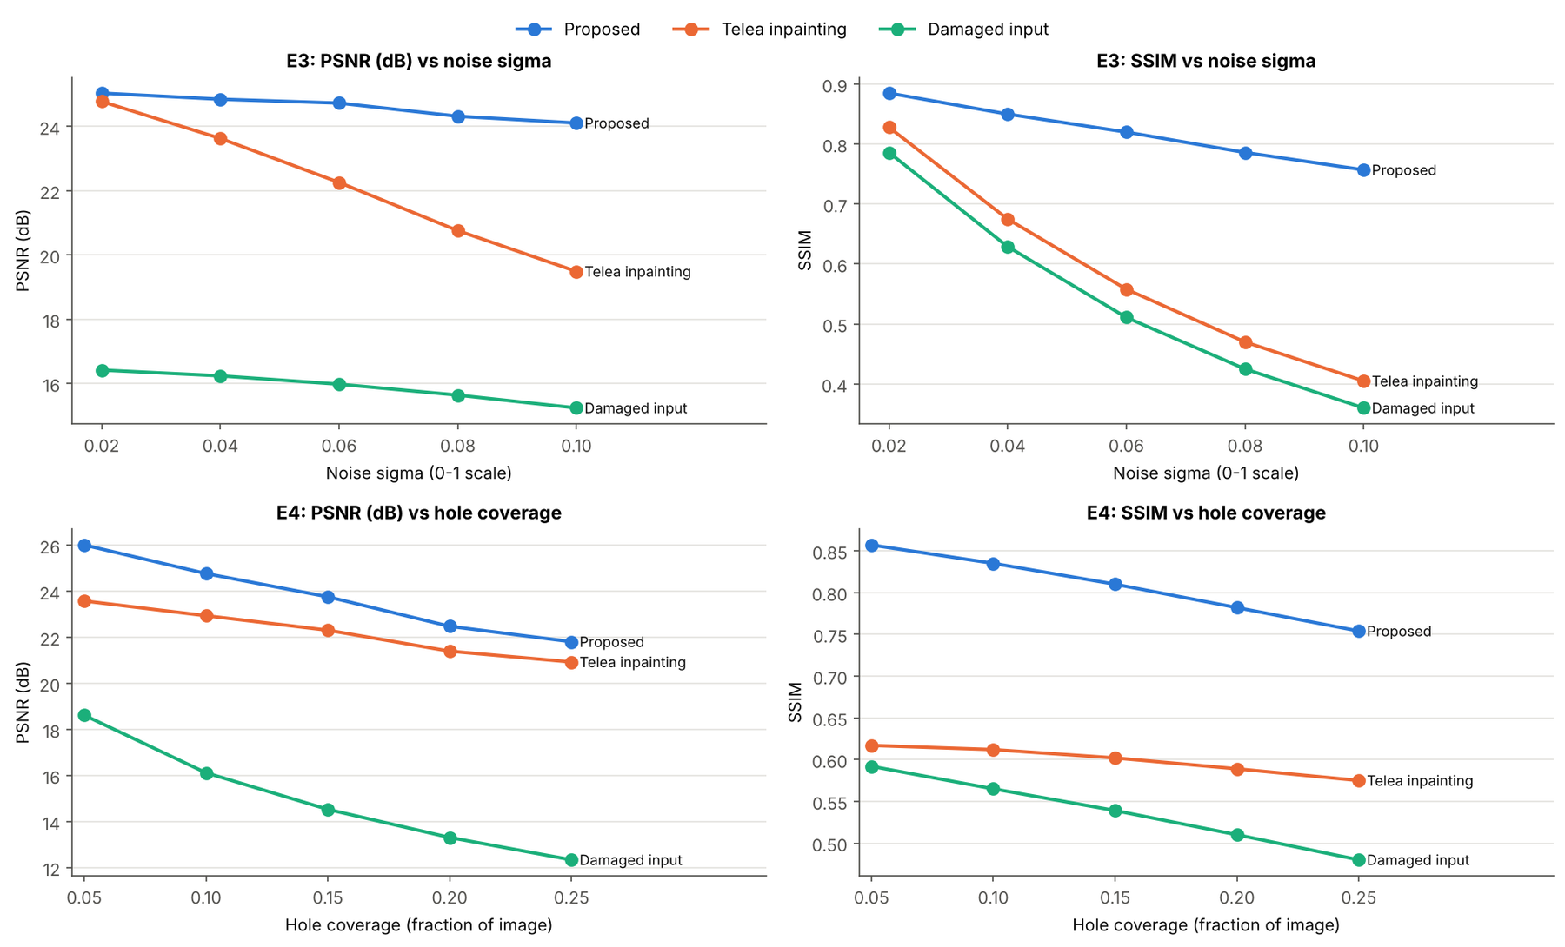
Fig. 13. E3 and E4: PSNR and SSIM of the damaged input, Telea inpainting and the proposed method against noise level (top) and hole coverage (bottom).
E3 – noise level. As σ rose from 0.02 to 0.10, Telea inpainting lost 5.29 dB (24.78 → 19.49 dB) while the proposed method lost only 0.93 dB (25.04 → 24.11 dB). The gap between them grew from 0.26 dB to 4.62 dB in PSNR and from 0.057 to 0.352 in SSIM. E4 – amount of damage. As hole coverage rose from 5% to 25%, both methods declined, and the gap narrowed from 2.43 dB to 0.88 dB, because errors inside the holes — where both methods rely on the same inpainting — increasingly dominate the overall score.
Analysis. Taken together, the evidence answers the case questions. Damage can be detected automatically with complete recall and good precision for this damage type (Q1). Wavelet thresholding removes about half of the noise and preserves edges, as shown by the coefficient statistics, the noise estimate and the zoomed results (Q2). The wavelet-plus-inpainting pipeline outperforms conventional inpainting on all three metrics, with the benefit located on intact areas (Q3). The method is robust to the choice among smooth wavelets and to levels beyond two, sensitive to the threshold rule, increasingly valuable as noise grows and decreasingly decisive as losses grow (Q4).

VI. OUTCOMES / IMPACT
Table IX summarises the measurable outcomes of the intervention, and Fig. 14 shows the final result beside the original and the damaged input.
Table IX. Before-and-after outcome indicators
Indicator | Before (damaged input) | After (restored) | Change
PSNR (dB) | 16.12 | 24.77 | +8.65 dB
SSIM | 0.565 | 0.835 | +0.270
MSE | 1589.63 | 217.00 | −86.3%
Noise std. on intact area | 0.0498 | 0.0232 | −53.4%
PSNR vs Telea inpainting alone | 22.94 dB | 24.77 dB | +1.83 dB
SSIM vs Telea inpainting alone | 0.612 | 0.835 | +0.223
Damage detection (Dice / recall) | — | 0.895 / 1.000 | 54 regions mapped
Processing time per image (detection + restoration) | — | ≈ 0.3 s | CPU only

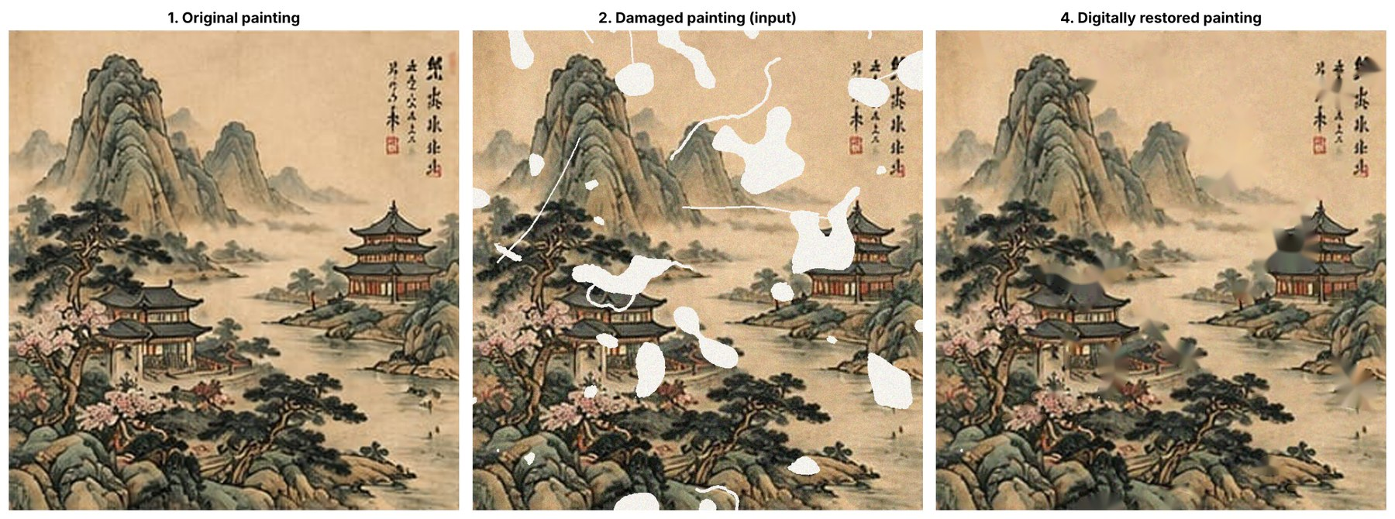
Fig. 14. Final result: original painting, damaged painting (input) and digitally restored painting.
Benefits. Scratches, cracks and losses over plain areas — sky, water, mist and paper ground — disappear almost completely, and the grainy noise over the whole painting is removed while mountain contours, pine needles and architectural lines remain sharp. The pipeline also produces a documented damage map (location, number and area of losses), which is useful in itself for condition reporting. It is fully automatic and reproducible, takes about 0.3 s per image on an ordinary CPU and uses only free software.
Limitations observed. Large losses over structured content — the pavilion roofs, dense pine foliage and parts of the inscription — are filled with smooth, plausibly coloured but structureless patches (Figs. 8 and 10); PSNR inside the damaged area stays near 16.8 dB. Missing calligraphic characters cannot be recovered, and inventing them would be inappropriate. Denoising also softens the finest paper grain slightly.
Unintended effects. The safety margin and a few false detections cause some authentic pixels to be replaced by inpainted values, and the optional display enhancement, while visually appealing, lowers objective fidelity by 3.55 dB. No formal evaluation by conservators or other stakeholders was carried out in this case, so stakeholder response is not reported.

VII. LESSONS LEARNED AND DISCUSSION
Evidence-based findings. The following lessons are supported directly by the measurements in Section V:
1. Wavelet denoising and inpainting solve different sub-problems and are complementary. Inside the holes all inpainting variants scored about 16.8 dB, while on intact areas wavelet denoising added 4.08 dB. Neither technique alone matched the combination.
2. Adaptive thresholding matters more than the choice of wavelet. Switching from BayesShrink to VisuShrink cost 1.76 dB, whereas the spread across all smooth wavelets was only 0.02 dB, and Haar versus db4 was 0.44 dB.
3. The order of operations matters. Denoising before inpainting avoids spreading noise into the fills. Performing the hole-filling itself in the wavelet domain gave lower quality inside the holes (15.16 dB versus 16.83 dB).
4. Detection sets the ceiling. Recall of 1.000 ensured every loss was treated, but the 2.51% over-detection cost fidelity on authentic paint, as shown by the 3 dB difference between the intact-area PSNR of wavelet-only denoising and the proposed method.
5. The wavelet stage is most valuable when noise is high, with its advantage growing from 0.26 dB to 4.62 dB across the tested noise range, and least decisive when large losses dominate.
6. Looking better is not the same as being more faithful. CLAHE and sharpening improved apparent crispness but reduced PSNR by 3.55 dB.
What did not work. Universal (VisuShrink) and hard thresholding, amplification of detail coefficients, purely wavelet-domain hole filling for large losses and cosmetic contrast enhancement all reduced objective quality. Diffusion-type inpainting (Telea and Navier–Stokes) could not reconstruct texture or structure inside large holes.
Interpretation. The following points are judgements drawn from the evidence rather than measured facts. The near-constant PSNR inside holes suggests that any method relying only on neighbouring pixels in a single image cannot recover lost content; in a heritage setting, filled areas should be treated as hypotheses and clearly marked. The smooth fills are probably acceptable for small cracks and plain backgrounds, but losses in figures, architecture or inscriptions call for exemplar-based or learned inpainting combined with expert judgement. Conservators might also prefer milder thresholds that keep more paper texture, accepting a little residual noise for greater authenticity.
Lessons for similar situations. Evaluate detection separately from restoration; report metrics separately for damaged and intact regions rather than one global number; create a ground truth through controlled simulation when real before-and-after pairs do not exist; fix random seeds so that results can be reproduced and checked; and distinguish enhancements made for display from processing intended for faithful restoration.

VIII. CONTEMPORARY RELEVANCE AND APPLICATION
Cultural heritage practice. Institutions are building large digital collections. An automatic pipeline of this kind can triage scans by mapping and quantifying damage, produce virtual restoration previews for exhibitions and online display without touching the object, and support conservators with documented damage maps before physical treatment. The same approach can be adapted to other fragile material held in Indian and international collections, such as manuscripts on paper and palm leaf, miniature paintings and archival photographs, with detection rules tuned to their typical damage.
Education and research. The case combines core DIP topics — colour spaces, mathematical morphology, multiresolution analysis, thresholding, inpainting and image-quality assessment — in one workflow that runs free of charge in a browser. It offers a reproducible baseline against which newer techniques can be compared.
Technology and industry. Wavelet methods remain widely used: the JPEG 2000 standard is built on the DWT, and wavelet shrinkage is used for denoising in photography, medical and remote-sensing imaging. Similar pipelines underlie consumer photo-restoration tools, document clean-up before optical character recognition and preprocessing for machine-learning models.
Scalability and future opportunities. Detection and restoration take about 0.3 s per 720 × 768 image on a CPU, so batch restoration of whole collections is feasible. Promising extensions include learned damage detection (for example a U-Net trained on annotated damage); exemplar-based [15] or deep large-mask inpainting [16] inside holes combined with wavelet denoising outside them; translation-invariant or directional transforms for better edge preservation; multispectral and infrared capture to reveal underdrawing; and an interactive tool through which conservators can accept, reject or adjust each fill.

IX. LIMITATIONS OF THE CASE STUDY
- Single image. All results come from one painting; other compositions, colours and resolutions may behave differently.
- Low-resolution source. The 302 × 316-pixel source was enlarged to 720 × 768 pixels. Enlargement makes the image smoother than a genuine high-resolution scan, which may favour wavelet denoising and overstate PSNR.
- Synthetic damage. Losses were modelled as bright, uniform backing and noise as additive white Gaussian noise. Real damage also includes stains, foxing, mould, flaking pigment, creases and colour shifts, and real noise is often signal-dependent and spatially correlated. Fading was disabled for the evaluation.
- Hand-tuned detection. Detection thresholds suit bright exposed backing; dark stains or losses with coloured backing would need retuning or a learned detector.
- Limited evaluation. MSE, PSNR and SSIM are full-reference pixel measures that do not judge historical plausibility; no conservator or user evaluation was conducted, and only one random seed was analysed.
- Classical baselines only. Exemplar-based and deep-learning inpainting methods were not compared.
- Nature of the test image. The reference is a traditional-style digital reproduction rather than a scan of an authenticated museum artwork, so the findings demonstrate the technique rather than an actual conservation outcome.

X. CONCLUSION
This case study addressed the restoration of a digitised Chinese painting suffering both physical losses and acquisition noise. An eight-stage pipeline was implemented in which damage is first detected and segmented, noise is removed by three-level db4 wavelet decomposition with BayesShrink soft thresholding and inverse transformation, and missing regions are then reconstructed by inpainting and smoothed at the seams. Damage was detected with a recall of 1.000 and a Dice coefficient of 0.895, and the restored painting reached a PSNR of 24.77 dB, an SSIM of 0.835 and an MSE of 217.00, compared with 16.12 dB, 0.565 and 1589.63 for the damaged input and 22.94 dB, 0.612 and 330.27 for conventional inpainting alone.
The principal lessons are that wavelet denoising and inpainting are complementary, that adaptive soft thresholding is more important than the exact wavelet chosen, that detection precision and region-wise evaluation are essential for an honest assessment, and that visual enhancement should be kept separate from faithful restoration. Large losses over detailed content remain beyond the reach of single-image propagation methods. In practical terms, the case shows that a low-cost, reproducible and fully open-source workflow can provide useful damage documentation and non-invasive virtual restoration to support the preservation of cultural heritage.

ACKNOWLEDGEMENT
The authors thank [Mentor Name Surname], Department of Electronics and Computer Science, Ramdeobaba University, Nagpur, for guidance throughout this case study. The authors also acknowledge the developers and maintainers of the open-source libraries NumPy, OpenCV, PyWavelets, scikit-image, pandas and Matplotlib, and Google for providing the Colab computing environment used for all experiments.

REFERENCES
[1]. S. G. Mallat, “A theory for multiresolution signal decomposition: the wavelet representation,” IEEE Transactions on Pattern Analysis and Machine Intelligence, vol. 11, no. 7, pp. 674–693, 1989.
[2]. I. Daubechies, “Ten Lectures on Wavelets,” SIAM, CBMS-NSF Regional Conference Series in Applied Mathematics, vol. 61, 1992.
[3]. D. L. Donoho and I. M. Johnstone, “Ideal spatial adaptation by wavelet shrinkage,” Biometrika, vol. 81, no. 3, pp. 425–455, 1994.
[4]. D. L. Donoho, “De-noising by soft-thresholding,” IEEE Transactions on Information Theory, vol. 41, no. 3, pp. 613–627, 1995.
[5]. S. G. Chang, B. Yu and M. Vetterli, “Adaptive wavelet thresholding for image denoising and compression,” IEEE Transactions on Image Processing, vol. 9, no. 9, pp. 1532–1546, 2000.
[6]. A. Telea, “An image inpainting technique based on the fast marching method,” Journal of Graphics Tools, vol. 9, no. 1, pp. 23–34, 2004.
[7]. M. Bertalmío, A. L. Bertozzi and G. Sapiro, “Navier–Stokes, fluid dynamics, and image and video inpainting,” Proceedings of the IEEE Conference on Computer Vision and Pattern Recognition (CVPR), vol. 1, pp. I-355–I-362, 2001.
[8]. M. Bertalmío, G. Sapiro, V. Caselles and C. Ballester, “Image inpainting,” Proceedings of ACM SIGGRAPH, pp. 417–424, 2000.
[9]. Z. Wang, A. C. Bovik, H. R. Sheikh and E. P. Simoncelli, “Image quality assessment: from error visibility to structural similarity,” IEEE Transactions on Image Processing, vol. 13, no. 4, pp. 600–612, 2004.
[10]. R. C. Gonzalez and R. E. Woods, “Digital Image Processing,” Pearson, 4th edition, 2018.
[11]. G. R. Lee, R. Gommers, F. Wasilewski, K. Wohlfahrt and A. O’Leary, “PyWavelets: A Python package for wavelet analysis,” Journal of Open Source Software, vol. 4, no. 36, p. 1237, 2019.
[12]. G. Bradski, “The OpenCV Library,” Dr. Dobb’s Journal of Software Tools, 2000.
[13]. S. van der Walt et al., “scikit-image: image processing in Python,” PeerJ, vol. 2, e453, 2014.
[14]. M. Elad, J.-L. Starck, P. Querre and D. L. Donoho, “Simultaneous cartoon and texture image inpainting using morphological component analysis (MCA),” Applied and Computational Harmonic Analysis, vol. 19, no. 3, pp. 340–358, 2005.
[15]. A. Criminisi, P. Pérez and K. Toyama, “Region filling and object removal by exemplar-based image inpainting,” IEEE Transactions on Image Processing, vol. 13, no. 9, pp. 1200–1212, 2004.
[16]. R. Suvorov et al., “Resolution-robust large mask inpainting with Fourier convolutions,” Proceedings of the IEEE/CVF Winter Conference on Applications of Computer Vision (WACV), pp. 2149–2159, 2022.

APPENDICES (OPTIONAL)

Appendix A. Parameter settings used
Table A1. Configuration of the restoration pipeline
Stage | Parameter | Value
Input | Working size; random seed | 720 × 768 px; 42
3.1 Pre-processing | Gaussian σ; median kernel | 1.2; 3 × 3
3.2 Detection | HSV thresholds V, S | V ≥ 225, S ≤ 40
3.2 Detection | Top-hat element; threshold; minimum line size | 9 × 9 ellipse; 28; 15 px
3.3 Segmentation | Closing; minimum region; safety margin | 3 × 3; 30 px; 2 px
3.4 DWT | Wavelet; levels; boundary mode | db4; 3; periodization
3.5 Thresholding | Noise estimate; rule; type; detail gain | MAD on HH₁; BayesShrink; soft; 1.0
3.7 Inpainting | Method; radius | Telea fast marching; 5 px
3.8 Post-processing | Seam ring; bilateral filter | 5 × 5 ring, Gaussian σ = 2; d = 7
3.8 Display (optional) | CLAHE clip; unsharp amount | 1.0; 0.3

Appendix B. Full results of experiment E1 (PSNR in dB / SSIM)
Table A2. Proposed method by wavelet family and decomposition level
Wavelet | Level 1 | Level 2 | Level 3 | Level 4
Haar | 24.16 / 0.752 | 24.31 / 0.779 | 24.33 / 0.781 | 24.33 / 0.781
db2 | 24.39 / 0.779 | 24.59 / 0.815 | 24.61 / 0.818 | 24.61 / 0.818
db4 | 24.51 / 0.791 | 24.75 / 0.833 | 24.77 / 0.835 | 24.77 / 0.835
sym4 | 24.52 / 0.790 | 24.76 / 0.833 | 24.77 / 0.835 | 24.78 / 0.835
coif2 | 24.52 / 0.791 | 24.77 / 0.834 | 24.78 / 0.836 | 24.79 / 0.836
bior2.2 | 24.43 / 0.781 | 24.60 / 0.809 | 24.61 / 0.810 | 24.61 / 0.810

Appendix C. Supplementary figures
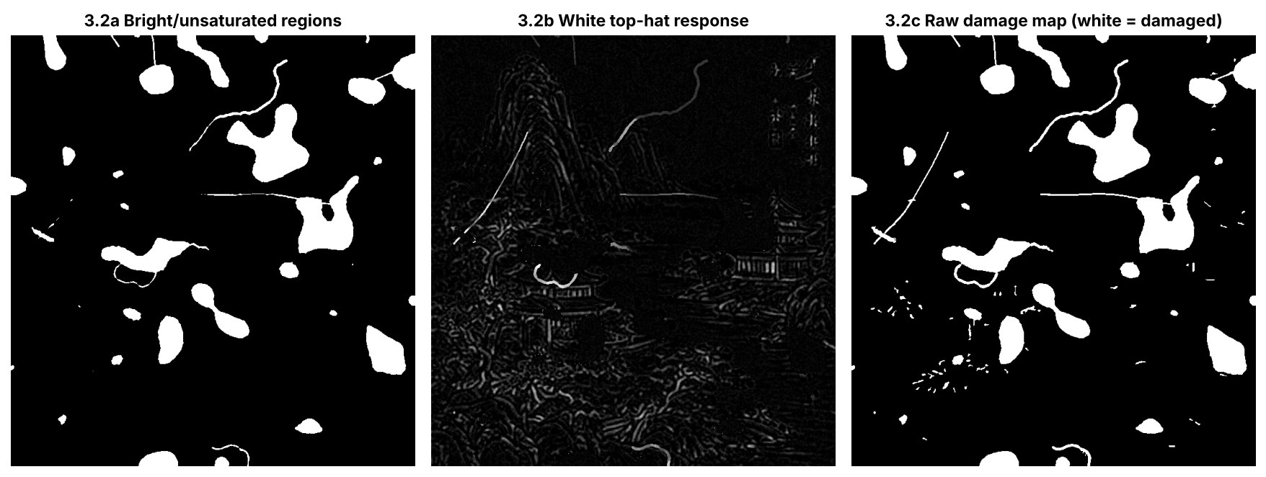
Fig. A1. Damage detection stages: bright, unsaturated regions; white top-hat response; and the combined raw damage map.
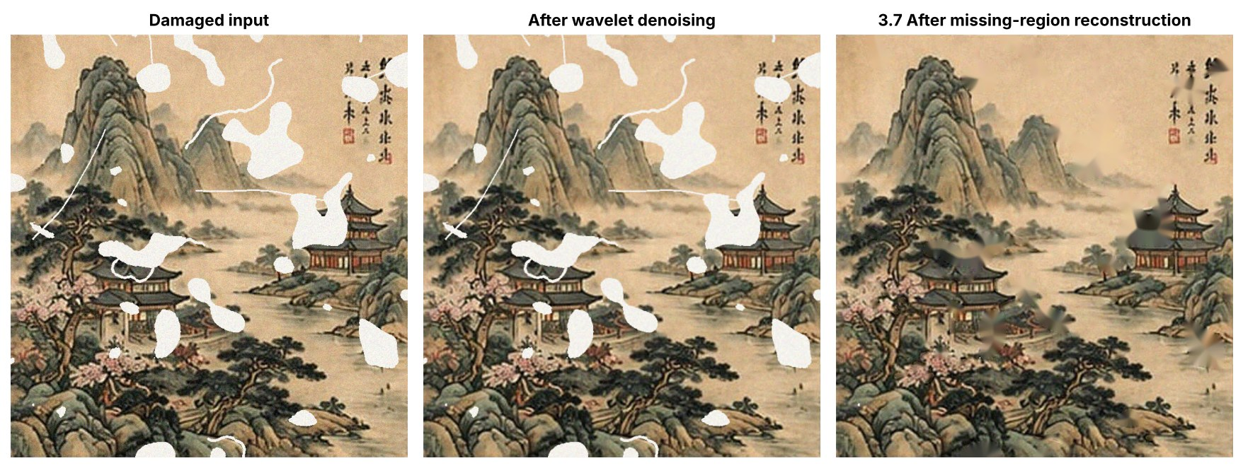
Fig. A2. Damaged input, the image after wavelet denoising, and the result after missing-region reconstruction.

Appendix D. Reproducibility
All results in this report were produced by the notebook DIP_Wavelet_Restoration_Chinese_Painting.ipynb. To reproduce them, open the notebook in Google Colab, set IMAGE_SOURCE = "upload" in the Configuration cell, choose Runtime → Run all and upload the reference painting image when prompted. The notebook saves every figure and table to /content/results/ and downloads them as dip_wavelet_results.zip. With the same input image and seed (42), the damage pattern is identical; small numerical differences can arise from different library versions.

