MyNEU

CSYE 7280 – User Experience Design & Testing

PROJECT REPORT

* Vineet Dandekar ([dandekar.v@husky.neu.edu](mailto:dandekar.v@husky.neu.edu))
* Rugved Jahagirdar ([jahagirdar.r@husky.neu.edu](mailto:jahagirdar.r@husky.neu.edu))

**Introduction**

This document is the final report for the project on Redesigning myNEU and its Associated Web Applications. This project is created as part of the curriculum for the User Experience Design & Testing course for the Summer 1 semester of the year 2016. While the previous document (Project Overview) was intended for introducing the project topic, this document will provide a very detailed information about each and every step carried out in designing this User Experience Design project.

We have followed the best practices for designing a user experience project by using the concepts and methods mentioned in the book The Elements of User Experience by Jesse James. As explained in the book, we have designed the project from all the five planes adopting a bottom-up approach i.e., starting with the strategy plane and gradually rising up each planes to scope, structure, skeleton and finally surface. Each component from each plane is well documented in this report with respect to the project.

We have also created wireframes and prototypes for the web application as well as for the mobile devices.

**Problem Definition**

Northeastern University has an internal web portal for its students called myNEU (<http://myneu.neu.edu>). Each and every student who is studying in Northeastern is given myNEU credentials from where s/he can manage a lot of things directly associated with the university. Some of the features provided by myNEU are as follows:

1. Course Registration: Students can look through the course catalog and search for suitable courses to register. They can use the Look Up classes features to search for sections of the courses which are well suited to them. They can Add a new class or Drop an existing class from their schedule.
2. Fees Payment: This portal provides feature which enables the students to pay their tuition and other fees online instead of visiting the financial department for the fee payments.
3. Student Employment: This section of the portal manages the employment details such as new job postings, time sheets for the current jobs, etc. for the students who work on-campus.
4. Blackboard: This is a student learning website which enables student to manage their coursework. Students submit assignments, attempt online quizzes, holds discussions, etc. using this website. Basically, it is a learning management website.
5. Other features include library management, parking, email, tickets, etc.

There are many such features provided by the myNEU portal. But, having said that, it is no way close to being a perfect website in its current form. The myNEU portal does not do good on some aspects from the user experience point of view. Following are some of the issues with the portal:

* Starting with the very first page of myNEU – the Login Page; the page is not very well designed with a lot of space wasted on either sides and have a huge image showing various photos from the university. This does not seem to be a very big issue but when we look at the size of the text fields and the buttons on the page, a lot of us will agree that the page needs a serious makeover.
* The error validations are not handled properly with the user experience point of view. For every error that takes place, the user is taken to a separate error page from where the user has to come back to the login page. This is just one extra click, but it can still become a little frustrating for the users.
* The main website is separated using tabs representing sections and each of these sections have a huge number of links to perform some functions. Even if the links are well segregated on the pages, it becomes very difficult to find some links if you are using the application for the first time.
* Many links open in a new window and this can get messy sometimes if the user accesses a lot of links simultaneously. It becomes very complicated and troublesome to manage so many different windows.
* There is no search functionality on the website and also no way to chat or contact tech-support if the user has issues with their account.
* Also, the above mentioned features like Fess Payment, Student Employment, Blackboard, etc. are available through the myNEU portal, but are different web applications altogether. They are not incorporated inside the myNEU website directly. This makes the maintaining of the websites a tedious job, as multiple applications have to be maintained instead of just one.

Blackboard is another application which we have included in this project and collaborated it inside myNEU application itself. This application currently has a link on myNEU and the Northeastern student can login into Blackboard only with their myNEU credentials. Blackboard is the learning management tool used by Northeastern to enable students and professors to collaborate their work online. As with myNEU, Blackboard also has a lot of user experience issues which are listed below:

* Global Navigation Menu appears too cluttered. Although it’s functionality is unique and it provides a comprehensive view, it also reduces look and feel of the menu bar.
* Statuses for assignments and test do not get updated on the real-time basis. It often happens that a certain assignment is still shown pending even after the user has submitted it. This gets updated once the user logins in again (creates a fresh session), but such things can be misleading and hence doesn’t go done well with user experience.
* Blackboard has a feature where users can view lectures online. These are recorded classroom lectures which are then uploaded by the professors. Sometimes the picture quality of the videos is not good as the video tends to pixelate. Also, in some cases the buffer rate for the video is very low.
* Contents uploaded by students are only available for the current semester. Once that semester is over, the contents which include assignments, project reports, tests, etc. sometimes become unavailable for the students.
* The information architecture for the website is not efficient enough as there is a lot of redundant data and duplicate links present in lot of pages.

This project aims to fix a lot of the user experience issues pointed out in the above sections and completely redesign the existing myNEU and Blackboard applications. Even if it is stated that the project is about redesigning the existing application, the final product will be a completely new application which will incorporate all the features of myNEU as well as Blackboard and attempt to introduce new conceptual features which are not currently existing in the applications but will certainly enhance the user experience for the product. Along with Blackboard, our project will incorporate various other features like Email, Student Employment, Fees Payments, NUPay, Library Management, etc. In addition to this, we have attempted to design an application for the mobile devices as well.

**Product Objectives**

Product Objectives constitute the first component of the Strategy Plane. These objectives are determined by the organization creating the product based on what the organization is expecting from the product. We have stated a list of objectives on behalf of Northeastern University as to what that organization will expect out of this new product and what all factors or reason will they consider for creating a new myNEU application.

**User Needs**

User needs constitute the second component of the Strategy Plane. Based on the usability of myNEU applications, we have identified different type of users who use these applications on a regular basis (at least once per week). Their personas are as follows:

1. On-Ground Student

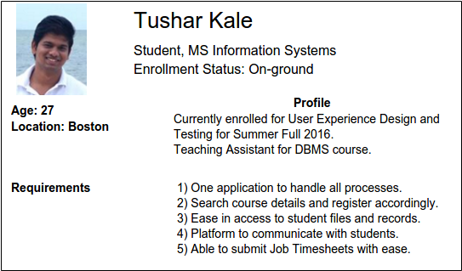

1. Online Student

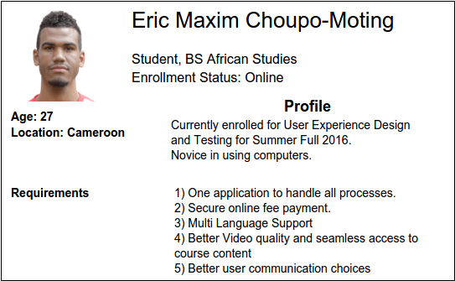

1. Faculty

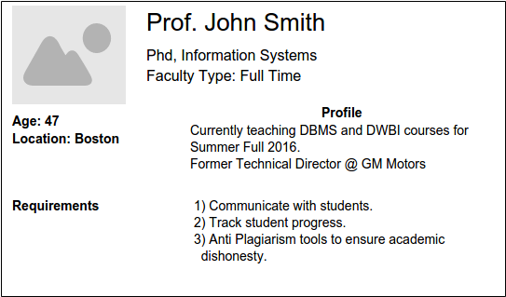

After identifying different users, we conducted a survey in form of a questionnaire to understand their requirements. This survey was passed along different age groups, gender who are currently using this application. The objective of this survey was to gather information / requirements directly from the users.

Here’s the link to our survey: - http://goo.gl/forms/cEu7PDY2GUimPWzA2

Post Prototyping, we intend to conduct a survey based on user testing the usability of redesigned application. This will help us touch base with users and verify if their requirements have been accomplished completely.