ASSIGNMENT 02

Vineet Dandekar | dandekar.v@husky.neu.edu

As with the first assignment, we will take the myNEU Portal and check which all changes can be made immediately and what will some pages look like if we completely redesign the website. Starting with the Login Page, one issue with it was that even if we do not enter the username and/or password, it tries to sign in the user and then takes you to the error page. Ideally, if the username and/or password are missing, then the server should not even be hit. Instead, there should be client-side validation which will display errors on the Login page itself.

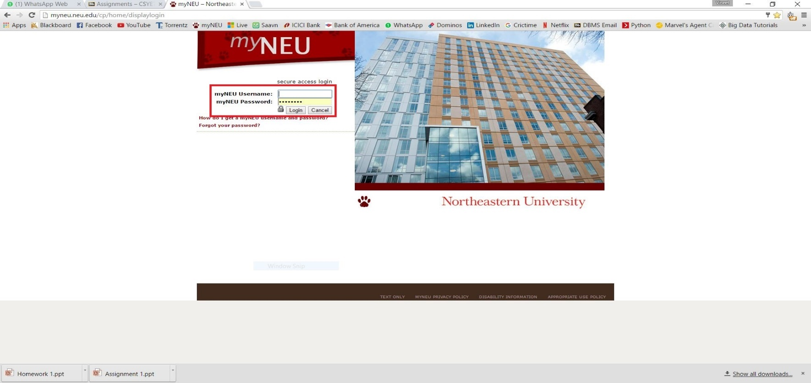

If you click the Login button without entering the username, you are redirected to the error page as shown below.

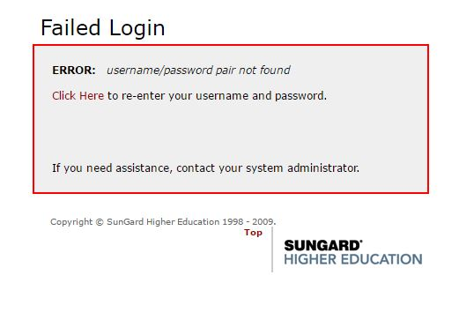

Now, having an error page to show the authentication error is actually not needed even if the incorrect credentials are entered, but that can be kept for later stage while redesigning the website. But, the blank field validations can be considered in the immediate changes category.

The second thing which can be handled on the immediate basis is the thing where certain pages open in a new window. For instance, see the screenshot below.

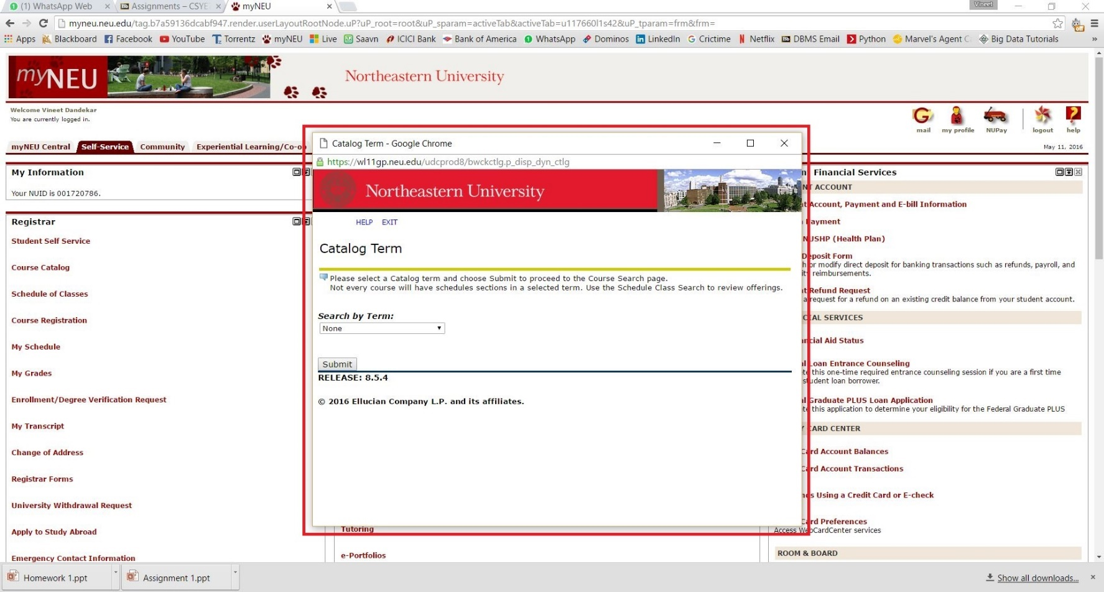

This window is opened when the user clicks the Course Catalog link on the Self Service tab of the website. Instead of opening it in the new window, it would be better if the page opens in the new tab of the same browser window. As many links on the website opens in a new window, it becomes very difficult to manage these multiple windows (at least for me).

Next thing which can be handled on the immediate basis is the navigation within the pages which open in the new window. As explained in the first assignment, let us go through the Course Registration functionality. When we click on the Course Registration link on the Self Service tab of the website, a new window is opened.

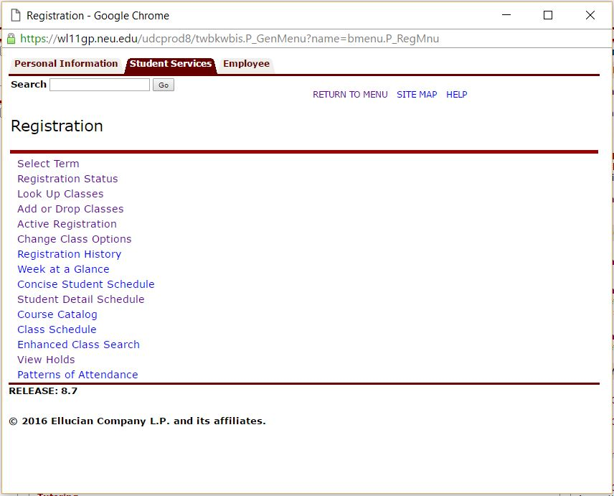

Now, if I click ‘Look Up Classes’ it takes me to the following page

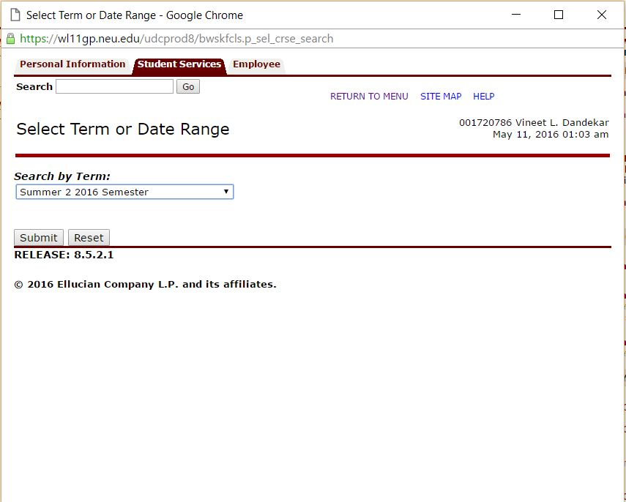

Here, I just select the term and then when I click submit, I am taken to the page where I select the Program or the Department.

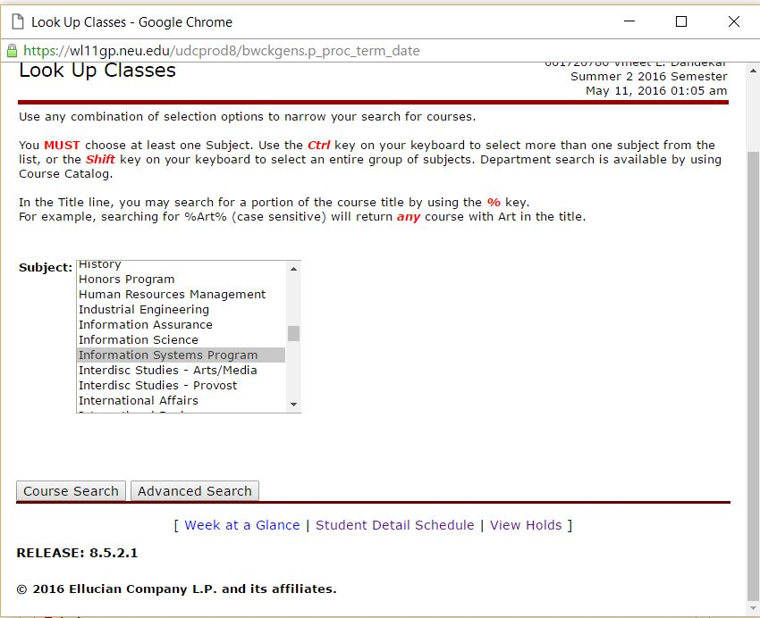

When, I select a certain program (here, I have selected Information Systems Program), the next page displays the courses offered for the select program and semester.

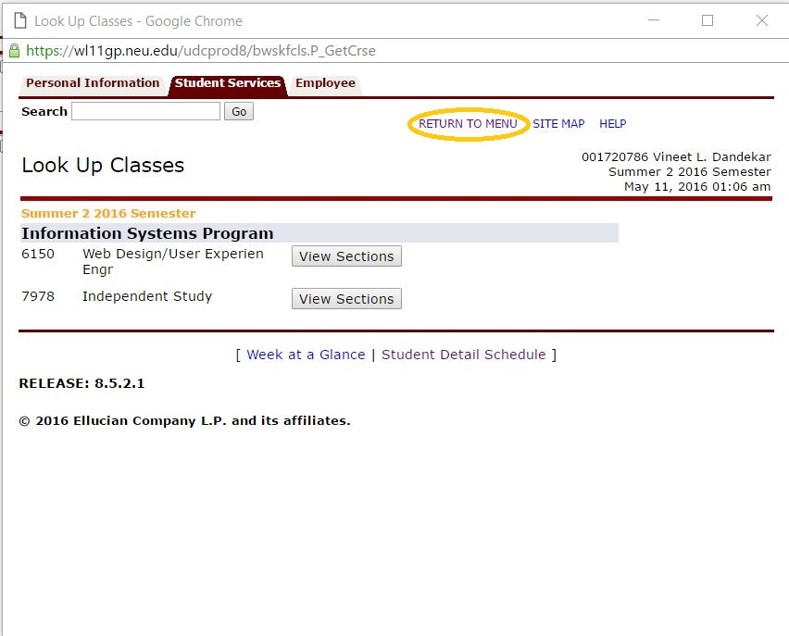

Now, thing to be noted here is that the page which displays the available courses has no link to go back and make the selections again.

Say, you want to check courses available in another program, you cannot go back to the previous page and change the program. The only link available is ‘Return to Menu’ which will take you all the way back to the first menu page (In this case, the Registration Page). From there, you need to follow the same steps again. I feel that the entire functionality can be done on one single page, but that will come as part of redesigning the website. As part of immediate fixes, Back button can be provided on each of the pages so that the user can navigate with some ease in both directions.

Now, if we consider a redesigned page for the above functionality, the page can look somewhat like this

