**PRACTICAL 4**

**TASK 1 :**

**CODE :**

#include <stdio.h>

#include <limits.h>

// Global Declaration to find the exact array

int global_max_sum = INT_MIN;

int global_start = 0;

int global_end = 0;

// Finding Max

int max(int a, int b) {

return (a > b) ? a : b;

}

// Return max of three integers but less than or equal to constraint

int max_of_three_constrained(int a, int b, int c, int constraint) {

int res = INT_MIN;

if (a <= constraint && a > res) res = a;

if (b <= constraint && b > res) res = b;

if (c <= constraint && c > res) res = c;

return res == INT_MIN ? 0 : res;

}

// Display Function

void Displaysubarray(int arr[], int low, int high) {

printf("[");

for (int i = low; i <= high; i++) {

printf("%d ", arr[i]);

}

printf("]");

}

// Max For Crossing.

int maxCrossingsum(int arr[], int low, int mid, int high, int constraint) {

// Left Side

int sum = 0;

int left_sum = INT_MIN;

int left_index = mid; // global

for (int i = mid; i >= low; i--) {

sum += arr[i];

if (sum <= constraint && sum > left_sum) {

left_sum = sum;

left_index = i; // Keeping Track of left part

}

}

// Right Side

sum = 0;

int right_sum = INT_MIN;

int right_index = mid + 1; // global

for (int i = mid + 1; i <= high; i++) {

sum += arr[i];

if (sum <= constraint && sum > right_sum) {

right_sum = sum;

right_index = i; // Keeping Track of right part

}

}

// Cross

int cross_sum = (left_sum == INT_MIN || right_sum == INT_MIN) ? INT_MIN : left_sum + right_sum;

// Update globals if crossing sum is more valid

if (cross_sum <= constraint && cross_sum > global_max_sum) {

global_max_sum = cross_sum;

global_start = left_index; // Update global start

global_end = right_index; // Update global end

}

if (cross_sum <= constraint && cross_sum > INT_MIN) return cross_sum;

// Return the best valid sum among left_sum and right_sum

if (left_sum == INT_MIN) {

if (right_sum <= constraint && right_sum > global_max_sum) {

global_max_sum = right_sum;

global_start = mid + 1;

global_end = right_index;

}

return (right_sum == INT_MIN) ? 0 : right_sum;

}

if (right_sum == INT_MIN) {

if (left_sum <= constraint && left_sum > global_max_sum) {

global_max_sum = left_sum;

global_start = left_index;

global_end = mid;

}

return left_sum;

}

// Compare and update globals for left and right sums

if (left_sum > right_sum) {

if (left_sum <= constraint && left_sum > global_max_sum) {

global_max_sum = left_sum;

global_start = left_index;

global_end = mid;

}

return left_sum;

}

else

{

if (right_sum <= constraint && right_sum > global_max_sum) {

global_max_sum = right_sum;

global_start = mid + 1;

global_end = right_index;

}

return right_sum;

}

}

// Recusive Division for each max.

int maxsumRecursive(int arr[], int low, int high, int constraint) {

if (low > high) return 0;

if (low == high) {

if (arr[low] <= constraint && arr[low] > global_max_sum) {

global_max_sum = arr[low];

global_start = low; // Track single element start

global_end = low; // Track single element end

}

return (arr[low] <= constraint) ? arr[low] : 0;

}

int mid = low + (high - low) / 2;

printf("\n--- Dividing Array ");

Displaysubarray(arr, low, high);

printf(" ---\n");

printf("First subarray: ");

Displaysubarray(arr, low, mid);

printf("\nSecond subarray: ");

Displaysubarray(arr, mid + 1, high);

printf("\n");

int left_max_sum = maxsumRecursive(arr, low, mid, constraint);

int right_max_sum = maxsumRecursive(arr, mid + 1, high, constraint);

// Calling function maxCrossingsum

int cross_max_sum = maxCrossingsum(arr, low, mid, high, constraint);

if (left_max_sum <= constraint && left_max_sum > global_max_sum) {

global_max_sum = left_max_sum;

// The subarray indices are updated during recursive calls

}

if (right_max_sum <= constraint && right_max_sum > global_max_sum) {

global_max_sum = right_max_sum;

// Subarray indices updated in recursive calls

}

printf("\n--- Dividing Array : ");

Displaysubarray(arr, low, high);

printf(" ---\n");

printf("Max sum in Left half : %d\n", left_max_sum);

printf("Max sum in Right half : %d\n", right_max_sum);

printf("Max sum for crossing subarray : %d\n", cross_max_sum);

return max_of_three_constrained(left_max_sum, right_max_sum, cross_max_sum, constraint);

}

int main() {

int oriarr[100], size, constraint;

printf("Enter array size: ");

scanf("%d", &size);

if(size<0){

printf("Empty Array ! No Subarrays !");

return 0;

}

printf("Enter array elements:\n");

for (int i = 0; i < size; i++) {

printf("Element %d: ", i);

scanf("%d", &oriarr[i]);

}

printf("Enter constraint value: ");

scanf("%d", &constraint);

printf("Original Array : ");

Displaysubarray(oriarr, 0, size - 1);

printf("\n------------------------------------------------\n");

printf("\n");

int maxsum = maxsumRecursive(oriarr, 0, size - 1, constraint);

if (maxsum == 0 || global_max_sum == INT_MIN ) {

printf("------------------------------------------------\n");

printf("No Valid subarray sum <= %d found.\n", constraint);

printf("\n------------------------------------------------\n");

}

else {

printf("\n------------------------------------------------\n");

printf("Maximum subarray sum <= %d is %d\n", constraint, global_max_sum);

printf("From Array/Subarray : ");

Displaysubarray(oriarr, global_start, global_end); // Displays max subarray

printf("\n------------------------------------------------\n");

printf("\n");

}

return 0;

}

**OUTPUT :**

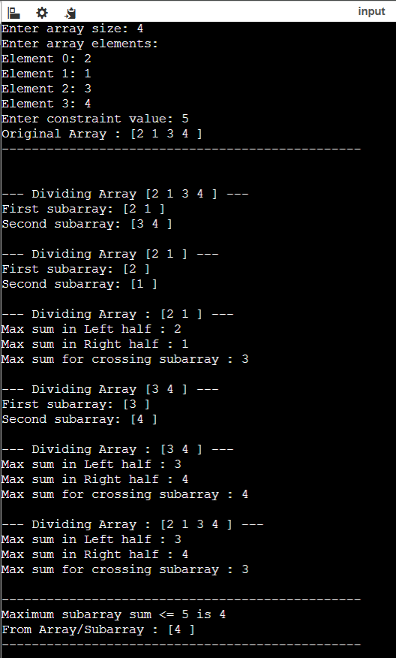

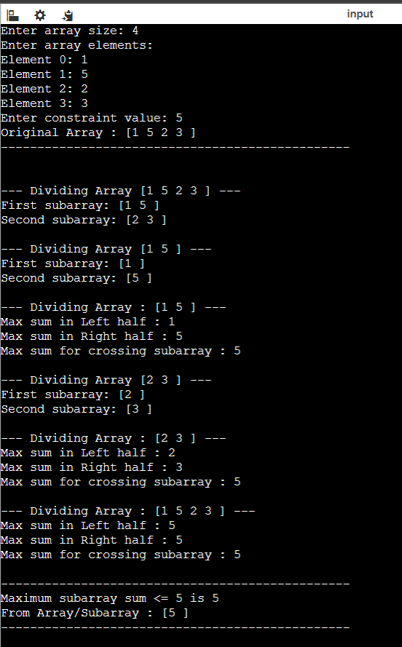

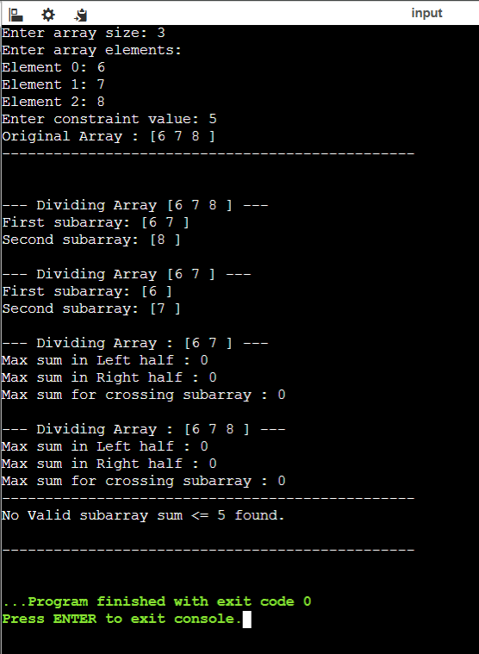

**TASK 2 :**

**CODE :**

**// To find max crossing sum**

**int maxCrossingSum(int* nums, int low, int mid, int high) {**

**// For Left**

**int sum = 0;**

**int left_sum = INT_MIN;**

**for (int i = mid; i >= low; i--) {**

**sum += nums[i];**

**if (sum > left_sum){**

**left_sum = sum;**

**}**

**}**

**// For Right**

**sum = 0;**

**int right_sum = INT_MIN;**

**for (int i = mid + 1; i <= high; i++) {**

**sum += nums[i];**

**if (sum > right_sum) right_sum = sum;**

**}**

**return left_sum + right_sum;**

**}**

**// Recursively Divide**

**int maxSubArraySum(int* nums, int low, int high) {**

**if (low == high) {**

**// Base case: one element**

**return nums[low];**

**}**

**int mid = low + (high - low) / 2;**

**int left_max = maxSubArraySum(nums, low, mid);**

**int right_max = maxSubArraySum(nums, mid + 1, high);**

**int cross_max = maxCrossingSum(nums, low, mid, high);**

**// Return maximum of the three**

**if (left_max >= right_max && left_max >= cross_max)**

**return left_max;**

**else if (right_max >= left_max && right_max >= cross_max)**

**return right_max;**

**else**

**return cross_max;**

**}**

**int maxSubArray(int* nums, int numsSize) {**

**return maxSubArraySum(nums, 0, numsSize - 1);**

**}**

**SCREENSHOT :**

