PRACTICAL 8

Aim :
Implement Graph Colouring algorithm. Use Graph colouring concept.
_______________________________________________________________________

TASK 1 :

CODE :

# Graph Colouring using the Backtracking

import networkx as nx
import matplotlib.pyplot as plt

# Global Variables

x = [] # Color assignment array
n = 0 # Number of vertices
m = 0 # Number of colors (frequencies)
G = [] # Adjacency matrix
count = 0 # Possibilities count.

def NextValue(k):
# Assigns the next possible legal color.
global x, G, n, m

while True:
x[k] = (x[k] + 1) % (m + 1) # Next color (1 to m)
if x[k] == 0:
return # All colors used, backtrack

# Check for conflicts
for j in range(1, n + 1):
if G[k - 1][j - 1] != 0 and x[k] == x[j]:
break
else:
# If loop completed without break -> legal color detected
return

def mcoloring(k):
global x, G, n, m, final_solution, count

while True:
NextValue(k)
if x[k] == 0:
return # no color possible, backtrack

if k == n:
# Print valid color assignment
print(f"Valid Coloring Found : {x[1:]}")
count += 1
final_solution.append(x[1:].copy())
else:
mcoloring(k + 1)

def draw_graph(G, colors):
"""
Draw the graph with node colors.
"""
g = nx.Graph()
for i in range(len(G)):
g.add_node(i + 1)
for j in range(i + 1, len(G)):
if G[i][j] == 1:
g.add_edge(i + 1, j + 1)

# Color palette
palette = ["red", "green", "blue", "yellow", "orange", "purple", "cyan", "magenta"]
node_colors = [palette[c - 1] for c in colors]

pos = nx.spring_layout(g, seed=42)
nx.draw(
g, pos,
with_labels=True,
node_color=node_colors,
node_size=800,
edgecolors="black",
font_color="white",
font_weight="bold"
)
plt.title("GSM Cell Frequency Allocation (Graph Coloring)")
plt.show()

# Main

G = [
[0, 1, 1, 1, 0],
[1, 0, 1, 0, 1],
[1, 1, 0, 1, 0],
[1, 0, 1, 0, 1],
[0, 1, 0, 1, 0]
]

n = len(G) # number of vertices
m = 3 # number of colors/frequencies

x = [0] * (n + 1) # color assignments ( initial 0 for all )
final_solution = []

# Main Algo

mcoloring(1)
print(f"\nTherefore {count} Valid Colouring detected !\n\n")

# Visualization for First Solution

if final_solution:
print("\nVisualizing First Valid Coloring...\n")
draw_graph(G, final_solution[0])
else:
print("\nNo valid coloring found.")

OUTPUT :
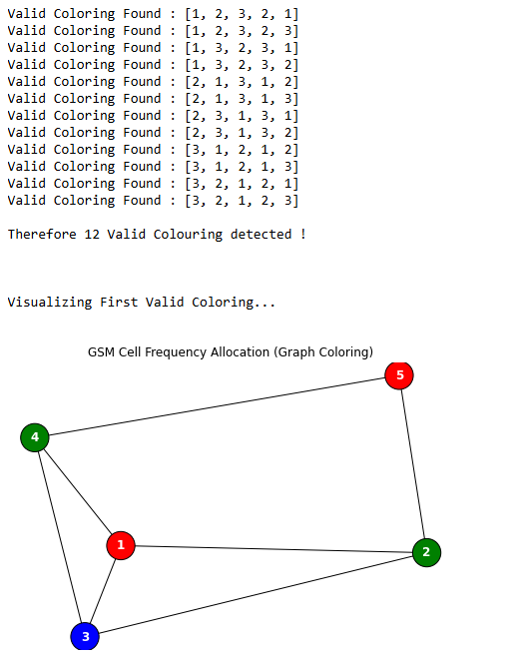

OUTPUT 2 : ( By Changing the Graph Input )

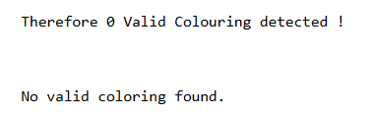
_______________________________________________________________________

TASK 2 :

CODE :

# User function Template for python3

class Solution:
def isSafe(self, node, color, graph, n, col):
# Check all adjacent vertices
for adj in graph[node]:
if color[adj] == col:
return False
return True

def solve(self, node, color, graph, m, n):
# If all vertices are assigned a color then return True
if node == n:
return True

# Try different colors for the current vertex
for col in range(1, m + 1):
if self.isSafe(node, color, graph, n, col):
color[node] = col
if self.solve(node + 1, color, graph, m, n):
return True
color[node] = 0 # Backtrack

return False

def graphColoring(self, v, edges, m):
# Build adjacency list for the graph
graph = [[] for _ in range(v)]
for u, w in edges:
graph[u].append(w)
graph[w].append(u)

color = [0] * v
return self.solve(0, color, graph, m, v)

OUTPUT :




