PRACTICAL 7

Aim :
Implement Hamiltonian Cycle using Backtracking.
______________________________________________________________________

Task 1 :

Code :

# Hamiltonian Cycle using Backtracking

# Adjacency Matrix

G = [
[0, 1, 1, 0, 1],
[1, 0, 1, 1, 0],
[1, 1, 0, 1, 0],
[0, 1, 1, 0, 1],
[1, 0, 0, 1, 0]
]

n = len(G) # Number of vertices.
x = [0] * (n + 1) # Path array ( 0 intially for all ). ( Storing the final path , if it exists).
x[1] = 1 # Starting from vertex 1. (A)
cycle = False # To check if any cycle exists.
count_cycles = 0 # To check the no. of cycles possible.

def NextValue(k):
global x, G, n
while True:
x[k] = (x[k] + 1) % (n + 1) # Assign Next Vertex
if x[k] == 0:
return
if G[x[k - 1] - 1][x[k] - 1] != 0: # Check adjacency
# Check for repetition
j = 1
while j < k:
if x[j] == x[k]: # Check Repetition
break
j += 1

if j == k: # Check for distinctions
if (k < n) or (k == n and G[x[n] - 1][x[1] - 1] != 0):
return

def Hamiltonian_cycle(k):
global x, G, n, count_cycles, cycle
while True:
NextValue(k)
if x[k] == 0:
return
if k == n:
print_cycle()
count_cycles += 1
found = True
else:
Hamiltonian_cycle(k + 1)

def print_cycle():
city_labels = ['A', 'B', 'C', 'D', 'E']
print("Hamiltonian Cycle (Night Patrol Route) Detected :")
for i in range(1, n + 1):
print(city_labels[x[i] - 1], end=" -> ")
print(city_labels[x[1] - 1])
print("-" * 50)

# Main

Hamiltonian_cycle(2) # Passing the index of the vertex.

print(f"Therefore {count_cycles} Possible Routes ( Hamiltonian Cycles ) detected !")

if not cycle :
print("No Hamiltonian Cycle Exists. / Ended.")

Output 1 :
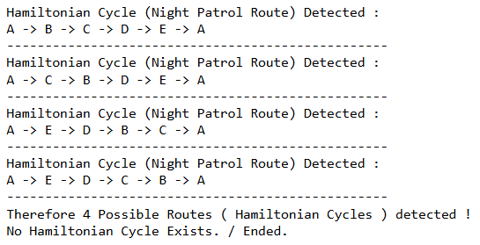

Output 2 : ( By Changing Graph Input ) :
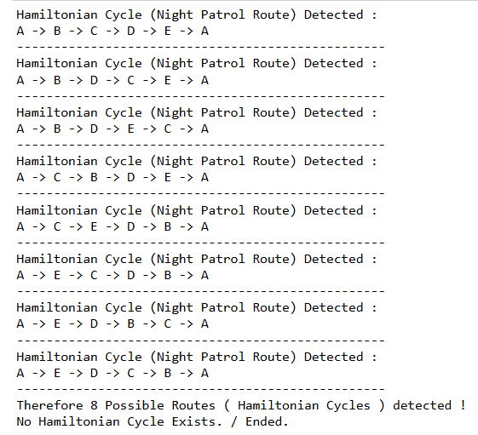
______________________________________________________________________

Task 2 :

Code :

#User function Template for python3
class Solution:
def check(self, n, m, edges):

# Create adjacency matrix

graph = [[] for _ in range(n + 1)]
for u, v in edges:
graph[u].append(v)
graph[v].append(u)

# Backtracking

def back(node, visited_count, visited):
# Base case: all vertices visited
if visited_count == n:
return True

for i in graph[node]:
if not visited[i]:
visited[i] = True
if back(i, visited_count + 1, visited):
return True
visited[i] = False # backtrack

return False

for start in range(1, n + 1):
visited = [False] * (n + 1)
visited[start] = True
if back(start, 1, visited):
return 1 # Hamiltonian Path exists

return 0 # No Hamiltonian Path found

Screenshot :




