begin program.
ad_names = ['ba','adidas1','burbury','cola', 'j20','lucazade','mands','mb1','mul', 'samsung', 'spsp','dogfood','asda', 'magnum1','mub','walls' ]
ad_name ='_2012' # Specify suffix.

import spss,spssaux

vdict=spssaux.VariableDict()
for ad in ad_names:
substr = "a_"+ad+"_"
for variable in vdict:
#print ad
if substr in str(variable):
print('Match found: ', variable)
#spss.Submit("COMPUTE temp_var"+ad_name+" = 1")
spss.Submit("""
FREQUENCIES VARIABLES=%s
/FORMAT dfreq
/PIECHART.
""" %(variable))
break
#else:
#print('No match')

#spss.Submit("COMPUTE temp_var"+ad_name+" = 1")

end program.
('Match found: ', Q005a_ba_53)

Frequencies

Notes
Output Created |  | 28-JUL-2016 20:34:30
Comments
Input | Data | C:\Users\mruhaim\Desktop\Adtesting analysis\only completed responses.sav
Input | Active Dataset | DataSet1
Input | Filter | <none>
Input | Weight | <none>
Input | Split File | <none>
Input | N of Rows in Working Data File | 659
Missing Value Handling | Definition of Missing | User-defined missing values are treated as missing.
Missing Value Handling | Cases Used | Statistics are based on all cases with valid data.
Syntax |  | FREQUENCIES VARIABLES=Q005a_ba_53  /FORMAT dfreq  /PIECHART.
Resources | Processor Time | 00:00:00.17
Resources | Elapsed Time | 00:00:00.10

Statistics
Which ad do you like best? (BA)
N | Valid | 193
N | Missing | 466

Which ad do you like best? (BA)
 |  | Frequency | Percent | Valid Percent | Cumulative Percent
Valid | Ad1 | 108 | 16.4 | 56.0 | 56.0
Valid | Ad2 | 85 | 12.9 | 44.0 | 100.0
Valid | Total | 193 | 29.3 | 100.0
Missing | System | 466 | 70.7
Total |  | 659 | 100.0

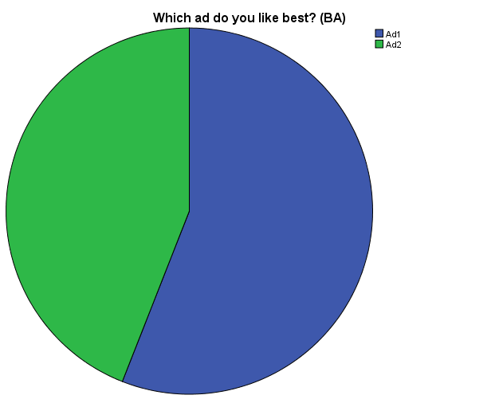

('Match found: ', Q010a_adidas1_55)

Frequencies

Notes
Output Created |  | 28-JUL-2016 20:34:30
Comments
Input | Data | C:\Users\mruhaim\Desktop\Adtesting analysis\only completed responses.sav
Input | Active Dataset | DataSet1
Input | Filter | <none>
Input | Weight | <none>
Input | Split File | <none>
Input | N of Rows in Working Data File | 659
Missing Value Handling | Definition of Missing | User-defined missing values are treated as missing.
Missing Value Handling | Cases Used | Statistics are based on all cases with valid data.
Syntax |  | FREQUENCIES VARIABLES=Q010a_adidas1_55  /FORMAT dfreq  /PIECHART.
Resources | Processor Time | 00:00:00.19
Resources | Elapsed Time | 00:00:00.25

Statistics
Which ad do you like best? (Adidas1)
N | Valid | 240
N | Missing | 419

Which ad do you like best? (Adidas1)
 |  | Frequency | Percent | Valid Percent | Cumulative Percent
Valid | 45% preferred this one | 132 | 20.0 | 55.0 | 55.0
Valid | 55% preferred this one | 108 | 16.4 | 45.0 | 100.0
Valid | Total | 240 | 36.4 | 100.0
Missing | System | 419 | 63.6
Total |  | 659 | 100.0

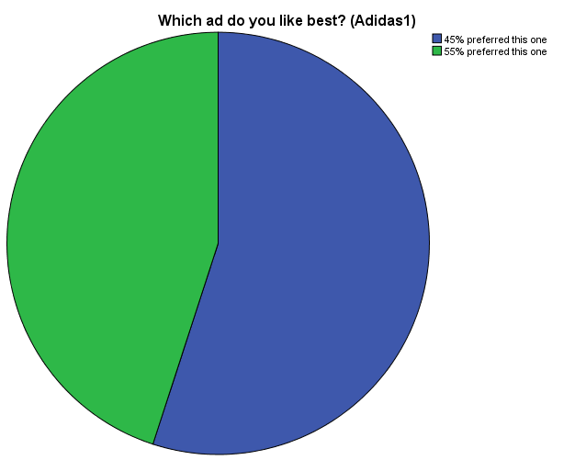

('Match found: ', Q015a_burbury_49)

Frequencies

Notes
Output Created |  | 28-JUL-2016 20:34:30
Comments
Input | Data | C:\Users\mruhaim\Desktop\Adtesting analysis\only completed responses.sav
Input | Active Dataset | DataSet1
Input | Filter | <none>
Input | Weight | <none>
Input | Split File | <none>
Input | N of Rows in Working Data File | 659
Missing Value Handling | Definition of Missing | User-defined missing values are treated as missing.
Missing Value Handling | Cases Used | Statistics are based on all cases with valid data.
Syntax |  | FREQUENCIES VARIABLES=Q015a_burbury_49  /FORMAT dfreq  /PIECHART.
Resources | Processor Time | 00:00:00.16
Resources | Elapsed Time | 00:00:00.13

Statistics
Which ad do you like best?
N | Valid | 225
N | Missing | 434

Which ad do you like best?
 |  | Frequency | Percent | Valid Percent | Cumulative Percent
Valid | 49% preferred this one | 116 | 17.6 | 51.6 | 51.6
Valid | 51% preferred this one | 109 | 16.5 | 48.4 | 100.0
Valid | Total | 225 | 34.1 | 100.0
Missing | System | 434 | 65.9
Total |  | 659 | 100.0

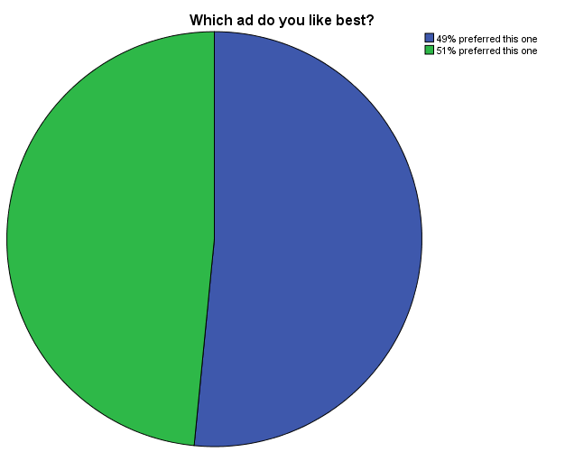

('Match found: ', Q020a_cola_65)

Frequencies

Notes
Output Created |  | 28-JUL-2016 20:34:30
Comments
Input | Data | C:\Users\mruhaim\Desktop\Adtesting analysis\only completed responses.sav
Input | Active Dataset | DataSet1
Input | Filter | <none>
Input | Weight | <none>
Input | Split File | <none>
Input | N of Rows in Working Data File | 659
Missing Value Handling | Definition of Missing | User-defined missing values are treated as missing.
Missing Value Handling | Cases Used | Statistics are based on all cases with valid data.
Syntax |  | FREQUENCIES VARIABLES=Q020a_cola_65  /FORMAT dfreq  /PIECHART.
Resources | Processor Time | 00:00:00.13
Resources | Elapsed Time | 00:00:00.14

Statistics
Which ad do you like best?
N | Valid | 228
N | Missing | 431

Which ad do you like best?
 |  | Frequency | Percent | Valid Percent | Cumulative Percent
Valid | 65% preferred this one | 149 | 22.6 | 65.4 | 65.4
Valid | 35% preferred this one | 79 | 12.0 | 34.6 | 100.0
Valid | Total | 228 | 34.6 | 100.0
Missing | System | 431 | 65.4
Total |  | 659 | 100.0

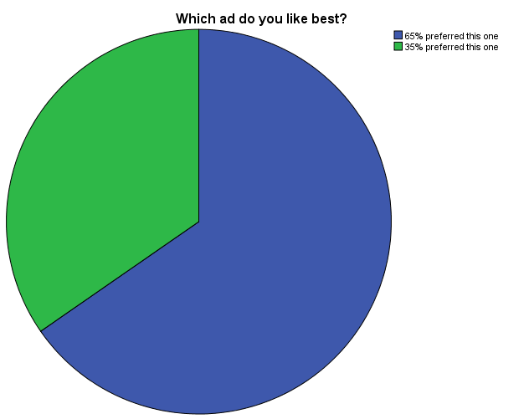

('Match found: ', Q025a_j20_68)

Frequencies

Notes
Output Created |  | 28-JUL-2016 20:34:31
Comments
Input | Data | C:\Users\mruhaim\Desktop\Adtesting analysis\only completed responses.sav
Input | Active Dataset | DataSet1
Input | Filter | <none>
Input | Weight | <none>
Input | Split File | <none>
Input | N of Rows in Working Data File | 659
Missing Value Handling | Definition of Missing | User-defined missing values are treated as missing.
Missing Value Handling | Cases Used | Statistics are based on all cases with valid data.
Syntax |  | FREQUENCIES VARIABLES=Q025a_j20_68  /FORMAT dfreq  /PIECHART.
Resources | Processor Time | 00:00:00.16
Resources | Elapsed Time | 00:00:00.11

Statistics
Which ad do you like best?
N | Valid | 226
N | Missing | 433

Which ad do you like best?
 |  | Frequency | Percent | Valid Percent | Cumulative Percent
Valid | 68% preferred this one | 139 | 21.1 | 61.5 | 61.5
Valid | 32% preferred this one | 87 | 13.2 | 38.5 | 100.0
Valid | Total | 226 | 34.3 | 100.0
Missing | System | 433 | 65.7
Total |  | 659 | 100.0

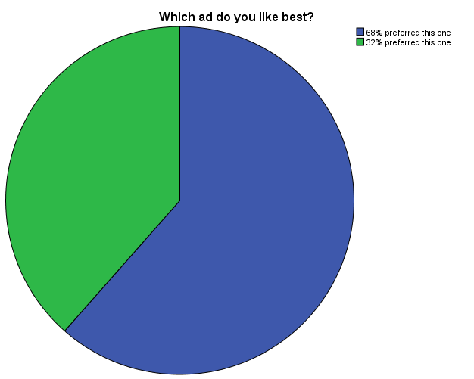

('Match found: ', Q030a_lucazade_55)

Frequencies

Notes
Output Created |  | 28-JUL-2016 20:34:31
Comments
Input | Data | C:\Users\mruhaim\Desktop\Adtesting analysis\only completed responses.sav
Input | Active Dataset | DataSet1
Input | Filter | <none>
Input | Weight | <none>
Input | Split File | <none>
Input | N of Rows in Working Data File | 659
Missing Value Handling | Definition of Missing | User-defined missing values are treated as missing.
Missing Value Handling | Cases Used | Statistics are based on all cases with valid data.
Syntax |  | FREQUENCIES VARIABLES=Q030a_lucazade_55  /FORMAT dfreq  /PIECHART.
Resources | Processor Time | 00:00:00.16
Resources | Elapsed Time | 00:00:00.13

Statistics
Which ad do you like best?
N | Valid | 223
N | Missing | 436

Which ad do you like best?
 |  | Frequency | Percent | Valid Percent | Cumulative Percent
Valid | 55% preferred this one | 119 | 18.1 | 53.4 | 53.4
Valid | 45% preferred this one | 104 | 15.8 | 46.6 | 100.0
Valid | Total | 223 | 33.8 | 100.0
Missing | System | 436 | 66.2
Total |  | 659 | 100.0

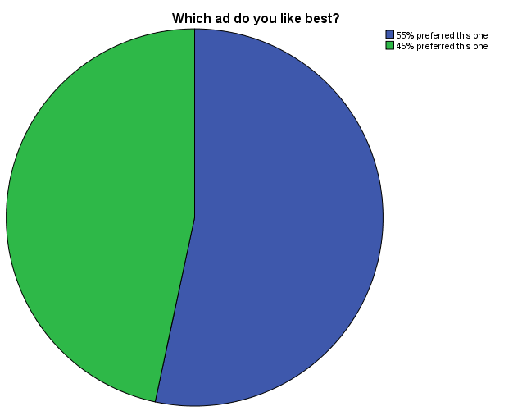

('Match found: ', Q035a_mands_46)

Frequencies

Notes
Output Created |  | 28-JUL-2016 20:34:31
Comments
Input | Data | C:\Users\mruhaim\Desktop\Adtesting analysis\only completed responses.sav
Input | Active Dataset | DataSet1
Input | Filter | <none>
Input | Weight | <none>
Input | Split File | <none>
Input | N of Rows in Working Data File | 659
Missing Value Handling | Definition of Missing | User-defined missing values are treated as missing.
Missing Value Handling | Cases Used | Statistics are based on all cases with valid data.
Syntax |  | FREQUENCIES VARIABLES=Q035a_mands_46  /FORMAT dfreq  /PIECHART.
Resources | Processor Time | 00:00:00.19
Resources | Elapsed Time | 00:00:00.21

Statistics
Which ad do you like best?
N | Valid | 245
N | Missing | 414

Which ad do you like best?
 |  | Frequency | Percent | Valid Percent | Cumulative Percent
Valid | 54% preferred this one | 125 | 19.0 | 51.0 | 51.0
Valid | 46% preferred this one | 120 | 18.2 | 49.0 | 100.0
Valid | Total | 245 | 37.2 | 100.0
Missing | System | 414 | 62.8
Total |  | 659 | 100.0

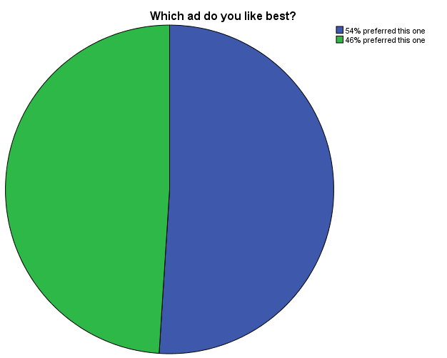

('Match found: ', Q040a_mb1_58)

Frequencies

Notes
Output Created |  | 28-JUL-2016 20:34:31
Comments
Input | Data | C:\Users\mruhaim\Desktop\Adtesting analysis\only completed responses.sav
Input | Active Dataset | DataSet1
Input | Filter | <none>
Input | Weight | <none>
Input | Split File | <none>
Input | N of Rows in Working Data File | 659
Missing Value Handling | Definition of Missing | User-defined missing values are treated as missing.
Missing Value Handling | Cases Used | Statistics are based on all cases with valid data.
Syntax |  | FREQUENCIES VARIABLES=Q040a_mb1_58  /FORMAT dfreq  /PIECHART.
Resources | Processor Time | 00:00:00.16
Resources | Elapsed Time | 00:00:00.25

Statistics
Which ad do you like best?
N | Valid | 230
N | Missing | 429

Which ad do you like best?
 |  | Frequency | Percent | Valid Percent | Cumulative Percent
Valid | 58% preferred this one | 139 | 21.1 | 60.4 | 60.4
Valid | 42% preferred this one | 91 | 13.8 | 39.6 | 100.0
Valid | Total | 230 | 34.9 | 100.0
Missing | System | 429 | 65.1
Total |  | 659 | 100.0

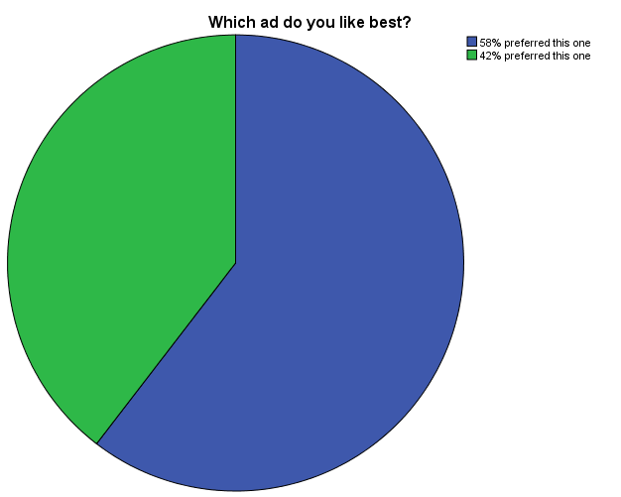

('Match found: ', Q045a_mul_53)

Frequencies

Notes
Output Created |  | 28-JUL-2016 20:34:31
Comments
Input | Data | C:\Users\mruhaim\Desktop\Adtesting analysis\only completed responses.sav
Input | Active Dataset | DataSet1
Input | Filter | <none>
Input | Weight | <none>
Input | Split File | <none>
Input | N of Rows in Working Data File | 659
Missing Value Handling | Definition of Missing | User-defined missing values are treated as missing.
Missing Value Handling | Cases Used | Statistics are based on all cases with valid data.
Syntax |  | FREQUENCIES VARIABLES=Q045a_mul_53  /FORMAT dfreq  /PIECHART.
Resources | Processor Time | 00:00:00.13
Resources | Elapsed Time | 00:00:00.24

Statistics
Which ad do you like best?
N | Valid | 244
N | Missing | 415

Which ad do you like best?
 |  | Frequency | Percent | Valid Percent | Cumulative Percent
Valid | 47% preferred this one | 127 | 19.3 | 52.0 | 52.0
Valid | 53% preferred this one | 117 | 17.8 | 48.0 | 100.0
Valid | Total | 244 | 37.0 | 100.0
Missing | System | 415 | 63.0
Total |  | 659 | 100.0

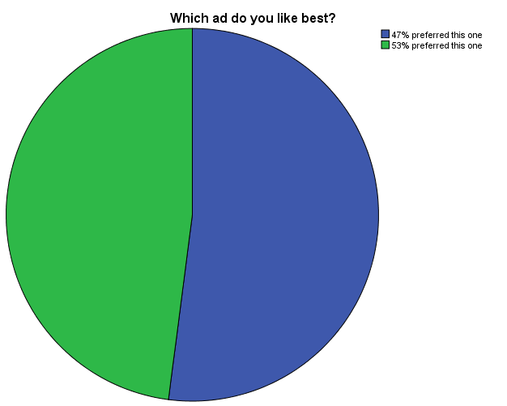

('Match found: ', Q050a_samsung_77)

Frequencies

Notes
Output Created |  | 28-JUL-2016 20:34:32
Comments
Input | Data | C:\Users\mruhaim\Desktop\Adtesting analysis\only completed responses.sav
Input | Active Dataset | DataSet1
Input | Filter | <none>
Input | Weight | <none>
Input | Split File | <none>
Input | N of Rows in Working Data File | 659
Missing Value Handling | Definition of Missing | User-defined missing values are treated as missing.
Missing Value Handling | Cases Used | Statistics are based on all cases with valid data.
Syntax |  | FREQUENCIES VARIABLES=Q050a_samsung_77  /FORMAT dfreq  /PIECHART.
Resources | Processor Time | 00:00:00.13
Resources | Elapsed Time | 00:00:00.15

Statistics
Which ad do you like best?
N | Valid | 236
N | Missing | 423

Which ad do you like best?
 |  | Frequency | Percent | Valid Percent | Cumulative Percent
Valid | 77% preferred this one | 177 | 26.9 | 75.0 | 75.0
Valid | 23% preferred this one | 59 | 9.0 | 25.0 | 100.0
Valid | Total | 236 | 35.8 | 100.0
Missing | System | 423 | 64.2
Total |  | 659 | 100.0

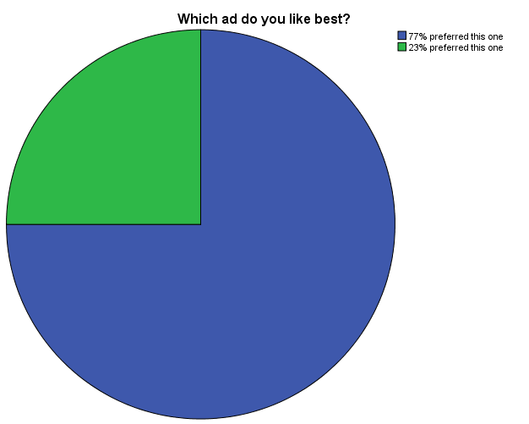

('Match found: ', Q055a_spsp_53)

Frequencies

Notes
Output Created |  | 28-JUL-2016 20:34:32
Comments
Input | Data | C:\Users\mruhaim\Desktop\Adtesting analysis\only completed responses.sav
Input | Active Dataset | DataSet1
Input | Filter | <none>
Input | Weight | <none>
Input | Split File | <none>
Input | N of Rows in Working Data File | 659
Missing Value Handling | Definition of Missing | User-defined missing values are treated as missing.
Missing Value Handling | Cases Used | Statistics are based on all cases with valid data.
Syntax |  | FREQUENCIES VARIABLES=Q055a_spsp_53  /FORMAT dfreq  /PIECHART.
Resources | Processor Time | 00:00:00.14
Resources | Elapsed Time | 00:00:00.20

Statistics
Which ad do you like best?
N | Valid | 232
N | Missing | 427

Which ad do you like best?
 |  | Frequency | Percent | Valid Percent | Cumulative Percent
Valid | 53% preferred this one | 136 | 20.6 | 58.6 | 58.6
Valid | 47% preferred this one | 96 | 14.6 | 41.4 | 100.0
Valid | Total | 232 | 35.2 | 100.0
Missing | System | 427 | 64.8
Total |  | 659 | 100.0

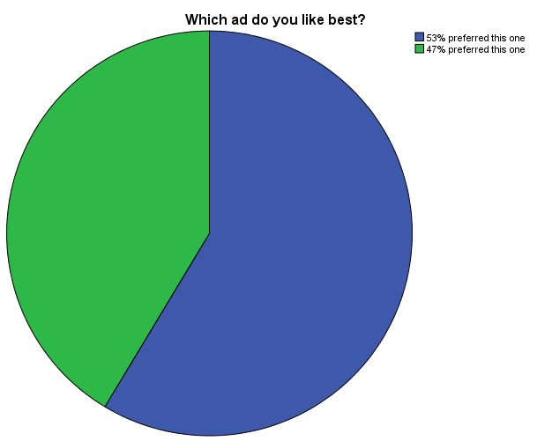

('Match found: ', Q060a_dogfood_45)

Frequencies

Notes
Output Created |  | 28-JUL-2016 20:34:32
Comments
Input | Data | C:\Users\mruhaim\Desktop\Adtesting analysis\only completed responses.sav
Input | Active Dataset | DataSet1
Input | Filter | <none>
Input | Weight | <none>
Input | Split File | <none>
Input | N of Rows in Working Data File | 659
Missing Value Handling | Definition of Missing | User-defined missing values are treated as missing.
Missing Value Handling | Cases Used | Statistics are based on all cases with valid data.
Syntax |  | FREQUENCIES VARIABLES=Q060a_dogfood_45  /FORMAT dfreq  /PIECHART.
Resources | Processor Time | 00:00:00.11
Resources | Elapsed Time | 00:00:00.15

Statistics
Which ad do you like best?
N | Valid | 253
N | Missing | 406

Which ad do you like best?
 |  | Frequency | Percent | Valid Percent | Cumulative Percent
Valid | 55% preferred this one | 141 | 21.4 | 55.7 | 55.7
Valid | 45% preferred this one | 112 | 17.0 | 44.3 | 100.0
Valid | Total | 253 | 38.4 | 100.0
Missing | System | 406 | 61.6
Total |  | 659 | 100.0

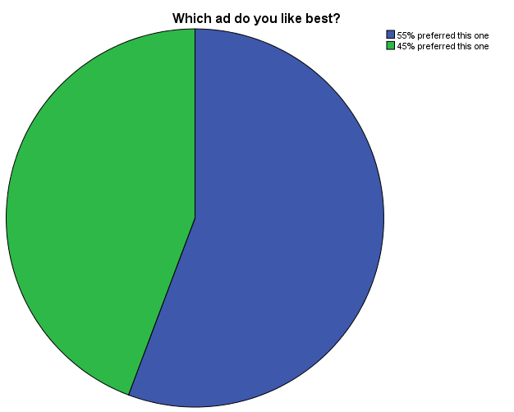

('Match found: ', Q065a_asda_35)

Frequencies

Notes
Output Created |  | 28-JUL-2016 20:34:33
Comments
Input | Data | C:\Users\mruhaim\Desktop\Adtesting analysis\only completed responses.sav
Input | Active Dataset | DataSet1
Input | Filter | <none>
Input | Weight | <none>
Input | Split File | <none>
Input | N of Rows in Working Data File | 659
Missing Value Handling | Definition of Missing | User-defined missing values are treated as missing.
Missing Value Handling | Cases Used | Statistics are based on all cases with valid data.
Syntax |  | FREQUENCIES VARIABLES=Q065a_asda_35  /FORMAT dfreq  /PIECHART.
Resources | Processor Time | 00:00:00.14
Resources | Elapsed Time | 00:00:00.15

Statistics
Which ad do you like best?
N | Valid | 249
N | Missing | 410

Which ad do you like best?
 |  | Frequency | Percent | Valid Percent | Cumulative Percent
Valid | 65% preferred this one | 159 | 24.1 | 63.9 | 63.9
Valid | 35% preferred this one | 90 | 13.7 | 36.1 | 100.0
Valid | Total | 249 | 37.8 | 100.0
Missing | System | 410 | 62.2
Total |  | 659 | 100.0

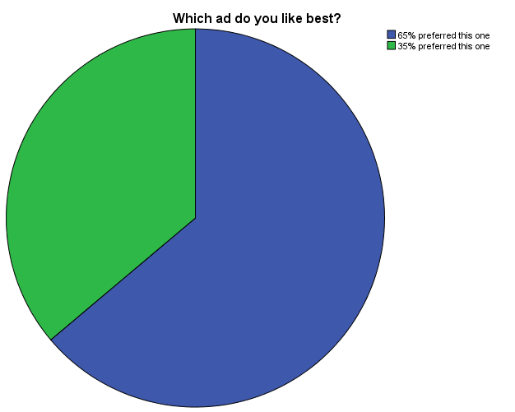

('Match found: ', Q070a_magnum1_62)

Frequencies

Notes
Output Created |  | 28-JUL-2016 20:34:33
Comments
Input | Data | C:\Users\mruhaim\Desktop\Adtesting analysis\only completed responses.sav
Input | Active Dataset | DataSet1
Input | Filter | <none>
Input | Weight | <none>
Input | Split File | <none>
Input | N of Rows in Working Data File | 659
Missing Value Handling | Definition of Missing | User-defined missing values are treated as missing.
Missing Value Handling | Cases Used | Statistics are based on all cases with valid data.
Syntax |  | FREQUENCIES VARIABLES=Q070a_magnum1_62  /FORMAT dfreq  /PIECHART.
Resources | Processor Time | 00:00:00.16
Resources | Elapsed Time | 00:00:00.18

Statistics
Which ad do you like best?
N | Valid | 202
N | Missing | 457

Which ad do you like best?
 |  | Frequency | Percent | Valid Percent | Cumulative Percent
Valid | 62% preferred this one | 110 | 16.7 | 54.5 | 54.5
Valid | 38% preferred this one | 92 | 14.0 | 45.5 | 100.0
Valid | Total | 202 | 30.7 | 100.0
Missing | System | 457 | 69.3
Total |  | 659 | 100.0

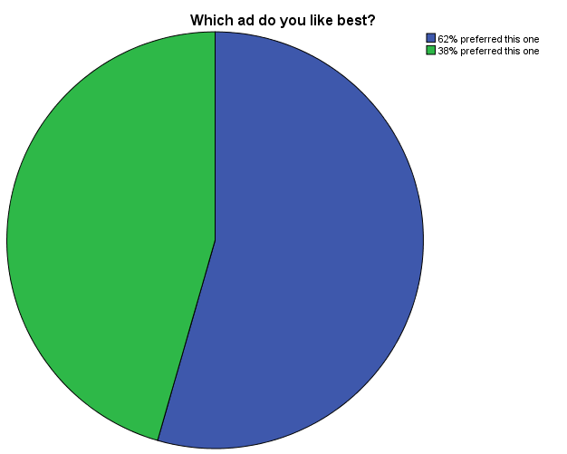

('Match found: ', Q075a_mub_72)

Frequencies

Notes
Output Created |  | 28-JUL-2016 20:34:33
Comments
Input | Data | C:\Users\mruhaim\Desktop\Adtesting analysis\only completed responses.sav
Input | Active Dataset | DataSet1
Input | Filter | <none>
Input | Weight | <none>
Input | Split File | <none>
Input | N of Rows in Working Data File | 659
Missing Value Handling | Definition of Missing | User-defined missing values are treated as missing.
Missing Value Handling | Cases Used | Statistics are based on all cases with valid data.
Syntax |  | FREQUENCIES VARIABLES=Q075a_mub_72  /FORMAT dfreq  /PIECHART.
Resources | Processor Time | 00:00:00.13
Resources | Elapsed Time | 00:00:00.14

Statistics
Which ad do you like best?
N | Valid | 265
N | Missing | 394

Which ad do you like best?
 |  | Frequency | Percent | Valid Percent | Cumulative Percent
Valid | 72% preferred this one | 177 | 26.9 | 66.8 | 66.8
Valid | 28% preferred this one | 88 | 13.4 | 33.2 | 100.0
Valid | Total | 265 | 40.2 | 100.0
Missing | System | 394 | 59.8
Total |  | 659 | 100.0

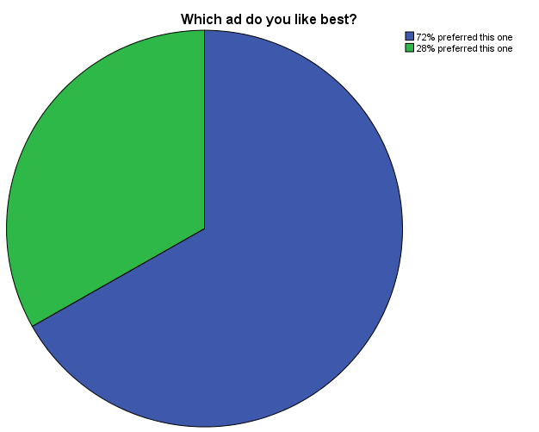

('Match found: ', Q080a_walls_70)

Frequencies

Notes
Output Created |  | 28-JUL-2016 20:34:33
Comments
Input | Data | C:\Users\mruhaim\Desktop\Adtesting analysis\only completed responses.sav
Input | Active Dataset | DataSet1
Input | Filter | <none>
Input | Weight | <none>
Input | Split File | <none>
Input | N of Rows in Working Data File | 659
Missing Value Handling | Definition of Missing | User-defined missing values are treated as missing.
Missing Value Handling | Cases Used | Statistics are based on all cases with valid data.
Syntax |  | FREQUENCIES VARIABLES=Q080a_walls_70  /FORMAT dfreq  /PIECHART.
Resources | Processor Time | 00:00:00.11
Resources | Elapsed Time | 00:00:00.23

Statistics
Which ad do you like best?
N | Valid | 232
N | Missing | 427

Which ad do you like best?
 |  | Frequency | Percent | Valid Percent | Cumulative Percent
Valid | 70% preferred this one | 170 | 25.8 | 73.3 | 73.3
Valid | 30% preferred this one | 62 | 9.4 | 26.7 | 100.0
Valid | Total | 232 | 35.2 | 100.0
Missing | System | 427 | 64.8
Total |  | 659 | 100.0

