

23CSE211
Design and Analysis of Algorithms
Lab-5 26/12/2025

Submitted to Submitted by
Dr SS Chakravarthi Ruhan T
LAB-5
Quick Sort, Merge Sort and Binary Search Tree

MERGE SORT:
Given array: [31, 58, 23, 10, 30, 49, 50, 24, 22, 51]
CODE :
#include <stdio.h>

void merge(int arr[], int left, int mid, int right) {
int i, j, k;
int n1 = mid - left + 1;
int n2 = right - mid;
int L[n1], R[n2];
for (i = 0; i < n1; i++)
L[i] = arr[left + i];
for (j = 0; j < n2; j++)
R[j] = arr[mid + 1 + j];
i = 0;
j = 0;
k = left;

while (i < n1 && j < n2) {
if (L[i] <= R[j]) {
arr[k] = L[i];
i++;
} else {
arr[k] = R[j];
j++;
}
k++;
}
while (i < n1) {
arr[k] = L[i];
i++;
k++;
}
while (j < n2) {
arr[k] = R[j];
j++;
k++;
}
}
void mergeSort(int arr[], int left, int right) {
if (left < right) {
int mid = (left + right) / 2;

mergeSort(arr, left, mid);
mergeSort(arr, mid + 1, right);
merge(arr, left, mid, right);
}
}
int main() {
int arr[] = {31, 58, 23, 10, 30, 49, 50, 24, 22, 51};
int n = sizeof(arr) / sizeof(arr[0]);

mergeSort(arr, 0, n - 1);

printf("Sorted array:\n");
for (int i = 0; i < n; i++)
printf("%d ", arr[i]);

return 0;
}

OUTPUT:
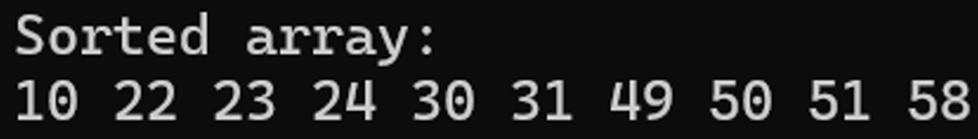

QUICK SORT:

Given array: [31, 58, 23, 10, 30, 49, 50, 24, 22, 51]
CODE:
#include <stdio.h>
int partition(int a[], int low, int high) {
int pivot = a[low];
int i = low + 1;
int j = high;
int temp;

while (i <= j) {
while (i <= high && a[i] <= pivot)
i++;
while (a[j] > pivot)
j--;

if (i < j) {
temp = a[i];
a[i] = a[j];
a[j] = temp;
}
temp = a[low];
a[low] = a[j];
a[j] = temp;

return j;
}
void quickSort(int a[], int low, int high) {
if (low < high) {
int p = partition(a, low, high);

quickSort(a, low, p - 1);
quickSort(a, p + 1, high);
}
}

int main() {
int a[] = {31, 58, 23, 10, 30, 49, 50, 24, 22, 51};
int n = sizeof(a) / sizeof(a[0]);
quickSort(a, 0, n - 1);
printf("Sorted array:\n");
for (int i = 0; i < n; i++)
printf("%d ", a[i]);
printf(“\n”);
return 0;
}
Output:
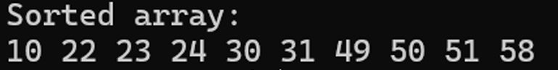

Binary Search Tree:
Preorder: 40 → 20 → 10 → 30 → 60
Inorder: 10 → 20 → 30 → 40 → 60
Postorder: 10 → 30 → 20 → 60 → 40

CODE:
#include <stdio.h>
#include <stdlib.h>
struct Node {
int data;
struct Node *left;
struct Node *right;
};

struct Node* newNode(int value) {
struct Node* temp = (struct Node*)malloc(sizeof(struct Node));
temp->data = value;
temp->left = temp->right = NULL;
return temp;
}

struct Node* insert(struct Node* root, int value) {
if (root == NULL)
return newNode(value);
if (value < root->data)
root->left = insert(root->left, value);
else
root->right = insert(root->right, value);
return root;
}
void preorder(struct Node* root) {
if (root != NULL) {
printf("%d ", root->data);
preorder(root->left);
preorder(root->right);
}
}
void inorder(struct Node* root) {
if (root != NULL) {
inorder(root->left);
printf("%d ", root->data);
inorder(root->right);
}
}
void postorder(struct Node* root) {
if (root != NULL) {
postorder(root->left);
postorder(root->right);
printf("%d ", root->data);
}
}

int main() {
struct Node* root = NULL;
int arr[] = {40, 20, 60, 10, 30};
int n = 5;
for (int i = 0; i < n; i++)
root = insert(root, arr[i]);
printf("Preorder Traversal: ");
preorder(root);
printf("\nInorder Traversal: ");
inorder(root);
printf("\nPostorder Traversal: ");
postorder(root);
printf(“\n”);
return 0;
}
Output:
