UIUC Heated Cantilever Suite

- Suhas Somnath

somnath2@illinois.edu

University of Illinois Urbana-Champaign

1206 W. Green Street, Room 64

Mechanical Engineering Building

Urbana 61801

Last Updated: 3/01/2012

Contents

Introduction 2

Software requirements: 2

Hardware requirements: 2

Disclaimer: 2

Electrical connections: 3

Basics 3

Cantilever Electrical Characterization 4

Cantilever Temperature Control Meter 6

Thermal Lithography 7

Thermal Topography Imaging 9

# Introduction

This software suite provides the capability to perform experiments such as thermal lithography and thermal topography imaging using heated micro-cantilevers via the hardware and software of Asylum Research AFMs. This software suite controls cantilever temperature in closed loop feedback using the AFM controller’s electronics to improve lithography and imaging performance of heated cantilevers.

# Software requirements:

Igor Pro 6.1 or later

Asylum Research software version: MFP3D 090909+xxxx or later

# Hardware requirements:

Asylum Research MFP-3D or Cypher AFM

Voltage follower circuit breaker for older AFM controllers (2011 Jan or before)

# Disclaimer:

This code is foreign to the existing AFM software. I have worked around many issues painstakingly to ensure that this code works as smoothly as possible. In the same manner, care has been taken to ensure that the normal AFM operation is not thwarted in any way. Sometimes, when this package is started up but not used actively, certain native operations of the AFM software tend to take back certain resources that were allocated for this code. This may manifest in the form of malfunctioning temperature control meters, stoppage in the PID controlling the cantilever temperature, etc. None of these should damage the cantilever in anyway. To resume normal operation of this code when necessary, use the reinitialize / refresh buttons provided. Typically, clicking on the start button is sufficient to bring things back to normal. This code has been tested extensively and its use has so far never resulted in any damage to the cantilever or the sample but please be careful when using this code and be mindful of the fact that this code is still foreign to the native AFM software.

# Electrical connections:

Please make sure to use the voltage follower box specially constructed to circumvent the impedance matching problem of older Asylum Research AFM controllers for this code to work accurately.

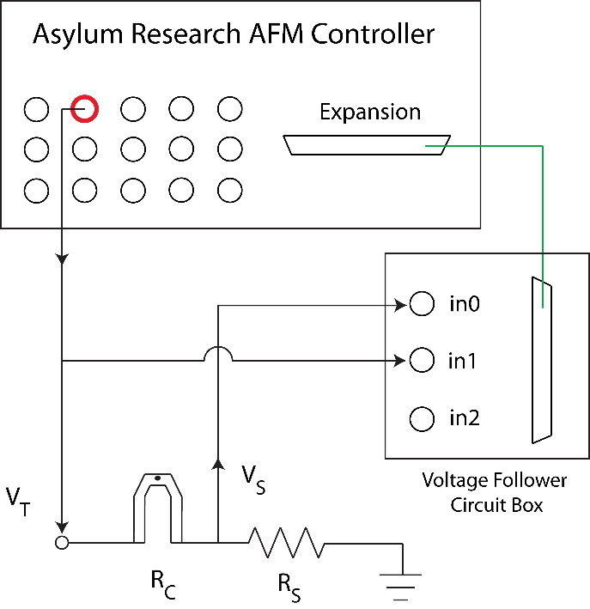

1. Connect the Expansion port (25 pin serial) on the AFM controller to the Voltage follower box

2. Connect VS (voltage across RS) to the in0 labeled on the voltage follower box

3. Connect VT to the in1 labeled on the voltage follower box and to BNCout0 on the AFM controller. You can use a BNC T-split for this.

# Basics

1. Installing the code: This is slightly complicated. Contact me for installation.
2. Accessing the Heated Cantilever Suite: In the top menu bar of the AFM software: UIUC >> Heated Cantilever Suite >>



# Cantilever Electrical Characterization

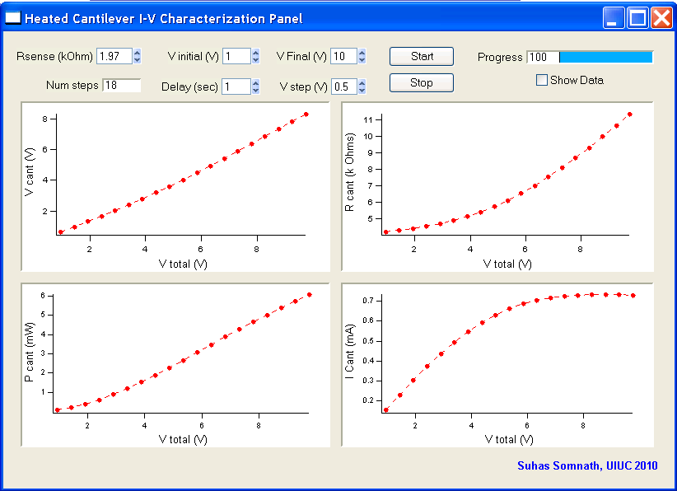

Introduction:

* This package is accessed by clicking on UIUC >> Heated Cantilever Suite >> I-V Characterization.
* This package lets you electrically characterize the probe by linearly ramping the voltage being applied across the heating circuit.

Parameters:

* **R sense (k Ohm)**: The resistance of the sense resistor in kΩ. You can apply at most 10V with this setup so choose your sense resistor that will allow you to access the cantilever temperatures you are interested in. I advise you to pick sense resistors in the range of 1 to 5 kΩ. The value entered here will persist throughout the AFM software.
* **V initial (V):** Initial voltage to be applied across the circuit (0V <= V initial <10V). Lower ranges of voltage (0-1V) are typically less reliable. 1V should be just fine.
* **V final (V)**: Maximum voltage that will be applied across the circuit (0V < V final <= 10V). I advise you to start with something small like 2V and go as high as necessary.
* **Delay (sec)**: Time delay in seconds between measurement points. Larger the delay, greater the number of points of data being averaged. Any time greater than 1 sec will not necessarily improve the accuracy of the results greatly. Ensure that the delay is at least 250 msec.
* **V step (V)**: Incremental voltage being applied across the circuit between measurement points.
* **Show data:** If this is left checked, a table will pop up with the results of the IV characterization.

Running an Experiment:

* Once the above parameters are specified, you may click the ‘Start’ button. If it does nothing on the first click, click it again.
* In the event that you want to stop the ramp at any time, you can do so by clicking the "Stop" button.
* Four graphs are updated in real time as each measurement point is acquired. Due to the nature of Igor Pro, the data may appear in an awkward manner because Igor Pro considers (0,0) as a point of measurement even if it is a virtual point on the graph. This will disappear and the data will look the way it should once the ramp is completed.
* The four graphs display circuit properties against actual bias applied across the circuit and are as follows in anti-clockwise direction:
  + Cantilever resistance
  + Voltage across the cantilever
  + Power supplied to the cantilever
  + Current through the cantilever

# Cantilever Temperature Control Meter

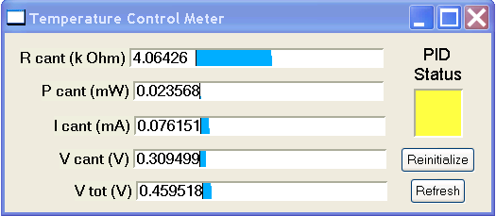

Introduction:

* This panel is initialized automatically when either the Thermal Lithography or Thermal Imaging packages are accessed.
* This panel can be accessed by clicking on UIUC >> Heated Cantilever Suite >> Meter Panel
* This panel provides real-time information about the cantilever’s resistance, power dissipation, voltage across the circuit, current through the circuit, etc.

Parameters:

* **Reinitialize**: This button reinitializes the code necessary to run this panel
* **Refresh**: This button can be used in the rare event that the data in the meter stops refreshing.
* **PID Status**: This LED provides the status of the PID loop that maintains the cantilever temperature constant:
  + Green: PID loop running
  + Yellow: PID loop Initialized but not running
  + Red: PID loop disabled.

# Thermal Lithography

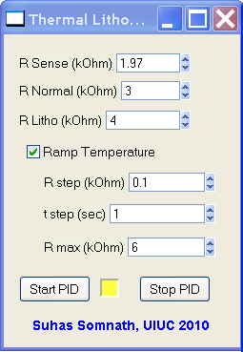

Introduction:

* This package is accessed by clicking on UIUC >> Heated Cantilever Suite >> Thermal Lithography
* This window allows you to perform thermal lithography with a heated cantilever. The lithography lines / patterns drawn either using Microangelo or SmartLitho can be synchronized if appropriate triggers are inserted into Asylum's code. With the trigger code inserted, this package is capable of switching the cantilever's temperature from warm to hot and vice-versa when performing lithography.
* Once this package is accessed, the ‘Temperature Control Meter’ panel starts up as well.

Parameters:

* **R sense (k Ohm):** The resistance of the sense resistor in kilo ohms. See notes on the I-V characterization section for more details.
* **R Normal (k Ohm):** This is the cantilever's resistance setpoint to be maintained when NOT performing lithography.
* **R Litho (k Ohm):** This is the cantilever resistance setpoint to be maintained when performing lithography.
* **Start PID:** This initializes and starts the PID loop that controls the cantilever temperature. Start the PID just before performing lithography and then click ‘Do Litho’ in the Litho Panel to perform lithography. The cantilever will not be heated unless the PID is started. When the PID is started, the square window to the right of the Start PID button will turn green indicating that the PID is currently maintaining constant cantilever temperature.
* **Stop PID:** Should the experiment go awry for some reason, you can use this button to stop the heating. If the experiment proceeds normally, the heating will be discontinued once the lithography is completed or the lithography is aborted by the user by clicking on ‘Stop Litho’ in the Litho Panel.

**Note** - Due to limitations of Asylum's hardware & software, the above mentioned cantilever resistance set-points may not be maintained very accurately (although the precision is very good). For typical purposes, the inaccuracy should be acceptable. Use the meter panel to tweak the set-points until the desired set-point is reached in the meter panel.

Don't set the Rcant setpoint too close to the room temperature resistance of the cantilever.

This causes the PID control to approach a singularity point. In this case 0V will be applied to the circuit resulting in no damage to the cantilever.

Cantilever Temperature Ramp:

* This package also allows slow ramping of cantilever temperature while performing lithography. This feature is disabled by default.
* The cantilever temperature is ramped only while performing lithography and not in between lines. Once the lithography of the current line / feature is completed and that of the next line starts, the temperature ramp starts from the beginning again.
* The ramp starts with the specified R Litho and ramps up to R max.
* **Ramp Temperature**: This needs to be checked to enable ramping of temperature during lithography
* **T step (sec)**: This is the time delay before the cantilever temperature is incremented
* **R max (k Ohm)**: This is the maximum cantilever electrical resistance up to which the cantilever temperature will be ramped and henceforth held constant till the lithography of the current feature ends.

# Thermal Topography Imaging

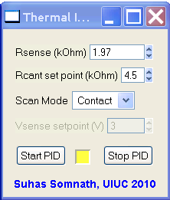

Introduction:

* This package is accessed by clicking on UIUC >> Heated Cantilever Suite >> Thermal Imaging
* This window allows you to perform thermal topography imaging with a heated cantilever.
* Once this package is accessed, the ‘Temperature Control Meter’ panel starts up as well.

Parameters:

* **R sense (k Ohm):** The resistance of the sense resistor in kilo ohms. See notes on the I-V characterization section for more details.
* **R cant (k Ohm):** This is the cantilever's resistance setpoint to be maintained when performing topography imaging.
* **Scan Mode:** This allows the user to choose the mode of actuation of the cantilever when imaging. The lateral channel has been used to display the voltage across the cantilever. This imaging window should be initialized automatically. Setting the mode of imaging here allows the software to set up the imaging windows among other parameters accordingly:
  + **Thermal Feedback:** This is a beta testing feature. Please don’t use this. Instead, please use the contact mode and tapping modes of imaging only.
* **Start PID:** This initializes and starts the PID loop that controls the cantilever temperature. Start the PID just before performing imaging and then click ‘Do Scan’ in the Master Panel to perform topography imaging. The cantilever will not be heated unless the PID is started. When the PID is started, the square window to the right of the Start PID button will turn green indicating that the PID is currently maintaining constant cantilever temperature.
* **Stop PID:** Should the experiment go awry for some reason, you can use this button to stop the heating. If the experiment proceeds normally, the heating will be discontinued once the imaging is completed or the imaging is aborted by the user by clicking on ‘Stop Scan’ in the Master Panel.