

American International University-Bangladesh (AIUB)  
**Department of Computer Science**  
**Faculty of Science & Technology (FST)**

**PROJECT TITLE**

AIUB Campus Navigator – A Smart Indoor & Outdoor Navigation System

A Software Engineering Project Submitted

By

|  |  |  |  |  |
| --- | --- | --- | --- | --- |
| **Semester: Summer_21_22** | | **Section:** | **Group Number:** | |
| SN | Student Name | Student ID | Contribution (CO3+CO4) | Individual Marks |
| 1 | MD. Mehedi Hasan Anik | 22-48937-3 | 25% |  |
| 2 | Maharin Binte Kibria Easha | 22-49593-3 | 25% |  |
| 3 | Ruhi Barua | 22-48496-3 | 25% |  |
| 4 | Sharif Ahmmed Nazmuzzam | 20-41939-1 | 25% |  |
|  |  |  |  |  |

The project will be Evaluated for the following Course Outcomes

|  |  |  |
| --- | --- | --- |
| **CO3:** *Select* appropriate software engineering models, project management roles and their associated skills for the complex software engineering project and evaluate the sustainability of developed software, taking into consideration the societal and environmental aspects | Total Marks | |
|  | |
| Appropriate Process Model Selection and Argumentation with Evidence | [5 Marks] |  |
| Evidence of Argumentation regarding process model selection | [5Marks] |  |
| Analysis the impact of societal, health, safety, legal and cultural issues | [5Marks] |  |
| Submission, Defense, Completeness, Spelling, grammar and Organization of the Project report | [5Marks] |  |
| **CO4:** *Develop* project management plan to manage software engineering projects following the principles of engineering management and economic decision process | Total Marks | |
|  | |
| Develop the project plan, its components of the proposed software products | [5Marks] |  |
| Identify all the activities/tasks related to project management and categorize them within the WBS structure. Perform detailed effort estimation correspond with the WBS and schedule the activities with resources | [5Marks] |  |
| Identify all the potential risks in your project and prioritize them to overcome these risk factors. | [5Marks] |  |

Description of Student’s Contribution in the Project work

|  |
| --- |
| Student Name: MD. Mehedi Hasan Anik  Student ID: 22-48937-3  Contribution in Percentage (25%):  Contribution in the Project:   * **Project Manager** * **Lead Developer** * **Functional Requirements** * **Diagrams** * **Risk Managment**   ___________________  Signature of the Student |
| Student Name: Maharin Binte Kibria Easha  Student ID: 22-49593-3  Contribution in Percentage (25%):  Contribution in the Project:   * **UI/UX Designer** * **QA Tester** * **UI/UX Design** * **Budget**   ___________________  Signature of the Student |
| Student Name: Ruhi Barua  Student ID: 22-48496-3  Contribution in Percentage (25%):  Contribution in the Project:   * **Database Administrator** * **Documentation Specialist** * **COCOMO Analysis** * **Gantt Chart**   ___________________  Signature of the Student |
| Student Name: Sharif Ahmmed Nazmuzzam  Student ID: 20-41939-1  Contribution in Percentage (25%):  Contribution in the Project:   * **Lead Developer** * **3D Model Designer** * **Stakeholders** * **UI/UX Design** * **Budget**   ___________________  Signature of the Student |
|  |

# PROJECT PROPOSAL

## Background to the Problem

**• Write the background description that helps putting your project into the right context of a problem domain and gives everyone involved a common view of the project.**

Navigating large university campuses can be challenging, especially for new students, visitors and event participants. AIUB is a sprawling academic institution with multiple buildings (like D building, C building), playgrounds, annexes and numerous departmental venues spread across its main and extended areas. Due to the lack of a centralized navigation system, individuals often face difficulties locating specific rooms, administrative offices or student services.

**• What is the root cause of this problem? Why this problem is so important to consider?**

The root cause of this issue lies in the absence of a dedicated, real-time indoor-outdoor navigation system tailored specifically to AIUB. While platforms like Google Maps provide generic direction services, they are not optimized for indoor or campus-specific navigation and do not include detailed, labeled internal locations of university facilities. This limitation often leads to confusion, delays and missed opportunities—especially during orientation weeks, job fairs and other large-scale academic or extracurricular events.

The problem is critical because it directly impacts the daily experience of thousands of students, faculty, staff and visitors. With growing student intake and events being held frequently, an efficient and user-friendly navigation system has become a necessity to ensure smooth campus operations and enhanced user satisfaction.

## Solution to the Problem

**• Describe what is your project/thesis objective? What solutions are you going to provide to solve the above-mentioned problems?**

The objective of this project is to design and develop “AIUB Campus Navigator”—an intelligent, mobile-friendly navigation software similar to Google Maps but exclusively tailored for the AIUB campus. The proposed solution will map every corner of AIUB including all academic buildings, administrative offices, parking zones, cafeterias, sports areas, annex buildings and key indoor venues.

**• What are the solutions you are going to propose to deal with the problem? Why is this solution particularly appropriate to solve the problem? Is the solution feasible to meet the business objective?**

This software will provide:

* Real-time indoor and outdoor navigation using GPS and Wi-Fi/Bluetooth signals.
* Detailed, zoomable 2D and 3D campus map with labeled building names and floor plans.
* Search functionality to locate classrooms, teacher rooms, events or specific services.
* Turn-by-turn guidance for walking routes.
* Voice-guided navigation and accessibility features for users with disabilities.
* Offline support, allowing core navigation and map access even without internet.
* AI-based smart suggestions based on class schedules or event traffic.
* Real-time updates for room reallocations, events or emergencies.

This solution is particularly appropriate because it addresses the specific limitations of existing general-purpose navigation tools by focusing entirely on AIUB’s infrastructure and user needs. Given the increasing use of smartphones and mobile apps among students and faculty, this solution is both technically feasible and well-aligned with the university's digital transformation goals.

**• Describe the basic functionalities of your proposed solution that makes the best use of state‐of‐art technology and produced a significant result that is likely to have a major impact on societal, health, safety, legal and cultural issues. Provide a deep insight that demonstrate and present a creative solution to the real‐life problem.**

From a societal and cultural perspective, this software will foster inclusivity and ease, enhancing user experience and accessibility on campus. It contributes to safety by guiding users in emergencies and can be extended with features like crowd monitoring, emergency exits and real-time event updates.

**• Describe the target group of users of your solution? And how they will be benefited by your proposed solution to the problem?**

The primary target group of this solution includes:

* New students and visitors are unfamiliar with the campus layout.
* Faculty and staff seeking easier access to departmental locations.
* Event participants and administrative personnel requiring navigation support.
* Individuals with mobility or visual challenges needing special assistance.

**• Describe the contribution of your project to the development of scientific results that is identified and well documented.**

In terms of scientific contribution, this project will explore the fusion of geolocation technologies, indoor mapping, 3D visualization, offline systems and human-centered UI design, contributing to the literature on smart campus development and location-based services in educational institutions.

### **Literature Review**

**• Provide a literature review on what are the other studies that have discussed the same topic of yours in the literature and explain how your study has utilized and extended the problems of existing studies.**

Several studies have addressed campus navigation and smart mapping systems. For example:

* IndoorAtlas and NavVis provide indoor navigation using magnetic field mapping and visual SLAM respectively. <https://www.indooratlas.com/> <https://www.navvis.com/>
* Research from MIT and Stanford University has explored indoor navigation using Bluetooth beacons and AI-driven localization algorithms.
* Apps like "Campus Maps" (available in the U.S.) provide simple floor maps but lack real-time guidance. <https://campusmaps.com/>

However, these solutions are either region-specific or lack the level of integration and detail we propose.

**• Provide a description of all the existing studies presented in the problem area. What are the existing software solutions (for project) are available to solve the aforementioned problems?**

IndoorAtlas, NavVis, Campus Maps (U.S.) and other research-driven apps serve as current references but none of them fully adapt to campus-specific indoor-outdoor navigation with rich interactivity.

**• What are the existing software solutions are available to solve the aforementioned problem? And how your proposed solution is going to extend them in providing more benefits to the users?**

Existing solutions like **Google Maps**, **Campus Maps (USA)**, **IndoorAtlas** and **NavVis** offer either generic outdoor navigation or limited indoor guidance. However, none of these systems are tailored specifically for AIUB’s infrastructure. Google Maps lacks internal building details. IndoorAtlas and NavVis require extensive setup and aren't optimized for AIUB’s academic systems or student use cases.

**Our system extends these existing solutions by offering:**

• **A unified map of both indoor and outdoor areas**  
 We will develop a **custom-built map of the entire AIUB campus** by:

* Digitally mapping all academic and administrative buildings, annexes, fields and cafeterias using floor plans, satellite imagery and drone mapping.
* Utilizing tools such as **OpenStreetMap** and **Mapbox SDK** to combine outdoor paths and indoor layouts into a single interface.
* Indoor locations (e.g., classrooms, labs) will be manually labeled and integrated via custom mapping layers.  
   This unified approach will allow seamless switching between buildings, floors and outdoor paths.

• **Interactive 3D visual layers for enhanced spatial understanding**  
 We will implement 3D views using:

* **Unity or Unreal Engine** to render the 3D structure of buildings and AIUB's terrain.
* Indoor models will be based on architectural plans and **visual walkthroughs** will simulate the real environment.
* We may use **CesiumJS** or **Three.js** for browser-based 3D visualizations.  
   These 3D visuals will help users understand spatial context—crucial for newcomers or those with navigation challenges.

• **Real-time route optimization and accessible path planning**

* We’ll use **Dijkstra’s algorithm** or A (A-star)* for optimal pathfinding between locations, including elevator/stair preferences for accessibility.
* For real-time updates (e.g., temporary room changes) we’ll sync with the university’s academic/event database using secure API calls.
* GPS and Wi-Fi triangulation will allow real-time tracking outdoors, while **Bluetooth beacons** or **QR-code scanning** can be used for precise indoor positioning.

• **Offline functionality for uninterrupted use in low-connectivity areas**

* The app will cache maps, floor plans and common routes locally using **SQLite database** or local JSON storage.
* We may use **Mapbox Offline SDK** or **Google Maps Tile Caching** (if allowed under licensing).
* Minimal internet will be required, especially helpful during network outages or in basement-level areas with poor coverage.

• **Data synchronization with AIUB’s academic systems for dynamic room allocations**

* We’ll integrate with AIUB’s internal database (e.g., class schedule management systems or teacher room allocation tools) through **REST APIs or WebSocket connections**.
* Regular updates will be fetched and pushed via **cron jobs** or **Firebase Cloud Messaging (FCM)** to ensure real-time consistency.
* Notifications will alert users of emergency reallocations, closed zones, or upcoming events.

**Third-party tools/libraries we may use:**

* **Google Maps API** (for base map layers, with custom overlays)
* **Mapbox / OpenStreetMap** (for customization and offline support)
* **Bluetooth Beacon SDKs** (for precise indoor navigation)
* **Unity / CesiumJS** (for 3D modeling)
* **Firebase / Node.js** (for data syncing, messaging)
* **SQLite / Room DB** (for offline local data storage)

No current software is fully customized for the unique structure and facilities of AIUB. Our solution bridges that gap by providing a hybrid and holistic platform. Through this comprehensive hybrid approach our solution will offer **customized, integrated and intelligent navigation**—going far beyond what any single existing tool currently offers for AIUB.

# SOFTWARE DEVELOPMENT LIFE CYCLE

## Process Model

Based on the nature of the proposed software—requiring iterative feedback from users, visual mapping updates and modular feature integration—the **Agile Software Development Model** is the most suitable.

Agile enables:

* Rapid development and continuous user feedback.
* Early delivery of core features (like map rendering and search).
* Flexibility in incorporating new venue data or campus updates.
* Support for testing complex features like **offline caching and 3D rendering**.

Compared to the Waterfall model (which lacks flexibility), Agile allows dynamic evolution and user-centered design, ensuring the system adapts to changing needs.

**Justification:**

* Frequent testing with students and faculty ensures usability.
* Modules like building map integration, routing algorithms and search features can be developed in sprints.
* Agile fits academic development timelines and allows deployment of beta versions for testing.

#### **Other Models Are Not Ideal Because:**

**Waterfall Model**

* It follows a **linear and rigid structure**, making it hard to adapt when new venues, features or user requirements arise during development.
* **No early testing** or feedback integration; testing is done at the end, which is risky for a dynamic app like this.
* Once a phase is completed, **going back is difficult**, which is not ideal for a navigation system that needs constant iteration and updates.

**V-Model**

* Similar to Waterfall, it's **sequential and rigid**, with limited flexibility to incorporate new ideas or campus changes mid-development.
* Emphasizes **early testing planning but** doesn't support **real-time user involvement** or iterative feature releases.
* Not well-suited for **non-critical, user-centric apps** that demand visual updates, user interface tuning and real-time feature testing.

**Scrum**

* Scrum relies on **strict roles** (Scrum Master, Product Owner, etc.), daily stand-up, and time-boxed sprints, which might be **too structured** for a small university-level team.
* It focuses more on **product backlog and sprint planning** but our project needs **flexibility across tasks** (UI, 3D modeling, testing, mapping) that don’t always fit neatly into sprint goals.
* Requires **intensive team coordination and meetings**, which may not be practical for a part-time academic team juggling multiple responsibilities.

### **Project Role Identification and Responsibilities**

1. **Project Manager (MD. MEHEDI HASAN ANIK)**
   1. **Role:** Responsible for overall project success and decision-making.
   2. **Responsibilities:**
      1. Oversees the project scope, schedule and resource allocation.
      2. Handles communication with stakeholders.
      3. Manages time, cost and risk.
      4. Ensures the project meets its objectives within the given constraints.
2. **Lead Developer (MD. MEHEDI HASAN ANIK, SHARIF AHMMED NAZMUZZAMAN)**
   1. **Role:** Responsible for the development of core application features.
   2. **Responsibilities:**
      1. Implements backend logic, GPS integration and mapping algorithms.
      2. Leads the development team and ensures coding standards are followed.
      3. Integrates offline sync and real-time positioning features.
3. **UI/UX Designer (MAHARIN BINTA KIBRIA EASHA)**
   1. **Role:** Responsible for the design of user interfaces and experience.
   2. **Responsibilities:**
      1. Creates intuitive and accessible UI for both mobile and desktop platforms.
      2. Ensures design consistency across views.
      3. Improves usability through user testing and design iteration.
4. **Database Administrator (RUHI BARUA)**
   1. **Role:** Responsible for managing all data-related components.
   2. **Responsibilities:**
      1. Structures and maintains location data, user logs and venue mappings.
      2. Ensures fast data retrieval and optimized queries.
      3. Maintains data integrity and security.
5. **QA Tester (MAHARIN BINTA KIBRIA EASHA)**
   1. **Role:** Ensures the quality and reliability of the software.
   2. **Responsibilities:**
      1. Performs manual and automated testing of all system modules.
      2. Validates navigation paths, offline usage and UI functionality.
      3. Tracks bugs and verifies fixes in each iteration.
6. **Documentation Specialist (RUHI BARUA)**
   1. **Role:** Responsible for preparing all necessary documentation.
   2. **Responsibilities:**
      1. Writes user manuals, technical specifications and project reports.
      2. Documents feedback and version changes.
      3. Maintains up-to-date system and usage guides.
7. **3D Model Designer (SHARIF AHMMED NAZMUZZAMAN)**
   1. **Role:** Responsible for developing 3D visual representations.
   2. **Responsibilities:**
      1. Creates 3D models of campus buildings, floors and surroundings.
      2. Enhances visual navigation by integrating 3D assets into the app.
      3. Ensures model accuracy and performance optimization.
8. **Stakeholders (SHARIF AHMMED NAZMUZZAMAN)**
   1. **Role:** Users who provide input and feedback throughout development.
   2. **Responsibilities:**
      1. Help define practical requirements based on real use cases.
      2. Participate in testing and evaluation.
      3. Offer suggestions for improvement during development cycles.

### **3.0 Functional Requirements**

1. **User Registration & Login**
   1. Sign Up
   2. Login
   3. Forgot Password / OTP Recovery
2. **User Customization**
   1. Personalization (e.g. preferred language, accessibility features)
   2. User role selection (student, faculty, visitor)
   3. Profile settings (update personal info, change password)
3. **Core Navigation Features**
   1. Indoor Navigation (using Wi-Fi, Bluetooth beacons and floor maps)
   2. Outdoor Navigation (using GPS)
   3. Turn-by-turn Guidance (voice + visual)
   4. Room/Facility Search (e.g. "Find D Building Room DS0105")
   5. Real-Time Location Tracking
4. **Interactive Map Features**
   1. 2D/3D Zoomable Campus Map
   2. Building Layer Toggle (enable/disable academic, admin, sports etc.)
   3. Floor Selection for Multi-story Buildings
   4. View Path Preview (show the suggested route before navigation starts)
5. **Voice Guidance & Accessibility**
   1. Voice-assisted directions
   2. Text-to-speech for visually impaired
   3. Route optimization for wheelchair accessibility
6. **Offline Functionality**
   1. Offline Map Access
   2. Cached Routes and Room Locations
7. **Smart Assistant & Notifications**
   1. AI-based Suggestions (e.g. next classroom location)
   2. Event-based Routing (e.g. navigate to a seminar)
   3. Push Notifications for room changes or emergencies
8. **Admin Panel (Restricted Access)**
   1. Update building or floor maps
   2. Add/Edit/Delete room or location entries
   3. Publish emergency alerts or event info

### **3.1 Nonfunctional Requirements.**

|  |  |
| --- | --- |
| **Requirement** | **Description** |
| **Availability** | 99% uptime to support everyday navigation during university hours. |
| **Performance** | Real-time updates and quick location rendering in under 3 seconds. |
| **Scalability** | Scalable to future expansion (e.g. new buildings, annex campuses). |
| **Security** | Secure login system and encrypted user data. |
| **Reliability** | High reliability for frequent use during campus hours. |
| **Maintainability** | Modular codebase for easy feature updates. |
| **Usability** | Intuitive UI/UX design for all user groups. |
| **Accessibility** | Inclusive for visually/mobility-impaired users. |
| **Portability** | Available on Android and iOS. |
| **Interoperability** | Sync with campus scheduling systems, possible integration with QR-based room info. |

### **3.2 Functionality & Features**

### **3.2.1 Sign Up / Login / Password Recovery**

* Allow registration via email or phone.
* Enable role-based login (student/faculty/visitor).
* OTP/email verification for password recovery.

### **3.2.2 User Preferences**

* Choose preferred language (English/Bangla).
* Enable voice navigation and screen reading features.
* Set accessibility preferences for visual or mobility support.

### **3.2.3 Core Navigation**

* Real-time indoor tracking using Wi-Fi and Bluetooth (like IndoorAtlas, NavVis).
* Outdoor navigation via GPS (like Google Maps).
* 3D visualization of buildings and routes.
* Update on alternate routes in case of blockages or maintenance.

### **3.2.4 Search & Filter**

* Search for rooms, people, departments, services.
* Filter by building type, accessibility, open/closed hours.

### **3.2.5 Offline & Caching**

* Preload buildings and maps.
* Offline availability of user’s class schedule and common destinations.

### **3.2.6 Smart Features**

* Suggest next class location based on current time and schedule.
* Suggest nearby cafeterias or restrooms based on user location.
* Event alerts and emergency route instructions.

### **3.2.7 Admin Controls**

* Add/update building maps (with CAD import support).
* Manage location database.
* Publish room change notices or evacuation routes.

This structure mirrors your previous requirement section but tailors the functionality to suits our new project while referencing industry-leading features from:

* **Google Maps** (outdoor routing, voice guidance, GPS),
* **IndoorAtlas** (magnetic field-based indoor location),
* **NavVis** (visual SLAM, floor-level indoor navigation),
* **Campus Maps** (academic building directories and simple floor plans).

**4.0 Diagram:**

**1. Activity Diagram** (Workflow of the system)

The activity diagram shows the step-by-step flow of actions a user performs in the app.

**For AIUB Campus Navigator:**

* **Start** → User opens the app
* **Login/Guest Access** → User either logs in (student/faculty) or continues as guest
* **Search Location** → User types/selects a destination (e.g. “D Building, Room DS0106”)
* **System Checks Map Data** → Retrieves building & floor details
* **Show Route Options** → Normal path, accessible path, shortest path
* **Navigation Start** → Provides turn-by-turn (voice/text) guidance
* **Arrive at Destination** → End

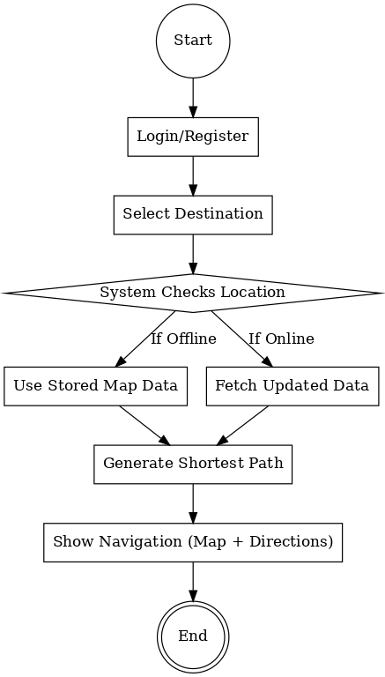

This diagram basically explains **“how the user interacts with the system step by step”**.

### **2. Class Diagram** (Structure of system in OOP)

### The class diagram shows the objects (classes), their attributes and relationships in your project.

**For AIUB Campus Navigator:**

* **User Class**
  + Attributes: userID, name, role (student/faculty/visitor)
  + Functions: login(), searchLocation(), getRoute()
* **Map Class**
  + Attributes: mapID, 2DLayer, 3DLayer
  + Functions: loadMap(), zoomIn(), zoomOut()
* **NavigationEngine Class**
  + Attributes: algorithmType (Dijkstra, A*)
  + Functions: calculateRoute(), optimizePath()
* **Database Class**
  + Attributes: locationData, userLogs, eventData
  + Functions: fetchData(), updateData(), syncOffline()

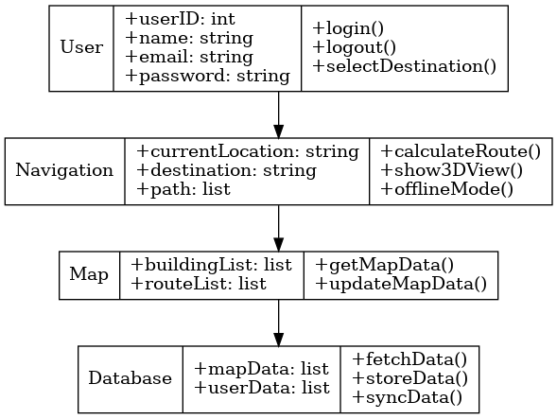

This diagram explains **“the system design in terms of classes/objects and their relationships”**.

### **3. Data Flow Diagram** (DFD – how data moves inside the system)

The DFD shows how information flows between the user, processes and database.

**For AIUB Campus Navigator:**

* **User** enters request (e.g. search for “Admin Office”).
* Request goes to **Navigation Engine** (process).
* Navigation Engine asks **Campus Database** for map details.
* Database sends building/floor/location info back to Navigation Engine.
* Navigation Engine applies **Pathfinding Algorithm** (Dijkstra/A*).
* Optimized route is sent to **User Interface (UI)**.
* User gets route in **2D/3D Map + Voice Guidance**.
* If offline → Data is fetched from **Local Cache (SQLite)**.
* If emergency → Data comes from **Event Notification System**.



This diagram explains **“how user input travels through the system and how the system responds with data”**.

**Gantt chart:**

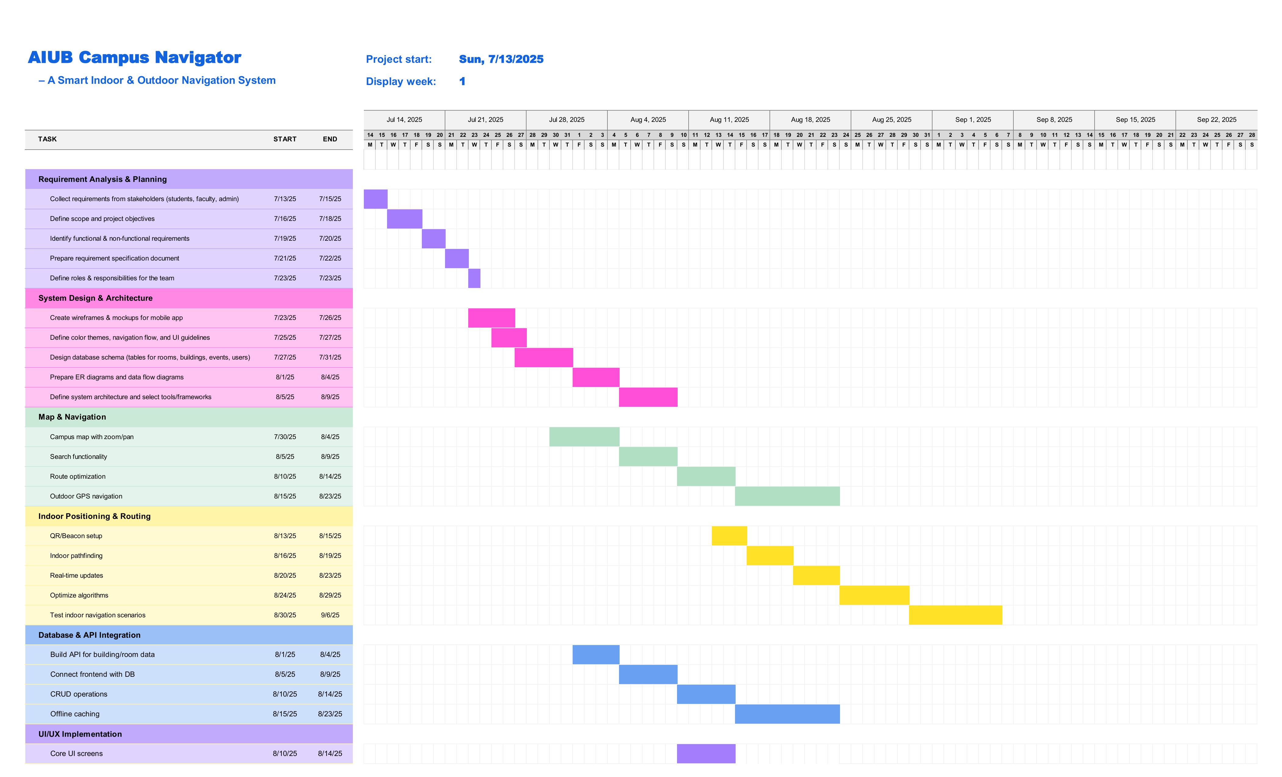

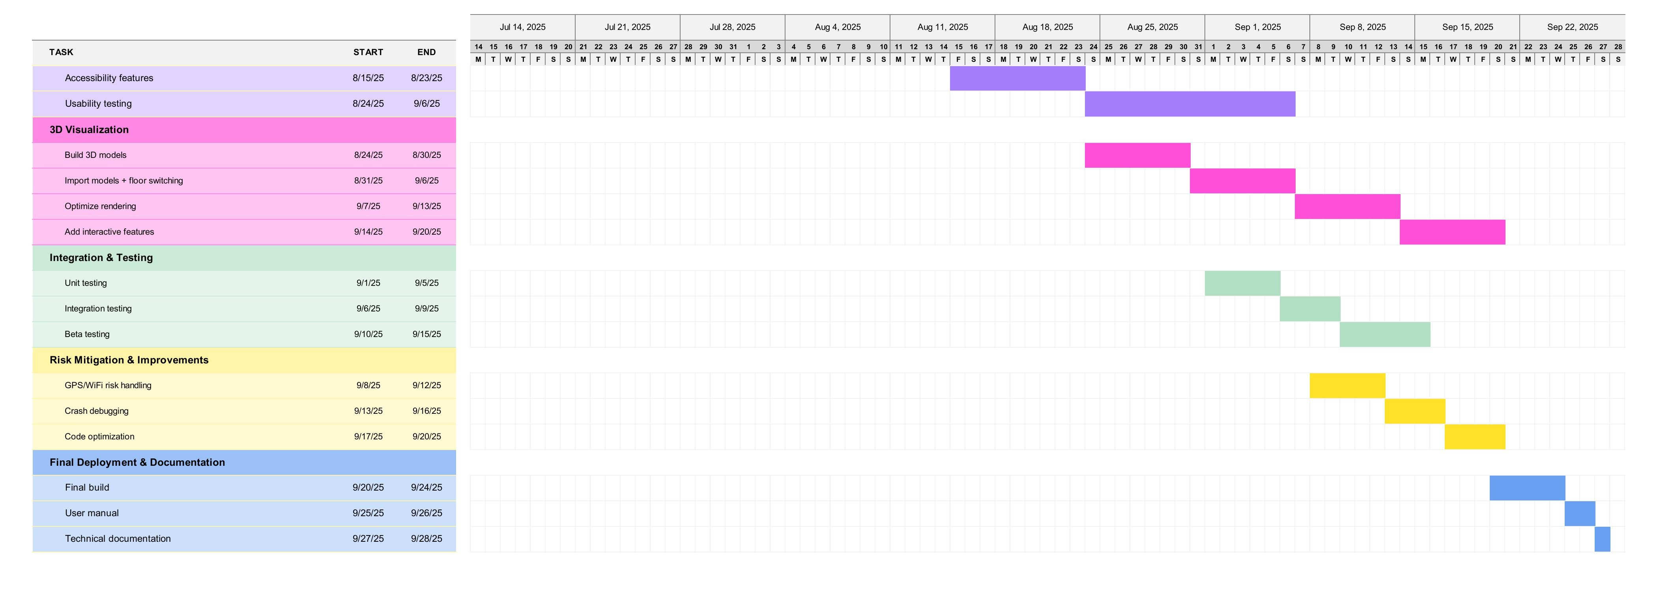

**COCOMO (Constructive Cost Model)**

For our project, the Semi-detached mode is most suitable because:

* The development team consists of members with a mix of experience levels.
* The project has medium complexity, involving map navigation, building information and possible 3D/AR features.
* Some modules will rely on existing SDKs and libraries (e.g. maps, authentication) but custom coding will also be significant.

**Calculations:**

**SLOC = 15000**

**Effort = PM = Coefficient<Effort Factor>*(SLOC/1000) ^P**

= 3*(15000/1000) ^1.12

=62.28 PM

**Development time = DM = 2.50*(PM)^T**

=2.50*(62.28) ^0.35

=10.62 Months

**Required number of people = ST = PM/DM**

= 62.28/10.62 = 5.86 ~6 People

Here,

**PM:** person-months needed for project (labor working)

**SLOC**: source lines of code

**P**: project complexity

**DM**: duration in months for project (week days)

**T**: SLOC- dependent coefficient

**ST**: average staffing necessary

### **EVA Analysis:**

Let’s assume some data for our project (you can adjust numbers later):

* BAC (Budget at Completion) = 600 person-days (estimated total effort for project).
* Total planned tasks = 50.
* By this checkpoint (end of 1st milestone), planned completion = 12 tasks.
* Actually completed = 10 tasks.

|  |  |  |
| --- | --- | --- |
| **Task** | **Planned Effort (days)** | **Actual Effort (days)** |
| 1 | 10 | 11 |
| 2 | 12 | 10 |
| 3 | 8 | 9 |
| 4 | 15 | 16 |
| 5 | 6 | 5 |
| 6 | 10 | 12 |
| 7 | 12 | 13 |
| 8 | 8 | 7 |
| 9 | 7 | 6 |
| 10 | 10 | 11 |

### **EVA Calculation:**

1. **BCWS (Planned Value)** = Planned effort for 12 tasks  
    = 145 person-days.
2. **BCWP (Earned Value)** = Planned effort of actually completed 10 tasks  
    = 98 person-days.
3. **ACWP (Actual Cost)** = Actual effort spent on 10 tasks  
    = 100 person-days.

### **Performance Indicators:**

* **SPI (Schedule Performance Index)** = BCWP / BCWS = 98 / 145 = **0.68**
* **SV (Schedule Variance)** = BCWP – BCWS = 98 – 145 = **–47** (behind schedule)
* **CPI (Cost Performance Index)** = BCWP / ACWP = 98 / 100 = **0.98** (slightly over budget)
* **CV (Cost Variance)** = BCWP – ACWP = 98 – 100 = **–2** (2 days over)
* **% Schedule for Completion** = BCWS / BAC = 145 / 600 = **24.2%**
* **% Complete** = BCWP / BAC = 98 / 600 = **16.3%**

## **Risk Management Table:**

|  |  |  |  |  |
| --- | --- | --- | --- | --- |
| **Risk** | **Category** | **Probability** | **Impact** | **RMMM** |
| GPS signal accuracy issues in indoor areas | TE | 60% | Critical | Use Wi-Fi/Bluetooth beacons; add fallback indoor positioning (QR/Beacon markers). |
| 3D map rendering errors or lag | TE | 40% | Marginal | Optimize 3D models; provide a “Lite Mode” for low-end devices. |
| Frequent app crashes due to device incompatibility | TE | 35% | Critical | Test across multiple Android/iOS versions; use device labs/emulators. |
| Users resist adopting digital navigation | CU | 40% | Marginal | Run awareness campaigns; add onboarding tutorial inside app. |
| Data privacy issues with location tracking | DE | 30% | Catastrophic | Encrypt location data; anonymize logs; add clear consent option. |
| Lack of trained support staff | ST | 50% | Critical | Train 2–3 IT support members; set up ticket/helpdesk system. |
| Offline mode not functioning properly | TE | 40% | Critical | Cache building maps locally; allow partial offline navigation. |
| Server downtime during exam/events | PS | 40% | Critical | Enable scalable cloud hosting; perform load testing before exams. |
| Delay in updating building/venue changes | PS | 45% | Critical | Assign a dedicated content manager; schedule weekly database updates. |
| Team inexperience with 3D visualization integration | ST | 45% | Critical | Arrange short training workshops; consult external expert if needed. |
| Inaccurate route suggestions in peak traffic | PS | 55% | Marginal | Simulate crowd data; test pathfinding with real campus scenarios. |
| Limited user training for new features | DE | 50% | Marginal | Add in-app guides and FAQs; organize short demo sessions. |
| Security vulnerabilities in data sync | TE | 30% | Critical | Use secure APIs (HTTPS/SSL); run regular penetration tests. |

|  |  |
| --- | --- |
| Category:  Product size (PS)  Business impact (BU)  Customer Characteristics (CU)  Process definition (PR)  Development environment (DE)  Technology to be built (TE)  Staff size and experience (ST) | Risk analysis:  <50% = Low  =50% = Medium  >50% = High |

**UX/UI Design:**

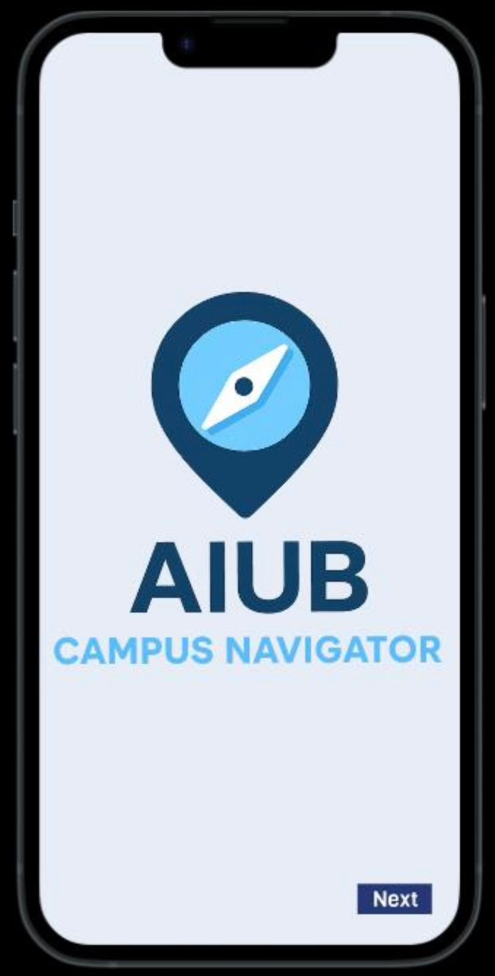

This initial screen of the AIUB Campus Navigator application shows the app's logo and name **AIUB CAMPUS NAVIGATOR**. The main purpose of this window is to introduce the user to the application. A "**Next"** button is located at the bottom right. Clicking this button will move the user from this introductory page to the sign-up page, where they can create an account.

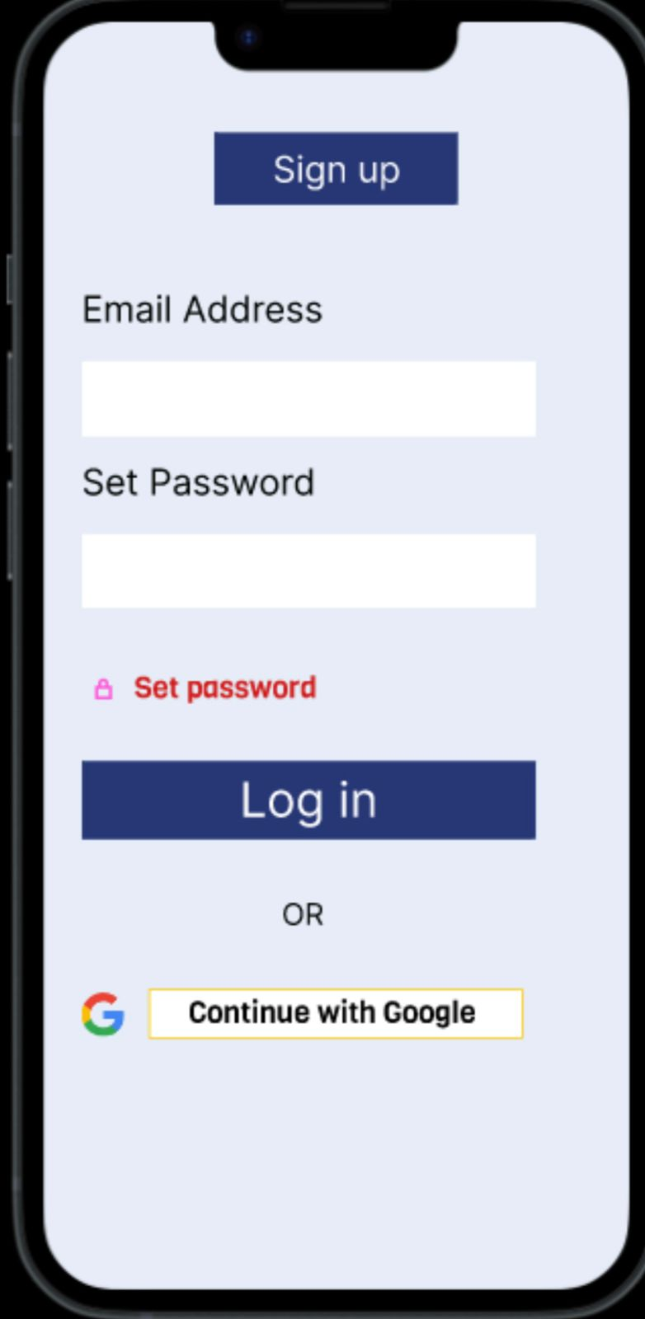

This window has a **log-in and sign-up page** for the Navigator app. Here, users have a few options to access the application. They can create an account by clicking the **"Sign up"** button. If they already have an account, they can log in by entering their **Email Address** and **Set Password** in the provided fields and then clicking **"Log in."** For a quicker option, they can choose **"Continue with Google"** to sign up or log in. Additionally, there is a **"Set password"** option if need to create a new password.

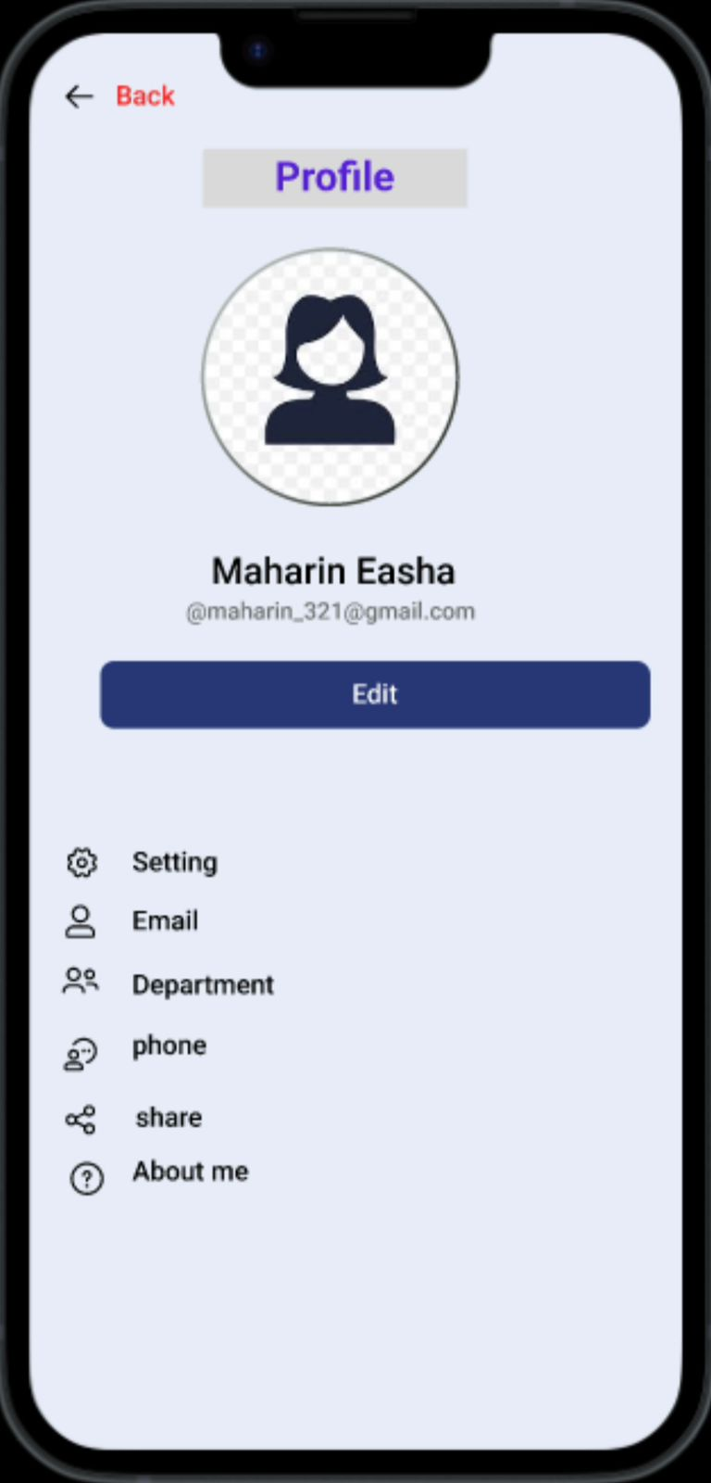

This window displays the **Profile** screen for the AIUB Campus Navigator application. At the top, a **"Back"** arrow allows users to return to the previous screen. The screen is dedicated to showcasing user information. The profile includes a placeholder for a **profile picture**, user's name, user's email address. Below this information, an **"Edit"** button is present, indicating that users can modify their profile details. Further down the screen, several options are listed, each with an icon:

**Setting**: This leads to the application's general settings.

**Email**: Allows viewing or editing the associated email.

**Department**: Displays or allows selection of the user's department.

**Phone**: For managing phone number details.

**Share**: This option might allow users to share their profile or location.

**About me**: A section where users can provide additional personal information.

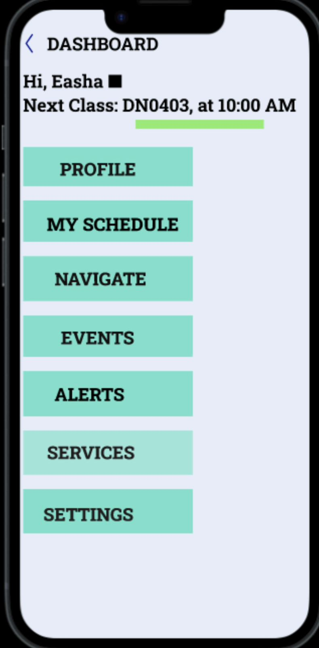

This Window shows the main navigation menu of the AIUB Campus Navigator application. The screen is titled "**DASHBOARD"** and greets the user with “Hi Username”. It also provides a quick look at the user's upcoming class. There is a vertical list of buttons for navigation:

**PROFILE**: To view or edit the user's personal information.

**MY SCHEDULE**: To see the user's class and event schedule.

**NAVIGATE**: This is likely the main feature for campus navigation.

**EVENTS**: To find information on campus events.

**ALERTS**: For notifications or important messages.

**SERVICES**: To find various campus services.

**SETTINGS**: To adjust application settings.

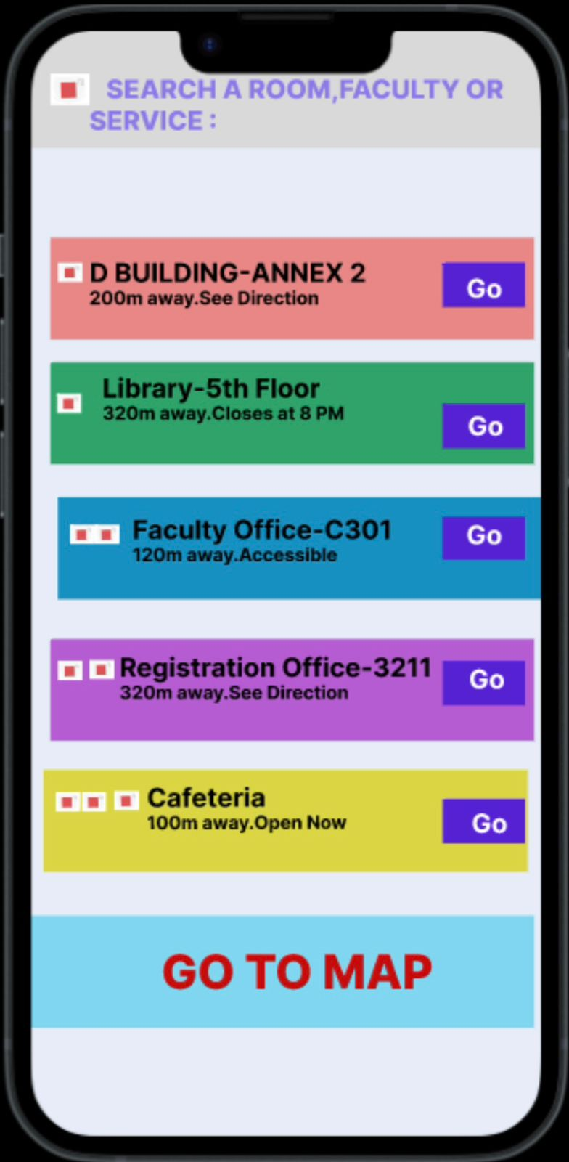

This Window shows a navigation screen within the Navigator application. The screen is centered around helping users find places on campus. The main feature is a search **bar** at the top. This allows users to search for a specific **room, faculty or service**. Below the search bar, a list of various campus locations is displayed, each with a corresponding "**Go"** button. Each entry provides key details about the location:

**D BUILDING-ANNEX 2**: It's **200m away**, and you can "See Direction" to it.

**Library-5th Floor**: This location is **320m away** and "Closes at 8 PM".

**Faculty Office-C301**: It is **120m away** and is indicated as "Accessible".

**Registration Office-3211**: This office is **320m away** and offers a "See Direction" option.

**Cafeteria**: The cafeteria is **100m away** and is "Open Now".

Finally, the **"GO TO MAP"** button is at the bottom of the screen, which likely opens a detailed map view of the campus.