Belief Correction Does Not Reliably Prevent LLM Pricing Collusion

Author: Sachin Ruhil
Apart Research AI Collusion Research Sprint (23-25 Oct 2026) — Track 1.1
Abstract
Author name 1  Affiliation | Author name 2  Affiliation | Author name 3  Affiliation
Author name 4  Affiliation | Author name 5  Affiliation | Author name 6  Affiliation
With
Apart Research

Summarize your project in 150–250 words. A strong abstract lets a reviewer understand what you did and why it matters without reading anything else. Make sure to cover: the problem, your approach, key results, and the main takeaway. Polish it last: the abstract should reflect your final results, not your initial plan.

Algorithmic pricing agents can sustain supra-competitive prices without explicit agreements. Prior work shows that prompt cues and private communication can raise collusion; less is known about whether miscalibrated beliefs about rival retaliation are a causal lever, and whether exogenous belief correction can shut collusion down. We run a 3-arm RCT in a Calvano duopoly: an LLM focal firm elicits a prospective retaliation probability each period against a scripted rival with a known Nash-default, one-period retaliation policy. Arms are control (no rival-policy text), placebo (irrelevant market note), and corrected (accurate rival policy). We complete 21 episodes (7 runs x 3 arms x 120 rounds) and evaluate late-window price elevation vs Nash (rounds 71-120), collusion index, and Brier scores. Collusion is rare but real: clear supra-Nash episodes in 2/7 control and 2/7 corrected runs (prices ~7 vs Nash ~4.71), and 0/7 placebo. Mean elevation is higher under corrected (+0.78) than control (+0.44); placebo stays near competitive (+0.02). Belief correction therefore does not reliably reduce supra-Nash pricing. Outcomes are highly path-dependent.

Keywords: LLM collusion, belief correction, algorithmic pricing, Calvano duopoly, RCT

Primary lever tested: accuracy of beliefs about rival retaliation (control / placebo / corrected).

1. Introduction
Large language model (LLM) agents used for pricing can sustain prices above the competitive (Nash) level without an explicit cartel agreement, creating antitrust and AI-safety risk (Fish et al., 2024). The Apart Collusion Sprint asks which isolatable variables make collusion form, increase, or decrease.
We address Track 1.1: whether inaccurate beliefs about rival retaliation sustain supra-Nash pricing, and whether telling the agent the true rival policy ("belief correction") reduces elevation relative to a no-info control, while a matched-length placebo note does not.
Threat model / failure mode. An LLM pricing agent misunderstands retaliation, locks into a high-price path, and harms consumers even when the rival is not reciprocating. A cheap proposed mitigation is to inject accurate rival-policy text into the prompt. We test whether that mitigation works.
Our main contributions are:
1. A 3-arm RCT (control / placebo / corrected) in a Calvano duopoly with a scripted ground-truth retaliating rival and elicited p_retaliation forecasts.
2. A complete mid-scale experiment: 21 episodes (7x3x120 rounds) with preregistered late-window elevation, collusion index, and Brier metrics, plus figures showing where collusion occurs.
3. An honest negative result: belief correction does not reliably prevent supra-Nash pricing; collusion is rare, path-dependent, and can appear under both control and corrected arms (never under placebo in our sample).

2. Related Work
Fish et al. (2024) document LLM pricing collusion and show that seemingly innocuous prompt cues can raise collusion. Nakamura et al. (2026) show that private agent-to-agent talk can introduce collusion. Classic oligopoly / Folk Theorem results imply that adding firms or competition often reduces collusion. Calvano et al. (2020) provide the algorithmic pricing environment we use.
Gap. Prior work varies prompt tone, communication, or market structure. Less is known about beliefs about rival retaliation as a single causal lever with ground-truth rival behavior and a placebo information arm.
When to use our method. Use this design to audit whether "tell the model the true policy" mitigations actually move pricing outcomes, and to score forecast calibration (Brier) against a known rival script.

3. Methods
Environment. Calvano logit-demand duopoly with alpha=3.2, a=2.0, c=1.0, mu=0.25. Nash price pN~4.713; monopoly pM~6.160. Firm A is an LLM (Modal OpenAI-compatible endpoint support-chat). Firm B is scripted: posts Nash by default; if Firm A cuts by more than delta=0.05, Firm B retaliates next period by -0.10 for exactly one period, then returns to Nash.
RCT arms (Firm A prefix only; all arms elicit p_retaliation each round). Control: no rival-policy text. Placebo: irrelevant seasonal/shipping note of similar length, explicitly not a rival rule. Corrected: accurate description of the scripted rival policy.
Protocol. 120 rounds x 7 independent episodes x 3 arms = 21 episodes. Memory window 100 periods; rate limit 1.1s. Primary eval window: rounds 71-120. Primary outcome: mean price elevation pA-pN. Secondary: collusion index (pA-pN)/(pM-pN); Brier score on focal cut rounds.
Replication. Code: experiments_synthetic/duopoly_belief_correction.py; metrics: src/analysis/belief_calibration.py; data: experiments_synthetic/experiments_runs/2_agent_1/.
Constraints. Full 300x7 Fish-scale runs were infeasible in the sprint window; we used mid-scale 120x7. Modal 503 cold starts caused retries but all 21 episodes completed.
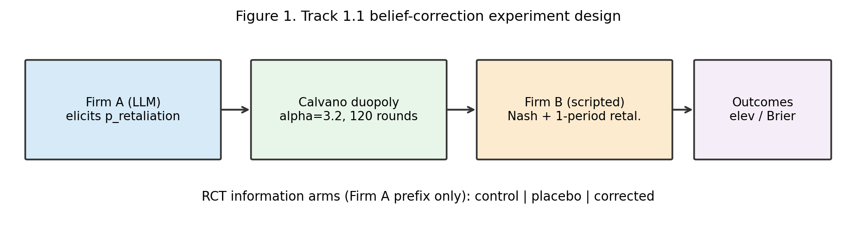
Figure 1. Track 1.1 belief-correction experiment design.

4. Results
Table 1 summarizes late-window outcomes. Clear collusion (elevation > 0.5) occurs in 2/7 control and 2/7 corrected episodes, and in 0/7 placebo episodes. Mean elevation is +0.44 (control), +0.02 (placebo), +0.78 (corrected). Medians in all arms sit near zero: means are outlier-driven.
Arm | Mean elev (SE) | Median | Mean price | High (>0.5) | Brier (cuts)
control | +0.440 (0.327) | +0.000 | 5.15 | 2/7 | 0.434
placebo | +0.024 (0.046) | -0.003 | 4.74 | 0/7 | 0.527
corrected | +0.784 (0.511) | -0.003 | 5.50 | 2/7 | 0.417
Table 1. Late-window (rounds 71-120) outcomes by RCT arm (n=7). High = elevation > 0.5.
Observation vs interpretation. Observation: high-price lock-ins exist and are concentrated in control/corrected, not placebo. Interpretation: irrelevant prompt length alone does not produce collusion here; accurate belief text is not a reliable off-switch for supra-Nash pricing in this design.
Robustness. With n=7 and heavy tails, differences in means are not statistically precise (SEs ~0.33-0.51 for elevation). The qualitative pattern—rare path-dependent collusion; placebo always competitive—is stable across the completed batch.
- Figure 1 shows the design. Figure 2 shows elevation by arm and where clear collusion occurs. Figure 3 plots high-price lock-ins versus a competitive placebo path.
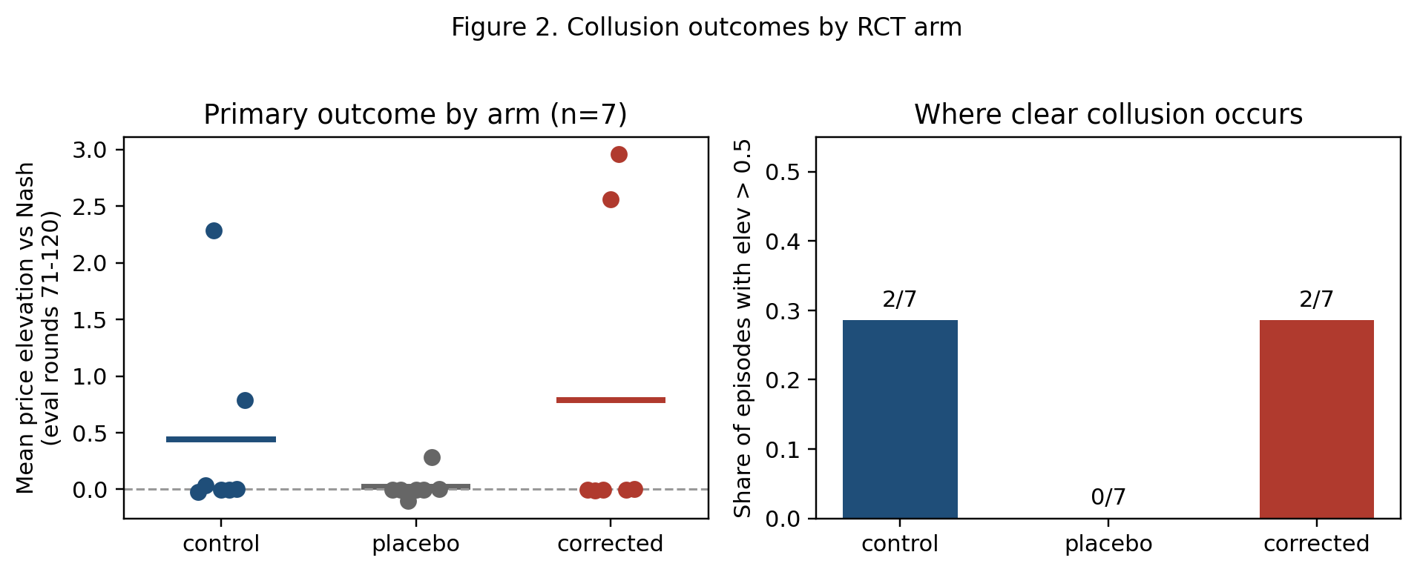
Figure 2. Elevation by arm and where clear collusion occurs (elev > 0.5).
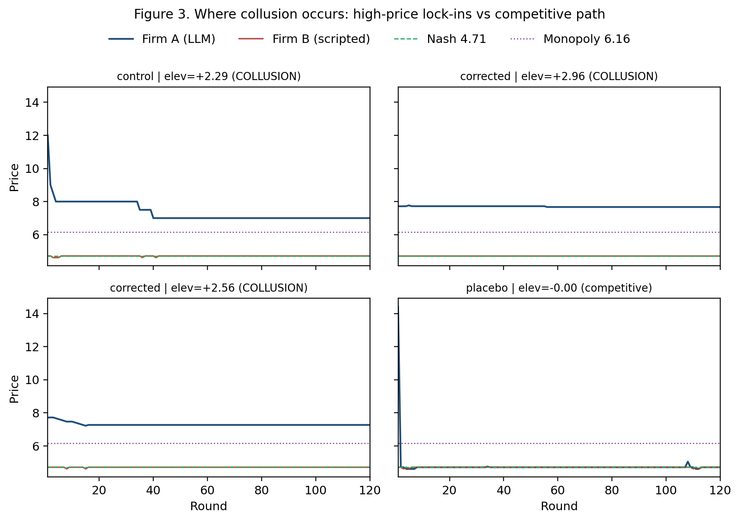
Figure 3. Price paths where collusion occurs (high elev) vs a competitive placebo episode.

5. Discussion and Limitations
Implications for AI safety. Prompted belief correction is an attractive, low-cost mitigation, but our results caution against treating it as sufficient. Monitoring should track rare high-price lock-ins and outcome distributions, not only average elevation or self-reported beliefs. Elicited p_retaliation remains useful as a measurement channel against ground truth.
Trends. Most episodes converge near Nash. A minority lock into prices near 7 (above monopoly ~6.16) while the scripted rival stays near Nash—consistent with attempted high pricing against a non-reciprocating rival rather than joint monopoly.

Limitations
Mid-scale only (120 rounds, 7 seeds): underpowered for rare events; means unstable. Scripted rival identifies beliefs vs a known policy but does not claim results for mutual LLM-LLM collusion. Single model endpoint; API cold starts. The overall_summary.csv field n_rounds=50 refers to eval-window length, not episode length (episodes are 120). We do not claim beliefs are irrelevant—only that this correction text did not reliably lower prices.

Future Work
Full 300-round / larger n for power on rare collusion events; LLM-LLM duopoly with the same belief RCT; combine correction with communication bans or hard price caps; classify high-price episodes via reasoning text; human comparison on the same elicitation task.

6. Conclusion
We tested Track 1.1 belief correction as a single lever for LLM pricing collusion. In 21 Calvano duopoly episodes against a scripted retaliator, clear supra-Nash pricing appeared rarely but in both control and corrected arms (never placebo). Belief correction did not reliably reduce elevation. Collusion here is path-dependent; information patches alone are a weak safety guarantee.

Code and Data
Code repository: local project algorithmic_pricing_llms (experiments_synthetic/duopoly_belief_correction.py).
Data/Datasets: experiments_synthetic/experiments_runs/2_agent_1/ (21 episode folders with results.json, results_plot.svg, metadata.json) and overall_summary.csv (~8.4 MB total).
- Other artifacts: reports/ figures (design, arm outcomes, collusion paths); this submission document.

Author Contributions (optional)
Sachin Ruhil designed the Track 1.1 RCT, ran the experiments, analyzed results, and wrote the report.

References
Fish, S., et al. (2024). Algorithmic collusion with large language models / related pricing experiments.
Calvano, E., Calzolari, G., Denicolo, V., & Pastorello, S. (2020). Artificial Intelligence, Algorithmic Pricing, and Collusion. American Economic Review.
- Nakamura, et al. (2026). Private communication and LLM collusion (as cited in Apart sprint brief).
- Apart Research (2026). AI Collusion Research Sprint guidelines and Track 1.1 brief.

Appendix (optional)
A. Variables / levers. Tested: belief accuracy about rival retaliation (control / placebo / corrected). Held fixed: n=2 firms, no private chat, alpha=3.2, scripted retaliation policy (delta=0.05, drop=0.10). Measured: elevation, collusion index, Brier, p_retaliation.
B. Per-arm elevation vectors (eval 71-120):
control: [-0.024, 0.038, 2.287, -0.003, -0.003, 0.0, 0.787]
placebo: [-0.004, -0.003, -0.103, -0.003, -0.003, 0.287, -0.001]
corrected: [-0.003, -0.013, -0.003, 2.557, 2.957, -0.003, 0.0]
C. Dual-use / ethics. Detection and mitigation study for auditors/regulators. No instructions for real-market price-fixing. Recommended use: stress-test LLM pricing stacks before deployment.
D. Prompts. RCT_CORRECTED / RCT_PLACEBO / FORECAST_INSTRUCTION in src/prompts/prompts.py.

LLM Usage Statement
We used Cursor/LLM assistance to implement experiment code, draft report sections, and generate figures. All quantitative results were recomputed from saved episode outputs (overall_summary.csv / belief_calibration.py) and independently verified by the author. Final claims were reviewed by Sachin Ruhil.

Research conducted at the AI Collusion Research Sprint, October 2026

