**Chapter 3**

**Information Gathering**

**Introduction**:

Information gathering is the combination of art and science. It is a key part of feasibility analysis process. The aim of fact-finding techniques is to determine the information requirements of an organization used by analysts to prepare a precise SRS understood by user. To gather information from any organization different kinds of tools are used. The first requirement of determining where to go for information and what tools to use is to figure out what information to gather. That means information must be acquired accurately and methodically under the right conditions and with minimum interruption to user personnel. The methodology and tools for information gathering require training and experience that the analyst is expected to have. So, it is necessary to have much knowledge of various information gathering tools. Each tool has a special function depending on the information needed.

From the above discussion, it can be said that information gathering is neither easy nor routine. Much preparation, experience and training are required.

To make an analysis on the prevailing system of Rajshahi Railway Station, we have gathered information from different sections of this organization using different tools. The primary external sources used to gather required information were government documents, online journals and the internal sources were personnel staff, professional staff and own website of the organization.

**3.2 Information gathering using different tools**

In this section, the information collected from the organization was presented.

**3.2.1 Forms, documents and statistical chart of Rajshahi railway station**

Very few system problems are unique. The increasing number of software packages suggests that problem solutions are becoming standardized. Therefore, as a first step, a search of literature through professional references and procedures, manuals, textbooks, company studies, government publications or consultant studies may prove invaluable.

Several forms, manuals and important news from the online journals, websites of the organization were collected to gather information about the organization.

<<<<<In section 3.2.1.1 we have included the important mails of the organization.

. In section 3.2.1.2 we have included the pdf of the online ticket from Rajshahi station.

In section 3.2.1.3 we have included the pdf of the offline ticket from Rajshahi station.

**3.2.1.1 Important Contact Mails**

Rajshahi Railway is situated in the main city of Rajshahi. And Bangladesh Railway is the state-owned rail transport agency of Bangladesh. It operates and maintains all railways including in the country and is overseen by the Directorate General of Bangladesh Railway. In this section the important mails of the office of the Directorate General are presented.

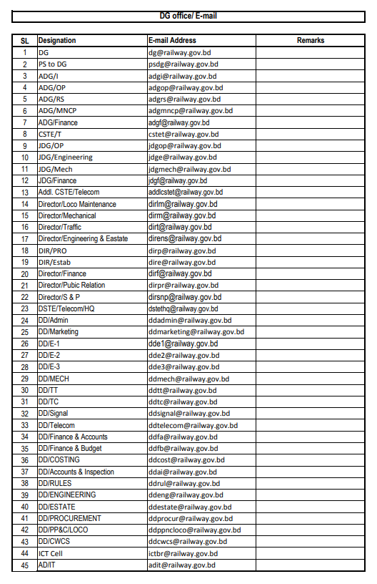

Figure 3.2.1.1(a) Important Mails of DG office

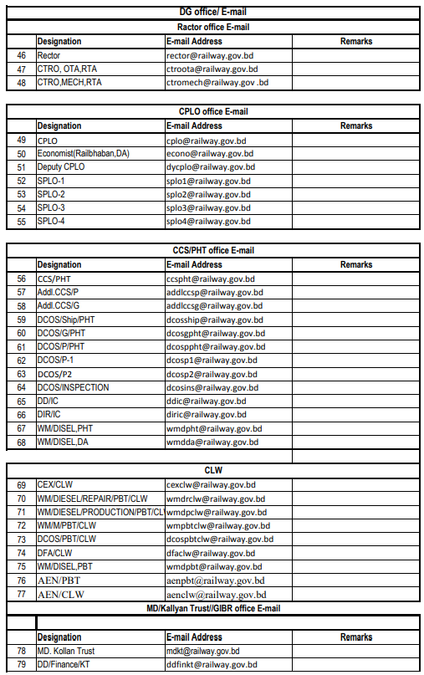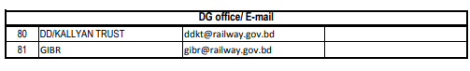

Figure 3.2.1.1(b) Important Mails of DG office

**3.2.1.2 Online Ticket**

The tickets from Rajshahi railway station are sold in two ways one of which is online. Shohoj, Synesis and Vincen JV, the three companies together maintain the online ticketing system. One has to register on the e-ticketing website of the organization with their NID and relatable information. When a passenger buys a ticket online, a confirmation mail along with the pdf of the online ticket is sent to the mail id of the passenger. The passenger must get the soft copy of the online ticket printed. It is encouraged that minor tickets are bought for the children between 3 to 12. The photo of the pdf of the online ticket of a passenger who bought ticket to travel from Rajshahi to Chuadanga is attached in the section.

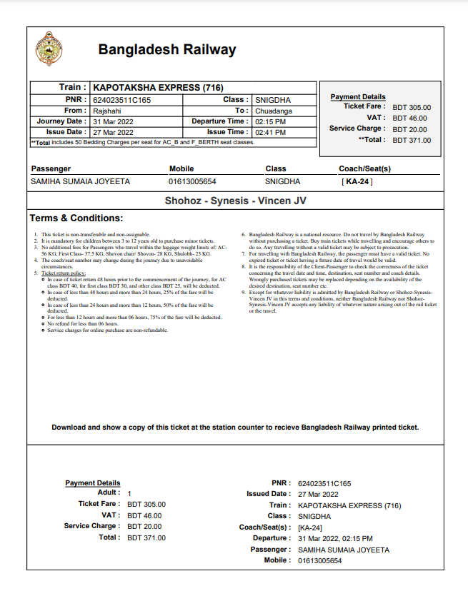

Figure 3.2.1.2 Online Ticket From Rajsahi To Chuadanga

**3.2.1.3 Offline Ticket**

The tickets from Rajshahi railway station are sold offline also. One has to keep their NID card or smart card along with them. Other information such as mobile number is also required. It is encouraged that minor tickets are bought for the children between 3 to 12 in this case too. The photo of offline ticket of a passenger who bought ticket to travel from Rajshahi to Ullapara is attached in the section.



Figure 3.2.1.3 Online Ticket From Rajshahi to Ullapara

**3.2.1.4 Job Circular**

Job circulars for different posts and of different catagories in railway are generated in newspapers and on the website of the organization. People can apply for jobs both online and offline. A job circular is attached here for the post of assistant station master from the year 2021.

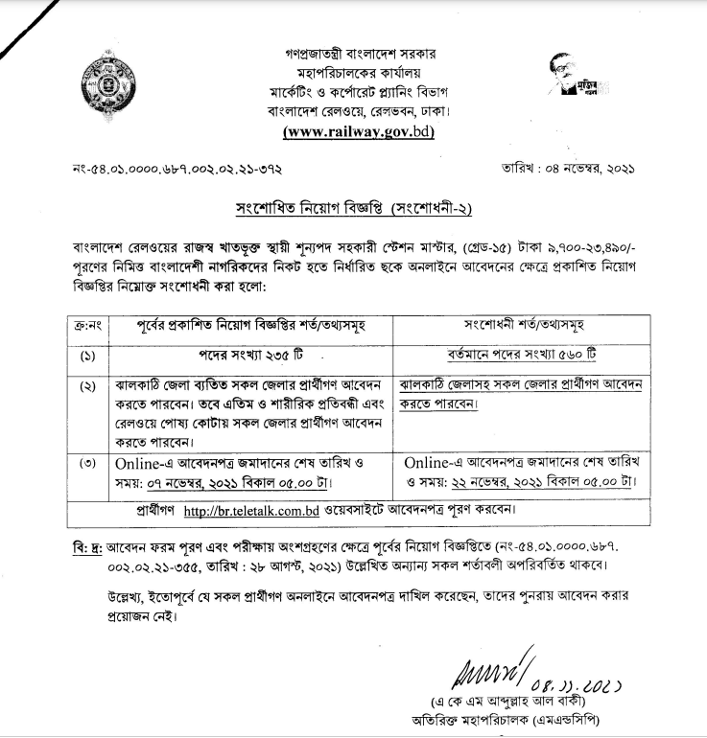

Figure 3.2.1.4 Job Circular For The Post of Assistant Station Master

**3.2.2 Observation on working process of Rajshahi Railway Station**

Onsite observation is a method of gathering information by noticing and observing the people, events, and objects related to any organization. The analyst visits the organization to observe the working of current system and understands the requirements of the system.Onsite observation is a very effective tool to gather information. The major objective of on-site observation is to get as close as possible to the real system. Keeping in mind the following questions, helps to gather important information about the system.

1. What kind of system we are observing.
2. The people running the system and who are important people of the system.
3. The history of the system and the evolution of the system to current stage.
4. How the system responses to internal and external crisis.

Four alternative observation methods are used usually.

1. Observation can be natural or contrived. A natural observation occurs in employee’s place and contrived observation is set up by the observer in a place like laboratory.
2. It can be obtrusive or unobtrusive. In an obtrusive observation the respondent knows he/she is being observed but in an unobtrusive observation the respondent doesn’t know.
3. It can be direct or indirect. A direct observation takes place when the observer actually observes the subject. But in case of indirect observation mechanical devices are used to capture information.
4. It can be structured or unstructured. In structured observation the observer looks for and records specific action. But in case of unstructured method, the observer is in a situation to observe whatever might be pertinent at the time.

We have observed the working process of Rajshahi railway station several times. Our observations were natural, direct, obtrusive and unstructured. Our observations are given below-

1. During our observation we have found the employees very much busy as there was an event to be held. We went to the station at working hour. Some people were found waiting for their respective trains while most of the people were found buying tickets. There were several counters each of which were for different classes of trains or compartments. A counter sells tickets for AC compartments, another counter is reserved for woman to buy tickets and other countes are for selling tickets for Non-AC and local trains.
2. We also observed some technical resources are available in the railway station. But the number of the computer resources and he number of technical employees both were not enough to handle crowd of people who came there to buy tickets. The online ticketing system is handled centrally from Dhaka. The representative of Shohoj works there to issue tickets. If any problem occurs related to the ticketing system, it is informed on whatsapp to the companies that maintain the ticketing system. So, they are dependent on third party to maintain and resolve the problems related to ticketing.
3. During our observation the employees were very helpful and they were giving us information willingly when we told about the reason of observation. Most of the people were active enough but pace of their working might be little better.

**3.2.3 Face to face question answer session**

The interview is a face-to-face interpersonal role situation in which a person called the interviewer asks a person being interviewed questions designed to gather information about a problem area.The interview is the oldest and most often used device for gathering information in systems work. It has qualities that behavioral and on-site observations don’t possess. It can be used for two main purposes:

i. It serves as an exploratory device to identify relations or verify information.

ii. It is used to capture information.

To analyze the system of Rajshahi Railway Station, interview of several employees was taken.

Among them, there was the Chairman of the board, secretary of the board, senior system analyst

and programmer of the board.

**To the Director/Traffic:** We got the opportunity to meet the director/traffic of the organization and had a great conversation with him. His office is in Dhaka but we got the opportunity to meet him as he was in Rajshahi for an event and agreed to give us his valuable time even though he was busy with the mentioned event. He was an enthusiast respondent which is why we asked him several question which are given below:

1. **Interviewer:** Is your system fully digitalized?

**Interviewee:** Not all systems are digitalized. Ticketing and train locating system is digitalized. There is another system available for E documents online. Pension and salary system is also digitalized.

2. **Interviewer:** Can a user find all the necessary information from the railway website?

**Interviewee:** All the necessary information are available on our website. But information are inserted according to needs time to time.

3. **Interviewer:** Does the railway have their own server?

**Interviewee:** All the digital systems available in railway are run by third party vendors but monitored by railway. They are considered to be railway's own property after a certain time.

4. **Interviewer:** Is railway dependent on any 3rd party organisation?

**Interviewee:** As there is no IT cell of our organisation, we have to depend on third party organizations for all our digital system.

5. **Interviewer:** Do you have to compromise the confidentiality of data because of your dependence on third party organisation?

**Interviewee:** As the third party organizations handle systems and servers, we have to compromise some confidentiality.

6. **Interviewer:** Do you take user feedback?

**Interviewee:** Railway passengers and properties' owners are our client. They can complaint and give feedback to train guards, station master or online on railway websites or through mobile app.

7. **Interviewer:** Do the government provide full technical support and budget to your organization?

**Interviewee:** The government give immense importance to this organization. So, the government gives full support to this organisation talking from the budget to technical support.

8. **Interviewer:** Do the government get proper benefit from the organization?

**Interviewee:** The railway is a public transport organization. It is mainly considered as a service provider by the government. The profit and loss of the service provider is not taken into account. Even then, the revenue and expenditure figures are kept as a transport company. Income increase and cost reduction activities are taken.

9. **Interviewer:** How do you plan to stop tickets in black market and corruption?

**Interviewee:** The Railway has signed an agreement with Bangladesh Election Commission. For purchasing railway ticket under this agreement, a passenger shall purchase the ticket subject to provision of correct NID. It is expected that ticket black market will be eliminated to a large extent through this. This function is being integrated with railway ticketing soon. Moreover, the new recruitment program is ongoing. If all these appointments are completed, it will be possible to conduct ticket checking in trains and stations smoothly.

10. **Interviewer:** What changes are you planning to introduce to the system?

**Interviewee:** There is a master plan for radical changes in the system. The process of forming "SMART RAILWAY" has been started with the year 2041 in mind. Short, medium and long term plans are being adopted. Bangladesh Computer Council, ICT Division and Bangladesh Railway will work jointly till 2025 to formulate and implement these plans. During this period, ICT Division and BCC will provide facilitation to Bangladesh Railways for capacity building. From the year 2026, Bangladesh Railways will conduct its operations single-handedly with the aim of emerging as a full-fledged digital organization and will complete its operations by 2041.

**To the Station Manager:** We met with the station manager of Rajshahi railway station. He was quite busy with the crowd of staffs surrounding him which is why we could only ask him a few questions which are given below:

1. **Interviewer:** What is the ticket ratio online and offline?

**Interviewee:** 50% tickets are available online and another 50% tickets are available offline according to quota.

1. **Interviewer:** Does the organisation provide full security of passengers' belongings?

**Interviewee:** Yes. There is full security of passengers' belongings.

1. **Interviewer:** Do you feel the need for more staffs in the railway?

**Interviewee:** Yes. I do feel the need for more manpower in the railway. There are several sectors that need more manpower.

1. **Interviewer:** Does the organisation provide full security of passengers' belongings?

**Interviewee:** Yes. There is full security of passengers' belongings.

1. **Interviewer:** How do you think selling tickets in black market and corruption can be stopped?

**Interviewee:** The higher authority must enlist the corrupt staffs and suspend them.

**To the programmer of Synesis:** We met with one of the programmers of Synesis, one of the companies responsible for the ticketing system of the system. The few questions asked and answered by the programmer are given below:

1. **Interviewer:** What are duties Synesis do?

**Interviewee:**  Synesis is behind the maintenance of the online system.

1. **Interviewer:** What are the problems you think the users face while using the e-ticketing website?

**Interviewee:**  The main problem the users face is traffic. After 8:00 pm the problem increases more. The users are also having trouble to change their NID numbers but changing the NID number is necessary because smart cards are being provided to the citizens of the country due to which the NID number is getting changed.

1. **Interviewer:** What can be done to prevent the problem?

**Interviewee:**  The hosting service needs to be improved using AWS, firebase etc. to solve the problem of online traffic. More features and proper verification system are needed to be added to let the users change their NID numbers.

1. **Interviewer:** Is there any issues with online payment?

**Interviewee:**  No, there are no complaints about online payment.

**3.2.4 Information collected by opinion poll**

Questionnaire or opinion poll is an effective alternative of interview. This method is used by analyst to gather information about various issues of system from large number of persons. It has several advantages over interview as it is economical and requires less skills. Moreover, many respondents feel better to answer the question in questionnairesrather than interview. There are two types of questionnaires −

1. Open-endedQuestionnaires − It consists of questions that can be easily and correctly interpreted. They can explore a problem and lead to a specific direction of answer.
2. Closed-ended Questionnaires − It consists of questions that are used when the systems analyst effectively lists all possible responses, which are mutually exclusive.

We have collected some information from the railway station by usingthis technique. The form of the questionnaires is given below:

Figure 3.2.4: Questionnares for gathering information about the organization

The questionnaire forms were distributed among 10 employees of the organization. The collected results are given below:

Table 3.1 Result of yes/no questions

|  |  |  |
| --- | --- | --- |
| Question No | Yes | No |
| 1 | 10 | 0 |
| 3 | 0 | 10 |
| 4 | 10 | 0 |
| 6 | 0 | 10 |
| 7 | 1 | 9 |
| 12 | 5 | 5 |

Question no. 02: 2 years (10%), 5 years (90%).

Question no. 05: Transportation sector, traffic sector, mechanics, engineering sectors

Question no. 08: Scarcity of tickets (80%), It doesn’t exist (10%), immorality of staffs (10%).

Question no. 09: 4 (30%), 5 (70%).

Question no. 10: 4 (10%), 5 (90%), immorality of staffs (10%).

Question no. 11: Raise awareness among passengers (50%), Recruiting more security staffs (50%).

Question no. 13: Raise awareness (30%), introducing double lines to the system (25%), increasing manpower (25%), interlocking system (20%).

**3.4 Conclusion**

To gather information several tools were used which means that the required information was collected using different criteria. These tools were very useful because the information were collected by using these tools very effectively. System was be observed closely and at the same time, an opportunity to build up an amicable relationship with the staffs of the respective organization was found. By gathering information using the tools mentioned, the actual need of the organization was found out. Lastly, a data flow diagram which is a graphical representation of the existing system of Rajshahi Railway Station was sketched. By data flow diagram one can easily understand the prevailing system of the railway station. So the importance of all the tools above discussed are enormous. Because the online ticketing system and ticket controlling system are handled and controlled centrally from Dhaka, we were unable to gather the information about the internal function of online ticketing system. And it was notable that there was neither the information or charts available online that kept the records of all the trains passing through Rajshahi station or in the western zone nor the contact mails of west zone while they were available for other zones.