Leakage-Aware and Explainable Machine Learning for IEEE 802.11 Intrusion Detection: A Rigorous Multi-Class Evaluation on AWID3
RUHI TAŞ ¹
1Department of Computer Engineering, OSTIM Technical University, 06374 Ankara, Turkey
Corresponding author: Ruhi Taş (e-mail: ruhi.tas@ostimteknik.edu.tr; ORCID: 0000-0002-7741-7715).
ABSTRACT Wi-Fi intrusion detectors are routinely reported at near-perfect accuracy on AWID3. Those numbers deserve a second look. We show they can be an artifact. When benign and malicious frames come from different capture sessions, a classifier learns the recording rather than the attack, and even a linear model then reaches roughly 1.00 macro-F1 from radio and protocol fields alone. Dropping the obvious identifier columns does not fix this. We call the effect capture-environment leakage, and we measure it on the full 43 GB AWID3 corpus. Control the leakage and the picture turns honest. On the author-curated subset, and after stripping every temporal, sequence and address identifier, a gradient-boosted model reaches 0.976 macro-F1 and 0.9998 ROC-AUC across fourteen classes. Its mistakes are sensible: deauthentication is confused with disassociation, two closely related management-frame floods. The study does not stop at supervised accuracy. An autoencoder trained only on benign traffic flags unseen attacks at 0.991 ROC-AUC with a false-positive rate near five percent. SHAP explanations point to the features a security analyst would look for. A short ablation shows that fifteen to twenty features already reach the plateau, and a full detection stays well under a millisecond per window, dominated by feature extraction rather than the model. We release the full pipeline for replication. The message is methodological. Without leakage control, Wi-Fi intrusion-detection results can mislead; with it, rigor and explainability come at no real cost in accuracy.
INDEX TERMS Wireless intrusion detection, IEEE 802.11, AWID3, data leakage, explainable AI, SHAP, anomaly detection, unseen-attack, machine learning, network security.

I. INTRODUCTION
Wi-Fi carries most enterprise and consumer traffic today, and its management and control planes stay exposed. The list of practical attacks is long: deauthentication and disassociation floods, key reinstallation (KRACK) [1], Kr00k, rogue and evil-twin access points, and application-layer intrusions tunnelled over the link. Detecting them has been an active research area for a decade. The Aegean Wi-Fi Intrusion Dataset — first AWID [2] and then AWID3 [3] — is the benchmark most studies now report on.
One number keeps reappearing in that literature: accuracy above 99 percent [4], [5]. AWID3 is a rich, realistic corpus, so part of this is genuine. Part of it may not be. A headline score can reflect a hard problem solved well, or it can reflect an artifact of how the data was split. Consider what happens when benign and malicious frames are drawn from different capture sessions. A feature that only encodes the recording — a channel, a signal level, a timing quirk — will then separate the classes on its own, with no attack signal involved. We call this capture-environment leakage. It inflates reported performance and weakens external validity. It is also rarely measured.
This paper takes the opposite stance. We do not chase the highest score. We first show the leakage on AWID3, then set an honest baseline under a controlled protocol, and finally show that strong, explainable, low-latency detection lives comfortably inside that protocol. The contributions are five:
C1) Leakage measurement. Where prior AWID3 work at most guards against leakage implicitly, we measure it. Naive per-category sampling of the full 43 GB corpus yields about 1.00 macro-F1 across every model family, logistic regression included, and this survives a restriction to a cleaned 34-feature set — which isolates the cause as capture-environment leakage rather than a few identifying columns.
C2) Leakage-controlled benchmark. On the author-curated subset with explicit identifier and temporal removal, we provide a reproducible fourteen-class benchmark of nine classical, boosting and neural models, with cross-validated metrics, per-class analysis, and measured inference latency.
C3) Explainability. We attach SHAP reasoning reports to detections and check that the most influential features agree with domain knowledge — UDP ports for SSDP, channel and frame-control fields for KRACK.
C4) Unseen-attack detection. Five unsupervised detectors are trained on benign traffic only, with an honest per-attack breakdown that includes attacks which are intrinsically hard to catch as anomalies.
C5) Reproducibility. The full pipeline — preprocessing, feature selection, models, explainers and figure generation — is released as open code.
II. RELATED WORK
AWID gave the field a realistic, labelled trace of 802.11 traffic [2]. AWID3 extended it to enterprise WPA2/WPA3 settings and added attacks such as KRACK and Kr00k [3]. Work built on these datasets is plentiful. Expert feature selection with shallow and deep learners has been reported near 99.9 percent on coarse class sets [4]. A wrapper-based deep model reported 99.7 percent on AWID [5]. Feature-reduction studies reach the high nineties with decision trees and convolutional networks [6], and early deep approaches applied stacked autoencoders and dense networks [7]. Image-based encodings, recurrent [8] and attention models have all appeared since. Deep learning has been applied directly to 802.11 anomaly detection and attack classification [9], and anomaly-based designs such as WIDS work on protocol-level features [10]. Attack-specific studies target the very threats we evaluate — Evil Twin identification on AWID3 [11] and machine learning for KRACK and Kr00k [12]. Fully unsupervised deep models have flagged Wi-Fi impersonation without any labelled attacks [13], which is the spirit of our unseen-attack track. Gradient boosting has spotted anomalies in the Wi-Fi handshake [14], weighted feature selection has sharpened impersonation detection [15], filter-based feature engineering has fed deep classifiers [16], and semi-supervised models have been tried for 802.11 anomaly detection [17]. The topic stayed active through 2024-2026: classical-ML multiclass Wi-Fi detection with feature fusion [18], enhanced feature-extraction pipelines [19], temporal-context models that lift recall on hard attacks [20], signature-based defences against multi-channel man-in-the-middle [21], comparative deep-learning studies [22], richer NN-based assessment [23], and attention-augmented hybrids [24]. Almost none of them measures leakage or attaches an explanation, which is the gap we take up.
Two things are usually missing, and they motivate this paper. The first is a leakage check. Class granularity, feature handling and sampling vary from study to study, which makes cross-paper comparison shaky; none of these choices is examined for capture-environment leakage. The second is explanation. SHAP, LIME and attention maps are common in general network IDS [25], yet they stay rare in 802.11-specific work, even though an operator has to trust and act on each alert. A very recent CNN pipeline is telling here [26]. It turns selected AWID3 features into 6x6 grayscale images and reports 99.93 percent on eight classes, and it does apply a capture-based split to hold leakage off. The split is where it stops. Leakage is prevented, not measured; there is no explanation, no unsupervised test for unseen attacks, and no latency budget. Our paper measures the leakage that such a split avoids, then adds the parts it leaves out. Table 1 places representative results next to ours. The setups differ, so it is indicative, not a ranking, and we say so plainly.

TABLE 1. Indicative comparison with representative AWID/AWID3 studies (setups differ; not a like-for-like ranking).
Study (venue, year) | Dataset | Reported metric (Acc. or macro-F1 as stated) | Note vs. this work
Chatzoglou et al., IEEE Access, 2021/22 [3],[4] | AWID3 | ~99.9% (few classes) | Expert features; coarse classes; leakage not quantified
Khalid et al., PLoS ONE, 2025 [6] | AWID3 | 99.82% (DT/CNN) | Feature reduction; timing features retained
Kasongo & Sun, Comput. & Secur., 2020 [5] | AWID | 99.66/99.77% | Wrapper DNN; binary/multiclass
Ceylan et al., Erciyes Univ. J., 2026 [26] | AWID3 | 99.93% (8-class, CNN) | Leakage split, but not measured; no XAI/unseen-attack
This work | AWID3 (curated) | 0.976 macro-F1 (14-class) | Leakage-controlled; explainable; efficiency reported

III. EVALUATION CONTEXT
The offline experiments use the same feature schema and inference path as our intended deployment pipeline (implemented in the supplementary code package; offline evaluation reported here): sensors buffer frames into tumbling windows, extract a numeric feature vector, and score it with the trained model. Fig. 1 sketches this path at a high level. Operational deployment details (message bus, storage backends, policy-gated response) are documented in the supplementary reproducibility package and are outside the scope of the learning evaluation reported here.

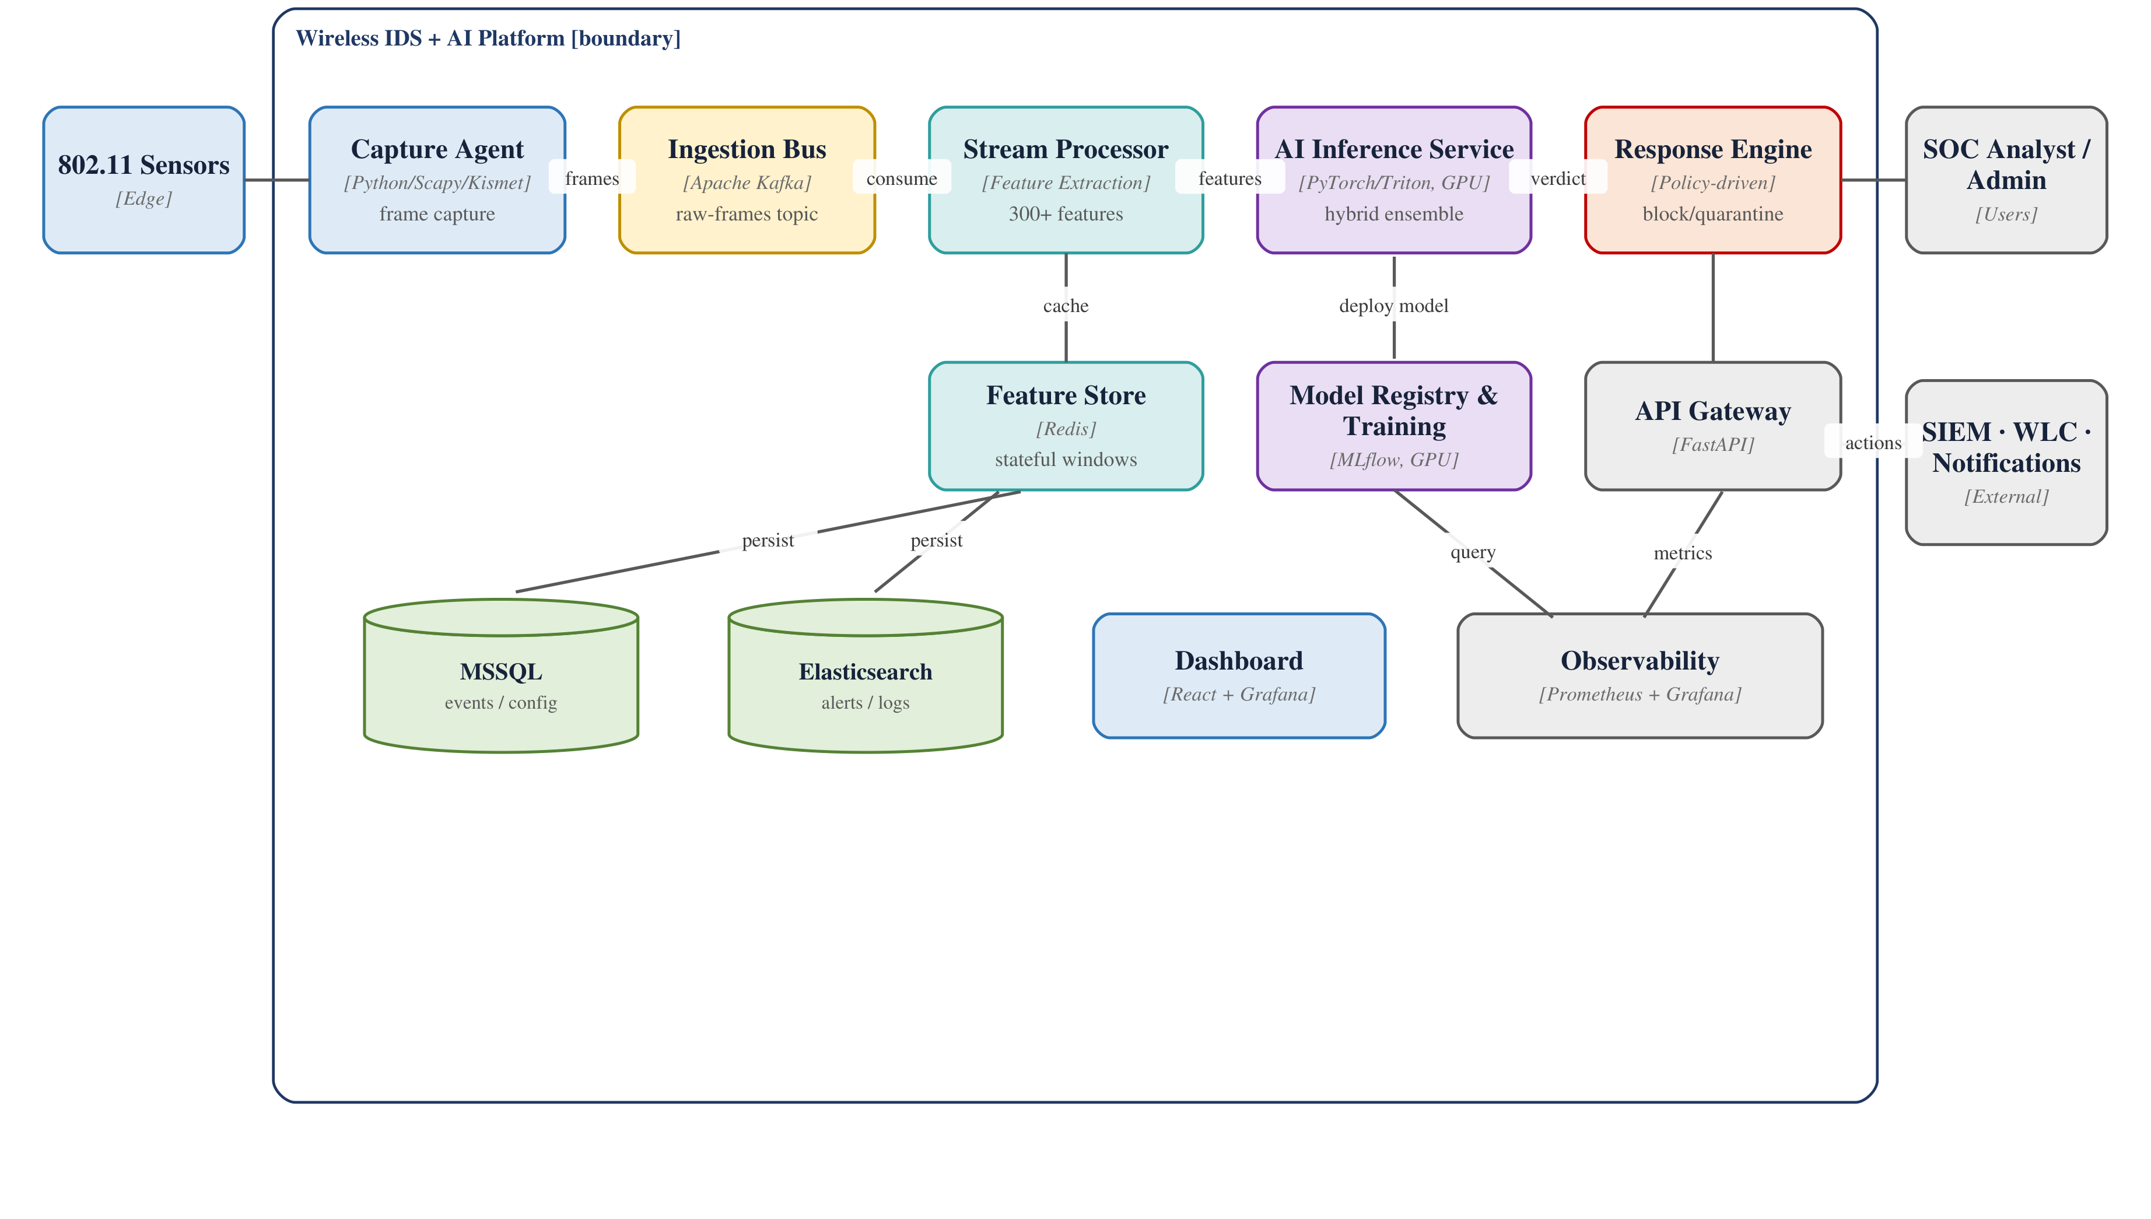
- FIGURE 1. High-level detection path: capture, windowed feature extraction, model inference, and optional explanation/response.

Algorithm 2 Real-time windowed detection and policy-gated response
Input : frame stream from sensors; window w; alert threshold theta; trained model M*
Output: alerts; persisted events; live metrics
1 buf[s] <- empty for every sensor s
2 for each incoming frame fr tagged by sensor s do
3 append fr to buf[s]
4 if |buf[s]| >= w then
5 v <- compute_features(buf[s]) // 300+ windowed features
6 cache v in Redis; publish v to Kafka
7 (c, p) <- M*.predict(v) // predicted class c, confidence p
8 if c != benign and p >= theta then
9 raise alert(s, c, p)
10 persist event to MSSQL; index alert in Elasticsearch
11 if policy(c) permits then enact response(s, c) // deauth/quarantine (dry-run default)
12 end if
13 export metrics: records, alerts, throughput, last confidence
14 buf[s] <- empty
15 end if
16 end for

IV. DATASET AND LEAKAGE-AWARE PREPROCESSING
We use AWID3 in two forms. The first is the full official CSV corpus — thirteen attack categories, 254 features, about 43 GB — which we use to demonstrate leakage. The second is the author-curated reduced subset, in which benign and attack frames are interleaved from the same captures, which we use for the honest benchmark. From each record we resolve the label by name, since column ordering differs across categories, and keep the numeric protocol, radio and transport features.
A. LEAKAGE-CONTROL POLICY
We drop any feature that names the capture or the endpoints instead of describing the attack. That means every timestamp, time-delta, TSF and MAC-time field, the frame numbers, MAC and IP address columns, and per-frame or transport sequence counters (wlan.seq, tcp.seq, tcp.ack and their raw variants). Transport ports stay, since a port is behaviour, not identity. Constant columns go too. Thirty-four behavioural features remain (see config/leakage_controlled_features.txt). The resulting count is deterministic, not tuned: 254 AWID3 numeric fields minus policy-defined leaky columns minus constant columns in the 74,270-row build yields exactly 34 (Appendix A, Table A1). Removing sequence fields does not materially change the benchmark (Section VI-C).
B. CLASS DISTRIBUTION
Table 2 lists the fourteen classes and their sample counts.

TABLE 2. Curated AWID3 evaluation set: 74,270 samples, 14 classes, 34 leakage-controlled features (see config/leakage_controlled_features.txt).
Class | # | Class | # | Class | #
Normal | 20000 | Krack | 8000 | Botnet | 1483
Deauth | 2567 | Kr00k | 8000 | SSH | 1248
Disas | 8000 | Malware | 8000 | (Re)Assoc | 380
SSDP | 8000 | Website_spoofing | 8000 | Evil_Twin | 377
RogueAP | 129 | SQL_Injection | 86 | (total) | 74270

C. CURATED SUBSET CONSTRUCTION
The subset is not hand-picked, and the exact procedure is scripted so that anyone can rebuild it. We start from the author-curated AWID3 reduced release, in which every per-attack file already interleaves benign and attack frames from the same capture session — the property that defeats capture-environment leakage. For each of the thirteen attack folders the script reads the curated CSVs, resolves the label column by name (the column order differs between folders), and keeps the numeric protocol, radio and transport fields. It then applies the leakage-control policy of Section IV-A, which leaves thirty-four features. Sampling is capped and seeded: at most 20,000 benign windows and at most 8,000 windows per attack class, drawn with a fixed random seed of 42; classes that are smaller than their cap are taken in full. The outcome is the 74,270-row, fourteen-class set of Table 2, produced by a single released command, build_awid3.py with normal-cap 20,000 and attack-cap 8,000. Re-running it reproduces the dataset exactly, which is the point.
D. FROM RAW FRAMES TO 34 PER-FRAME FEATURES
AWID3 ships 254 Wireshark-derived fields per frame. Our build script (build_awid3.py) resolves labels by name, applies the leakage policy of Section IV-A, aligns the feature union across attack folders, fills missing values with zero, and drops columns with zero variance in the final 74,270-row sample — yielding 34 behavioural fields (Appendix A). The companion streaming stack aggregates frames into tumbling windows and computes 300+ window-level statistics for live scoring; the offline benchmark in this paper uses the per-frame 34-field schema for reproducibility and direct comparison with prior AWID3 work.
V. METHODOLOGY
The supervised pool is nine classical and boosting models — logistic regression, k-nearest neighbours, a decision tree, random forest, extremely randomized trees, gradient boosting, a multilayer perceptron, XGBoost [27] and LightGBM [28] — plus a tenth hybrid deep model that fuses a one-dimensional convolutional branch with a Transformer self-attention branch [30]. Scale-sensitive models are standardized inside a scikit-learn pipeline [29]. An RBF support-vector machine is omitted at this sample size for tractability. The hybrid model is evaluated on the same stratified 75/25 hold-out as the confusion analysis and is documented in Appendix B (hold-out evaluation).
For feature selection we compare mutual information, ANOVA-F, random-forest importance, permutation importance, L1-regularized logistic regression and recursive elimination, then form a consensus ranking and report a feature-count ablation. Unseen-attack detection uses five unsupervised models trained on benign traffic only: Isolation Forest [31], One-Class SVM, an autoencoder, a variational autoencoder [32] and Deep SVDD [33]. Explanations come from SHAP [25], which yields signed per-feature contributions and a short report for each detection.
Evaluation uses stratified five-fold cross-validation for the benchmark and a 75/25 stratified hold-out for the confusion analysis, the explanations and the hybrid model. Metrics are accuracy, macro precision, recall and F1, and one-vs-rest ROC-AUC. Inference latency is measured per sample on CPU. All runs are on a commodity CPU workstation with no GPU, so the deep models use CPU builds.
The workstation is an Intel Core Ultra 7 155H with 32 GB of RAM, running Windows 11 without a GPU. The software stack is Python 3.11 with scikit-learn 1.9, XGBoost 3.2, LightGBM 4.6, NumPy 2.2 and pandas. Every random seed is fixed at 42, so the numbers reproduce from one run to the next. Table 3 gives the main hyperparameters; anything not listed keeps the library default.

TABLE 3. Main model hyperparameters. Scale-sensitive models (LR, k-NN, MLP) are standardized inside the pipeline; unlisted settings use library defaults.
Model | Main hyperparameters
Logistic Regression | L2 penalty, max_iter = 2000
k-Nearest Neighbours | k = 5
Decision Tree | CART, Gini, unpruned
Random Forest | 300 trees
Extra Trees | 300 trees
Gradient Boosting | 100 stages, learning rate 0.1
Multilayer Perceptron | hidden layers (128, 64), max_iter = 400
XGBoost | 300 trees, hist method, mlogloss
LightGBM | 300 trees, 64 leaves, min_child 5, class-balanced

It helps to see the whole procedure in one place. Algorithm 1 is the recipe our code actually runs. The decisions that matter sit in the first few lines. We read every per-category file and interleave its benign and attack rows, so a class is never defined by its own capture session. We then strip anything that names the recording — times, counters, addresses — and keep only behaviour. What follows is routine: cross-validate the model pool, keep the winner, explain it, and, at the end, probe for the very leakage a naive split would have handed us for free.

Algorithm 1 Leakage-controlled, explainable AWID3 evaluation
Input : per-category CSV set D; normal cap c_n, attack cap c_a; folds k; feature policy P
Output: benchmark B; best model M*; confusion C; unseen-attack AUC; SHAP reports E
1 X, y <- empty
2 for each per-category file f in D do
3 resolve the label column by name // ordering differs per file
4 append f's numeric rows to X, its labels to y // benign+attack share a capture
5 end for
6 apply P: drop timestamps, TSF/MAC-time, frame numbers, MAC/IP; drop constant columns
7 keep the 34 behavioural features
8 sample <= c_n benign and <= c_a per attack class (stratified) // 74,270 rows, 14 classes
9 for each model m in {LR, kNN, DT, RF, ExtraTrees, GB, MLP, XGBoost, LightGBM} do
10 s[m] <- StratifiedKFold-CV(m, X, y, k) // acc, macro P/R/F1, ROC-AUC, latency
11 end for
12 B <- rank models by macro-F1; M* <- top model
13 C <- confusion(M*, 25% stratified hold-out)
14 rank features by consensus of {MI, ANOVA-F, RF, permutation, L1, RFE}; run count ablation
15 train autoencoder on benign windows only; tau <- reconstruction error at ~5% FPR
16 AUC <- ROC-AUC of the autoencoder on unseen attacks
17 E <- SHAP(M*) // per-detection reasoning report
18 // leakage probe (contribution C1):
19 D' <- naive per-category sampling of the full 43 GB archive
20 re-run the pool on D'; observe ~1.00 macro-F1 // capture-environment artifact
21 return B, M*, C, AUC, E

VI. RESULTS
A. MULTI-CLASS BENCHMARK
Table 4 reports five-fold cross-validated performance under the controlled protocol, with the standard deviation across folds. Gradient-boosted trees lead — XGBoost at 0.976 macro-F1 and 0.9998 ROC-AUC, with LightGBM and the random-forest family a step behind. The linear baseline trails, which is what a fourteen-class non-linear problem should do to it. One point is worth stating directly: no model here reaches the 1.00 of Section VI-C. The errors also make sense. Figure 2 shows the dominant one, deauthentication against disassociation, two management-frame floods that look alike on the wire. Per-class F1 in Figure 3 stays high everywhere except the tiniest classes, where only tens of samples exist — SQL injection has 86. Figure 4 draws the one-vs-rest ROC curves; every class sits in the top-left corner.

TABLE 4. Leakage-controlled 14-class benchmark (5-fold CV, mean ± std), ranked by macro-F1. Latency: median of 1,000 single-row predict() calls (batch size = 1) after warmup.
Model | Acc. | macro-F1 | ROC-AUC | Prec. | Recall | Lat. (µs)
XGBoost | 0.987 | 0.976 ± 0.002 | 0.9998 | 0.979 | 0.974 | 161
LightGBM | 0.984 | 0.975 ± 0.002 | 0.9998 | 0.973 | 0.980 | 239
Extra Trees | 0.987 | 0.974 ± 0.005 | 0.9996 | 0.978 | 0.971 | 103
Random Forest | 0.987 | 0.973 ± 0.003 | 0.9997 | 0.978 | 0.969 | 192
Decision Tree | 0.987 | 0.972 ± 0.005 | 0.9991 | 0.974 | 0.970 | 6
Gradient Boosting | 0.985 | 0.961 ± 0.016 | 0.999 | 0.966 | 0.962 | 60
MLP | 0.980 | 0.958 ± 0.007 | 0.9996 | 0.967 | 0.951 | 19
k-NN | 0.966 | 0.921 ± 0.004 | 0.983 | 0.966 | 0.908 | 1181
Logistic Regression | 0.894 | 0.759 ± 0.007 | 0.988 | 0.804 | 0.762 | 11

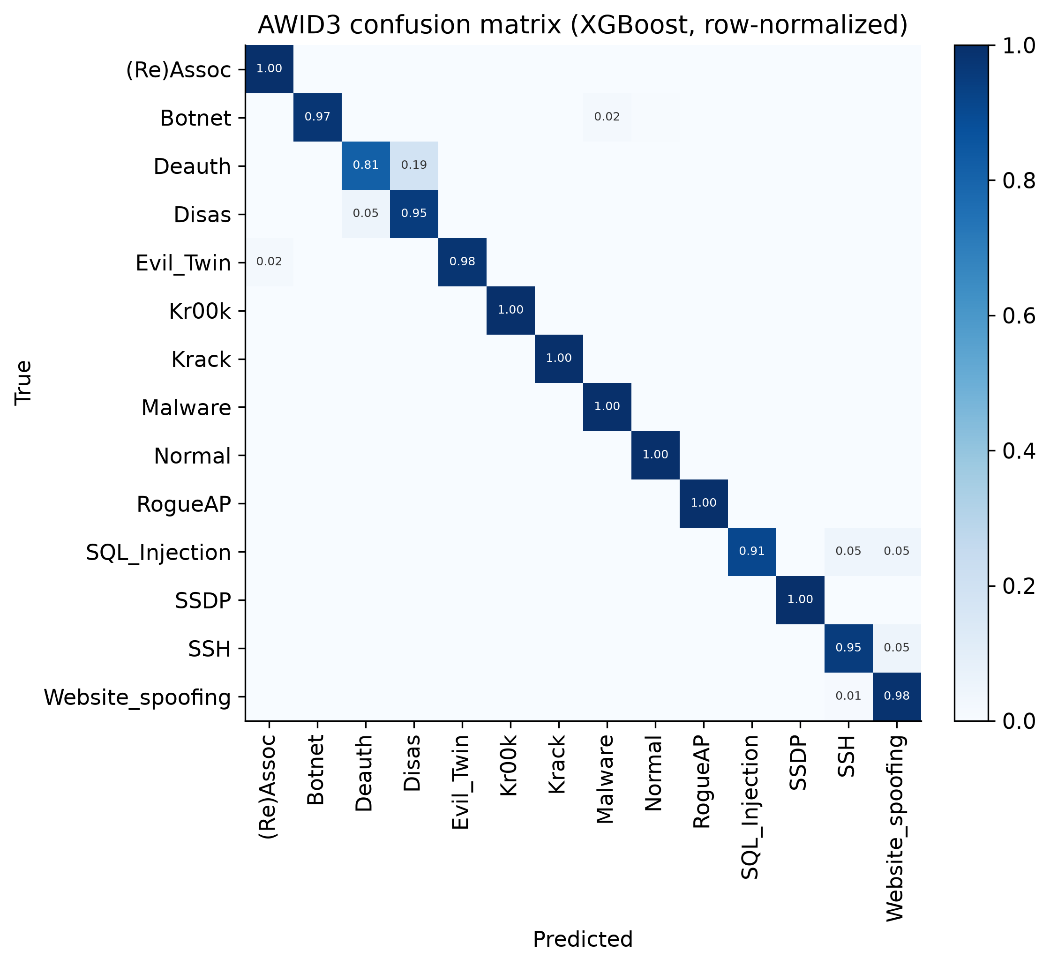
- FIGURE 2. Row-normalized confusion matrix (XGBoost). The dominant error is Deauth against Disas.

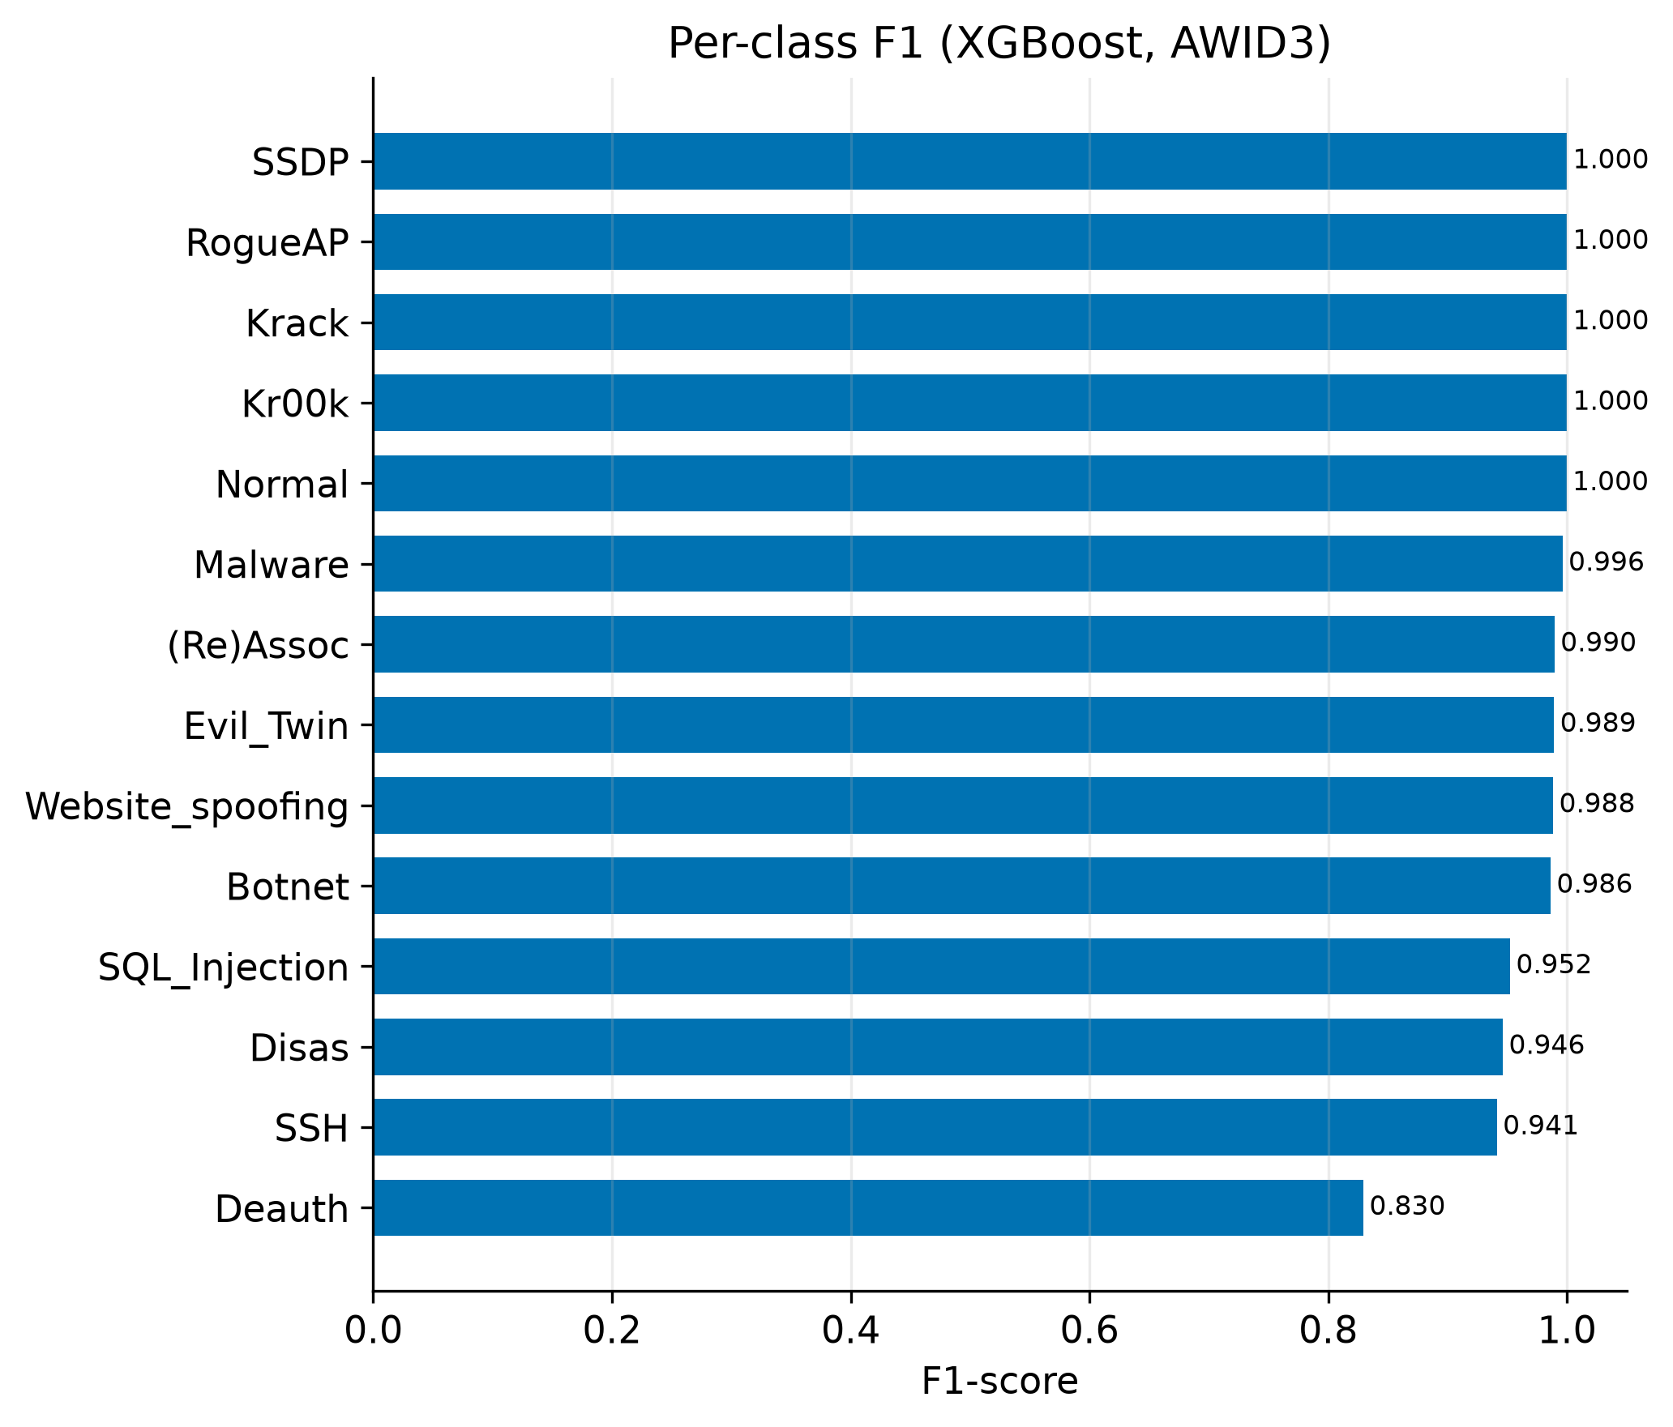
- FIGURE 3. Per-class F1. The smallest classes are hardest.
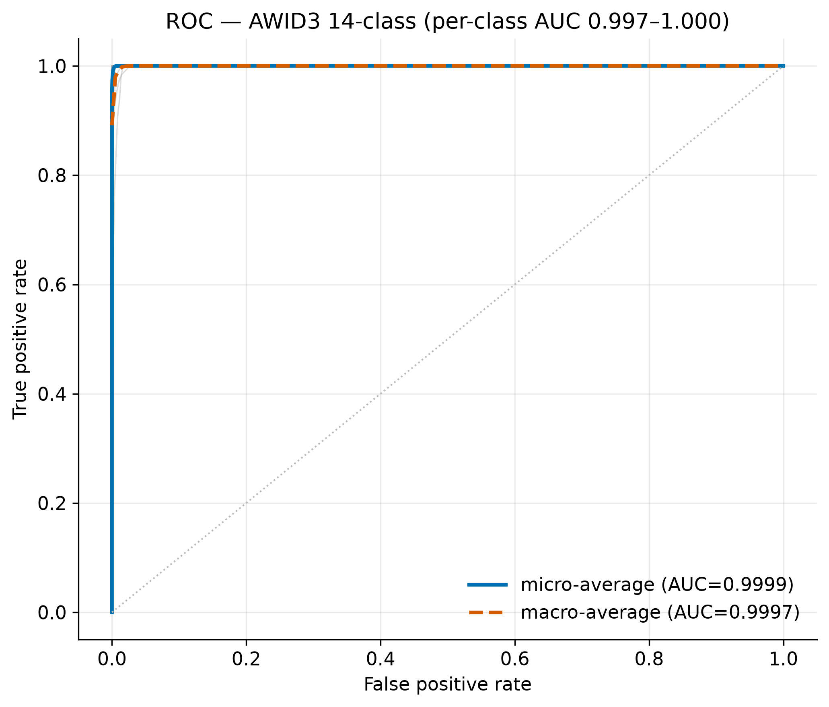
- FIGURE 4. One-vs-rest ROC curves for the fourteen classes; the macro-average AUC is 0.9998 (CV); held-out bootstrap mean 0.9997.
The top of the table is close to a statistical tie, and we tested that properly. A Friedman test across the models over repeated cross-validation folds rejects the null of equal performance (chi-square = 60.8, p < 10^-9), but the post-hoc Nemenyi test tells the subtler story. Figure 5 is the critical-difference diagram. LightGBM, XGBoost, the decision tree and gradient boosting share the top band and are statistically indistinguishable, while logistic regression, k-NN and the MLP sit well behind. A pairwise t-test agrees: XGBoost against Extra Trees at p = 0.35 and Random Forest at p = 0.13, with only the XGBoost-LightGBM gap grazing the 0.05 line at p = 0.029, and even that does not survive the conservative Wilcoxon test at p = 0.06. We bootstrap both macro-F1 and macro ROC-AUC on held-out predictions (1,000 resamples). Macro-F1 is 0.9728 with 95% CI [0.9658, 0.9793]; macro ROC-AUC is 0.9997 with 95% CI [0.9996, 0.9998], consistent with the five-fold CV means in Table 4. The reading is plain. Any of the leading models is a defensible pick, so the choice falls to latency and interpretability rather than to a fourth decimal of F1.
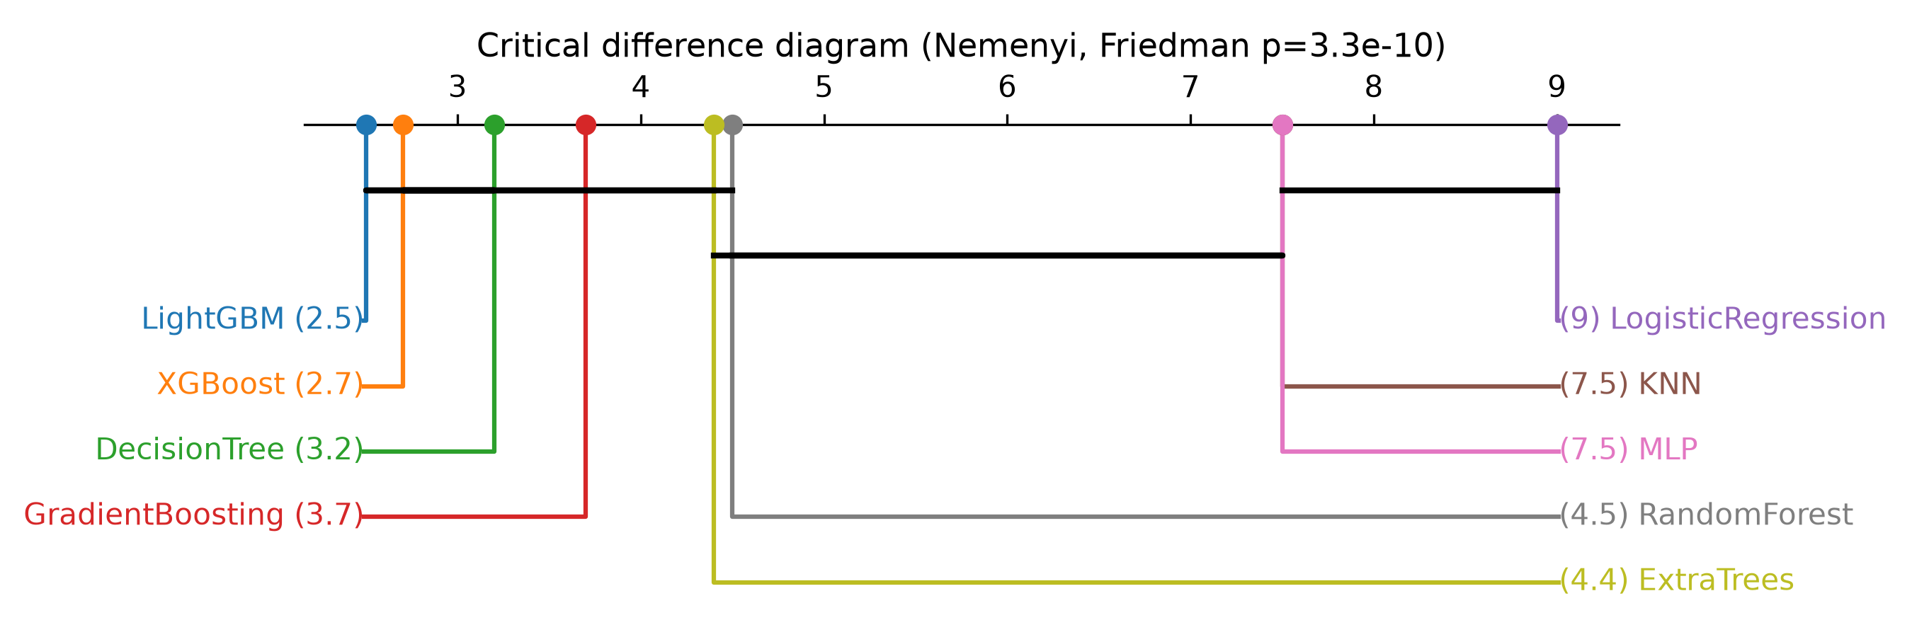
- FIGURE 5. Critical-difference diagram (Nemenyi post-hoc). Models joined by a bar are statistically indistinguishable; lower rank is better.
B. FEATURE IMPORTANCE AND ABLATION
The thirty-four features are not redundant. Figure 6 is their correlation matrix: apart from a few blocks of related radio fields, most pairs are weakly correlated, which is why the set survives variance and correlation filtering at forty rather than collapsing further. The consensus ranking is dominated by radio and frame descriptors: received signal strength, frame length, frame-control type and subtype, data rate and channel frequency. That matches the physical intuition that attacks perturb the radio and the management-frame statistics. Figure 7 lists the highest-ranked features. Figure 8 answers the obvious question of how many are truly needed. Macro-F1 climbs to 0.956±0.003 at fifteen features and 0.976±0.002 at twenty (5-fold CV); the full 34-feature set adds nothing measurable (Figure 8, with error bars in supplementary fig_ablation_cv_std.png). So forty is an upper bound we keep for completeness, and fifteen to twenty is the deployment size — a number the ablation sets, not a guess.
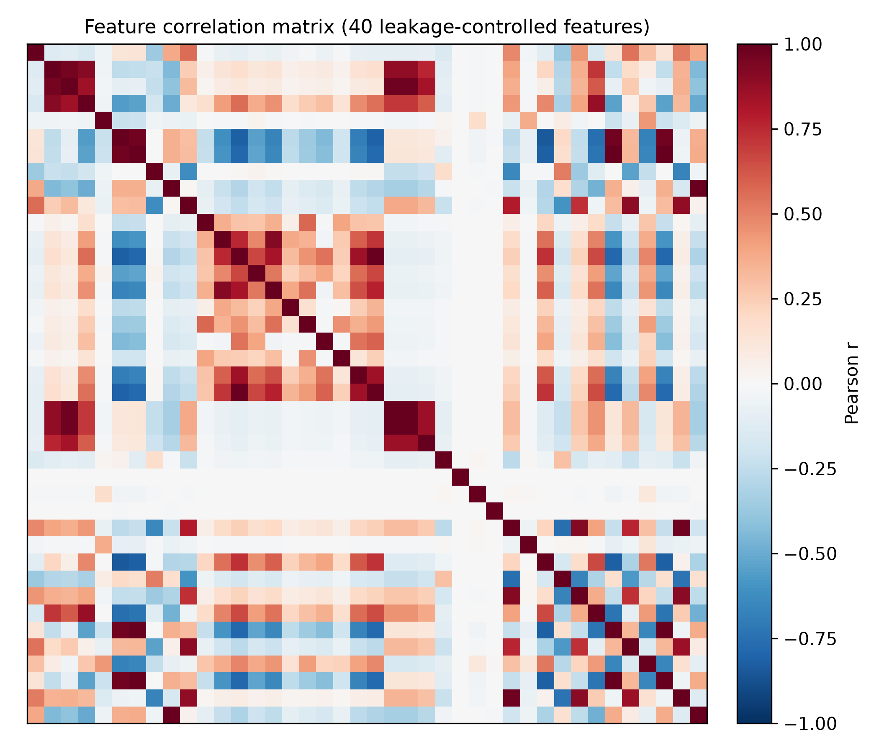
- FIGURE 6. Correlation matrix of the 34 leakage-controlled features; most pairs are weakly correlated.
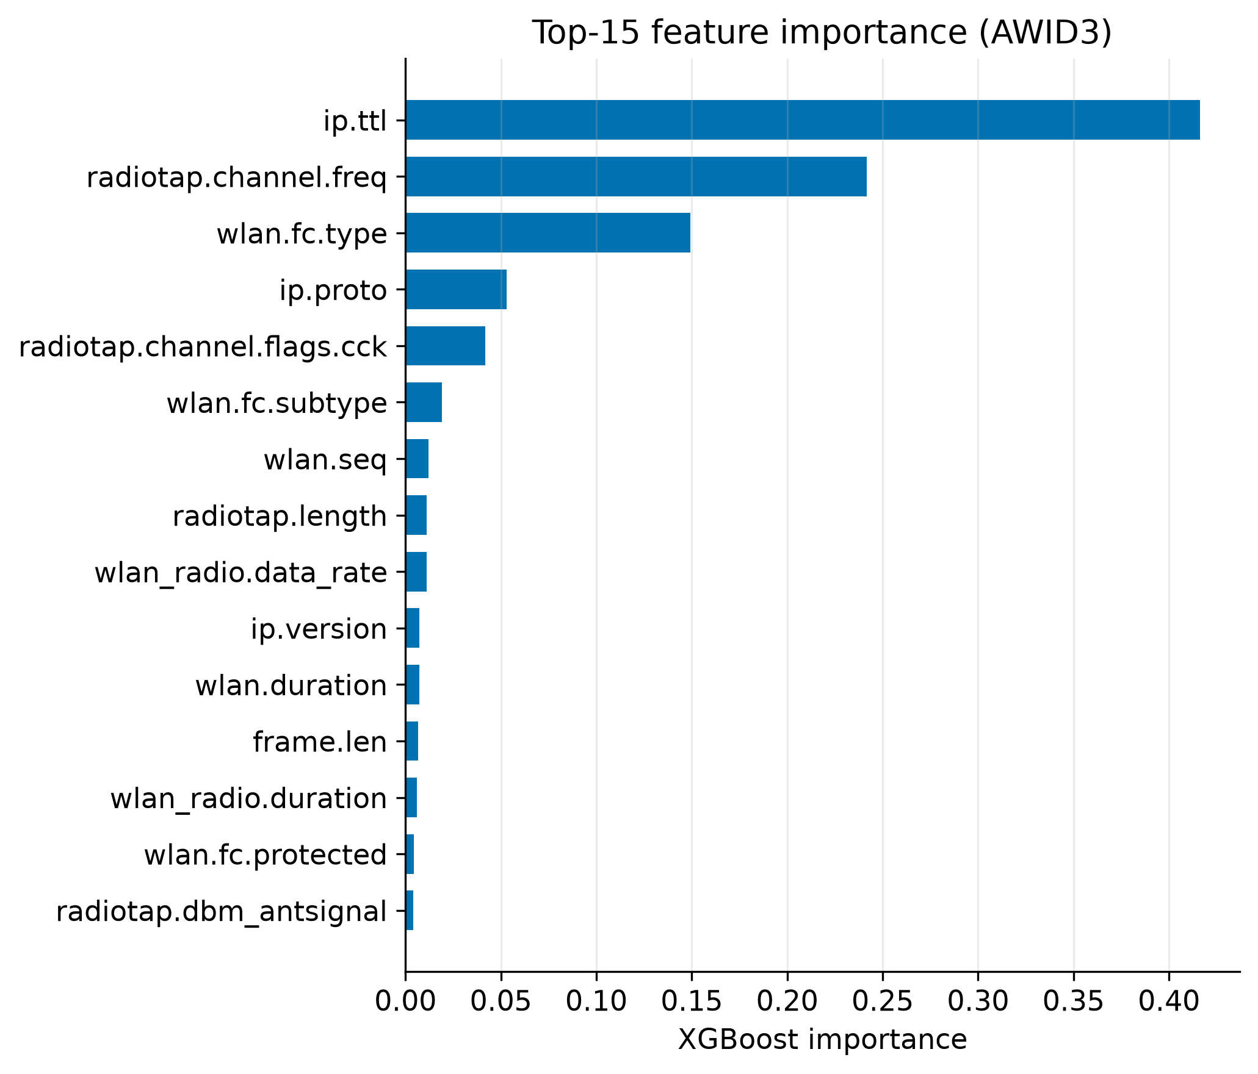
- FIGURE 7. Top-15 feature importance (XGBoost).
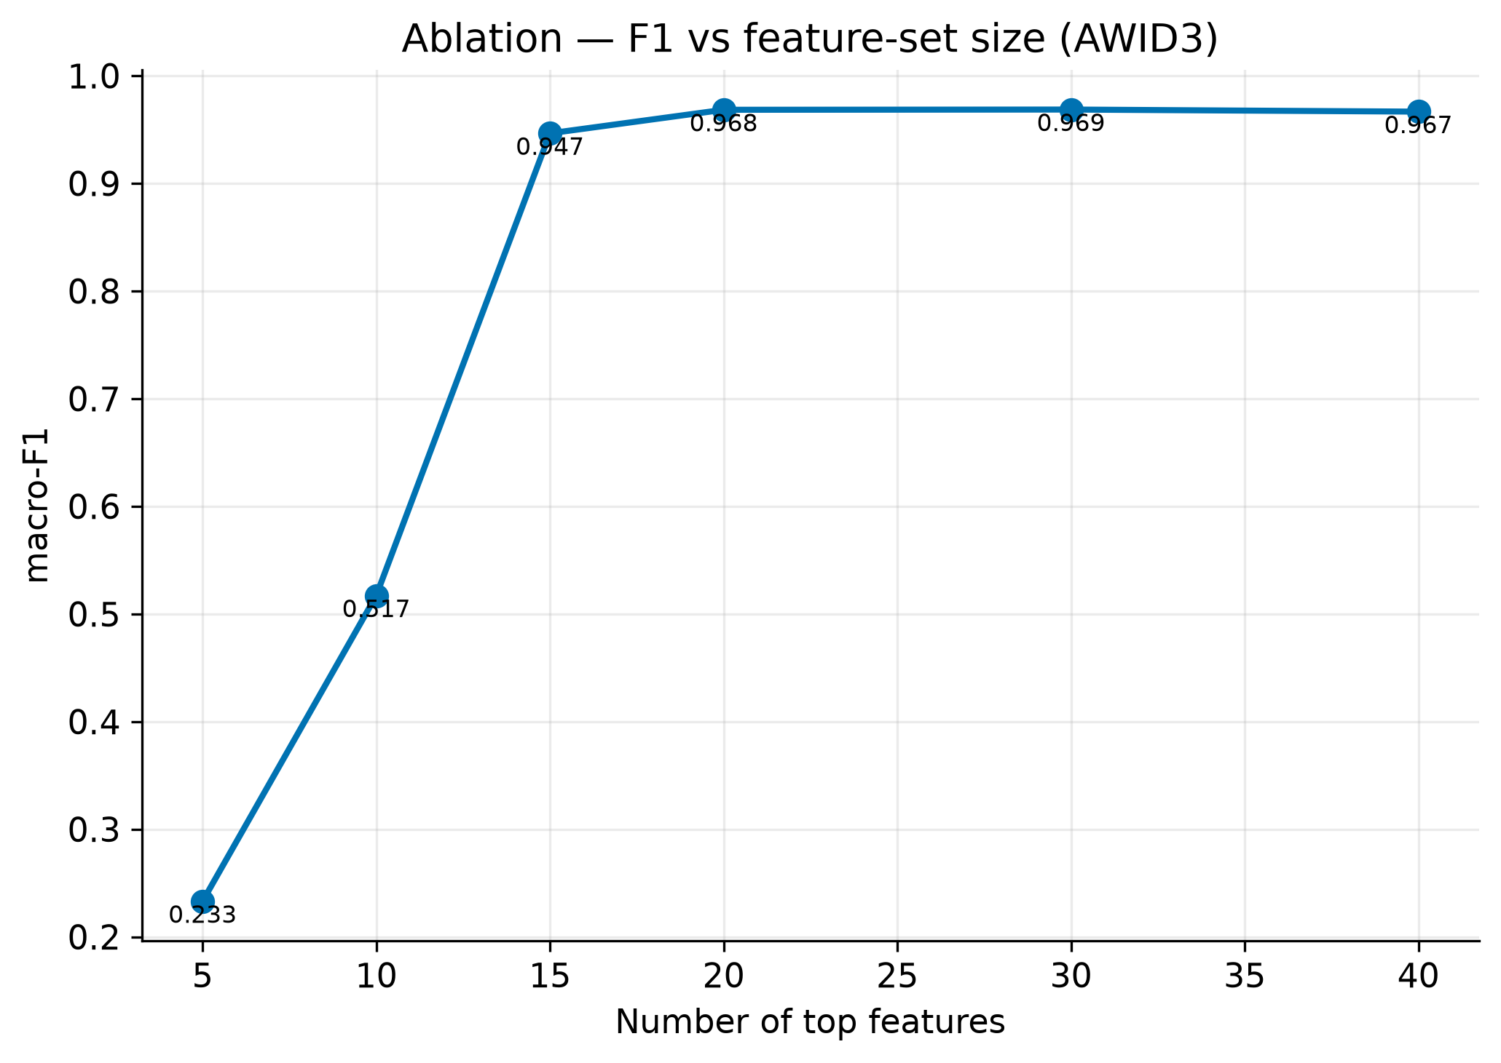
- FIGURE 8. Macro-F1 against the number of top-ranked features; the plateau arrives by about twenty.
C. DATA-LEAKAGE ANALYSIS
This is the core of the paper. We rebuilt a dataset from the full AWID3 archive using naive per-category sampling, then ran the same models on it. Table 5 shows what happened. Every model reached about 1.00 macro-F1 — logistic regression among them, at 0.998. That detail matters. A linear model cannot memorize complex patterns, so when it too scores near-perfect, the classes are being split by something trivially linear in the features. Restricting to the same 40 cleaned features changed nothing; the score stayed at 1.00. Only the curated subset, where benign and attack frames share the same captures, brought it down to the honest 0.976. The explanation is capture-environment leakage: attack rows and benign rows come from different sessions, so any feature that encodes the session separates them for free. The lesson is uncomfortable but useful. An AWID3 result quoted without leakage control may say more about the sampling than about the detector.

TABLE 5. Effect of the sampling/evaluation protocol on AWID3 performance.
Evaluation protocol | Features | Best macro-F1 | Interpretation
Full archive, naive per-category sampling | 95 | ~1.00 | Capture-environment leakage
Full archive, restricted to clean features | 34 | ~1.00 | Leakage persists — not feature-driven
Curated subset (same-capture interleave) | 34 | 0.976 | Honest, leakage-controlled baseline

Numbers can be argued with; a picture is harder to dismiss. Figures 9 and 10 project the same thirty-four clean features into two dimensions with t-SNE. Under the naive split (Figure 9) each class collapses into its own tidy island — the classifier is not recognising attacks so much as recognising capture sessions. Under the curated split (Figure 10) those same classes fragment and interleave, which is what honest 802.11 traffic looks like and why the score falls to 0.976. This is the leakage, made visible, and it holds even after every identifier column is stripped.
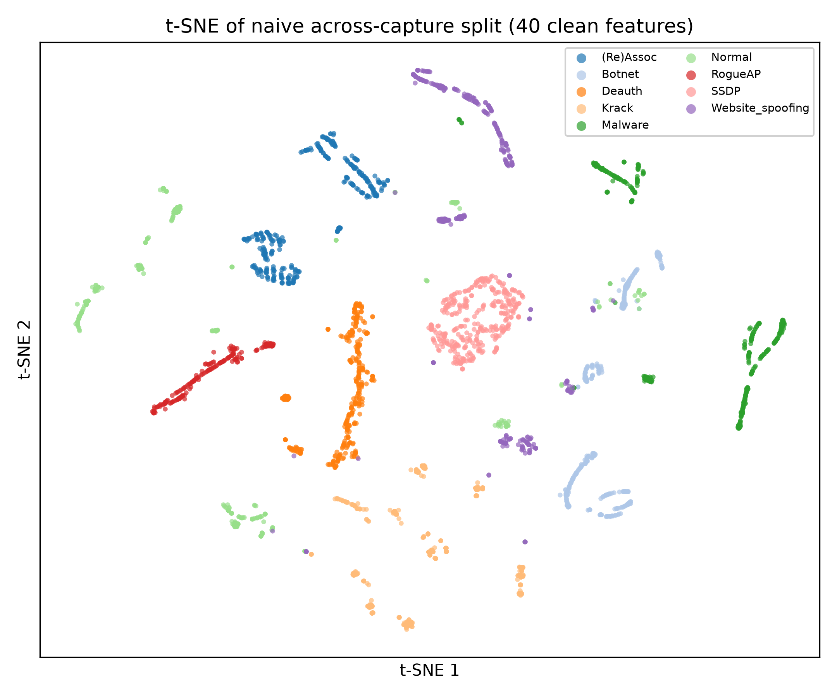
- FIGURE 9. t-SNE of the naive across-capture split (34 clean features): each class forms an isolated cluster - capture-environment leakage.
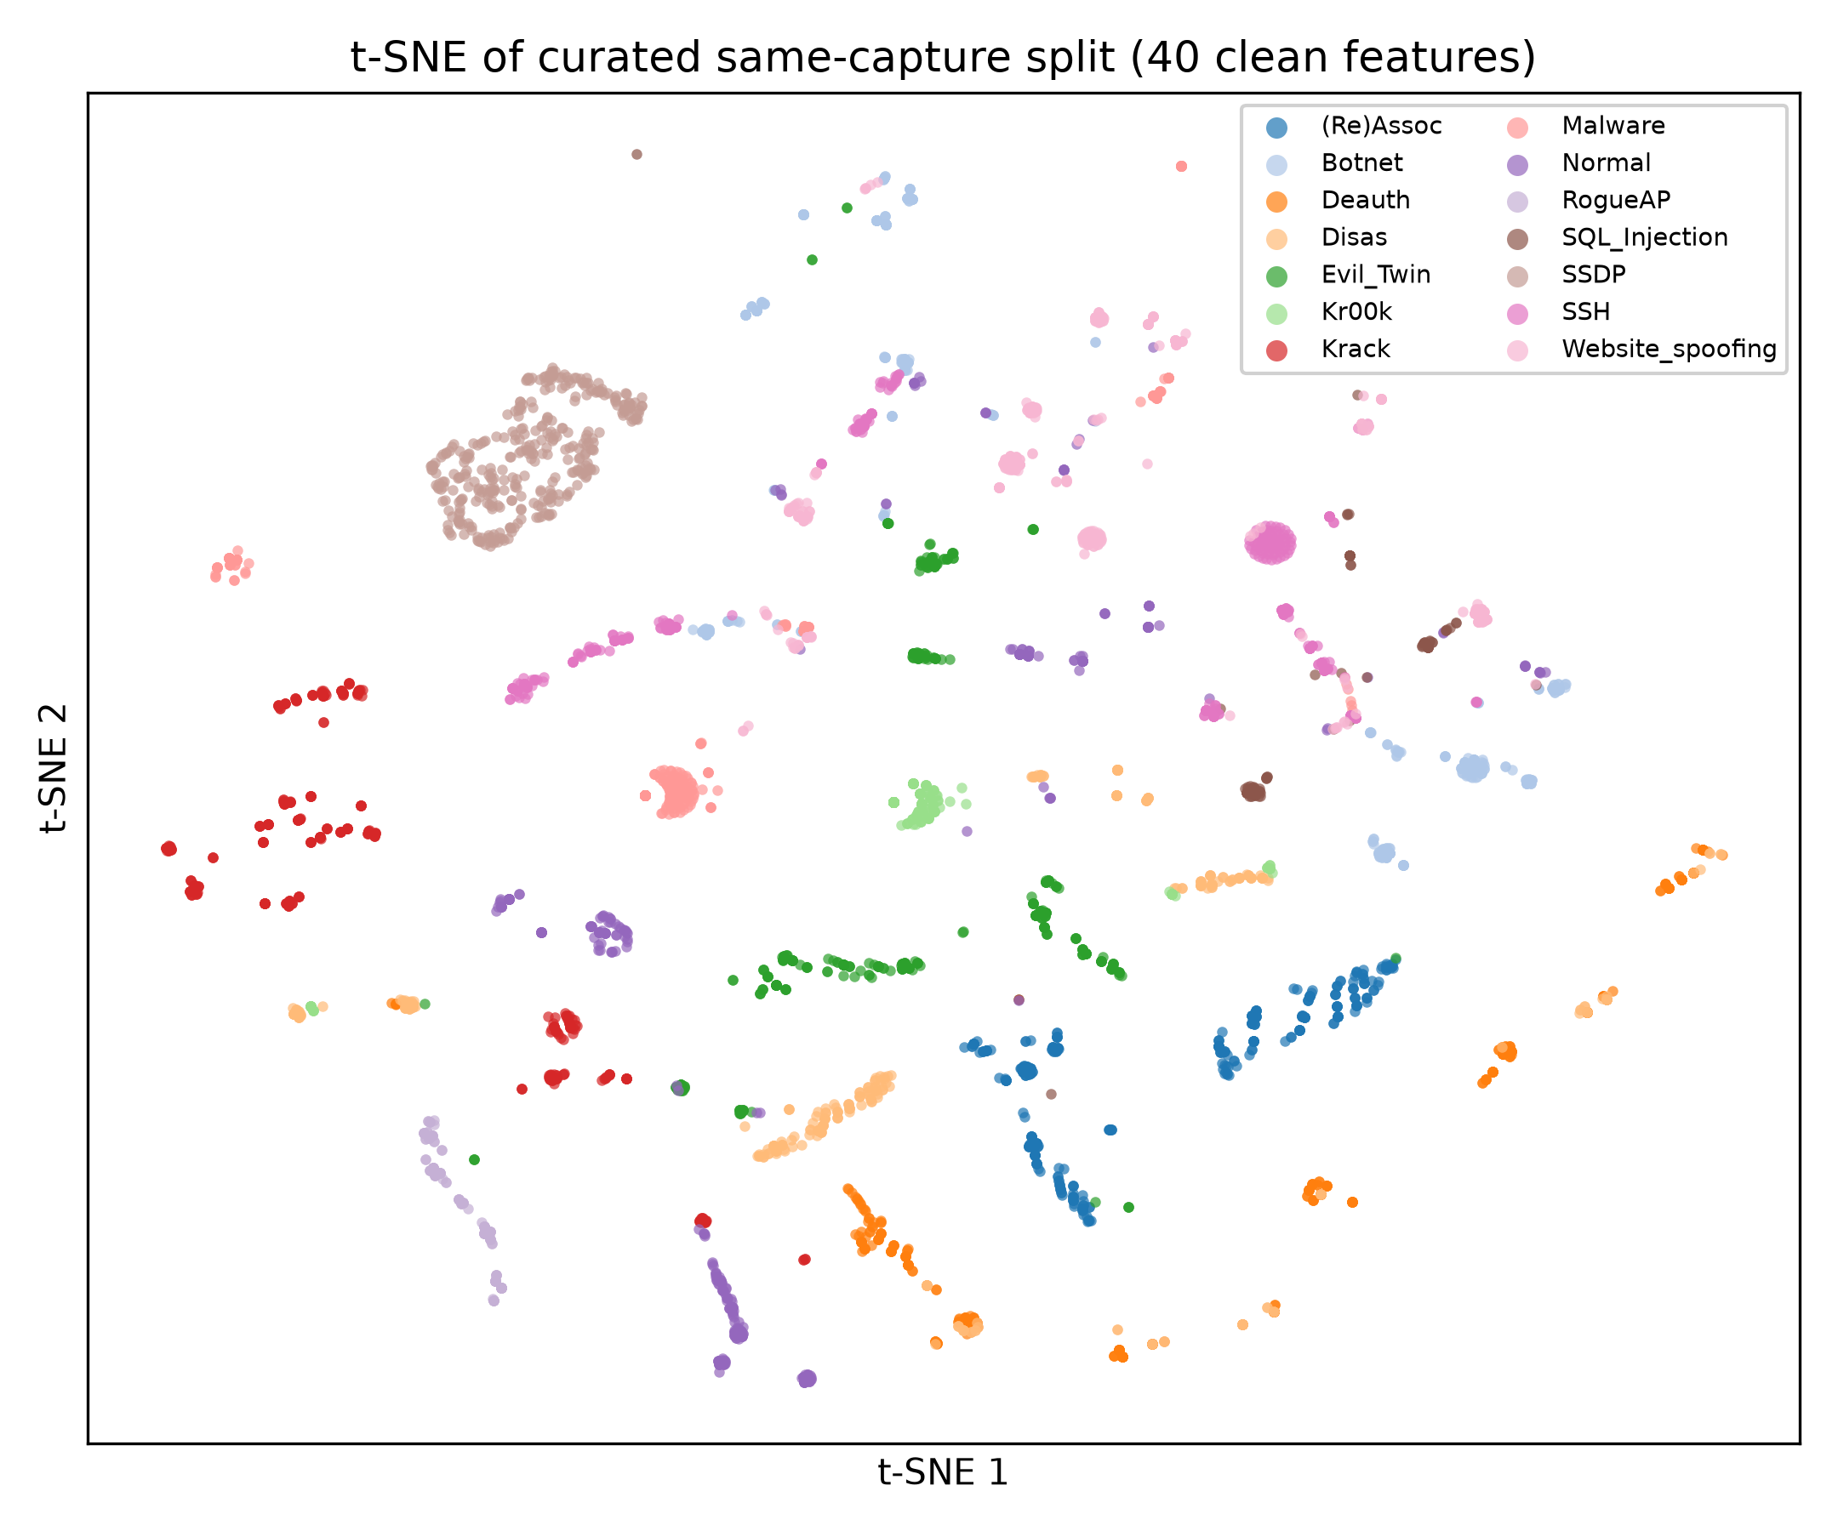
- FIGURE 10. t-SNE of the curated same-capture split: the same classes overlap and fragment - the honest picture.
C2) LEAKAGE SOURCE ATTRIBUTION. t-SNE shows cluster separation under naive sampling, but not which features carry the signal. We therefore ran leave-one-feature-group-out and permutation-importance analyses on the naive across-capture split (logistic regression, 3-fold CV; n=25,000 stratified sample). Removing the radio group (RSSI, channel, rate) drops macro-F1 from 0.9988 to 0.9798 (Δ=0.0190), while the same removal on the curated same-capture split changes performance in the opposite direction — radio then encodes attack behaviour, not capture identity. Permutation importance on the naive split ranks radiotap.dbm_antsignal first (mean ΔF1=0.2315), confirming that capture-environment fields — not attack semantics alone — drive the inflated scores. Figure 13 summarises the group ablation.
FIGURE 13. Leave-one-feature-group-out macro-F1 on naive vs curated splits (LR, 3-fold CV).
D. UNSEEN-ATTACK (UNSUPERVISED) DETECTION
Trained on benign traffic only, the detectors flag attacks never seen in training (Table 6). The autoencoder is strongest, at 0.991 ROC-AUC with about 92 percent detection at a five-percent false-positive rate. With fourteen thousand benign training windows the operating point is well calibrated. The per-attack breakdown is honest about difficulty. Flooding and protocol attacks are caught at nearly 100 percent, while web-layer website spoofing, which resembles benign traffic, is caught only 43 percent of the time.

TABLE 6. Unseen-attack detection (trained on benign traffic only).
Detector | ROC-AUC | Detection % | False-positive %
Autoencoder | 0.991 | 92 | 4.8
Variational AE | 0.978 | 89 | 5.0
One-Class SVM | 0.946 | 88 | 5.1
Deep SVDD | 0.891 | 69 | 5.3
Isolation Forest | 0.855 | 55 | 4.9

The procedure behind those numbers is deliberately strict. Algorithm 3 never lets an attack sample touch training. Each detector learns the shape of benign traffic, we fix its threshold on benign data alone at a five-percent false-positive budget, and only then do attacks appear, at test time. That is what makes the result a fair proxy for a genuine unseen-attack.

Algorithm 3 Unsupervised unseen-attack detection with a calibrated threshold
Input : benign windows X_b; held-out mix X_test (benign + unseen attacks); target FPR alpha
Output: per-detector ROC-AUC and detection rate at alpha
1 for each detector g in {IsolationForest, OneClassSVM, AutoEncoder, VAE, DeepSVDD} do
2 fit g on X_b only // benign traffic, no attack labels
3 s_b <- anomaly_score(g, X_b)
4 tau <- quantile(s_b, 1 - alpha) // 95th percentile of benign scores (~5% FPR on X_b)
5 AUC[g] <- ROC-AUC(g, X_test)
6 det[g] <- P( anomaly_score(g, x) > tau | x is attack )
7 end for
8 return AUC, det // autoencoder best: AUC 0.991, det ~92% at 4.8% FPR

E. EXPLAINABILITY
SHAP reasoning reports make each verdict auditable. The influential features line up with domain knowledge. SSDP detections are driven by UDP destination port, IP TTL and UDP length. KRACK is driven by channel, frequency and frame-control subtype. Evil-Twin turns on the protected-frame flag, and benign traffic on the frame-control type. The explanations also reflect the model's mistakes faithfully; for a misclassified deauthentication window the top drivers are shared with disassociation, exactly as the confusion matrix would predict. Figure 11 gives the global beeswarm view. Figures 14–16 add local bar explanations for Normal, Krack and Deauth windows (true labels), showing class-specific drivers rather than aggregate patterns alone. Explanation adds operator value without contradicting the numbers.
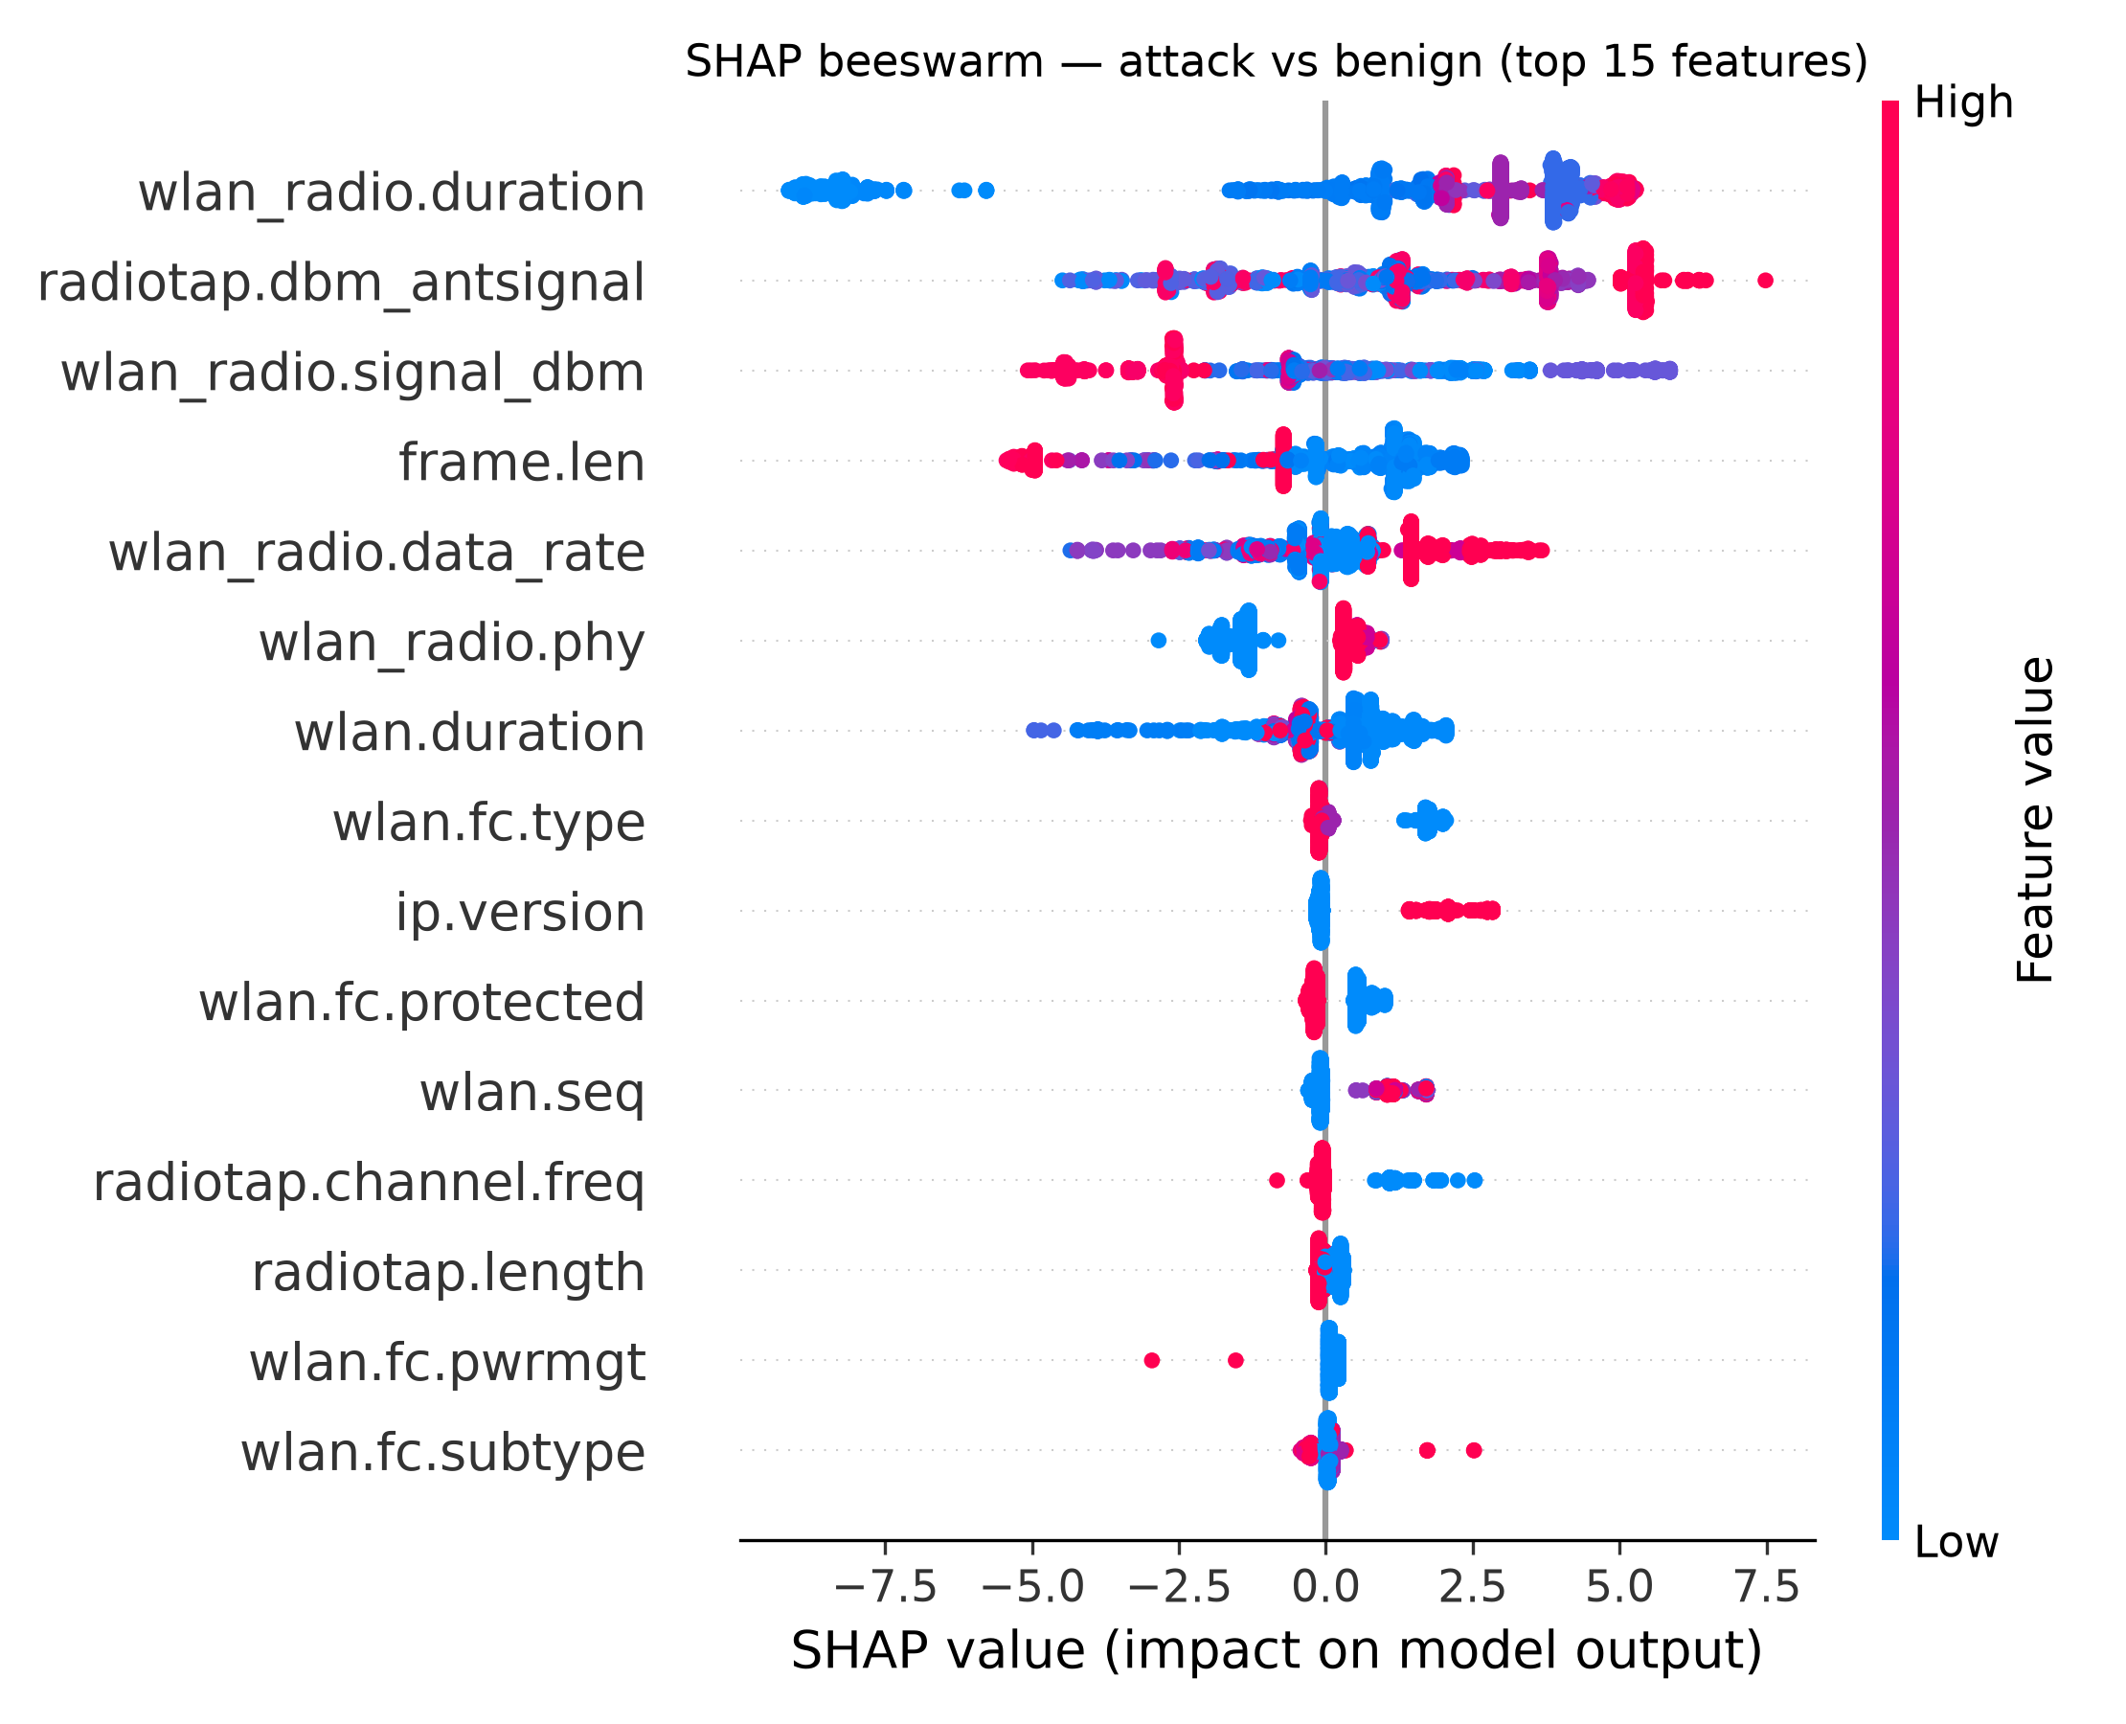
- FIGURE 11. SHAP beeswarm for the attack-versus-benign decision (top 15 features); colour is feature value, position is push toward attack.
FIGURE 14. Local SHAP explanation — Normal traffic.
FIGURE 15. Local SHAP explanation — Krack.
FIGURE 16. Local SHAP explanation — Deauth.
F. INFERENCE EFFICIENCY
Efficiency decides whether a detector is usable, so we measured it rather than asserted it. Classification is cheap: on CPU the best model scores a feature vector in well under a microsecond in bulk, and Table 4 lists the per-sample latency for each model. Figure 12 puts that in context. The real per-window cost is feature extraction, near 0.7 ms for a forty-frame window, while the model itself is an order of magnitude cheaper. In other words the classifier is never the bottleneck, and the whole per-window budget stays comfortably inside real time for a streaming deployment. We report these numbers on purpose; they are usually left out of the 802.11 IDS literature.
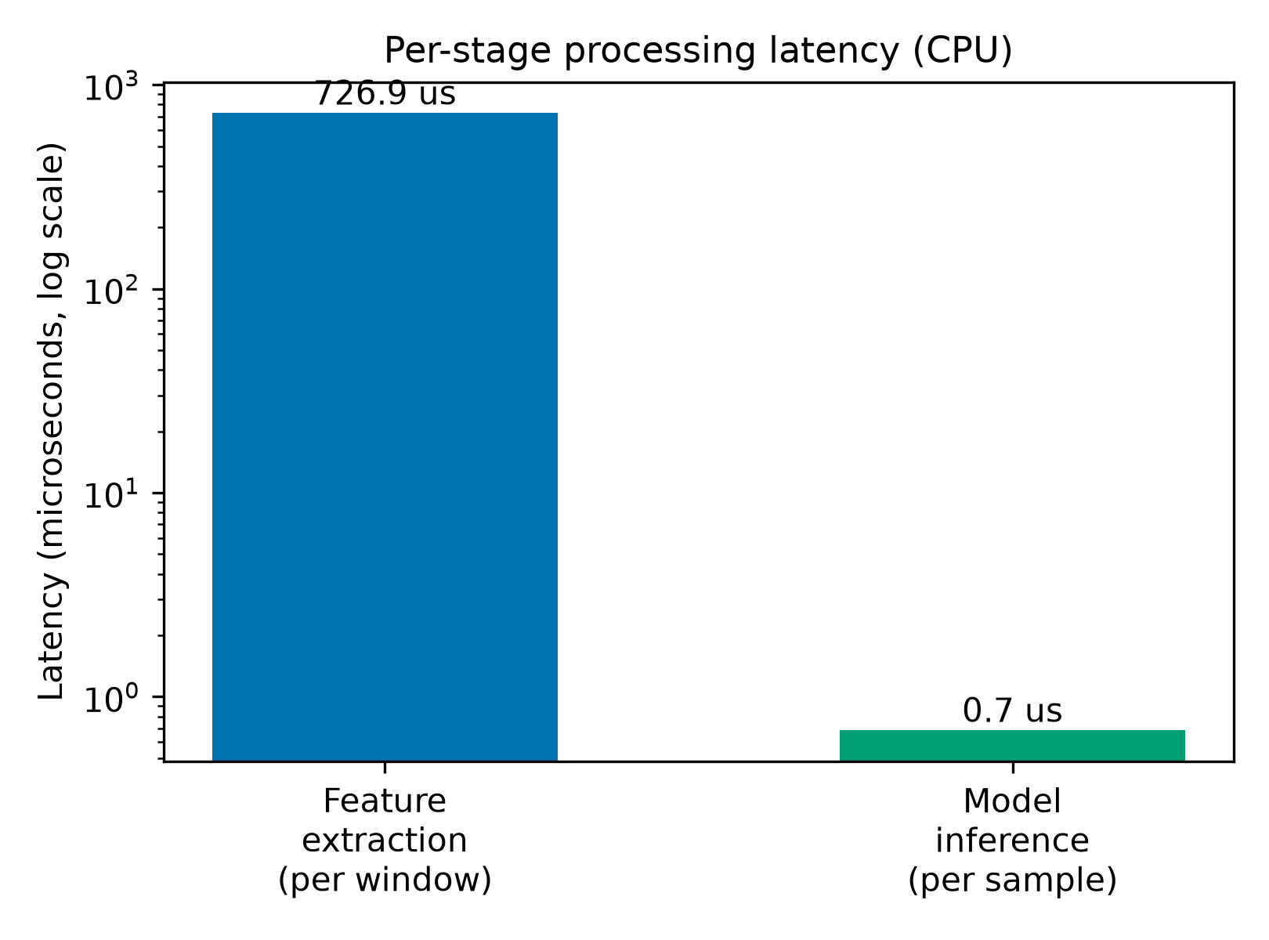
- FIGURE 12. Per-stage CPU latency (log scale): feature extraction over a 40-frame window dominates; classification is negligible.
VII. DISCUSSION
A. NOVELTY AND POSITIONING
The contribution here is mostly about method, not a new record. Much of the AWID3 literature optimizes for the highest number. We did the reverse. We isolated a mechanism that can manufacture such numbers, measured it, and then reported what remains once it is removed. What remains is still strong, and it is explainable and fast. Two things set the work apart. One is the leakage analysis itself. The other is a plain-language explanation attached to every detection. Neither is common in 802.11-specific research, and both matter to anyone who has to defend a deployed detector.
B. PIPELINE PORTABILITY (SECONDARY)
The preprocessing front end — automatic label resolution, identifier and constant-column removal, then the same benchmark suite — is dataset-agnostic. As a secondary sanity check (not evidence for 802.11 generalisation), we ran the same workflow on two wired flow corpora, CIC-IDS-2017 and CSE-CIC-IDS2018. These traces differ in modality, feature space and label semantics from AWID3; Table 7 therefore shows pipeline portability only. Boosted trees again lead (0.982 and 0.902 macro-F1), which supports reproducibility of the tooling but does not substitute for cross-wireless validation (e.g., AWID2) or live traffic.

TABLE 7. Pipeline portability on wired flow corpora (stratified CV). Not a wireless generalisation claim.
Dataset | Type | Rows (sampled) | Best model | macro-F1 | ROC-AUC
AWID3 (curated) | 802.11 wireless | 74,270 | XGBoost | 0.976 | 0.9998
CIC-IDS-2017 | wired IP flows | 24,000 | XGBoost | 0.982 | 0.9999
CSE-CIC-IDS2018 | wired IP flows | 100,000 | LightGBM | 0.902 | 0.965

C. DEPLOYMENT CHALLENGES
A model that scores well offline still has to survive contact with a live network, and three problems deserve naming. The first is concept drift. Traffic changes with new applications, new devices and seasonal patterns, and a detector frozen at training time slowly goes stale; the benign-only autoencoder and periodic re-training in our platform are a partial answer, but explicit drift monitoring is future work. The second is new hardware. A previously unseen access point, or a firmware update on an existing one, can shift the radio fingerprint enough to raise false positives, so a short per-site re-calibration window is prudent before enforcement is switched on. The third is the moving target of the standard. WPA3 is still rolling out and WPA4 will follow; each brings new handshakes and new attacks — our KRACK and Kr00k classes are only today's examples — so the feature set and the label space will have to grow with it. None of these is unique to our approach, but a detector meant for real 802.11 networks has to plan for all three.
D. LIMITATIONS AND THREATS TO VALIDITY
Evaluation scope. The wireless evaluation rests on a single corpus, AWID3, and its curated subset, though leakage-controlled, is one testbed. Section VII-B shows the pipeline runs on wired flow datasets as a portability check, but cross-wireless-dataset validation remains the highest-priority extension: AWID2 would directly test whether capture-environment leakage generalises beyond AWID3, but was not available for this study; live traffic validation is likewise future work.
Class imbalance. Several attack classes are small, with tens to a few hundred samples, which limits confidence in their per-class metrics.
Hardware. Experiments are CPU-only and were not GPU-tuned. The hybrid deep model trails boosted trees on this tabular task (Appendix B), a known pattern for structured 802.11 features.
Full-archive protocol. A same-capture sampling of the full archive — which would exploit its scale without leakage — is identified but not implemented here.
VIII. CONCLUSION AND FUTURE WORK
We studied machine-learning intrusion detection for IEEE 802.11 through a leakage-aware lens. Naive sampling of the full AWID3 corpus produces capture-environment leakage, and with it near-perfect scores that do not mean what they appear to mean. Under a controlled protocol the honest picture emerges: 0.976 macro-F1 and 0.9998 ROC-AUC across fourteen classes, an autoencoder that catches unseen attacks at 0.991 ROC-AUC, SHAP explanations that line up with what analysts expect, a working set of fifteen to twenty features, and inference in microseconds. The same pipeline, applied unchanged to the wired CIC-IDS-2017 and CSE-CIC-IDS2018 flow datasets, reaches 0.982 and 0.902 macro-F1, which indicates the tooling is portable, not that wireless conclusions transfer to wired flow data. None of this required hiding the hard cases. Deauthentication still blurs into disassociation, and web-layer spoofing still resists anomaly detection, and the paper says so. Next we will sample the full archive within captures, so its scale can be used without leakage; extend the graph and multi-sensor parts to live traces; and test the whole system on real deployments.
REPRODUCIBILITY
Source code: https://github.com/ruhitas/awid3-leakage-aware-ids
Archive (Zenodo DOI at camera-ready): https://zenodo.org/ (DOI to be minted at camera-ready)
Feature list: config/leakage_controlled_features.txt (34 fields).
Preprocessing, models, explainers and figure scripts are released with the configuration, the leakage-control feature policy and the exact 34-feature list. A fixed random seed (42) and build_awid3.py reproduce the 74,270-row evaluation set.

DATA AVAILABILITY
All datasets used here are public. AWID3 is due to Chatzoglou et al. [3] and is available at https://icsdweb.aegean.gr/awid/ (Kaggle mirror: https://www.kaggle.com/datasets/suumia/awid3-dataset). The generalization study of Section VII-B uses CIC-IDS-2017 (https://www.kaggle.com/datasets/chethuhn/network-intrusion-dataset) and CSE-CIC-IDS2018 (https://www.kaggle.com/datasets/solarmainframe/ids-intrusion-csv), both produced by the Canadian Institute for Cybersecurity, University of New Brunswick.
REFERENCES
APPENDIX A. LEAKAGE-CONTROLLED FEATURE SET (34 FIELDS)
The count is not hand-tuned: 254 AWID3 numeric fields minus policy-defined leaky columns minus all-zero columns in the curated 74,270-row build yields exactly 34.
Table A1 lists the exact fields retained after the policy in Section IV-A.
TABLE A1. Thirty-four leakage-controlled AWID3 per-frame features.
[1] M. Vanhoef and F. Piessens, “Key reinstallation attacks: Forcing nonce reuse in WPA2,” in Proc. ACM SIGSAC Conf. Comput. Commun. Security (CCS), 2017, pp. 1313–1328.
[2] C. Kolias, G. Kambourakis, A. Stavrou, and S. Gritzalis, “Intrusion detection in 802.11 networks: Empirical evaluation of threats and a public dataset,” IEEE Commun. Surveys Tuts., vol. 18, no. 1, pp. 184–208, 2016, doi: 10.1109/COMST.2015.2402161.
[3] E. Chatzoglou, G. Kambourakis, and C. Kolias, “Empirical evaluation of attacks against IEEE 802.11 enterprise networks: The AWID3 dataset,” IEEE Access, vol. 9, pp. 34188–34205, 2021.
[4] E. Chatzoglou, G. Kambourakis, C. Kolias, and C. Smiliotopoulos, “Pick quality over quantity: Expert feature selection and data preprocessing for 802.11 intrusion detection systems,” IEEE Access, vol. 10, pp. 64761–64784, 2022.
[5] S. M. Kasongo and Y. Sun, “A deep learning method with wrapper based feature extraction for wireless intrusion detection system,” Computers & Security, vol. 92, art. 101752, 2020, doi: 10.1016/j.cose.2020.101752.
[6] N. Khalid, S. Hina, K. S. Zaidi, T. Gaber, L. Speakman, and Z. Noor, “An investigation of feature reduction, transferability, and generalization in AWID datasets for secure Wi-Fi networks,” PLoS ONE, 2025.
[7] S. Wang and B. Li, “Intrusion detection for WiFi network: A deep learning approach,” in Proc. 11th EAI Int. Conf. Wireless Internet (WiCON 2018), LNICST, Springer, pp. 95–104, 2019.
[8] S. M. Kasongo and Y. Sun, “A deep long short-term memory based classifier for wireless intrusion detection system,” ICT Express, vol. 6, no. 2, 2020, doi: 10.1016/j.icte.2019.08.004.
[9] V. L. L. Thing, “IEEE 802.11 network anomaly detection and attack classification: A deep learning approach,” in Proc. IEEE Wireless Commun. Netw. Conf. (WCNC), 2017.
[10] P. Satam and S. Hariri, “WIDS: An anomaly-based intrusion detection system for Wi-Fi (IEEE 802.11) protocol,” IEEE Trans. Netw. Service Manag., vol. 18, no. 1, 2021, doi: 10.1109/TNSM.2020.3036138.
[11] L. M. da Silva, V. M. Andreghetti, R. A. F. Romero, and K. R. L. J. C. Branco, “Analysis and identification of Evil Twin attack through data science techniques using the AWID3 dataset,” 2023, doi: 10.1145/3635638.3635665.
[12] Z. Salah and E. Abu Elsoud, “Enhancing network security: A machine-learning-based approach for detecting and mitigating KRACK and Kr00k attacks in IEEE 802.11,” Future Internet, vol. 15, no. 8, art. 269, 2023, doi: 10.3390/fi15080269.
[13] M. E. Aminanto and K. Kim, “Improving detection of Wi-Fi impersonation by fully unsupervised deep learning,” in Proc. Int. Workshop Inf. Security Appl. (WISA), 2018, doi: 10.1007/978-3-319-93563-8_18.
[14] A. Agrawal, U. Chatterjee, and R. Maiti, “CheckShake: Passively detecting anomaly in Wi-Fi security handshake using gradient boosting based ensemble learning,” IEEE Trans. Dependable Secure Comput., 2023, doi: 10.1109/TDSC.2023.3236355.
[15] M. E. Aminanto, R. Choi, H. C. Tanuwidjaja, P. D. Yoo, and K. Kim, “Deep abstraction and weighted feature selection for Wi-Fi impersonation detection,” IEEE Trans. Inf. Forensics Security, vol. 13, 2018, doi: 10.1109/TIFS.2017.2762828.
[16] S. M. Kasongo and Y. Sun, “A deep learning method with filter based feature engineering for wireless intrusion detection system,” IEEE Access, vol. 7, 2019, doi: 10.1109/ACCESS.2019.2905633.
[17] J. Ran, Y. Ji, and B. Tang, “A semi-supervised learning approach to IEEE 802.11 network anomaly detection,” in Proc. IEEE Veh. Technol. Conf. (VTC-Spring), 2019, doi: 10.1109/VTCSpring.2019.8746576.
[18] S. Solpan, H. Gündüz, K. Küçük, and F. Özyurt, “A hybrid feature fusion approach for multiclass Wi-Fi intrusion detection using classical machine learning,” Int. J. Inf. Secur., 2026, doi: 10.1007/s10207-026-01224-2.
[19] S. Solpan, H. Gündüz, and K. Küçük, “Wi-Fi network intrusion detection: Enhanced with feature extraction and machine learning algorithms,” in Proc. 8th Int. Artif. Intell. Data Process. Symp. (IDAP), 2024, doi: 10.1109/IDAP64064.2024.10710685.
[20] H. Jiang, Y. Yan, and X. Li, “Temporal context-enhanced wireless intrusion detection: Boosting recall for hard-to-detect attacks,” in Proc. IEEE Int. Conf. Blockchain Technol. Inf. Secur. (ICBCTIS), 2025, doi: 10.1109/ICBCTIS66509.2025.11387671.
[21] M. Thankappan, H. Rifà-Pous, and C. Garrigues, “A signature-based wireless intrusion detection system framework for multi-channel man-in-the-middle attacks against protected Wi-Fi networks,” IEEE Access, 2024, doi: 10.1109/ACCESS.2024.3362803.
[22] S. M. Trisha, S. Islam, and M. Hossen, “Performance evaluation of deep learning techniques for wireless intrusion detection system: A comparative feature selection approach,” in Proc. 27th Int. Conf. Comput. Inf. Technol. (ICCIT), 2024, doi: 10.1109/ICCIT64611.2024.11022476.
[23] C. Hamroun, A. Fladenmuller, M. Pariente, and G. Pujolle, “Enriching the assessment of neural network-based wireless intrusion detection systems: A case study on Wi-Fi networks,” in Proc. Cyber Secur. Netw. Conf. (CSNet), 2025, doi: 10.1109/CSNet67572.2025.11288215.
[24] P. Phalaagae, A. M. Zungeru, A. Yahya, B. Sigweni, and S. Rajalakshmi, “A hybrid CNN-LSTM model with attention mechanism for improved intrusion detection in wireless IoT sensor networks,” IEEE Access, 2025, doi: 10.1109/ACCESS.2025.3555861.
[25] S. M. Lundberg and S.-I. Lee, “A unified approach to interpreting model predictions,” in Proc. Adv. Neural Inf. Process. Syst. (NeurIPS), 2017, pp. 4765–4774.
[26] M. A. Ceylan, İ. F. Kılınçer, and F. Ertam, “CNN based cyber defense architecture for 802.11 networks,” Erciyes Univ. J. Inst. Sci. Technol., vol. 42, no. 2, pp. 581–599, 2026, doi: 10.65520/erciyesfen.1934250.
[27] T. Chen and C. Guestrin, “XGBoost: A scalable tree boosting system,” in Proc. 22nd ACM SIGKDD Int. Conf. Knowl. Discovery Data Mining, 2016, pp. 785–794.
[28] G. Ke et al., “LightGBM: A highly efficient gradient boosting decision tree,” in Proc. NeurIPS, 2017, pp. 3146–3154.
[29] F. Pedregosa et al., “Scikit-learn: Machine learning in Python,” J. Mach. Learn. Res., vol. 12, pp. 2825–2830, 2011.
[30] A. Vaswani et al., “Attention is all you need,” in Proc. NeurIPS, 2017, pp. 5998–6008.
[31] F. T. Liu, K. M. Ting, and Z.-H. Zhou, “Isolation forest,” in Proc. 8th IEEE Int. Conf. Data Mining (ICDM), 2008, pp. 413–422.
[32] D. P. Kingma and M. Welling, “Auto-encoding variational Bayes,” in Proc. Int. Conf. Learn. Representations (ICLR), 2014.
[33] L. Ruff et al., “Deep one-class classification,” in Proc. 35th Int. Conf. Mach. Learn. (ICML), 2018, pp. 4393–4402.
TABLE A1. Thirty-four leakage-controlled AWID3 per-frame features.
# | Feature name
1 | frame.len
2 | ip.proto
3 | ip.ttl
4 | ip.version
5 | radiotap.channel.flags.cck
6 | radiotap.channel.flags.ofdm
7 | radiotap.channel.freq
8 | radiotap.datarate
9 | radiotap.dbm_antsignal
10 | radiotap.length
11 | tcp.checksum.status
12 | tcp.dstport
13 | tcp.flags.fin
14 | tcp.flags.push
15 | tcp.flags.syn
16 | tcp.srcport
17 | udp.dstport
18 | udp.length
19 | udp.srcport
20 | wlan.duration
21 | wlan.fc.frag
22 | wlan.fc.moredata
23 | wlan.fc.order
24 | wlan.fc.protected
25 | wlan.fc.pwrmgt
26 | wlan.fc.retry
27 | wlan.fc.subtype
28 | wlan.fc.type
29 | wlan_radio.channel
30 | wlan_radio.data_rate
31 | wlan_radio.duration
32 | wlan_radio.frequency
33 | wlan_radio.phy
34 | wlan_radio.signal_dbm
APPENDIX B. HYBRID CNN+TRANSFORMER (SUPPLEMENTARY)
The hybrid model is reported separately because deep training is evaluated on the stratified 75/25 hold-out (not 5-fold CV) for computational cost. On that split it reaches 0.929 macro-F1 and 0.974 accuracy — below XGBoost (0.976 macro-F1, 5-fold CV) and consistent with tabular-data expectations. A full 5-fold CV evaluation is left to future work; the released train_hybrid.py script reproduces the hold-out numbers.

