Software Architecture Document
Enterprise Wireless Intrusion Detection & AI Platform
Distributed multi-sensor 802.11 threat detection with hybrid explainable AI
Phase 1 Deliverable — Architecture Baseline
Version 1.1 · 16 July 2026 · Status: Draft for review
Grounded in the project literature review & research-gap analysis

Document Control

Revision history
Version | Date | Author | Description
0.1 | 10 Jul 2026 | Architecture team | Initial skeleton and driver capture
0.5 | 14 Jul 2026 | Architecture team | Views, data model and threat model drafted
1.0 | 16 Jul 2026 | Architecture team | First complete baseline for review
1.1 | 16 Jul 2026 | Architecture team | Data tier updated to reuse existing host services: MSSQL 2019 (replaces PostgreSQL), Redis 8.2, Elasticsearch

Approvals
Role | Name | Decision | Date
Principal Investigator | (pending)
Lead Architect | (pending)
Security Reviewer | (pending)

This document is the authoritative architecture baseline for the platform. Changes after v1.0 are tracked through the revision history and, where they alter a recorded decision, through a new Architecture Decision Record (Section 3).

Table of Contents

Executive Summary
This document defines the architecture of a distributed, real-time Wireless Intrusion Detection platform for enterprise 802.11 networks, enhanced with a hybrid, explainable AI pipeline. It is the Phase 1 baseline of an 18-phase programme whose aim is both a deployable security capability and a high-tier scientific contribution.
The architecture is deliberately shaped by the project's literature review, which found that detection accuracy on the standard benchmark is saturated while the genuinely open problems lie elsewhere. Accordingly, the platform is built around five differentiating capabilities: (1) a distributed multi-sensor fabric with cross-sensor correlation; (2) graph-based device/BSSID features consumed by a Graph Neural Network; (3) a measured, sub-second real-time streaming pipeline; (4) explainability on every high-severity detection; and (5) a self-building unified dataset feeding continuous retraining.
Structurally it is an event-driven microservices system spanning a thin edge (capture) and a smart cloud-native core (correlation, inference, response), connected by an append-only message bus. Automated response is policy-gated, reversible and audited. The remainder of this document presents the drivers and decisions, the C4 and behavioural views, the data, deployment, network, API and security architectures, and the quality, risk and traceability analyses that make the design testable and buildable.
Two cautions are carried forward from the review and reflected in the positioning: zero-day detection and autonomous response overlap recent prior art and are therefore framed as engineering completeness rather than the core novelty, which rests on multi-sensor fusion and graph features; and the 18-phase scope should be delivered incrementally, leading with those core novelties.

1. Introduction

1.1 Purpose
This Software Architecture Document (SAD) describes the architecture of an enterprise-grade Wireless Intrusion Detection System (WIDS) augmented with a hybrid, explainable artificial-intelligence pipeline. It is the Phase 1 deliverable of the project roadmap and establishes the structures, decisions, interfaces and quality targets that later implementation phases (development environment, sensors, capture, streaming, feature engineering, modelling, response, and cloud-native operations) must satisfy.
The SAD serves three audiences at once: it is an engineering contract for the build, a review artefact for scientific and security stakeholders, and the reference against which the eventual research paper's system claims will be validated.

1.2 Scope
In scope: the end-to-end detection platform — distributed 802.11 sensors, the streaming ingestion and feature-extraction pipeline, the hybrid AI inference service, the explainability and zero-day subsystems, the policy-gated autonomous-response engine, the data stores, and the cloud-native deployment and operations layer. Out of scope for this baseline: the internal wiring diagrams of third-party systems (SIEM, WLAN controller, firewall), physical site surveys, and the detailed experimental protocol for the paper (covered by later benchmark phases).

1.3 Intended audience
- Researchers / PI: to confirm the architecture embodies the intended scientific contributions (multi-sensor fusion, graph features, real-time latency, explainability).
- Developers: to implement components against defined responsibilities, interfaces and data contracts.
- Security reviewers: to assess trust boundaries, the threat model and mitigations.
- Operations / MLOps: to understand deployment, scaling, observability and model governance.

1.4 Definitions, acronyms and abbreviations
Term | Meaning
802.11 / Wi-Fi | IEEE wireless LAN standard family; the monitored medium
WIDS / WIPS | Wireless Intrusion Detection / Prevention System
AWID3 | Aegean Wi-Fi Intrusion Dataset v3 (2021) — public 802.11 benchmark
C4 | Context–Container–Component–Code architecture diagram model
DFD | Data Flow Diagram
GNN | Graph Neural Network
XAI | Explainable AI (e.g. SHAP, attention attributions)
AE / VAE | Autoencoder / Variational Autoencoder (anomaly / zero-day detection)
MLOps | Machine-learning operations: training, registry, deployment, drift
BSSID | Basic Service Set Identifier (AP MAC address)
STRIDE | Spoofing, Tampering, Repudiation, Information disclosure, DoS, Elevation
SLA / SLO | Service-Level Agreement / Objective

1.5 References
- R1 Wireless IDS Literature Review and Research-Gap Analysis (project document, 16 Jul 2026) — motivates the architectural drivers in Section 2.6.
- R2 Chatzoglou et al. (2021/2022), AWID3 dataset and expert feature selection, IEEE Access — baseline dataset and features.
- R3 Project 18-phase roadmap — the phased build plan this SAD front-loads.

1.6 Conventions
Diagrams use a consistent visual language: blue for platform/edge elements, purple for AI, teal for streaming/feature state, green for data/enforcement/XAI, amber for the message bus, red for untrusted/attacker and destructive actions, grey for external systems. Requirement identifiers are FR-n (functional) and QA-n (quality). Decisions are ADR-nnn.

1.7 How to read this document
The document proceeds from the outside in and from structure to behaviour. Sections 1–3 establish why the system exists and the decisions that shape it. Sections 4–6 give the static C4 views (context, containers, components). Section 7 shows behaviour through sequence diagrams. Sections 8–11 cover data, domain, deployment and network. Sections 12–14 address interfaces, security and cross-cutting concerns. Sections 15–17 make the architecture testable and traceable, and the appendices provide reference material.
If you are a… | Start with
Reviewer / PI | §2 (drivers), §2.6 (gap traceability), §6.2 (models)
Developer | §5 (containers), §5.2 (contracts), §9 (domain), §12 (API)
Security reviewer | §11 (network), §13 (threat model)
MLOps / Ops | §10 (deployment), §14 (cross-cutting), §7.3 (training)

2. Architectural Drivers

2.1 Business and research context
The platform's reason to exist is twofold: to provide a deployable, real-time defence for enterprise 802.11 networks, and to generate a defensible scientific contribution suitable for a high-tier (SCI Q1) venue. The literature review (R1) showed that detection accuracy on the dominant benchmark is saturated at 99%+, so the architecture is deliberately optimised for the axes where the field is still open: distributed multi-sensor sensing, graph-based features, measured real-time latency, explainability, and closed-loop response.

2.2 Stakeholders and concerns
Stakeholder | Primary concerns
Principal Investigator | Scientific novelty; reproducibility; publishable, measurable results
SOC Analyst | Trustworthy alerts; low false positives; clear explanations; fast triage
Security Administrator | Safe, reversible automated responses; policy control; auditability
Developer | Clear component boundaries and contracts; testability
MLOps engineer | Continuous training, versioning, drift handling, safe rollout
Compliance / privacy | Handling of captured traffic; data minimisation; audit trail

2.3 Key functional requirements
ID | Requirement
FR-1 | Capture 802.11 frames in monitor mode from N distributed sensors concurrently
FR-2 | Stream captured data to a central pipeline with back-pressure and ordering guarantees
FR-3 | Extract a large (300+) feature set including temporal, RF and graph features
FR-4 | Classify traffic with a hybrid ensemble (CNN + Transformer + GNN) in real time
FR-5 | Detect unknown/zero-day behaviour via unsupervised anomaly models
FR-6 | Produce a human-readable explanation (XAI) for every high-severity detection
FR-7 | Correlate detections across sensors to localise and de-duplicate attacks
FR-8 | Execute policy-gated responses (deauth, MAC block, VLAN quarantine) with override
FR-9 | Persist events, alerts and actions with an immutable audit trail
FR-10 | Continuously (re)train models from a self-built unified dataset and govern versions

2.4 Quality attributes (non-functional requirements)
Quality attributes are the primary shapers of this architecture. Each is stated with a measurable target; Section 15 expresses them as testable scenarios with the tactics used to achieve them.
ID | Attribute | Target
QA-1 | Latency | End-to-end capture→verdict p95 < 1 s; inference p95 < 150 ms
QA-2 | Throughput | Sustained ≥ 50k frames/s aggregate across sensors without loss
QA-3 | Scalability | Linear horizontal scaling to 1000 simulated APs (Phase 15)
QA-4 | Availability | Core services ≥ 99.5%; graceful degradation if a sensor drops
QA-5 | Detection quality | Match/exceed AWID3 baselines; report PR/ROC, not accuracy alone
QA-6 | Explainability | XAI attribution available for 100% of high-severity detections
QA-7 | Security | All inter-zone traffic authenticated (mTLS); least privilege; audit
QA-8 | Modifiability | New model or feature added without pipeline redeploy (plug-in)
QA-9 | Observability | Every stage emits latency, throughput and resource metrics

2.5 Constraints and assumptions
- Constraint: sensors are commodity edge devices (mini-PC / Raspberry Pi) with monitor-mode NICs (e.g. Intel AX210, RTL8812AU).
- Constraint: the core runs on Kubernetes with at least one GPU node pool for training and accelerated inference.
- Constraint: public dataset grounding (AWID3) must remain reproducible alongside live-captured data.
- Assumption: enforcement targets (WLAN controller, firewall) expose an API for block/quarantine actions.
- Assumption: capture is performed with appropriate authorisation on networks the operator controls.

2.6 Traceability to research gaps
The following table ties each gap identified in the literature review (R1) to the architectural element that addresses it. This is the backbone of the platform's scientific positioning.
Research gap (R1) | Architectural response | Where
No real-time streaming pipeline | Event-driven Kafka pipeline, edge→core | §5, §7.1
Latency never measured | Per-stage latency budget + metrics everywhere | §7.1, §14.1, QA-1
Single-node only; no multi-sensor fusion | Distributed sensor fabric + cross-sensor correlation | §4, §5, §7.1, FR-7
Narrow, manual feature spaces | 300+ automated features incl. temporal/RF/graph | §8.4, FR-3
Graph modelling of 802.11 absent | Device/BSSID graph features + GNN in ensemble | §6, §8.4, §9
Explainability under-applied | XAI Explainer component (SHAP/attention) | §6, §7.1, FR-6
Poor generalization / dataset monoculture | Self-built unified dataset + drift retraining | §7.3, FR-10
Elite-journal placement needs systems novelty | Cloud-native, reproducible, benchmarked platform | §10, §14

Caution carried from R1: zero-day detection and autonomous response overlap a recent AE-MLP Wi-Fi IPS. They are therefore treated here as engineering completeness (FR-5, FR-8) rather than the core scientific claim; the differentiators are the multi-sensor fabric and graph features.

2.7 Platform success criteria
Criterion | Definition of done
Real-time | End-to-end p95 latency under 1 s demonstrated (QA-1)
Multi-sensor | Cross-sensor correlation localises an attack seen by ≥2 sensors
Explainable | Every high-severity detection carries an attribution (FR-6)
Reproducible | Full stack stands up from Docker/Helm; results re-runnable
Novel | Multi-sensor + graph features differentiate from prior art (R1)
Safe | No autonomous action without policy gate, override and audit

3. Architectural Principles and Key Decisions

3.1 Guiding principles
- Stream-first: data moves as events through an append-only bus; components are stateless consumers where possible.
- Edge-thin, core-smart: sensors capture and forward; heavy computation is centralised for correlation and GPU use.
- Pluggable intelligence: models and feature extractors are plug-ins behind stable interfaces (QA-8).
- Explainable by default: a detection without an explanation is incomplete.
- Safe autonomy: automated actions are policy-gated, reversible and audited; humans can always override.
- Measure everything: latency and resource metrics are first-class outputs, not afterthoughts.

3.2 Architectural style
The system is an event-driven microservices architecture spanning an edge tier and a cloud-native core. Apache Kafka is the backbone; services communicate through topics rather than direct synchronous calls on the hot path, giving natural back-pressure, replay and decoupling. The management and query surface (API, dashboard) is a conventional request/response layer over the same data stores. This hybrid — asynchronous data plane, synchronous control plane — is the recurring shape of every view that follows.

3.3 Architecture Decision Records (ADRs)
ADR | Decision | Context | Consequence
ADR-001  Event-driven streaming (Kafka) on the hot path | Request/response coupling cannot absorb bursty capture or provide replay. | Kafka topics decouple stages and give back-pressure and reprocessing. | More moving parts; requires schema governance and consumer-group tuning.
ADR-002  Edge capture, central inference | Full edge inference limits model size, cross-sensor correlation and GPU use. | Sensors forward features; the core fuses and infers. | Network dependency; capture VLAN must be sized and secured.
ADR-003  Hybrid ensemble (CNN+Transformer+GNN+AE) | Single models miss spatial, temporal, relational and unknown-attack signals. | Combine complementary learners with a fusion layer. | Higher training/inference cost; needs a calibration and fusion strategy.
ADR-004  Self-built unified dataset | AWID3-only training overfits capture conditions (R1 gap). | Fuse AWID3 + live capture + generated attacks into one governed dataset. | Labelling and quality control effort; provenance tracking required.
ADR-005  Kubernetes cloud-native core | Reproducibility and elastic scale (QA-3) are hard on a monolith. | Containerised, Helm-managed namespaces with a GPU node pool. | Operational complexity; cluster and GPU scheduling to manage.
ADR-006  Redis feature store for windowed state | Temporal features need low-latency stateful windows. | Keep sliding-window state in Redis with TTLs. | State is volatile; must be rebuildable from the raw-frames topic.
ADR-007  Policy-gated autonomous response | Unconditional auto-blocking risks self-inflicted DoS. | Confidence thresholds + human override + audit before enforcement. | Slightly delayed mitigation for low-confidence cases (acceptable).
ADR-008  gRPC on inference path, REST for management | One protocol cannot serve both streaming inference and CRUD well. | gRPC streaming for verdicts; REST/JSON for config and queries. | Two interface styles to document and test.
ADR-009  Reuse existing host data services | The environment already provides MSSQL LocalDB (database WirelesSecureDB), Redis 8.2 (Docker) and Elasticsearch 9.1.4. | Connect to the existing MSSQL, Redis and Elasticsearch instead of provisioning new ones; MSSQL replaces the previously-planned PostgreSQL. | LocalDB is host-only (no container access); Express/LocalDB size/RAM limits apply (§10.3).

3.3.1 Rationale for the load-bearing decisions
ADR-001 (streaming) and ADR-002 (edge capture, central inference) together define the platform's shape. A synchronous request/response design was rejected because 802.11 capture is inherently bursty — a deauthentication flood can multiply frame rates by orders of magnitude in milliseconds — and a synchronous consumer would either drop data or propagate back-pressure as failures. An append-only log absorbs bursts, lets slow consumers catch up, and makes reprocessing (for new features or retrained models) a matter of replaying a topic rather than re-capturing traffic that no longer exists.
ADR-002 was the most debated. Running full inference at the edge would minimise latency and network dependence, but it caps model size to what a Raspberry Pi can run, prevents cross-sensor correlation (the platform's headline novelty), and wastes the central GPU. The chosen split — capture and light feature preparation at the edge, heavy feature assembly, correlation and inference in the core — preserves correlation and GPU economics while keeping the edge cheap and replaceable. The cost, a dependency on the capture network, is mitigated by VLAN sizing (§11) and local buffering on the sensor if the uplink stalls.
ADR-003 (hybrid ensemble) reflects the review finding that no single model family captures every signal: convolutional models excel at local spatial patterns, sequence/attention models at temporal structure, graph networks at relational structure between devices, and autoencoders at the unknown. Fusing them trades compute for coverage; the fusion-and-calibration layer (§6) keeps the combined confidence meaningful rather than a naive average.
ADR-007 (policy-gated response) exists because an intrusion-prevention system that acts on every low-confidence signal becomes its own denial-of-service vector. Binding enforcement to a confidence threshold, a human override, and an audit record makes autonomy safe enough to enable by default.

3.4 Alternatives considered
Area | Chosen | Rejected alternative | Why rejected
Transport | Kafka log | Direct REST/gRPC to core | No burst absorption, no replay, tight coupling
Inference site | Central (GPU) | Full edge inference | Caps model size; blocks cross-sensor fusion
Model | Hybrid ensemble | Single best model | Misses relational/temporal/unknown signals
Dataset | Self-built unified | AWID3 only | Overfits capture conditions (R1 gap)
Orchestration | Kubernetes | Single VM / monolith | No elastic scale or reproducibility (QA-3)
State | Redis + Kafka replay | In-memory only in processor | State lost on restart; not rebuildable
Response | Policy-gated + override | Always auto-block | Self-inflicted DoS risk

4. System Context View (C4 Level 1)
The context view fixes the system boundary and the actors and external systems it interacts with. The platform ingests live 802.11 traffic through distributed sensors and the AWID3 dataset for training; it serves SOC analysts and administrators; and it drives external enforcement (WLAN controller / firewall), a SIEM, and notification channels.
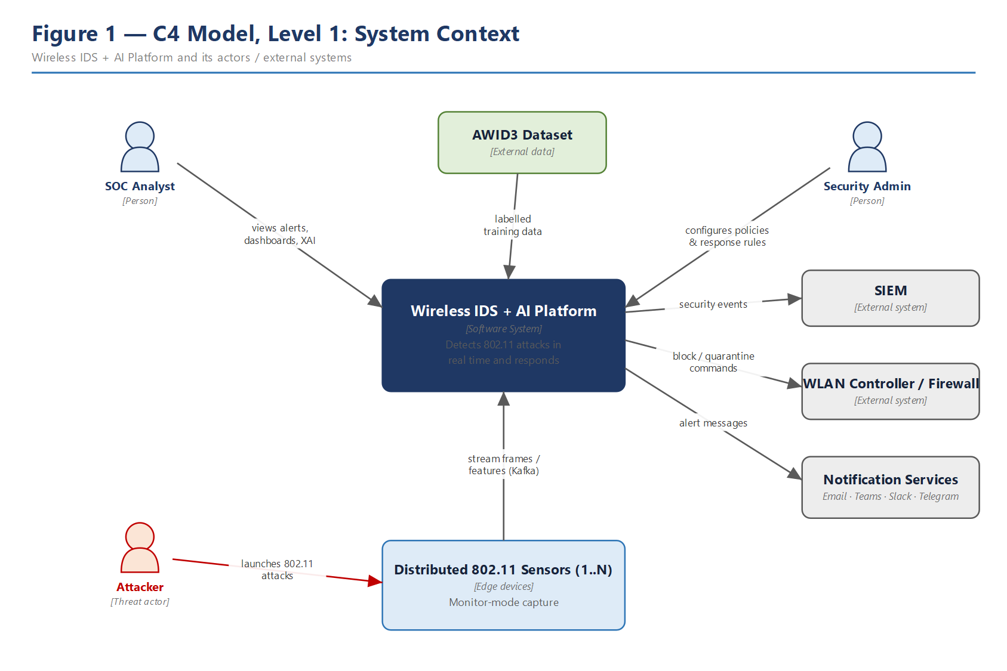
Figure 1 — System context: the platform, its human actors and external systems.

4.1 External interfaces
External entity | Direction | Interface / data
Distributed 802.11 sensors | in | Feature/frame stream over TLS to Kafka (data plane)
AWID3 dataset | in | Batch import of labelled frames for training
SOC Analyst | in/out | Dashboard, alerts, XAI; manual response / override
Security Administrator | in | Detection & response policy, thresholds, sensor config
SIEM | out | Normalised security events (e.g. CEF/JSON)
WLAN Controller / Firewall | out | Block / deauth / quarantine commands via API (mTLS)
Notification services | out | Alerts to Email / Teams / Slack / Telegram
Attacker (threat actor) | in | Adversarial 802.11 traffic against the monitored RF domain

5. Container View (C4 Level 2)
The container view decomposes the platform into independently deployable units and shows the primary left-to-right data pipeline: capture → ingestion → feature extraction → inference → response, with supporting stores, model registry, API, dashboard and observability.
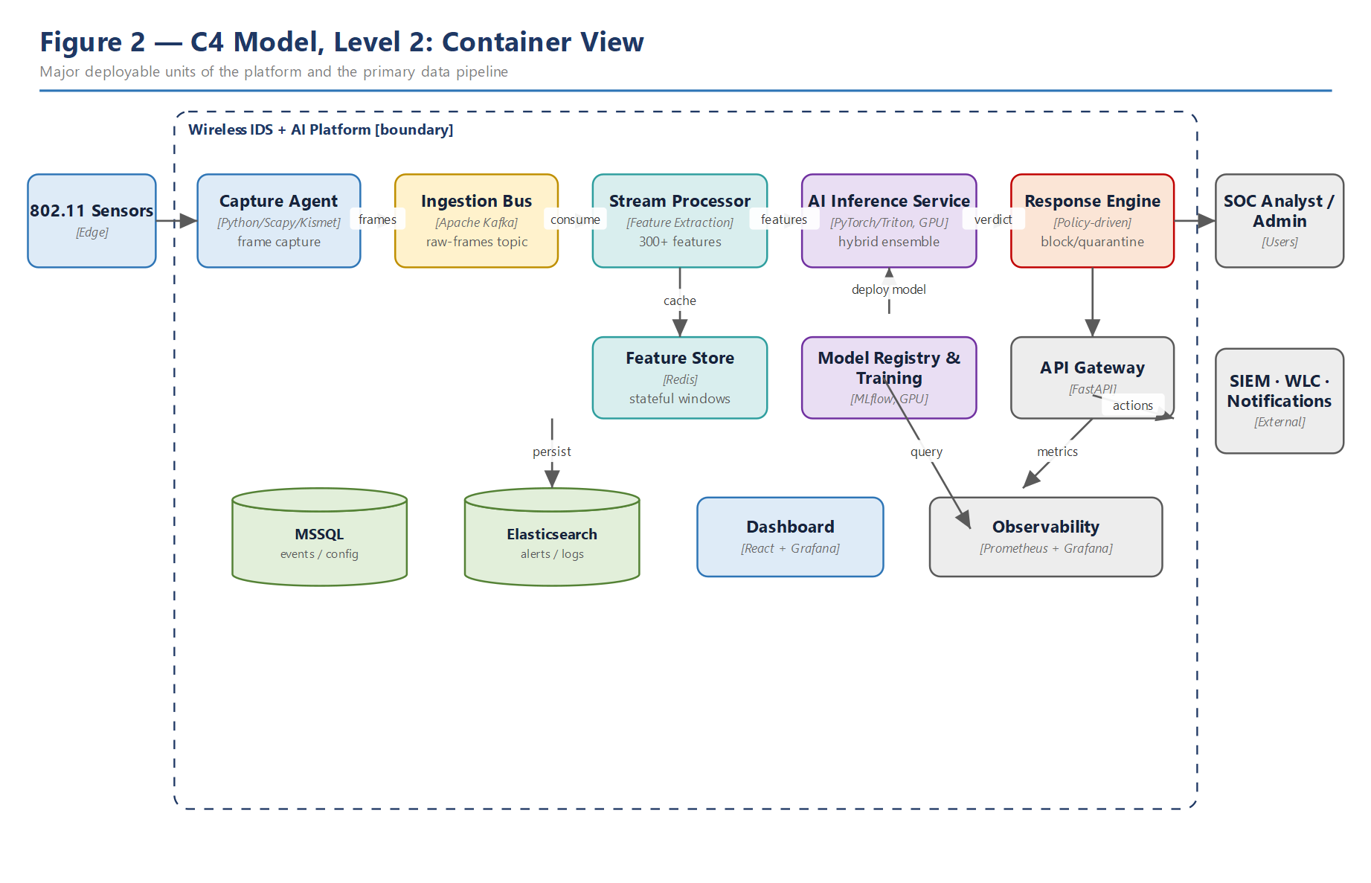
Figure 2 — Container view: deployable units and the primary data pipeline.

5.1 Container responsibilities
Container | Technology | Responsibility
Capture Agent | Python, Scapy/PyShark, Kismet, libpcap | Monitor-mode capture on each sensor; publish frames
Ingestion Bus | Apache Kafka | Durable, ordered transport; back-pressure; replay
Stream Processor | Python (Faust-style consumers) | Windowed 300+ feature extraction incl. graph features
Feature Store | Redis 8.2 (existing, Docker) | Low-latency sliding-window and graph state (TTL)
AI Inference Service | PyTorch, Triton, CUDA (GPU) | Hybrid ensemble prediction, fusion, calibration, XAI
Model Registry & Training | MLflow, TensorFlow/PyTorch (GPU) | Dataset builds, training, versioning, promotion
Response Engine | Python + Policy Engine | Policy-gated mitigation, override, audit
API Gateway | FastAPI | REST management/query surface; authN/Z
Dashboard | React + Grafana | Live monitoring, alerts, XAI, administration
Data stores | MSSQL 2019 + Elasticsearch (existing) | Events/config (relational); alerts/logs (search)
Observability | Prometheus + Grafana | Metrics, latency budgets, resource and model telemetry

5.2 Inter-container contracts
Containers integrate through explicit, versioned contracts so they can evolve independently. On the data plane, contracts are Kafka topics with schema-registry-governed message schemas; on the control plane, they are OpenAPI/gRPC definitions. The table lists the principal contracts and their stability expectations.
From → To | Contract | Stability
Capture → Ingestion | raw-frames topic (frame schema v1) | Versioned; additive changes only
Ingestion → Processing | consumer group on raw-frames | Stable; partitions may grow
Processing → Redis | window/graph state keys (TTL) | Internal; rebuildable
Processing → Ingestion | feature-vectors topic (fv schema) | Versioned with feature-set version
Ingestion → Inference | consumer group on feature-vectors | Stable
Inference → Ingestion | detections topic (verdict schema) | Versioned; XAI fields additive
Inference → Registry | model load by version URI | Stable (MLflow API)
Decision → Response | responses topic + policy call | Stable; policy is config
API → stores | SQL / ES queries | Internal; migration-managed

5.3 Container failure modes and degradation
Container | Failure | Behaviour
Capture Agent | Sensor offline | Detection continues on remaining sensors; gap flagged
Ingestion Bus | Broker loss | Replicated partitions fail over; no data loss
Stream Processor | Pod crash | Consumer group rebalances; state rebuilt from Kafka
Feature Store | Redis eviction/restart | Windows re-warm from replay; brief feature gaps
Inference Service | GPU saturation | Back-pressure + batching; anomaly-only fallback path
Response Engine | Enforcement API down | Queue actions, alert only, retry with backoff
Data stores | Primary loss | Read replica promotion; queries degrade to cache

6. Component View (C4 Level 3): AI Inference Service
Because the inference service carries the platform's scientific weight, it is decomposed to component level. Feature vectors arrive from Kafka, are normalised and assembled, then dispatched by the Ensemble Manager to complementary models. A fusion-and-decision component combines calibrated scores, the XAI Explainer attaches attributions, and the Result Publisher emits the verdict to the response and persistence paths.
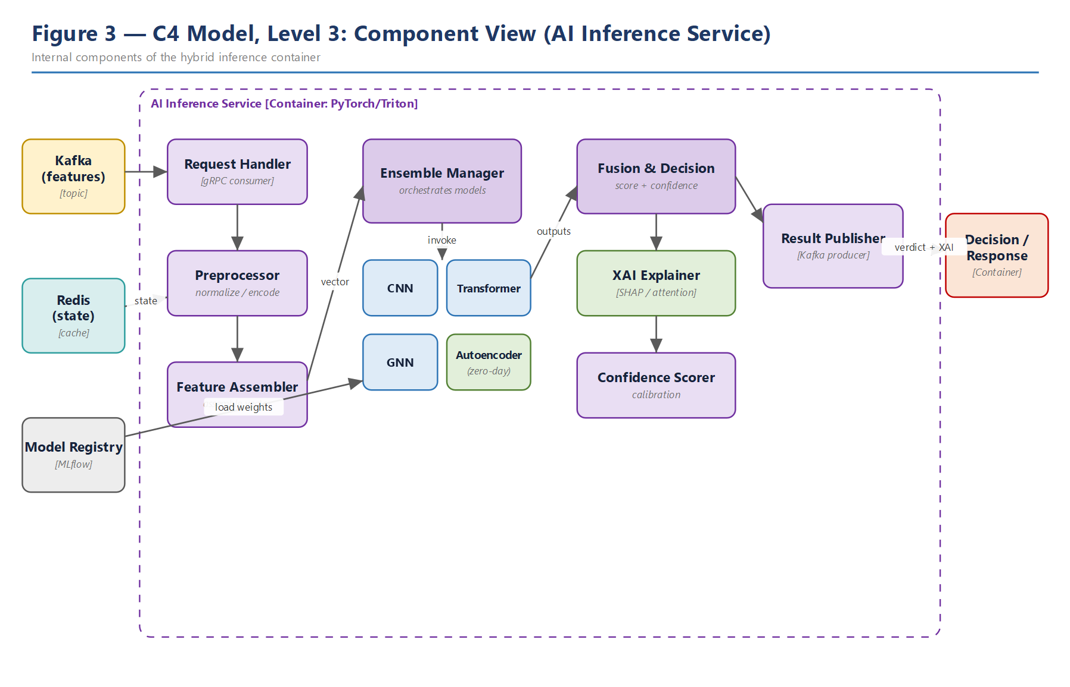
Figure 3 — Component view of the hybrid AI inference container.

6.1 Component notes
- Ensemble Manager: orchestrates CNN (spatial), Transformer (temporal/sequence), GNN (device/BSSID relational) and Autoencoder (zero-day) models behind a common Model interface.
- Fusion & Decision: weighted combination + confidence calibration; produces a single verdict with a confidence score.
- XAI Explainer: SHAP values and attention maps translated into operator-facing reasoning for high-severity detections (FR-6).
- Result Publisher: writes verdict + explanation to the detections topic for the Decision/Response and persistence consumers.

6.2 Model roster
The Ensemble Manager coordinates four complementary learners behind the common Model interface (§9). Each targets a distinct signal class; the fusion layer weights them and calibrates the combined confidence.
Model | Signal captured | Role in ensemble
CNN | Local spatial patterns in frame/feature images | Fast, high-precision on known attack shapes
Transformer | Temporal / sequential structure | Detects timing and burst anomalies over windows
GNN | Device/BSSID relational structure | Cross-device correlation; rogue/evil-twin topology
Autoencoder / VAE | Reconstruction error on 'normal' | Unsupervised zero-day / unknown-attack detection

The GNN is the scientific centrepiece at the model level: operating on the device/BSSID graph, it can flag relational anomalies (an access point that suddenly appears with a duplicate SSID but an anomalous neighbourhood) that per-flow classifiers cannot see. Combined with the multi-sensor fabric, this is the differentiation strategy against the prior art identified in R1.

6.3 Inference performance and concurrency
The inference service is the latency-critical component (QA-1). Feature vectors are consumed in micro-batches and scored on the GPU to amortise kernel-launch overhead; the ensemble runs its member models concurrently and the fusion layer waits only for the slowest required model. Triton serves versioned models with dynamic batching, so throughput scales with replica count on the GPU node pool without changing client code. The XAI step is computed only for detections above a severity threshold, keeping explanation cost off the common path.

7. Runtime (Behavioural) Views

7.1 Real-time detection flow
The hot path is fully asynchronous. Sensors publish frames; the Stream Processor maintains windowed state in Redis and emits feature vectors; the Inference Service consumes them, runs the ensemble on GPU, fuses and explains, and publishes a verdict to the dashboard and event store. A per-stage latency budget keeps the end-to-end p95 under one second (QA-1).
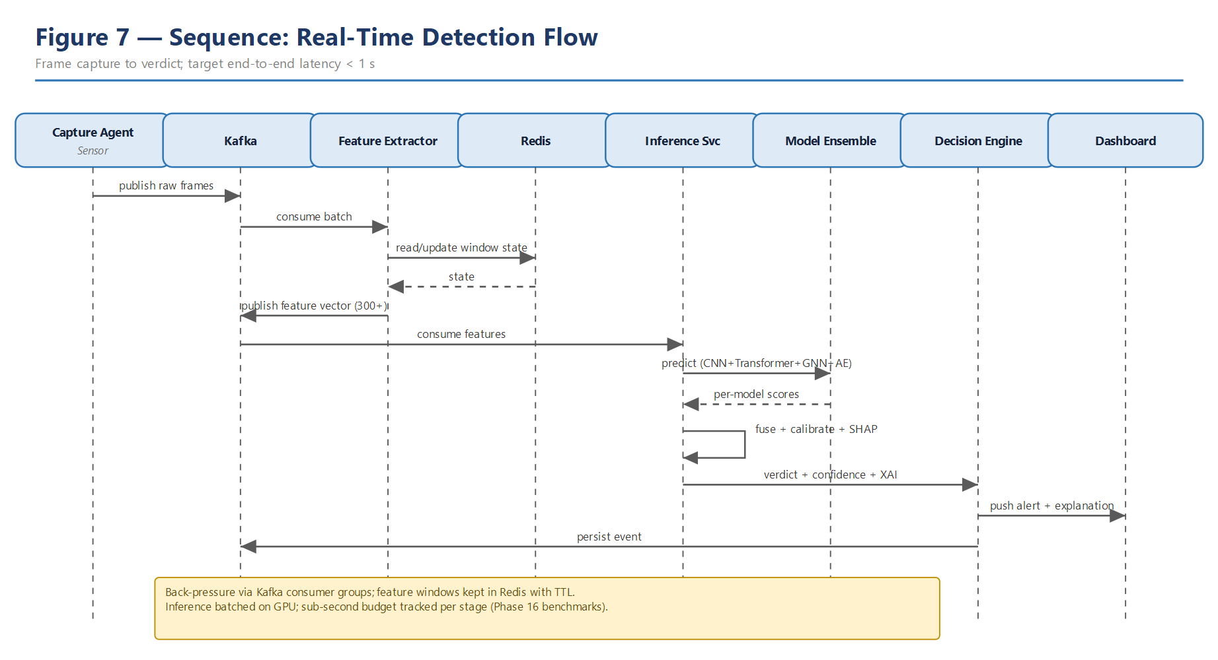
Figure 7 — Sequence: real-time detection from capture to verdict.
- A sensor captures 802.11 frames in monitor mode and publishes them to the raw-frames topic.
- The Stream Processor consumes a batch and reads/updates the sliding-window and graph state in Redis.
- It computes the 300+ feature vector and publishes it to the feature-vectors topic.
- The Inference Service consumes the vector and runs the hybrid ensemble on the GPU.
- Per-model scores are fused and calibrated; the XAI Explainer attaches SHAP/attention attributions.
- The verdict (label, score, confidence, explanation) is published; the dashboard updates and the event is persisted.

7.2 Autonomous response flow
When a verdict indicates an attack, the Decision Engine consults the Policy Engine. Low-confidence detections raise an alert only; high-confidence detections trigger policy-authorised mitigation (deauth, MAC block, VLAN quarantine) on the WLAN controller / firewall. Every action is forwarded to the SIEM, announced on notification channels, and appended to an immutable audit log; a SOC analyst can override or roll back.
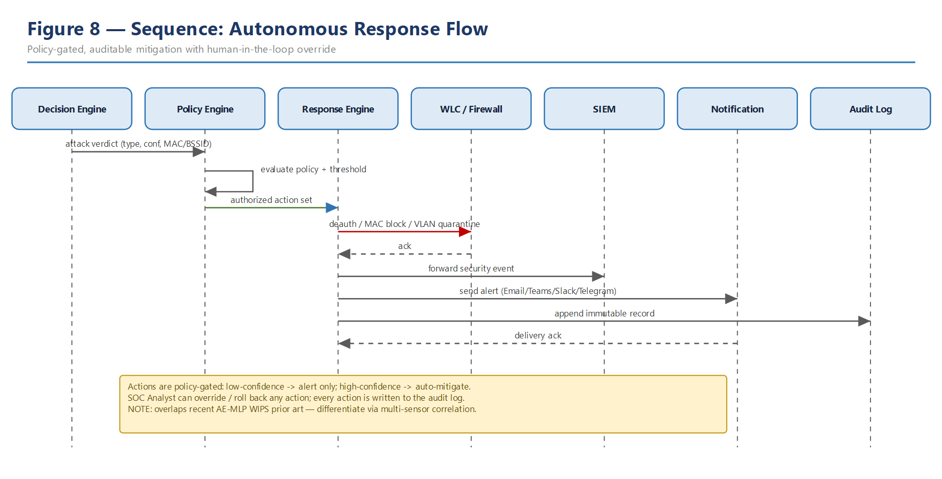
Figure 8 — Sequence: policy-gated autonomous response with human override.
- The Decision Engine receives an attack verdict with type, confidence and target MAC/BSSID.
- The Policy Engine evaluates the applicable policy and confidence threshold.
- Low confidence raises an alert only; high confidence returns an authorised action set.
- The Response Engine executes mitigation (deauth / MAC block / VLAN quarantine) on the WLAN controller or firewall.
- The action is forwarded to the SIEM, announced on notification channels, and appended to the immutable audit log.
- A SOC analyst may override or roll back the action; the rollback is itself audited.

7.3 Model training and retraining (MLOps)
Training is triggered on a schedule or by a drift alarm. The Dataset Builder assembles the unified dataset (AWID3 + live capture + generated attacks); the Feature Pipeline produces engineered features and splits; the Trainer fits the ensemble; the Evaluator compares ROC/AUC/F1 and latency against the incumbent; better models are registered and rolled out via canary, with automatic rollback on canary failure.
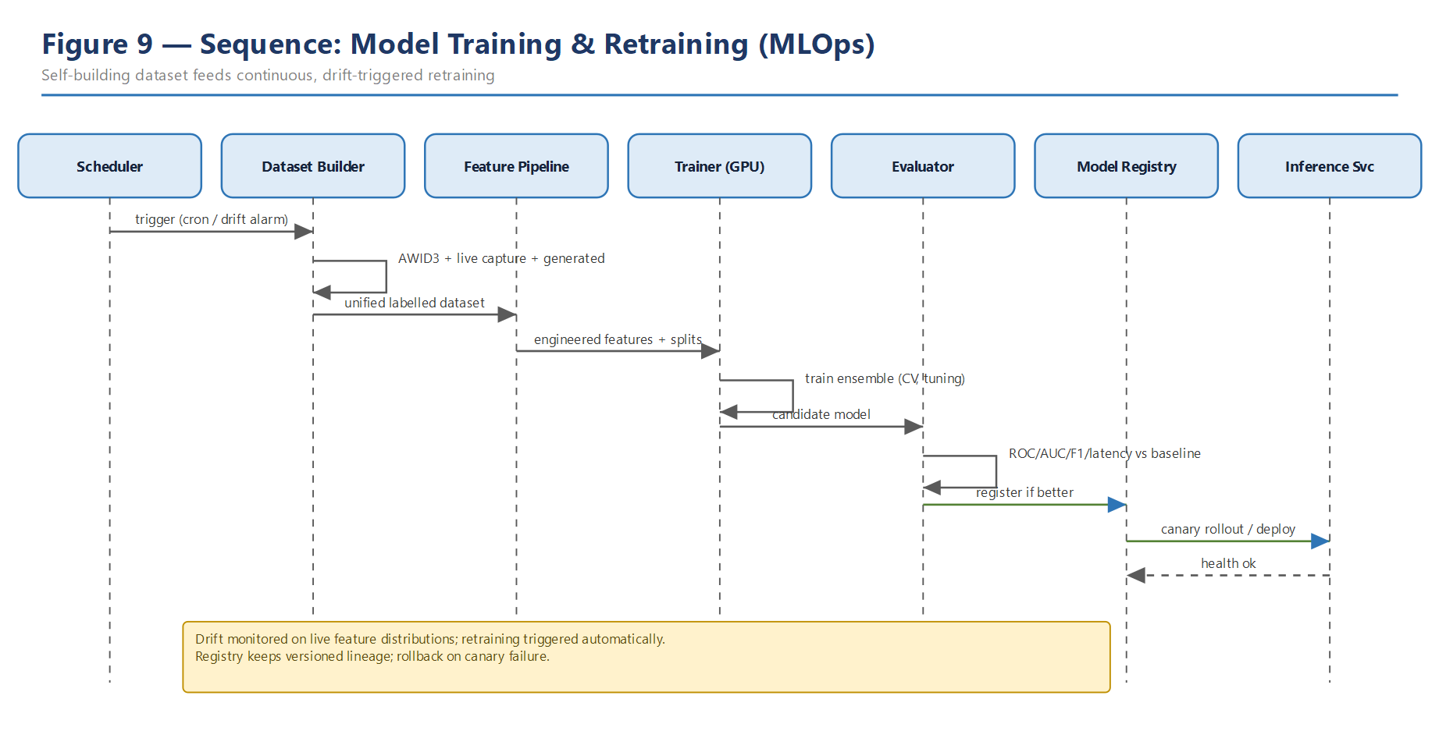
Figure 9 — Sequence: continuous, drift-triggered training and safe rollout.
- A schedule or a drift alarm triggers the Dataset Builder.
- It assembles the unified dataset from AWID3, live capture and generated attacks.
- The Feature Pipeline produces engineered features and train/validation/test splits.
- The Trainer fits the ensemble with cross-validation and hyper-parameter tuning on GPU.
- The Evaluator compares ROC/AUC/F1 and latency against the incumbent production model.
- If better, the model is registered and rolled out via canary, with automatic rollback on failure.

7.4 Cross-sensor correlation
Cross-sensor correlation is the platform's distinguishing behaviour (FR-7, Gap 3) and warrants explicit description. Each sensor timestamps its observations against a disciplined clock (NTP/PTP). The Decision Engine maintains a short correlation window keyed by device/BSSID and channel; when the same attacker signature is reported by two or more sensors within that window, the events are fused into a single higher-confidence detection annotated with an approximate location (which sensors observed it and their relative signal strengths). This achieves three things the single-node literature cannot: it raises confidence and suppresses duplicate alerts, it localises the attacker within the monitored space, and it supplies the GNN with genuinely multi-vantage-point graph features. Correlation tolerances (window length, permitted clock skew) are configuration, so the fabric can be tuned per deployment.

8. Data Architecture

8.1 Data flow
The Level-1 DFD shows the processes (capture, feature extraction, inference, decision/response, visualisation), the four data stores, and the flows between them and the external entities. It is the data-centric complement to the container view.
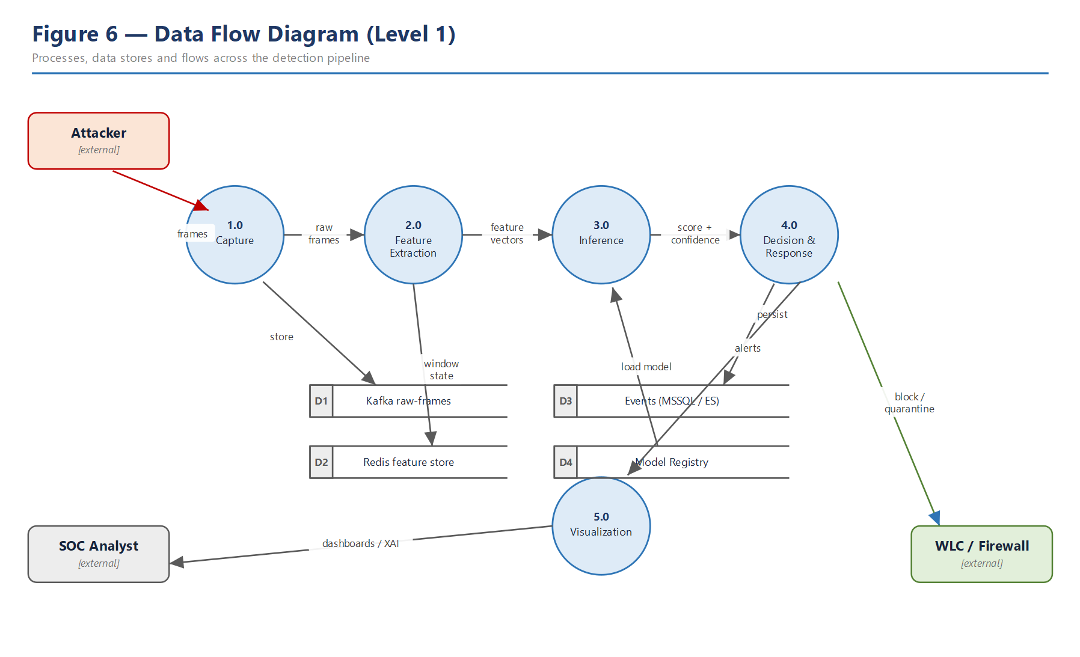
Figure 6 — Level-1 data flow diagram of the detection pipeline.

8.2 Logical data model
The ER model captures the persisted entities: sensors and their capture sessions; frame batches and the feature vectors derived from them; detection events with their attack type, model version, score and confidence; the response actions and alerts they generate; the model catalogue and versions; and the devices (by MAC/BSSID) referenced by detections.
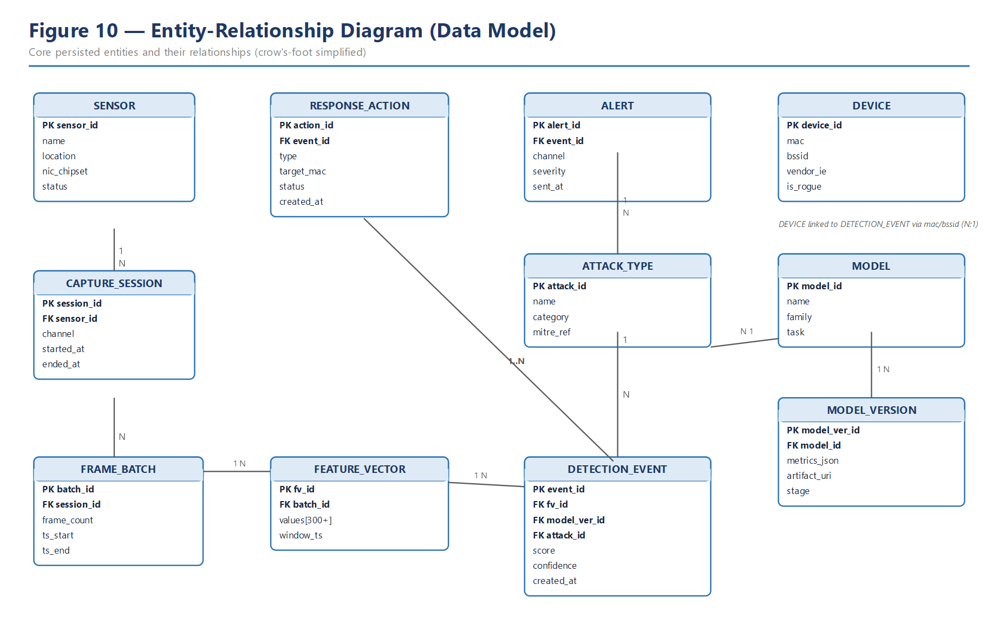
Figure 10 — Entity-relationship model of the persisted domain.

8.3 Data stores and retention
Store | Role | Retention / notes
Kafka (raw-frames) | Durable transport & replay buffer | Hours–days; sized for reprocessing window
Redis 8.2 (existing, Docker) | Windowed & graph state | Seconds–minutes TTL; rebuildable from Kafka
MSSQL 2019 (existing, SQLEXPRESS) | Events, config, model & response records | Long-term; source of truth for relational data (T-SQL)
Elasticsearch (existing) | Alerts, logs, fast search | Medium-term; index lifecycle managed
Object store (artifacts) | Model weights, dataset snapshots | Versioned; referenced by Model Registry

8.4 Feature taxonomy (300+ features)
The platform deliberately exceeds the small, hand-picked feature sets common in the literature. Features are grouped by category; the table summarises the categories with representative examples rather than enumerating all features.
Category | ≈ count | Representative features
Frame/header statistics | 70+ | Type/subtype rates, retry frequency, sequence discontinuity
Temporal statistics | 60+ | Inter-frame timing, beacon interval variance, frame burst
RF / signal | 40+ | RSSI mean/variance, signal variance, channel hopping
Entropy & distribution | 30+ | Packet entropy, QoS pattern, hidden-SSID score
Vendor / fingerprint | 30+ | Vendor IE, vendor fingerprint, device fingerprint
Graph / relational | 40+ | BSSID graph degree/centrality, client mobility, MAC movement
Session / behavioural | 30+ | Session duration, association patterns, re-association rate

The graph and relational category (enabled by the GNN, ADR-003) is the feature-level differentiator called out in R1: modelling device/BSSID relationships is largely unexplored for 802.11 infrastructure IDS.

8.5 Data dictionary (selected entities)
The principal entities are defined below at attribute level. Types are indicative; PK/FK denote primary and foreign keys.

DETECTION_EVENT
Attribute | Type | Notes
event_id (PK) | uuid | Unique detection identifier
fv_id (FK) | uuid | Feature vector that produced it
model_ver_id (FK) | uuid | Model version that scored it
attack_id (FK) | int | Classified attack type (nullable if anomaly-only)
score | float | Model score [0,1]
confidence | float | Calibrated confidence [0,1]
severity | enum | info / low / medium / high / critical
created_at | timestamp | Detection time (sensor-synchronised)

FEATURE_VECTOR
Attribute | Type | Notes
fv_id (PK) | uuid | Vector identifier
batch_id (FK) | uuid | Source frame batch
feature_set_ver | string | Version of the 300+ feature schema
values | float[] | Ordered feature values (300+)
window_ts | timestamp | End of the aggregation window

RESPONSE_ACTION
Attribute | Type | Notes
action_id (PK) | uuid | Action identifier
event_id (FK) | uuid | Triggering detection
type | enum | deauth / mac_block / vlan_quarantine / disable_ap
target_mac | string | Affected device / BSSID
status | enum | proposed / executed / failed / rolled_back
actor | string | auto or operator id (override)
created_at | timestamp | When taken

8.6 Data governance and privacy
Captured 802.11 data can contain sensitive metadata, so the platform applies data minimisation (only the fields needed for features are retained beyond the replay window), encryption in transit and at rest, and role-gated access with full audit. Retention is bounded per store (§8.3). Dataset snapshots used for training carry provenance — which sensors, which time range, which generated-attack sets — so any published result can be reproduced and any privacy concern traced. Capture is assumed to occur only on networks the operator is authorised to monitor (§2.5).

9. Domain (Class) Model
The class model shows the core domain abstractions and how pluggability (QA-8, ADR-003) is realised: FeatureExtractor and Model are interfaces/abstractions with concrete implementations, so new extractors or learners are added without touching the pipeline. The EnsembleFusion aggregates models; the Explainer produces attributions; Detection is consumed by the policy-driven ResponseEngine.
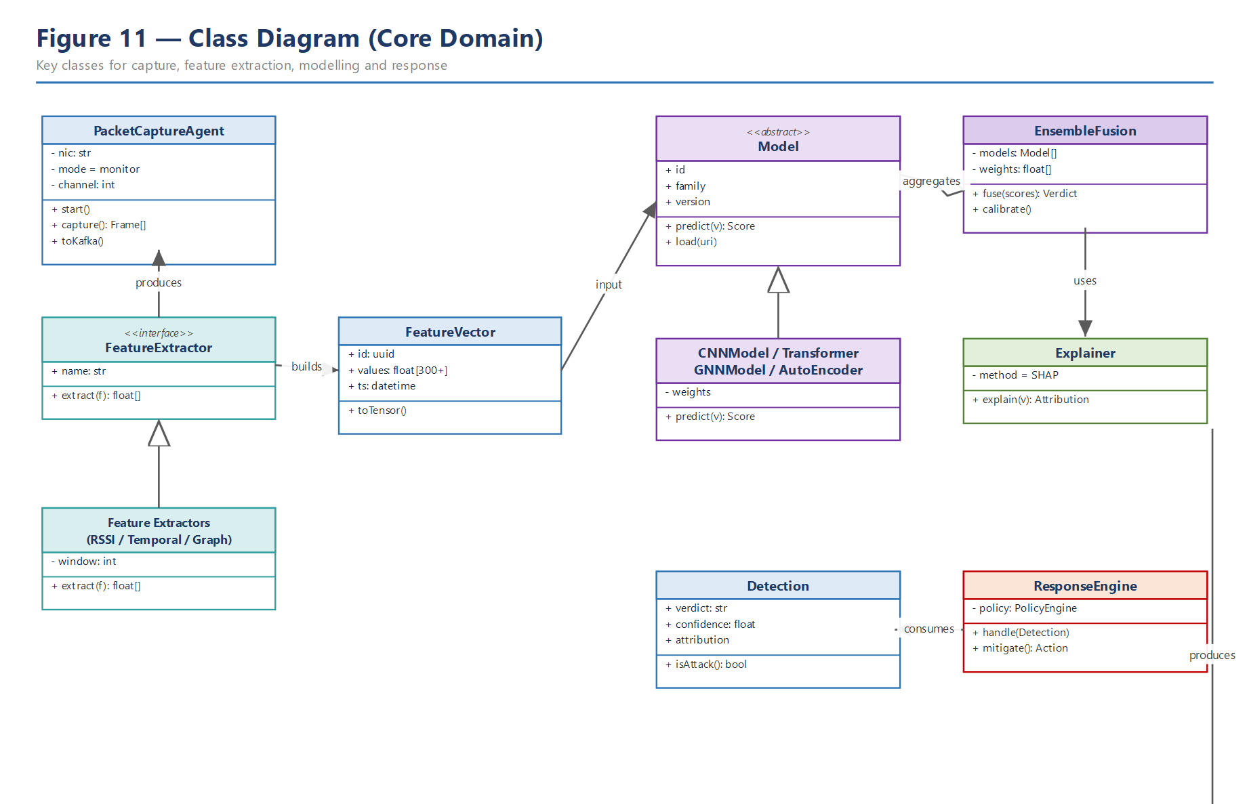
Figure 11 — Core domain class model.

9.1 Extension points
Two seams keep the platform open to research iteration without core changes. A new FeatureExtractor implementation is discovered by configuration and contributes columns to the feature vector under a new feature-set version (§5.2). A new Model implementation registers with the Ensemble Manager and participates in fusion once promoted (§14.2). This lets the team trial, for example, an alternative graph construction or a new transformer variant behind a flag, compare it on the benchmark (§14.6), and promote it only if it wins — directly supporting the experimental cadence the research goal demands (QA-8).

10. Deployment View
The deployment view maps containers onto physical/virtual nodes: an edge sensor layer feeding, over TLS through an aggregation switch, a Helm-managed Kubernetes cluster organised into namespaces (ingestion, processing, AI with a GPU node pool, data, ops, edge services, response), plus external enforcement and operations systems.
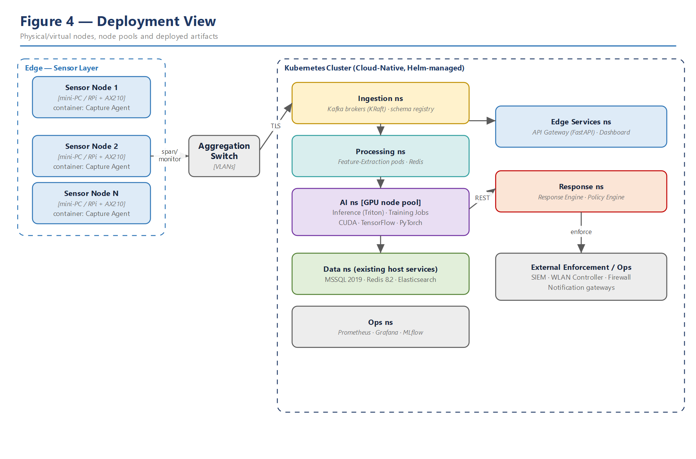
Figure 4 — Deployment view: nodes, node pools and deployed artefacts.

10.1 Namespaces and scaling
Namespace | Contents | Scaling strategy
ingestion | Kafka (KRaft), schema registry | Partitions scale with sensor count; broker replicas for HA
processing | Feature-extraction pods, Redis | HPA on consumer lag; Redis clustered for state
ai [GPU] | Inference (Triton), training jobs | GPU node pool; inference replicas behind load balancer
data (external) | MSSQL 2019, Redis 8.2, Elasticsearch (existing host) | Reused, not deployed in-cluster; see §10.3
edge-services | API Gateway, Dashboard | Stateless HPA on request rate
response | Response Engine, Policy Engine | Low replica count; leader-based action serialisation
ops | Prometheus, Grafana, MLflow | Vertical scaling; long-term metric storage

10.2 Deployment environments
Environment | Purpose | Notes
Development | Local build; unit/integration tests | Docker Compose of core services (Phase 2)
Staging | Pre-production validation | Scaled-down cluster; canary target; synthetic load
Production | Live monitoring and response | Full cluster with GPU pool and HA data tier

10.3 Current environment integration
The initial deployment reuses data services already present on the host (ADR-009), so Phase 2 provisions only the remaining components (Kafka, Prometheus, Grafana, MLflow and the application services) and wires them to the existing endpoints below.
Service | Endpoint / instance | Status and integration notes
MSSQL | (localdb)\MSSQLLocalDB · database WirelesSecureDB | SQL Server LocalDB. Host-only: LocalDB is a user-scoped, named-pipe instance and cannot be reached from Docker containers — services that need the DB run on the host (pyodbc + ODBC Driver 18, Windows auth). For container access, use a full SQL Server / SQLEXPRESS instance with TCP enabled instead. (A SQLEXPRESS 2019 instance is also present on the host.)
Redis | localhost:6379 (Docker container) | Running; Redis 8.2.1 (PING → PONG). Reachable from other containers via host.docker.internal:6379 or a shared Docker network.
Elasticsearch | https://localhost:9200 (node CMIT0601L-010) | Running: Elasticsearch 9.1.4, single-node, TLS + auth enabled (HTTPS; plain HTTP is rejected). SHARED with other applications (telegram/pdf/aegis indices present) — use a dedicated 'wids-*' index prefix and set number_of_replicas=0 for our indices to keep cluster health green.

Capacity note (MSSQL): SQL Server Express and LocalDB both cap each database at 10 GB and roughly 1 GB of buffer-pool RAM on a single socket, and LocalDB additionally has no network listener. This is fine for development, but for the Phase 15 scale test and Phase 16 benchmark — which store tens of thousands of events per second and run services in containers — a move to the free Developer edition (production-equivalent, no size cap, TCP enabled) or Standard is recommended; on Express/LocalDB, event retention must otherwise be kept short.
Capacity note (host disk): at the time of writing the host system disk was ~96% full (about 41 GB free), which had already tripped the Elasticsearch flood-stage watermark and marked all indices read-only — blocking writes. Since Kafka logs, MSSQL data and packet-capture buffers will share this disk, disk space must be freed and monitored before the platform is relied upon; a dedicated data volume for the streaming/capture path is recommended.

11. Network Architecture
The network view emphasises isolation. The RF domain is untrusted. Sensors capture on a one-way capture VLAN (span) and are managed on a separate out-of-band management VLAN, so capture traffic can never be used to reach the sensors. An 802.1Q trunk carries VLANs to the aggregation switch; only authenticated TLS flows enter the trusted core. Enforcement actions leave the core to the WLAN controller / firewall over a controlled path.
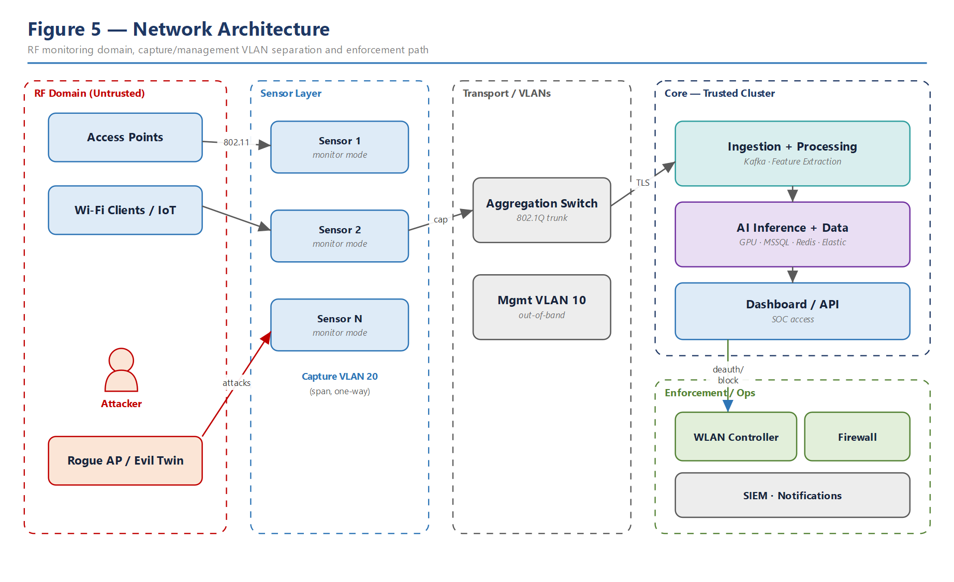
Figure 5 — Network architecture with capture/management VLAN separation.

11.1 Segments
Segment / VLAN | Trust | Purpose
RF domain | Untrusted | Monitored 802.11 airspace; attacker-controlled
Capture VLAN 20 | Low | One-way span of captured traffic to sensors
Management VLAN 10 | Medium | Out-of-band sensor administration
Core cluster network | Trusted | Ingestion, AI, data, dashboard — mTLS internally
Enforcement path | Controlled | Authenticated block/quarantine to WLC/firewall

11.2 Principal network flows
Source → Destination | Protocol / port | Direction
Sensor → Kafka | TLS (9093) | edge → core (data, one-way)
Admin → Sensor management | SSH / HTTPS (mgmt VLAN) | ops → edge (out-of-band)
Core services (internal) | mTLS (service mesh) | east-west
Analyst → API / Dashboard | HTTPS (443) | user → core
Response → WLC / Firewall | HTTPS / mTLS (API) | core → enforcement
Core → SIEM / Notifications | HTTPS / syslog | core → ops

12. API Design

12.1 Principles
Two interface styles per ADR-008: a gRPC streaming interface on the inference hot path for low-latency verdict delivery, and a REST/JSON management-and-query surface (OpenAPI-documented) for configuration, retrieval and manual actions. All endpoints require authentication; mutating and response endpoints require elevated authorisation and are audited.

12.2 REST endpoint catalogue (selection)
Method & path | Purpose | Auth
GET /api/v1/health | Liveness/readiness | service
GET /api/v1/sensors | List sensors and status | analyst
POST /api/v1/sensors/{id}/config | Update sensor capture config | admin
GET /api/v1/detections?from&to&type | Query detections | analyst
GET /api/v1/detections/{id} | Detection detail incl. XAI attribution | analyst
GET /api/v1/alerts | List alerts | analyst
GET /api/v1/models | Model catalogue & versions | analyst
POST /api/v1/models/{ver}/promote | Promote a model version | admin
POST /api/v1/response/actions | Trigger a manual response action | admin
POST /api/v1/response/{id}/rollback | Roll back a response action | admin

12.3 Streaming interfaces
Interface | Type | Payload
InferenceService.Predict | gRPC (bidi stream) | FeatureVector → Verdict{label,score,confidence,attribution}
/ws/live | WebSocket | Live detections/alerts push to dashboard
Kafka: raw-frames | topic | Raw captured frames from sensors
Kafka: feature-vectors | topic | Engineered 300+ feature vectors
Kafka: detections | topic | Verdicts + explanations
Kafka: responses / audit | topic | Actions taken and immutable audit records

12.4 Example verdict payload
GET /api/v1/detections/{id} returns, in essence: { id, timestamp, sensor_id, attack_type: "deauth_flood", score: 0.984, confidence: 0.97, top_features: ["retry_frequency", "beacon_interval_var", "bssid_degree"], explanation: "Burst of deauthentication frames with abnormal retry rate from a spoofed BSSID observed by sensors 2 and 3." }. The explanation and top_features satisfy FR-6.

12.5 Error model and status codes
The REST surface uses conventional HTTP semantics with a consistent error envelope { error_code, message, trace_id } so failures are machine- and human-actionable, and every trace_id correlates to observability data (§14.1).
Code | Meaning | Typical cause
200 / 202 | OK / Accepted | Query served; async action queued
400 | Bad request | Malformed filter or payload
401 / 403 | Unauthenticated / Forbidden | Missing token / insufficient role
404 | Not found | Unknown detection/model/action id
409 | Conflict | Duplicate promotion or rollback of a completed action
422 | Unprocessable | Policy rejects the requested response
429 | Too many requests | Rate limit / back-pressure
503 | Unavailable | Enforcement target or dependency down (retryable)

13. Security Architecture and Threat Model
Security is analysed with STRIDE across three trust boundaries: the untrusted RF/sensor edge, the trusted core cluster, and the enforcement/ops zone. The platform is itself a security tool, so its own attack surface — model poisoning, response abuse, capture-data leakage — is treated as first-class.
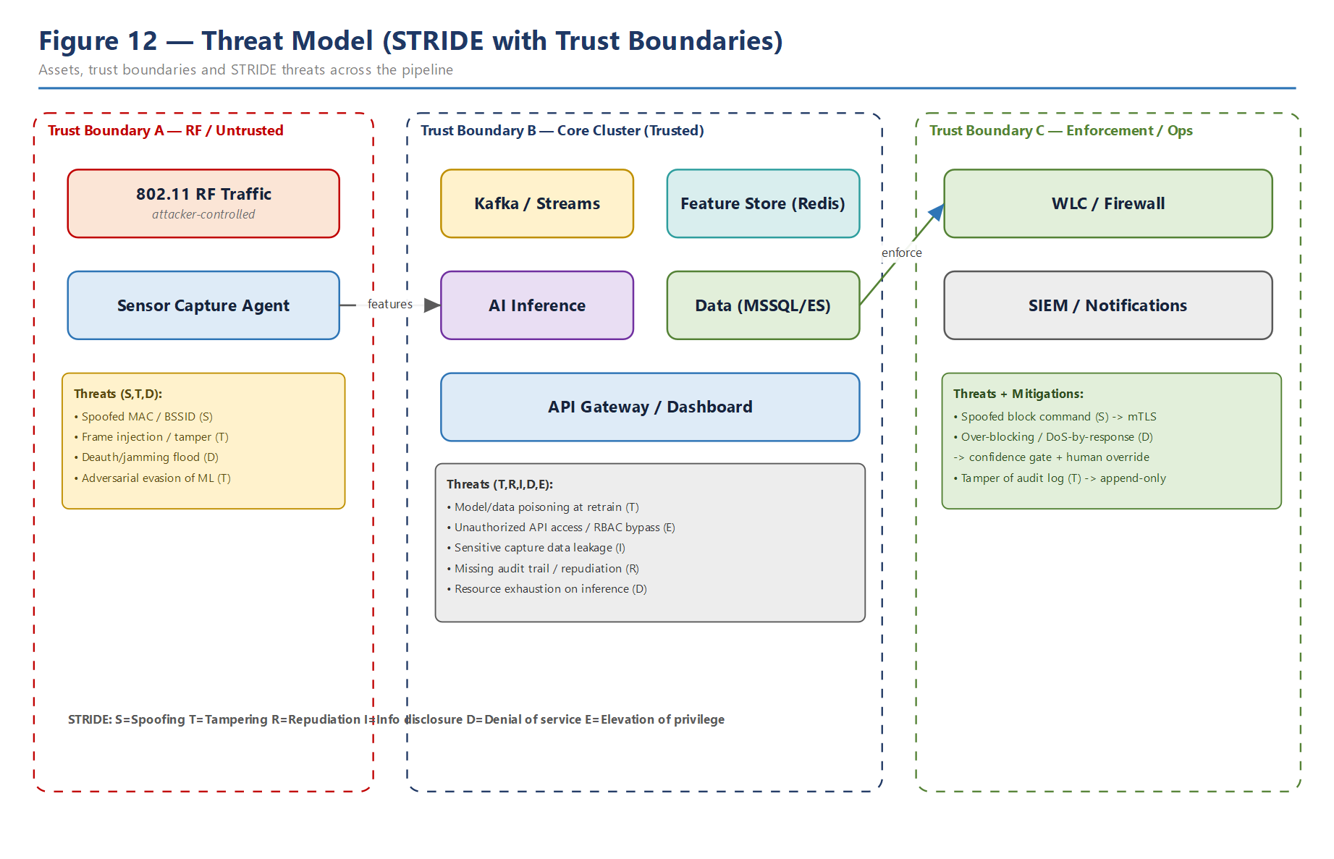
Figure 12 — STRIDE threat model across the three trust boundaries.

13.1 Threat register (selection)
Threat (STRIDE) | Boundary | Mitigation
Spoofed MAC/BSSID (S) | RF edge | Detection feature itself; cross-sensor correlation (FR-7)
Frame injection / tamper (T) | RF edge | Anomaly models; integrity checks on capture stream
Adversarial ML evasion (T) | RF edge | Ensemble diversity; anomaly fallback; adversarial training
Deauth/jamming flood (D) | RF edge | Primary detection target; rate/entropy features
Model / data poisoning (T) | Core | Dataset provenance; validation gates before promotion
Unauthorized API / RBAC bypass (E) | Core | AuthN + least-privilege RBAC; audit of mutations
Capture-data leakage (I) | Core | Encryption in transit/at rest; data minimisation; access control
Repudiation / missing audit (R) | Core | Append-only audit log of detections and actions
Inference resource exhaustion (D) | Core | Back-pressure, quotas, autoscaling, batching
Spoofed block command (S) | Enforcement | mTLS to WLC/firewall; signed action requests
Over-blocking / DoS-by-response (D) | Enforcement | Confidence gate + human override + rollback (ADR-007)

13.2 Identity, secrets and data protection
- Authentication for all human and service access; role-based authorisation with least privilege.
- mTLS between sensors, core services, and enforcement targets; secrets held in a managed secret store.
- Captured traffic encrypted in transit and at rest; retention minimised; access logged.
- Immutable, append-only audit trail for every detection and response action (supports non-repudiation).

13.3 Authorization roles
Roles follow least privilege. The authority to trigger enforcement is separated from the authority to govern models, and both are separated from read-only monitoring; every privileged action is audited.
Role | Read | Configure | Respond | Govern models
Viewer | yes | no | no | no
SOC Analyst | yes | no | override / rollback | no
Security Admin | yes | yes | yes | no
MLOps Engineer | yes | limited | no | yes
Service (system) | scoped | no | execute (gated) | no

13.4 Safe-operation and compliance considerations
Because the platform can both observe traffic and act on the network, two safeguards are architecturally mandated rather than left to policy. First, observation is bounded: only authorised airspace is monitored (§2.5), captured data is minimised and access-controlled (§8.6), and retention is time-boxed (§8.3). Second, action is constrained: enforcement is confidence-gated, reversible and audited (ADR-007, §7.2), so an operator can always reconstruct what was done, why, and by whom (or by which model version), and can undo it. Together these make the system defensible both operationally and, where relevant, for privacy and compliance review — a property the eventual research write-up can cite as part of responsible-deployment claims.

14. Cross-Cutting Concerns

14.1 Observability and latency budget
Every pipeline stage emits latency, throughput and resource metrics to Prometheus, visualised in Grafana. The one-second end-to-end target (QA-1) is decomposed into a per-stage budget so regressions are attributable. This instrumentation is also the source of the latency/throughput evidence that the literature review flagged as missing — it is a deliberate, publishable output.
Stage | p95 budget | Key metric
Capture → Kafka | < 50 ms | publish latency
Feature extraction | < 300 ms | window compute time
Inference (GPU) | < 150 ms | batch inference latency
Fusion + XAI | < 200 ms | explanation compute time
Decision + publish | < 100 ms | end-to-end tail
End-to-end | < 1000 ms | capture→verdict p95

14.2 MLOps and model governance
Models are versioned artefacts with lineage: dataset snapshot, features, metrics and stage (candidate/staging/production). Promotion is gated on beating the incumbent across ROC/AUC/F1 and latency. Drift is monitored on live feature distributions and triggers retraining; rollout is canaried with automatic rollback.

14.2.1 Model lifecycle stages
Stage | Meaning | Gate to next
candidate | Freshly trained model | Beats incumbent on metrics and latency
staging | Shadow / canary traffic | Healthy on canary; no regression
production | Serving live verdicts | —
archived | Superseded or rolled back | Retained for lineage / audit

14.2.2 Drift signals and responses
Signal | Monitored on | Action
Feature distribution shift | Live feature vectors (PSI / KL) | Trigger retraining
Score distribution shift | Detection scores | Investigate / recalibrate
Confidence collapse | Calibrated confidence | Alert; fall back to anomaly model
Label feedback | Analyst confirmations / overrides | Feed the next dataset build

14.3 Configuration and feature flags
Detection thresholds, response policies and model selection are runtime configuration, not code. New feature extractors and models register as plug-ins (ADR-003, QA-8), so capability can be added without a pipeline redeploy.

14.4 Resilience and degradation
If a sensor drops, detection continues on the remaining fabric with reduced spatial coverage (QA-4). If the GPU inference tier is saturated, back-pressure and batching protect stability; the anomaly model provides a lightweight fallback path. Redis state is always rebuildable from the raw-frames topic (ADR-006).

14.5 Capacity
Kafka partitions and consumer groups scale with sensor count; inference replicas scale on the GPU node pool; data-tier read replicas absorb query load. The Phase 15 large-scale test (100/500/1000 APs) validates the scaling model against QA-2 and QA-3.
Scale (APs) | Sensors | Peak frames/s | Kafka partitions | Inference replicas (GPU)
100 | ~10 | ~10k | 12 | 2
500 | ~40 | ~30k | 32 | 4
1000 | ~80 | ~50k+ | 64 | 6+

These are planning estimates that set the sizing envelope for the Phase 15 scale test, not measured results; the Phase 16 benchmark validates them.

14.6 Test and verification strategy
Verification is layered so that each quality attribute has an owning test type. Functional correctness is covered by unit and integration tests against the container contracts (§5.2); the scientific claims are covered by the benchmark harness (Phase 16); and safety of autonomy is covered by response-engine simulation before any live enforcement.
Level | Scope | Verifies
Unit | Feature extractors, models, policy rules | Correctness of individual components
Contract | Topic schemas, API/gRPC definitions | Inter-container compatibility (§5.2)
Integration | Capture→feature→inference→response path | End-to-end functional flow (§7)
Performance | Load against QA-1/QA-2 targets | Latency budget and throughput (§14.1)
Scale | 100/500/1000 AP simulation | Horizontal scaling (QA-3, Phase 15)
Model | Held-out sets, cross-network, adversarial | Detection quality & robustness (QA-5)
Security | Threat-case tests per §13.1 | Mitigations effective; audit complete
Chaos | Kill sensors/pods/broker | Degradation behaviour (§5.3, QA-4)

A change is considered done only when its owning tests pass and no undocumented technical debt remains — the discipline carried from the project's per-phase working rules.

15. Quality Attribute Scenarios and Tactics
QA | Scenario (stimulus → response) | Tactic
QA-1 Latency | Burst of frames arrives → verdict within 1 s p95 | Async pipeline, GPU batching, per-stage budget
QA-2 Throughput | 50k frames/s sustained → no loss | Kafka partitioning, back-pressure, HPA on lag
QA-3 Scale | APs grow 100→1000 → linear resource growth | Stateless consumers, partition & replica scaling
QA-4 Availability | A sensor fails → detection continues degraded | Redundant sensors, rebuildable state, health checks
QA-5 Quality | New attack in test set → detected & reported | Hybrid ensemble + anomaly model; PR/ROC reporting
QA-6 Explainability | High-severity hit → attribution shown | SHAP/attention Explainer on every high-severity verdict
QA-7 Security | Forged block command → rejected | mTLS, signed requests, RBAC, audit
QA-8 Modifiability | Add a model → no pipeline redeploy | Plug-in Model/Extractor interfaces, config-driven
QA-9 Observability | Latency regresses → attributable alert | Per-stage metrics, budgets, Grafana alerts

16. Risks, Assumptions and Technical Debt
ID | Risk | Impact | Mitigation
RK-1 | Prior art (AE-MLP WIPS) overlaps zero-day + response | Weakens novelty claim | Lead with multi-sensor + graph; cite & differentiate (R1)
RK-2 | Live labelling quality for self-built dataset | Model quality / credibility | Controlled attack generation; provenance; expert review
RK-3 | GPU capacity for real-time + training | Latency or cost overrun | Node-pool isolation, batching, off-peak training
RK-4 | Sensor time synchronisation for correlation | False cross-sensor fusion | NTP/PTP discipline; timestamp tolerance in fusion
RK-5 | Adversarial evasion of ML models | Missed detections | Ensemble diversity, anomaly fallback, adversarial training
RK-6 | Scope of 18-phase plan | Delivery risk | Sequence phases; MVP core first; treat some phases as platform
RK-7 | Autonomous response causing outage | Operational harm | Confidence gate, human override, rollback, audit (ADR-007)
RK-8 | Host disk ~96% full (ES read-only, shared node) | Data loss; blocked writes | Free disk; dedicated capture/stream volume; ES 'wids-*' prefix; disk-usage alerts (§10.3)

Technical debt is tracked per phase; the discipline of leaving no undocumented debt before advancing a phase applies to every module delivered against this SAD.

16.2 Assumptions
- Sensors have authorised monitor-mode access to the target airspace (§2.5).
- Enforcement targets expose an authenticated API for block/quarantine actions.
- A GPU node pool is available for real-time inference and periodic training.
- Sensor clocks are disciplined (NTP/PTP) within the correlation tolerance (§7.4).

16.3 Open questions for later phases
- Exact graph construction (edge definition, temporal window) for the GNN — to be settled in Phase 10.
- Labelling protocol and quality gates for generated attacks in the self-built dataset — Phase 7.
- Calibration method for cross-model confidence fusion and its effect on the response threshold — Phase 10.
- Physical-localisation accuracy achievable from sensor signal-strength triangulation — Phase 15.

17. Traceability Matrix
This matrix links functional requirements to the containers/components and the views that realise them, closing the loop from need to design.
FR | Realised by | View(s)
FR-1 Capture | Capture Agent | §4, §5, §10, §11
FR-2 Stream | Ingestion Bus (Kafka) | §5, §7.1, §8.1
FR-3 Features | Stream Processor, Feature Store | §5, §8.4
FR-4 Hybrid classify | AI Inference Service (ensemble) | §6, §7.1, §9
FR-5 Zero-day | Autoencoder component | §6, §7.1
FR-6 Explainability | XAI Explainer | §6, §7.1, §12.4
FR-7 Correlation | Fusion + Decision Engine | §4, §7.1
FR-8 Response | Response + Policy Engine | §7.2, §13
FR-9 Audit | MSSQL + audit log | §8, §13
FR-10 Retraining | Model Registry & Training | §7.3, §14.2

18. Appendices

Appendix A — Technology stack (Phase 2 mapping)
Concern | Technology
Capture | Scapy, PyShark, TShark, Kismet, tcpdump, libpcap; Intel AX210 / RTL8812AU
Streaming | Apache Kafka
State / cache | Redis 8.2 (existing, Docker)
ML / DL | Python, PyTorch, TensorFlow, CUDA; Triton inference
Feature selection | InfoGain, Boruta, SHAP, mutual information, PCA/UMAP, LASSO
Storage / search | MSSQL 2019 (existing), Elasticsearch (existing), object store
MLOps | MLflow (registry, tracking)
Orchestration | Docker, Kubernetes, Helm
Observability | Prometheus, Grafana
Interfaces | gRPC (inference), FastAPI (REST), React (dashboard)

Appendix B — Diagram index
Figure | Title | Section
1 | System context (C4 L1) | §4
2 | Container view (C4 L2) | §5
3 | Component view (C4 L3) | §6
4 | Deployment view | §10
5 | Network architecture | §11
6 | Data flow diagram (L1) | §8.1
7 | Sequence: detection | §7.1
8 | Sequence: response | §7.2
9 | Sequence: training | §7.3
10 | Entity-relationship model | §8.2
11 | Class / domain model | §9
12 | Threat model (STRIDE) | §13

Appendix C — Next steps
With this baseline approved, Phase 2 provisions the development environment. Because MSSQL 2019, Redis 8.2 and Elasticsearch already exist on the host (§10.3), Docker Compose provisions only the remaining components — Kafka, Prometheus, Grafana, MLflow, plus the CUDA/PyTorch/TensorFlow application services — and wires them to the existing data services rather than standing up new ones. Phases 3–5 then realise the sensor fabric, capture engine and streaming path that the runtime views (§7) describe.

Appendix D — Glossary
Term | Definition
Back-pressure | Flow-control that slows producers when consumers lag, preventing loss
Canary rollout | Releasing a new model version to a small slice of traffic first
Drift | Change in live data distribution that degrades a trained model
Evil twin | Rogue access point impersonating a legitimate SSID/BSSID
Deauthentication attack | Forcing clients off a network via spoofed deauth frames
Feature vector | The 300+ numeric features summarising a traffic window
Fusion | Combining multiple model outputs into one calibrated verdict
KRaft | Kafka's built-in consensus mode (no external ZooKeeper)
Monitor mode | NIC mode that captures all 802.11 frames on a channel
Zero-day | A previously unseen attack with no supervised label

Appendix E — Roadmap phase mapping
This appendix ties the project's 18-phase roadmap to the architecture, so each future phase has a defined home in this document and a clear requirement/gap it advances.
Phase | Focus | Realised in / advances
1 | Software Architecture Document | This document (baseline)
2 | Development environment | §10.2, Appendix A
3 | Wireless sensor fabric | §4, §5, §10, §11 — FR-1, Gap 3
4 | Packet capture engine | Capture Agent §5.1 — FR-1
5 | Streaming pipeline | Kafka ingestion §5, §7.1 — FR-2, Gap 1
6 | Feature extraction (300+) | §8.4 — FR-3, Gap 4
7 | Dataset builder | §7.3 — FR-10, Gap 7
8 | Feature engineering | §8.4, Appendix A
9 | Algorithm benchmark | §14.6, §16 — QA-5
10 | Hybrid AI | §6, §6.2 — FR-4, Gap 5
11 | Zero-day detection | Autoencoder §6.2 — FR-5
12 | Explainable AI | XAI Explainer §6, §7.1 — FR-6, Gap 6
13 | Autonomous response | §7.2, §13 — FR-8
14 | Cloud-native | §10 — QA-3, Gap 8
15 | Large-scale test | §14.5 — QA-2, QA-3
16 | Scientific benchmark | §14.1, §14.6 — QA-1
17 | Paper figure generator | Metrics/figures from §7, §14
18 | Patent candidates | Novelty in §2.6, §6.2 (multi-sensor + graph)

Appendix F — Operational runbook (summary)
This summary gives operations a deterministic startup order and a first-response guide; detailed procedures are maintained as living runbooks alongside the code.

Startup order (cold start)
Step | Bring up | Reason
1 | Existing data services (MSSQL, Redis [Docker], Elasticsearch) | Everything else depends on state
2 | Kafka brokers + schema registry | Data-plane backbone must exist first
3 | Observability (Prometheus, Grafana) | Capture metrics from the very start
4 | Model Registry (MLflow) + load production model | Inference needs a model to serve
5 | Inference service | Ready before features flow
6 | Stream processors | Begin consuming and producing features
7 | API gateway + dashboard | Expose query and monitoring surface
8 | Response engine (policy loaded) | Enable enforcement only once stable
9 | Sensors begin publishing | Live capture starts last, after the pipe is ready

First-response guide (common incidents)
Symptom | Likely cause | First action
Rising end-to-end latency | Consumer lag or GPU saturation | Check §14.1 budgets; scale inference/processing replicas
Detections stopped | Sensor offline or Kafka backlog | Check sensor health; inspect consumer-group lag
Alert storm | Threshold too low or real incident | Verify with cross-sensor correlation; adjust policy
Auto-response not firing | Confidence below gate / policy off | Review policy & thresholds (§7.2); check audit log
Model quality dropped | Data drift | Check drift signals (§14.2.2); trigger retraining
Enforcement failing | WLC/firewall API down | Actions queue & retry; alert-only fallback (§5.3)

— End of document —

