Task 1: Develop a C program using fork() that creates a parent and child process.Display the process ID(PID), Parent Process ID(PPID), and process states at different stages of execution.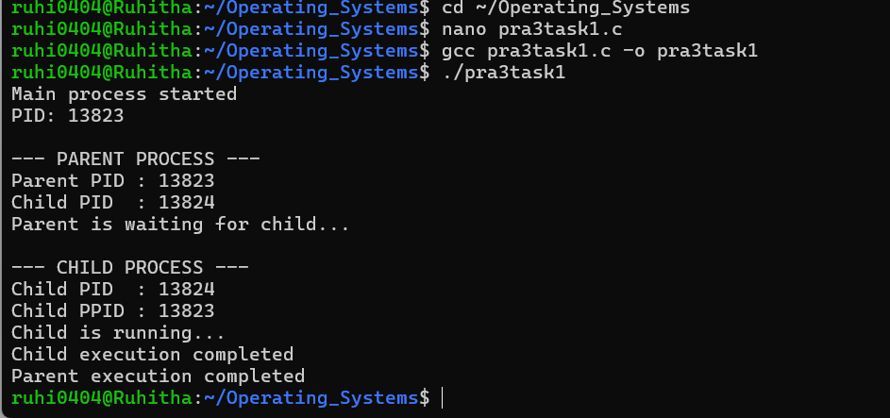
Task 2: Design an experiment to observe process state transitions(Ready, Running, Waiting,Terminated) using Linux monitoring tools such as ps, top and /proc.Document the observations.
