PRACTICAL -1

Task 1: Develop a C program that demonstrates how a Linux BTL operating system executes a command entered by a user that 1. Accept a Linux command as input. 2. Create a child process using fork(). 3. Execute the command in the child 4 process using an appropriate exec() system call. 4. Allow the parent process to wait for the child using wait O. 5. Display the Process ID (PID) of both parent and child processes.
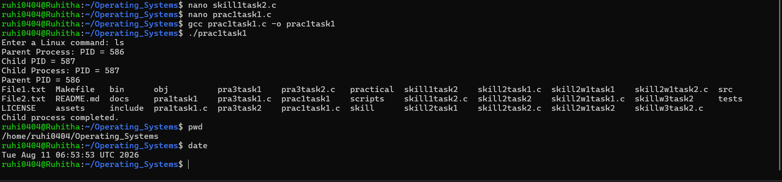
Observation: The program successfully accepts a Linux command from the user and creates a child process using fork(). The child process executes the entered command using execlp(), while the parent process waits for the child using wait(). The PIDs of both the parent and child processes are displayed, demonstrating process creation, command execution, and parent-child process synchronization in Linux.

Task 2: Using Linux terminal commands (uname, Iscpu, Isblk, PS, top), investigate the relationship between hardware resources and operating system services. Prepare a report explaining 4 how the OS abstracts CPU , memory, storage, and 1/0 devices.
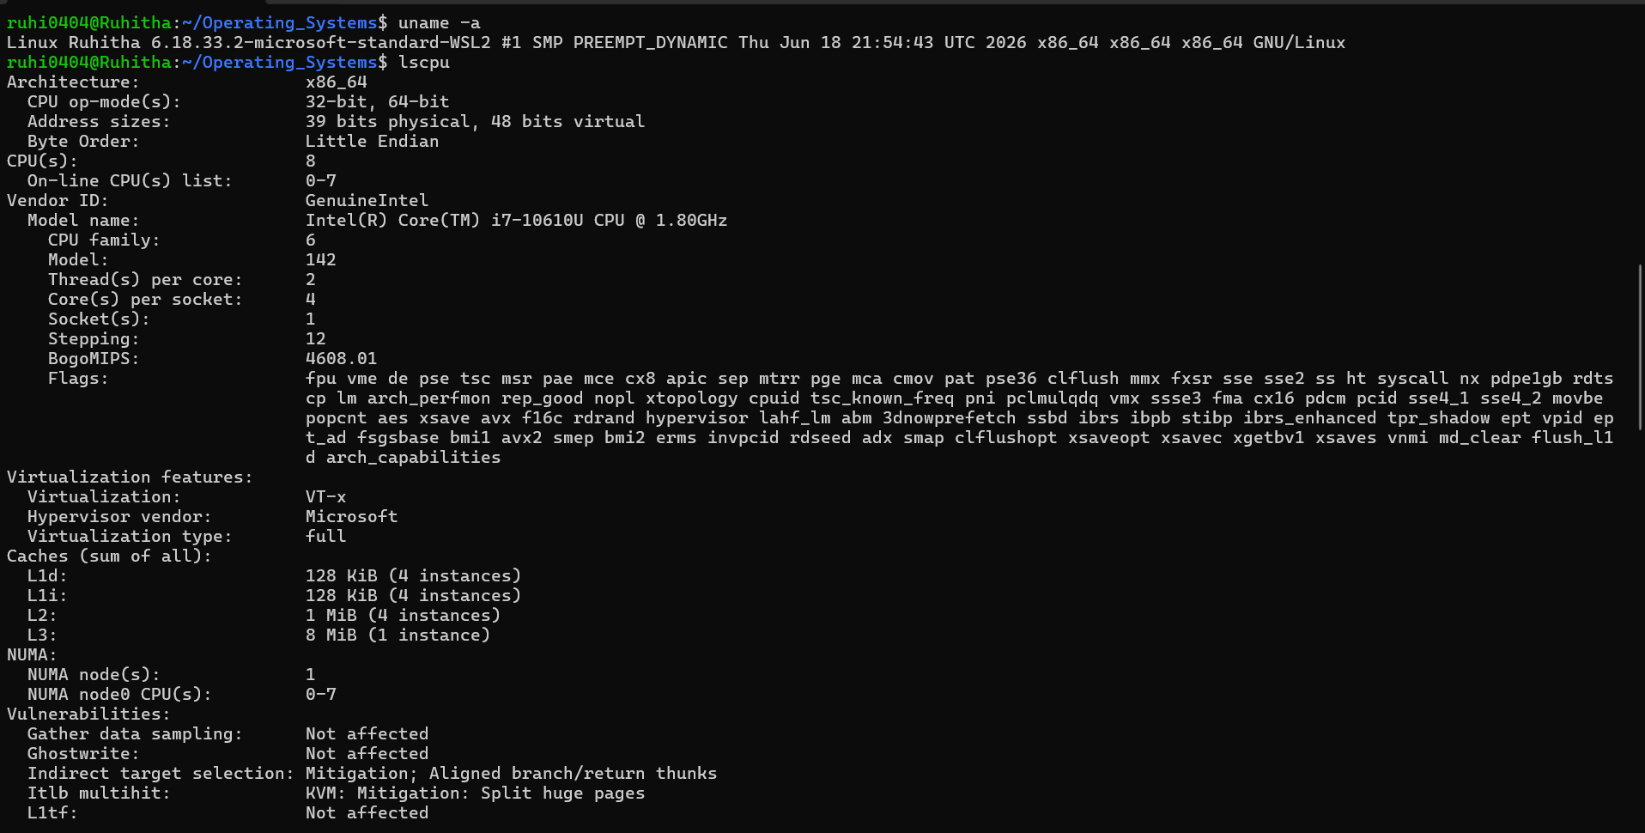
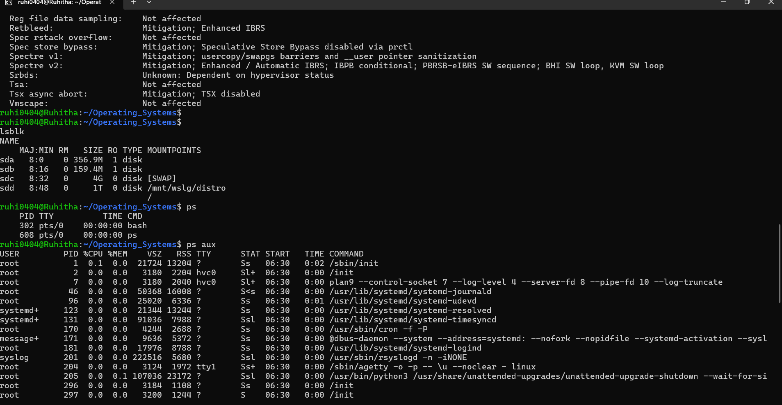
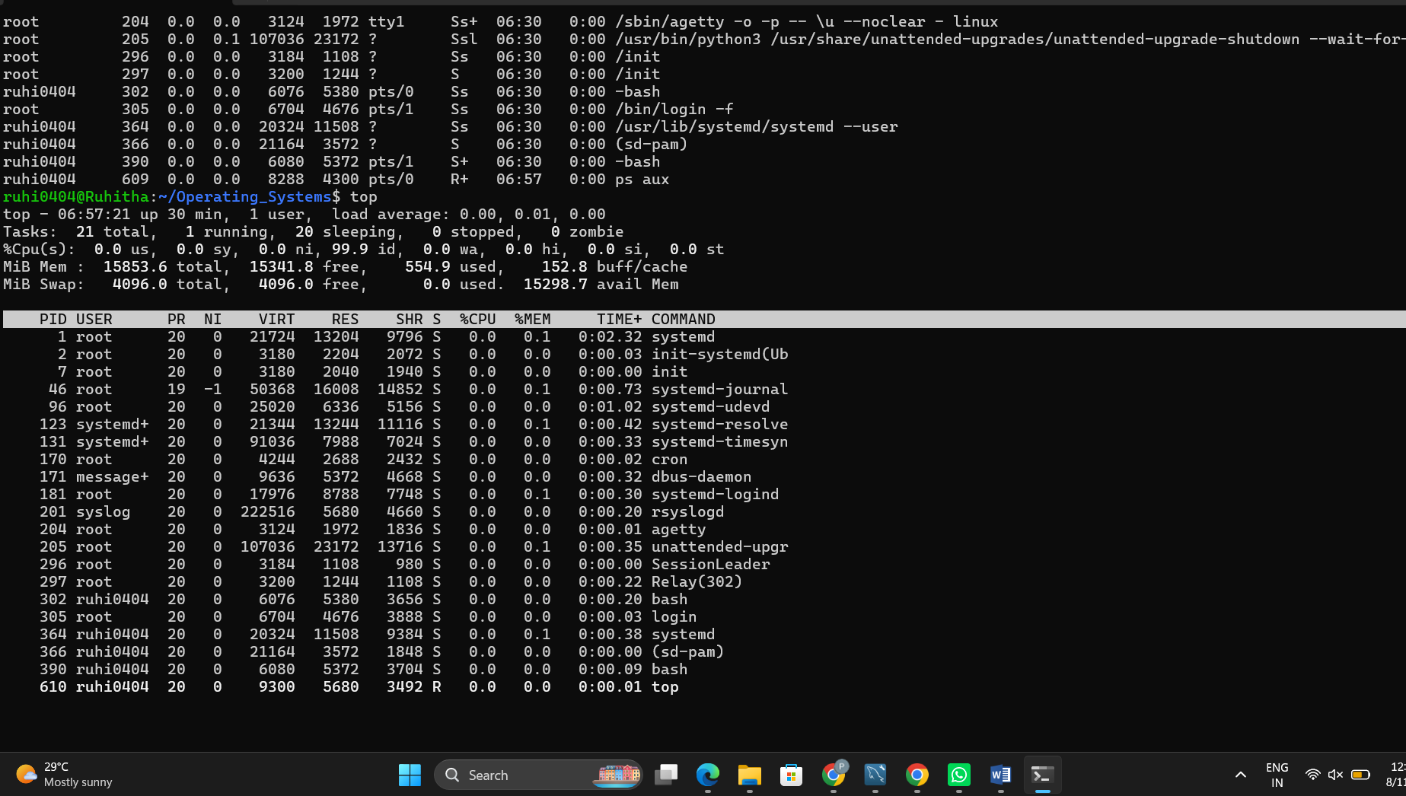

Observation
The Linux terminal commands were used to investigate the relationship between hardware resources and operating system services. The uname command provided information about the operating system and kernel. The lscpu command displayed CPU architecture, processor count, and CPU characteristics. The lsblk command displayed the available block storage devices and their partitions. The ps command displayed running processes, while top provided real-time information about processes, CPU usage, and memory usage.

How the OS abstracts hardware resources
1. CPU:
The operating system abstracts the CPU by providing processes and threads with CPU time without requiring applications to directly control the processor. The scheduler decides which process runs and for how long.
2. Memory:
The OS provides each process with its own virtual address space. Applications can use memory without needing to know the physical RAM locations. The OS manages allocation, protection, and virtual memory.
3. Storage:
The OS abstracts physical storage devices through files and directories. Applications can read and write files without directly controlling disk sectors. File systems and device drivers handle the underlying storage operations.
4. I/O Devices:
Input/output devices such as keyboards, displays, network cards, and USB devices are accessed through operating-system interfaces and device drivers. Applications do not normally need to communicate directly with the hardware.

