Übungen zu Web Design
Klaus Ruhland

Thema CSS Flexbox

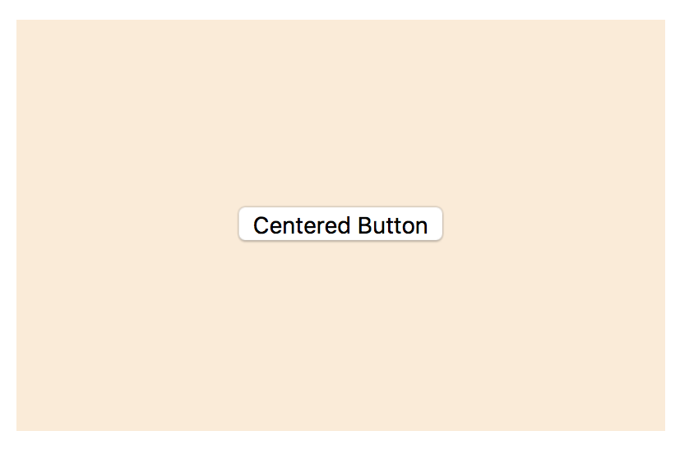  Zentrieren eines Elements in einem <div> | html  <div id="button-area">  <button>Centered Button</button>  </div>  CSS  #button-area {  display: flex;  align-items: center;  justify-content: center;  background-color: antiquewhite;  }
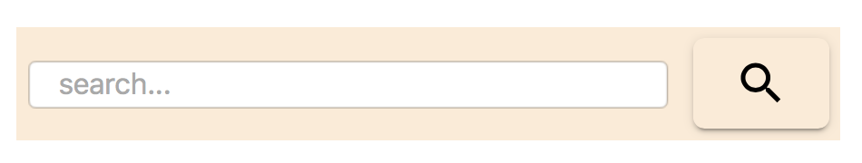  Suchfeld mit Button  flex: 1; bewirkt dass das input sich ausbreitet | html  <div id="search-area">  <input class="search-input" type="search"  placeholder="search..." />  <div class="search-button"></div>  </div>  CSS  #search-area {  display: flex;  align-items: center;  background-color: antiquewhite;  }  #search-area .search-input{  flex: 1;  margin-left: 5px;  margin-right: 5px;  min-width: 10px;  }  #search-area .search-button{  background-image:  url("./baseline-search-24px.svg");  background-repeat: no-repeat;  background-position: center center;  width: 60px;  height: 40px;  margin: 5px;  border-radius: 5px;  }

Button-Leiste  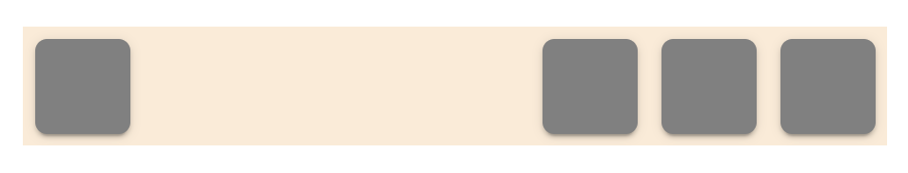  margin-right: auto;  beim ersten Button bewirkt, dass die 3 Buttons rechtsbündig angeordnet sind | html  <div id="button-area">  <div class="fixed-button shift-rest"></div>  <div class="fixed-button"></div>  <div class="fixed-button"></div>  <div class="fixed-button"></div>  </div>  CSS  #button-area {  display: flex;  align-items: center;  justify-content: center;  background-color: antiquewhite;  }  #button-area .fixed-button {  width: 40px;  height: 40px;  background-color: grey;  margin: 5px;  border-radius: 5px;  }  #button-area .shift-rest{  margin-right: auto!important;  }

Suchfeld mit Paging  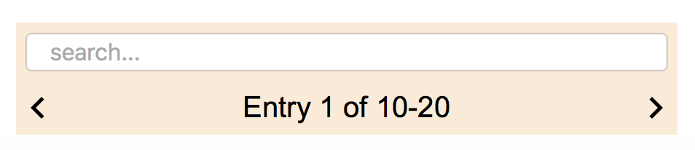  flex-wrap: wrap;  bewirkt einen Zeilenumbruch | html  <div id="paging-area">  <input class="paging-input" type="search"  placeholder="search..." />  <div class="paging-left-button"></div>  <div class="paging-text">Entry 1 of 10-20  </div>  <div class="paging-right-button"></div>  </div>  CSS  #paging-area {  display: flex;  align-items: center;  flex-wrap: wrap;  font-family: Arial;  background-color: antiquewhite;  }  #paging-area .paging-input{  margin: 5px;  font-size: inherit;  min-width: 10px;  width: 100%;  }  #paging-area .paging-left-button{  background-image:  url("./arrow_left-24px.svg");  background-repeat: no-repeat;  background-size: contain;  width: 24px;  height: 24px;  }  #paging-area .paging-text{  flex: 1;  text-align: center;  }  #paging-area .paging-right-button{  background-image:  url("./arrow_right-24px.svg");  background-repeat: no-repeat;  background-size: contain;  width: 24px;  height: 24px;  }

