CAOS Assignment 1

Make your own shell

Commands being executed:

Internal:
cd’, ‘echo’, ‘history’, ‘pwd’ and ‘exit’

External:
ls’, ‘cat’, ‘date’, ‘rm’ and ‘mkdir’

For external commands, all options such as ‘-v’, i.e. verbose flag, ‘-r’, ‘-f’, etc. all will work in this shell
For internal command, ‘echo’, option ‘-n’ and ‘-E’ will work.
For internal command, ‘history’, option ‘-c’ and ‘-n’ will work.
For internal command ‘pwd’, option ‘-L’ and ‘-P’ will work.
Error cases such as trying to remove an invalid directory, using a wrong option for pwd, using echo for a blank line, trying to open a file that does not exist, trying to create a directory with the same name, etc. are handled by the shell

Screenshots are attached below to show the working of the shell:

Makefile:

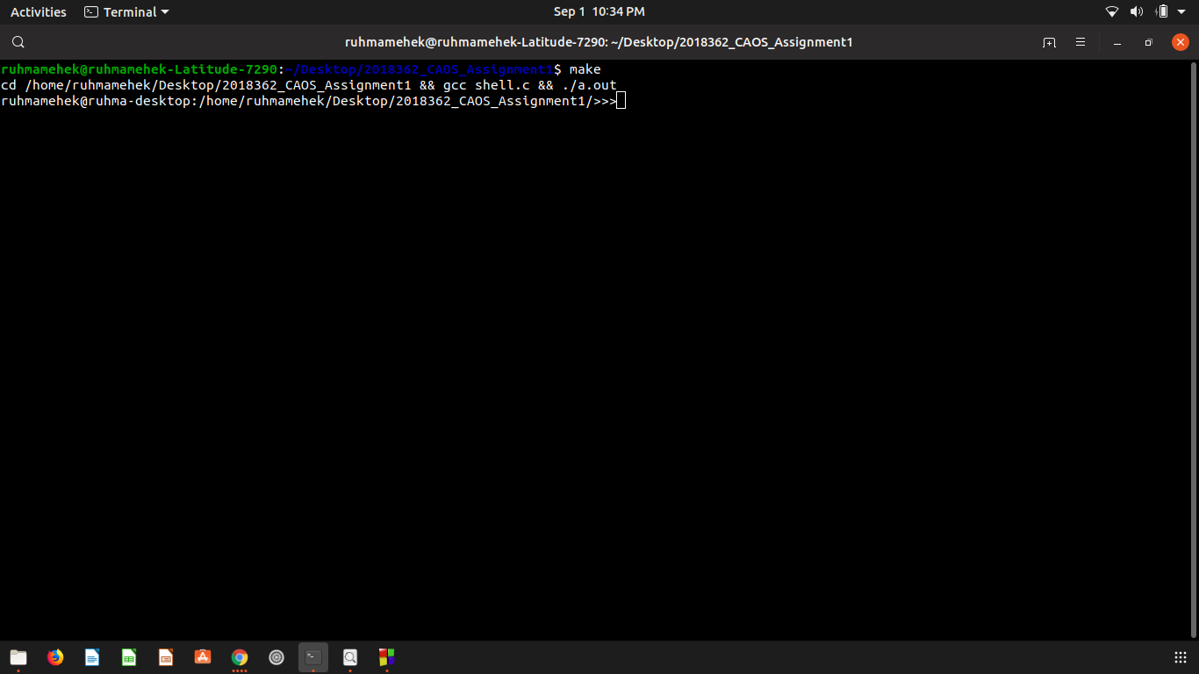

Shell commands:

