Samurai => Read Me !

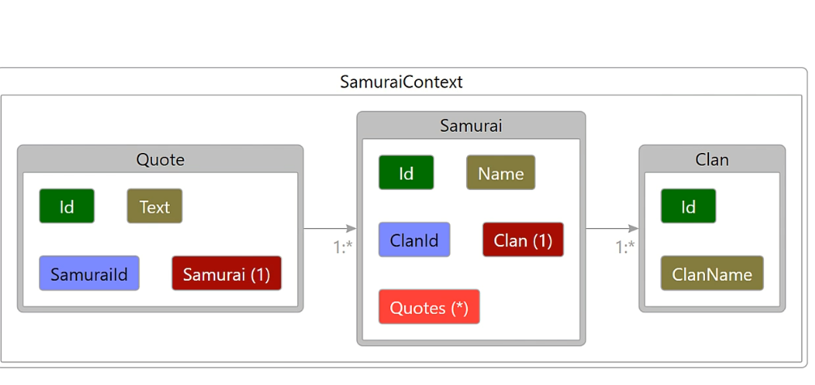

-----------------------------------------------------------------------------------------------------------------------------------------

**_/\__**

**---==/ \\**

**___ ___ |. \|\**

**| __|| __| | ) \\\**

**| _| | _| \_/ | //|\\**

**|___||_| / \\\/\\**

**Add Package** =>

**Entity Framework Core Tools** for the NuGet Package Manager Console in Visual Studio.

Enables these commonly used commands:

**Add-Migration**

Drop-Database

Get-DbContext

Get-Migration

Remove-Migration

Scaffold-DbContext

Script-Migration

**Update-Database**

-----------------------------------------------------------------------------------------------------------------------------------

**CLI :**

**get-help entityframework => Add To Data And Console => Microsoft.EntityFrameworkCore.Design**