# Recipes

You need to add 17 things to this document. (Make sure to number them just as I did in the example.) It may be helpful to copy and paste this list and then fill it in as you go along. All image names must start with your location, e.g yellowstone_sunset.jpg unless you are using a link from the internet.

## Name of recipe

1. **Origin**: Italian, Korean, Mexican, American, etc, write unknown if unknown
2. **Source**: (Prefer own recipe, but you can add a link here.)
3. **Category**: Main Dish, Vegetarian, Comfort Food, Dessert, etc.
4. Primary Image of food
5. Name of file with food picture (make sure to add the picture to the proper Google Drive!)
6. Paragraph One about the recipe
7. **Recipe Ingredients – Just write Recipe Ingredients**
   1. Ingredient
   2. Ingredient
   3. Ingredient
   4. etc.
8. **Recipe Steps – Just write Recipe Steps**
   1. Step
   2. Step
   3. Step
   4. Step
9. **Additional Food images**

For the next three pictures you can just put the names of the files, you don't have to include the files in this drive, but you do need to add them to the proper Google Drive.

1. file name
2. Visual description of the image/movie
3. file name
4. Visual description of the image/movie
5. file name
6. Visual description of the image/movie
7. Your Name(s)

## Swedish Pancakes

1. **Origin**: Sweden
2. **Source**: Kristi, [true-north-kitchen.com](https://true-north-kitchen.com/swedish-pancakes-with-lingonberries/)
3. **Category**: Breakfast
4. 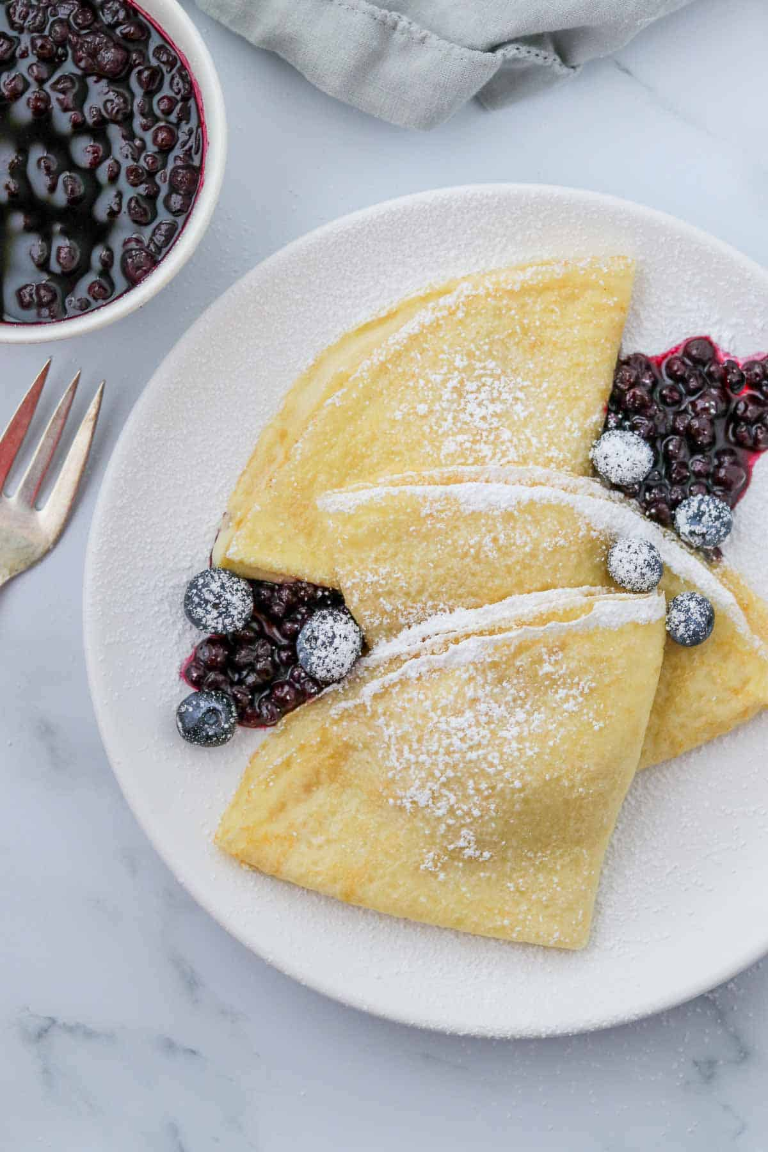
5. swedish-pancakes-platted.jpeg
6. Swedish pancakes (Pannkaka [singular] or Pannkakor [plural] in Swedish) are one of the most well-known Scandinavian delicacies, and rightfully so. Tender, buttery and often served with butter and lingonberry jam, there is much to account for their popularity.
7. **Recipe Ingredients**
   1. Butter
   2. Sugar
   3. Eggs
   4. Vanilla
   5. Milk
   6. Water
   7. Salt
   8. Flour
8. **Recipe Steps**
   1. Combine all ingredients in a blender and blend until completely smooth.Transfer to the refrigerator to rest for at least 2 hours or up to 2 days.
   2. Preheat the oven to 200 degrees if you plan to eat the pannkakor right away. Heat a 10 inch nonstick skillet over medium heat. Stir the batter briefly to recombine. Brush skillet with melted butter. Pick the skillet up off of the burner and quickly add ¼ cup of batter. Immediately begin swirling the batter around the skillet so that it coats the bottom of the pan. Continue swirling until the batter is just set. Return skillet to the burner. Cook until the pancake is golden brown in spots on the bottom, about 30 seconds. Use a thin spatula to loosen the pancake, flip it over continue to cook on the other side for about 30 seconds. Transfer to a plate. Cover with foil and transfer to oven to keep warm and repeat with remaining batter, wiping out skillet in between pancakes with paper towel as needed.
   3. Serve with lingonberry jam and butter (see note below) or other desired toppings and/or fillings. See notes below for more information about making ahead of time and storing in the refrigerator or freezer.
9. **Additional Food images**

For the next three pictures you can just put the names of the files, you don't have to include the files in this drive, but you do need to add them to the proper Google Drive.

1. swedish-pancakes-platted.jpeg
2. Three Swedish pancakes folded with a dusting of powdered sugar and berries on a plate.
3. <https://true-north-kitchen.com/wp-content/uploads/2023/08/traditional-swedish-pancakes-pannkakor-1.jpg>
4. swedish-pancakes-pan.jpeg
5. A thin layer of pancake batter cooking in a stainless steel pan.
6. <https://true-north-kitchen.com/wp-content/uploads/2020/12/swedish-pancakes-9.jpg>
7. Alyssa Sklar