# Travel

You need to add 25 things to this document. (Make sure to number them just as I did in the example.) It may be helpful to copy and paste this list and then fill it in as you go along. All image names must start with your location, e.g yellowstone_sunset.jpg unless you are using a link from the internet.

[Link to Travel Files](https://drive.google.com/drive/folders/1q5vIvE3hqb4EL_0czgf-xbAWGyGAP2fc)

## Location: London, United Kingdom

1. London_Cityscape.jpg

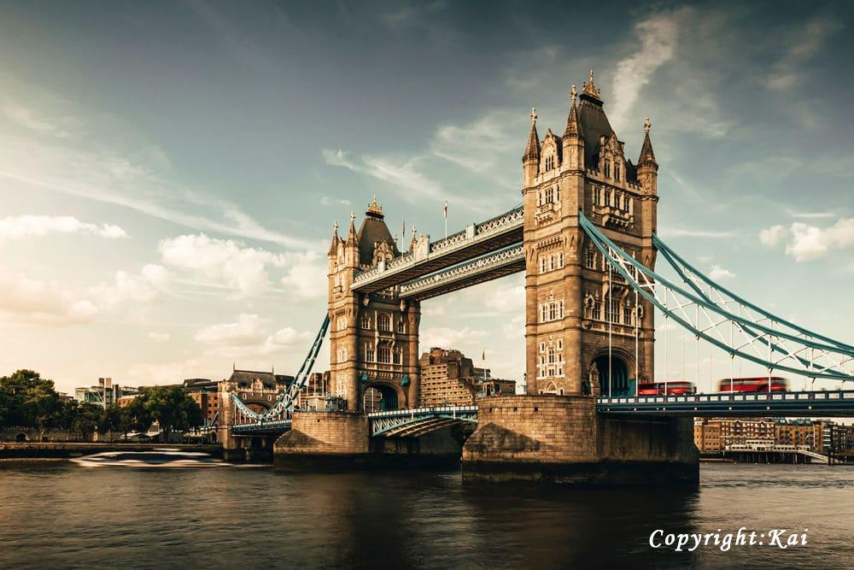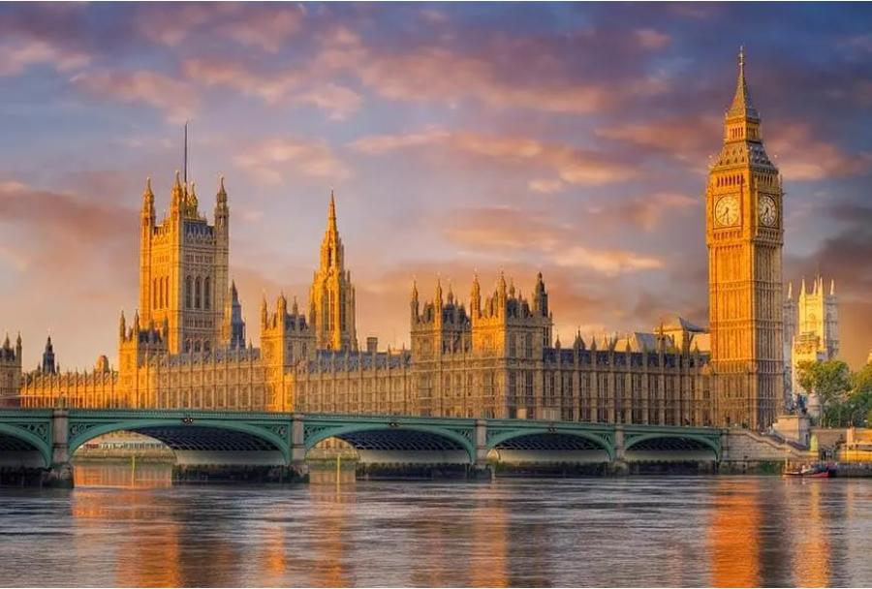

1. London_Kings_Cross_Station.jpg

Mexico_Guanajuato_Colourful town.jpg

Mexico_Guanajuato Night (2).jpg

1. Geographical Location: London, United Kingdom
2. Paragraph One about the location

As one of the most iconic cities in the world, London carries a rich history that is matched by its continuous growth and evolution. A powerhouse of culture, politics, and finance, it stands as a city where the past and present exist harmoniously side by side. From the ancient towers that narrate tales of a regal past to modern architectural marvels that reach for the skies, London offers an unrivaled blend of history and modernity.

1. Paragraph Two about the location.

As one of the most iconic cities in the world, London carries a rich history that is matched by its continuous growth and evolution. A powerhouse of culture, politics, and finance, it stands as a city where the past and present exist harmoniously side by side. From the ancient towers that narrate tales of a regal past to modern architectural marvels that reach for the skies, London offers an unrivaled blend of history and modernity.

1. **Photo Gallery – (Just write Photo Gallery)**
2. London_Big_Ben.jpg
3. Big Ben stands tall as a testament to London's historical grandeur, its chimes echoing tales of times gone by.
4. London_Tower_Bridge.jpg
5. The Tower Bridge, a symbol of engineering marvel and historical significance, stretches across the River Thames with its iconic twin towers.
6. London_Westminster_Abbey.jpg
7. Westminster Abbey, an architectural masterpiece, has been the setting for countless royal ceremonies, weaving itself seamlessly into the fabric of British history.
8. London_Cityscape.jpg
9. The expansive London skyline, a blend of the old and new, offers a panoramic view that captures the city's essence, where history meets modernity.
10. London_Kings_Cross_Station.jpg
11. King's Cross Station, more than just a transport hub, is a symbol of London's continuous evolution, and the magical lore associated with it beckons to fans of literature and adventure alike.

**Name:Kai**