# Travel

You need to add 25 things to this document. (Make sure to number them just as I did in the example.) It may be helpful to copy and paste this list and then fill it in as you go along. All image names must start with your location, e.g yellowstone_sunset.jpg unless you are using a link from the internet.

[Link to Travel Files](https://drive.google.com/drive/folders/1q5vIvE3hqb4EL_0czgf-xbAWGyGAP2fc)

## Location: GuaMexico

1. Primary Image of Location as a jpg

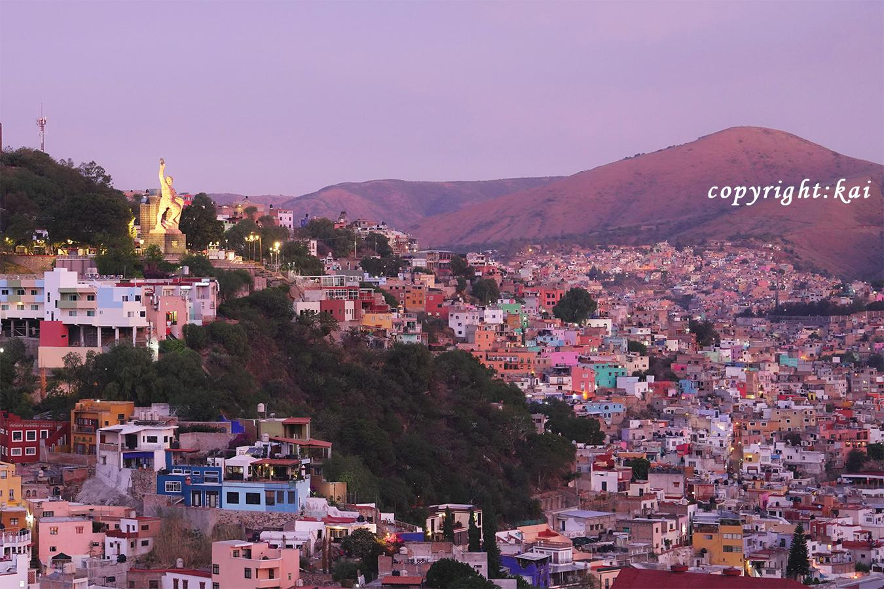

1. Primary Image of Location as jpg

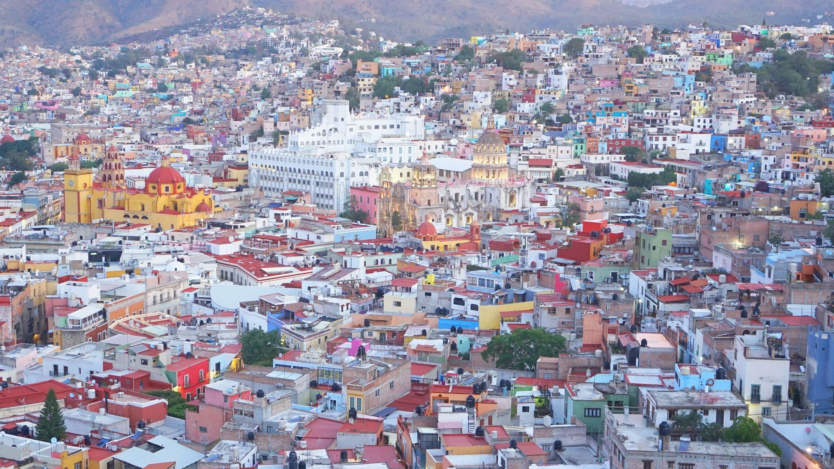

Mexico_Guanajuato_Colourful town.jpg

Mexico_Guanajuato Night (2).jpg

1. **Geographical Location**: Guanajuato， Mexico
2. Paragraph One about the location

As the sun dips low in the sky, Guanajuato, the vibrant small town in Mexico, unfolds a spectacular tableau of hues and shadows that bewitch every onlooker. The historic town, celebrated as the backdrop for the acclaimed animation "Coco," transforms into a realm of dreams. Its vividly painted houses, basking in the warm golden glow of the evening sun, offer a picturesque sight that resonates deeply with the joyous and spirited theme of the beloved movie.

1. Paragraph Two about the location.

Guanajuato at twilight is a painting that comes to life, a perfect blend of reality and the fantastic world depicted in "Coco." The array of colors presented by the quaint houses form a harmonious canvas that radiates a tranquil yet vibrant energy as the day transitions to night. This little town, full of life and color, offers a surreal experience, inviting dreamers and artists alike to immerse themselves in its poetic scenery, alive with stories and rich cultural tapestry.

1. **Photo Gallery – (Just write Photo Gallery)**
2. Mexico_Plaza.jpg
   1. The Mexico Plaza teems with vibrant life as locals and visitors alike gather amidst historic architecture
3. Mexico_Chichen Itza.jpg
   1. Chichen Itza showcases the grandeur of Mayan civilization through its iconic, steeply-tiered pyramids."
4. Mexcio_Teotihuacan.jpg
   1. Teotihuacan mesmerizes with its immense pyramids, tracing back to a pre-Aztec civilization steeped in mystery..
5. Mexico_Guanajuato_Colourful town
   1. Guanajuato greets visitors with a burst of colors, where every street corner offers a vibrant tableau echoing stories of a rich history.
6. Mexico_Guanajuato Night (2)
   1. As night falls, Guanajuato transforms into a magical spectacle, with golden lights illuminating the vivid, multicolored façades, offering a surreal and romantic atmosphere that enchants every visitor.

**Name:Kai**