🎓 CoE Academic Document Processing — Complete Workflow Guide
**Office of the Controller of Examinations (CoE)**

BAUST Student Document Application Portal

📋 What is this system?
Students at BAUST who need official academic documents (certificates, transcripts, grade sheets, recommendation letters, etc.) must formally apply through the CoE Portal. This system manages the entire journey — from the student's online application all the way to physical document handover at the CoE Desk — with SMS notifications at every major step.
🗂️ Supported Document Types
# | Document | Who Needs It
1 | Main / Original Certificate | Final year graduates
2 | Provisional / Main Academic Transcript | Job or higher study applications
3 | Incomplete Academic Transcript | Mid-study applications
4 | Student's Name Correction | Name mismatch with NID/Board certificate
5 | Father/Mother Name Correction | Parent name mismatch
6 | Recommendation Letter | Scholarship, visa, job purpose
7 | Grade Sheet | Specific semester/term grade record
8 | Duplicate Documents (as per GD) | Replacement for lost documents

👥 Who is Involved?

🔄 Full Application Lifecycle — At a Glance
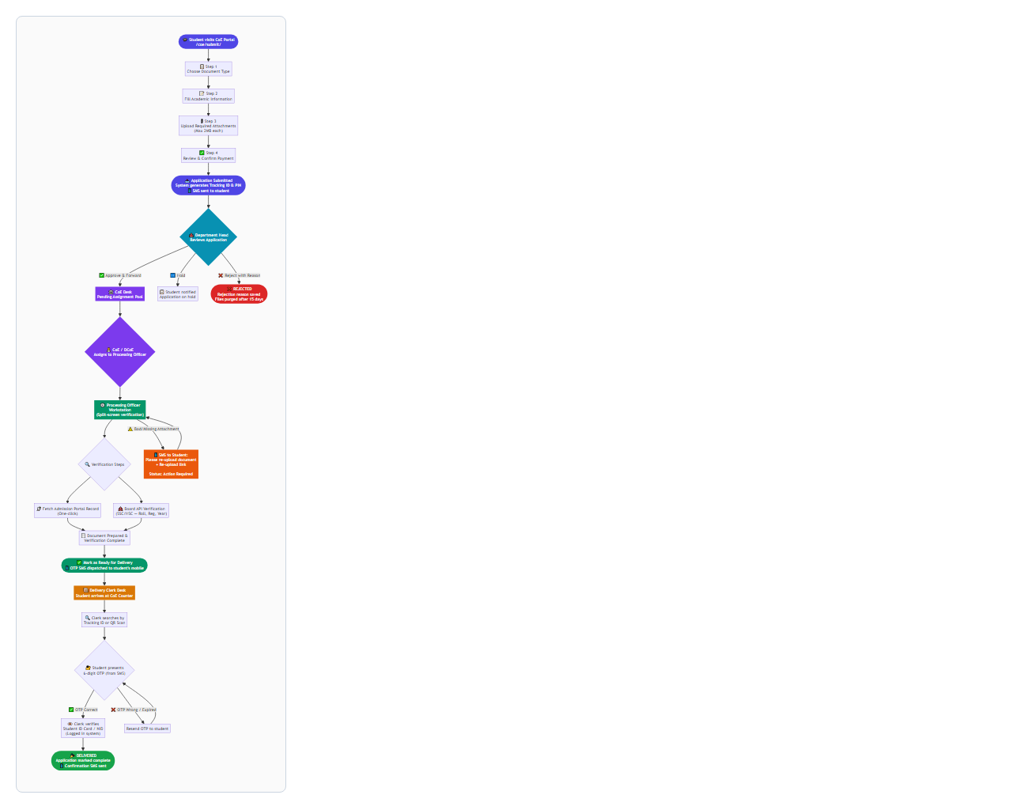
🔢 Application Status — Complete State Map
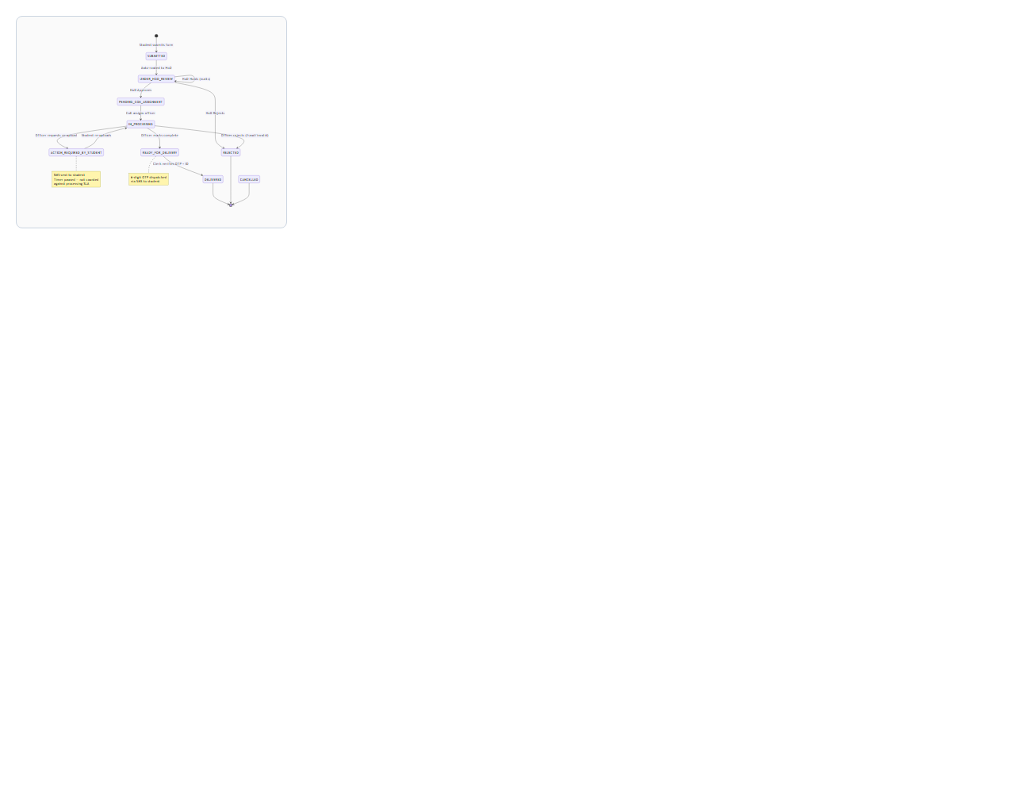
🎓 Role 1 — Student (Public Portal, No Login Required)

🏫 Role 2 — Department Head (HoD)
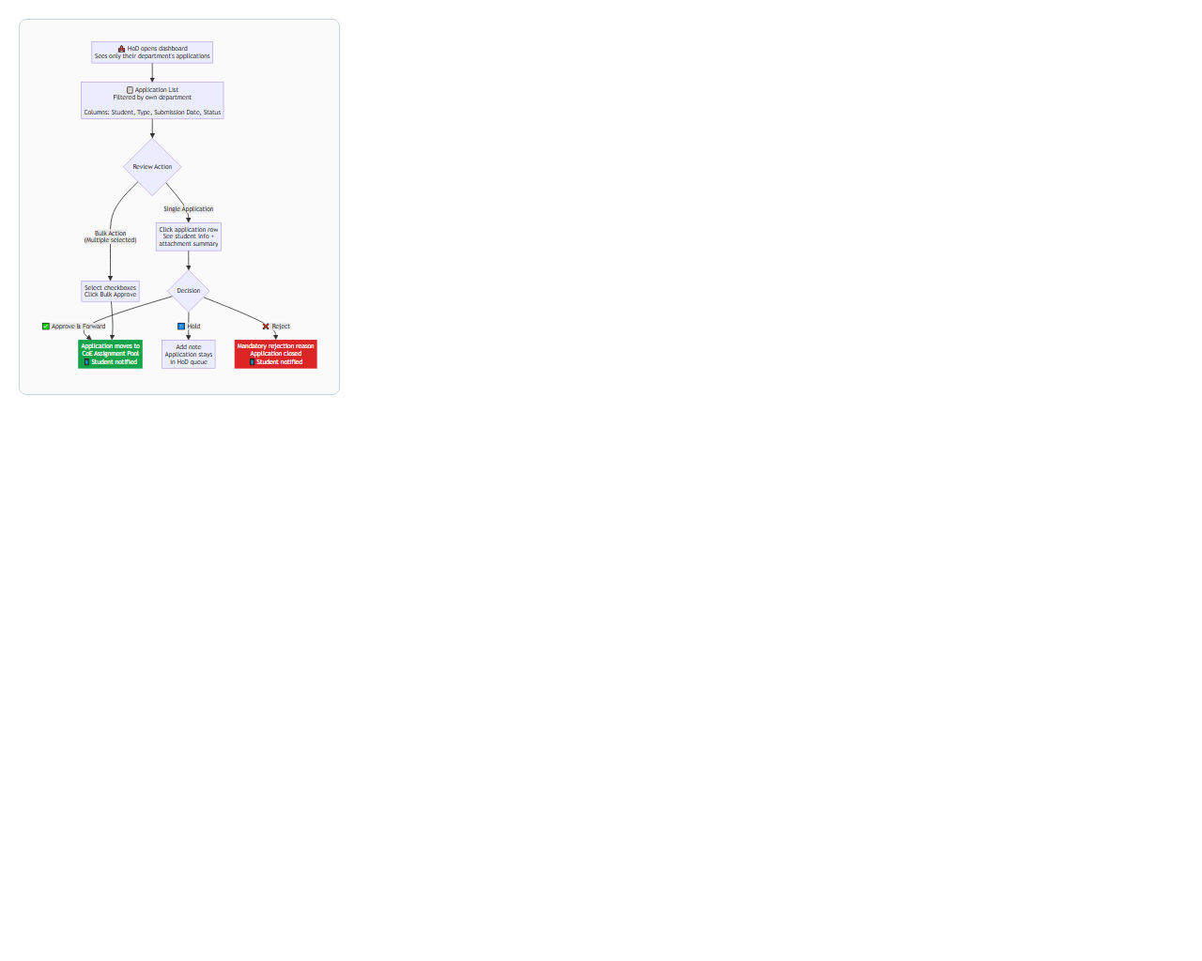
🏛️ Role 3 — CoE / Deputy CoE (Assignment Kanban Desk)
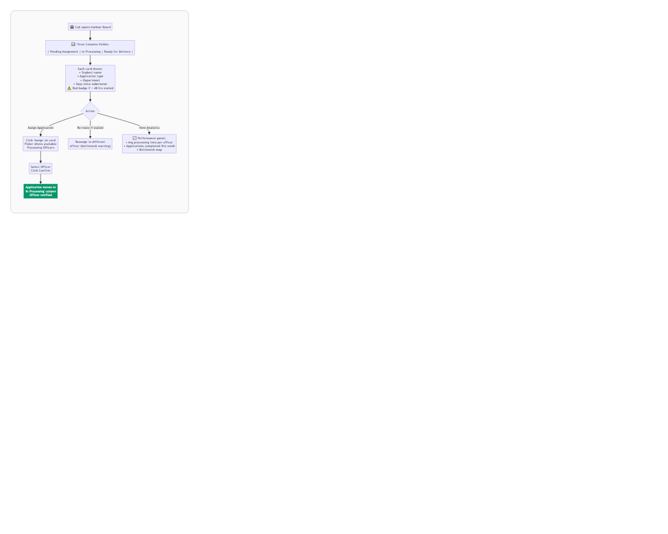
⚙️ Role 4 — Processing Officer (Verification Workstation)
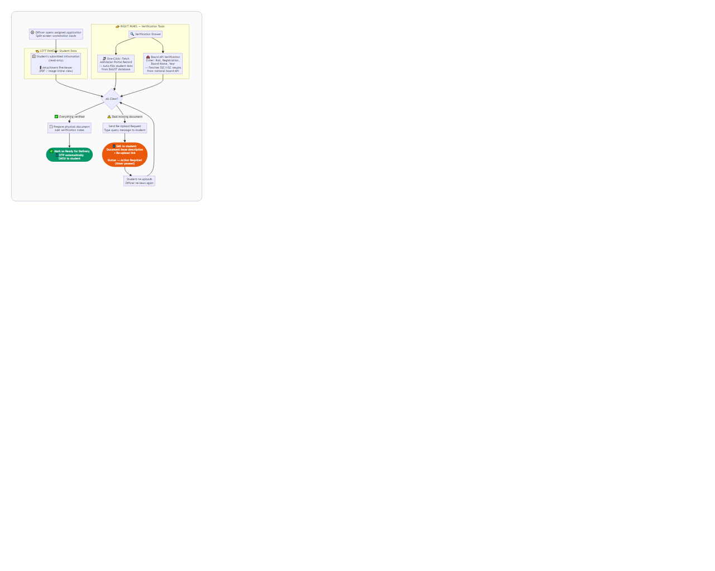
📦 Role 5 — Delivery Clerk (Counter Desk)
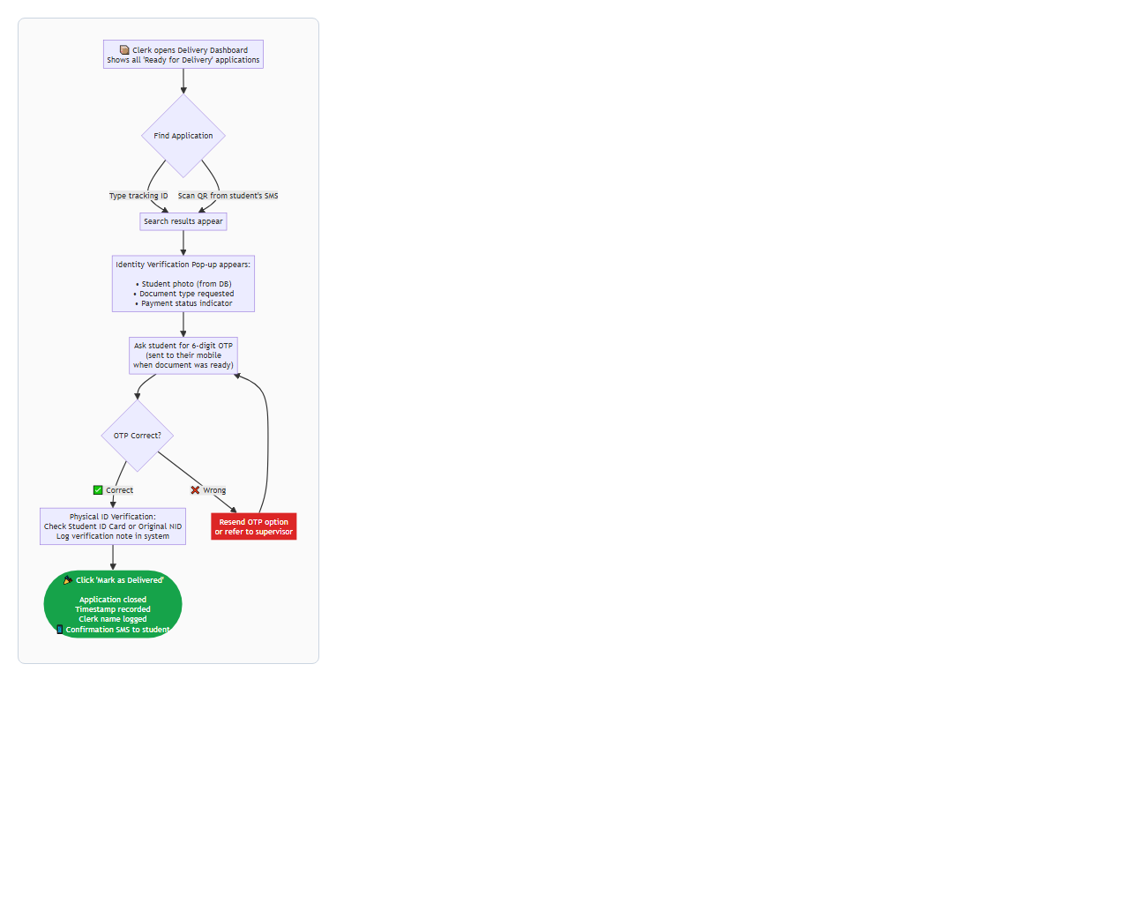
📱 SMS Notifications — Full Reference
Event | Who Receives | Message (in Bangla)
📤 Application Submitted | Student | Tracking ID + PIN provided
✅ HoD Approved | Student | Application forwarded to CoE
⚠️ Action Required | Student | Issue description + re-upload link
📄 Ready for Delivery | Student | Document ready to collect + OTP
🔁 OTP Resent | Student | New 6-digit OTP
🎉 Delivered | Student | Confirmation of document handover
❌ Rejected | Student | Rejection reason

🗄️ Data Retention Policy
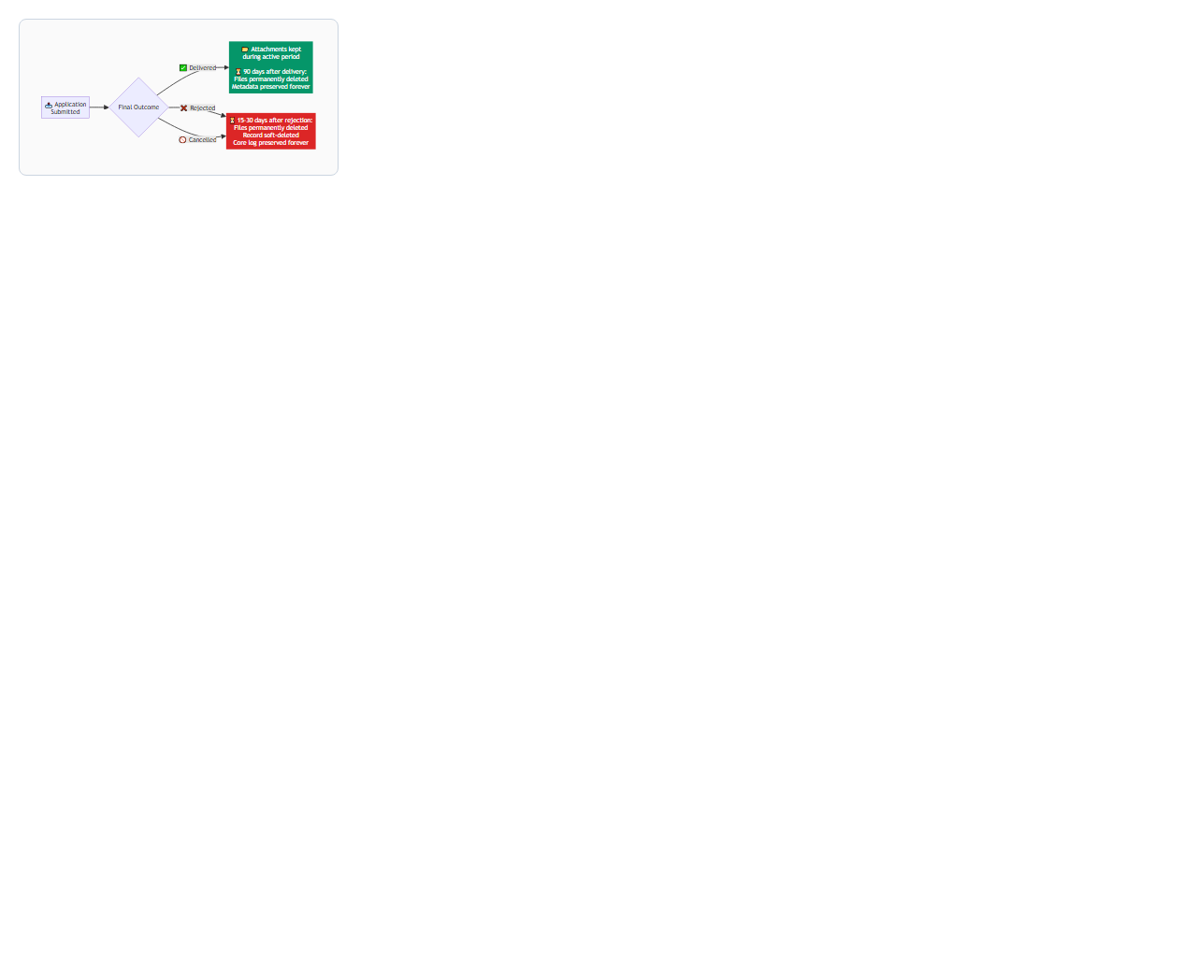
**Why?** To keep server storage lean while preserving historical reporting integrity. All transaction records (who applied, what was processed, dates) remain permanently — only uploaded files are removed after the retention window.

🔐 Security Measures Summary
Risk | Protection
Anyone claiming a document at counter | 6-digit OTP must be provided (sent only to student's registered mobile)
Forged payment slips | Officer manually verifies at Processing Workstation; future: bKash/SSLCommerz integration
Unreadable/fraudulent attachments | Action Required state with officer query + student re-upload (workflow paused, not cancelled)
Application tracking without login | Requires Tracking ID + Mobile Number (two-factor lookup)
Stale data accumulating | Automated cron cleanup after retention windows

📌 Quick Reference — Department Head Checklist
- ☐ Log in to the portal
- ☐ Go to CoE → HoD Dashboard
- ☐ Review pending applications in your department
- ☐ Check attached documents in each application
- ☐ Click Approve & Forward / Hold / Reject with Reason
- ☐ For bulk clear cases: use Select All → Bulk Approve
📌 Quick Reference — Processing Officer Checklist
- ☐ Log in to the portal
- ☐ Go to CoE → Processing Workstation
- ☐ Open your assigned application
- ☐ Click Fetch Admission Record (right panel)
- ☐ Fill in Board details → Click Verify Board
- ☐ Review all attachments in the left panel
- ☐ If issue: click Request Re-Upload → type message
- ☐ When all clear: click Mark as Ready for Delivery
📌 Quick Reference — Delivery Clerk Checklist
- ☐ Student arrives at CoE Counter
- ☐ Open CoE → Delivery Desk
- ☐ Search by Tracking ID or scan QR
- ☐ Identity verification pop-up appears — confirm student matches
- ☐ Ask student for the 6-digit OTP from their SMS
- ☐ Enter OTP → if correct, click Mark as Delivered
- ☐ System logs delivery with your name, time, and OTP confirmation

