

# Course Title: Microprocessor interfacing and embedded system (3 Cr)

**Team project**

**Semester**: Summer 2019

**Group: 5**

**Section:**

**Names, Student IDs and emails:**

Implement the given encryption table using microcontroller. Use single pole, double throw switch to configure the inputs for high and low conditions. Use LEDs to represent the corresponding output statuses

|  |  |  |  |  |  |  |  |
| --- | --- | --- | --- | --- | --- | --- | --- |
| **Input** | | | | **Output** | | | |
| I3 | I2 | I1 | I0 | O3 | O2 | O2 | O1 |
| 0 | 0 | 0 | 0 | 0 | 1 | 0 | 1 |
| 1 | 0 | 0 | 0 | 1 | 1 | 0 | 0 |
| 0 | 1 | 0 | 0 | 1 | 1 | 1 | 0 |
| 1 | 1 | 0 | 0 | 0 | 0 | 0 | 1 |
| 0 | 0 | 1 | 0 | 0 | 1 | 1 | 1 |
| 1 | 0 | 1 | 0 | 0 | 0 | 1 | 0 |
| 0 | 1 | 1 | 0 | 0 | 1 | 1 | 0 |
| 1 | 1 | 1 | 0 | 0 | 1 | 0 | 0 |
| 0 | 0 | 0 | 1 | 1 | 1 | 0 | 0 |
| 1 | 0 | 0 | 1 | 0 | 0 | 0 | 0 |
| 0 | 1 | 0 | 1 | 0 | 1 | 1 | 0 |
| 1 | 1 | 0 | 1 | 1 | 0 | 1 | 1 |
| 0 | 0 | 1 | 1 | 0 | 0 | 0 | 0 |
| 1 | 0 | 1 | 1 | 0 | 0 | 1 | 1 |
| 0 | 1 | 1 | 1 | 1 | 0 | 1 | 1 |
| 1 | 1 | 1 | 1 | 0 | 0 | 1 | 1 |

Hints for deriving the logic expression:

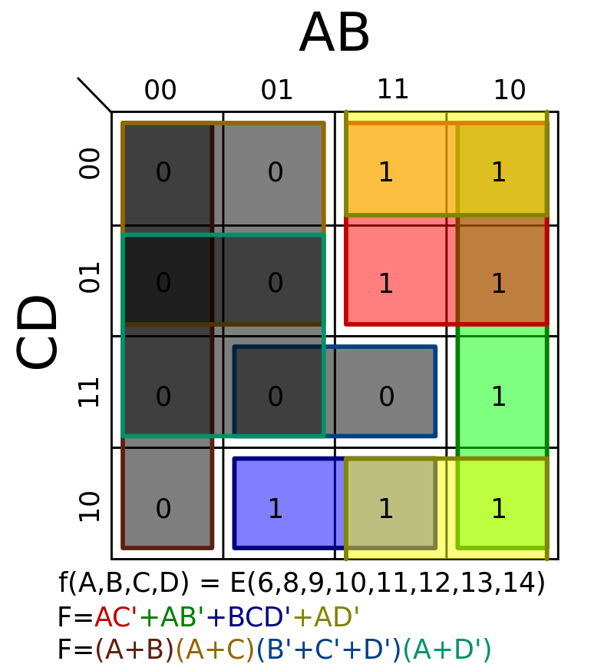

Example microcontroller: (Arduino UNO)

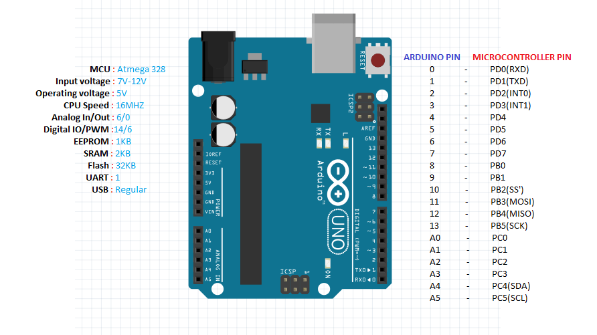

**Supporting materials**

1. Proteus design suite
2. Google