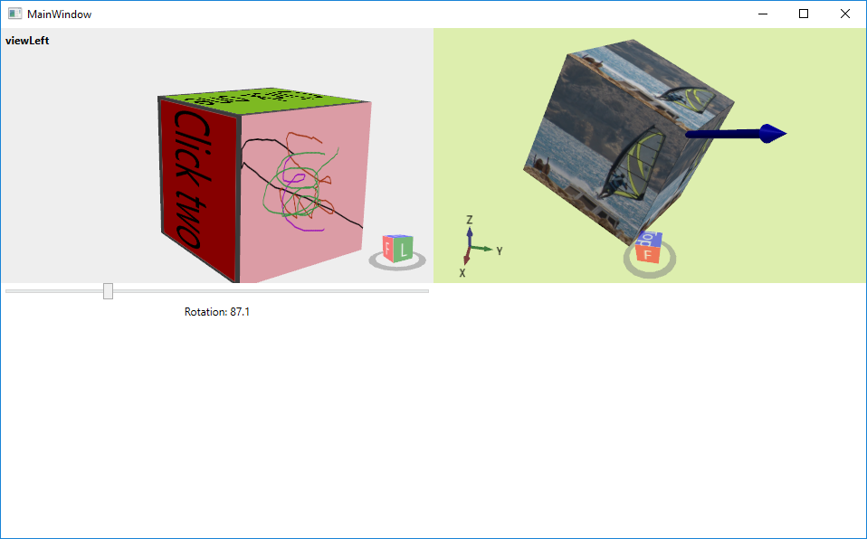

# Lehrinhalt

* HelixToolkit
* MeshGeometry3D (Positions, TriangleIndices, TextureCoordinates)
* Viewport2DVisual3D (für Steuerelemente)
* ModelUIElement3D (erlaubt Events)
* InkCanvas

# MainWindow.xaml

<Window x:Class="BrowserOnCube.MainWindow"

xmlns="http://schemas.microsoft.com/winfx/2006/xaml/presentation"

xmlns:x="http://schemas.microsoft.com/winfx/2006/xaml"

xmlns:d="http://schemas.microsoft.com/expression/blend/2008"

xmlns:mc="http://schemas.openxmlformats.org/markup-compatibility/2006"

xmlns:helix="http://helix-toolkit.org/wpf"

xmlns:local="clr-namespace:BrowserOnCube"

mc:Ignorable="d"

Title="MainWindow" Height="350" Width="525">

<UniformGrid Columns="2">

<helix:HelixViewport3D Background="#EEEEEE" Name="viewLeft">

<helix:DefaultLights/>

<helix:RotateManipulator/>

<Viewport2DVisual3D>

<Viewport2DVisual3D.Material>

<DiffuseMaterial Viewport2DVisual3D.IsVisualHostMaterial="True" Brush="GreenYellow"/>

</Viewport2DVisual3D.Material>

<Viewport2DVisual3D.Geometry>

<MeshGeometry3D Positions="-1,1,1 -1,-1,1 1,-1,1 1,1,1"

TriangleIndices="0,1,2 2,3,0"

TextureCoordinates="0,0 0,1 1,1 1,0"/>

</Viewport2DVisual3D.Geometry>

<Viewport2DVisual3D.Visual>

<StackPanel>

<Button Content="Click one" Click="button_Click" Background="GreenYellow"/>

</StackPanel>

</Viewport2DVisual3D.Visual>

</Viewport2DVisual3D>

<Viewport2DVisual3D>

<Viewport2DVisual3D.Material>

<DiffuseMaterial Viewport2DVisual3D.IsVisualHostMaterial="True" Brush="Red"/>

</Viewport2DVisual3D.Material>

<Viewport2DVisual3D.Geometry>

<MeshGeometry3D Positions="1,1,1 1,-1,1 1,-1,-1 1,1,-1"

TriangleIndices="0,1,2 2,3,0"

TextureCoordinates="0,0 0,1 1,1 1,0"/>

</Viewport2DVisual3D.Geometry>

<Viewport2DVisual3D.Visual>

<StackPanel>

<Button Content="Click two" Click="button_Click" Background="Red"/>

</StackPanel>

</Viewport2DVisual3D.Visual>

</Viewport2DVisual3D>

<Viewport2DVisual3D>

<Viewport2DVisual3D.Material>

<DiffuseMaterial Viewport2DVisual3D.IsVisualHostMaterial="True" Brush="LightBlue"/>

</Viewport2DVisual3D.Material>

<Viewport2DVisual3D.Geometry>

<MeshGeometry3D Positions="-1,1,-1 -1,1,1 1,1,1 1,1,-1"

TriangleIndices="0,1,2 2,3,0"

TextureCoordinates="0,0 0,1 1,1 1,0"/>

</Viewport2DVisual3D.Geometry>

<Viewport2DVisual3D.Visual>

<StackPanel>

<InkCanvas

Background="LightPink"

Name="inkCanvas"

MouseLeftButtonUp="inkCanvas_MouseLeftButtonUp"/>

</StackPanel>

</Viewport2DVisual3D.Visual>

</Viewport2DVisual3D>

</helix:HelixViewport3D>

<helix:HelixViewport3D Background="#DDEEAE" ViewCubeTopText="Top" ViewCubeHorizontalPosition="Center" Name="viewRight"

ShowCoordinateSystem="True">

<helix:DefaultLights/>

<helix:RotateManipulator/>

<helix:ArrowVisual3D Point1="-1,-1,-1" Point2="2,2,2" Diameter="0.1"/>

<ModelUIElement3D x:Name="cubeRight" MouseEnter="cubeRight_MouseEnter" MouseLeave="cubeRight_MouseLeave">

<GeometryModel3D x:Name="cubeRightModel3D">

<GeometryModel3D.Material>

<DiffuseMaterial>

<DiffuseMaterial.Brush>

<ImageBrush ImageSource="Jibe.png"/>

</DiffuseMaterial.Brush>

</DiffuseMaterial>

</GeometryModel3D.Material>

<GeometryModel3D.BackMaterial>

<DiffuseMaterial Brush="LightBlue"/>

</GeometryModel3D.BackMaterial>

<GeometryModel3D.Geometry>

<MeshGeometry3D Positions="-1,1,1 -1,-1,1 1,-1,1 1,1,1

1,1,1 1,-1,1 1,-1,-1 1,1,-1

-1,1,-1 -1,1,1 1,1,1 1,1,-1"

TriangleIndices="0,1,2 2,3,0

4,5,6 6,7,4

8,9,10 10,11,8"

TextureCoordinates="0,0 0,1 1,1 1,0

0,0 0,1 1,1 1,0

0,0 0,1 1,1 1,0"/>

</GeometryModel3D.Geometry>

</GeometryModel3D>

</ModelUIElement3D>

</helix:HelixViewport3D>

<StackPanel>

<Slider Name="sliderRotate" ValueChanged="sliderRotate_ValueChanged"

Minimum="0" Maximum="360" Value="10"/>

<Label Content="{Binding Path=Value, ElementName=sliderRotate}"

ContentStringFormat="Rotation: {0:0.0}" HorizontalAlignment="Center"/>

</StackPanel>

</UniformGrid>

</Window>

# MainWindow.xaml.cs

using System;

using System.Reflection;

using System.Windows;

using System.Windows.Controls;

using System.Windows.Media;

using System.Windows.Media.Imaging;

using System.Windows.Media.Media3D;

namespace BrowserOnCube

{

/// <summary>

/// Interaction logic for MainWindow.xaml

/// Install-Package HelixToolkit.Wpf

/// </summary>

public partial class MainWindow : Window

{

Random r = new Random();

public MainWindow()

{

InitializeComponent();

viewRight.ZoomExtentsWhenLoaded = true;

viewLeft.ZoomExtentsWhenLoaded = true;

viewLeft.Title = "viewLeft";

viewRight.Title = viewRight.TriangleCountInfo;

viewRight.TitleBackground = Brushes.Yellow;

}

private void button_Click(object sender, RoutedEventArgs e)

{

MessageBox.Show((sender as Button).Content.ToString());

cubeRightModel3D.Transform = new RotateTransform3D();

}

private void cubeRight_MouseEnter(object sender, System.Windows.Input.MouseEventArgs e)

{

cubeRightModel3D.Material = new DiffuseMaterial(Brushes.Red);

}

private void cubeRight_MouseLeave(object sender, System.Windows.Input.MouseEventArgs e)

{

ImageBrush ib = new ImageBrush();

// physikalische Ressource

ib.ImageSource = new BitmapImage(new Uri("../../Jibe.png", UriKind.Relative));

// oder zufälliges Bild mit 400x400 px

//ib.ImageSource = new BitmapImage(new Uri(

// "http://lorempixel.com/400/400/", UriKind.Absolute));

cubeRightModel3D.Material = new DiffuseMaterial(ib);

}

private void inkCanvas_MouseLeftButtonUp(object sender, System.Windows.Input.MouseButtonEventArgs e)

{

inkCanvas.DefaultDrawingAttributes.Color = Color.FromRgb(

(byte)r.Next(256),

(byte)r.Next(256),

(byte)r.Next(256));

}

private void sliderRotate_ValueChanged(object sender, RoutedPropertyChangedEventArgs<double> e)

{

RotateTransform3D rottrans = new RotateTransform3D();

AxisAngleRotation3D axisRot = new AxisAngleRotation3D(new Vector3D(1, 1, 1), sliderRotate.Value);

rottrans.Rotation = axisRot;

cubeRightModel3D.Transform = rottrans;

}

}

}