Super Bug Zapper
By Rui Duan, Qiyan Wang

Gallery

Rui Duan(rduan@lakeheadu.ca)
Qiyan Wang(qwang4@lakeheadu.ca)
- Basic features
- Disk at the origin viewed from above
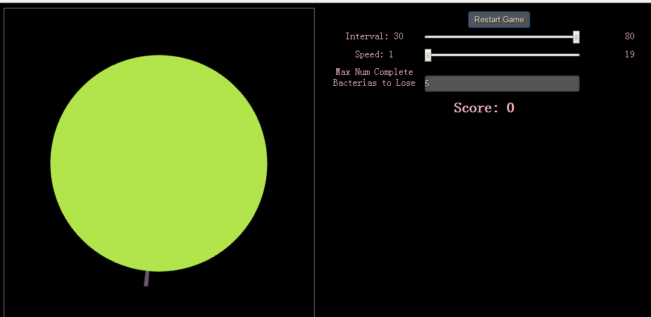
1.1.1 (One bacteria is generating on the bottom of the disk)

- Bacteria on circumference starting random growing, each direction from start point
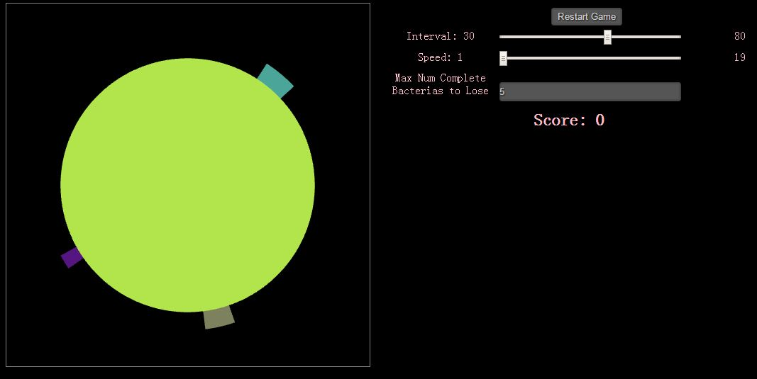
1.2.1 Three bacteria generate randomly and start growing.

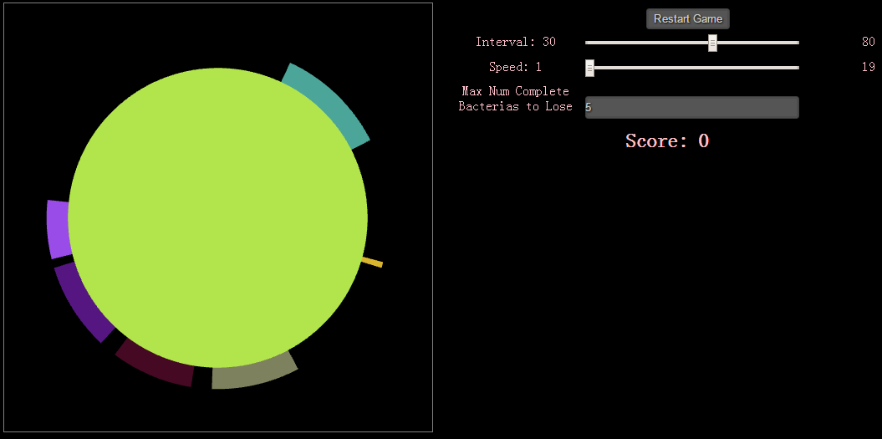
1.2.2 Bacteria grow to both directions from start point. (Comparing to 1.2.1)

- The player picks a bacteria
- Poison removes bacteria
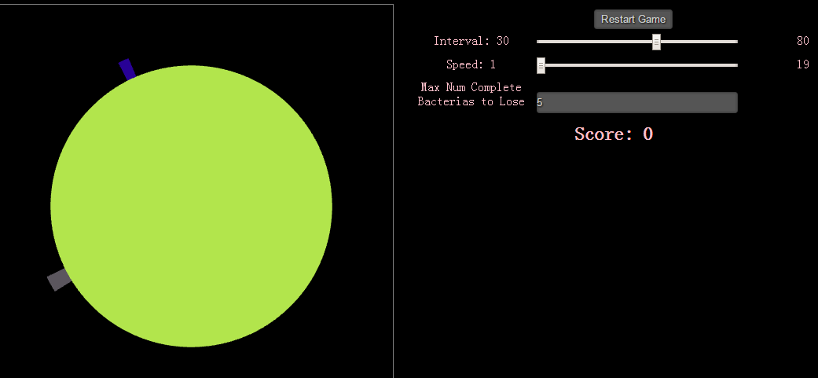
1.3.1

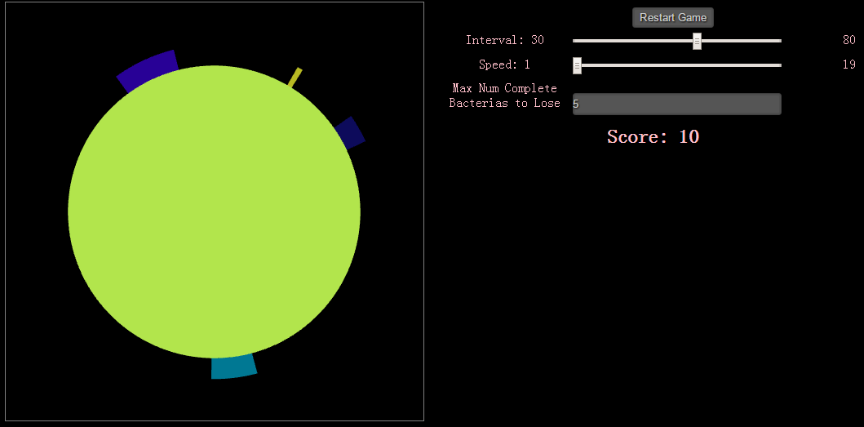
1.3.2 Move mouse over bacteria and click it, and then it is removed (like the grey bacteria on the lower left of the disk in 1.3.1).

- Randomly generate up to a fixed number different bacteria
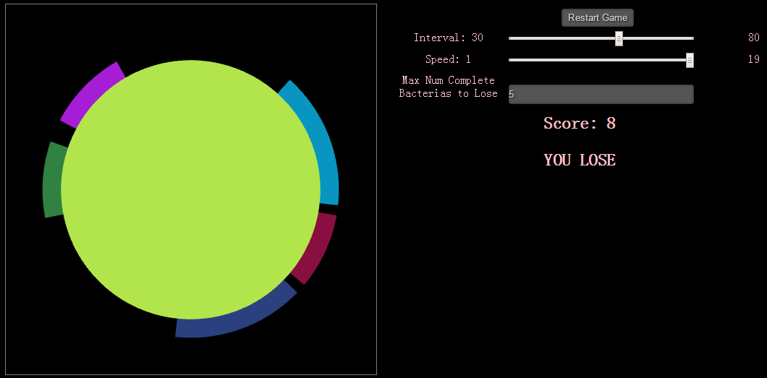
1.4.1 In the settings, there is allowed up to five different complete bacteria randomly generated on the disk, or you will lose the game. (Please check the meaning of complete bacteria in user’s guide)

- The bacteria stay near circumference
1.5.1 As shown above, the bacteria stay on the disk.

- Game points
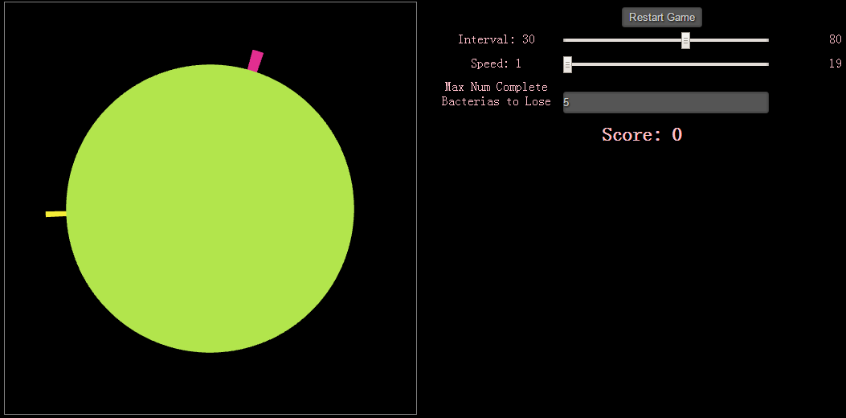
1.6.1

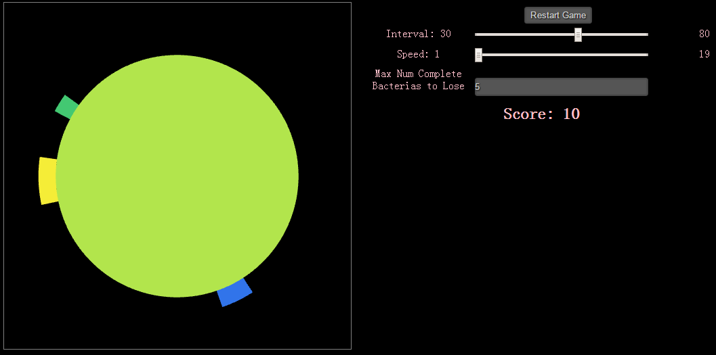
1.6.2 If one bacteria does not grow to threshold (30 degree in this game) when user removes it. The user will get 10 scores. (like the pink bacteria on the top of the disk in 1.6.1)
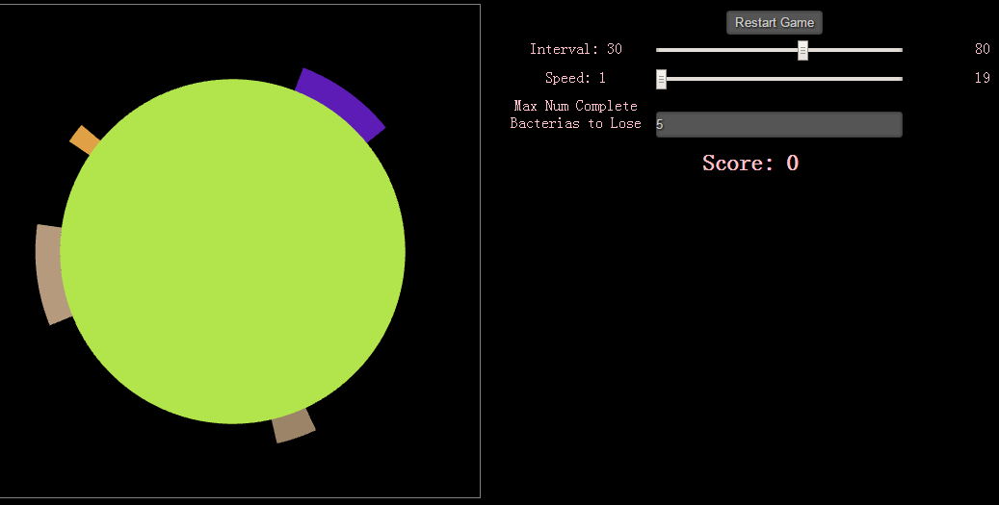
1.6.3

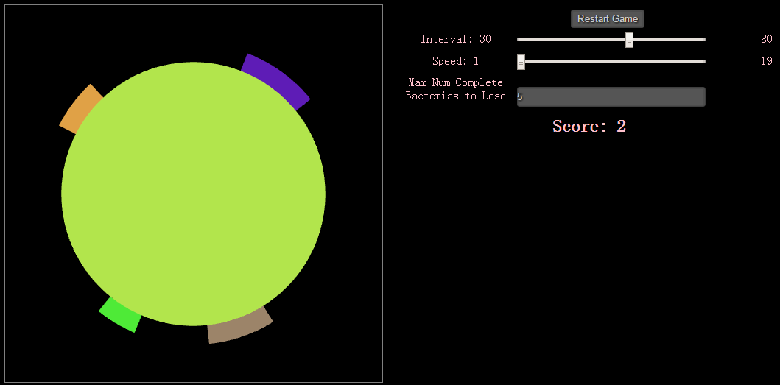
1.6.4 If one bacteria has grew to threshold (30 degree in this game) when user removes it. The user will only get 2 scores. (like the light pink bacteria on left of the disk in 1.6.3)

- Player wins if all bacteria poisoned before game gets set number of points
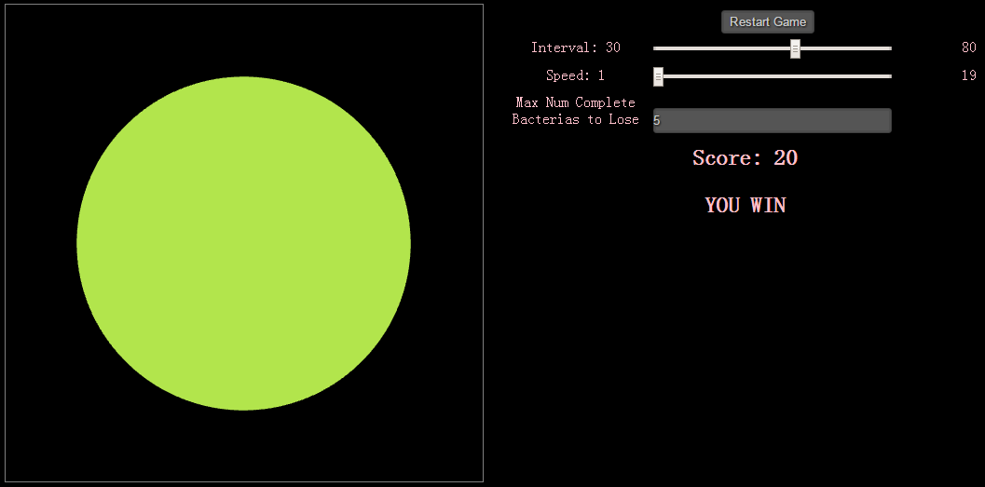
1.7.1 When all bacteria on the disk get removed, user wins the game.

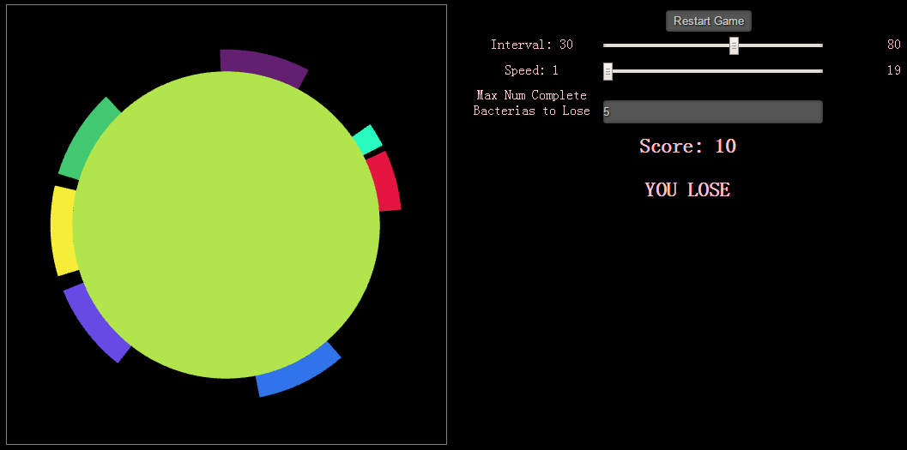
1.7.2 As the game setting, when there are five complete bacteria totally on the disk, user loses the game. (Please check the meaning of complete bacteria in user’s guide)

1.7.3 In certain cases, if bacteria covers all over the disk, user also loses the game.

- Additional features
- Poison administered propagates outward from the point of insertion until all the bacteria are destroyed
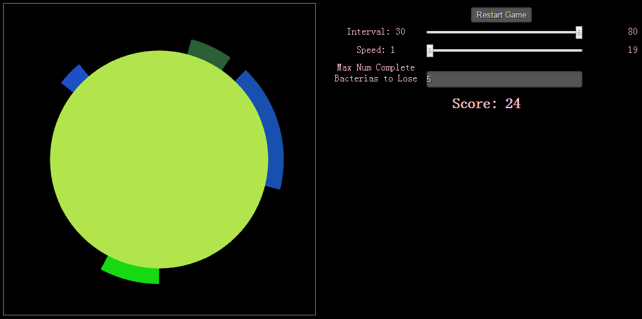
2.2.1
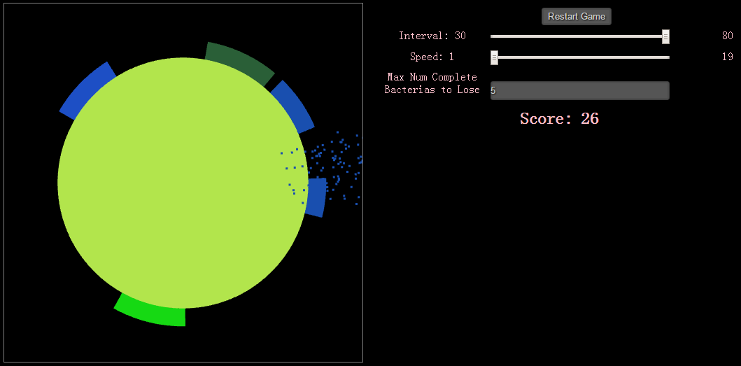
2.2.2 When user clicks a bacteria (like the blue bacteria on the right of the disk in 2.2.1), poison administered propagates outward from the point of insertion until all the bacteria are destroyed.
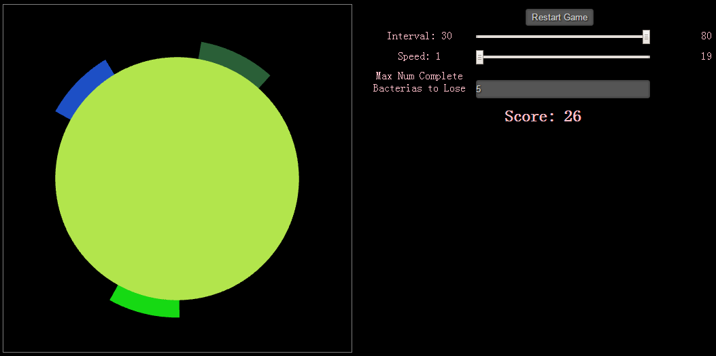
2.2.3 The blue bacteria on the right of the disk in 2.2.1 has been removed completely from the desk.
- Two bacteria cultures collide, the first one to appear on the circumference dominates and consumes the later generated bacteria
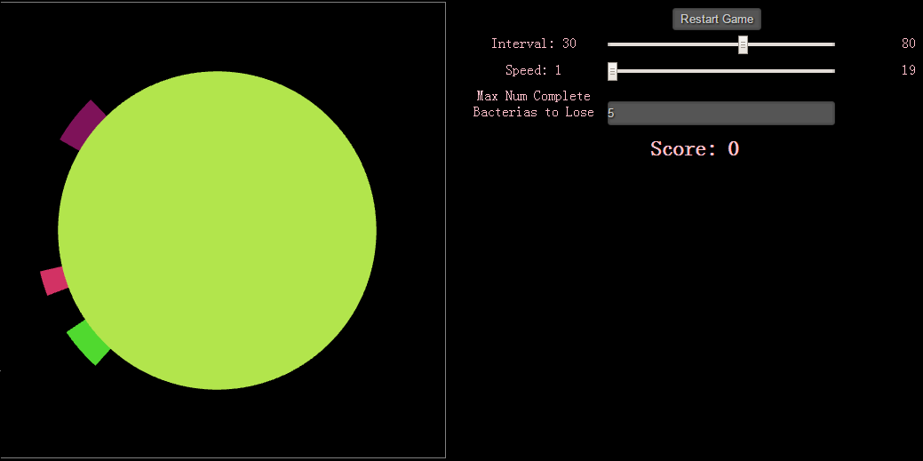
2.2.1 The green bacteria generates earlier than the pink bacteria.

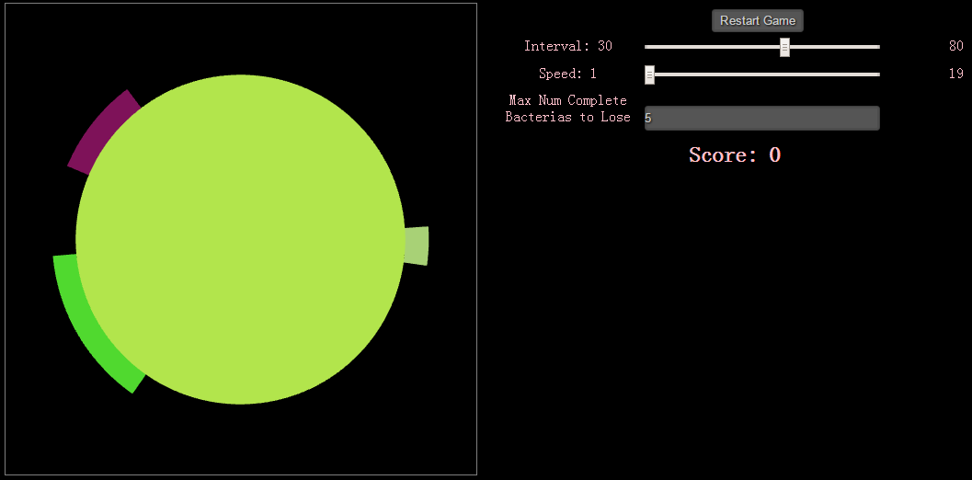
2.2.2 When they collide, the green bacteria, which generates earlier, eats the pink bacteria.

- When hit, particle system simulates an explosion where the poison is
2.3.1
2.3.2 When user clicks a bacteria (like the blue bacteria on the right of the disk in 2.3.1), poison administered propagates outward from the point with the effect of particle system.
2.3.3 The blue bacteria on the right of the disk in 2.3.1 has been removed completely from the desk.

