Super Bug Zapper
By Rui Duan, Qiyan Wang

Gallery

Rui Duan(rduan@lakeheadu.ca)
Qiyan Wang(qwang4@lakeheadu.ca)
- Additional features
- Merge
The older bacteria dominate the younger bacteria;
Merge can happen anywhere on the circumference. The cases around 0 degree is specially processed, so that they can merge correctly.
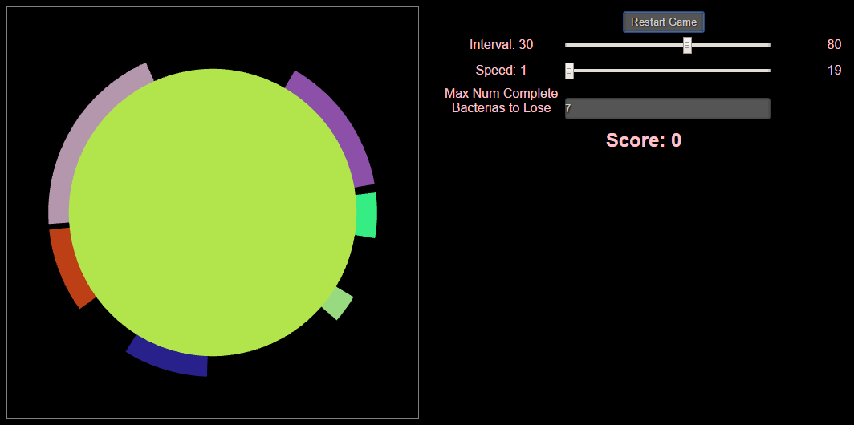
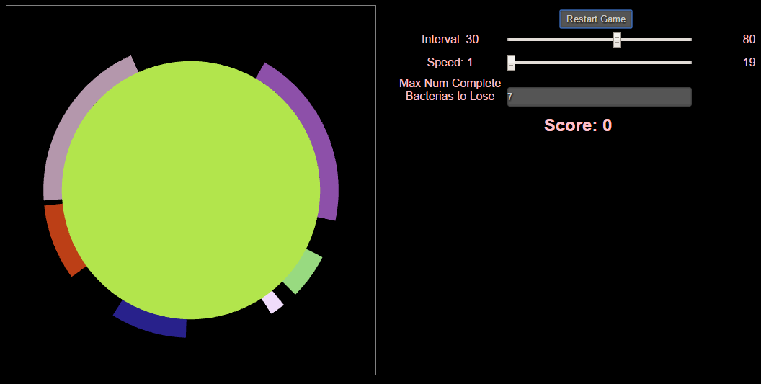
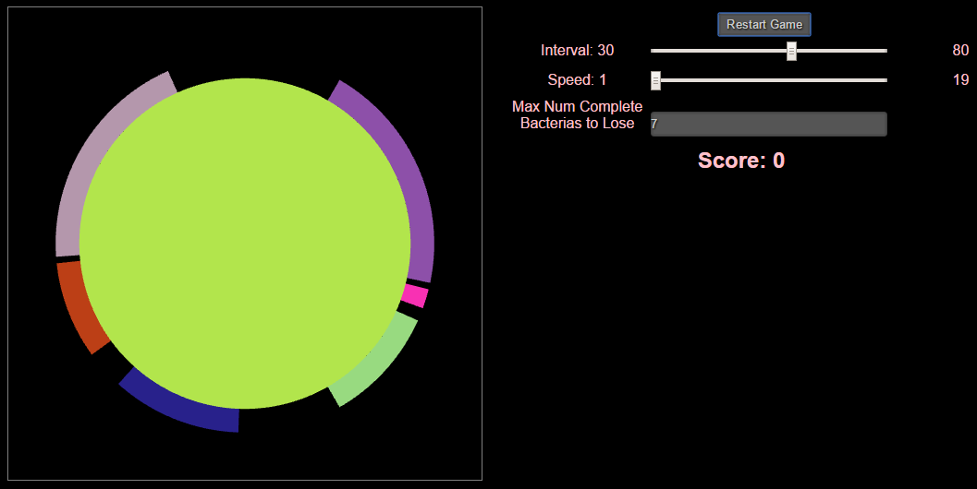
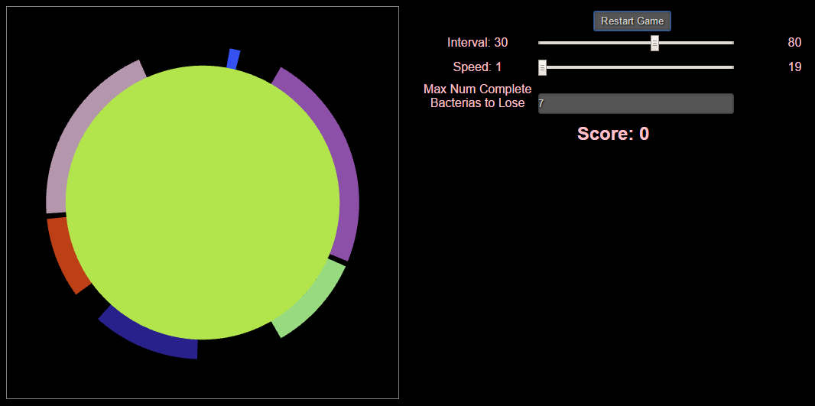

- Poison administered propagates outward from the point of insertion until all the bacteria are destroyed
The poison area is transparent so if there are two layers of bacteria, and the upper layer bacteria is eradicating, the lower layer bacteria will show up in the transparent poison area.
- Explosion simulated by a particle system
The cases around the 0 degree is specially processed so that the bacteria’s eradication animation performs correctly.
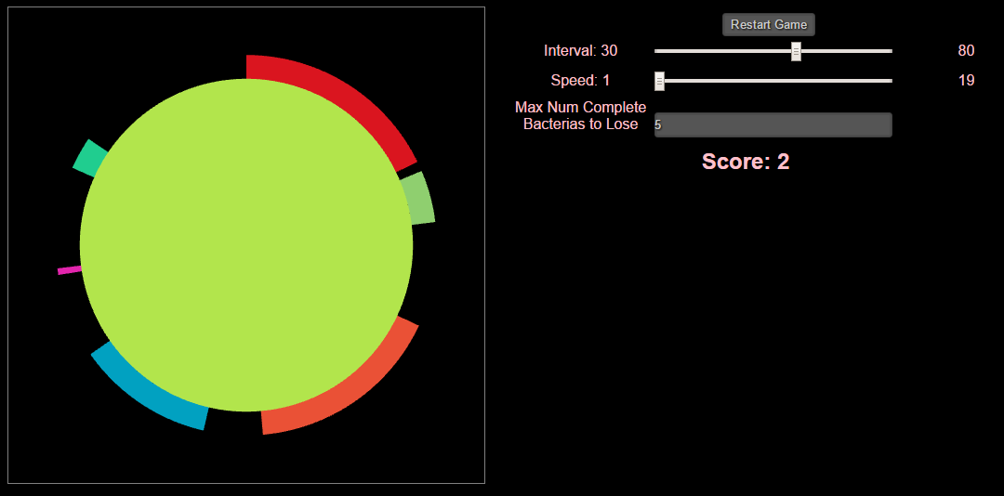
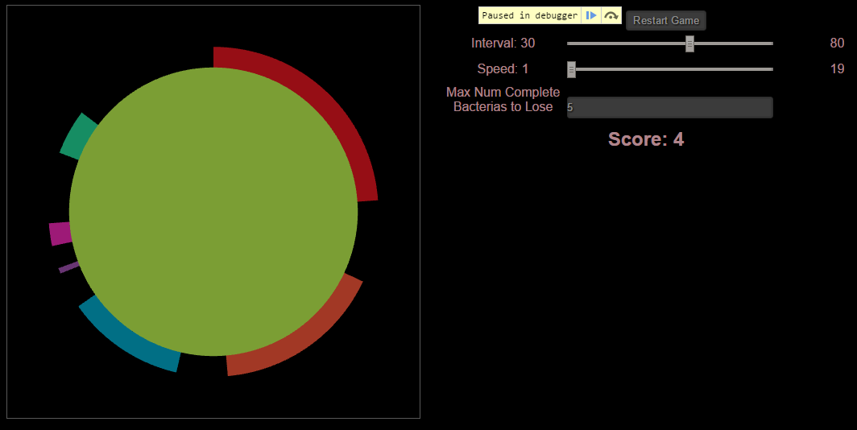

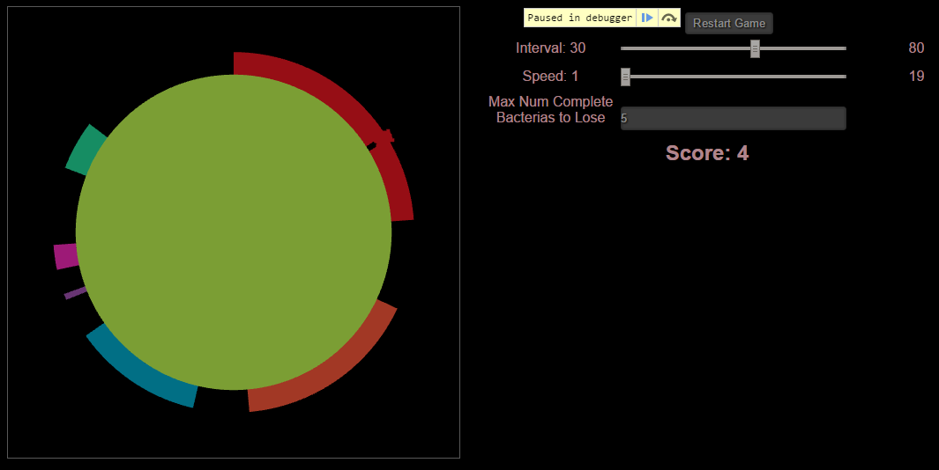
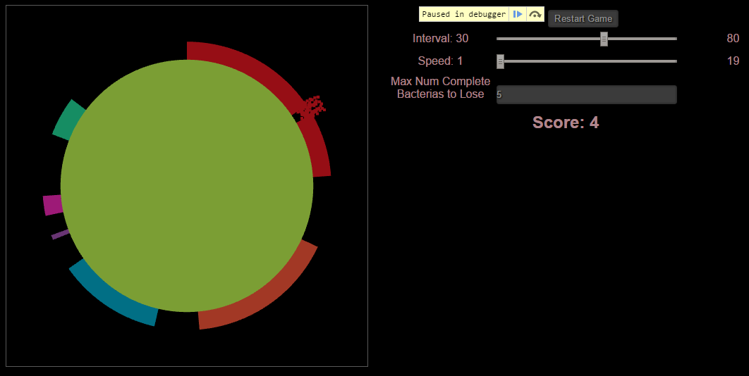
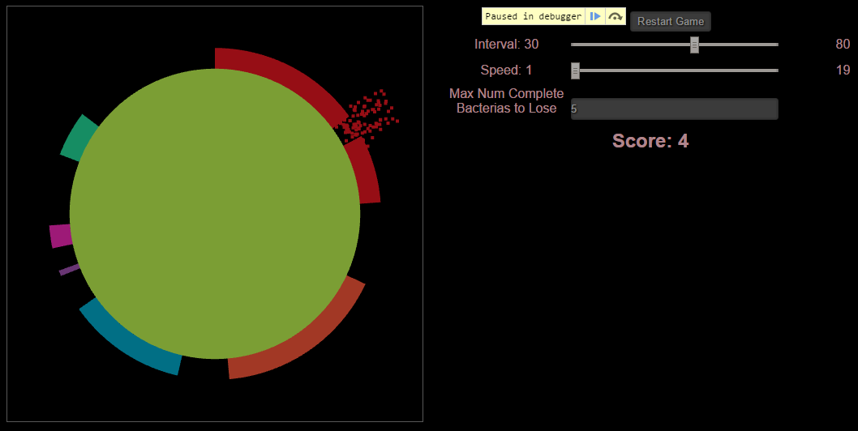
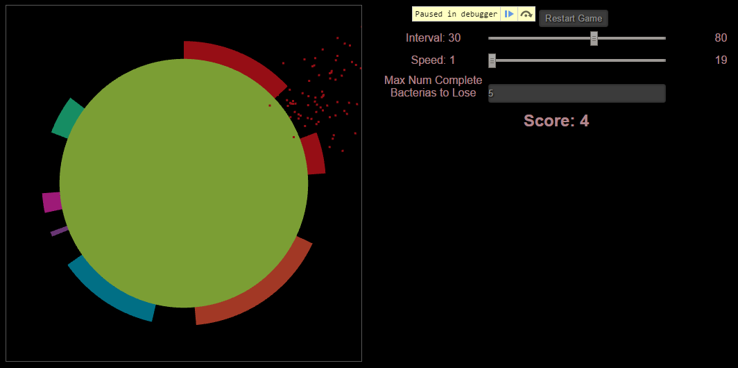
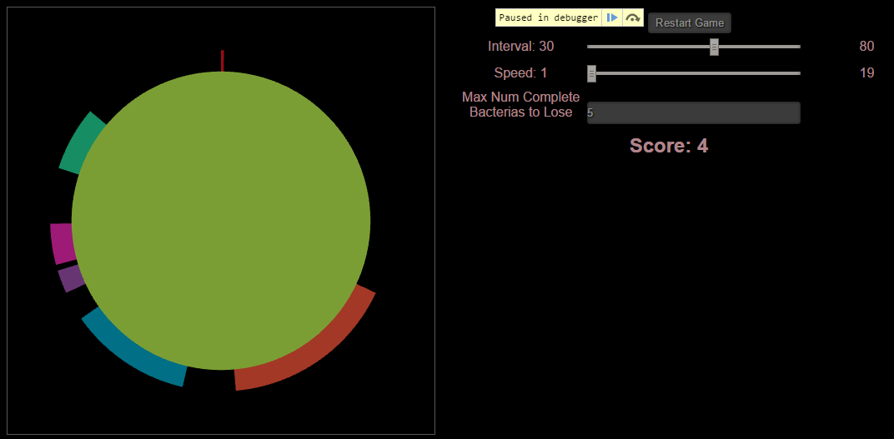

- Basic features
- Disk at the origin viewed from above
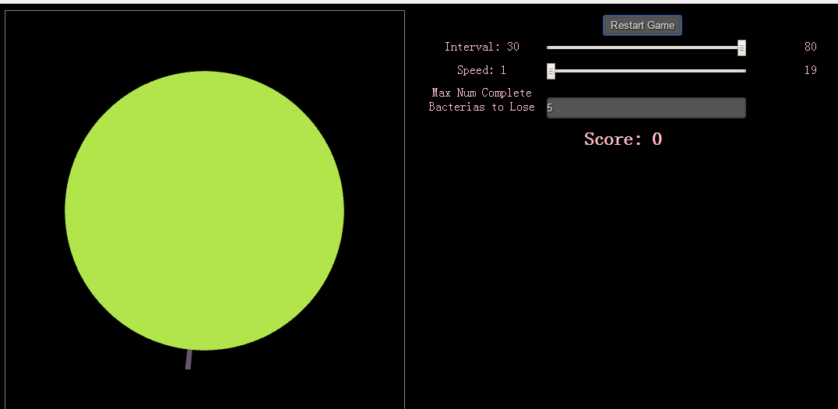
2.1.1 (One bacteria is generating on the bottom of the disk)

- Bacteria on circumference starting random growing, each direction from start point
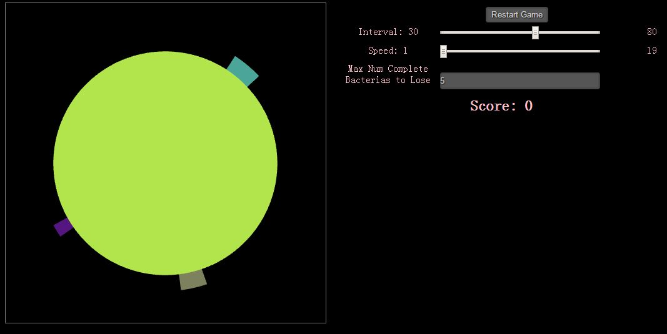
2.2.1 Three bacteria generate randomly and start growing.
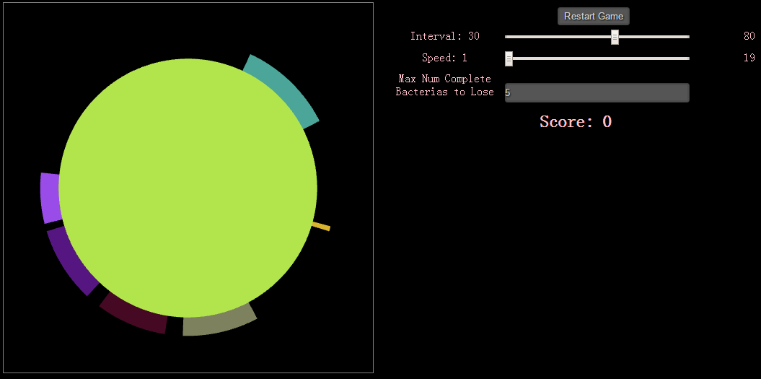
2.2.2 Bacteria grow to both directions from start point. (Comparing to 1.2.1)
- The player picks a bacteria
- Poison removes bacteria
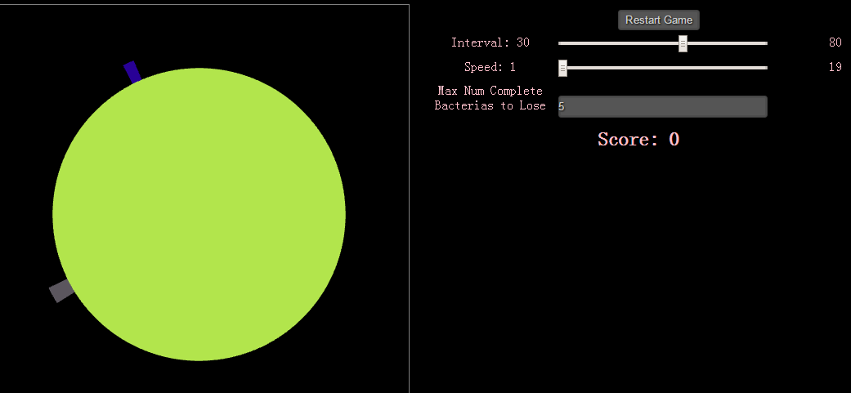
2.3.1
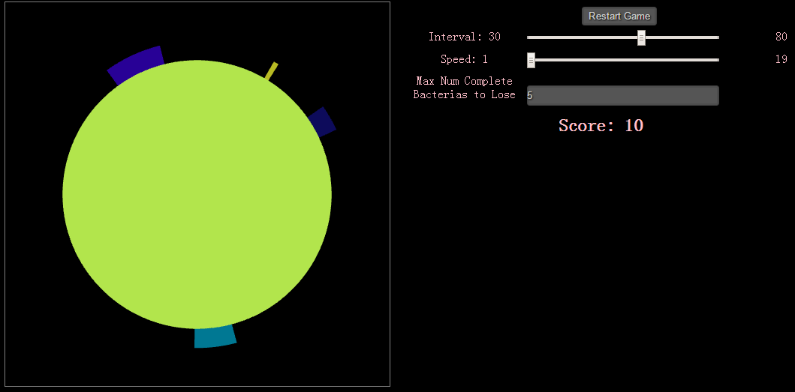
2.3.2 Move mouse over bacteria and click it, and then it is removed (like the grey bacteria on the lower left of the disk in 1.3.1).
- Randomly generate up to a fixed number different bacteria
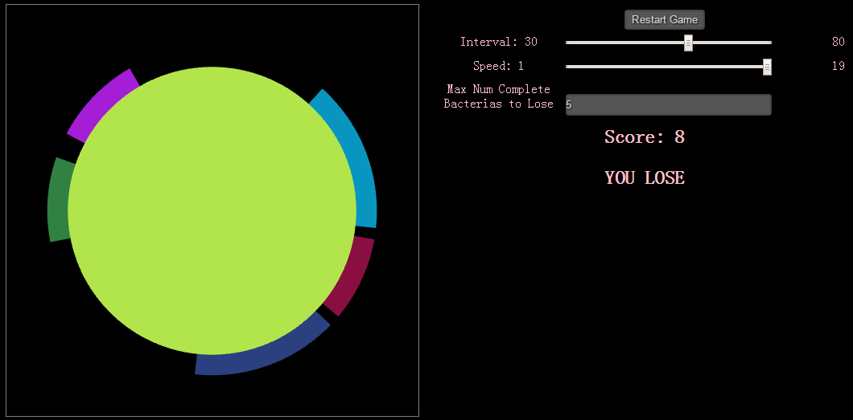
2.4.1 In the settings, there is allowed up to five different complete bacteria randomly generated on the disk, or you will lose the game. (Please check the meaning of complete bacteria in user’s guide)
- The bacteria stay near circumference
2.5.1 As shown above, the bacteria stay on the disk.
- Game points
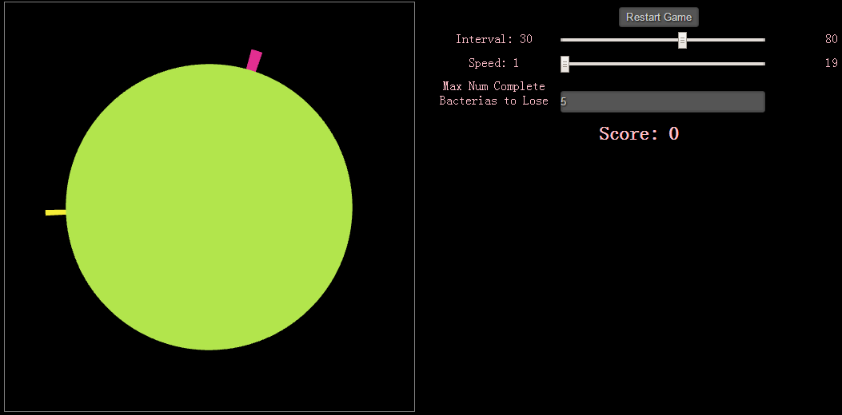
2.6.1

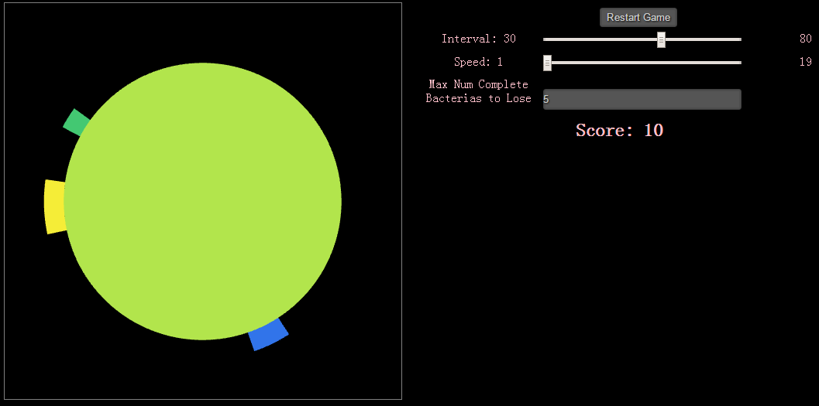
2.6.2 If one bacteria does not grow to threshold (30 degree in this game) when user removes it. The user will get 10 scores. (like the pink bacteria on the top of the disk in 1.6.1)
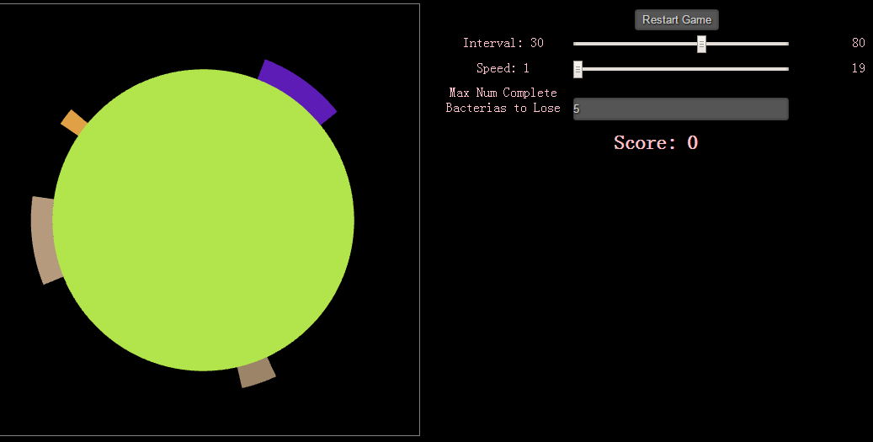
2.6.3

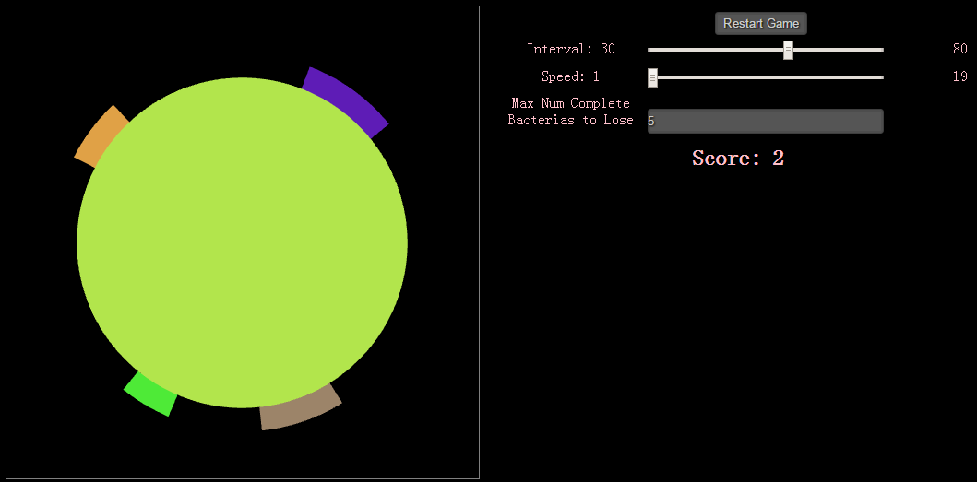
2.6.4 If one bacteria has grew to threshold (30 degree in this game) when user removes it. The user will only get 2 scores. (like the light pink bacteria on left of the disk in 1.6.3)

- Player wins if all bacteria poisoned before game gets set number of points

2.7.1 When all bacteria on the disk get removed, user wins the game.

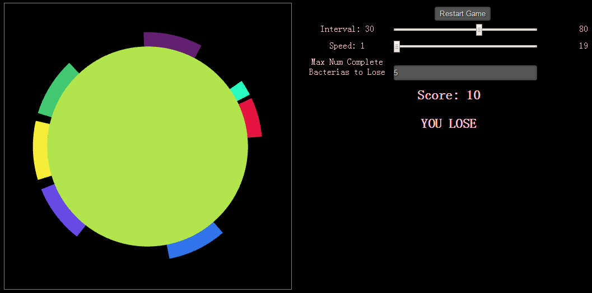
2.7.2 As the game setting, when there are five complete bacteria totally on the disk, user loses the game. (Please check the meaning of complete bacteria in user’s guide)

2.7.3 In certain cases, if bacteria cover all over the disk, user also loses the game.

