If you use windows, please:
- Go to the file path and use command: python hanoi.py
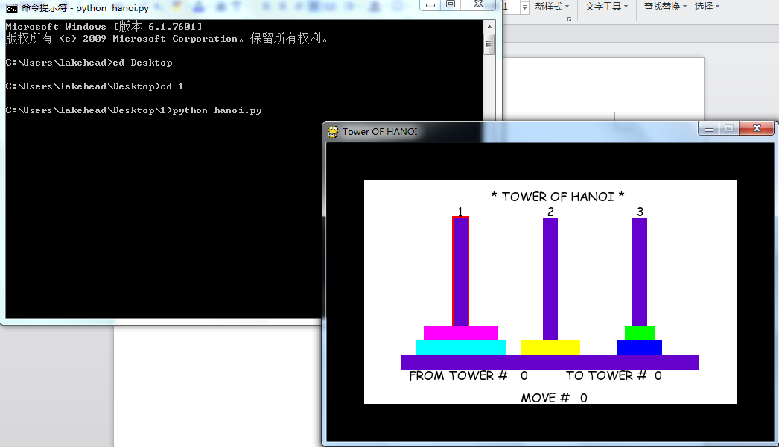
Use your mouse to click on the bar and click another bar to move it.
When you finish ,you can see:
