TBMI26 – Computer Assignment Report Supervised Learning

Author/-s:
Bing Rui Yao(binya518)

Selen Karaduman (selka266)

In order to pass the assignment you will need to answer the following questions and upload the document to LISAM. Please upload the document in PDF format. You will also need to upload all code in .m-file format. We will correct the reports continuously so feel free to send them as soon as possible. If you meet the deadline you will have the lab part of the course reported in LADOK together with the exam. If not, you’ll get the lab part reported during the re-exam period.

- Give an overview of the four datasets from a machine learning perspective. Consider if you need linear or non-linear classifiers etc.

Dataset 1 is a linearly separable dataset with 2 classes. Dataset 2 and 3 are non-linearly separable and have 2 and 3 classes respectively. Dataset 4 contains 8X8 pixels images with 10 classes and is non-linearly separable. Dataset 1 can be classified by linear classifiers. Dataset 2, 3, 4 need non-linear classifiers.

- Explain why the down sampling of the OCR data (done as pre-processing) result in a more robust feature representation. See http://archive.ics.uci.edu/ml/datasets/Optical+Recognition+of+Handwritten+Digits

The pre-processing reduces the dimensionality of the training data by divided the digit maps of 32x32 pixels into blocks and count the number of pixels in block as input data. The dimension of input data is reduced to 8x8 so that the computation is more efficient. And instead of using every pixel as input data, the count of pixels in blocks are more flexible when the digit maps are written by different people and the handwritings of same number show a little different in shape.

- Give a short summary of how you implemented the kNN algorithm.

For every point in the dataset, we compute the Euclidean distances between the point and all points in the training dataset. Then select the k nearest neighbors and count their classes. The class of the point is classified as the most common class among its neighbors. If there are draws, increase k by one until the point is classified. (See the figure below).
- Explain how you handle draws in kNN, e.g. with two classes (k = 2)?

If draws occur, increase k by one for this point and classify. If there are more than one classes and still have draws, keep increasing k until the point is classified.

- Explain how you selected the best k for each dataset using cross validation. Include the accuracy and images of your results for each dataset.

Code:

Set the number of bins, in every loop select one bin from training data as validation dataset and others as training dataset. Train different k on the training dataset and compute error on validation dataset. For every k from 1 to 30, compute the average error among the validation datasets and choose the k with lowest error.

Number of bins: 6
Optimal k for dataset 1: 14
Accuracy: 0.994
Plots:

Optimal k for dataset 2: 1
Accuracy: 0.997

Plots:

Optimal k for dataset 3: 14
Accuracy: 1

Plots:

Optimal k for dataset 4: 2
Accuracy: 0.9815

- Give a short summary of your backprop implementations (single + multi). You do not need to derive the update rules.

In the single layer implementation, we multiplied two input XTrain, W and use hyperbolic tangent as activation function. To train the single layer, we randomly set the initial W matrix and set a learning rate. In every iteration, the W matrix was updated by gradient descent method, then run the network on training and test data and record the accuracy. In the multiple networks, three inputs are needed: training dataset XTrain, weights of hidden neurons W, weights of output neurons V. We used a hyperbolic tangent as activation function for both hidden layer and output layer. In every training iteration, The W and V matrix were updated by gradient descent method, and the accuracy on training and test dataset were recorded. Finally, by comparing the errors on training and test datasets, we can evaluate the performance of the networks.

- Present the results from the neural network training and how you reached the accuracy criteria for each dataset. Motivate your choice of network for each dataset. Explain how you selected good values for the learning rate, iterations and number of hidden neurons. Include images of your best result for each dataset, including parameters etc.

Dataset 1:

Dataset 1 is linearly separable, so a single layer network model can reach a high accuracy.
Hyperparameters:
Number of iterations: 500

Learning rate:0.0001
Accuracy: 0.99

For dataset 2, 3, 4, the datasets are not linearly separable, we need to imply multilayer networks.

Dataset 2:
Hyperparameters:
Number of hidden neurons: 20

Number of iterations: 500
Learning rate: 0.001
Accuracy: 0.9962

Dataset 3:
Hyperparameters:
Number of hidden neurons: 30
Number of iterations: 500
Learning rate: 0.0001
Accuracy: 0.9975

Dataset 4:
Hyperparameters:
Number of hidden neurons: 120
Number of iterations: 3000
Learning rate: 0.00006

- Present the results, including images, of your example of a non-generalizable backprop solution. Explain why this example is non-generalizable.

To build a non-generalizable backprop solution, we divided data into 1 training dataset and 99 test dataset and use hyperparameters: 50 hidden layers, 3000 iterations, and learning 0.0001. The model fitted training dataset well but didn’t work well on test dataset. The reason is that the training dataset is too small compared to the whole dataset and the model overfits the training data.
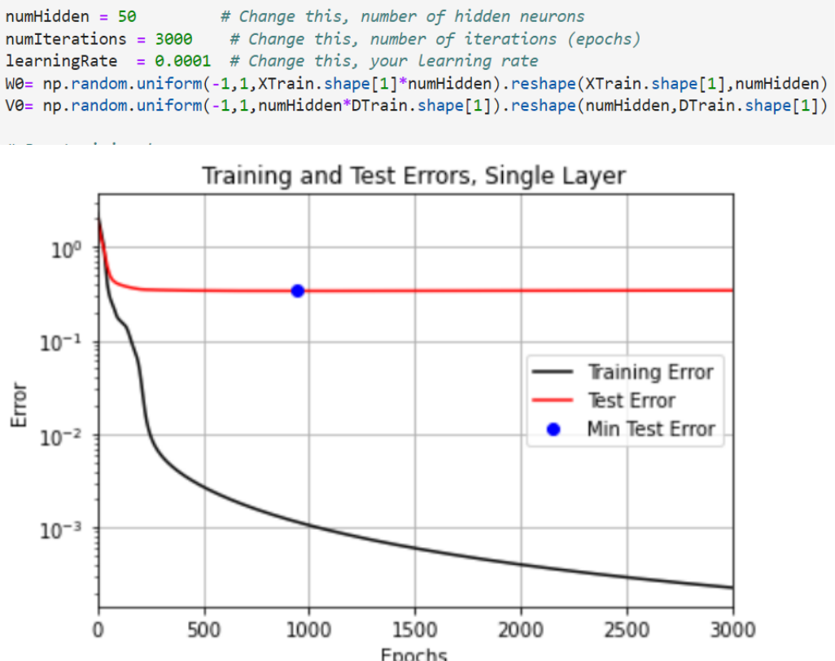

- Give a final discussion and conclusion where you explain the differences between the performances of the different classifiers. Pros and cons etc.

KNN classifiers only need one hyperparameter k and don’t need training steps. This makes it easy to implement on big datasets. But KNN is sensitive to outliers and the accuracy is influenced by the division of training and test dataset. The neural network classifiers can learn the parameters on their own in iterations, and once trained, it’s fast to predict on new data. The cons of neural network classifiers are: take long time to train, need to optimize hyperparameters by user, and rely on a lot of training data.

- Do you think there is something that can improve the results? Pre-processing, algorithm-wise etc.

There are several ways to improve the results. In the preprocessing, we can standardize the data to make quicker convergence in the training. In the training processing, we can add more layers in the networks or adjust the learning rate to get higher accuracy. Increasing the iteration numbers can help to find a better local optimum.

