CS 440 report 1.1

A*

**Medium maze:**

Path found:

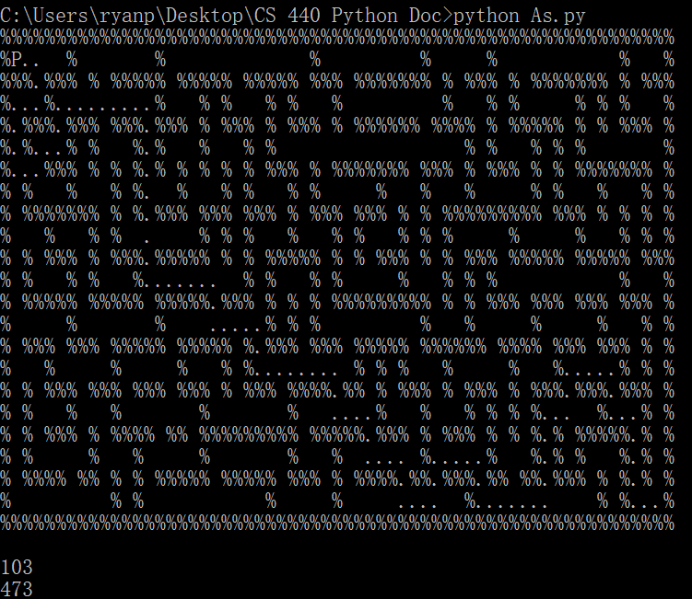

Path cost: 103 Expanded node: 473

**Big maze:**

Path found:

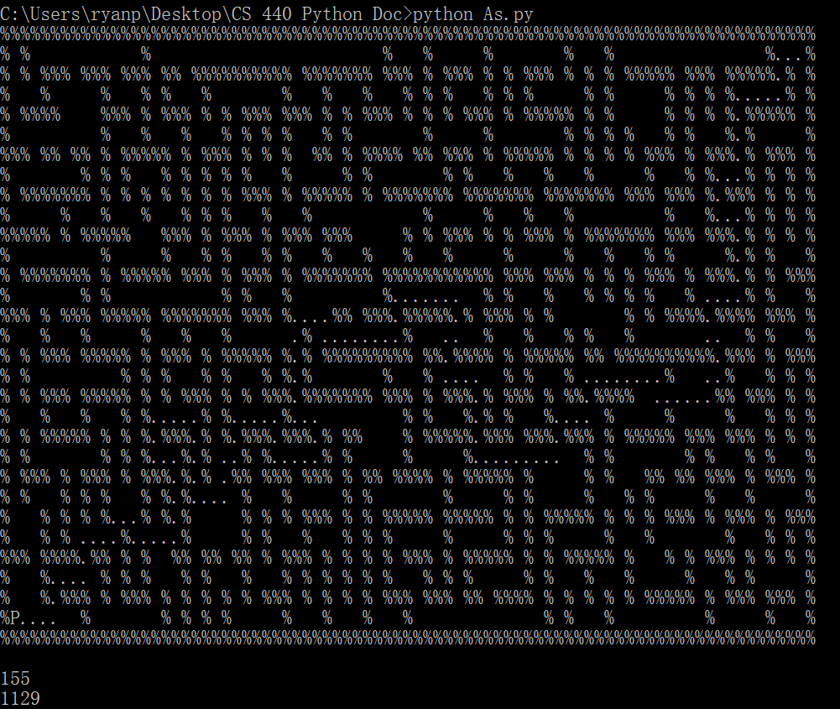

Path cost:155 Expanded Nodes: 1129

**Open Maze**

Path Found

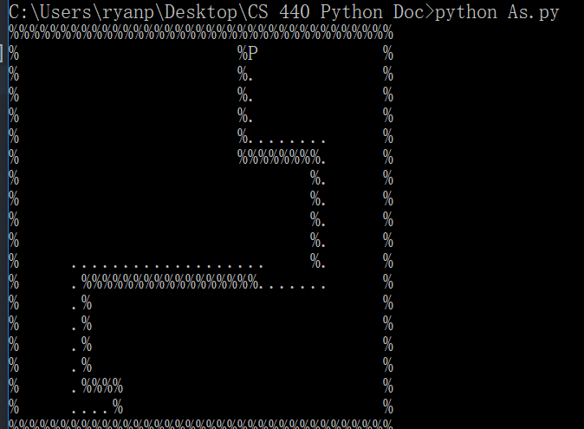

Path Cost: 52 Expanded Nodes: 352

DFS

**Medium maze:**

Path found:

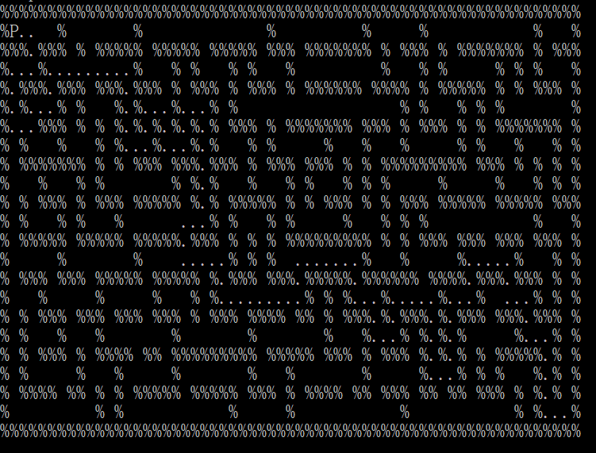

Path cost: 120 Expanded Nodes: 239

**Big Maze:**

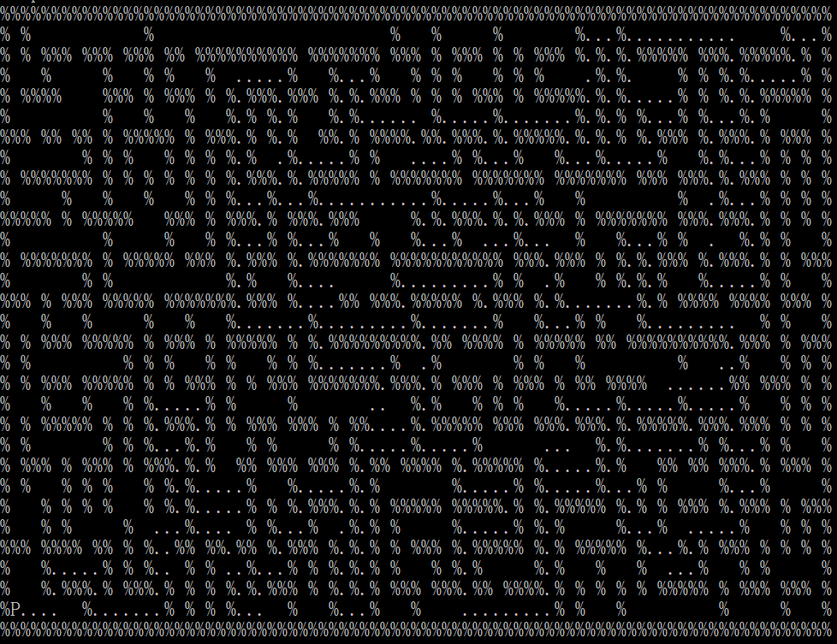

Path Cost: 492 Expanded Nodes: 655

Open Maze:

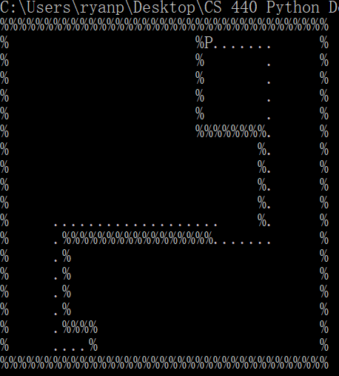

Path Cost: 52 Expanded Nodes: 567

BFS

**Medium maze:**

Path found:

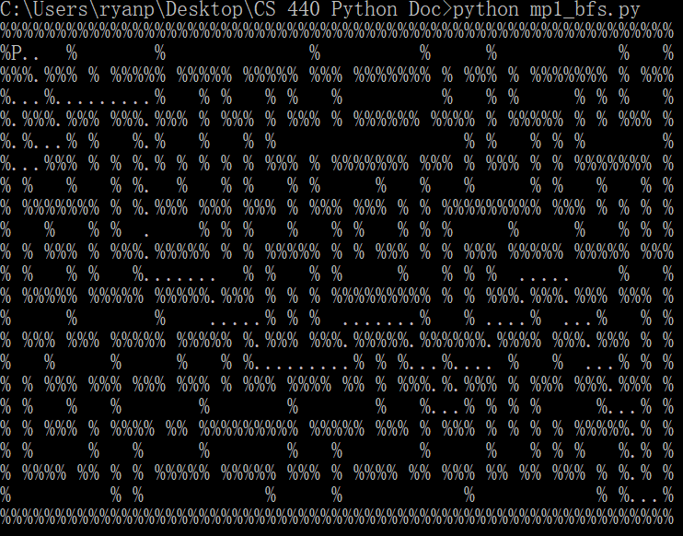

Path cost: 103 Expanded Nodes: 631

**Big Maze:**

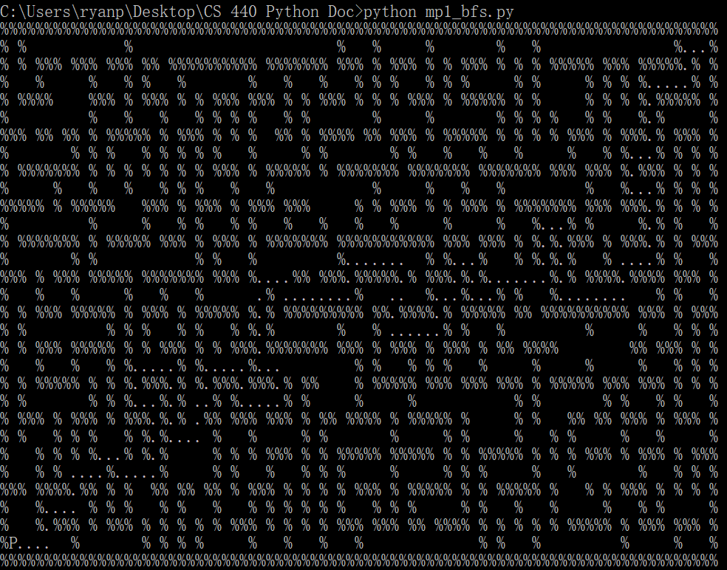

Path Cost: 155 Expanded Nodes: 1258

Open Maze:



Path Cost: 52 Expanded Nodes: 567

CS 440 report 2.1 (extra credit)

We implemented two ways of sokoban solver. The first one is an uninformed BFS and the second one is an A* algorithm. Both solutions avoid putting boxes to the corner, where it cannot be gotten out (to include efficiency).

The heuristic for the second implementation is the sum of distance from the boxes to the neatest dots to them.

Uninformed BFS

Input 1: 0.53s

Path length:33

Expanded nodes: 1034

Input 2: 0.73s

Path length:51

Expanded nodes: 1512

Input 3: 19min10s

Path length:34

Expanded nodes: 44064

Input 4: 2min 10s

Path length:144

Expanded nodes: 17256

A*

Input 1: 0.93s

Path length:36

Expanded nodes: 295

Input 2: 1.42s

Path length:53

Expanded nodes: 737

Input 3: 16min40s

Path length:38

Expanded nodes: 20290

Input 4: 2min 40s

Path length:206

Expanded nodes: 16998