Test Specification ID : RAG-FIN-INT-001
Name of Tester : Hashireen
Use Case ID : UC01 – Upload Documents & Trigger Ingestion
Date of Test : 29 January 2026
Description of Test : To verify that the system supports single and multiple file uploads, correctly saves files to the input folder, and triggers backend processing without UI errors.
S/No | Test Case | Expected Result | Pass/ Fail | Remarks
File Upload (Single file)
 | Upload one financial PDF document(1st 5pages)  Steps:  - Open the chatbot application  - Upload one valid financial PDF via drag-and-drop (File is saved into the input folder) | - File appears in the File Collection panel | Pass
Multiple files (good to have)
 | Upload 3-5 financial PDFs at once using drag-and-drop  Steps:  - Select 4 PDF files  - Drag and drop them into the upload area | | - All files are uploaded successfully  - All files appear in file collection  - No partial upload occurs | Fail | - Unable to upload more than 1 file
Duplicate File Upload
 | Upload a file with the same filename twice.  Steps:  - Upload a PDF file  - Upload the same file again | - Duplicate file is not re-added  - System does not crash | Pass
Processing Status
 | Upload a large PDF to trigger a processing delay | - Upload a large PDF to trigger processing delay.  - App remains responsive | Pass
Unsupported File Type
 | Attempt to upload an unsupported file type(e.g. annual report.xlxs) | - When uploading file, does not show excel file to select | Pass | When uploading file, does not show excel file to select

Test Specification ID : RAG-FIN-INT-002
Name of Tester : Hashireen D/O Abdul Khadar
Use Case ID : UC02 – Select / Unselect Files
Date of Test : 29 January 2026
Description of Test : To verify that file selection, unselection, search filtering, and persistence across reruns function correctly.

S/No | Test Case | Expected Result | Pass/ Fail | Remarks
Select File
 | Select one uploaded file using the checkbox.  Steps:  - Upload a file  - Select the file checkbox | - File is marked as selected  - Selection persists after rerun | Pass
Unselect File
 | Unselect the previously selected file. | - When a file is unselected, the number of files selected decreases to 1 from 2.  - State persists after rerun | Pass

Test Specification ID : RAG-FIN-INT-003
Name of Tester : Hashireen D/O Abdul Khadar
Use Case ID : UC02 – Select / Unselect Files
Date of Test : 30 January 2026
Description of Test : Validate that chatbot answers are grounded in uploaded docs and show correct sources/chunks.

S/No | Test Case | Expected Result | Pass/ Fail | Remarks
Basic factual retrieval
 | Ask: “What is the mission of the company”  Steps:  - Upload a financial document  - Ask: “What is the mission of the company?” | - Our mission is to be a premier insurer in the Asia Pacific region, committed to providing quality products, excellent customer service while upholding strong corporate governance and enhancing shareholders’ value. | Pass
Cross-document question
 | Ask a comparison question across two documents  Steps:  - Upload 1st 5 pages of CBA annul reports 2021 and 2022  - Ask a comparison question “what is the difference between the revenue of CBA - Annual Report 2021 1ST 5 PAGES.pdf and CBA - Annual Report 2022.pdf” | - Answer references both docs; sources include chunks from both. | Fail | - Unable to retrieve the revenue to 2022 report  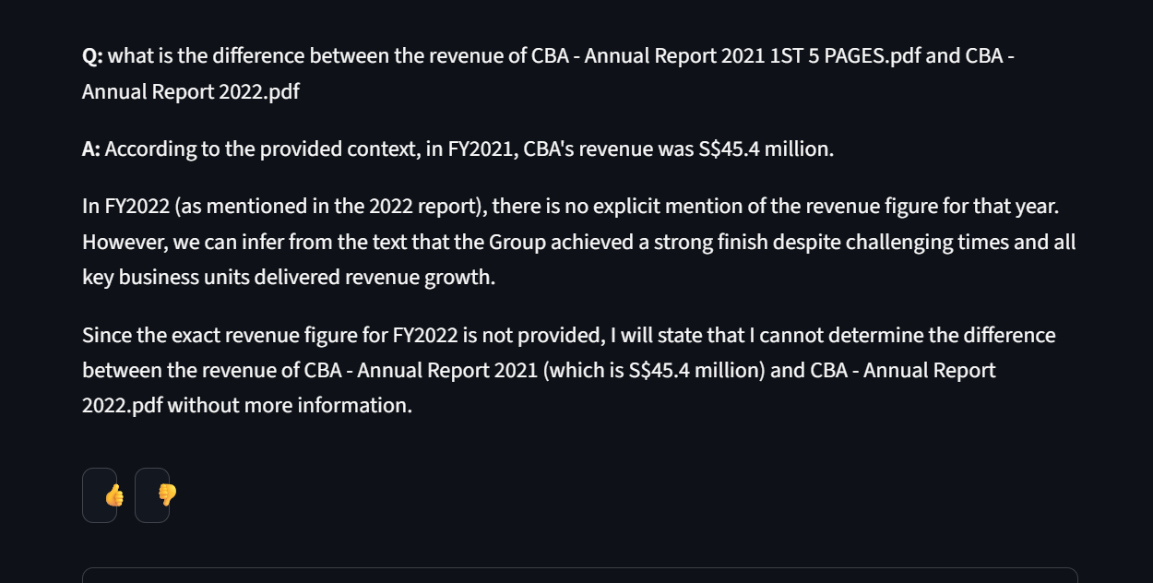
Select/unselect affects retrieval
 | Unselect a document and query its content  Steps:  - Select only CBA - Annual Report 2021 1ST 5 PAGES.pdf  - Ask a question related to CBA - Annual Report 2022 | - Model should say cannot find / no relevant info OR not cite CBA - Annual Report 2022 | Fail | - Did not answer with “Information not found in this document selected”  - However, gave the answer according to CBA - Annual Report 2021 1ST 5 PAGES.pdf
Hallucination resistance
 | Ask a question not covered by the uploaded documents:  - Upload OCBC annual report 2021  - Ask “what is the total revenue in 2010” | - Chatbot indicates insufficient information  - No fabricated response is generated | Pass
Source visibility
 | Check the “View Document Chunks/Sources” expander. | - Sources show chunk text + metadata (filename/source). | Pass

Test Specification ID : RAG-FIN-INT-004
Name of Tester : Hashireen D/O Abdul Khadar
Use Case ID : UC04 Remove Files & Ensure System Stability
Date of Test : 30 January 2026
Description of Test : Validate deletion behavior, reupload, and that the system doesn’t break during reruns.

S/No | Test Case | Expected Result | Pass/ Fail | Remarks
Delete file
 | Remove an uploaded document using the delete (✕) button. | - File is removed from the UI  - File is removed from the input folder  - Chatbot no longer retrieves information from the deleted document | Pass
Deletion Persistence Across Reruns
 | Refresh or rerun the application after deletion. | - Deleted file does not reappear | Pass
Deletion of Selected Document
 | Select a document, then delete it. | - File is removed from selected set  - No system error occurs  - Chatbot continues to function normally | Pass
Reupload and Re-ingestion
 | Delete a document and upload the same file again. | - File upload succeeds  - Backend re-ingests the document  - Chatbot can retrieve information from the reuploaded document | Pass

