# **GPS**

# Created on November 16 2019

# **Table of Contents**

1.0. Page 1

2.0. Page 2

3.0. Page 3

# **1.0. Page 1**

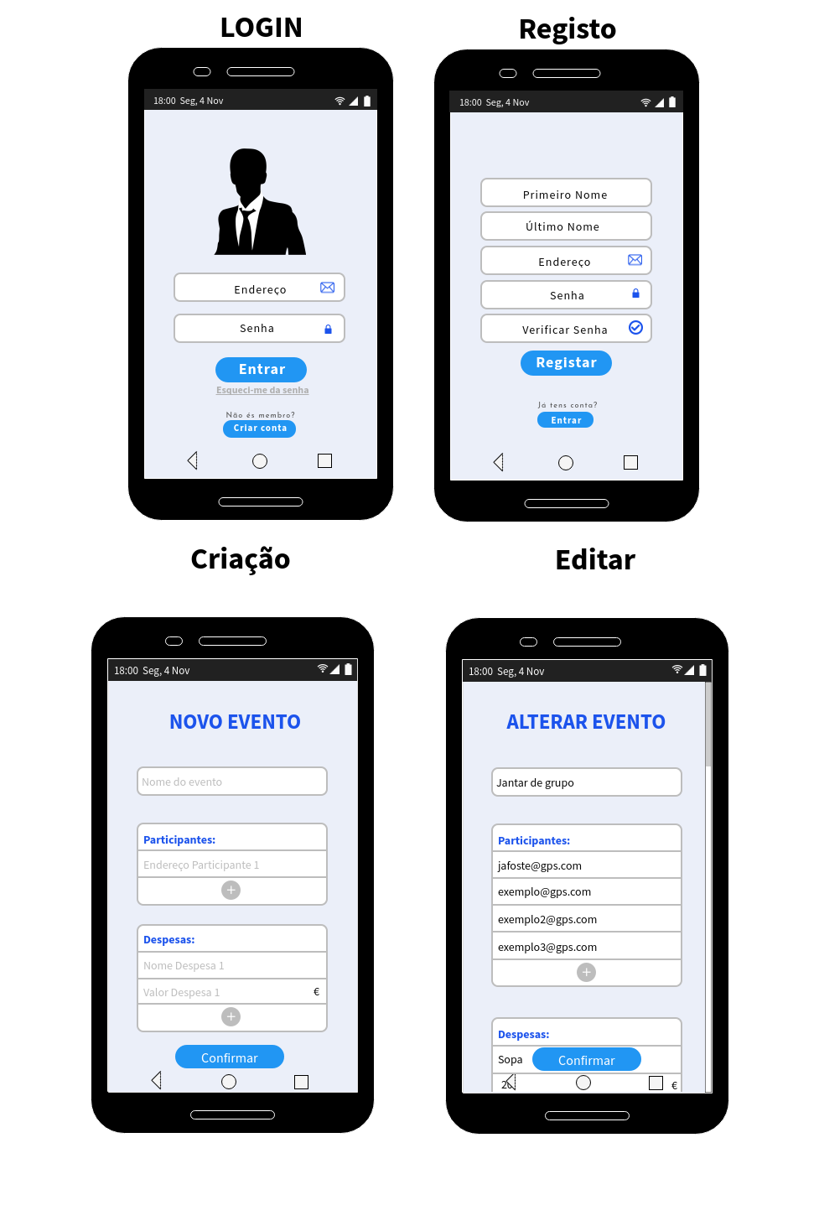

# **2.0. Page 2**

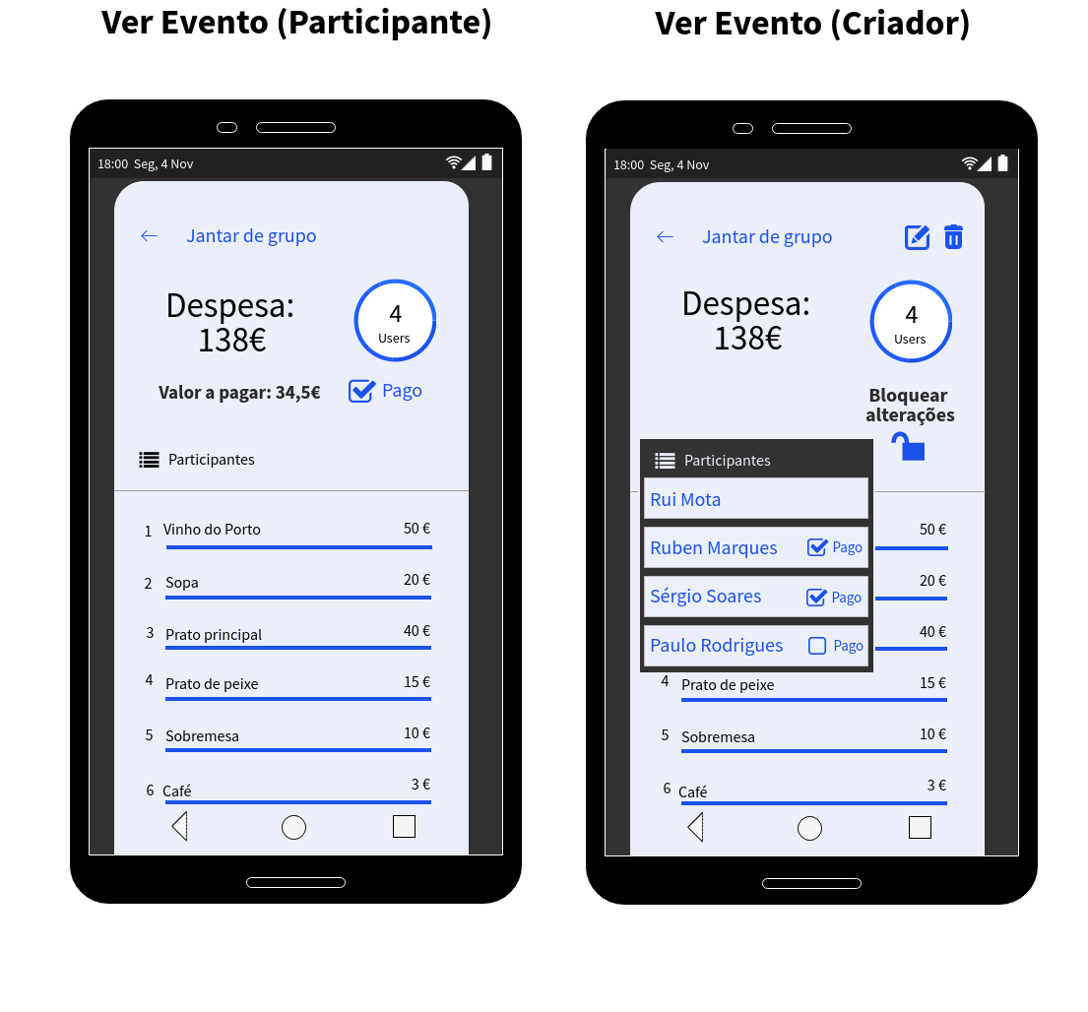

# **3.0. Page 3**

