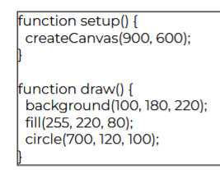
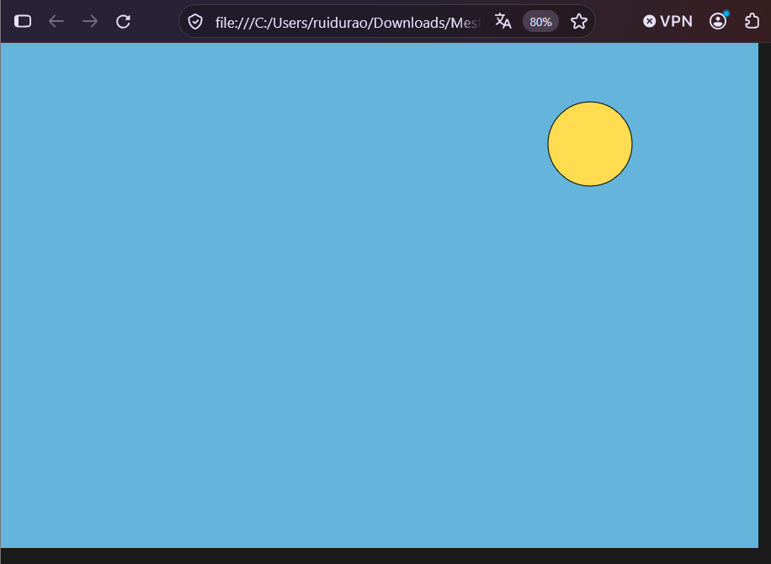
Change the color of the sky
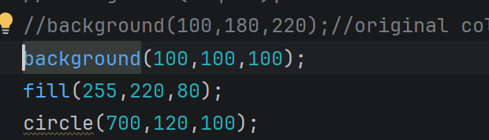
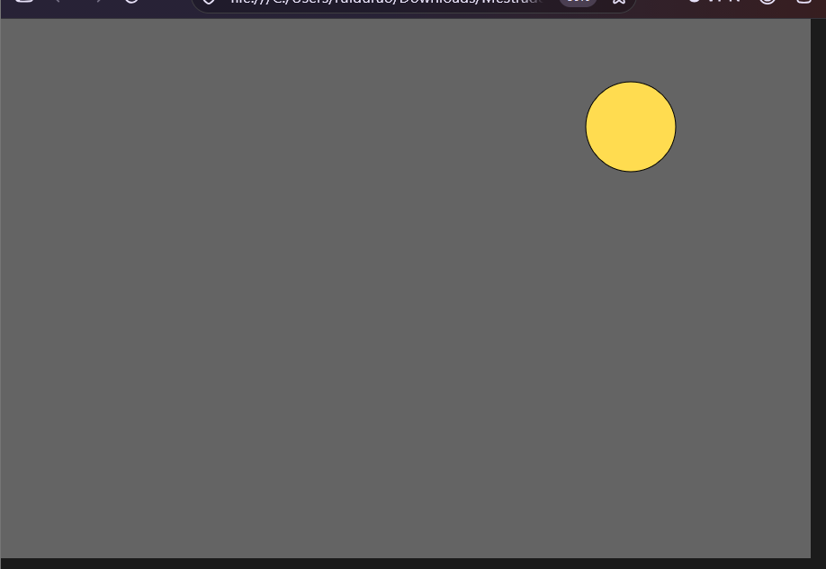
Change again
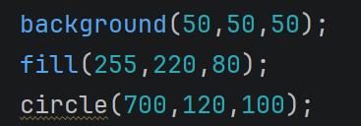
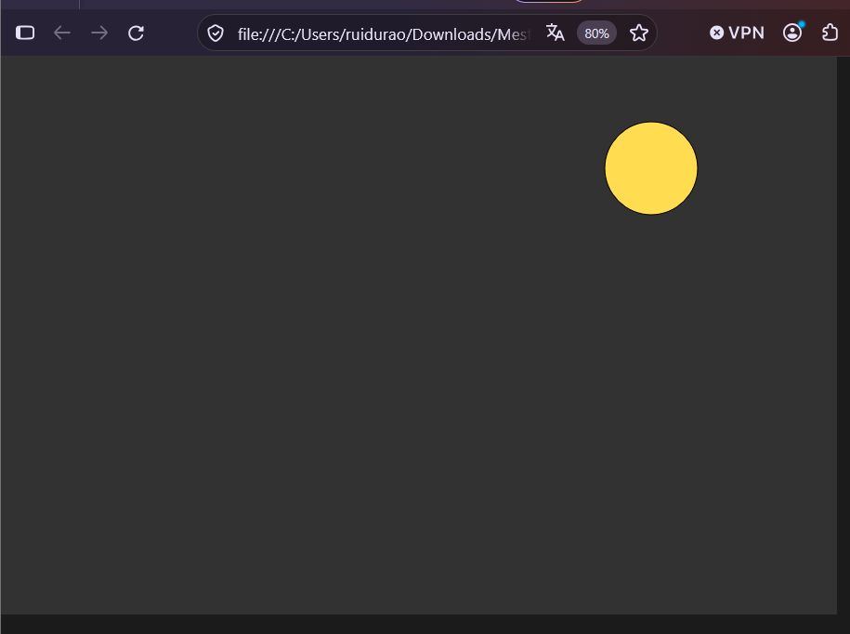
Move the sun to the left (I choose to have a margin):
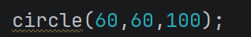
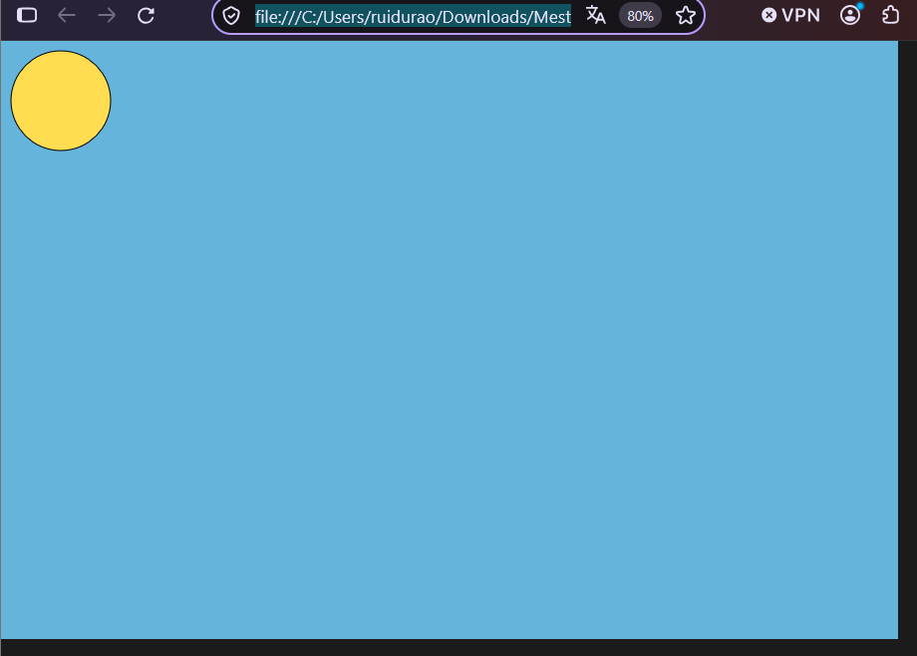
Change the size of the sun (making it bigger):
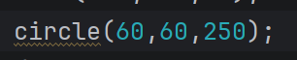
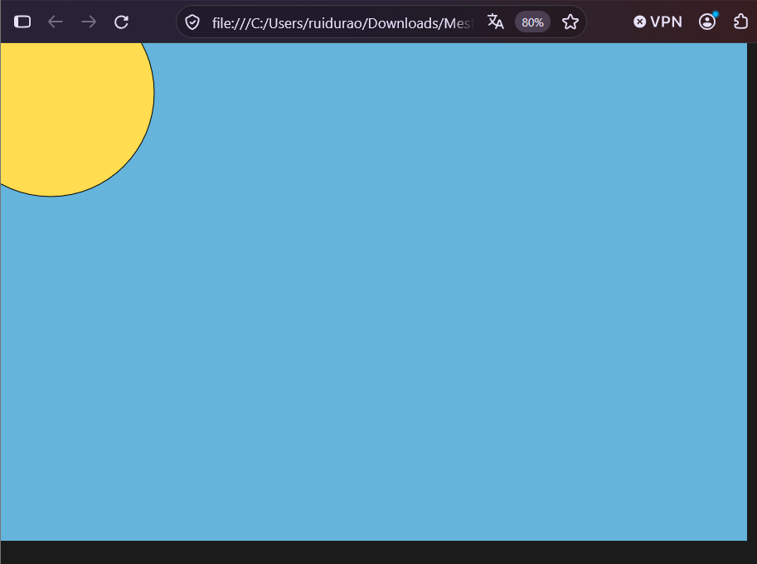
Ajust the X and Y position:
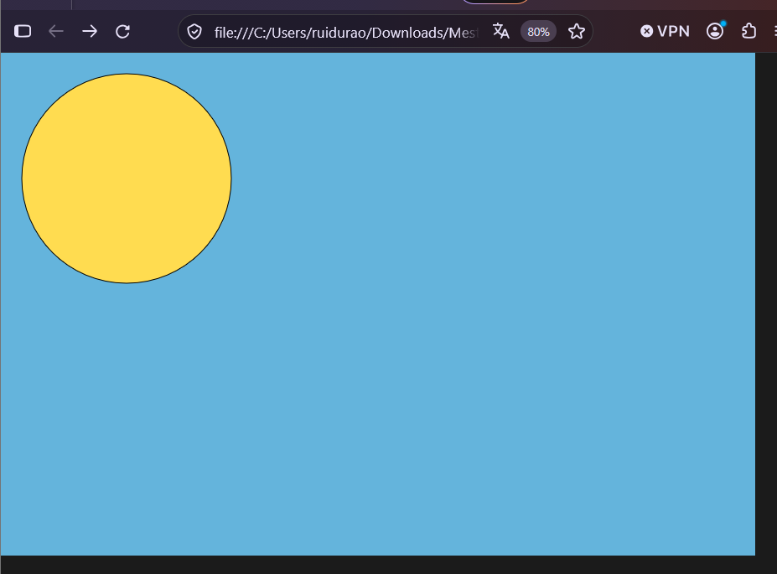

Explaining the JSON:
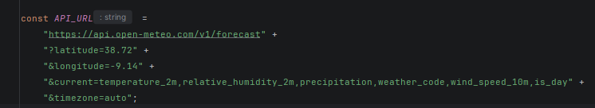
The string starting at https is the general access to the data. The Application Programming Interface provides the data according to the parameteres in the rest of the URL. The ? symbol indicates the beginning of a querry, on the latitude and longitude 38.72,9.14, and timezone in auto, the only input values, the others, current, relative_humidity_2m, percipitation, weather_code, wind_speed_10m, is_day, is the data we need, those values are going to be outputed as json.
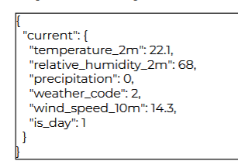
A data structure in the type: key and value, and sub keys, used in several programming projects.

