MILESTONE 1
PRODUCTION DOSSIER

RUI DURÃO

MASTERS IN CREATIVE COMPUTING AND ARTIFICIAL INTELLIGENCE
IADE
2026/2027

NOVEMBER 3rd, 2026
CONTENTS
CREATIVE JOURNAL 4
OUTCOME SELECTED AND DESIGN PROTOTYPE 6
ITERATIONS ON THE IDEA USING GENERATIVE AI 7
COURSES APPLICATION ON PROJECT 11
INTRODUCTION TO ARTIFICIAL INTELLIGENCE 11
APPLIED MACHINE LEARNING 13
CREATIVE PROGRAMMING 15
PHYSICAL COMPUTING AND IOT 17
SOURCE CODES 20
DEMO 22
ACTIVITY PLAN 24
1. Planning Baseline and Deadlines 25
2. Initial Preparation — starting 1 November 2026 26
3. Milestone 2 — Weekly Action Plan 27
Milestone 2 objective 27
Week 1 — 2–8 November 2026 27
Week 2 — 9–15 November 2026 28
Week 3 — 16–22 November 2026 30
Week 4 — 23–29 November 2026 31
Week 5 — 30 November–6 December 2026 32
Week 6 — 7–13 December 2026 34
Milestone 2 Submission — 14–15 December 2026 35
4. Milestone 3 — Weekly Action Plan 35
Milestone 3 objective 35
Week 7 — 16–20 December 2026 35
Week 8 — 21–27 December 2026 36
Week 9 — 28 December 2026–3 January 2027 37
Week 10 — 4–10 January 2027 38
Milestone 3 Submission — 11–12 January 2027 39
5. IoT Acceptance Checkpoints 40
6. Weekly Monitoring and Scope Control 41
BIBLIOGRAPHY AND WEBOGRAPHY 42
APENDIX I – DATA AND COMPONENTS FLOW FLUXOGRAM 44
APENDIX II – INTERACTION SEQUENCE 44

CREATIVE JOURNAL
During Rudolfo Quintas presentation and projects presentation several ideas were registered, most of them not feasible for the scope of the project, but worth noticing and presenting.
(AI images were generated using Perplexity AI)
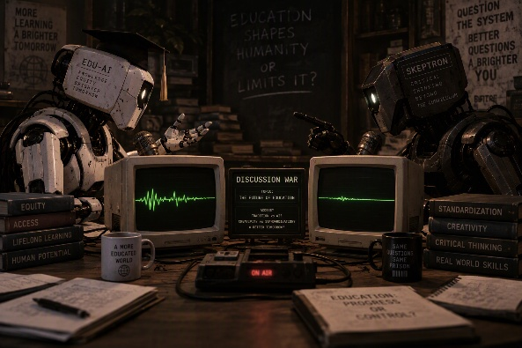
Two AIs clash in a live debate, each fighting to prove its answer right.

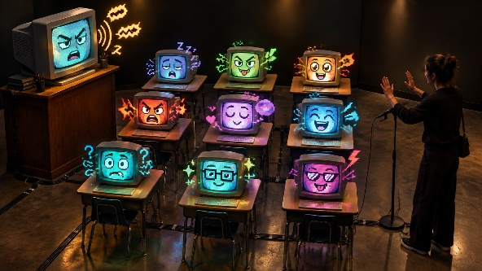
An interactive installation where one CRT teacher and nine smaller CRT students, each powered by an AI agent with a distinct personality, simulate a chaotic classroom that visitors must try to bring to order.


An interactive audiovisual experience that transforms user-provided words into AI-generated landscapes and music, creating unique sensory journeys inspired by language.

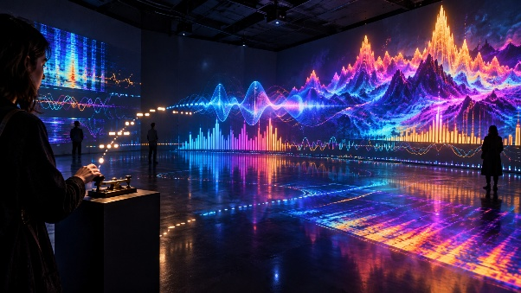
An interactive audiovisual installation where visitors use a Morse key to input words, which are translated into Morse code and transformed into dynamic musical landscapes and real-time spectrum visualizations.

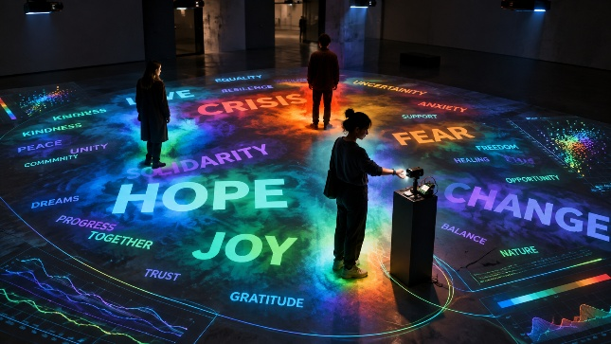
An interactive installation that projects Twitter’s trending words of the day onto the floor, while an ESP32 measures ambient and participant body temperature to explore and visualize correlations between physiological responses and the sentiment of the displayed words.

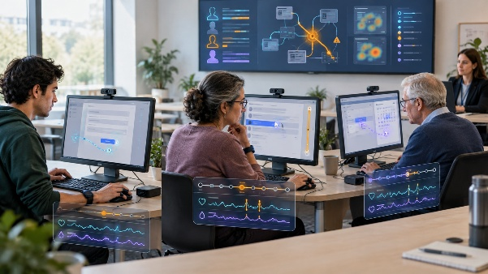
A study on digital inclusion where participants from different age groups perform everyday tasks on standard computers while cameras, interaction tracking, and physiological sensors monitor their actions, difficulties, and stress levels to better understand usability barriers and user experience.

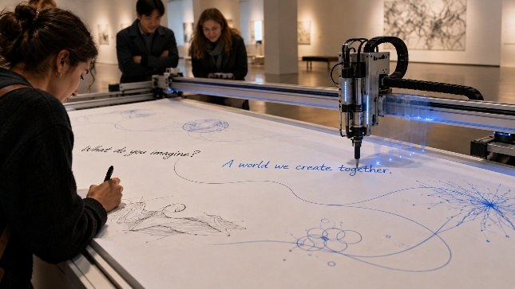
A large-scale CNC plotter, or a small mobile robot moving back and forth, dynamically writes responses in real time based on what people write, creating a live human-machine dialogue.

Apply questionnaire to high schoolers and analyze and visualize the data.
The ideas presented are only centered on presenting data in a creative way, none of them represents the essence of Rudolfo Quintas Artwork. The idea of applying a questionnaire to high schoolers was not feasible due to bureaucratic, time and RGPD constraints. In the next chapter it is presented the “final” ideation process of the idea for further development.

OUTCOME SELECTED AND DESIGN PROTOTYPE
As requested by Project Briefing, the way of development was chosen, beginning with one or several Rudolfo’s Art Installations as a base to develop ours. Were selected Type Datasets and Sentiment Data Paintings from the art repertoire as initial inspiration
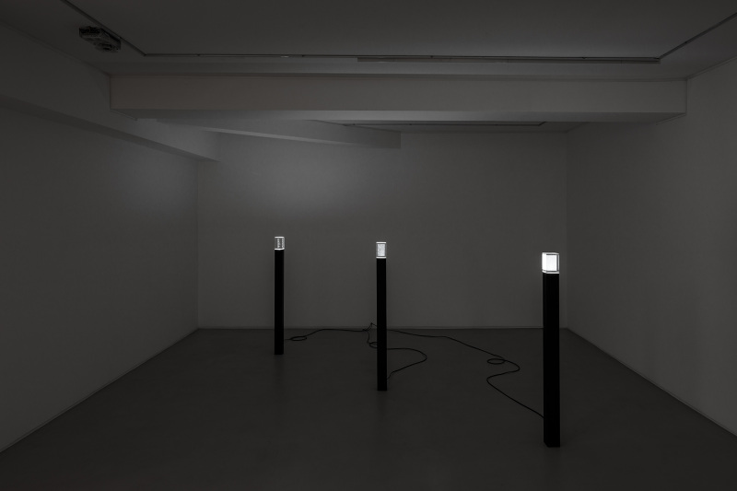
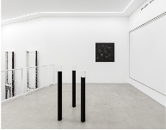
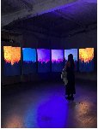
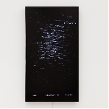

From the two instalations, the one with the moste resonance was Type Datasets. It was associated with an Information Post style, a design caracteristic as a starting point for the personal instalation.
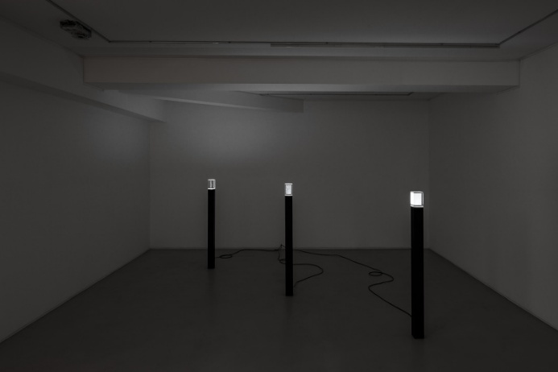
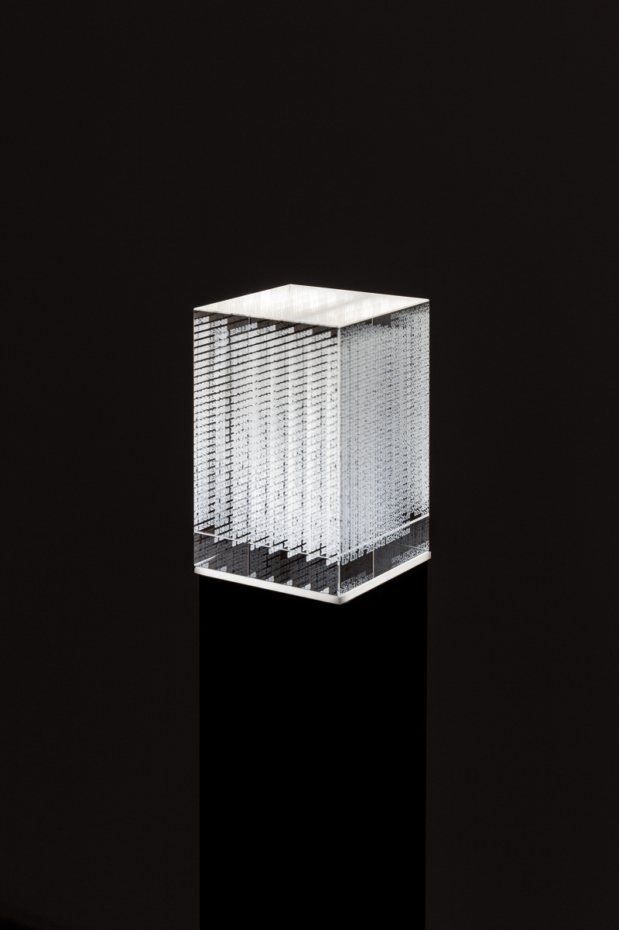

ITERATIONS ON THE IDEA USING GENERATIVE AI
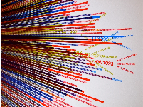
This image is not AI generated, it represents a data visualization method gather from Google Images Search (Google, s.d.). As the first starting point, several iterations were made with Rudolfo Quintas’ Art Installation Type Datasets and the visualization method.

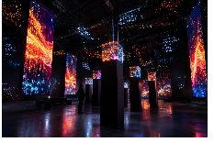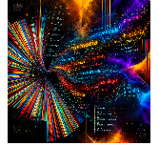
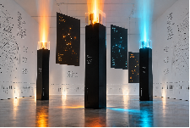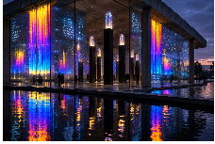
At this point, the light on the images were becoming interesting and an idea of making them fall from the celing, or from the sides, or from the botton were explored. First using Thinkercad as a draft “drawned” in 3D and AI for refinement.
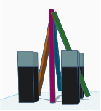
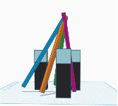
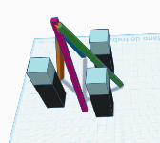
These 3 images were snapshots taken from Tinkercad.

AI Exploration:
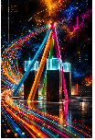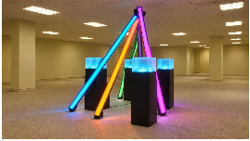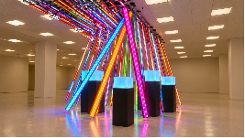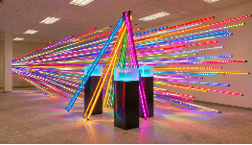
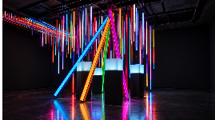
Converging from ideation to operational planning, as interesting and visual appealing the previous images might be, sharing the ideas with other artists, we concluded: a feasibility path is using either LED Matrix or LED Strips.
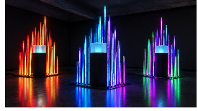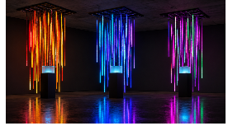
As further research LED Strips ou Matrix Requires the usage of a microcontroller not studied in Physical Computing and IoT Course as demonstrated by the YouTube video (Maher, 2026).
The next iteration introduced 2D Holographic display, with the ability to be programmed using an ESP32 Microcontroller (Tech Arrange, s.d.).
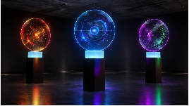
Final idea – Title: Reading Between the Lines
An interactive installation invites visitors to explore the relationship between public perceptions of education in Portugal, patterns retrieved from PISA database query and future forecasting through machine-learning model trained on PISA Dataset. Combining a tactile book, video-hands interface responsive lighting, transparent data visualization, and spoken narration, the installation creates a dialogue between personal experience and educational data.
An open, acrylic info station mounted on a pedestal presents questions about education, each accompanied by an interactive sensor area. Visitors register their responses through these interfaces, allowing a rule-based system to categorize their expressed views. Questions include:
- “As a parent, how satisfied are you with education in Portugal up to the selected year?”
- “How confident are you that students completing secondary school in the selected year are prepared for the future?”
- Additional questions exploring educational opportunities, learning experiences, and expectations.
Positioned in front of the book, a sky-blue cube with a transparent display presents the collected responses alongside findings from the PISA analysis. RGB LEDs integrated into the base of the cube change color according to visitors’ selected responses. The same color scheme appears in the on-screen visualizations, creating a consistent connection between each response, its category, and its visual representation. Visitors’ perceptions and dataset-derived findings remain clearly distinguished, inviting comparison rather than presenting them as equivalent measures.
A narrated voice guides visitors through analytical findings, introducing patterns associated with different years and educational topics. When visitors wish to interact, they move closer to a proximity sensor to activate an interaction mode, through which they can select a year, explore a topic, or respond to a related question. The narration and display then adapt to the chosen focus.
As contributions accumulate, the installation develops an evolving collective portrait of attitudes towards education. The book provides a space for personal reflection, while the illuminated cube brings those perspectives into conversation with the data—encouraging visitors to consider where lived experience and measured outcomes align, differ, or raise further questions.
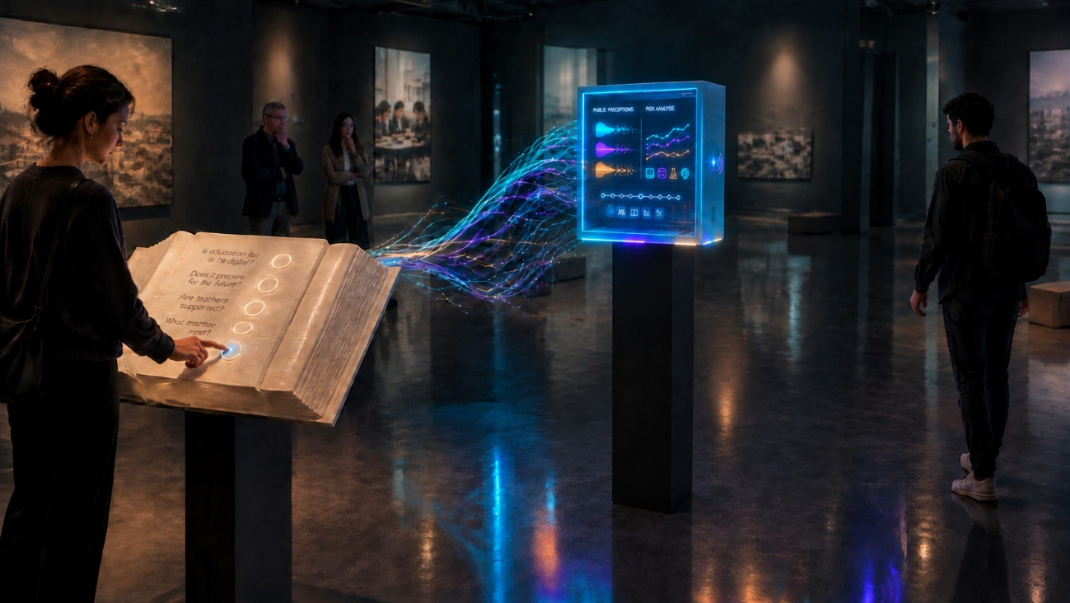
Previous representation is considered the best one to represent what is intended to build. Other generated images were part of the ideation process:
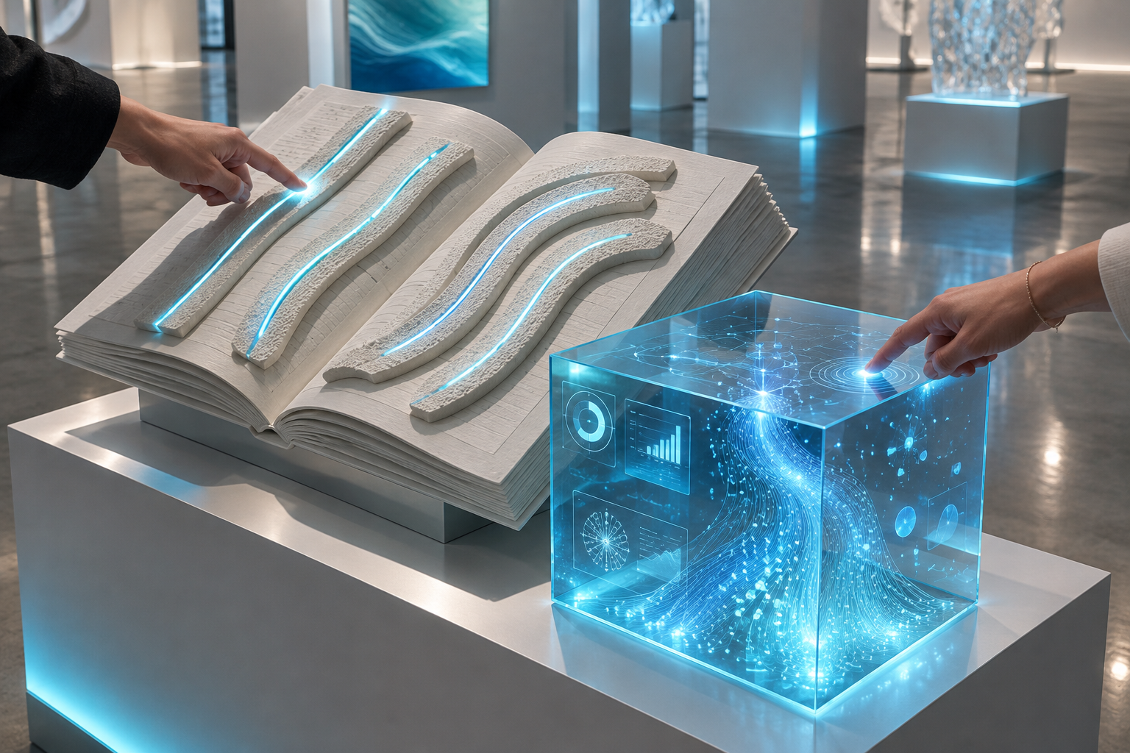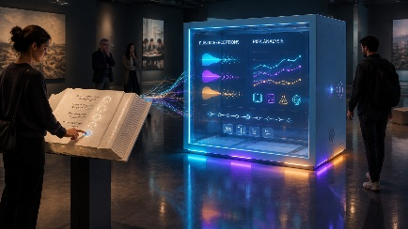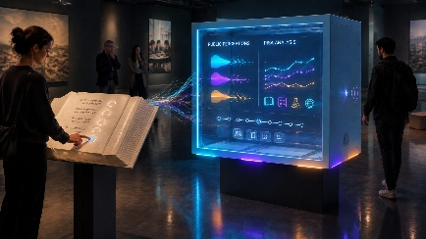
The feasibility of the transparent screen is demonstrated by this YouTube video: (Evan and Katelyn, s.d.), If transparent TV is not feasible, would default to a TV inside a cube.
Further ideation using LLM to generate a Python Script to build the following 3D Mockup (python code interactions: python_script_generate_3d_mockup_v1.py, python_script_generate_3d_mockup_v2.py, python_script_generate_3d_mockup_v3.py, python_script_generate_3d_mockup_v4.py, python_script_generate_3d_mockup_v5.py, python_script_generate_3d_mockup_v6.py, python_script_generate_3d_mockup_v7.py, python_script_generate_3d_mockup_v8.py):
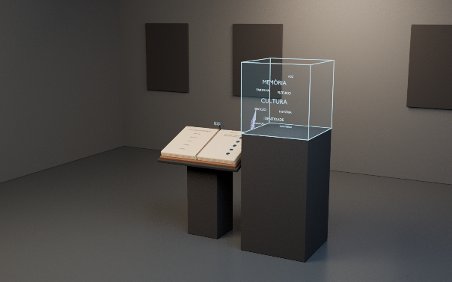 to 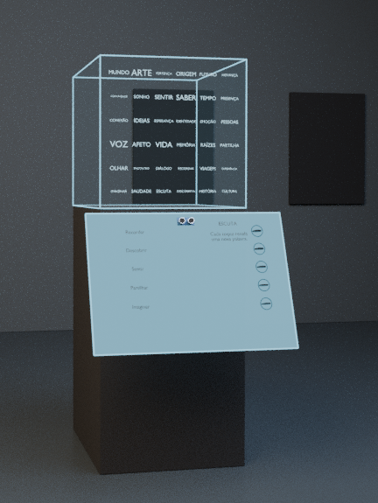
At Apendix I and Apendix II is presented a fluxgram of data and components flow and interaction sequence for the installation.

COURSES APPLICATION ON PROJECT

INTRODUCTION TO ARTIFICIAL INTELLIGENCE
Role within the Project
In “Reading Between the Lines”, Artificial Intelligence will support the interpretation of visitor input and the selection of appropriate responses within the installation. The objective is to create an interactive experience in which visitors can explore educational topics, express their perceptions, and receive contextualized visual and audio feedback. The proposed approach combines rule-based decision-making with the use of a pre-trained hand-tracking model in the initial interaction prototype.
The rule-based component will manage the relationship between visitor actions and installation behavior. Rather than generating unrestricted responses, the system will operate through explicit rules that connect selected questions, response values, educational topics, visual representations, and narration. This approach will make the installation’s behavior easier to explain and align with its artistic concept.
Proposed Rule-Based Interaction
The installation is intended to alternate between an autonomous presentation mode and an interactive mode. During autonomous operation, it will present educational information and visual content. When a visitor approaches the proximity sensor, the system will use the presence signal to initiate an interaction sequence.
Within this sequence, visitors will be able to select a topic, explore an available reference year, or respond to a question about education. Their responses will be mapped to predefined categories representing the position they have explicitly selected. These categories will then inform the visual and audio response of the installation.
The proposed decision rules will address:
- The conditions required to enter and leave interactive mode.
- The interpretation of visitor selections and response values.
- The categorization of explicitly expressed opinions.
- The selection of relevant educational information.
- The coordination of screen content, color feedback, and narration.
- The handling of incomplete input or unavailable sensor information.
These rules will form the decision-making layer connecting physical interaction with the installation’s digital presentation.
Initial Computer-Vision Experiment
An initial prototype uses `ml5.handPose()` to identify hand landmarks in a webcam feed. The position of the visitor’s index finger controls an on-screen response scale ranging from 0 to 100. This experiment demonstrates an alternative interaction method through which visitors can explicitly communicate their level of satisfaction, confidence, or hope regarding the questions presented.
The distinction between gesture detection and opinion interpretation is important. The model identifies the position of the hand; it does not infer the visitor’s emotional state. The response value results from the visitor’s deliberate movement, while the proposed rule-based system will determine how that value is categorized and represented.
Required Data and Development Plan
The AI component will require presence information, selected questions and topics, response values, interaction state, and the associations between response categories and presentation content. Hand landmark coordinates will also be required when the webcam-based interface is used.
At Milestone 1, the dossier presents an initial hand-tracking experiment and presence-detection rules. The complete interaction logic, opinion categorization, and adaptive narration remain proposed development work. Subsequent testing will examine whether the system responds consistently to visitors’ actions and whether its behavior remains understandable throughout the experience. This progression follows the briefing’s requirement to move from identifying AI applications and data needs to implementing and integrating the decision-making component.

APPLIED MACHINE LEARNING
Role within the Project
Applied Machine Learning will provide the analytical component of “Reading Between the Lines”. The installation will bring visitors’ perceptions of education into dialogue with patterns identified in educational datasets, with OECD PISA data identified in the dossier as the principal source to investigate. The purpose is to support reflection through data-driven analysis without presenting visitors’ opinions and measured educational outcomes as equivalent forms of evidence.
The proposed approach is supervised learning using multiple regression. The model will examine relationships between selected explanatory variables and a clearly defined educational outcome. Its results will subsequently inform the visual and narrative content presented by the installation.
Dataset Selection and Prediction Task
The first stage will establish the exact dataset, available reference periods, relevant variables, and prediction target. The dossier currently proposes forecasting an educational indicator for a future period; however, the target indicator and forecasting horizon have not yet been specified.
The development process will therefore distinguish between two possible objectives: predicting an outcome from explanatory variables within the available data, and forecasting that outcome for a future reference period. The final objective will be selected after examining whether the data supports the intended task.
The analytical specification will identify:
- The educational outcome to be predicted.
- The explanatory variables used as model inputs.
- The unit of analysis represented by each observation.
- The reference periods included in the analysis.
- The geographical scope of the selected data.
- The output to be communicated through the installation.
Future-period prediction will remain a conditional objective rather than a confirmed capability until the suitability of the data has been assessed.
Data Preparation, Training, and Evaluation
The proposed workflow will include inspecting the dataset documentation, selecting relevant records and variables, identifying missing or invalid values, and preparing the data for training and evaluation. Any transformations or exclusions will be documented so that the relationship between the original data and the model inputs remains traceable.
A regression model will then be trained and evaluated using a clearly described procedure. The evaluation will examine the difference between predicted and observed values and establish whether the model produces results that are useful for the installation’s analytical purpose. The dossier will document the selected evaluation measures, the results obtained, and the limitations identified during testing.
The model will not be presented as an authoritative judgement about the education system. Its outputs will be framed as estimates associated with a particular dataset, modelling task, and set of assumptions.

Integration with the Installation
The trained model’s output will be connected to the p5.js presentation layer. Depending on the selected topic, the interface will display observed values, model estimates, or comparisons relevant to the question being explored.
Visitors’ responses will be stored and presented separately from the educational dataset and model outputs. This separation is central to the artistic concept: the installation invites comparison between personal perceptions and dataset-derived findings, rather than treating one as a direct measurement of the other.
At Milestone 1, this component consists of a proposed regression approach and an initial identification of data sources. A trained model, evaluation results, and integration with the installation have not yet been demonstrated. These will form the subsequent development stages required by the project briefing.
As part of Ideation Process, a curated list of datasets was generated, centered on the topic of education. While preparing the idea and thinking on data to visualize, news channels were presenting the results of Portuguese Students in the PISA Study and how low the performance was, this presented a catalyst to the topic chosen. Several datasets sources and studies where searched: (PISA 2025 Results (Volume I) Future-Ready Students, s.d.), (PISA 2025 Results (Volume I): Portugal, s.d.), (Kaggle, s.d.), (Nova, s.d.), (Espelage & Lopes, 2013), (Ioana), (Lopes, Silva, Oliveira, Sass, & Martin), (Pordata, s.d.) and the last one, that will serve as a data source for the installation (OECD, s.d.)
Initial output from the PISA datasets will center in Cognitive Capacities and Financial Literacy of Portuguese Students related to OECD and the world. Multiple Regression Model, trained model for predictions will have

CREATIVE PROGRAMMING
Role within the Project
Creative Programming will translate the project’s educational data, visitor responses, and interaction states into a coherent visual experience. The digital layer will be developed in p5.js, with ml5.js used where machine-learning-supported interaction is appropriate. This component will connect the installation’s artistic concept with the information and actions presented to its audience.
The proposed visual language combines typography, color, animation, and graphical representations. These elements will connect the physical book, the illuminated cube, and the screen-based content, helping visitors recognize how their actions affect the installation.
Audience Interface
The audience interface will support both autonomous presentation and direct interaction. During autonomous presentation, it will display thematic visual content relating to education. During interaction, it will present questions, response controls, selected topics, and relevant analytical findings.
An initial p5.js sketch generates thematic word clouds using education-related vocabulary. The sketch alternates between six thematic compositions every five seconds and includes color variation and opacity transitions. In its current form, it is a visual exploration based on a predefined word list, rather than a representation of measured word frequencies extracted from the educational dataset.
A second prototype combines webcam feed with questions and interactive response bars. The visitor’s index-finger position controls the selected response value, and the interface displays that value numerically and through a color gradient. This demonstrates how computer-vision input can be incorporated into a creative interface.
Further development will connect the interface to the physical sensors and analytical outputs, allowing visitors to influence the displayed content.
Visual Representation of Data and Responses
The final visualization will distinguish between historical observations, model-generated estimates, and visitor contributions. Labels, color conventions, and screen composition will be used to communicate the source and meaning of each representation.
The color associated with a visitor’s response will also inform the proposed RGB lighting around the cube. This will create continuity between the physical and digital elements while preserving a clear distinction between individual responses and the wider educational analysis. The lighting and screen coordination are part of the proposed installation concept and remain to be integrated.

Curator and Backoffice Interface
A separate interface will be developed for the curator or operator. In accordance with the briefing, this interface will include a digital representation of the artwork and a virtual representation of its IoT devices. It will support the inspection of sensor information, interaction states, and the relationship between physical input and digital behavior.
The proposed back office will provide:
- A three-dimensional representation of the installation.
- Visual indications of sensor readings and device states.
- A representation of the current operating mode.
- Controls for exploring simulated interaction conditions.
- Visual feedback showing how changes in input affect the artwork.
At Milestone 1, the word-cloud and gesture-based audience interfaces constitute the initial demonstrations. The curator interface and the complete connection to live IoT data remain planned components. Subsequent development will address the briefing’s requirement for both an audience-facing experience and an operational backoffice.

PHYSICAL COMPUTING AND IOT
Role within the Project
Physical Computing and IoT will provide the connection between visitors, the physical installation, and the digital application. This component includes the selection and integration of sensors, microcontroller firmware, the acquisition of interaction data, communication with the presentation software, and the control of physical feedback devices.
The proposed installation combines a tactile book mounted on a pedestal, a proximity sensor, interactive touch areas, an illuminated cube, and a screen. An ESP32 is planned as the microcontroller responsible for acquiring physical input and making it available to the software through a Wi-Fi connection.

Sensors and Physical Feedback
The ultrasonic proximity sensor will measure the distance between the installation and a nearby visitor. This information will provide the presence signal used by the interaction logic to determine when an interactive sequence should begin.
Capacitive touch areas are proposed for the book, allowing visitors to respond to questions or make selections through a physical interface. RGB LEDs are also proposed to provide color feedback associated with the selected responses. The precise touch-sensor arrangement, wiring, and lighting integration remain to be defined and tested.
The physical components have different responsibilities: the sensors acquire input, the microcontroller processes and transmit device information, and the LEDs provide physical output. The higher-level interpretation of responses and the screen-based visualization will be handled by the corresponding software components.
Firmware and Communication
The dossier includes ESP32 firmware for an ultrasonic sensor and an HTTP server exposing a REST API. The API provides access to distance measurements, presence information, sensor validity, configuration values, and diagnostic information. The documented endpoints are `/api/status`, `/api/distance`, `/api/presence`, and `/api/config`.
The firmware also includes a configurable presence threshold, filtering of sensor readings, a timeout for unsuccessful measurements, and two buttons that can override the detected presence state. These features support testing and allow the application to distinguish valid measurements from unavailable readings.
The intended data flow is:
- A sensor acquires physical measurement or visitor input.
- The microcontroller processes the reading and updates the device state.
- The communication interface makes the information available to the application.
- The interaction logic determines the appropriate response.
- The p5.js interface updates the visual presentation.
- Where implemented, a control command updates the physical lighting.
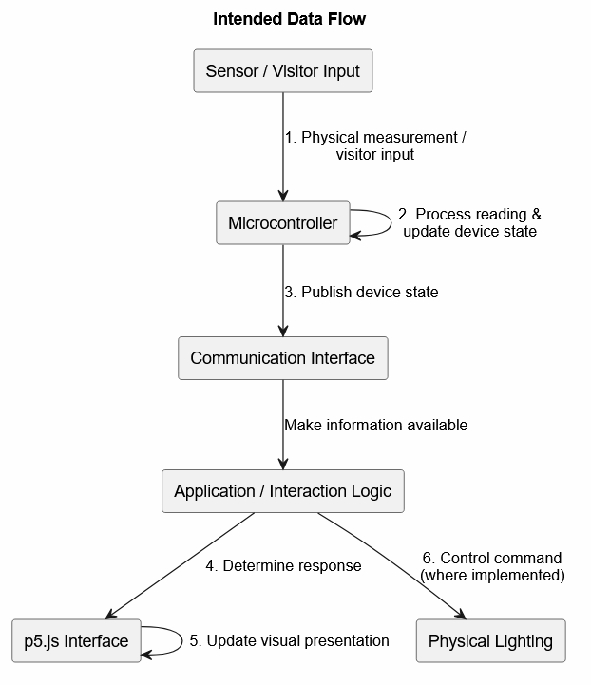
Intended Dataflow Schematics
The submitted firmware demonstrates the proximity-sensing and communication elements; it does not yet demonstrate the complete touch-input and RGB-lighting system.
Initial Prototype and Further Development
The documented initial simulation uses an Arduino connected to an ultrasonic proximity sensor to demonstrate distance acquisition. ESP32 is identified as the intended platform for the final installation, adding network communication and the REST interface described in the firmware.
Further development will integrate the selected hardware, document the circuit diagrams and connections, and connect live sensor readings to the digital interface. Testing will examine measurement consistency, communication stability, response time, and behavior when sensor information is unavailable.
At Milestone 1, the physical-computing contribution consists of the proposed hardware architecture, an initial ultrasonic-sensor demonstration, and the ESP32 communication code. The completed physical prototype, touch interfaces, lighting control, and live end-to-end integration remain subsequent development objectives, consistent with the progression established in the project briefing.

SOURCE CODES
Code to upload to ESP32 and provide a Webserver with REST API to measure distance using Ultrasonic Proximity Sensor: ESP32_Webserver_and_Ultrasonic.ino
Expected outcomes in JSON:
Nobody in range | Someone walks in front of the sensor
{  "present": false,  "distance_cm": 213.7,  "sensor_ok": true,  "threshold_cm": 150.0,  "override": "none",  "force_present_button": false,  "force_absent_button": false,  "uptime_ms": 48213,  "rssi": -58  } | {  "present": true,  "distance_cm": 74.2,  "sensor_ok": true,  "threshold_cm": 150.0,  "override": "none",  "force_present_button": false,  "force_absent_button": false,  "uptime_ms": 51966,  "rssi": -58  }
The boundary case, distance_cm exactly at the threshold, still counts as present because the comparison is <= | Button overrides, first button held while the sensor genuinely sees nothing — the override wins and the raw distance stays honest
{  "present": true, "distance_cm": 150.0, "sensor_ok": true, "threshold_cm": 150.0,  "override": "none", "force_present_button": false, "force_absent_button": false,  "uptime_ms": 52410, "rssi": -61  } | {  "present": true,  "distance_cm": null,  "sensor_ok": false,  "threshold_cm": 150.0,  "override": "force_present",  "force_present_button": true,  "force_absent_button": false,  "uptime_ms": 63002,  "rssi": -63  }
Second button held while someone is standing right there — the fail-safe suppresses the detection | Both pressed, or a stuck contact, resolves to force_absent — the safe state
{  "present": false,  "distance_cm": 41.8,  "sensor_ok": true,  "threshold_cm": 150.0,  "override": "force_absent",  "force_present_button": false,  "force_absent_button": true,  "uptime_ms": 67845,  "rssi": -60  } | {  "present": false,  "distance_cm": 88.0,  "sensor_ok": true,  "threshold_cm": 150.0,  "override": "force_absent",  "force_present_button": true,  "force_absent_button": true,  "uptime_ms": 69010,  "rssi": -60  }
Sensor failures, No echo at all — soft target, out of range beyond 4 m, unplugged sensor, or a missing divider. All three samples failed, so sensor_ok drops and the distance become null rather than a stale number
{
"present": false,
"distance_cm": null,
"sensor_ok": false,
"threshold_cm": 150.0,
"override": "none",
"force_present_button": false,
"force_absent_button": false,
"uptime_ms": 120334,
"rssi": -71
}
API ACCESS AND ERRORS
GET /api/distance, reading valid | GET /api/distance, sensor dead — a null, not 0, so a dashboard can distinguish "no object" from "no measurement"
{"distance_cm": 42.5} | {"distance_cm": null}
GET /api/presence, no override | GET /api/presence, override active
{  "present": true,  "override": "none"  } | {  "present": false,  "override": "force_absent"  }
POST /api/config?threshold_cm=500 — rejected, HTTP 400, config unchanged | Any unknown path — HTTP 404
{"error": "threshold_cm must be between 2 and 400"} | {"error": "not found"}
Code for showing a different Word Cloud every 5 seconds in P5.js: wordcloud-p5.js.txt.
Code for displaying webcam feed and capture visitors’ sentiment regarding each statement: webcam_feed_ml5_p5.js.txt.

DEMO
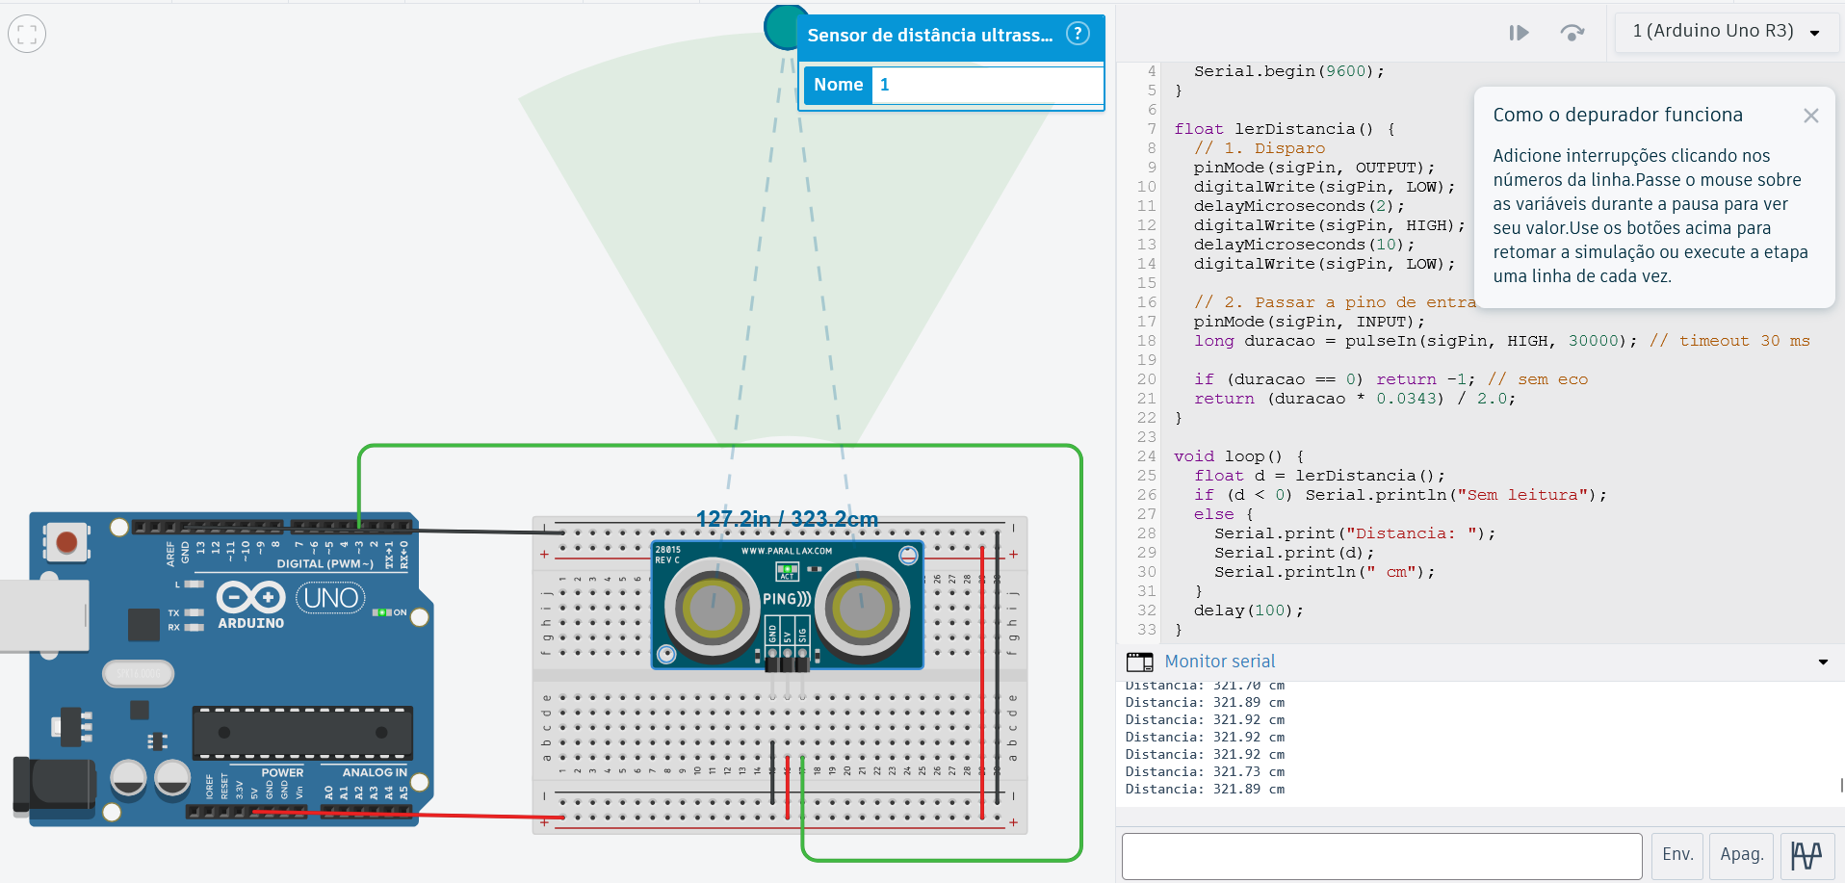
In the simulation above we have an Arduino receiving data from an Ultrasonic proximity sensor and outputting the distances (calculated with eco and sound distance). At final installation it will be used an ESP32, but the functionality is the same with the added features of providing a webserver with REST API, as presented in previous section.
An object / person is only detected within 320 cm / 325 cm from the sensor | The lowest distance the sensor can measure is about 19 cm / 20 cm
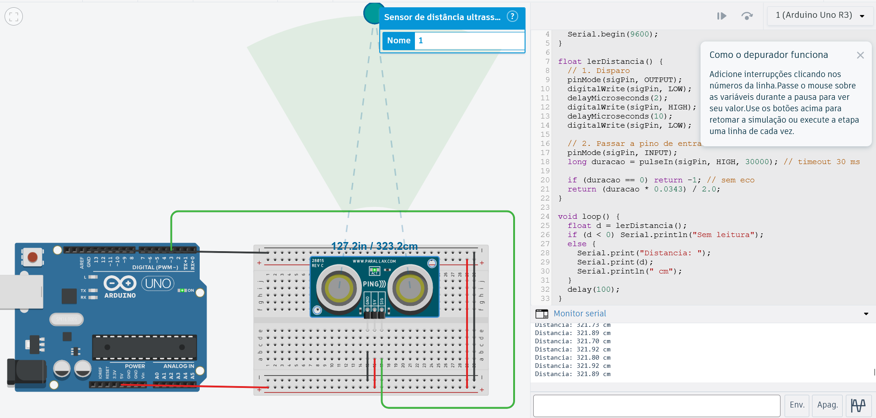 | 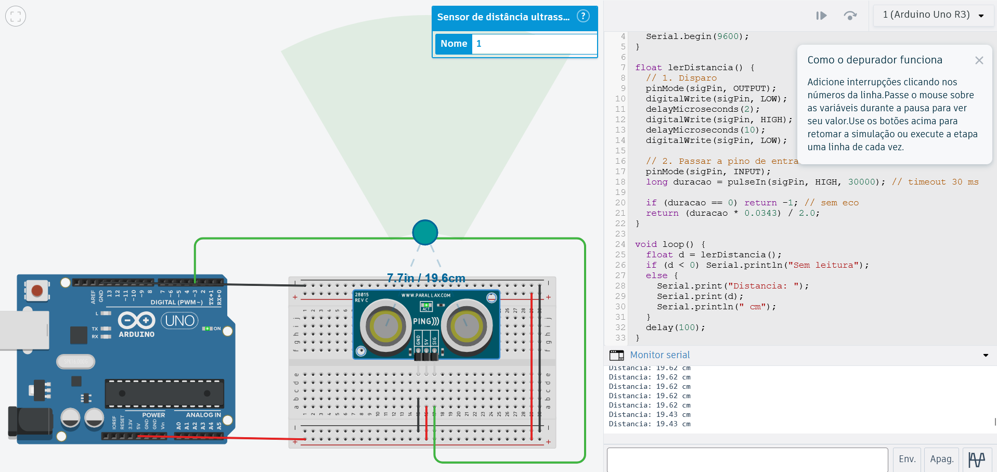

Word Cloud Sample graphic in P5.js
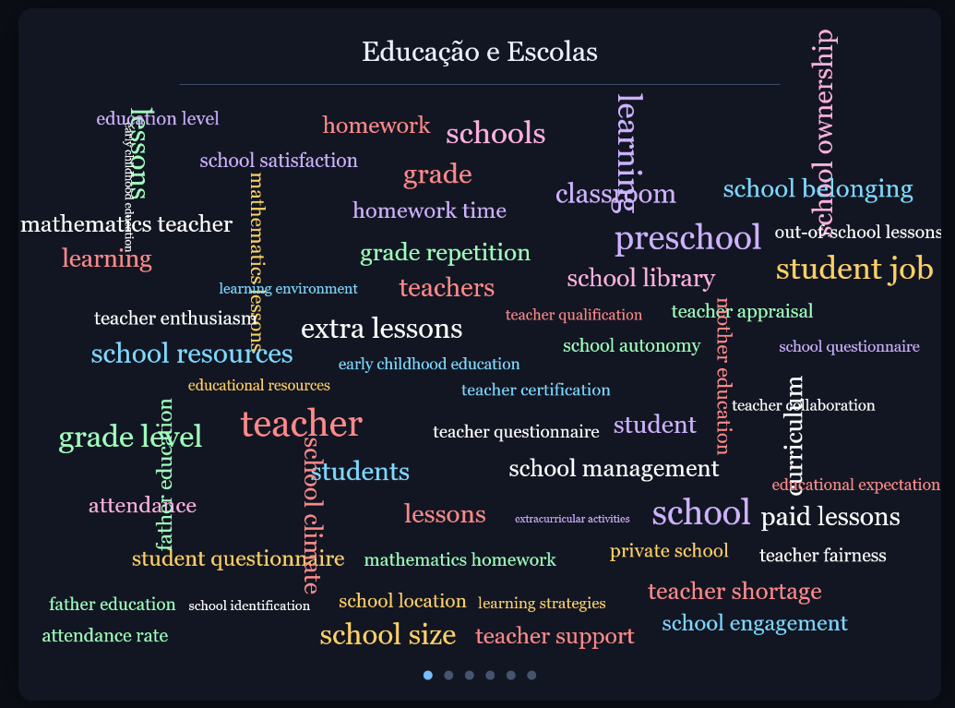
ML5 in P5.js showing webcam feed, questions where visitors interact using a finger to express their sentiment regarding each statement.
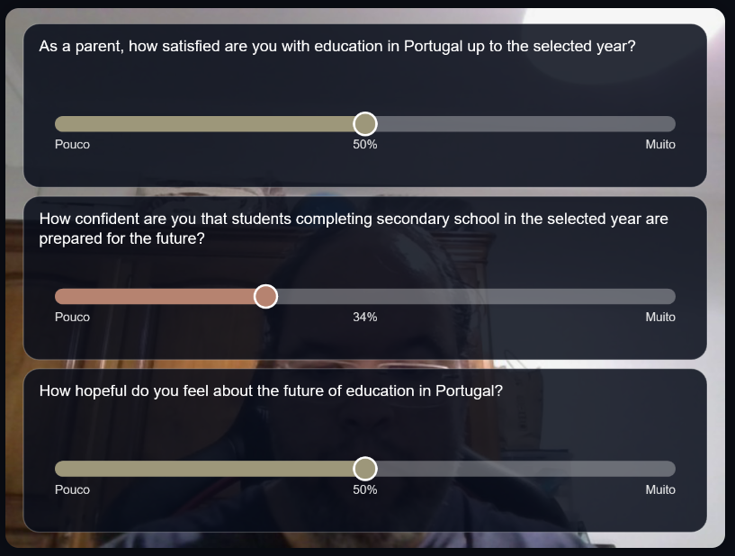

For lighting the cube there are 2 options:
- The same color for all the RGB LEDs arranged in a matrix, so the same color for the entirety of the cube (without limitation on the number of LEDs in the matrix).
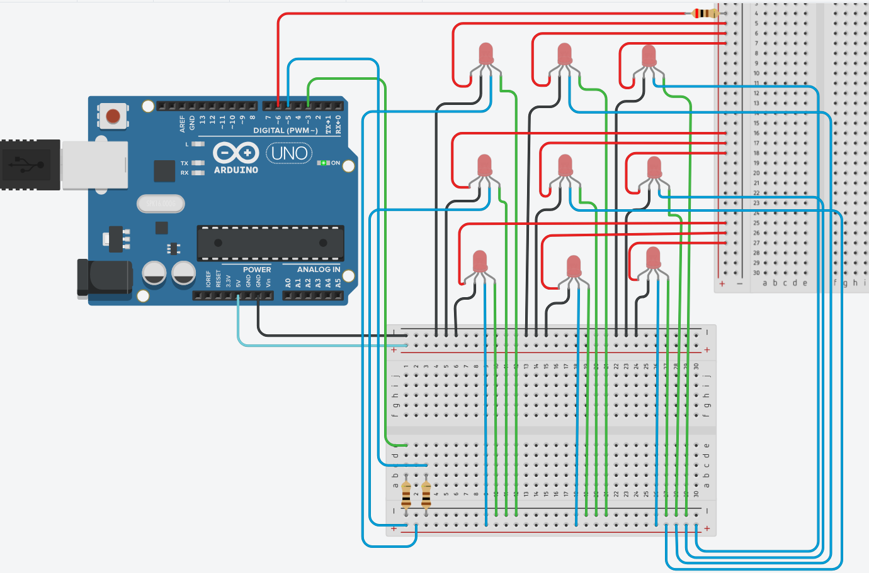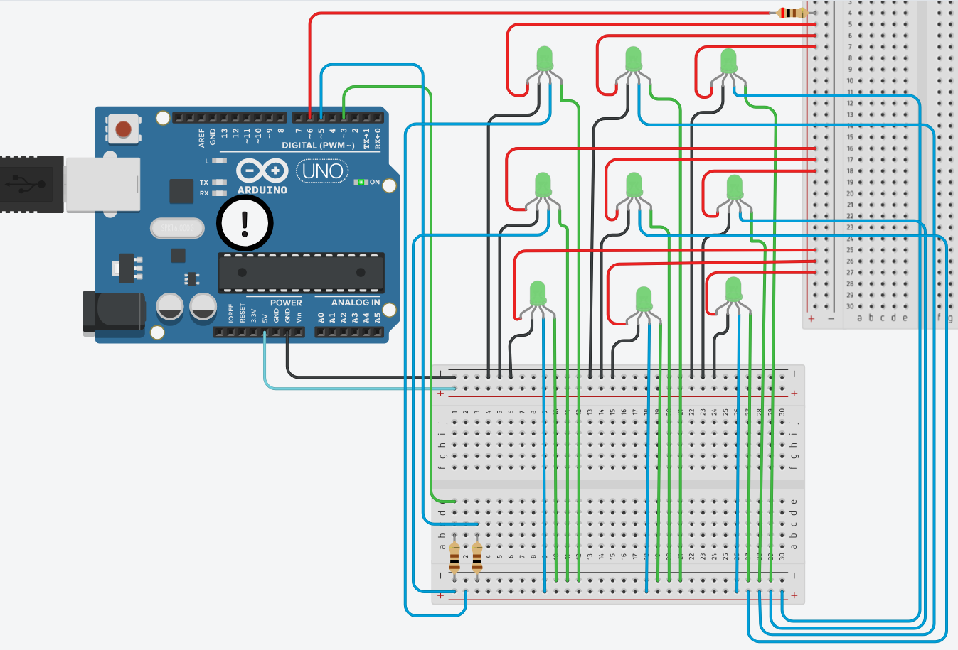
- Individual addressed LED in a matrix, using ESP32 (with a limitation of 9 LEDs in a 3x3 matrix).
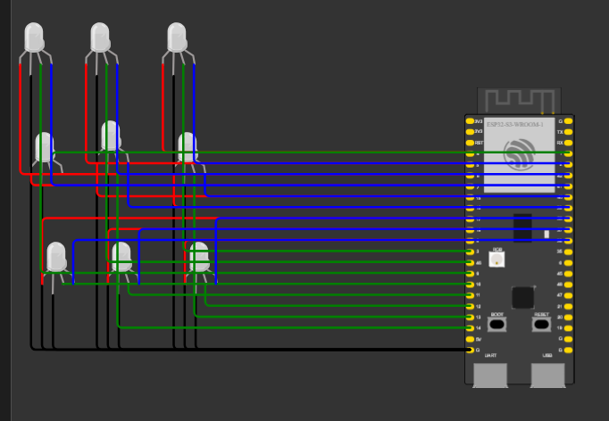
Wokwi demonstration using ESP32

ACTIVITY PLAN
The main priority: early end-to-end demonstration: physical input → ESP32 communication → interaction rules → p5.js visual feedback → RGB lighting.

1. Planning Baseline and Deadlines
Starting position:
Component | Documented starting position | Remaining development
Introduction to AI | Presence-detection rules and a hand-tracking experiment. | Complete interaction states, response categorization, content selection, and coordinated feedback.
Applied Machine Learning | Proposed regression approach and identified educational data sources. | Verify datasets, define the prediction task, prepare data, train and evaluate the model, and integrate its outputs.
Creative Programming | p5.js word clouds and a webcam-based response interface. | Integrated audience interface, analytical visualizations, and curator back office with a 3D artwork representation and virtual IoT devices.
Physical Computing and IoT | Arduino ultrasonic-sensor simulation and ESP32 firmware exposing a REST API. | Validate the firmware on the selected ESP32 hardware; integrate capacitive touch areas and RGB LEDs; complete wiring, communication, testing, and mounting.

The report distinguishes the initial simulation and submitted firmware from a completed physical installation. This plan therefore treats live ESP32 operation and the full touch-and-lighting system as development tasks, not as already validated capabilities.
The schedule begins on 1 November 2026. Week numbers below refer to this action plan, not to the semester-week numbering in the briefing. Holiday periods have a lighter planned workload; no institutional closure dates are assumed.

2. Initial Preparation — starting 1 November 2026
Activity | Expected output
Review the latest report and identify completed, partially completed, and proposed components. | Development-status checklist.
Define the minimum complete interaction: detect a visitor, display a question, accept and confirm a response, categorize it, and update the screen and lighting. | Minimum working-prototype specification.
List required hardware, display equipment, fabrication resources, and data dependencies. | Procurement and feasibility checklist.
Create a task board and assign responsibility for each activity. | Initial backlog and contribution record.
Establish folders or repository sections for firmware, audience interface, back office, data analysis, assets, and documentation. | Organized project structure.
These proposed management activities support the report’s four technical workstreams and the briefing’s planning and contribution records.

3. Milestone 2 — Weekly Action Plan

Milestone 2 objective
Deliver a working prototype with tested AI logic, a trained and evaluated small ML model, an early audience interface, a 3D back office representation with virtual IoT devices, and initial physical sensor acquisition and transmission. These are the assessment requirements; the additional integration targets below are proposed steps towards the final installation.

Week 1 — 2–8 November 2026
Confirm the interaction architecture and hardware specification
Workstream | Planned activities
Project management | Complete Milestone 1 on 3 November, record feedback, and revise the development backlog.
Introduction to AI | Define operating states: autonomous presentation, presence detected, question selection, response entry, confirmation, feedback, and return to idle. Draft the transition rules.
Applied ML | Verify the actual dataset files and documentation. Define the target variable, candidate inputs, unit of analysis, available reference periods, and geographical scope. Decide whether the task is outcome prediction or future-period forecasting.
Creative Programming | Sketch the complete audience sequence and curator interface. Define how observed educational data, model estimates, and visitor responses will be visually distinguished.
Physical Computing and IoT | Confirm the ESP32 board, ultrasonic sensor, capacitive input arrangement, RGB hardware, power arrangement, and component connections. Prepare the circuit diagram and obtain missing components.
Integration | Define a shared data contract: sensor values, validity indicators, presence state, response events, and lighting commands.
Physical presentation | Assess the transparent-display concept and conventional-screen fallback. Identify fabrication requirements for the book and cube.
Expected outputs:
- Interaction-state diagram and initial rule table.
- Verified dataset inventory and analytical task specification.
- Hardware list, circuit diagram, and proposed pin allocation.
- Initial communication specification.
- Audience and curator interface sketches.
The updated report leaves the precise touch arrangement, wiring, lighting integration, and prediction target open, making these early decisions necessary.

Week 2 — 9–15 November 2026
Validate the ESP32 and connect live proximity data to p5.js
Workstream | Planned activities
Introduction to AI | Implement autonomous-to-interactive transitions using presence information. Define behavior when measurements are invalid or the visitor leaves.
Applied ML | Prepare dataset version 1. Document selected records, variables, missing values, and transformations. Establish the training and evaluation procedure.
Creative Programming | Connect p5.js to the ESP32 API and display live distance, presence, and sensor-validity information. Begin the back office 3D representation and virtual sensor controls.
Physical Computing and IoT | Load and test the proximity firmware on the selected ESP32. Validate `/api/status`, `/api/distance`, `/api/presence`, and `/api/config`. Test threshold changes, invalid readings, and override buttons.
Touch-input development | Test one capacitive touch area using representative book material and mounting arrangement. Record touch and no-touch readings and select an initial detection threshold.
Display decision | Test the interface on the intended display arrangement and decide whether to retain the transparent-display approach or use the conventional-screen fallback.
Expected outputs:
- Live ESP32 proximity readings reaching p5.js.
- Working presence-controlled screen transition.
- First calibrated capacitive-input experiment.
- Prepared dataset and documented evaluation plan.
- Initial back office model and virtual-device controls.
The API endpoints and existing firmware behaviors are already documented; this week validates them on the actual selected hardware.

Week 3 — 16–22 November 2026
Complete the first response-to-feedback interaction
Workstream | Planned activities
Introduction to AI | Implement response categorization, confirmation, inactivity handling, and feedback selection. Prevent incomplete interaction from being treated as a confirmed response.
Applied ML | Train an initial regression model and a simple comparison baseline. Evaluate both and record the results.
Creative Programming | Implement the question-and-response sequence and consistent text, color, and animation feedback.
Physical Computing and IoT | Integrate the required capacitive inputs and an initial RGB output. Extend the firmware and communication interface to expose response events and accept lighting commands.
Integration | Define how a physical input maps to a question, response value or category, and confirmation action. Keep the webcam-based scale as a distinct interaction method rather than assuming it is equivalent to a discrete touch area.
Physical prototype | Build a low-fidelity book-and-cube assembly to test component placement and access.
Expected outputs:
- Physical response input producing on-screen feedback.
- RGB output responding to the selected category.
- Model version 1 and evaluation record.
- Low-fidelity physical assembly.
- Updated API and interaction mapping.
The report proposes both capacitive book interaction and a webcam-controlled 0–100 scale. Their final relationship must be specified during implementation.

Week 4 — 23–29 November 2026
Integrate analytical content, narration, and back office behavior
Workstream | Planned activities
Introduction to AI | Connect questions and selected topics to the appropriate analytical content. Add rules for cancelled interactions, unavailable data, and interrupted sessions.
Applied ML | Review model errors, revise the approach where justified, and prepare outputs for the visualization. Decide whether the installation will use precomputed estimates or live inference.
Creative Programming | Present observed data and model estimates alongside—but clearly separate from—visitor contributions. Connect the back office’s virtual devices to the same interaction logic.
Physical Computing and IoT | Integrate proximity sensing, touch input, and RGB control in one firmware version. Verify the full acquisition–communication–feedback sequence.
Narration | Implement one completely narrated path, including start, interruption, and return-to-idle behavior.
Response storage | Implement basic storage of confirmed visitor responses and an aggregate view. Define what is stored and how test records can be cleared.
Documentation | Update the system architecture, data-flow diagram, and component descriptions.
Expected outputs:
- Integrated prototype version 1.
- Model outputs visible in the audience interface.
- One complete narrated interaction.
- Stored response records and an aggregate display.
- Backoffice with artwork and device-state feedback.
Narration and the accumulation of visitor contributions are part of the proposed experience in the report; their implementation is explicitly scheduled here.

Week 5 — 30 November–6 December 2026
Test reliability and conduct formative user evaluation
Workstream | Planned activities
Introduction to AI | Test state transitions, response-category boundaries, inactivity, repeated input, and recovery rules.
Applied ML | Finalize the Milestone 2 evaluation record: data, target, inputs, preparation, evaluation procedure, results, and limitations.
Creative Programming | Test instructions, readability, response confirmation, navigation, and understanding of data categories. Verify virtual-device controls in the back office.
Physical Computing and IoT | Test repeated approach and departure, capacitive sensitivity, unintended activation, sensor disconnection, communication loss, and restart behavior.
Integration testing | Measure and record the delay between physical input and visible feedback. Confirm that screen and RGB colors remain consistent.
User evaluation | Run a small formative test with available participants and record completion difficulties and misunderstandings.
Documentation | Assemble screenshots, circuit photographs, test logs, and short demonstration recordings.
Expected outputs:
- Prototype version 2.
- Hardware and integration test record.
- Formative user-test findings.
- Prioritized defect list.
- Draft Milestone 2 dossier.

Week 6 — 7–13 December 2026
Stabilize the prototype and complete submission materials
Workstream | Planned activities
Project management | Freeze non-essential features and prioritize defects affecting the demonstration.
Introduction to AI | Prepare evidence showing how sensor input and visitor selections produce rule-based decisions.
Applied ML | Re-run the documented workflow and verify that reported results match the saved outputs.
Creative Programming | Complete the audience demonstration and back office 3D/virtual-IoT demonstration.
Physical Computing and IoT | Secure prototype wiring, label connections, record calibration values, and complete firmware and API instructions.
Presentation | Rehearse the full interaction, including startup, response submission, analytical feedback, and return to idle.
Documentation and media | Finalize the report, execution record, contribution record, slides, source-code package, HD photographs, and demonstration video.
Expected outputs:
- Stable Milestone 2 release candidate.
- Complete submission package.
- Rehearsed presentation.
- Backup video and recorded test evidence.

Milestone 2 Submission — 14–15 December 2026
- Perform a final startup and end-to-end interaction test.
- Verify that code, data dependencies, assets, and setup instructions are included.
- Present the working prototype on 15 December.
- Submit the required materials through Canvas by 23:59:59 GMT.
- Record feedback for the final development cycle.

4. Milestone 3 — Weekly Action Plan

Milestone 3 objective
Complete the physical installation prototype, demonstrate live IoT acquisition and communication, integrate the AI and trained-model outputs, and deliver completed audience and curator interfaces. The final documentation must explain the model’s results and limitations and reflect on planning and work distribution.

Week 7 — 16–20 December 2026
Apply feedback and finalize the physical design
This is a shortened week following Milestone 2.
Workstream | Planned activities
Project management | Convert feedback into essential corrections, desirable refinements, and out-of-scope requests.
Introduction to AI | Refine confusing transitions, confirmation rules, and content-selection behavior.
Applied ML | Address the most important evaluation weaknesses and select the model version intended for final integration.
Creative Programming | Refine the audience layout, color conventions, narration timing, and curator controls.
Physical Computing and IoT | Finalize sensor placement, capacitive electrode mounting, LED placement, cable routing, and maintenance access.
Fabrication | Finalize dimensions and initiate remaining book, pedestal, or cube fabrication and assembly.
Documentation | Update the exhibition-layout sketch and installation specification.
Expected outputs:
- Final-development backlog.
- Final physical-design and mounting specifications.
- Selected model and interaction revisions.
- Fabrication or final assembly underway.

Week 8 — 21–27 December 2026
Complete software, analytical content, and documentation
This week priorities work that can continue without access to fabrication facilities or the complete installation.
Workstream | Planned activities
Introduction to AI | Run rule tests using recorded or simulated events. Complete the decision-rule documentation.
Applied ML | Finalize output files or the inference interface, explanatory text, and model limitations.
Creative Programming | Refine typography, transitions, questions, and back office interactions. Verify that simulation and live modes are clearly identified.
Narration | Complete audio assets and verify that each statement matches the data or estimate displayed.
Physical Computing and IoT | Complete firmware refinements and prepare the calibration, troubleshooting, and restart procedures.
Documentation | Draft the final architecture, methods, evaluation, installation, and operator-guide sections.
Expected outputs:
- Near-final software and narration.
- Final analytical output package.
- Firmware and calibration documentation.
- Substantial final-dossier draft.

Week 9 — 28 December 2026–3 January 2027
Complete physical assembly and validate the integrated installation
Workstream | Planned activities
Introduction to AI | Test the complete interaction with the final hardware arrangement, including abandonment, interruption, and reset.
Applied ML | Verify that displayed estimates match the final model outputs and that labels accurately explain their meaning.
Creative Programming | Connect the final audience interface to real IoT readings. Complete the required back office visualizations and interactions between the artwork model and virtual devices.
Physical Computing and IoT | Finish mounting and wiring. Recalibrate proximity and capacitive inputs in the final assembly. Verify RGB control, startup, and reconnection behavior.
Response storage | Verify that confirmed responses are stored once, incomplete responses are excluded, and aggregate views update correctly.
Reliability testing | Run repeated complete sessions and an extended operating test. Record failures, response delays, and recovery actions.
Documentation | Photograph the actual assembly and revise circuit diagrams to match the built system.
Expected outputs:
- Fully assembled integrated prototype.
- Live sensor-to-visualization and lighting operation.
- Final circuit and architecture diagrams.
- Reliability test record.
- Remaining-defect list.

Week 10 — 4–10 January 2027
Complete evaluation, presentation, and final deliverables
Workstream | Planned activities
User experience | Conduct final user testing and record whether participants can understand and complete the experience.
Introduction to AI | Verify the final rule behavior and document its contribution to interaction and presentation.
Applied ML | Finalize evaluation evidence, results, assumptions, and limitations.
Creative Programming | Correct remaining readability and interaction problems. Verify both completed interfaces.
Physical Computing and IoT | Inspect mounting, connections, power arrangements, calibration, and startup/shutdown procedures.
Exhibition presentation | Finalize the spatial-layout sketch and explain how the prototype would be installed and operated.
Documentation | Complete the final report, planning reflection, contribution record, source-code package, setup guide, and operator guide.
Media and presentation | Capture final HD photographs and video, complete slides, and rehearse the full demonstration.
Expected outputs:
- Final prototype release.
- Final evaluation record.
- Complete dossier and source-code package.
- Exhibition-layout sketch.
- Promotional media and rehearsed presentation.

Milestone 3 Submission — 11–12 January 2027
- Make only critical corrections.
- Test the installation from a clean startup.
- Verify all source code, assets, configuration instructions, and analytical files.
- Prepare transport, assembly, and demonstration materials.
- Present the final prototype on 12 January.
- Submit all required materials through Canvas by 23:59:59 GMT.

5. IoT Acceptance Checkpoints
The following are proposed internal checkpoints, not additional assessment requirements. They translate the updated report’s hardware and communication objectives into observable evidence.
Target date | Checkpoint | Evidence of completion
8 November | Hardware architecture defined | Component list, circuit diagram, connection plan, and communication specification.
15 November | ESP32 proximity acquisition operational | Live distance, presence, and validity information displayed in p5.js.
22 November | Physical response and lighting operational | A confirmed touch selection produces the intended screen and RGB feedback.
29 November | Combined firmware and application integrated | Proximity, touch, response handling, and lighting operate in one complete sequence.
6 December | Initial reliability testing completed | Recorded tests of repeated inputs, invalid readings, communication loss, and restart.
13 December | Milestone 2 prototype stabilized | Reproducible setup and a complete recorded demonstration.
3 January | Final physical integration completed | Mounted components, final calibration, live operation, and updated diagrams.
10 January | Final operational readiness confirmed | Startup, complete session, recovery, and shutdown demonstrated using the operator guide.

6. Weekly Monitoring and Scope Control
At the end of every week, update:
- Planned versus completed activities.
- Named task ownership and actual contributions.
- Code revisions and working versions.
- Test results and supporting photographs or recordings.
- Decisions, unresolved problems, and dependencies.
- Changes required for the following week.
This supports the execution and contribution records required in both milestone dossiers.

BIBLIOGRAPHY AND WEBOGRAPHY
Espelage, D., & Lopes, J. J. (2013). Indisciplina na Escola.
Evan and Katelyn. (n.d.). DIY Transparent Screen. From YouTube: https://www.youtube.com/watch?v=Shp5JhOqdKI
Google. (n.d.). Google Image Search: Data Visualization. From https://www.google.com/search?client=firefox-b-d&hs=e9uq&sca_esv=467df02f7c1b663d&sxsrf=AKL5yDiVW7LSadEYf_F1p1OFsGxuUWGBMQ:1793530903456&udm=2&fbs=ACAhTvwdifjn2dKXmjtOfBxVFl_koHVe5RLSnJlTH2QYaq_YVdLmrLcUHX_SwxOCJnubtILo6JQUEbpQ0N3gq1xU4jSPiIfgQd3V4w-rlGsZ
Ioana, D. (n.d.). Correlations between teachers’ sense of self-efficacy and classroom management.
Kaggle. (n.d.). Search Results for: Education Portugal. From Kaggle - Evaluating what works at AI’s frontier: https://www.kaggle.com/search?q=education+portugal
Lopes, J., Silva, E., Oliveira, C., Sass, D., & Martin, N. (n.d.). Teacher’s Classroom Management Behavior and Students’ Classroom Misbehavior: A Study with 5th through 9th- Grade Students.
Maher, C. (2026, May). DIY Matrix Panel: EASY, One Controller, One Power supply. From YouTube: https://www.youtube.com/watch?v=BbjeQdJIMK0
Nova, A. (n.d.). Education Research Topics: 150+ Ideas for 2026. From myperfectwords: https://myperfectwords.com/blog/research-paper-guide/education-research-topics
OECD. (n.d.). PISA 2025 Results (Volume I) Future-Ready Students. From OECD (Organisation for Economic Co-operation and Development): https://www.oecd.org/en/publications/pisa-2025-results-volume-i_73451bc5-en/support-materials.html
OECD. (n.d.). PISA 2025 Results (Volume I): Portugal. From OECD (Organisation for Economic Co-operation and Development): https://www.oecd.org/en/publications/pisa-2025-results-volume-i-country-notes_2d4ff9ea-en/portugal_1b9ed477-en.html
OECD. (n.d.). PISA Datasets 2000-2025. From OECD (Organisation for Economic Co-operation and Development): https://webfs.oecd.org/pisa2022/index.html#section0
Pordata. (n.d.). Educational Attainment. From Pordata - Fundação Francisco Manuel dos Santos: https://www.pordata.pt/en/subtheme/portugal/educational+attainment-45
Tech Arrange. (n.d.). Hologram LED Projects using DC Motor. From YouTube: https://www.youtube.com/watch?v=Q_6kZSBrXEo

APENDIX I – DATA AND COMPONENTS FLOW FLUXOGRAM
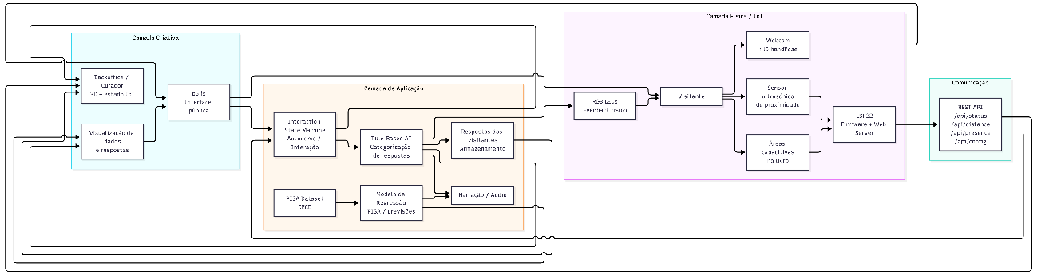

APENDIX II – INTERACTION SEQUENCE


