**Use Cases**

User Inputs custom test script into website

Several visualizations (graphs, charts, etc)

Execute periodically

**Use cases text**

User Inputs custom test script into website

|  |  |
| --- | --- |
| 1. User builds jmeter test |  |
| 1. User inputs custom test script into website |  |
|  | 1. Website tests the file extension (.jmx) inputted by the user |
|  | 1. Jmeter test file is executed |
|  | 1. Saving test results to influxDB |

Several visualizations (graphs, charts, etc)//User monitoring

(display the graphs from grafana in our website)

|  |  |
| --- | --- |
| 1. User enters monitoring page |  |
|  | 1. Grafana loads the influxDB containing the test results |
|  | 1. Grafana displays visualizations for the test results |

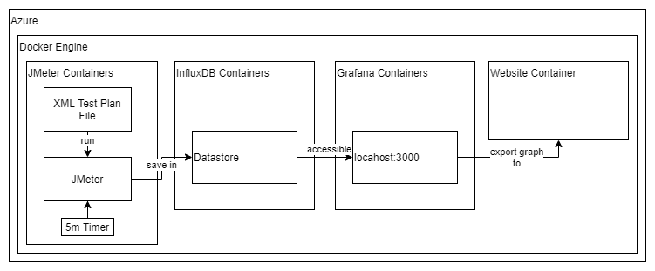

Initial System Architecture Diagram