Assignment for Chapter 5 (A)
- Fill-in-blank：
1. Based on whether a sequential logic circuit contains a unified clock pulse generator, the sequential logic circuit can be categorized into - and such two types.
2. A synchronous sequential logic circuit can be represented by ， ，and such three sets of logic function expressions.
3. The output function of the Mealy type sequential logic circuit consists of ，the output function of the Moore type sequential logic circuit consists of .
4. “When the clock pulse is at a high-level voltage, the input signals can affect the states of the flip-flops”. This statement is (True/False).
5. “The Mealy type and Moore type logic circuits are equivalent to each other.” This statement is (True/False).
6. “The basic RS flip-flop can be directly used as the synchronous sequential logic circuit’s storage circuit. “ This statement is (True/False).
7. “If the CP inputs of all the flip-flops in a sequential logic circuit are connected together, the circuit is the synchronous sequential logic circuit”. This statement is (True/False).
- Short Answer：
- Determine the circuit type (Mealy or Moore) of the table listed as follows, and explain why it is such type; then, draw the state diagram of this table.
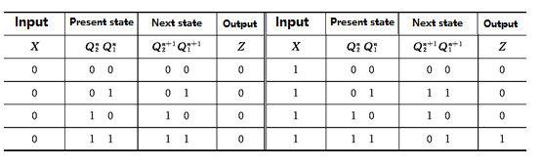

2, Analyze the sequential logic circuit as shown in the following figure to illustrate the function of the circuit
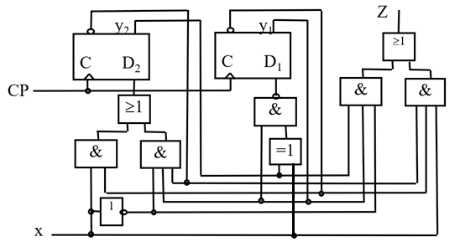

3, Analyze the synchronous sequential logic circuit as shown in the figure to illustrate the function of the circuit.
