Digital Image Processing
Programming lab
Project 1

Code
% Load the image
originalImage = imread('Bird.jpg');

% Convert the image to grayscale if it's in RGB format
grayImage = im2gray(originalImage);

% Apply median filtering to reduce noise
filteredImage = medfilt2(grayImage);

% Enhance contrast
enhancedImage = imadjust(filteredImage);

% Use edge detection to find object boundaries
edgeImage = edge(enhancedImage, 'sobel');

% Dilate the edges to connect broken boundaries
dilatedEdges = imdilate(edgeImage, strel('square', 3));

% Fill the enclosed regions in the dilated image
filledImage = imfill(dilatedEdges, 'holes');

% Remove small objects (noise) from the filled image
cleanedImage = bwareaopen(filledImage, 100);

% Display the results
figure;
subplot(1, 3, 1)
imshow(originalImage)
title('Original Image');

subplot(1, 3, 2)
imshow(edgeImage)
title('Edge Detection');

subplot(1, 3, 3)
imshow(cleanedImage)
title('Segmented Objects');

Results
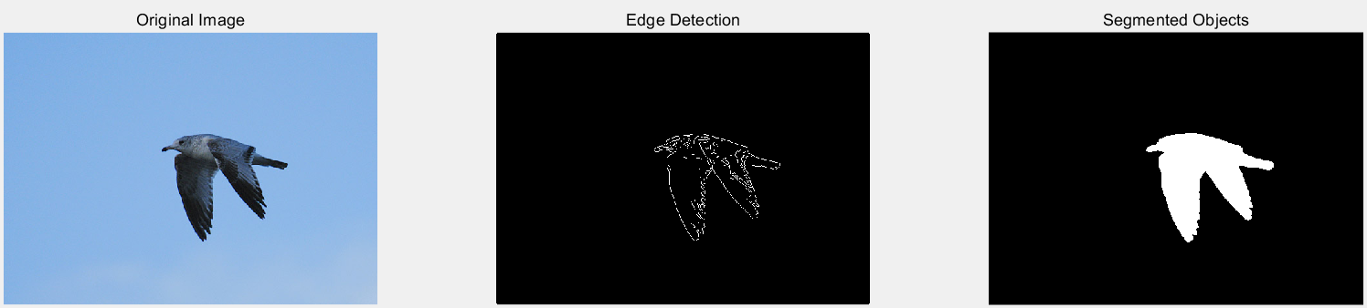
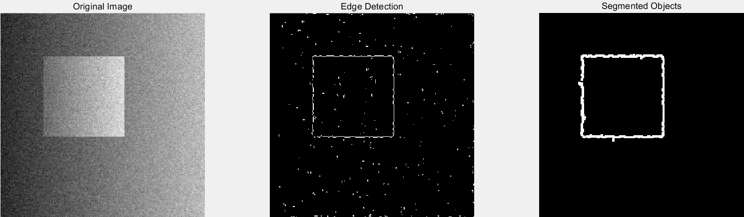

Personal Experience
I've learned how to segment objects in an image using MATLAB. Specifically, I gained proficiency in utilizing various MATLAB functions effectively, including imread, rgb2gray, medfilt2, imadjust, edge, imdilate, imfill, and bwareaopen. These functions allowed me to manipulate and analyze images to achieve desired outcomes. This experience provides a foundation for understanding basic image segmentation techniques and their practical application.

Digital Image Processing
Programming lab
Project 2

Code
% Read the image
% originalImage = imread('ManWithNoise.jpg');
originalImage = imread('TruckWithNoise.bmp');
% Convert the image to double for processing
originalImage = double(originalImage);

% Set the size of the filter window (e.g., 3x3, 5x5)
filterSize = 4;

% Apply mean filter
meanFiltered = imfilter(originalImage, fspecial('average', [filterSize filterSize]));

% Display original and filtered images
figure;
imshow(uint8(meanFiltered));
title('Mean Filtered Image');

Results
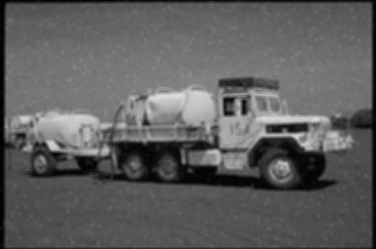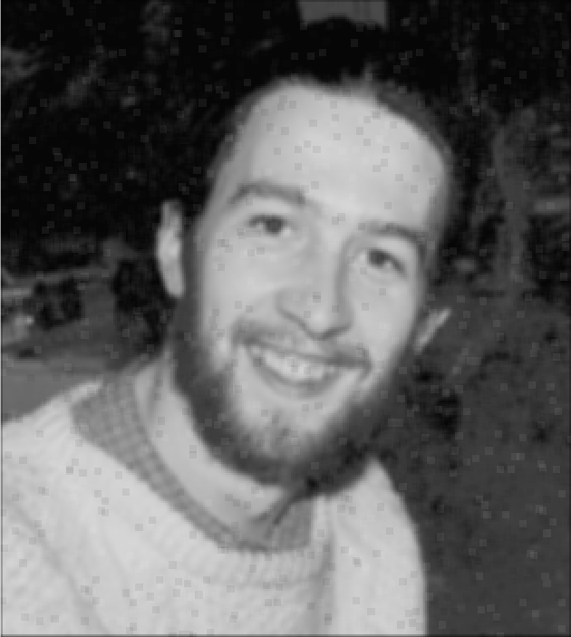

Personal Experience

I've learned to apply a mean filter to an image using MATLAB. By specifying the size of the filter window (e.g., 3x3 or 5x5), I discovered that the choice of filter size influences the smoothing effect on the image. Larger window sizes generally result in more pronounced smoothing but may lead to a loss of image details. This experience has taught me the practical importance of selecting an appropriate filter size based on the specific characteristics and requirements of the image.

Digital Image Processing
Programming lab
Project 3

Code
% Read the image
originalImage = imread('Cashew.jpg');

% Convert the image to grayscale if it's not already
grayImage = rgb2gray(originalImage);

% Perform histogram equalization
enhancedImage = histeq(grayImage);

% Display original and enhanced images
figure;
imshow(enhancedImage);
title('Contrast Enhanced Image');

Results
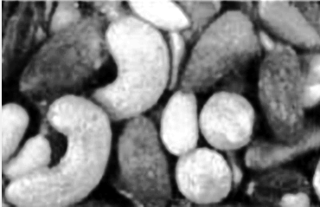

Personal Experience
I've learned how to enhance the contrast of an image in MATLAB using histogram equalization. Specifically, I now know how to apply histogram equalization to improve contrast. This newfound knowledge helps me understand a practical technique for enhancing image contrast, which can be valuable in various image processing applications.

Digital Image Processing
Programming lab
Project 4

Code
% Read the image
originalImage = imread('Flower.jpg');

% Convert the image to double for processing
originalImage = double(originalImage);

% Create a Laplacian kernel
laplacianKernel = [0 -1 0; -1 4 -1; 0 -1 0];

% Apply Laplacian filter to the image And Add it to original image
edge = imfilter(originalImage, laplacianKernel);
sharpened = edge + originalImage;

% Clip values to the valid intensity range
sharpened = max(0, min(sharpened, 255));
edge = max(0, min(edge, 255));

% Convert back to uint8 for display
sharpened = uint8(sharpened);
edge = uint8(edge);

% Display original and sharpened images
figure;
subplot(1, 3, 1);
imshow(uint8(originalImage));
title('Original Image');
subplot(1, 3, 2);
imshow(edge);
title('Edge Image');
subplot(1, 3, 3);
imshow(sharpened);
title('Sharpened Image');

Results
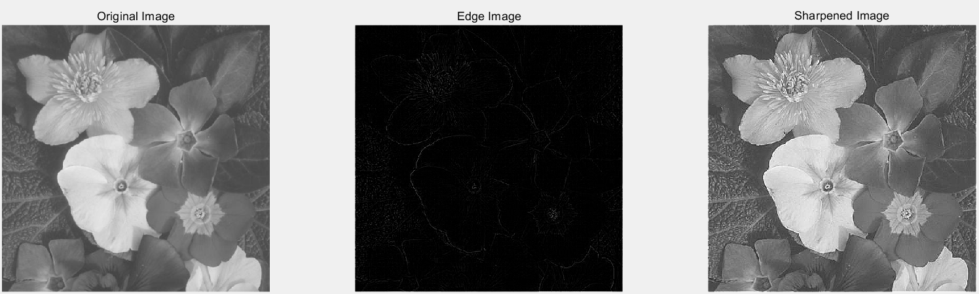

Personal Experience
I've learned how to sharpen an image using the Laplacian operator in MATLAB. Specifically, I now understand create a Laplacian kernel for filtering, apply the Laplacian operator, and then address the issue of darkening by adding the Laplacian result back to the original image. This experience has taught me practical steps for enhancing image features and the importance of considering the impact on image intensity.

