第4章习题参考答案

1. 有如下数据：
X | 1 | 1.1 | 1.2 | 1.3 | 1.4
y | 1.00000 | 1.23368 | 1.55271 | 1.99372 | 2.61170

利用本章介绍的几种插值方法对其进行插值，得到每隔0.05的结果。
编写脚本文件，文件内容为：
% Interpolation using the four methods
x=[1 1.1 1.2 1.3 1.4];
y=[1.00000 1.23368 1.55271 1.99372 2.61170];
length_of_x=length(x);
scalar_x=x(1):0.05:x(length_of_x);
length_of_sx=length(scalar_x);
y_nearest = zeros(length(scalar_x),1);
y_linear = zeros(length(scalar_x),1);
y_spline = zeros(length(scalar_x),1);
y_cubic = zeros(length(scalar_x),1);
for i=1:length_of_sx
y_nearest(i)=interp1(x,y,scalar_x(i),'nearest');
y_linear(i) =interp1(x,y,scalar_x(i),'linear');
y_spline(i) =interp1(x,y,scalar_x(i),'spline');
y_cubic(i) =interp1(x,y,scalar_x(i),'cubic');
end
subplot(2,2,1),plot(x,y,'*'),hold on,plot(scalar_x,y_nearest),title('method=nearest');
subplot(2,2,2),plot(x,y,'*'),hold on,plot(scalar_x,y_linear),title('method=linear');
subplot(2,2,3),plot(x,y,'*'),hold on,plot(scalar_x,y_spline),title('method=spline');
subplot(2,2,4),plot(x,y,'*'),hold on,plot(scalar_x,y_cubic),title('method=cubic');
得到结果为：
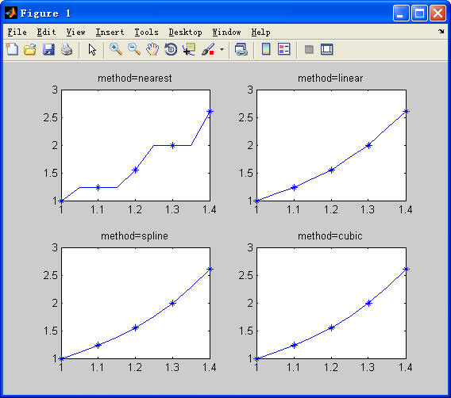

2. 求函数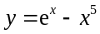，初始点为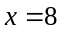的解，并绘制图形。
参考答案：
>> y=@(x)exp(x)-x^5;
>> x = fzero(y,8)
x =
12.7132
>> fplot(y,[x-1,x+1]);
>> hold on
>> plot(x,y(x),'r*');
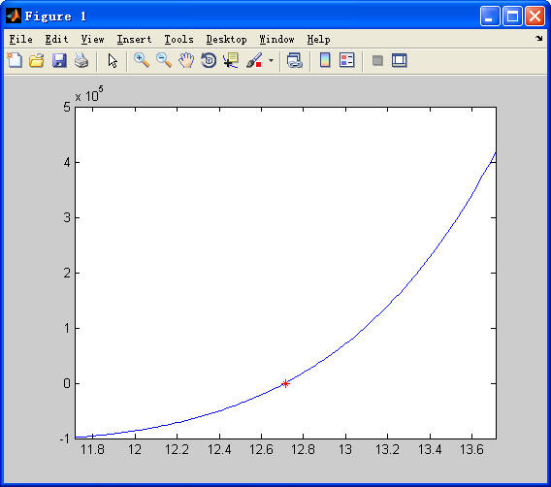

3. 求下列函数的极值。
(1) 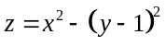
(2) 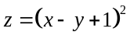
参考答案：
(1)
>> z = @(x)x(1)^2-(x(2)-1)^2;
>> [x,fvalue,flag,output]=fminsearch(z,[0,0])
Exiting: Maximum number of function evaluations has been exceeded
- increase MaxFunEvals option.
Current function value: -359212266339440800000000000000000000000000000000000000000000000000000000000000000000.000000
x =
1.0e+41 *
0.9523 -6.0686
fvalue =
-3.5921e+83
flag =
0
output =
iterations: 200
funcCount: 401
algorithm: 'Nelder-Mead simplex direct search'
message: [1x233 char]

(2)
>> z = @(x)(x(1)-x(2)+1)^2;
>> [x,fvalue,flag,output]=fminsearch(z,[0,0])
x =
-0.5425 0.4575
fvalue =
2.4109e-11
flag =
1
output =
iterations: 40
funcCount: 74
algorithm: 'Nelder-Mead simplex direct search'
message: [1x194 char]

4. 计算下列积分。
(1) 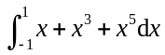
(2) 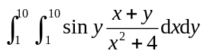
参考答案：
(1)
>> f = @(x)x+x.^3+x.^5;
>> q = quad(f,-1,1)
q =
2.2204e-16
(2)
>> f5 = @(x,y)sin(y).*(x+y)./(x.^2+4);
>> q = dblquad(f5,1,10,1,10)
q =
5.5254

