OpenSimQt Source Code & Compiling Help
File OpenSimQtSourceCodeAndCompilingHelp.doc last updated Thursday April 7, 2011 by Paul Mitiguy

Windows specific information
Install a C++ compiler, preferably with Documentation such as Help files and Examples.
For example, I installed Microsoft Visual Studio 2008, version 9.0.2.

To install Qt binary libraries and include files for Windows.  - Visit Nokia’s download center at http://qt.nokia.com/downloads/  - Select LGPL license.  Licensing terms (http://qt.nokia.com/products/licensing) and summary from the “Qt legal gal” (http://blog.qt.nokia.com/2009/11/30/qt-making-the-right-licensing-decision/ ) are on Nokia website’s. A non-legal, non-binding, summary interpretation is that for practical purposes, LGPL Qt is free to use/deploy for commercial applications, without providing the commercial application’s source code, as long as there are no modifications to Qt source code and/or possibly no static linking to Qt .dlls. Provide the end-user the requisite Qt .dlls as well as the LGPL v. 2.1 licensing terms, e.g., the files LICENSE.LGPL and LGPL_EXCEPTION.txt. A summary of information is in the .zip file “QtNokiaLicensingLGPL.zip”.  Note: It seems unnecessary to download Qt source code from Nokia/Qt website. It seems that it is necessary to use Qt qmake (builds Microsoft Visual Studio .vcproj compiler file or makefile) and Qt moc (meta object compiler to convert Qt code to C++) as well as Qt’s .dlls.  - Click on Qt libraries 4.7.2 for Windows (VS 2008, 218 MB)  - This should link to: http://qt.nokia.com/downloads/windows-cpp-vs2008  - Click http://get.qt.nokia.com/qt/source/qt-win-opensource-4.7.2-vs2008.exe  - Download the installer to your computer and install Qt.  - Ensure the computer’s PATH environment variable has Qt’s bin on the path. For example, my computer’s PATH variable starts with C:\Qt\4.7.2\bin | 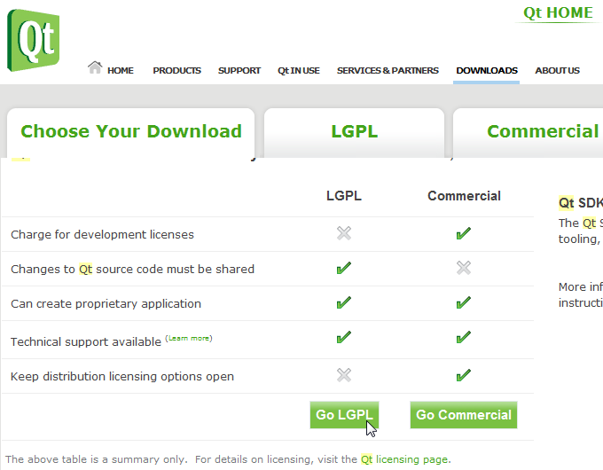  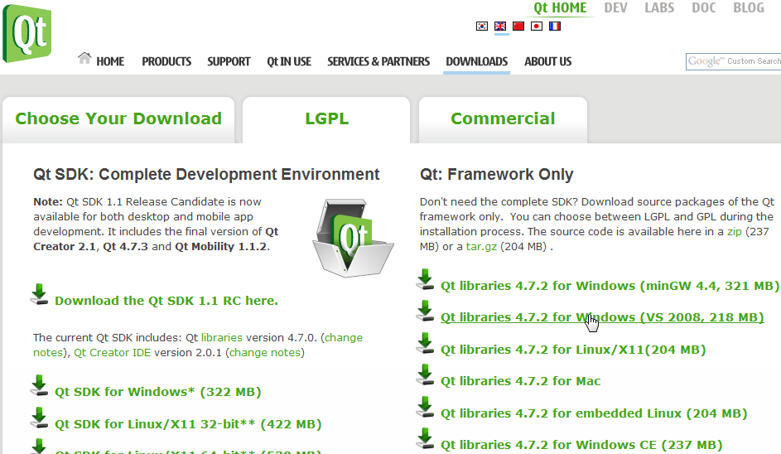  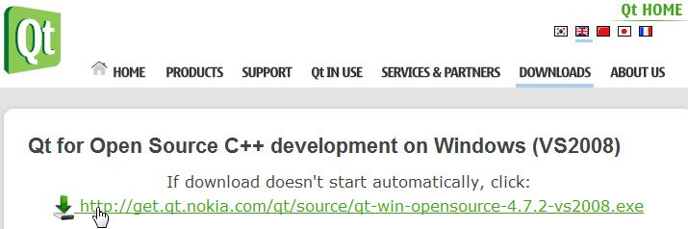

To download OpenSimQt source code to your computer.  - Visit www.simtk.org. If necessary, register and login with username/password.  In the Search SimTk.org box, type OpenSimQt and click  Click on the link OpenSimQt: C++ tool for easy-to-use biomechanics …  Shortcut: Go directly to https://simtk.org/home/opensimqt  - On left-hand panel, click on Advanced and then Source Code Repository.  - The instructions for using SVN (Subversion) to download the source code to your computer are provided on the html page that appears. If necessary, install SVN tool, e.g., from http://tortoisesvn.net/ or http://tortoisesvn.tigris.org/ |   

To use Qt’s qmake to create the OpenSimQt Microsoft Visual Studio .vcproj project or to have Qt’s qmake create a makefile for subsequent use by your compiler:  - Ensure qmake.exe is on a path specified in your computer’s PATH variable.  For example, ensure the computer’s PATH includes C:\Qt\4.7.2\bin  - Create a Microsoft Window’s shortcut to the cmd.exe command prompt.  Right-click on the shortcut to cmd.exe and change the “Start in” folder to the folder containing the file OpenSimQt.pro (e.g., C:\OpenSimQt\trunk).  - Double-click on the shortcut to cmd.exe to open the command prompt.  - Create a folder in which you want qmake to put the .vcproj file, e.g., create a directory C:\OpenSimQtBuilds. Change directories to that folder, e.g., type  C:\OpenSimQtBuilds  To create a .vcproj in C:\OpenSimQtBuilds, (the current directory), type  qmake ..\OpenSimQt\OpenSimQt.pro  - More info: The tutorial for how to use qmake to create your compiler’s Microsoft Visual Studio vcproj file or Macinstosh/Unix makefiles is at http://doc.trolltech.com/4.2/qmake-tutorial.html | 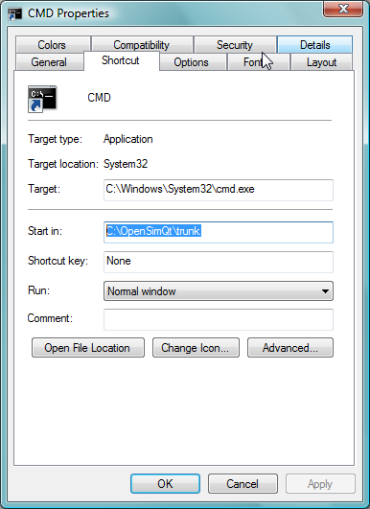  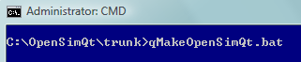

To install SimTK libraries and include files on Windows, Macintosh, or Linux Operating Systems  - Visit the Simbody project at http://www.simtk.org (https://simtk.org/home/simbody)  - Click the Downloads tab on the left-hand side of the page.  - Find your operating system (e.g., Windows) and click on the appropriate download link, e.g.,  - Install onto your computer, e.g., by double-clicking on SimTKcore_VC9.exe or unzipping to a folder of your choice, e.g., C:\SimTK  - Ensure you include the path to the SimTK header files, e.g., for Qt, add the following to the .pro file:  INCLUDEPATH += /SimTK/include/  - At the top of source code files that need to be aware of SimTK classes or methods, put the following:  #include <SimTKsimbody.h>  - If necessary, build the source code from source using the information at HowToBuildSimbodyFromSource_Windows.pdf  - May require installation of cmake (currently cmake 2.8) from www.cmake.org  - If needed, install documentation reader “doxygen” from www.doxygen.org  - Once inside Microsoft Visual Studio, right-click on ALL_BUILD. Otherwise try to redo cmake. The full release takes about 20 minutes. Always use build RelWithDebugInfo as it gives end-user core-dump information. The binary is bigger, but same speed. If Simbody is 100% rock-solid, live dangerously and use Release build.  - Click on RUN_TESTS (about 4 minutes) to run tests to ensure built OK.  - Click on INSTALL (about 10 minutes).  - Ensure the .dlls are added to path, e.g., add C:\Simbody\bin to path. | 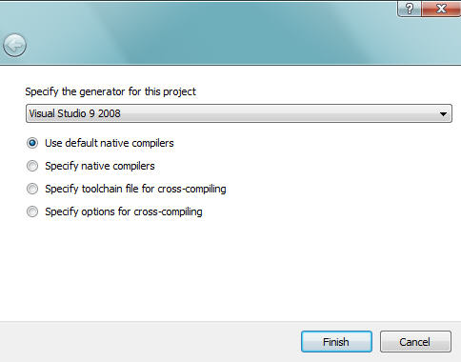  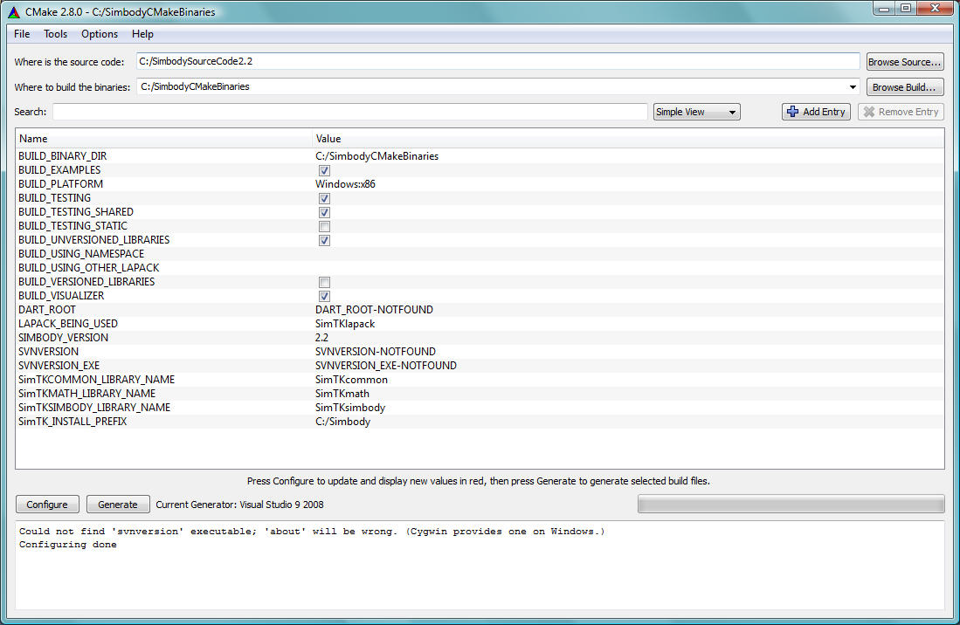
  SimTKcore_VC9.exe (72347 kB) | binary | Windows | Aug 16, 2010
  Description: Installation package for SimTK Core 2.1 using Visual Studio 9 (2008).

To install OpenSimAPI libraries and include files (Windows, Macintosh, etc.).
- Visit the OpenSim project at http://www.simtk.org (https://simtk.org/home/opensim)
- Login and click the Downloads tab on the left-hand side of the page.
- Find your operating system (e.g., Windows) and click on the appropriate download link, e.g.,
- Install onto your computer, e.g., by clicking OpenSim-2.2.1-win32-VC8P.exe

To download OpenSim for compile debug/release (with source code for OpenSimAPI)  - Create a folder on the root of the C: drive called OpensimSourceCode.  - Use Microsoft Windows explorer (press Windows Key  and E) to browse to folder OpensimSourceCode. Right-click on open white space and select SVN Checkout… A Checkout box will appear. Get the Trunk or recent branch, e.g.,  URL repository: https://simtk.org/svn/opensim/Trunk  URL repository: https://simtk.org/svn/opensim/Branches/OpenSim23  For checkout directory, type: C:\OpensimSourceCode  - OpenSim API (may also have Java UI code) will download for 30-60 minutes .  - Ensure cmake (currently cmake 2.8) is installed from www.cmake.org  - Click the Windows-Start Key , click Programs (or All Programs), click on the CMake folder on the list of programs, then click on CMake (cmake-gui)  - In CMAKE “Where is the source code”, enter: C:/OpenSimSourceCode  In CMAKE “Where to build the binaries”, enter: C:/OpenSimBuildBinariesEtc  (folder for compiler files, debug and release sub-folders, etc.).  - Under the File menu, select Delete CACHE.  - Press Configure button in CMake Window  - Verify the generator for this project (e.g., Use default native compiler) and press Finish.  - Press Configure again and a CMake window with options appear.  - Click Configure 2x and then click Generate  - Exit CMake by clicking X on top-right-hand corner  - Using Microsoft Windows, browse to C:\ OpenSimBuildBinariesEtc folder  - Double-click on the file: OpenSim.sln (if using Microsoft Visual Studio).  - Under “Solution Explorer”, right click on ALL_BUILD and select Build.  - Under “Solution Explorer”, right click on INSTALL and select Build  [copies .dlls, .h, and .lib files to CMAKE_INSTALL_PREFIX (e.g., OpenSimToEndUser)]  - Ensure the OpenSim\bin folder is on a path specified in your computer’s PATH variable, e.g., ensure the computer’s PATH includes C:\ OpenSimToEndUser \bin  - Should now be able to call the OpenSim API .dlls. | 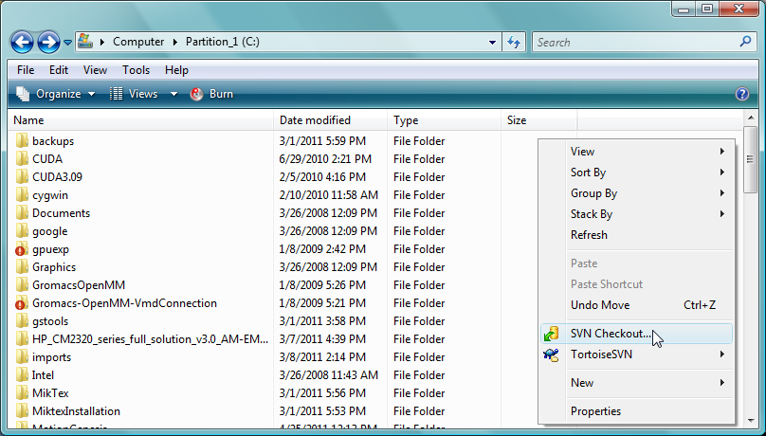  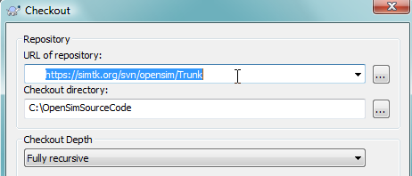  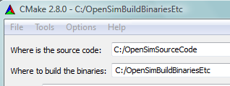  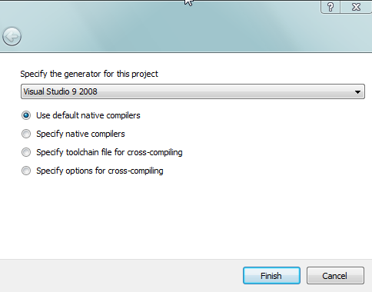  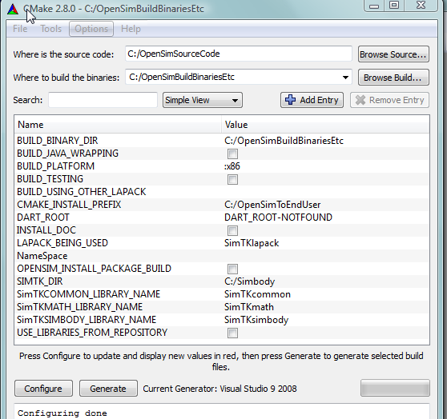  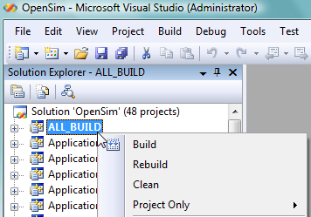
  ARCH64 | Unchecked | 64 bit is not fully supported yet
  BUILD_JAVA_WRAPPING | Unchecked | Unnecessary since doing C++
  BUILD_TESTING | Unchecked | If want API regression test examples
  Note: BUILD_TESTING creates sub-projects options to build regression test examples (useful for OpenSim developers)
  BUILD_UTILITIES | Unchecked | e.g. OpenSimToSimm.exe converter …
  CMAKE_INSTALL_PREFIX | C:/OpenSimToEndUser
  Note: OpenSimToEndUser mimics end-user install folder for end-user release .dlls, documentation, test files, etc.
  COPY_PREBUILT_LIBRARIES | Unchecked | Not exactly sure what this means
  DART_ROOT | N/A | Automated nightly builds
  INSTALL_DOC | Unchecked | If checked, copies API documentation
  NameSpace | OpenSim_ | Notice trailing underscore _
  NameSpace differentiate Simbody .dlls built by OpenSim from those built in a Simbody project.
  If want to use self-built Simbody .dlls, replace OpenSim_ with empty string and ensure correct SIMTK_DIR as it is used to find Simbody lib, include, bin, … files. The combined NameSpace and SIMTK_DIR are mutually exclusive with USE_LIBRARIES_FROM_REPOSITORY which instead pulls Simbody .dlls from the folder created in SVN checkout.
  Generally, use empty string for NameSpace if building your own Simbody .dlls, otherwise use OpenSim_
  OPENSIM_INSTALL_PACKAGE_BUILD | Unchecked | For end-user OpenSim installers
  SHARED_LIB_EXT | .so | May only applies on Unix systems.
  SIMTK_DIR | C:\Simbody | Locates Simbody bin, lib, includes, etc.
  USE_LIBRARIES_FROM_REPOSITORY | Unchecked | If checked, copies libraries from the folder created in SVN checkout.
  USE_STATIC_SIMTK_LIBRARIES | Unchecked | Generally a bad idea

