QSim Source Code & Compiling Help
File: QSimCompileAndBuildHelp.doc last updated Thursday May 12, 2011 by Paul Mitiguy

General Information about the QSim project
- Visit www.simtk.org. If necessary, register and login with username/password.  - In the Search SimTk.org box, type OpenSimQt and click  - Click on the link OpenSimQt: C++ tool for easy-to-use biomechanics …  Shortcut: Go directly to https://simtk.org/home/opensimqt |   

General Information about Qt
Qt/3D for OpenGL graphics: Once Qt/3D is part of Qt, it will be available with Qt binary packages. Until then, it must be built from source which may be downloaded from the git repository at http://qt.gitorious.org/qt-labs/qt3d. Follow build information at http://doc.qt.nokia.com/qt3d-snapshot/qt3d-building.html. Please note that building Qt/3D also requires building the entire Qt from source as it depends on the various source files. For more information and free Qt book, visit http://dcsoft.wordpress.com/. To download Qt/3D may first require downloading and installing git client from http://git-scm.com/ (see platform specific instructions below).

Licensing terms (http://qt.nokia.com/products/licensing) and summary from the “Qt legal gal” (http://blog.qt.nokia.com/2009/11/30/qt-making-the-right-licensing-decision/ ) are on Nokia website’s. A non-legal, non-binding, summary interpretation is that for practical purposes, LGPL Qt is free to use/deploy for commercial applications, without providing the commercial application’s source code, as long as there are no modifications to Qt source code and/or possibly no static linking to Qt .dlls. Provide the end-user the requisite Qt .dlls as well as the LGPL v. 2.1 licensing terms, e.g., the files LICENSE.LGPL and LGPL_EXCEPTION.txt. A summary of information is in the .zip file “QtNokiaLicensingLGPL.zip”.

Windows specific information
Install a C++ compiler (e.g., Microsoft Visual Studio 2008, version 9.0.2) preferably with Help files and Examples.
General rule: Do NOT mix debug and release versions, e.g., if use debug .dll of OpenSim use debug .dll of Simbody.

1(a). Installing Qt (by Nokia, formerly trolltech) for creating C++ GUIs.
To install Qt binary libraries and include files for Windows.  - Visit Nokia’s download center at http://qt.nokia.com/downloads/  - Select LGPL license.  Note: It seems unnecessary to download Qt source code from Nokia/Qt website. It seems that it is necessary to use Qt qmake (builds Microsoft Visual Studio .vcproj compiler file or makefile) and Qt moc (meta object compiler to convert Qt code to C++) as well as Qt’s .dlls.  - Click on Qt libraries 4.7.2 for Windows (VS 2008, 218 MB)  - This should link to: http://qt.nokia.com/downloads/windows-cpp-vs2008  - Click http://get.qt.nokia.com/qt/source/qt-win-opensource-4.7.2-vs2008.exe  - Download the installer to your computer and install Qt.  - Ensure the computer’s PATH environment variable has Qt’s bin on the path.  For example, my computer’s PATH variable starts with C:\Qt\4.7.2\bin  - If you need (or want) to build from source code (e.g., as needed to build Qt/3D in June 2011), download and unzip the source code (e.g., qt-everywhere-opensource-src-4.7.3.zip) to the folder C:\QtSourceCode. Follow these steps: (1) start Microsoft Visual Studio 2008, (2) click on the Tools menu and select Visual Studio 2008 Command Prompt, (3) change to the directory containing the Qt source code (e.g, C:\QtSourceCode), (4) type configure –platform win32-msvc2008, (5) type nmake. Wait several hours.  - Skip the Optional section for Qt/3D if you do not need 3D OpenGLGraphics | 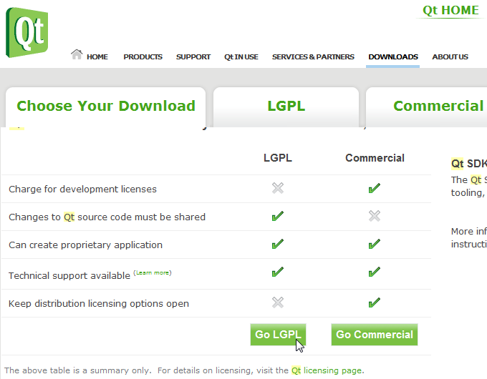  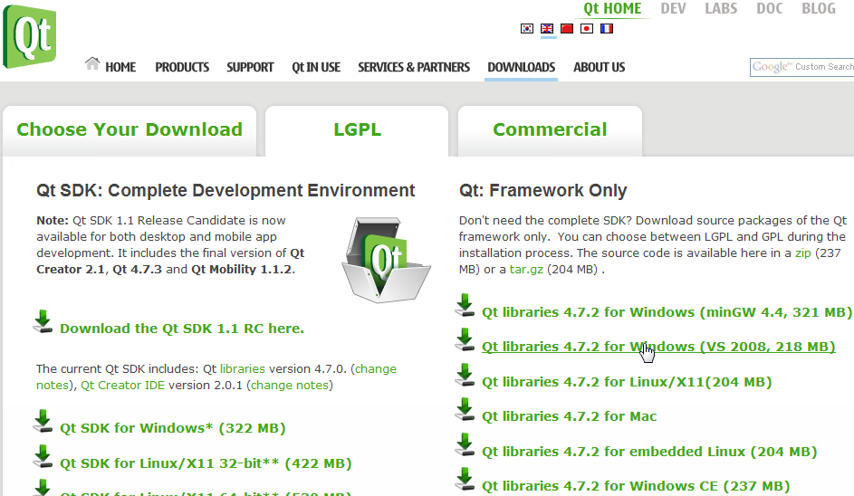  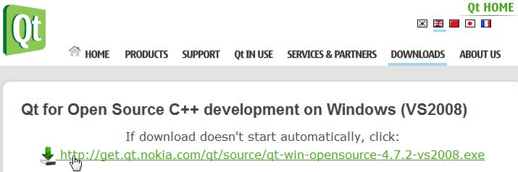

Optional: Installing Qt/3D for 3D OpenGL Graphics
To install Qt/3D source code for Windows (as of June 2011).  - See Qt/3D platform-independent information above.  - If not on your computer, install the git client by going to http://git-scm.com/  When you install, ensure you allow git to be run from the CMD prompt.  - Make a folder called C:\Qt3D and change directory to that folder,  e.g., by typing cd C:\Qt3D from the CMD prompt.  - From the CMD prompt and from within the Qt3D folder, type  git clone git://gitorious.org/qt-labs/qt3d.git (downloads Qt3d source code)  - Next, type cd qt3d to change to the qt3d subdirectory containing the source code.  - To create a compiler Makefile, type (from the CMD prompt) qmake opengl.pro  - If you are using Microsoft Visual Studio from the CMD prompt, ensure the path is set to the compiler e.g., my computer’s PATH environment variable includes:  "C:\Program Files\Microsoft Visual Studio 9.0\vc\bin"  At the CMD prompt, type vcvars32.bat (to avoid strange nmake errors).  - To build the Qt/3D source code (debug), type (from the CMD prompt) nmake  - To create a compiler Makefile, type (from the CMD prompt)  qmake CONFIG+=release opengl.pro  To build the Qt/3D release libraries, type (from the CMD prompt) nmake release  Note: The last line of the demo teaservice.cpp is #include "teaservice.moc"  To avoid compile problems, type (from the teaservice CMD prompt) moc teaservice > teaservice.moc  - Ensure the computer’s PATH environment variable has Qt3d bin on the path.  For example, my computer’s PATH variable starts with C:\Qt3D\qt3d\bin  Alternately, to temporarily add this to your path, type (from the CMD prompt), PATH=%PATH%;\C:\Qt3D\qt3d\bin | 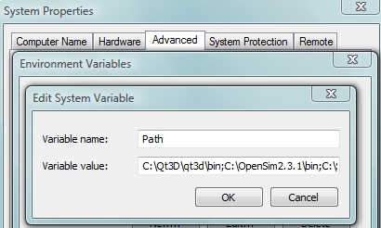

1(b). Installing QSim (rapid C++ GUI development for biomechanics simulation).
To download QSim source code for compile debug/release to your computer.  1. Visit https://simtk.org/home/opensimqt  - On left-hand panel, click on Advanced and then Source Code Repository.  - The instructions for using SVN (Subversion) to download the source code to your computer are provided on the html page that appears. If necessary, install SVN tool, e.g., from http://tortoisesvn.net/ or http://tortoisesvn.tigris.org/  - Create a folder on the root of the C: drive called QSimSourceCode  - Browse with Microsoft Windows Explorer (press Windows Key  and E) to folder OpensimQt. Right-click on open white space and select SVN Checkout…  A Checkout box will appear. Get the Trunk or recent branch, e.g.,  URL repository: https://simtk.org/svn/opensimqt/Trunk  For checkout directory, type: C:\QSimSourceCode  6. QSim source code and related files will download in less than 10 minutes. | 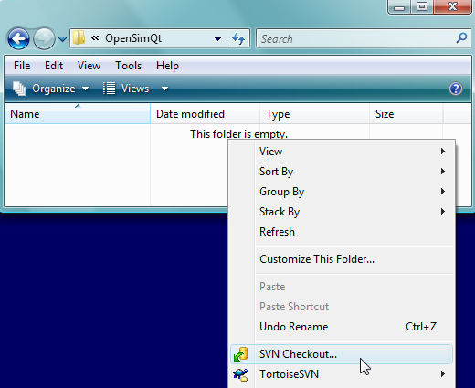

1(c). Using Qt’s qmake and QSim.pro file to create compiler files.
To use Qt’s qmake to create the QSim.vcproj Microsoft Visual Studio project or to have Qt’s qmake create a makefile for subsequent use by your compiler:  - Ensure qmake.exe is on a path specified in your computer’s PATH variable.  For example, ensure the computer’s PATH includes C:\Qt\4.7.2\bin  - Create a Microsoft Window’s shortcut to the cmd.exe command prompt.  Right-click on the shortcut to cmd.exe and change the “Start in” folder to the folder containing the file QSim.pro (e.g., C:\QSimSourceCode\trunk).  - Double-click on the shortcut to cmd.exe to open the command prompt.  - Create a folder in which you want qmake to put the .vcproj file, e.g., create a directory C:\QSimCompilerMisc. Change directories to that folder, e.g., type:  cd C:\QSimSourceCode To create a .vcproj in C:\QSimCompilerMisc, (the current directory), type: qmake ..\QSimSourcCode\QSim.pro  - More info: A tutorial for using qmake to create your compiler’s project files is at http://doc.trolltech.com/4.2/qmake-tutorial.html | 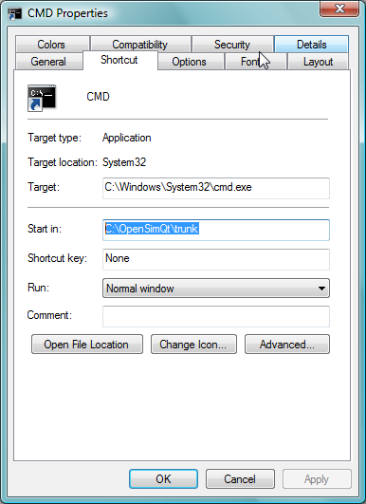  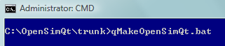

1(d). Installing Simbody libraries for force and motion calculations.
To install Simbody libraries and include files  - Visit the Simbody project at http://www.simtk.org (https://simtk.org/home/simbody)  - Click the Downloads tab on the left-hand side of the page.  - Click on the download for your operating system (Windows, Macintosh, or Linux)    - Install onto your computer, e.g., by double-clicking on SimTKcore_VC9.exe or unzipping to a folder of your choice, e.g., C:\Simbody  - Ensure the path to Simbody .h files is added to OpenSimQt.pro file, e.g., as:  INCLUDEPATH += /Simbody/include/  - Put the following line at the top of .cpp and .h files that need to be Simbody-aware:  #include <SimTKsimbody.h>  - If necessary, build the source code from source using the information at HowToBuildSimbodyFromSource_Windows.pdf  - May require installation of cmake (currently cmake 2.8) from www.cmake.org  - If needed, install documentation reader “doxygen” from www.doxygen.org  - Once inside Microsoft Visual Studio, right-click on ALL_BUILD. Otherwise redo cmake. Full release takes about 20 minutes. Use build RelWithDebugInfo as it gives end-user core-dump information. Binary is bigger, but same speed. If Simbody is rock-solid, live dangerously and use Release build.  - Click on RUN_TESTS (about 4 minutes) to run tests to ensure built OK.  - Click on INSTALL (about 10 minutes).  - Ensure folder containing the .dlls are added to computer’s PATH, C:\Simbody\bin | 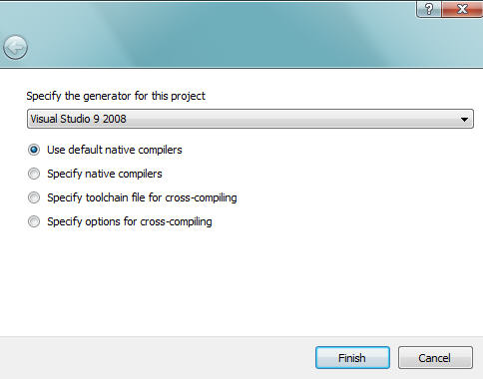  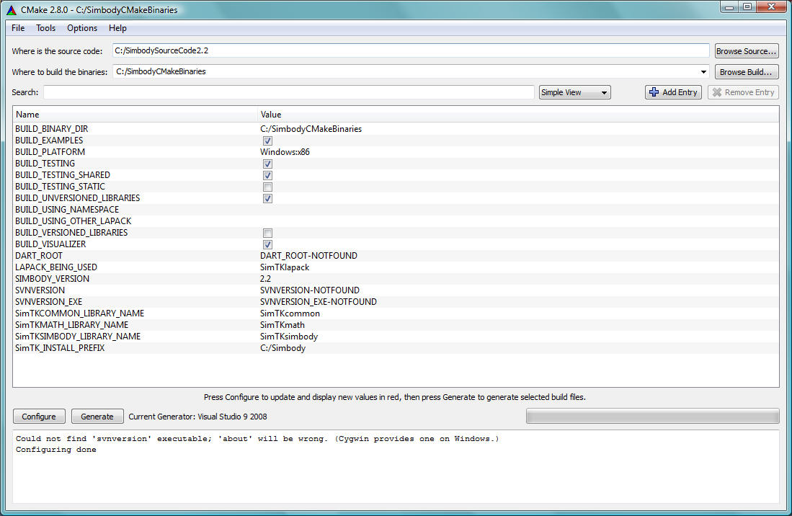  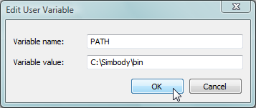

1(e). Install OpenSimAPI libraries for biomechanics modeling libraries.
The umbrella name “OpenSim” is a collection of C++ libraries and standalone executables. The references to OpenSim here does not include the OpenSim Java GUI and associated build tools (Java, NetBeans, VTK).
Use this step to use the prebuilt release libraries/headers for VisualStudio 2005-Pro or 2008-Pro or Linux 32-bit or Intel-Mac 32-bit. Otherwise, build the libraries/headers from source as described in the next step.

To install OpenSimAPI libraries and include files (Windows, Macintosh, etc.).  - Visit the OpenSim project at https://simtk.org/home/opensim and click the Downloads tab on the left-hand side of the page.  - Find your operating system (e.g., Windows) and click on the appropriate download link, e.g.,  - Install onto your computer, e.g., by clicking OpenSim-2.2.1-win32-VC8P.exe | 

1(f). Alternately: Compile OpenSimAPI biomechanics modeling libraries.
To download OpenSim for compile debug/release (with source code for OpenSimAPI)  - Create a folder on the root of the C: drive called OpensimSourceCode.  - Use Microsoft Windows explorer (press Windows Key and E) to browse to folder OpensimSourceCode. Right-click on open white space and select SVN Checkout… A Checkout box will appear. Get the Trunk or recent branch, e.g.,  URL repository: https://simtk.org/svn/opensim/Trunk or  URL repository: https://simtk.org/svn/opensim/Branches/OpenSim23  For checkout directory, type: C:\OpensimSourceCode  - OpenSim API and other code will download for 30-60 minutes .  - Ensure CMake (currently cmake 2.8) is installed from www.cmake.org  - Click the Windows-Start Key , click Programs (or All Programs), click on the CMake folder on the list of programs, then click on CMake (cmake-gui)  - In CMAKE “Where is the source code”, type: C:/OpenSimSourceCode  (designates the folder containing the top-level CMake file named CMakeLists.txt).  In CMAKE “Where to build the binaries”, type: C:/OpenSimBuildBinariesEtc  (designates the folder for compiler files, debug and release sub-folders, etc.).  - Under the File menu, select Delete CACHE.  - Press Configure button in CMake Window  - Verify the generator for this project (e.g., Use default native compiler) and press Finish.  - Press Configure again and a CMake window with options appear.  - Click Configure 2x and then click Generate  - Exit CMake by clicking X on top-right-hand corner  - Using Microsoft Windows, browse to C:\ OpenSimBuildBinariesEtc folder  - Double-click on the file: OpenSim.sln (if using Microsoft Visual Studio).  Under “Solution Explorer”, right click on ALL_BUILD and select Build.  Under “Solution Explorer”, right click on INSTALL and select Build  [copies .dlls, .h, and .lib files to CMAKE_INSTALL_PREFIX (e.g., OpenSimToEndUser)]  - Ensure the OpenSim\bin folder is on a path specified in your computer’s PATH environment variable, e.g., ensure PATH includes C:\ OpenSimToEndUser \bin  (Note: This is similar to Linux LD_LIBRARY_PATH and Macintosh DLD_LIBRARY_PATH)  - Should now be able to call the OpenSim API .dlls from OpenSimQt. | 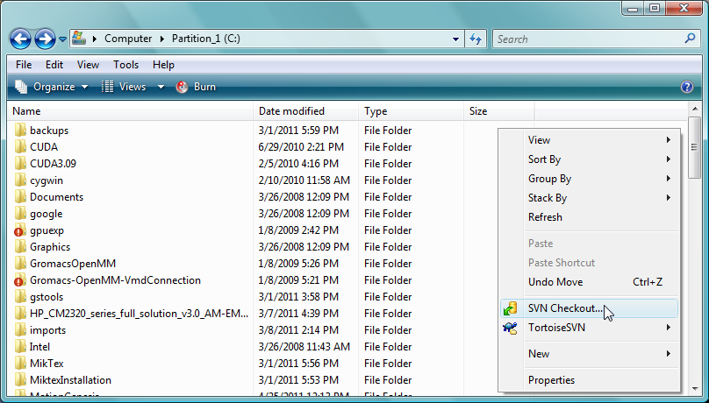  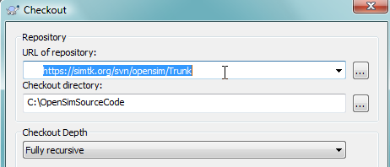  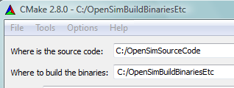  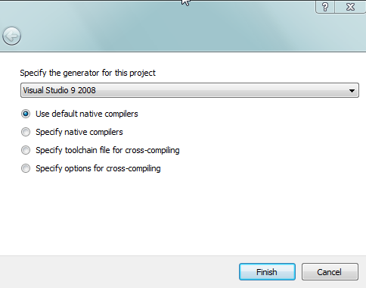  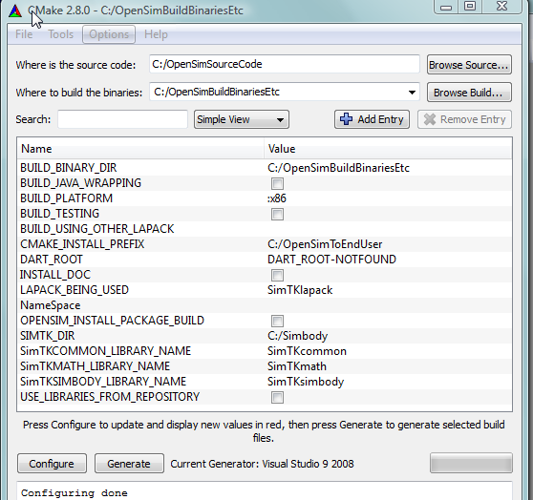  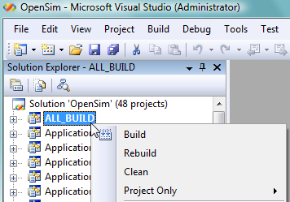
  BUILD_BINARY_DIR | C:/OpenSimBuildBinariesEtc
  BUILD_JAVA_WRAPPING | Unchecked | Unnecessary since doing C++
  BUILD_PLATFORM | :x86 | Building for Windows/PC computer
  BUILD_TESTING | Unchecked | If want API regression test examples
  Note: BUILD_TESTING creates sub-projects options to build regression test examples (useful for OpenSim developers)
  BUILD_USING_OTHER_LAPACK | ?? | ??
  CMAKE_INSTALL_PREFIX | C:/OpenSimToEndUser
  Note: OpenSimToEndUser mimics end-user install folder for end-user release .dlls, documentation, test files, etc.
  DART_ROOT | Not Useful |  | Automates Simbios nightly builds
  LAPACK_BEING_USED | SimTKlapack
  NameSpace | OpenSim_ |  | Notice trailing underscore _
  NameSpace differentiate Simbody .dlls built by OpenSim from those built in a Simbody project.
  If want to use self-built Simbody .dlls, replace OpenSim_ with empty string and ensure correct SIMTK_DIR as it is used to find Simbody lib, include, bin, … files. The combined NameSpace and SIMTK_DIR are mutually exclusive with USE_LIBRARIES_FROM_REPOSITORY which instead pulls Simbody .dlls from the folder created in SVN checkout.
  Generally, use empty string for NameSpace if building your own Simbody .dlls, otherwise use OpenSim_
  SIMTK_DIR | C:\Simbody | Locates Simbody bin, lib, includes, etc.
  USE_LIBRARIES_FROM_REPOSITORY | Unchecked | If checked, copies libraries from the folder created in SVN checkout.
  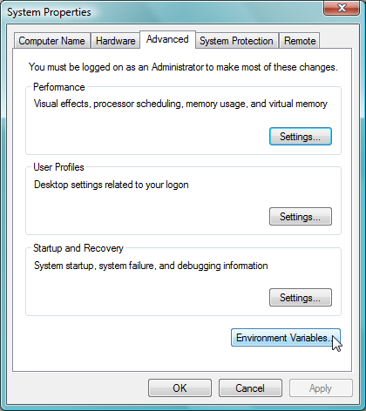 | 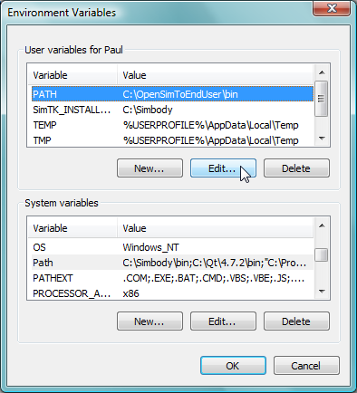

2. Linux specific information
Install Linux on your computer. For example to install ubuntu on a USB stick/drive (i.e., thumb/flash drive), visit
https://help.ubuntu.com/community/Installation/FromUSBStick
Install a C++ compiler (e.g., gcc) preferably with Help files and Examples.
General rule: Do NOT mix debug and release versions, e.g., if use debug .so of OpenSim use debug .so of Simbody.

2(a). Installing Qt (by Nokia, formerly trolltech) for creating C++ GUIs.
To install Qt binary libraries and include files for Linux.  - Visit Nokia’s download center at http://qt.nokia.com/downloads/  - Select LGPL license.  - To compile develop for Linux (32-bit and 64-bit), click on  http://qt.nokia.com/downloads/linux-x11-cpp  (203 MB, includes build and interface tools).  Note: As of May 2011, Simbody depends on 32-bit LAPACK and does not support 64-bit builds. Hence it is unwise to use 64-bit Qt binaries or Qt universal binaries (binaries with both 32-bit and 64-bit capabilities) that use Simbody or OpenSimAPI. This 32-bit limitation has minimal affect on speed and really only limits running really huge problems (with thousands of degrees of freedom).  - Next step ?? | 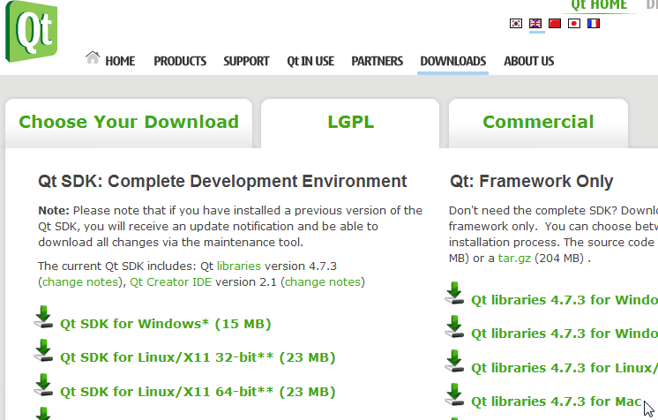  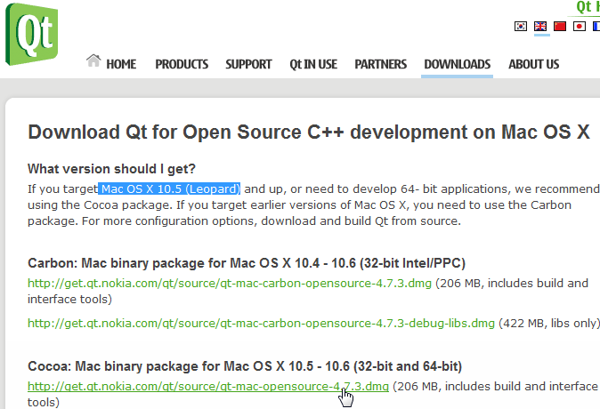

3. Macintosh OSX specific information
Ensure your Macintosh computer is running OSX and has a compiler installed. Many Macintosh computers have gcc pre-installed. To test this, start a Macintosh terminal window and type gcc at the command prompt. If gcc is not installed, install it from your system DVD. Or become an Apple developer (http://developer.apple.com/programs/start/standard/) and download XCode development tools (which include C++) at http://developer.apple.com/xcode/

2(a). Installing Qt (by Nokia, formerly trolltech) for creating C++ GUIs.
To install Qt binary libraries and include files for Macintosh OSX.
- Visit Nokia’s download center at http://qt.nokia.com/downloads/
- Select LGPL license.
- To compile/develop for Leopard Mac OSX (released October 26, 2007), click on: Cocoa: Mac binary package for Mac OSX 10.5-10.6 (32-bit and 64-bit), i.e.,
http://get.qt.nokia.com/qt/source/qt-mac-opensource-4.7.3.dmg
(206 MB, includes build and interface tools).
Note: As of May 2011, Simbody depends on 32-bit LAPACK and does not support 64-bit builds. Hence it is unwise to use 64-bit Qt binaries or Qt universal binaries (binaries with both 32-bit and 64-bit capabilities) that use Simbody or OpenSimAPI. This 32-bit limitation has minimal affect on speed and really only limits running really huge problems (with thousands of degrees of freedom).
Alternately, compile/develop for backward compatibility with Tiger Mac OSX (released April 29, 2005).
- Download the .dmg file to your computer, double-click on the file, and install Qt.
- The .dmg file puts Qt in the /usr/bin folder which is on the computer’s PATH.

1(b). Installing QSim (rapid C++ GUI development for biomechanics simulation).
To download QSim source code for compile debug/release to your computer.
- Visit https://simtk.org/home/opensimqt
- On left-hand panel, click on Advanced and then Source Code Repository.
- The instructions for using SVN (Subversion) to download the source code to your computer are provided on the html page that appears. If necessary, install SVN tool, e.g., from http://tortoisesvn.net/ or http://tortoisesvn.tigris.org/
- Create a folder on your computer’s hard drive called QSimSourceCode
- Open a Macintosh terminal window (e.g., open Spotlight and search for terminal)
- At the terminal command prompt, type cd /QSimSourceCode
- To copy source code from the project’s “trunk”, type (at the terminal prompt)
svn checkout --username developerName https://simtk.org/svn/opensimqt/trunk destFolder
8. QSim source code and related files will download in less than 10 minutes.
9. To again copy the latest source code to destFolder, type (at the terminal prompt)
svn checkout --username developerName https://simtk.org/svn/opensimqt/trunk destFolder

1(c). Using Qt’s qmake and QSim.pro file to create compiler files.
To use Qt’s qmake to create a makefile for subsequent use by your compiler:
- Open a Macintosh terminal window and type cd /QSimSourceCode
- Using a text editor, edit the file QSimLinkedToSimbody.pro to correct the lines:
INCLUDEPATH += /Simbody/include/
QMAKE_LIBDIR += /Simbody/lib/
- If you do not need to simulate bones and muscles (do not need the OpenSim API) use a text editor to edit the file QSim.pro and comment out the following line, i.e.,
# include(QSimLinkedToOpenSimAPI.pro)
- If you are using OpenSimAPI, use a text editor to correct the following lines in the file QSimLinkedToOpenSimAPI.pro with their proper folder locations.
INCLUDEPATH += /OpenSimToEndUser/sdk/include/
INCLUDEPATH += /OpenSimToEndUser/sdk/include/OpenSim/
INCLUDEPATH += /OpenSimToEndUser/sdk/include/SimTK/include/
QMAKE_LIBDIR += /OpenSimToEndUser/sdk/lib/
- Create a folder for the CMake file and debug/release compiler files by typing:
mkdir ../QSimCompilerMisc
- Change directories to that folder by typing:
cd ../QSimCompilerMisc
- To create a makefile.xcodeproj file in /QSimCompilerMisc, type:
qmake -o makefile ../QSimSourceCode/QSim.pro
- To open the makefile, type (at the terminal prompt) open makefile.xcodeproj
Or double-click on the file makefile.xcodeproj from the Macintosh finder.
Alternately, from the terminal prompt, type make –f makefile.xcodeproj
- More info: A tutorial for using qmake to create your compiler’s project files is at http://doc.trolltech.com/4.2/qmake-tutorial.html

