QSim Source Code & Compiling Help
File: QSimCompileAndBuildHelp.doc last updated Thursday May 12, 2011 by Paul Mitiguy

General Information about the QSim project
- Visit www.simtk.org. If necessary, register and login with username/password.  - In the Search SimTk.org box, type OpenSimQt and click  - Click on the link OpenSimQt: C++ tool for easy-to-use biomechanics …  Shortcut: Go directly to https://simtk.org/home/opensimqt |   

Windows specific information
Install a C++ compiler (e.g., Microsoft Visual Studio 2008, version 9.0.2) preferably with Help files and Examples.
General rule: Do NOT mix debug and release versions, e.g., if use debug .dll of OpenSim use debug .dll of Simbody.

1(a). Installing Qt (by Nokia, formerly trolltech) for creating C++ GUIs.
To install Qt binary libraries and include files for Windows.  - Visit Nokia’s download center at http://qt.nokia.com/downloads/  - Select LGPL license.  Licensing terms (http://qt.nokia.com/products/licensing) and summary from the “Qt legal gal” (http://blog.qt.nokia.com/2009/11/30/qt-making-the-right-licensing-decision/ ) are on Nokia website’s. A non-legal, non-binding, summary interpretation is that for practical purposes, LGPL Qt is free to use/deploy for commercial applications, without providing the commercial application’s source code, as long as there are no modifications to Qt source code and/or possibly no static linking to Qt .dlls. Provide the end-user the requisite Qt .dlls as well as the LGPL v. 2.1 licensing terms, e.g., the files LICENSE.LGPL and LGPL_EXCEPTION.txt. A summary of information is in the .zip file “QtNokiaLicensingLGPL.zip”.  Note: It seems unnecessary to download Qt source code from Nokia/Qt website. It seems that it is necessary to use Qt qmake (builds Microsoft Visual Studio .vcproj compiler file or makefile) and Qt moc (meta object compiler to convert Qt code to C++) as well as Qt’s .dlls.  - Click on Qt libraries 4.7.2 for Windows (VS 2008, 218 MB)  - This should link to: http://qt.nokia.com/downloads/windows-cpp-vs2008  - Click http://get.qt.nokia.com/qt/source/qt-win-opensource-4.7.2-vs2008.exe  - Download the installer to your computer and install Qt.  - Ensure the computer’s PATH environment variable has Qt’s bin on the path.  For example, my computer’s PATH variable starts with C:\Qt\4.7.2\bin | 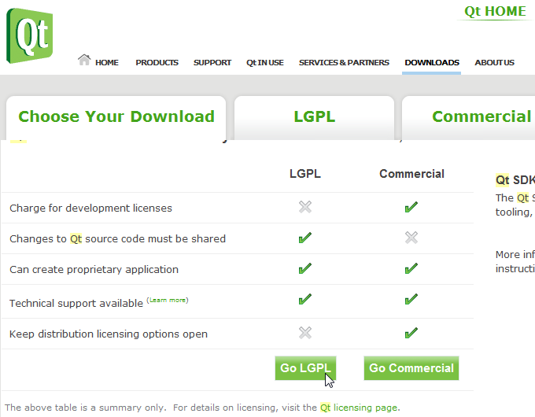  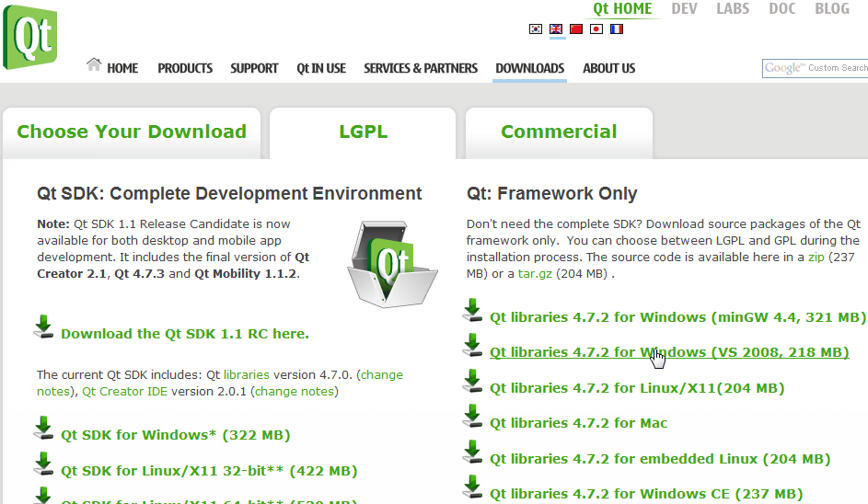  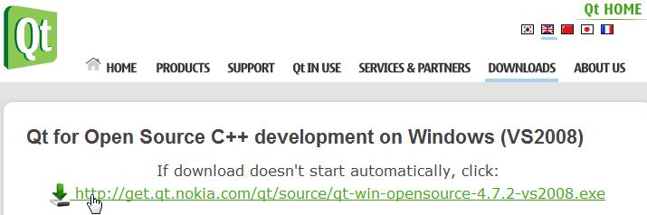

1(b). Installing QSim (rapid C++ GUI development for biomechanics simulation).
To download QSim source code for compile debug/release to your computer.  1. Visit https://simtk.org/home/opensimqt  - On left-hand panel, click on Advanced and then Source Code Repository.  - The instructions for using SVN (Subversion) to download the source code to your computer are provided on the html page that appears. If necessary, install SVN tool, e.g., from http://tortoisesvn.net/ or http://tortoisesvn.tigris.org/  - Create a folder on the root of the C: drive called QSimSourceCode  - Browse with Microsoft Windows Explorer (press Windows Key  and E) to folder OpensimQt. Right-click on open white space and select SVN Checkout…  A Checkout box will appear. Get the Trunk or recent branch, e.g.,  URL repository: https://simtk.org/svn/opensimqt/Trunk  For checkout directory, type: C:\QSimSourceCode  6. QSim source code and related files will download in less than 10 minutes. | 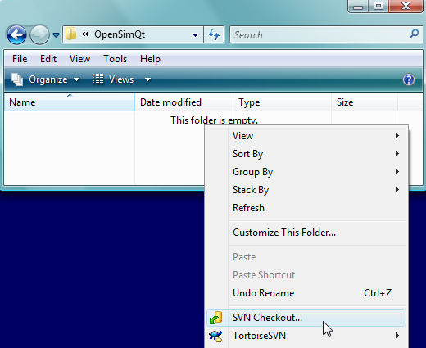

1(c). Using Qt’s qmake and QSim.pro file to create compiler files.
To use Qt’s qmake to create the QSim.vcproj Microsoft Visual Studio project or to have Qt’s qmake create a makefile for subsequent use by your compiler:  - Ensure qmake.exe is on a path specified in your computer’s PATH variable.  For example, ensure the computer’s PATH includes C:\Qt\4.7.2\bin  - Create a Microsoft Window’s shortcut to the cmd.exe command prompt.  Right-click on the shortcut to cmd.exe and change the “Start in” folder to the folder containing the file QSim.pro (e.g., C:\QSimSourceCode\trunk).  - Double-click on the shortcut to cmd.exe to open the command prompt.  - Create a folder in which you want qmake to put the .vcproj file, e.g., create a directory C:\QSimCompilerMisc. Change directories to that folder, e.g., type:  cd C:\QSimSourceCode To create a .vcproj in C:\QSimCompilerMisc, (the current directory), type: qmake ..\QSimSourcCode\QSim.pro  - More info: The tutorial for using qmake to create your compiler’s Microsoft Visual Studio vcproj file or Macinstosh/Unix makefiles is at http://doc.trolltech.com/4.2/qmake-tutorial.html | 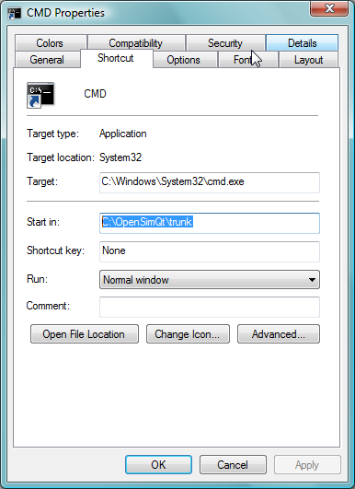  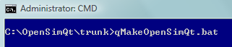

1(d). Installing Simbody libraries for force and motion calculations.
To install Simbody libraries and include files  - Visit the Simbody project at http://www.simtk.org (https://simtk.org/home/simbody)  - Click the Downloads tab on the left-hand side of the page.  - Click on the download for your operating system (Windows, Macintosh, or Linux)    - Install onto your computer, e.g., by double-clicking on SimTKcore_VC9.exe or unzipping to a folder of your choice, e.g., C:\Simbody  - Ensure the path to Simbody .h files is added to OpenSimQt.pro file, e.g., as:  INCLUDEPATH += /Simbody/include/  - Put the following line at the top of .cpp and .h files that need to be Simbody-aware:  #include <SimTKsimbody.h>  - If necessary, build the source code from source using the information at HowToBuildSimbodyFromSource_Windows.pdf  - May require installation of cmake (currently cmake 2.8) from www.cmake.org  - If needed, install documentation reader “doxygen” from www.doxygen.org  - Once inside Microsoft Visual Studio, right-click on ALL_BUILD. Otherwise redo cmake. Full release takes about 20 minutes. Use build RelWithDebugInfo as it gives end-user core-dump information. Binary is bigger, but same speed. If Simbody is rock-solid, live dangerously and use Release build.  - Click on RUN_TESTS (about 4 minutes) to run tests to ensure built OK.  - Click on INSTALL (about 10 minutes).  - Ensure folder containing the .dlls are added to computer’s PATH, C:\Simbody\bin | 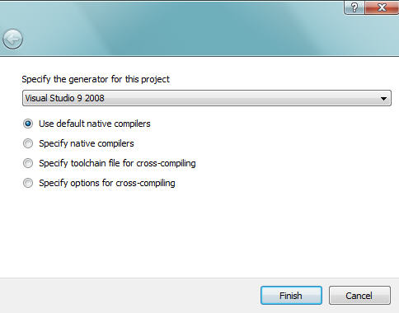  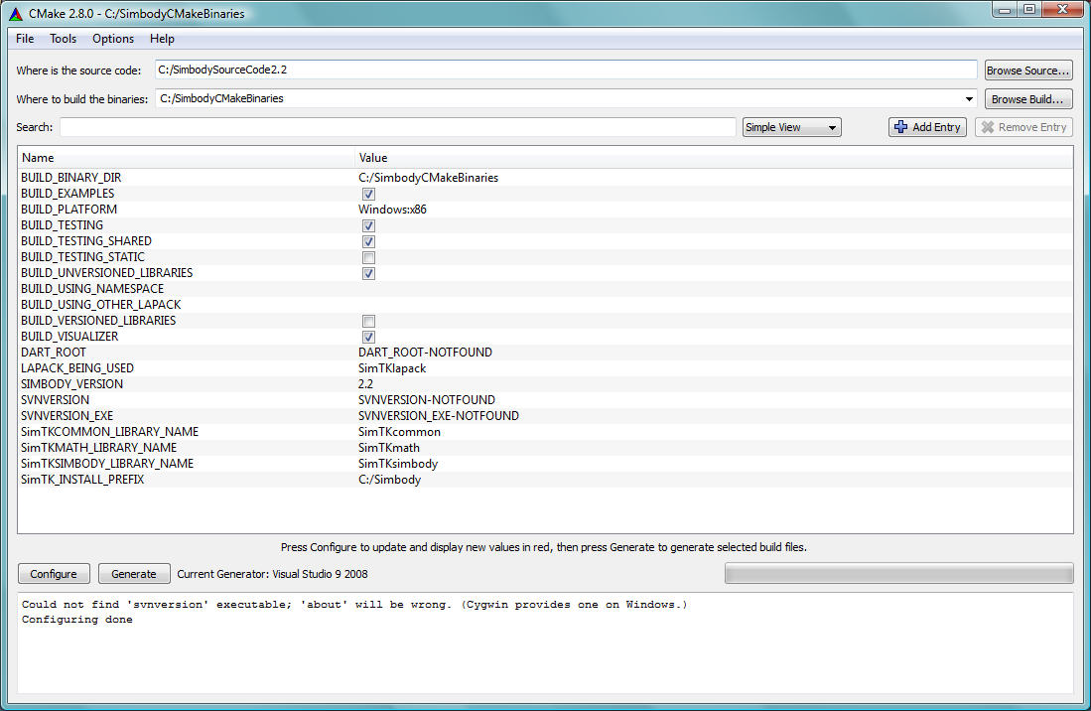  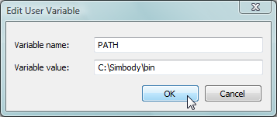

1(e). Install OpenSimAPI libraries for biomechanics modeling libraries.
The context here for the umbrella name “OpenSim” is a collection of C++ libraries and standalone executables. The context here does not include the OpenSim Java GUI and associated build tools (Java, NetBeans, VTK).
Use this step to use the prebuilt release libraries/headers for VisualStudio 2005-Pro or 2008-Pro or Linux 32-bit or Intel-Mac 32-bit. Otherwise, build the libraries/headers from source as described in the next step.

To install OpenSimAPI libraries and include files (Windows, Macintosh, etc.).  - Visit the OpenSim project at http://www.simtk.org (https://simtk.org/home/opensim)  - Login and click the Downloads tab on the left-hand side of the page.  - Find your operating system (e.g., Windows) and click on the appropriate download link, e.g.,  - Install onto your computer, e.g., by clicking OpenSim-2.2.1-win32-VC8P.exe | 

1(f). Alternately: Compile OpenSimAPI biomechanics modeling libraries.
To download OpenSim for compile debug/release (with source code for OpenSimAPI)  - Create a folder on the root of the C: drive called OpensimSourceCode.  - Use Microsoft Windows explorer (press Windows Key and E) to browse to folder OpensimSourceCode. Right-click on open white space and select SVN Checkout… A Checkout box will appear. Get the Trunk or recent branch, e.g.,  URL repository: https://simtk.org/svn/opensim/Trunk or  URL repository: https://simtk.org/svn/opensim/Branches/OpenSim23  For checkout directory, type: C:\OpensimSourceCode  - OpenSim API and other code will download for 30-60 minutes .  - Ensure CMake (currently cmake 2.8) is installed from www.cmake.org  - Click the Windows-Start Key , click Programs (or All Programs), click on the CMake folder on the list of programs, then click on CMake (cmake-gui)  - In CMAKE “Where is the source code”, type: C:/OpenSimSourceCode  (designates the folder containing the top-level CMake file named CMakeLists.txt).  In CMAKE “Where to build the binaries”, type: C:/OpenSimBuildBinariesEtc  (designates the folder for compiler files, debug and release sub-folders, etc.).  - Under the File menu, select Delete CACHE.  - Press Configure button in CMake Window  - Verify the generator for this project (e.g., Use default native compiler) and press Finish.  - Press Configure again and a CMake window with options appear.  - Click Configure 2x and then click Generate  - Exit CMake by clicking X on top-right-hand corner  - Using Microsoft Windows, browse to C:\ OpenSimBuildBinariesEtc folder  - Double-click on the file: OpenSim.sln (if using Microsoft Visual Studio).  Under “Solution Explorer”, right click on ALL_BUILD and select Build.  Under “Solution Explorer”, right click on INSTALL and select Build  [copies .dlls, .h, and .lib files to CMAKE_INSTALL_PREFIX (e.g., OpenSimToEndUser)]  - Ensure the OpenSim\bin folder is on a path specified in your computer’s PATH environment variable, e.g., ensure PATH includes C:\ OpenSimToEndUser \bin  (Note: This is similar to Linux LD_LIBRARY_PATH and Macintosh DLD_LIBRARY_PATH)  - Should now be able to call the OpenSim API .dlls from OpenSimQt. | 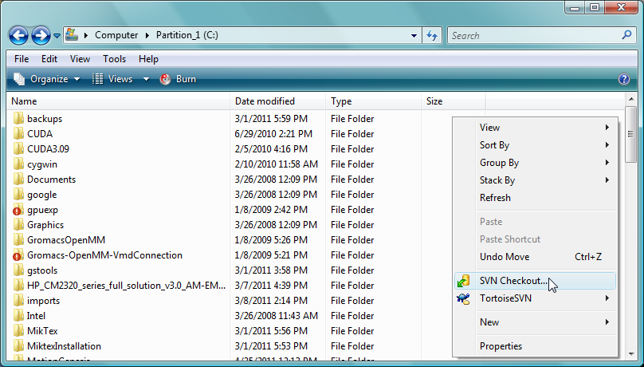  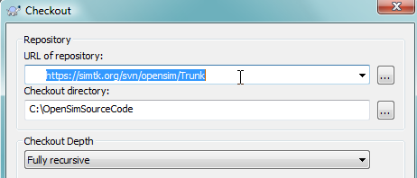  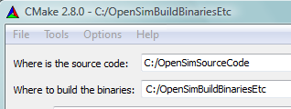  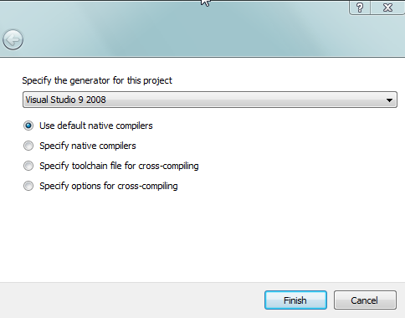  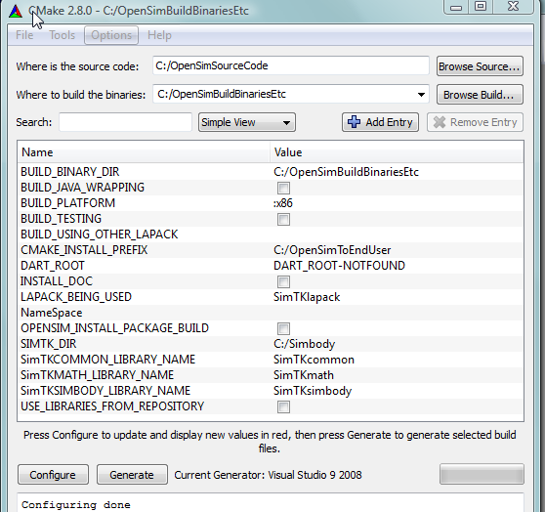  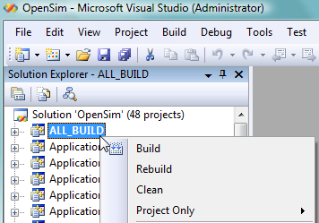
  BUILD_BINARY_DIR | C:/OpenSimBuildBinariesEtc
  BUILD_JAVA_WRAPPING | Unchecked | Unnecessary since doing C++
  BUILD_PLATFORM | :x86 | Building for Windows/PC computer
  BUILD_TESTING | Unchecked | If want API regression test examples
  Note: BUILD_TESTING creates sub-projects options to build regression test examples (useful for OpenSim developers)
  BUILD_USING_OTHER_LAPACK | ?? | ??
  CMAKE_INSTALL_PREFIX | C:/OpenSimToEndUser
  Note: OpenSimToEndUser mimics end-user install folder for end-user release .dlls, documentation, test files, etc.
  DART_ROOT | Not Useful |  | Automates Simbios nightly builds
  LAPACK_BEING_USED | SimTKlapack
  NameSpace | OpenSim_ |  | Notice trailing underscore _
  NameSpace differentiate Simbody .dlls built by OpenSim from those built in a Simbody project.
  If want to use self-built Simbody .dlls, replace OpenSim_ with empty string and ensure correct SIMTK_DIR as it is used to find Simbody lib, include, bin, … files. The combined NameSpace and SIMTK_DIR are mutually exclusive with USE_LIBRARIES_FROM_REPOSITORY which instead pulls Simbody .dlls from the folder created in SVN checkout.
  Generally, use empty string for NameSpace if building your own Simbody .dlls, otherwise use OpenSim_
  SIMTK_DIR | C:\Simbody | Locates Simbody bin, lib, includes, etc.
  USE_LIBRARIES_FROM_REPOSITORY | Unchecked | If checked, copies libraries from the folder created in SVN checkout.
  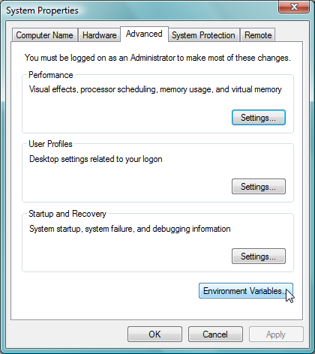 | 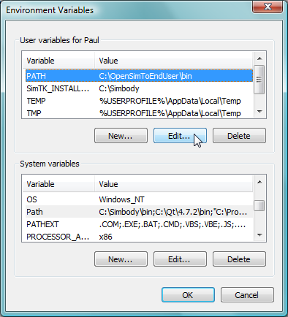

2. Linux specific information
Install Linux on your computer. For example to install ubuntu on a USB stick/drive (i.e., thumb/flash drive), visit
https://help.ubuntu.com/community/Installation/FromUSBStick
Install a C++ compiler (e.g., gcc) preferably with Help files and Examples.
General rule: Do NOT mix debug and release versions, e.g., if use debug .so of OpenSim use debug .so of Simbody.

2(a). Installing Qt (by Nokia, formerly trolltech) for creating C++ GUIs.

