Comprehensive Bank Policy Framework
Applicable to Banks Operating in Portugal under Banco de Portugal and ECB (SSM) Supervision
I. GOVERNANCE & OVERSIGHT POLICIES (ECB CORE REQUIREMENT)
1. Corporate Governance Policy
This policy defines how the bank is directed and controlled.
Must clearly set out:
Roles and responsibilities of:
- Board of Directors
Executive Management
- Committees (Audit, Risk, Remuneration, Nomination)
Separation between oversight and executive functions
Decision
- making processes and delegation of authority
Frequency and documentation of meetings
Accountability mechanisms

ECB focus: effective challenge by the Board, not rubber-stamping.
2. Internal Governance & Control Framework Policy
Defines how the bank controls itself internally.
Must include:

- Escalation and remediation processes
- Internal reporting standards

3. Fit & Proper (Suitability) Policy
Ensures that board members and senior managers are suitable.
Covers:
- Initial and ongoing assessments
- Integrity, honesty, reputation
- Competence, experience, time commitment
- Collective suitability of the board
- Handling of adverse findings

Mandatory for ECB approvals.
II. RISK MANAGEMENT POLICIES (SREP CRITICAL)
4. Risk Management Framework (RMF) Policy
The backbone of the risk system.
Includes:
- Risk taxonomy (credit, market, liquidity, operational, ICT, ESG, etc.)
- Risk identification processes
- Risk measurement methodologies
- Risk monitoring and reporting frequency
- Risk culture principles

5. Risk Appetite Framework (RAF) Policy
Defines how much risk the bank is willing to take.
Must specify:
- Quantitative limits (capital, losses, liquidity, NPL ratios)
- Qualitative statements
- Limit breaches and escalation
- Board approval and review cycle

ECB expects strong linkage to strategy.
6. Credit Risk Policy
Controls all lending activities.
Must cover:
- Credit approval authorities
- Credit analysis standards
- Collateral valuation
- Single-name and sector concentrations
- Loan classification and impairment
- Monitoring and recovery processes

7. Operational Risk Policy
Controls non-financial risks.
Includes:
- Identification of operational risk events
- Loss data collection and thresholds
- Risk and Control Self-Assessments (RCSA)
- Key Risk Indicators (KRIs)

- Operational risk reporting

III. CAPITAL, LIQUIDITY & PRUDENTIAL POLICIES
8. ICAAP Policy
Internal Capital Adequacy Assessment.
Must contain:
- Capital planning horizon (minimum 3 years)
- Risk coverage beyond Pillar 1
- Stress testing methodologies
- Capital buffers and contingency actions

9. Liquidity & Funding Risk Policy
Ensures the bank can meet obligations.
Covers:
- LCR / NSFR governance
- Funding sources diversification
- Liquidity stress scenarios
- Contingency Funding Plan (CFP)

10. Recovery Plan Policy
Used in financial distress situations.
Includes:
- Recovery indicators
- Recovery measures and feasibility
- Crisis governance structure
- Alignment with resolution authorities

IV. COMPLIANCE, ETHICS & CONDUCT POLICIES
11. Code of Conduct & Ethics Policy
Defines acceptable behaviour.
Covers:
- Integrity and professionalism
- Conflicts of interest
- Gifts and hospitality
- Market abuse
- Disciplinary consequences

Mandatory training annually.
12. Compliance Policy
Defines the role of the Compliance Function.
Includes:
- Regulatory monitoring
- Compliance risk assessment
- Advisory and challenge role
- Reporting to senior management and board

13. Conflicts of Interest Policy
Prevent personal interests harming the bank.
Includes:
- Identification and disclosure
- Management of related-party transactions
- Personal account dealing

- Register of conflicts

14. Whistleblowing Policy
Protected reporting of misconduct.
Must ensure:
- Confidential channels
- Protection from retaliation
- Clear investigation processes
- Reporting to competent authorities if required

V. AML / CTF & FINANCIAL CRIME POLICIES (LEGAL REQUIREMENT)
15. AML / CTF Policy
Top-level framework.
Aligned with Portuguese Law 83/2017 and EU AML rules.
Includes:
- Governance and accountability
- Risk-based approach
- Reporting obligations

16. Customer Due Diligence (CDD / KYC) Policy
Identifies who customers really are.
Includes:
- Identification and verification rules
- Beneficial owner determination
- Ongoing monitoring
- Low, medium, high risk categorisation

17. Enhanced Due Diligence (EDD) Policy
For high-risk customers.
Includes:
- PEPs
- High-risk jurisdictions
- Source of funds/wealth verification
- Senior management approval

18. Transaction Monitoring & STR Policy
Detects and reports suspicious activity.
Includes:
- Monitoring rules
- Alerts handling
- Reporting to UIF
- Record retention

VI. ICT, CYBER & OPERATIONAL RESILIENCE (DORA)
19. ICT Risk Management Policy
Controls IT-related risks.
Includes:
- System reliability and availability
- Change management
- Access controls
- Incident reporting

20. Cybersecurity Policy
Protects against cyber threats.
Includes:
- Threat detection
- Incident response
- Penetration testing
- Staff awareness

21. Business Continuity & Disaster Recovery Policy
Ensures operations continue during crises.
Includes:
- Business Impact Analysis (BIA)
- Recovery Time Objectives (RTO)
- Crisis management teams
- Regular testing

22. Outsourcing & Third-Party Risk Policy
Critical for cloud and service providers.
Includes:
- Due diligence
- Risk classification
- Contractual safeguards
- Exit strategies

VII. DATA, GDPR & RECORD KEEPING
23. Data Protection (GDPR) Policy
Ensures lawful data processing.
Includes:
- Lawful bases

- Data subject rights
- Role of DPO
- Supervisory authority notification

24. Data Retention Policy
Controls how long records are kept.
Aligned with:
- AML retention rules
- Prudential requirements
- GDPR principles

VIII. INTERNAL AUDIT & ASSURANCE
25. Internal Audit Policy & Charter
Ensures independent oversight.
Includes:
- Audit independence
- Annual audit plan
- Reporting lines to the Board
- Follow-up of findings

IX. HR & REMUNERATION (ECB VERY SENSITIVE)
26. Remuneration Policy
Must discourage excessive risk-taking.
Includes:
- Fixed/variable pay split
- Malus and clawback

- Remuneration committees
- Compliance with EU remuneration rules

27. Training & Competence Policy
Ensures staff competence.
Includes:
- Mandatory compliance training
- AML, ethics, risk
- Documentation of attendance

X. CONSUMER PROTECTION & CONDUCT OF BUSINESS
28. Consumer Protection Policy
Protects retail clients.
Includes:
- Transparency
- Fair treatment
- Marketing standards

29. Complaints Handling Policy
Manages customer complaints.
Includes:
- Timelines
- Documentation
- Reporting to regulators if required

XI. ESG & CLIMATE (INCREASING ECB EXPECTATIONS)
30. ESG & Climate Risk Policy
Integrates sustainability risks.
Includes:
- Identification of climate risks
- Integration into risk management
- Long-term impact assessment

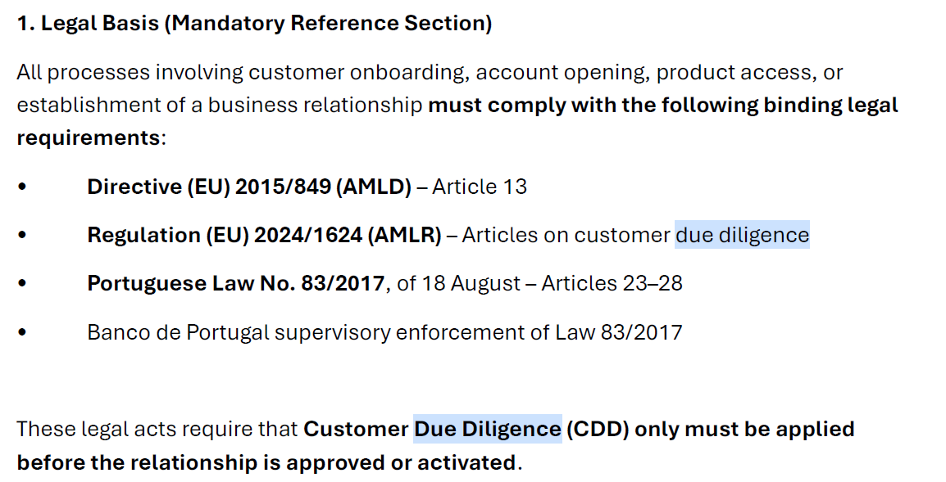

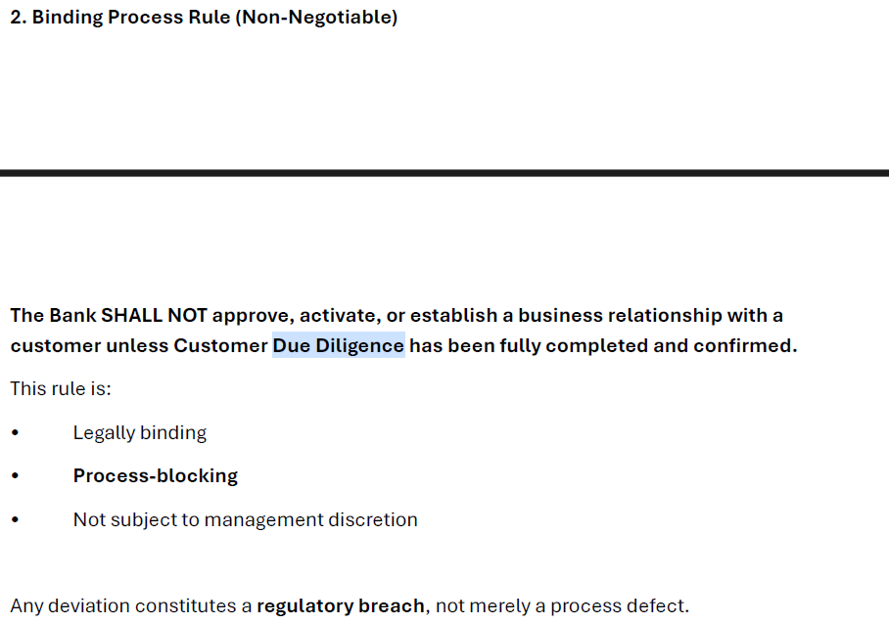
Any deviation constitutes a regulatory breach, not merely a process defect.
