Appendices for:

Towards Intelligent Geospatial Data Discovery: a knowledge graph-driven multi-agent framework powered by large language models

Ruixiang Liuª, Zhenlong Li^{a*}, Ali Khosravi Kazaziª
ª Geoinformation and Big Data Research Laboratory, Department of Geography, The Pennsylvania State University, University Park, PA, USA
*Corresponding author: zhenlong@psu.edu

Contents
Appendix A. Mapping of ontology 2
Appendix B. Orchestration and memory module 3
Appendix C. Discovered datasets for representative use cases 3
Appendix D. Repeated-run robustness analysis 8
Appendix E. Parameter sensitivity analysis 9

Appendix A. Mapping of ontology
Table. A1. Mapping of geospatial metadata ontology and existing geospatial metadata standards.
Entity | Geospatial Metadata Ontology | STAC Collection | FGDC CSDGM | CKAN Model
Dataset | id | id | / | id
 | title | title | Identification_Information.Citation.Citation_Information.Title | title
 | description | description | Identification_Information.Description | description
 | url | links[rel=’self’].href | / | /
Organization | id | / | / | organization.id
 | title | providers.name | Identification_Information.Citation.Citation_Information.Originator | organization.title
 | description | / | / | organization.description
Keyword | id | / | / | tags.id
 | name | keywords | Identification_Information.Keywords | tags.name
License | id | / | / | license_id
 | title | license | Identification_Information.Access_Constraints+ Identification_Information.Use_Constraints | license_title
Space | east | extent.spatial.bbox[2] | Identification_Information.Spatial_Domain. Bounding_Coordinates.East_Bounding_Coordinate | extras[key=’bbox-east-long’].value
 | west | extent.spatial.bbox[0] | Identification_Information.Spatial_Domain. Bounding_Coordinates.West_Bounding_Coordinate | extras[key=’bbox-west-long’].value
 | north | extent.spatial.bbox[3] | Identification_Information.Spatial_Domain. Bounding_Coordinates.North_Bounding_Coordinate | extras[key=’bbox-north-lat’].value
 | south | extent.spatial.bbox[1] | Identification_Information.Spatial_Domain. Bounding_Coordinates.South_Bounding_Coordinate | extras[key=’bbox-south-lat’].value
Time | begin | extent.temporal.interval[0][0] | Identification_Information.Time_Period_of_Content.Range_of_Dates/Times.Beginning_Date | extras[key=’temporal-extent-begin’].value
 | end | extent.temporal.interval[0][1] | Identification_Information.Time_Period_of_Content.Range_of_Dates/Times.Ending_Date | extras[key=’temporal-extent-end’].value
Resource | id | / | / | resources.id
 | title | links[rel=’*’].rel | / | resources.title
 | description | / | / | resources.description
 | url | links[rel=’*’].href | / | resources.url
Format | id | / | / | /
 | name | links[rel=’*’].type | / | resources.format

Appendix B. Orchestration and memory module
The orchestration and memory module serves as the system-level core of the multi-agent geospatial data discovery framework. During runtime, the orchestration module models geospatial data discovery as a workflow composed of multiple interdependent subtasks. It not only triggers and coordinates the execution of specialized agents, but also monitors and evaluates their outputs, persisting critical state information to the memory module. Its core responsibilities include workflow orchestration, service coordination, state management, routing control, exception handling, and data persistence, ensuring robust system operation under complex queries and uncertain conditions.
The memory module provides structured short-term and long-term memory support, continuously storing key contextual information generated throughout the discovery process. This includes users’ original queries and interaction histories, parsed and structured intent representations, and intermediate outputs produced by individual agents at different stages. Through unified management of problem-level and session-level memory, the system supports progressive evolution of user intent across multiple interaction rounds and supplies contextual grounding for subsequent retrieval, ranking, and result synthesis. In addition, the memory module preserves a complete execution trace of the discovery process, enabling transparency and reproducibility of system behavior and facilitating result interpretation and methodological evaluation.

Appendix C. Discovered datasets for representative use cases
Table. C1. Top 20 datasets generated by the graph retrieval agent for the climate data discovery.
No. | Dataset | Topic | Space | Time | Total/Normalized Score | Synthesis Ranking by LLM
 | PRISM Daily Spatial Climate Dataset ANd  (From Google Earth Engine Proxy for openEO) | daily air temperature  Score: 0.8925 | [-125, 24, -66, 50]  Score: 0.9702 | [19810101 00:00:00, 20251108 12:00:00]  Score: 0.8174 | 0.6253/1.0000 | 1
 | GRIDMET: University of Idaho Gridded Surface Meteorological Dataset  (From Google Earth Engine Proxy for openEO) | daily air temperature  Score: 0.8925 | [-124.9, 24.9, -66.8, 49.6]  Score: 0.9833 | [19790101 00:00:00, 20251110 06:00:00]  Score: 0.7963 | 0.6237/0.9975 | 2
 | U.S. Daily Gridded Precipitation and Temperature Climate Normals for 2006-2020 (NCEI Accession 0259964)  (From Data.gov) | daily temperature normals  Score: 0.8906 | [-124.6875, 24.5625, -67.0208, 49.3542]  Score: 0.9946 | [20060101 00:00:00, 20201231 00:00:00]  Score: 0.6521 | 0.5965/0.9540 | 4
 | NOAA nClimGrid-Daily Version 1 â Daily gridded temperature and precipitation for the Contiguous United States since 1951  (From Data.gov) | maximum minimum temperature  Score: 0.8488 | [-125, 24, -66, 50]  Score: 0.9702 | [19510101 00:00:00, 20251231 00:00:00]  Score: 0.5850 | 0.5657/0.9047 | 3
 | PRISM Monthly Spatial Climate Dataset ANm  (From Google Earth Engine Proxy for openEO) | monthly temperature  Score: 0.9067 | [-125, 24, -66, 50]  Score: 0.9702 | [18950101 00:00:00, 20251001 00:00:00]  Score: 0.3833 | 0.5427/0.8679 | /
 | PRISM Monthly Spatial Climate Dataset AN81m [deprecated]  (From Google Earth Engine Proxy for openEO) | monthly air temperature  Score: 0.8454 | [-125, 24, -66, 50]  Score: 0.9702 | [18950101 00:00:00, 20201201 00:00:00]  Score: 0.3940 | 0.5265/0.8420 | /
 | A spatially comprehensive, meteorological data set for Mexico, the U.S., and southern Canada (NCEI Accession 0129374)  (From Data.gov) | daily air temperature  Score: 0.8925 | [-125.0000, 14.6563, -67.0000, 53.0000]  Score: 0.7871 | [19500101 00:00:00, 20131231 00:00:00]  Score: 0.5052 | 0.5262/0.8416 | 5
 | U.S. Climate Divisional Dataset (Version Superseded)  (From Data.gov) | maximum/minimum temperature  Score: 0.8488 | [-125, 24, -66, 50]  Score: 0.9702 | [18950101 00:00:00, 20251231 00:00:00]  Score: 0.3827 | 0.5252/0.8400 | 10
 | SST, Aqua MODIS, NPP, 0.0125Â°, West US, Day time (11 microns), 2002-present (1 Day Composite)  (From Data.gov) | daily temperature composites  Score: 0.8518 | [-155, 22, -105, 51]  Score: 0.3415 | [20020624 12:00:00, 20220902 12:00:00]  Score: 0.7237 | 0.4686/0.7494 | /
 | SST, NOAA POES AVHRR, LAC, 0.0125 degrees, West US, Day and Night, 2004-present (1 Day Composite)  (From Data.gov) | daily temperature composites  Score: 0.8518 | [-145, 22, -105, 51]  Score: 0.3795 | [20040102 12:00:00, 20220902 12:00:00]  Score: 0.6845 | 0.4683/0.7490 | /
 | SST, NOAA POES AVHRR, LAC, 0.0125 degrees, West US, Day and Night, 2004-present (1 Day Composite), degree_F  (From Data.gov) | daily temperature composites  Score: 0.8518 | [-145, 22, -105, 51]  Score: 0.3795 | [20040102 12:00:00, 20220902 12:00:00]  Score: 0.6845 | 0.4683/0.7490 | /
 | SST, NOAA POES AVHRR, LAC, 0.0125 degrees, West US, Day and Night, 2004-present (1 Day Composite), Lon+/-180  (From Data.gov) | daily temperature composites  Score: 0.8518 | [-145, 22, -105, 51]  Score: 0.3795 | [20040102 12:00:00, 20220902 12:00:00]  Score: 0.6845 | 0.4683/0.7490 | /
 | SST, Aqua MODIS, NPP, East US, Daytime and Nighttime (11 microns), 2002-2011 (3 Day Composite)  (From Data.gov) | day night temperature  Score: 0.8609 | [-90, 20, -60, 50]  Score: 0.4912 | [20020705 12:00:00, 20110911 12:00:00]  Score: 0.4571 | 0.4479/0.7164 | /
 | ERA5 Daily Aggregates - Latest Climate Reanalysis Produced by ECMWF / Copernicus Climate Change Service  (From Google Earth Engine Proxy for openEO) | daily air temperature  Score: 0.8925 | [-180, -90, 180, 90]  Score: 0.0436 | [19790102 00:00:00, 20200709 00:00:00]  Score: 0.8417 | 0.4448/0.7114 | 6
 | SST, Aqua MODIS, NPP, East US, Daytime and Nighttime (11 microns), 2002-2010 (8 Day Composite)  (From Data.gov) | day night temperature  Score: 0.8609 | [-90, 20, -60, 50]  Score: 0.4912 | [20020705 12:00:00, 20101228 00:00:00]  Score: 0.4297 | 0.4424/0.7076 | /
 | SST, GOES Imager, Day and Night, Western Hemisphere, 2000-2020 (1 Day Composite)  (From Data.gov) | daily temperature composites  Score: 0.8518 | [-179.975, -44.975, -30.025, 59.975]  Score: 0.1682 | [20001201 12:00:00, 20200302 12:00:00]  Score: 0.7662 | 0.4424/0.7075 | /
 | SST, GOES Imager, Day and Night, Western Hemisphere, 2000-2020 (1 Day Composite), Lon+/-180  (From Data.gov) | daily temperature composites  Score: 0.8518 | [-179.975, -44.975, -30.025, 59.975]  Score: 0.1682 | [20001201 12:00:00, 20200302 12:00:00]  Score: 0.7662 | 0.4424/0.7075 | /
 | CHIRTS-daily: Climate Hazards Center InfraRed Temperature with Stations daily temperature data product  (From Google Earth Engine Proxy for openEO) | daily maximum temperature  Score: 0.8601 | [-180, -60, 180, 70]  Score: 0.0599 | [19830101 00:00:00, 20161231 00:00:00]  Score: 0.8307 | 0.4361/0.6975 | 8
 | MOD11A1.006 Terra Land Surface Temperature and Emissivity Daily Global 1km [deprecated]  (From Google Earth Engine Proxy for openEO) | daytime temperature  Score: 0.8974 | [-180, -90, 180, 90]  Score: 0.0436 | [20000224 00:00:00, 20221115 00:00:00]  Score: 0.7763 | 0.4332/0.6928 | 9
 | CPC Global Unified Temperature  (From Google Earth Engine Proxy for openEO) | daily maximum temperature  Score: 0.8601 | [-180, -90, 180, 90]  Score: 0.0436 | [19790101 00:00:00, 20251110 00:00:00]  Score: 0.7963 | 0.4260/0.6813 | 7

Table. C2. Top 10 datasets generated by the answer synthesis agent for the U.S. census data discovery.
No. | Dataset | Score | Match Reason
 | TIGER/Line Shapefile, 2022, State, California, Primary and Secondary Roads | Raw Total Score: 0.7714  Normalized Score: 1.0000  Topic:0.9049, Format:1.0000, Organization: 0.8206, Space: 1.0000, Time: 0.5894 | • Exact geography match: California (state-level)  • Exact year match: TIGER/Line Shapefile 2022  • Direct topic match: Primary and Secondary Roads; Census Bureau TIGER/Line ZIP distribution
 | TIGER/Line Shapefile, 2022, Nation, U.S., Primary Roads | Raw Total Score: 0.5728  Normalized Score: 0.7426  Topic:0.9049, Format:1.0000, Organization: 0.8206, Space: 0.0070, Time: 0.5894 | • Direct topic match: Primary Roads (explicitly named)  • Correct year and format: 2022 TIGER/Line Shapefile, typically provided as ZIP  • Useful fallback if statewide CA layer is not sufficient (can subset to California)
 | TIGER/Line Shapefile, 2022, County, Inyo County, CA, All Roads | Raw Total Score: 0.5924  Normalized Score: 0.7679  Topic:0.9069, Format:1.0000, Organization: 0.8206, Space: 0.1020, Time: 0.5894 | • California coverage (Inyo County, CA) within the requested state  • Road network content (All Roads) can include primary roads segments  • Correct vintage/format: 2022 TIGER/Line Shapefile in ZIP
 | TIGER/Line Shapefile, 2022, County, Fresno County, CA, All Roads | Raw Total Score: 0.5888  Normalized Score: 0.7632  Topic:0.9069, Format:1.0000, Organization: 0.8206, Space: 0.0839, Time: 0.5894 | • California coverage (Fresno County, CA) relevant to the requested geography  • All Roads layer includes primary roads as a subset  • Matches 2022 TIGER/Line Shapefile ZIP delivery format
 | TIGER/Line Shapefile, 2022, County, Yolo County, CA, All Roads | Raw Total Score: 0.5700  Normalized Score: 0.7389  Topic:0.8925, Format:1.0000, Organization: 0.8206, Space: 0.0114, Time: 0.5894 | • California coverage (Yolo County, CA) relevant to the request  • All Roads provides road features that can be filtered to primary roads  • 2022 TIGER/Line Shapefile, commonly distributed as ZIP
 | TIGER/Line Shapefile, 2022, County, Yuba County, CA, All Roads | Raw Total Score: 0.5565  Normalized Score: 0.7214  Topic:0.8490, Format:1.0000, Organization: 0.8206, Space: 0.0092, Time: 0.5894 | • California coverage (Yuba County, CA) within requested state  • All Roads can be used to derive/select primary roads  • Correct year/format: 2022 TIGER/Line Shapefile ZIP
 | TIGER/Line Shapefile, 2022, State, Nevada, Primary and Secondary Roads | Raw Total Score: 0.6890  Normalized Score: 0.8932  Topic:0.9049, Format:1.0000, Organization: 0.8206, Space: 0.5879, Time: 0.5894 | • Same TIGER/Line 2022 road product type (Primary and Secondary Roads) from Census Bureau  • ZIP format match (TIGER/Line Shapefile distribution)  • Geography mismatch (Nevada) but structurally closest alternative road dataset
 | TIGER/Line Shapefile, 2022, State, Oregon, Primary and Secondary Roads | Raw Total Score: 0.5718  Normalized Score: 0.7413  Topic:0.9049, Format:1.0000, Organization: 0.8206, Space: 0.0021, Time: 0.5894 | • Same TIGER/Line 2022 road product type (Primary and Secondary Roads)  • Matches requested format (ZIP) and authoritative source (U.S. Census Bureau)  • Geography mismatch (Oregon) but relevant as comparable dataset
 | TIGER/Line Shapefile, 2022, State, Idaho, Primary and Secondary Roads | Raw Total Score: 0.5716  Normalized Score: 0.7410  Topic:0.9049, Format:1.0000, Organization: 0.8206, Space: 0.0009, Time: 0.5894 | • Same TIGER/Line 2022 road product type (Primary and Secondary Roads)  • ZIP format match and Census Bureau origin  • Geography mismatch (Idaho) but still relevant for the specific 'primary/secondary roads' theme
 | TIGER/Line Shapefile, 2022, State, Arizona, Primary and Secondary Roads | Raw Total Score: 0.5667  Normalized Score: 0.7347  Topic:0.8581, Format:1.0000, Organization: 0.8206, Space: 0.0469, Time: 0.5894 | • Same TIGER/Line 2022 road product type (Primary and Secondary Roads)  • ZIP format match and produced by the U.S. Census Bureau  • Geography mismatch (Arizona) but closer topical match than non-road California layers

Table. C3. Health data discovery results (showing Top 3).
Question | Dataset | Match Reason
I am looking for HIV data in District of Columbia. | HIV and AIDS Clinic | • Direct topic match: HIV/AIDS (clinic-focused dataset)  • Most relevant to finding HIV-related services/providers in DC context  • High topic score (0.94) among candidates
 | AIDS Drug Assistance Program | • Direct topic match: AIDS Drug Assistance Program (HIV/AIDS support program data)  • Useful for HIV program coverage/access information relevant to DC residents  • High topic score (0.94) among candidates
 | DC Health Planning Neighborhoods to Census Tracts | • Strong DC geographic relevance (Space=1.00) for District of Columbia analyses  • Provides neighborhood-to-census-tract crosswalk to map/aggregate HIV indicators  • Supports joining HIV metrics to DC health planning geographies
Please find opioid use datasets published by the City of Tempe, licensed under the Creative Commons Attribution license, and provided in GeoJSON format. | Opioid EMS Calls | • Direct opioid-related dataset (EMS calls) matching the 'opioid use' topic  • Matches key constraints: City of Tempe organization and CC BY license  • GeoJSON format match (high format score)
 | Biomarker Opioids (open data) | • Strong opioid relevance (opioids biomarker data) aligned with opioid use monitoring  • Published by City of Tempe and licensed under Creative Commons Attribution  • Available in GeoJSON per candidate format score
 | 1.31 Opioid EMS Calls (summary) | • Opioid-specific EMS calls summary relevant to opioid use/overdose activity  • City of Tempe publisher and CC BY license match the request  • GeoJSON format match (high format score)

Appendix D. Repeated-run robustness analysis
The repeated-run results show that the proposed framework is stable across independent executions. As shown in Table. D1 and Table. D2, IGDD(D)-G&A achieves a mean NDCG@10 of 70.95% with a standard deviation of 0.67%, while IGDD(D)-G achieves a mean NDCG@10 of 57.00% with a standard deviation of 0.39%. The narrow 95% confidence intervals indicate that the ranking performance varies only slightly across repeated runs. IGDD(D)-G&A also maintains stable Recall@20 performance, with a mean of 46.64%, a standard deviation of 0.56%, and a 95% confidence interval of [46.24%, 47.05%]. These results suggest that the observed performance improvements are not caused by a single favorable execution.
Fig. D1 shows the 95% confidence intervals of repeated-run performance across the four query complexity levels. The confidence intervals remain narrow for all four levels, indicating limited variation across repeated executions. Level 4 shows a slightly wider interval than the other levels, suggesting that more complex queries with multiple constraints may introduce somewhat higher variability, but the overall repeated-run performance remains stable.
Table. D1. Repeated-run performance of IGDD(D)-G&A and IGDD(D)-G across ten independent executions.
No. | Component | NDCG@10 |  | Recall@20 | No. | Component | NDCG@10 | Recall@20
1 | IGDD(D)-G&A | 71.55% | 47.18% |  | 6 | IGDD(D)-G&A | 71.07% | 47.39%
 | IGDD(D)-G | 57.79% |  |  |  | IGDD(D)-G | 57.09%
2 | IGDD(D)-G&A | 71.76% | 46.10% |  | 7 | IGDD(D)-G&A | 70.26% | 45.93%
 | IGDD(D)-G | 57.18% |  |  |  | IGDD(D)-G | 56.93%
3 | IGDD(D)-G&A | 71.19% | 46.96% |  | 8 | IGDD(D)-G&A | 71.31% | 46.04%
 | IGDD(D)-G | 56.29% |  |  |  | IGDD(D)-G | 56.69%
4 | IGDD(D)-G&A | 69.87% | 46.89% |  | 9 | IGDD(D)-G&A | 70.21% | 47.01%
 | IGDD(D)-G | 57.24% |  |  |  | IGDD(D)-G | 56.99%
5 | IGDD(D)-G&A | 71.65% | 45.97% |  | 10 | IGDD(D)-G&A | 70.61% | 46.95%
 | IGDD(D)-G | 56.92% |  |  |  | IGDD(D)-G | 56.89%

Table. D2. Summary statistics of repeated-run performance.
Component | Metric | Mean | SD | 95% CI
IGDD(D)-G&A | NDCG@10 | 70.95% | 0.67% | [70.47%, 71.43%]
IGDD(D)-G | NDCG@10 | 57.00% | 0.39% | [56.72%, 57.28%]
IGDD(D)-G&A | Recall@20 | 46.64% | 0.56% | [46.24%, 47.05%]

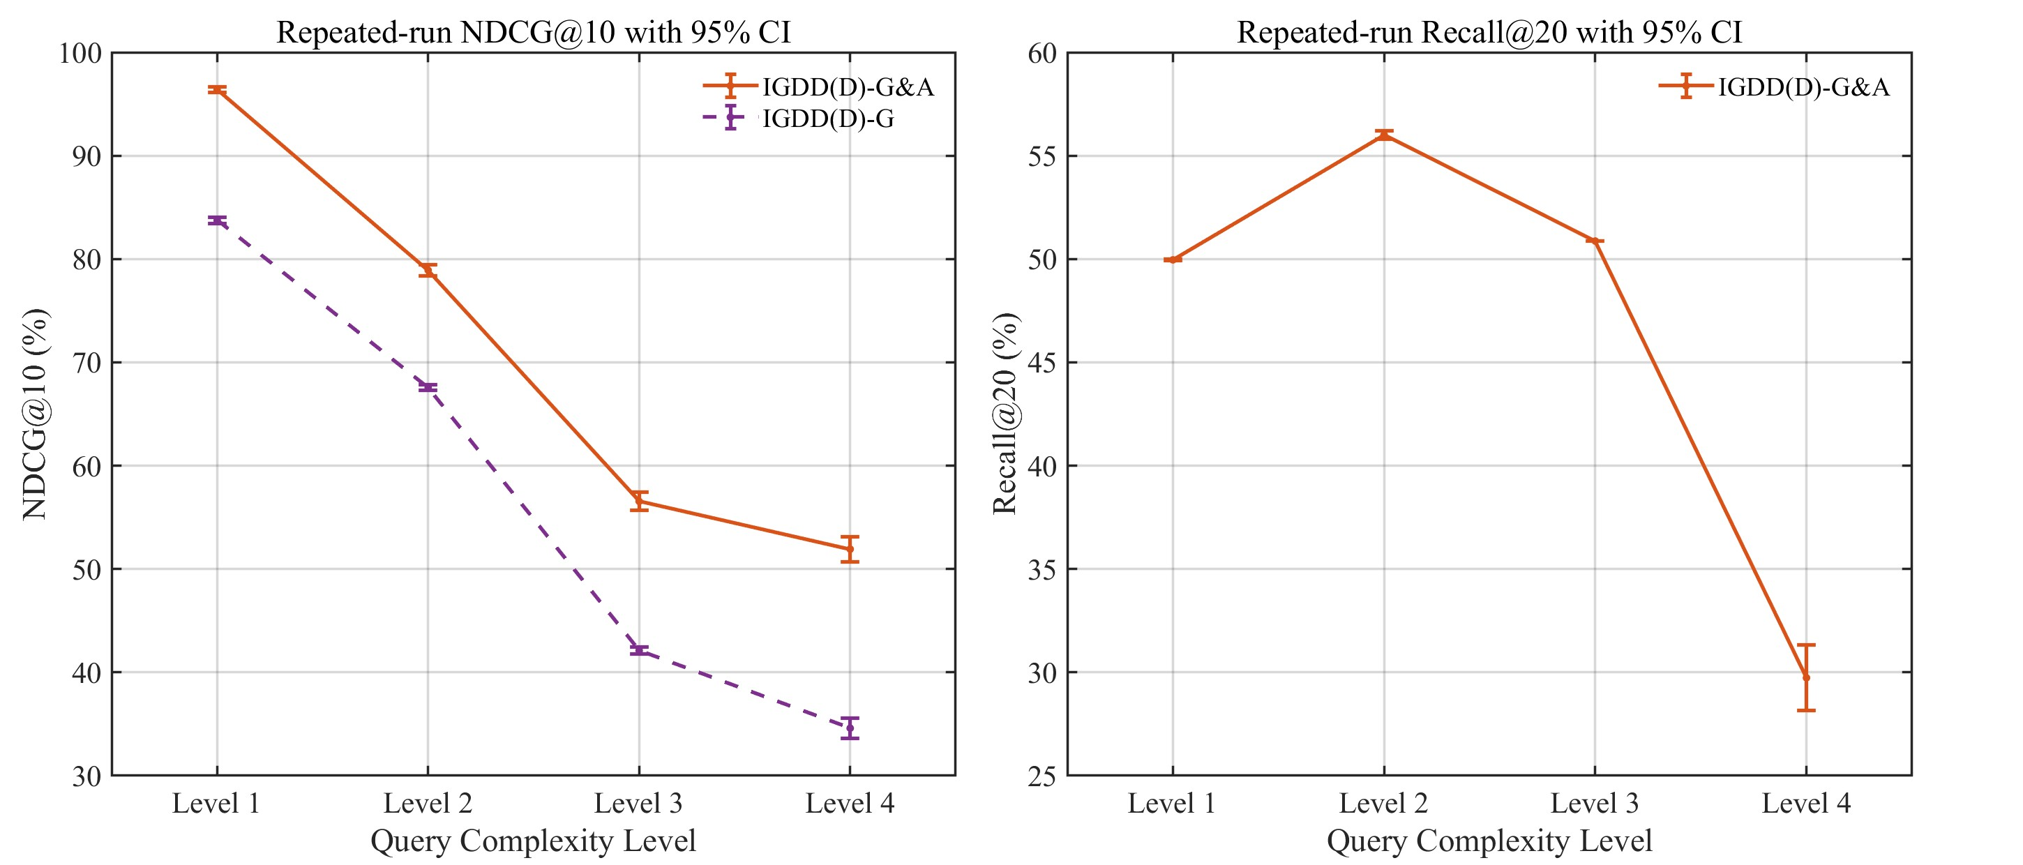
Fig. D1. Mean NDCG@10 and Recall@20 with 95% confidence intervals across ten repeated experiments.

Appendix E. Parameter sensitivity analysis
Appendix E presents additional sensitivity analyses for graph retrieval weights, entity similarity thresholds, and NDCG cutoffs. As shown in Table. E1, the default graph retrieval weight setting achieves the strongest overall performance. Alternative settings, including equal weights, space-time-heavy weights, and metadata-heavy weights, all lead to lower performance, while the topic-heavy setting remains relatively competitive. These results suggest that assigning relatively higher importance to Topic, Space, and Time provides a better balance for geospatial data discovery. Fig. E1 further shows that this pattern is generally consistent across different query complexity levels. Although all weight settings perform well on simpler queries, the differences become more visible for more complex queries, especially at Level 4.
Table. E1. Parameter sensitivity analysis of graph retrieval weights.
Setting | Graph Retrieval Weights | Component | NDCG@10 | Recall@20
Default | Topic: 0.3, Space: 0.2, Time: 0.2, Organization: 0.1, Format:0.1, License: 0.1 | IGDD(D)-G&A | 71.55% | 47.18%
 |  | IGDD(D)-G | 57.79%
Equal | Topic: 1/6, Space: 1/6, Time: 1/6, Organization: 1/6, Format: 1/6, License: 1/6 | IGDD(D)-G&A | 66.35% | 43.62%
 |  | IGDD(D)-G | 52.66%
Topic-heavy | Topic: 0.5, Space: 0.15, Time: 0.15, Organization: 0.07, Format:0.07, License: 0.06 | IGDD(D)-G&A | 70.40% | 46.55%
 |  | IGDD(D)-G | 57.84%
SpaceTime-heavy | Topic: 0.2, Space: 0.3, Time: 0.3, Organization: 0.07, Format:0.07, License: 0.06 | IGDD(D)-G&A | 64.94% | 43.44%
 |  | IGDD(D)-G | 52.80%
Metadata-heavy | Topic: 0.2, Space: 0.15, Time: 0.15, Organization: 0.2, Format:0.15, License: 0.15 | IGDD(D)-G&A | 69.31% | 45.11%
 |  | IGDD(D)-G | 54.47%
Data.gov | / | / | 43.03% | 26.40%
BM25 | / | / | 43.17% | 26.07%

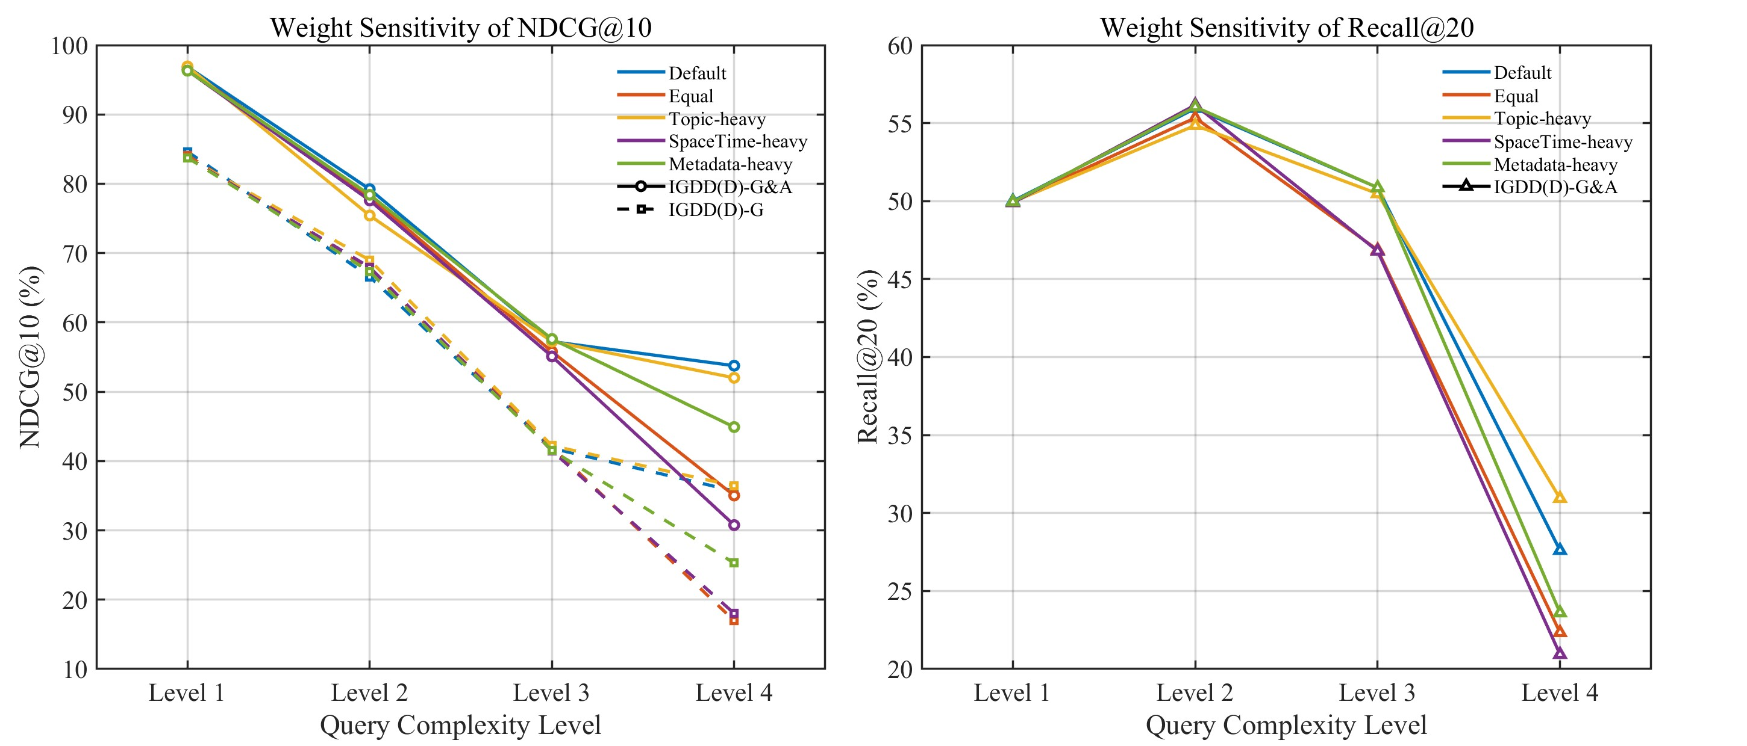
Fig. E1. Parameter sensitivity of graph retrieval weights of NDCG@10 and Recall@20 across query complexity levels.
Table. E2 and Fig. E2 present the sensitivity analysis of the entity similarity threshold. The results show that thresholds from 0.5 to 0.8 produce generally comparable performance, indicating that the framework is not highly sensitive to moderate changes in this parameter. Among these settings, the default threshold of 0.7 provides a practical balance between retrieval accuracy and computational efficiency. A lower threshold may retain more candidate entities but also introduce more weakly related matches, while a higher threshold may improve semantic strictness but reduce candidate coverage. Thus, the overly strict threshold of 0.9 causes a substantial drop in both NDCG@10 and Recall@20, showing that excessive filtering can remove useful candidate entities and reduce retrieval effectiveness.

Table. E2. Parameter sensitivity analysis of entity similarity thresholds.
Setting | Entity Similarity Threshold | Component | NDCG@10 | Recall@20
Default | 0.5 | IGDD(D)-G&A | 70.63% | 46.09%
 |  | IGDD(D)-G | 55.27%
Default | 0.6 | IGDD(D)-G&A | 70.87% | 46.17%
 |  | IGDD(D)-G | 56.10%
Default | 0.7 | IGDD(D)-G&A | 71.55% | 46.39%
 |  | IGDD(D)-G | 57.79%
Default | 0.8 | IGDD(D)-G&A | 70.50% | 46.15%
 |  | IGDD(D)-G | 56.19%
Default | 0.9 | IGDD(D)-G&A | 54.00% | 31.09%
 |  | IGDD(D)-G | 45.49%
Data.gov | / | / | 43.03% | 25.69%
BM25 | / | / | 43.17% | 41.21%

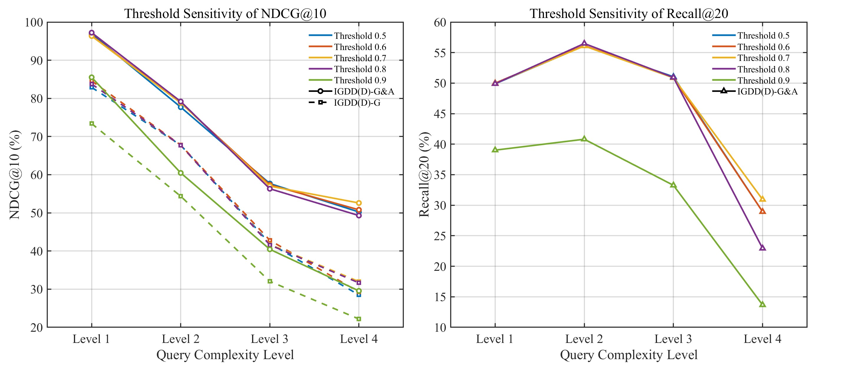
Fig. E2. Parameter sensitivity of entity similarity thresholds of NDCG@10 and Recall@20 across query complexity levels.

Table. E3 and Fig. E3 show the sensitivity of final ranking performance under different NDCG cutoffs. As expected, NDCG values decrease gradually as the cutoff increases from 3 to 10, because deeper ranked lists include more lower-ranked candidates. However, the relative performance pattern remains highly consistent across all cutoffs and query complexity levels. IGDD-G&A consistently achieves the best results, followed by IGDD(D)-G&A, while IGDD-G and IGDD(D)-G remain below their answer-synthesis counterparts. These results indicate that the observed ranking advantage of the proposed framework is not limited to a single cutoff choice, but remains stable across different output depths.
Table. E3. Sensitivity analysis of different Top N datasets.
Setting | N (Top N Datasets) | Component | NDCG@N
Default | 3 | IGDD-G&A | 87.21%
 |  | IGDD(D)-G&A | 80.27%
 |  | IGDD-G | 63.87%
 |  | IGDD(D)-G | 58.96%
 |  | Data.gov | 46.94%
 |  | BM25 | 42.97%
Default | 5 | IGDD-G&A | 85.26%
 |  | IGDD(D)-G&A | 76.71%
 |  | IGDD-G | 65.52%
 |  | IGDD(D)-G | 58.62%
 |  | Data.gov | 44.78%
 |  | BM25 | 43.17%
Default | 8 | IGDD-G&A | 83.17%
 |  | IGDD(D)-G&A | 73.30%
 |  | IGDD-G | 66.22%
 |  | IGDD(D)-G | 58.25%
 |  | Data.gov | 43.50%
 |  | BM25 | 43.01%
Default | 10 | IGDD-G&A | 81.68%
 |  | IGDD(D)-G&A | 71.55%
 |  | IGDD-G | 66.34%
 |  | IGDD(D)-G | 57.79%
 |  | Data.gov | 43.03%
 |  | BM25 | 43.17%

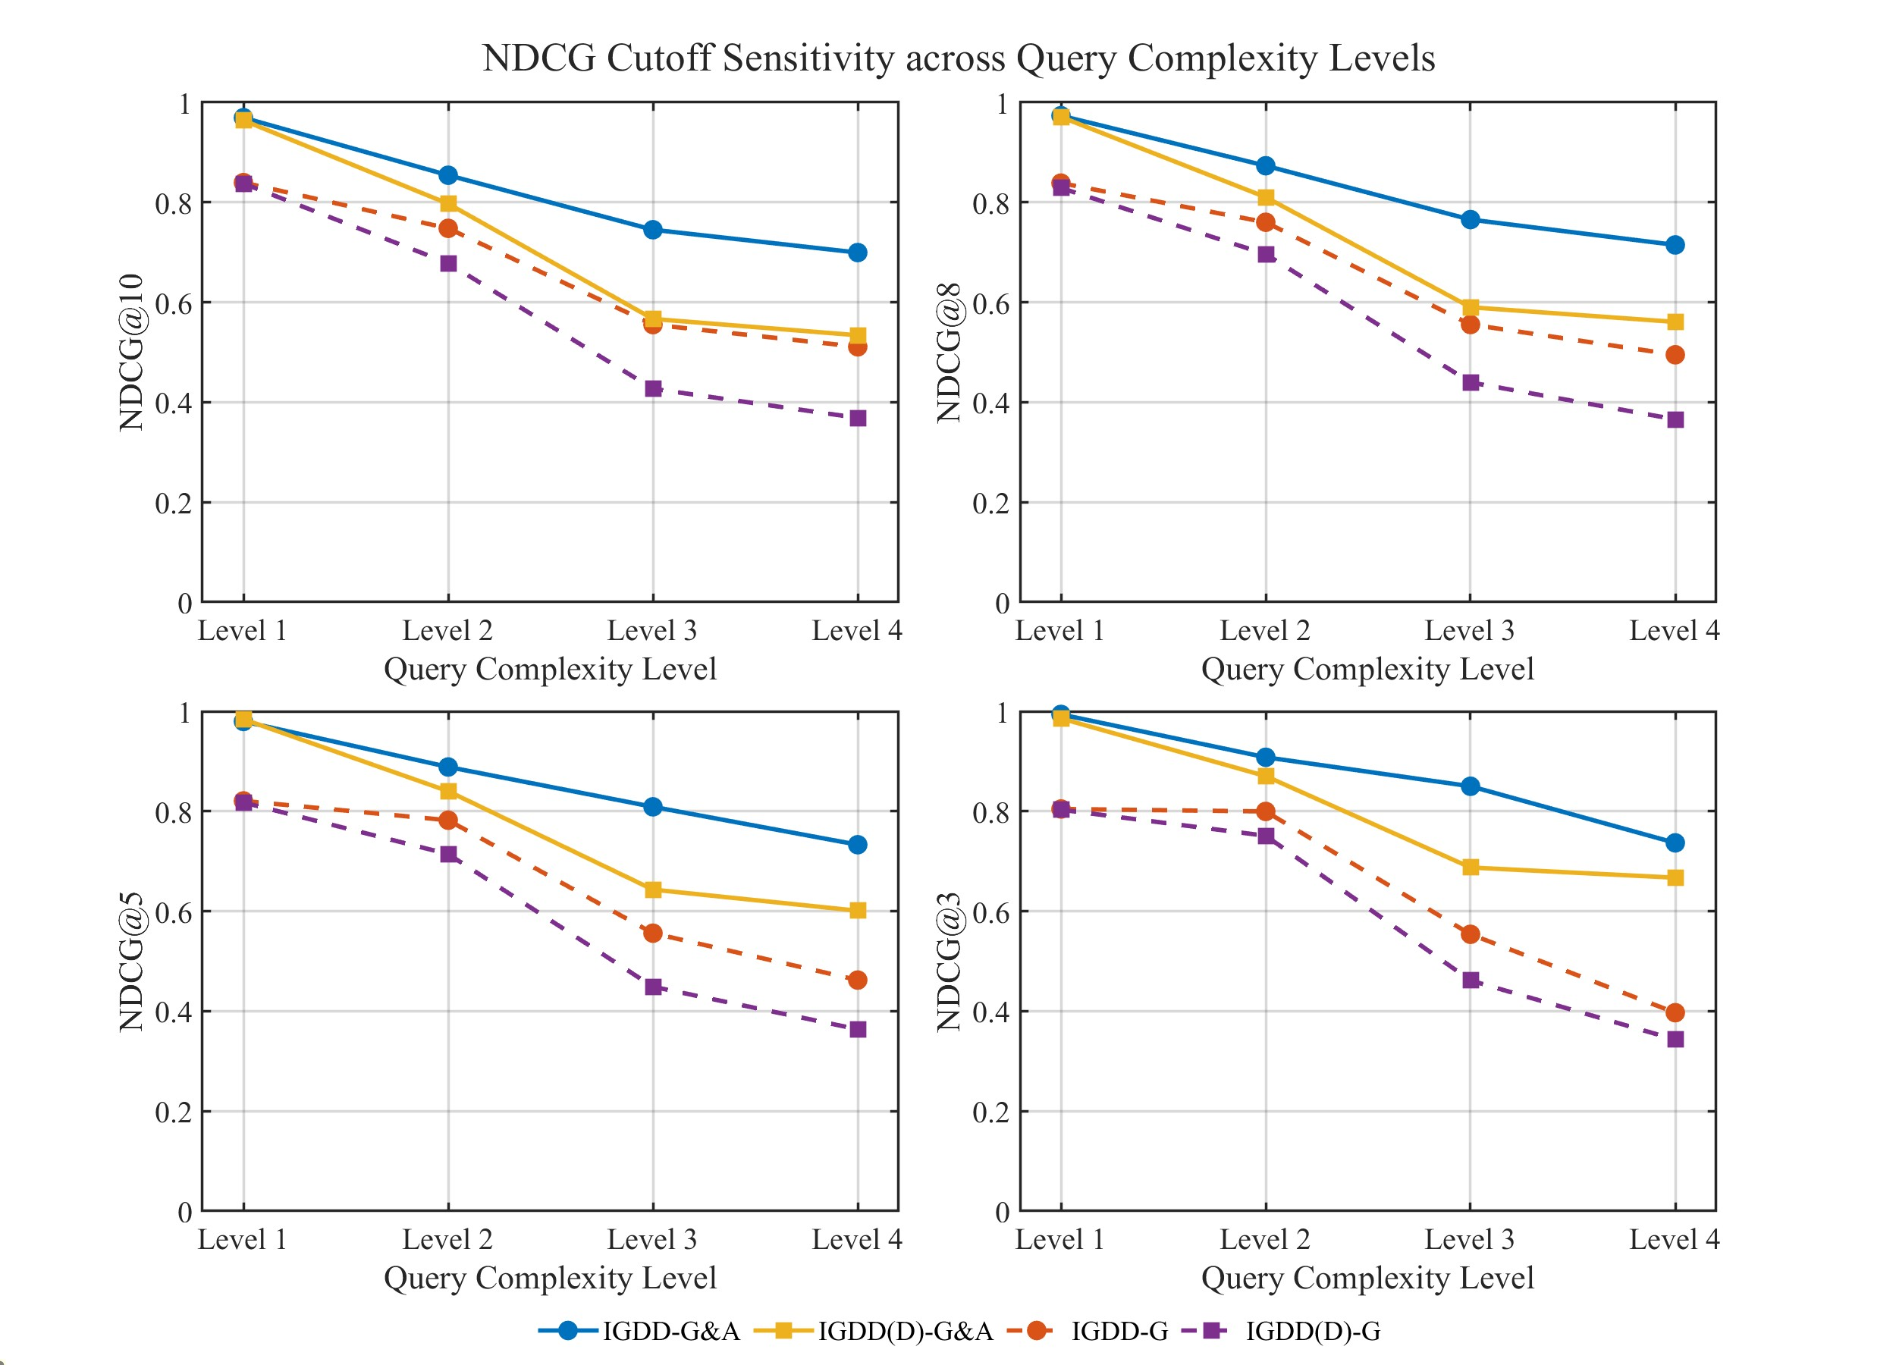
Fig. E3. NDCG cutoff sensitivity across query complexity levels.

