Histogram:

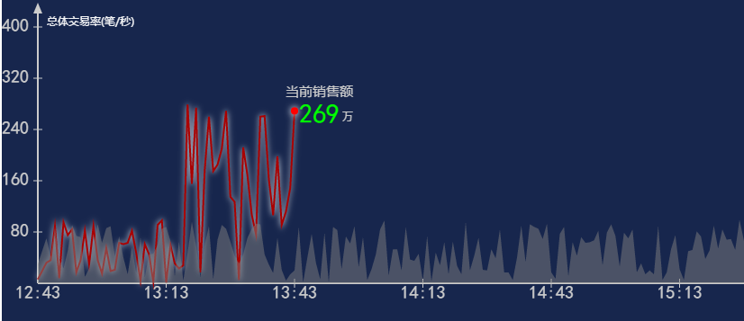

1视图样式(构造函数传入)

style = {  
  
 w:900,  
 h:300,  
 xTime:30,  
 beforeHour:2,  
 afterHour:1,  
 sortData:false,  
 yNum:5,  
 title:{  
 txtStr:'总体交易率(笔/秒)',  
 txtColor:'#fff',  
 txtSize:12,  
 txtFont:'Microsoft YaHei',  
 x:10,  
 y:0  
 },  
 xAxis:{  
 lineColor:'#ccc',  
 thickness:2,  
 txtColor:'#ccc',  
 txtSize:20,  
 txtFont:'黑体',  
 mark:true  
 },  
 yAxis:{  
 lineColor:'#ccc',  
 thickness:2,  
 txtColor:'#ccc',  
 txtSize:20,  
 txtFont:'黑体',  
 mark:true  
 },  
 lineArr:[  
 {  
 lineType:'a',  
 id:'A',  
 value:currentA,  
 lineColor:'#0f0',  
 thickness:2,  
 valueColor:'#0f0',  
 valueSize:20,  
 txtFont:'黑体',  
 ballR:4,  
 ballColor:'#f00',

shadowColor:'#fff',

shadowSize:10  
 },  
 {  
 lineType:'b',  
 id:'B',  
 value:historyA,  
 lineColor:'rgba(126,126,126,0)',  
 thickness:2,  
 fillColor:'rgba(126,126,126,0.5)'  
 },  
 {  
 lineType:'c',  
 id:'C',  
 value:300,  
 valueColor:'#a00',  
 valueSize:50,  
 lineColor:'#f00',  
 thickness:1,  
 titleStr:'系统预警:',  
 titleColor:'#ccc',  
 titleSize:20,  
 titleFont:'Microsoft YaHei',  
 valueFont:'Microsoft YaHei'  
 },  
 {  
 lineType:'c',  
 id:'D',  
 value:50,  
 valueColor:'#ff0',  
 valueSize:30,  
 lineColor:'#00f',  
 thickness:1,  
 titleStr:'系统预警1:',  
 titleColor:'#ccc',  
 titleSize:15,  
 titleFont:'Microsoft YaHei',  
 valueFont:'Microsoft YaHei'  
 },  
 {  
 lineType:'d',  
 id:'E',  
 value:A,  
 lineColor:'#00f',  
 thickness:2  
 }  
  
 ]  
}

复制下面内容框

b.updata([{value:currentA,id:'A'}])

2.updata 为更新方法参数为数组，

每一个元素为obj,key为value和id，id必须要与构造函数中传的样式id一致

let style = {

w:900,

h:300,

xTime:30,

beforeHour:2,

afterHour:1,

sortData:false,

yNum:5,

title:{

txtStr:'总体交易率(笔/秒)',

txtColor:'#fff',

txtSize:12,

txtFont:'Microsoft YaHei',

x:10,

y:0

},

xAxis:{

lineColor:'#ccc',

thickness:2,

txtColor:'#ccc',

txtSize:20,

txtFont:'黑体',

mark:true

},

yAxis:{

lineColor:'#ccc',

thickness:2,

txtColor:'#ccc',

txtSize:20,

txtFont:'黑体',

mark:true

},

lineArr:[

{

lineType:'a',

id:'A',

value:currentA,

lineColor:'#0f0',

thickness:2,

valueColor:'#0f0',

valueSize:20,

txtFont:'黑体',

ballR:4,

ballColor:'#f00',

},

{

lineType:'b',

id:'B',

value:historyA,

lineColor:'rgba(126,126,126,0)',

thickness:2,

fillColor:'rgba(126,126,126,0.5)'

},

{

lineType:'c',

id:'C',

value:300,

valueColor:'#a00',

valueSize:50,

lineColor:'#f00',

thickness:1,

titleStr:'系统预警:',

titleColor:'#ccc',

titleSize:20,

titleFont:'Microsoft YaHei',

valueFont:'Microsoft YaHei'

},

{

lineType:'c',

id:'D',

value:50,

valueColor:'#ff0',

valueSize:30,

lineColor:'#00f',

thickness:1,

titleStr:'系统预警1:',

titleColor:'#ccc',

titleSize:15,

titleFont:'Microsoft YaHei',

valueFont:'Microsoft YaHei'

},

{

lineType:'d',

id:'E',

value:A,

lineColor:'#00f',

thickness:2

}

]

}

2.FixedXHistogram：

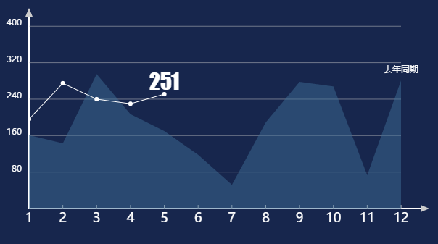

let style = {

w:540,

h:265,

// yMax:100,

xAxisDash:true,

**typeFixed:’C’,**

xAxis:{

value:['1','2','3','4','5','6','7','8','9','10','11','12'],

lineColor:'#fff',

thickness:2,

txtColor:'#fff',

txtSize:18,

txtFont:'微软雅黑',

mark:true

},

yAxis:{

lineColor:'#fff',

thickness:2,

txtColor:'#fff',

txtSize:12,

txtFont:'微软雅黑'

},

lineArr:[

{

lineType:'b',

id:'B',

value:this.currentA,

lineColor:'rgba(0,0,0,0)',

thickness:2,

valueColor:'#fff',

valueSize:14,

txtFont:'黑体',

fillColor:'rgba(60,109,149,0.5)',

isTitle:true,

titleFont:'微软雅黑',

titleSize:12,

titleColor:'#fff',

titleValue:'去年同期',

name:’’

},

{

lineType:'a',

id:'A',

value:this.currentB,

lineColor:'#fff',

thickness:2,

valueColor:'#fff',

valueSize:16,

txtFont:'Arial',

ballR:3,

ballColor:'#fff',

isTitle:true,

titleFont:'Impact',

titleSize:30,

titleColor:'#fff',

name:’’

}

]

};

使用方法与Histogram一致

3:PiPingDraw



PiPingDraw(50,30,false,[{name:'S1',value:[780,420,780,490,300,490],color:'#44a50a'}]);

updata([{name:'S2',color:'#0000ff'}]);

4:ChatPie

有图例

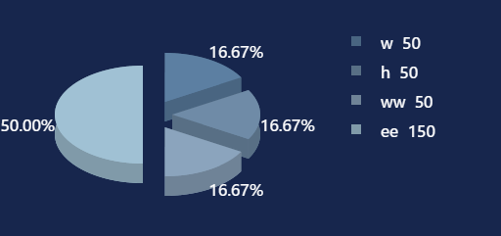

无图例

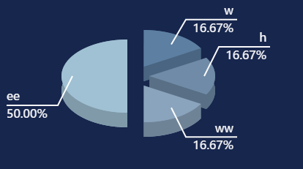

let pieStyle = {

a:90,

b:50,

h:20,

open:true,

colorList:["#5c7fa2","#6f8ba7","#8ba4bd","#a0c1d4","#c8dfec","#d8e5ee","#f8f8fa"],

dataList:[50,50,50,150],

nameList:['w','h','ww','ee'],

R:0,

leg:{

w:10,

size:16

},

txtColor:'#fff',

lineColor:'#fff',

txtSize:16,

txtFont:'微软雅黑',

}

this.pie1 = new ChatPie(pieStyle);

this.pie1.createView();

this.pie1.updata(obj['key'],obj['value']);

5:ProgressBar

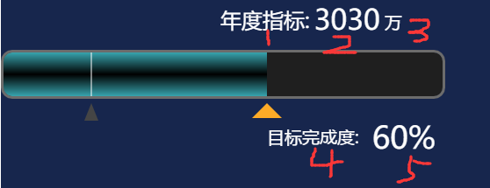

{

barWidth:500,

barHeight:50,

prgColor:"rgb(69,161,169)",

bgColor:"rgb(31,31,31)",

shadowLinearGradientColors:["rgb(55,164,174)","#000","rgb(55,164,174)"],

shadowLinearGradientRatios:[0,0.5,1],

shadowLinearGradientDir:"l2r",

borderThickness:3,

flagTrgColor:"rgb(69,69,69)",

curTrgColor:"rgb(254,171,39)",

boardColor:"#6c6c6c",//"#685420",

flagTrgHalfLength:8,//长度的一半

flagTrgHeight:20,//高度

flagTrgBarGap:8,

curTrgBarGap:8,

barRound:10,

barMaginLeft:0,

tweenDuring:2000,

txtArr:[

{value:'年度指标:',id:'mainTitle',size:24,color:'#fff',font:'Microsoft YaHei',offsetX:0,offsetY:0,autoSize:'left'},

{value:'6000',id:'mainValue',size:32,color:'#fff',font:'Microsoft YaHei',offsetX:0,offsetY:-7,autoSize:'left'},

{value:'万',id:'mainTitleEM',size:20,color:'#fff',font:'Microsoft YaHei',offsetX:0,offsetY:5,autoSize:'left'},

{value:'目标完成度:',id:'secTitle',size:20,color:'#fff',font:'Microsoft YaHei',offsetX:0,offsetY:10,autoSize:'left'},

{value:'20.13%',id:'secValue',size:35,color:'#fff',font:'Microsoft YaHei',offsetX:0,offsetY:0,autoSize:'left'}

]

}

{

barWidth:500,

barHeight:50,

// prgColor:"rgb(69,161,169)",//如果此属性存在 则用纯色填充 否则则用渐变填充效果

bgColor:"rgb(31,31,31)",

shadowLinearGradientColors:["rgb(55,164,174)","#000","rgb(55,164,174)"],

shadowLinearGradientRatios:[0,0.5,1],

shadowLinearGradientDir:"#0f0",

borderThickness:3,

flagTrgColor:"rgb(69,69,69)",

curTrgColor:"rgb(254,171,39)",

boardColor:"#6c6c6c",//"#685420",

flagTrgHalfLength:8,//长度的一半

flagTrgHeight:20,//高度

flagTrgBarGap:8,

curTrgBarGap:8,

barRound:10,

barMaginLeft:0,

curPos:0,

tweenDuring:2000,

txtArr:[

{value:'年度指标:',id:'mainTitle',size:24,color:'#fff',font:'Microsoft YaHei',offsetX:0,offsetY:0,autoSize:'left'},

{value:'6000',id:'mainValue',size:32,color:'#fff',font:'Microsoft YaHei',offsetX:0,offsetY:-7,autoSize:'left'},

{value:'万',id:'mainTitleEM',size:20,color:'#fff',font:'Microsoft YaHei',offsetX:0,offsetY:5,autoSize:'left'},

{value:'目标完成度:',id:'secTitle',size:20,color:'#fff',font:'Microsoft YaHei',offsetX:0,offsetY:10,autoSize:'left'},

{value:'20.13%',id:'secValue',size:35,color:'#fff',font:'Microsoft YaHei',offsetX:0,offsetY:0,autoSize:'left'}

]

}

updata([{id:'total',value:'3030'},{id:'history',value:0.2},{id:'current',value:0.6}]

6.拓扑图 ListMap

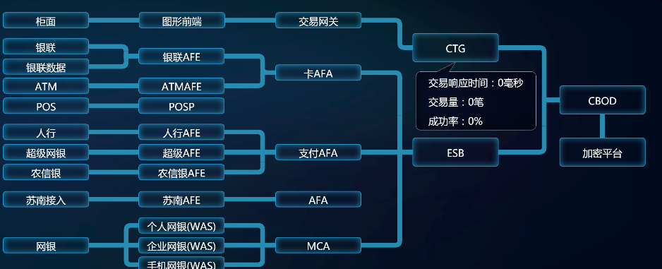

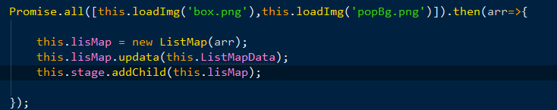

1. 构造函数中需要传入一张背景图 一张悬浮框图(不区分大小)
2. this.ListMapData = [{name:'A',title:'柜面',x:235,y:112,spl:false,target:null}];

3.Updata(arr1,arr2) 只会初次调用, arr1为 2中的this.LisListMapData ,arr2为手动补充的绘制线的数据[{name:'B2GG',color:'rgb(38,140,178)',value:[0,100,100,100,100,200]}]规则 从左到右 从上到下 如果不是这规则 请单独添加

4.updataNode(obj) 此为更新数据的方法 obj.nodeData 为每个节点的数据 obj.lineData 为线路高亮数据

详细的更新数据方法需要自己写

5.getGroup('X-Y-Z-I-E-EE') 更新对应线图时调用,'X-Y-Z-I-E-EE' 用-将各节点名字隔开

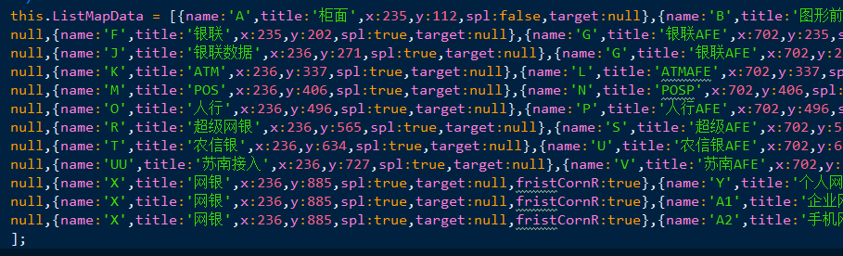

以下为数据示例

this.ListMapData = [{name:'A',title:'柜面',x:235,y:112,spl:false,target:null},{name:'B',title:'图形前端',x:703,y:112,spl:true,target:null},{name:'C',title:'交易网关',x:1173,y:112,spl:false,target:null},{name:'D',title:'CTG',x:1644,y:184,spl:true,target:null,size:1},{name:'E',title:'CBOD',x:2149,y:364,spl:false,target:null,size:1,infoItemPos:0},{name:'EE',title:'加密平台',x:2149,y:543,spl:false,target:null,size:1,infoItemPos:3},

null,{name:'F',title:'银联',x:235,y:202,spl:true,target:null},{name:'G',title:'银联AFE',x:702,y:235,spl:false,target:null},{name:'H',title:'卡AFA',x:1172,y:292,spl:true,target:null},{name:'I',title:'ESB',x:1644,y:543,spl:true,target:null,size:1},{name:'E',title:'CBOD',x:2149,y:364,spl:false,target:null,infoItemPos:0},

null,{name:'J',title:'银联数据',x:236,y:271,spl:true,target:null},{name:'G',title:'银联AFE',x:702,y:235,spl:true,target:null},

null,{name:'K',title:'ATM',x:236,y:337,spl:true,target:null},{name:'L',title:'ATMAFE',x:702,y:337,spl:true,target:null},{name:'H',title:'卡AFA',x:1172,y:292,spl:true,target:null},

null,{name:'M',title:'POS',x:236,y:406,spl:true,target:null},{name:'N',title:'POSP',x:702,y:406,spl:true,target:null},

null,{name:'O',title:'人行',x:236,y:496,spl:true,target:null},{name:'P',title:'人行AFE',x:702,y:496,spl:true,target:null},{name:'Q',title:'支付AFA',x:1172,y:565,spl:false,target:null},

null,{name:'R',title:'超级网银',x:236,y:565,spl:true,target:null},{name:'S',title:'超级AFE',x:702,y:565,spl:true,target:null},{name:'Q',title:'支付AFA',x:1172,y:565,spl:false,target:null},{name:'I',title:'ESB',x:1644,y:543,spl:true,target:null},

null,{name:'T',title:'农信银',x:236,y:634,spl:true,target:null},{name:'U',title:'农信银AFE',x:702,y:634,spl:true,target:null},{name:'Q',title:'支付AFA',x:1172,y:565,spl:true,target:null},

null,{name:'UU',title:'苏南接入',x:236,y:727,spl:true,target:null},{name:'V',title:'苏南AFE',x:702,y:727,spl:true,target:null},{name:'W',title:'AFA',x:1172,y:727,spl:true,target:null},

null,{name:'X',title:'网银',x:236,y:885,spl:true,target:null,fristCornR:true},{name:'Y',title:'个人网银(WAS)',x:702,y:817,spl:true,target:null},{name:'Z',title:'MCA',x:1172,y:885,spl:true,target:null},

null,{name:'X',title:'网银',x:236,y:885,spl:true,target:null,fristCornR:true},{name:'A1',title:'企业网银(WAS)',x:702,y:885,spl:true,target:null},{name:'Z',title:'MCA',x:1172,y:885,spl:true,target:null},{name:'I',title:'ESB',x:1644,y:543,spl:true,target:null},

null,{name:'X',title:'网银',x:236,y:885,spl:true,target:null,fristCornR:true},{name:'A2',title:'手机网银(WAS)',x:702,y:952,spl:true,target:null},{name:'Z',title:'MCA',x:1172,y:885,spl:true,target:null}

];

7:文本串TextString

用于显示一些位置相关的文本，常见的为列表行



**var** ts = **new** TextString({  
 **left**:10,  
 **top**:10,  
 **gapH**:10,  
 **gapV**:10,  
 **dir**:**"h"**,  
 **itemW**:100,  
 **itemH**:30,  
 **font**:**"15px 微软雅黑"**,  
 **color**:**"#000000"**,  
 **textAlign**:**"left"**,  
 **value**:**""**,  
 **itemsStyle**:  
 [{**valueField**:**"v1"**,**font**:**"15px 微软雅黑"**,**color**:**"#ff0000"**,**value**:**"text1"**,**textAlign**:**"left"**,**width**:100,**height**:30},  
 {**valueField**:**"v2"**,**font**:**"15px 微软雅黑"**,**color**:**"#000000"**,**value**:**"text2"**,**textAlign**:**"left"**,**width**:100,**height**:30},  
 {**valueField**:**"v3"**,**font**:**"15px 微软雅黑"**,**color**:**"#000000"**,**value**:**"text3"**,**textAlign**:**"left"**,**width**:100,**height**:30}],

**bgImg***:***null***,***bgImgX***:***0***,***bgImgY***:***0**

});

修改数据

ts.setData({**v1**:**"第一个文本"**,**v2**:**"第二个文本"**,**v3**:**"第三个文本"**});

8:双状态文本TextDoubleString

用于有状态变换的文本

 

**var** tds = **new** TextDoubleState(  
{  
 **text**:**""**,  
 **width**:100,  
 **height**:30,  
 **textAlign**:**"center"**,  
 **selected**:**false**,  
 **textSelectedFont**:**"15px 微软雅黑"**,  
 **textSelectedColor**:**"#ffffff"**,

**textSelectedAlpha**:1,  
 **textUnselectedFont**:**"15px 微软雅黑"**,  
 **textUnselectedColor**:**"#000000"**,  
 **textUnselectedAlpha**:1,  
 **bgSelectedColor**:**"#333333"**,  
 **bgSelectedAlpha**:0.5,  
 **bgUnselectedColor**:**"#ffffff"**,  
 **bgUnselectedAlpha**:0.5  
 }  
);

方法

tds.setData({**key1**:**"key1_Value"**,**key2**:**"key2_value"**},**"key2"**);  
tds.setData(**"key2_value"**);  
tds.text = **"key2_value"**;

tds.selected = **false**;

9:菜单Menu

用于菜单、导航

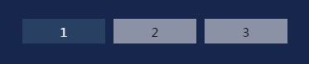

**var** m = **new** Menu({  
 **items**:[tds1,tds2,tds3],  
 **gap**:10,  
 **dir**:**"h"**,  
 **selectedIndex**:0,  
 **trigger**:**"click"**,  
 **blLoop**:**true**,  
 **loopTime**:1000,  
 **blMouseRelCon**:**true**,  
 **relCons**:[tds4]  
 });

属性

blMouseRelCon

relCons

selectedIndex

selectedItem

menuItems

width

height

eventState

事件

Menu选中索引改变时，会派发MenuChanged事件

方法

resetItems (arrItems)

relConsAdd (arr)

relConsRemove (arr)

10:瓦片菜单MenuTile（与Menu的区别在于，此组件支持多行多列）

用于菜单、导航

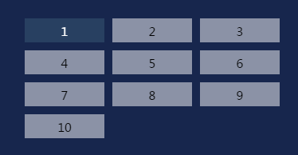

**var** m = **new** MenuTile({  
 **items**:arr,  
 **dir**:**"h"**,  
 **groupCount**:3,  
 **itemW**:100,  
 **itemH**:30,  
 **gapH**:10,  
 **gapV**:10,  
 **selectedIndex**:0,  
 **trigger**:**"click"**,  
 **blLoop**:**true**,  
 **loopTime**:1000,  
 **blMouseRelCon**:**true**,  
 **relCons**:[tds0]  
});

例子：

**var** o = {  
 **text**:**""**,  
 **width**:100,  
 **height**:30,  
 **selected**:**false**,  
 **textSelectedFont**:**"15px 微软雅黑"**,  
 **textSelectedColor**:**"#ffffff"**,  
 **textSelectedAlpha**:1,  
 **textUnselectedFont**:**"15px 微软雅黑"**,  
 **textUnselectedColor**:**"#000000"**,  
 **textUnselectedAlpha**:1,  
 **bgSelectedColor**:**"#395b74"**,  
 **bgSelectedAlpha**:0.5,  
 **bgUnselectedColor**:**"#ffffff"**,  
 **bgUnselectedAlpha**:0.5  
 };  
**var** arr = [];  
**var** tds0 = **new** TextDoubleState(o);tds0.text = **"relCons"**;  
**for**(**var** i=0;i<10;i++){  
 **var** tds = **new** TextDoubleState(o);tds.text = i+1;  
 arr.push(tds);  
}

**var** m = **new** MenuTile({  
 **items**:arr,  
 **dir**:**"h"**,  
 **groupCount**:3,  
 **itemW**:100,  
 **itemH**:30,  
 **gapH**:10,  
 **gapV**:10,  
 **selectedIndex**:0,  
 **trigger**:**"click"**,  
 **blLoop**:**true**,  
 **loopTime**:1000,  
 **blMouseRelCon**:**true**,  
 **relCons**:[tds0]  
});  
m.**x** = 100;m.**y** = 100;  
stage.enableMouseOver(60);  
stage.addChild(tds0,m);

11:分页列表PageList

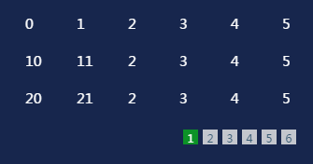

**var** p = **new** PageList({

**width**:300,

**height**:150,

**listItemClass**:ExpItem,

listItemParam:**null**,

**listDir**:**"v"**,  
**listGap**:10,

**listCount**:3,

**listItemTriggle**:**"click"**,

**pageTiggle**:**"click"**,

**pageBLLoop**:**true**,

**pageLoopTime**:2000

**pageItemClass**:TextDoubleState,  
**pageItemParam**:

{  
 **text**:**""**,  
 **width**:16,  
 **height**:16,  
 **selected**:**false**,  
 **textSelectedFont**:**"6px 微软雅黑"**,  
 **textSelectedColor**:**"#ffffff"**,  
 **textSelectedAlpha**:1,  
 **textUnselectedFont**:**"6px 微软雅黑"**,  
 **textUnselectedColor**:**"#395b74"**,  
 **textUnselectedAlpha**:1,  
 **bgSelectedColor**:**"#00ff00"**,  
 **bgSelectedAlpha**:0.5,  
 **bgUnselectedColor**:**"#eeeeee"**,  
 **bgUnselectedAlpha**:0.8  
},  
**pageGap**:5,  
**pageMarginH**:10,  
**pageMarginV**:10,

arrData:[]

});

方法：

设置数据

p.setData([{**t0**:0,**t1**:1,**t2**:2,**t3**:3},  
 {**t0**:10,**t1**:11,**t2**:2,**t3**:3},  
 {**t0**:20,**t1**:21,**t2**:2,**t3**:3},  
 {**t0**:30,**t1**:31,**t2**:2,**t3**:3},  
 {**t0**:40,**t1**:41,**t2**:2,**t3**:3},  
 {**t0**:50,**t1**:51,**t2**:2,**t3**:3},  
 {**t0**:60,**t1**:61,**t2**:2,**t3**:3},  
 {**t0**:70,**t1**:71,**t2**:2,**t3**:3},  
 {**t0**:80,**t1**:81,**t2**:2,**t3**:3},  
 {**t0**:90,**t1**:91,**t2**:2,**t3**:3},  
 {**t0**:110,**t1**:111,**t2**:2,**t3**:3},  
 {**t0**:220,**t1**:221,**t2**:2,**t3**:3},  
 {**t0**:330,**t1**:331,**t2**:2,**t3**:3},  
 {**t0**:440,**t1**:441,**t2**:2,**t3**:3},  
 {**t0**:550,**t1**:551,**t2**:2,**t3**:3},  
 {**t0**:660,**t1**:661,**t2**:2,**t3**:3},  
 {**t0**:770,**t1**:771,**t2**:2,**t3**:3}]);

12:界面分页列表UIPageList

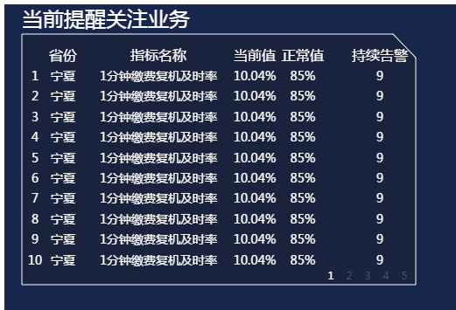

**var** p = **new** UIPageList(

{

**titleStr**:**"当前提醒关注业务"**,

**bg**:bgS,

**listTitleParam**:listTitleP,

**pageListParam**:pageListP});

例子：

**var** bgS = **new createjs**.**Shape**();  
**var** g = bgS.**graphics**.setStrokeStyle(1).beginStroke(**"#fff"**).beginFill(**"#19233e"**).moveTo(0,0).lineTo(424,0).lineTo(450,27).lineTo(450,287).lineTo(0,287).lineTo(0,0).endFill();  
**var** listTitleP = {  
 **itemsStyle**:  
 [{**valueField**:**"t1"**,**font**:**"16px 微软雅黑"**,**color**:**"#fff"**,**value**:**"省份"**,**textAlign**:**"center"**,**x**:42},  
 {**valueField**:**"t2"**,**font**:**"16px 微软雅黑"**,**color**:**"#fff"**,**value**:**"指标名称"**,**textAlign**:**"center"**,**x**:151},  
 {**valueField**:**"t3"**,**font**:**"16px 微软雅黑"**,**color**:**"#fff"**,**value**:**"当前值"**,**textAlign**:**"center"**,**x**:261},  
 {**valueField**:**"t4"**,**font**:**"16px 微软雅黑"**,**color**:**"#fff"**,**value**:**"正常值"**,**textAlign**:**"center"**,**x**:316},  
 {**valueField**:**"t5"**,**font**:**"16px 微软雅黑"**,**color**:**"#fff"**,**value**:**"持续告警"**,**textAlign**:**"center"**,**x**:404}]  
 };  
**var** listItemP = {  
 **itemsStyle**:  
 [{**valueField**:**"v0"**,**font**:**"14px 微软雅黑"**,**color**:**"#fff"**,**value**:**""**,**textAlign**:**"center"**,**x**:10},  
 {**valueField**:**"v1"**,**font**:**"14px 微软雅黑"**,**color**:**"#fff"**,**value**:**""**,**textAlign**:**"center"**,**x**:42},  
 {**valueField**:**"v2"**,**font**:**"14px 微软雅黑"**,**color**:**"#fff"**,**value**:**""**,**textAlign**:**"center"**,**x**:151},  
 {**valueField**:**"v3"**,**font**:**"14px 微软雅黑"**,**color**:**"#fff"**,**value**:**""**,**textAlign**:**"center"**,**x**:261},  
 {**valueField**:**"v4"**,**font**:**"14px 微软雅黑"**,**color**:**"#fff"**,**value**:**""**,**textAlign**:**"center"**,**x**:316},  
 {**valueField**:**"v5"**,**font**:**"14px 微软雅黑"**,**color**:**"#fff"**,**value**:**""**,**textAlign**:**"center"**,**x**:404}]  
};  
**var** pageItemP = {  
 **text**:**""**,  
 **width**:16,  
 **height**:16,  
 **selected**:**false**,  
 **textSelectedFont**:**"6px 微软雅黑"**,  
 **textSelectedColor**:**"#ffffff"**,  
 **textSelectedAlpha**:1,  
 **textUnselectedFont**:**"6px 微软雅黑"**,  
 **textUnselectedColor**:**"#395b74"**,  
 **textUnselectedAlpha**:1,  
 **bgSelectedColor**:**"#ff0000"**,  
 **bgSelectedAlpha**:0.01,  
 **bgUnselectedColor**:**"#00ff00"**,  
 **bgUnselectedAlpha**:0.01  
};  
  
  
**var** pageListP = {**width**:450,**height**:248,  
 **listItemClass**:TextString,**listItemParam**:listItemP,**listCount**:10,**listGap**:7,  
 */*pageItemClass:TextDoubleState,*/***pageItemParam**:pageItemP,**pageMarginH**:10,**pageMarginV**:3,  
 **listItemTriggle**:**"click"**,**pageTiggle**:**"click"**,  
 **pageBLLoop**:**true**,**pageLoopTime**:2000};

**var** p = **new** UIPageList({**titleStr**:**"当前提醒关注业务"**,**bg**:bgS,**listTitleParam**:listTitleP,**pageListParam**:pageListP});

p.setListTitle({**t1**:**"省份"**,**t2**:**"指标名称"**,**t3**:**"当前值"**,**t4**:**"正常值"**,**t5**:**"持续告警"**});  
p.setData([  
 {**v0**:1,**v1**:**"宁夏"**,**v2**:**"1分钟缴费复机及时率"**,**v3**:**"10.04%"**,**v4**:**"85%"**,**v5**:9},  
 {**v0**:2,**v1**:**"宁夏"**,**v2**:**"1分钟缴费复机及时率"**,**v3**:**"10.04%"**,**v4**:**"85%"**,**v5**:9},  
 {**v0**:3,**v1**:**"宁夏"**,**v2**:**"1分钟缴费复机及时率"**,**v3**:**"10.04%"**,**v4**:**"85%"**,**v5**:9},  
 {**v0**:4,**v1**:**"宁夏"**,**v2**:**"1分钟缴费复机及时率"**,**v3**:**"10.04%"**,**v4**:**"85%"**,**v5**:9},  
 {**v0**:5,**v1**:**"宁夏"**,**v2**:**"1分钟缴费复机及时率"**,**v3**:**"10.04%"**,**v4**:**"85%"**,**v5**:9},  
 {**v0**:6,**v1**:**"宁夏"**,**v2**:**"1分钟缴费复机及时率"**,**v3**:**"10.04%"**,**v4**:**"85%"**,**v5**:9},  
 {**v0**:7,**v1**:**"宁夏"**,**v2**:**"1分钟缴费复机及时率"**,**v3**:**"10.04%"**,**v4**:**"85%"**,**v5**:9},  
 {**v0**:8,**v1**:**"宁夏"**,**v2**:**"1分钟缴费复机及时率"**,**v3**:**"10.04%"**,**v4**:**"85%"**,**v5**:9},  
 {**v0**:9,**v1**:**"宁夏"**,**v2**:**"1分钟缴费复机及时率"**,**v3**:**"10.04%"**,**v4**:**"85%"**,**v5**:9},  
 {**v0**:10,**v1**:**"宁夏"**,**v2**:**"1分钟缴费复机及时率"**,**v3**:**"10.04%"**,**v4**:**"85%"**,**v5**:9},  
 {**v0**:11,**v1**:**"宁夏"**,**v2**:**"1分钟缴费复机及时率"**,**v3**:**"10.04%"**,**v4**:**"85%"**,**v5**:9},  
 {**v0**:12,**v1**:**"宁夏"**,**v2**:**"1分钟缴费复机及时率"**,**v3**:**"10.04%"**,**v4**:**"85%"**,**v5**:9},  
 {**v0**:13,**v1**:**"宁夏"**,**v2**:**"1分钟缴费复机及时率"**,**v3**:**"10.04%"**,**v4**:**"85%"**,**v5**:9},  
 {**v0**:14,**v1**:**"宁夏"**,**v2**:**"1分钟缴费复机及时率"**,**v3**:**"10.04%"**,**v4**:**"85%"**,**v5**:9},  
 {**v0**:15,**v1**:**"宁夏"**,**v2**:**"1分钟缴费复机及时率"**,**v3**:**"10.04%"**,**v4**:**"85%"**,**v5**:9},  
 {**v0**:16,**v1**:**"宁夏"**,**v2**:**"1分钟缴费复机及时率"**,**v3**:**"10.04%"**,**v4**:**"85%"**,**v5**:9},  
 {**v0**:17,**v1**:**"宁夏"**,**v2**:**"1分钟缴费复机及时率"**,**v3**:**"10.04%"**,**v4**:**"85%"**,**v5**:9},  
 {**v0**:18,**v1**:**"宁夏"**,**v2**:**"1分钟缴费复机及时率"**,**v3**:**"10.04%"**,**v4**:**"85%"**,**v5**:9},  
 {**v0**:19,**v1**:**"宁夏"**,**v2**:**"1分钟缴费复机及时率"**,**v3**:**"10.04%"**,**v4**:**"85%"**,**v5**:9},  
 {**v0**:20,**v1**:**"宁夏"**,**v2**:**"1分钟缴费复机及时率"**,**v3**:**"10.04%"**,**v4**:**"85%"**,**v5**:9},  
 {**v0**:31,**v1**:**"宁夏"**,**v2**:**"1分钟缴费复机及时率"**,**v3**:**"10.04%"**,**v4**:**"85%"**,**v5**:9},  
 {**v0**:32,**v1**:**"宁夏"**,**v2**:**"1分钟缴费复机及时率"**,**v3**:**"10.04%"**,**v4**:**"85%"**,**v5**:9},  
 {**v0**:33,**v1**:**"宁夏"**,**v2**:**"1分钟缴费复机及时率"**,**v3**:**"10.04%"**,**v4**:**"85%"**,**v5**:9},  
 {**v0**:34,**v1**:**"宁夏"**,**v2**:**"1分钟缴费复机及时率"**,**v3**:**"10.04%"**,**v4**:**"85%"**,**v5**:9},  
 {**v0**:35,**v1**:**"宁夏"**,**v2**:**"1分钟缴费复机及时率"**,**v3**:**"10.04%"**,**v4**:**"85%"**,**v5**:9},  
 {**v0**:36,**v1**:**"宁夏"**,**v2**:**"1分钟缴费复机及时率"**,**v3**:**"10.04%"**,**v4**:**"85%"**,**v5**:9},  
 {**v0**:37,**v1**:**"宁夏"**,**v2**:**"1分钟缴费复机及时率"**,**v3**:**"10.04%"**,**v4**:**"85%"**,**v5**:9},  
 {**v0**:38,**v1**:**"宁夏"**,**v2**:**"1分钟缴费复机及时率"**,**v3**:**"10.04%"**,**v4**:**"85%"**,**v5**:9},  
 {**v0**:39,**v1**:**"宁夏"**,**v2**:**"1分钟缴费复机及时率"**,**v3**:**"10.04%"**,**v4**:**"85%"**,**v5**:9},  
 {**v0**:40,**v1**:**"宁夏"**,**v2**:**"1分钟缴费复机及时率"**,**v3**:**"10.04%"**,**v4**:**"85%"**,**v5**:9},  
 {**v0**:51,**v1**:**"宁夏"**,**v2**:**"1分钟缴费复机及时率"**,**v3**:**"10.04%"**,**v4**:**"85%"**,**v5**:9},  
 {**v0**:52,**v1**:**"宁夏"**,**v2**:**"1分钟缴费复机及时率"**,**v3**:**"10.04%"**,**v4**:**"85%"**,**v5**:9},  
 {**v0**:53,**v1**:**"宁夏"**,**v2**:**"1分钟缴费复机及时率"**,**v3**:**"10.04%"**,**v4**:**"85%"**,**v5**:9},  
 {**v0**:54,**v1**:**"宁夏"**,**v2**:**"1分钟缴费复机及时率"**,**v3**:**"10.04%"**,**v4**:**"85%"**,**v5**:9},  
 {**v0**:55,**v1**:**"宁夏"**,**v2**:**"1分钟缴费复机及时率"**,**v3**:**"10.04%"**,**v4**:**"85%"**,**v5**:9},  
 {**v0**:56,**v1**:**"宁夏"**,**v2**:**"1分钟缴费复机及时率"**,**v3**:**"10.04%"**,**v4**:**"85%"**,**v5**:9},  
 {**v0**:57,**v1**:**"宁夏"**,**v2**:**"1分钟缴费复机及时率"**,**v3**:**"10.04%"**,**v4**:**"85%"**,**v5**:9},  
 {**v0**:58,**v1**:**"宁夏"**,**v2**:**"1分钟缴费复机及时率"**,**v3**:**"10.04%"**,**v4**:**"85%"**,**v5**:9},  
 {**v0**:59,**v1**:**"宁夏"**,**v2**:**"1分钟缴费复机及时率"**,**v3**:**"10.04%"**,**v4**:**"85%"**,**v5**:9},  
 {**v0**:60,**v1**:**"宁夏"**,**v2**:**"1分钟缴费复机及时率"**,**v3**:**"10.04%"**,**v4**:**"85%"**,**v5**:9},  
 {**v0**:61,**v1**:**"宁夏"**,**v2**:**"1分钟缴费复机及时率"**,**v3**:**"10.04%"**,**v4**:**"85%"**,**v5**:9}  
  
]);

13:图例CategoryLegend

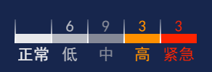

**var** cl = **new** CategoryLegend(

{  
 **itemW**:50,  
 **itemH**:13,  
 **itemNameGap**:4,  
 **itemValueGap**:4,  
 **itemTexts**:[**"正常"**,**"低"**,**"中"**,**"高"**,**"紧急"**],  
 **itemColors**:[**"#E7E8EB"**,**"#B6B9C1"**,**"#858997"**,**"#FF9000"**,**"#FF2400"**],  
 **itemNameFont**:**"22px 黑体"**,  
 **itemValueFont**:**"22px 黑体"**,  
 **blLine**:**true**,  
 **lineL**:33,  
 **lineW**:2,  
 **lineLinearGradientColors**:[**"rgba(255,255,255,0.2)"**,**"rgba(255,255,255,1)"**],  
 **lineLinearGradientRatios**:[0,1]  
 }

);

方法：  
cl.setData({**"正常"**:3,**"低"**:3,**"中"**:3,**"高"**:3,**"紧急"**:3});  
cl.setDataByIndex(1,6);  
cl.setDataByName(**"中"**,9);  
  
cl.setLineVisibleByIdx(5,**false**);  
cl.setValueVisibleByIdx(0,**false**);

14:滚动组件Roller

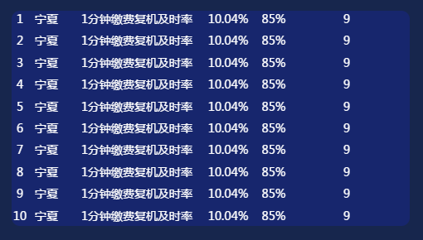

**var** r = **new** Roller(

{  
 **width**:480,  
 **height**:260,  
 **dir**:**"v"**,  
 **itemClass**: TextString,  
 **itemParam**: listItemP,  
 **showCount**:10,  
 **itemGap**:10,  
 **marginTop**:0,  
 **marginLeft**:0,  
 **curFirstIdx**:0,  
  
 **blAlpha**:1,  
 **bgColor**:**"#17266D"**,  
  
 **bgRadius**:10,  
 **bgRadiusTL**:**null**,  
 **bgRadiusTR**:**null**,  
 **bgRadiusBR**:**null**,  
 **bgRadiusBL**:**null**,  
  
 **blAni**:**true**,  
 **skipCount**:1,  
 **skipTime**:2000,  
 **pauseTime**:3000,  
 **arrData**:[]  
 }

);

方法：

r.setData([  
 {**v0**:1,**v1**:**"宁夏"**,**v2**:**"1分钟缴费复机及时率"**,**v3**:**"10.04%"**,**v4**:**"85%"**,**v5**:**"9"**},  
 {**v0**:2,**v1**:**"宁夏"**,**v2**:**"1分钟缴费复机及时率"**,**v3**:**"10.04%"**,**v4**:**"85%"**,**v5**:**"9"**},  
 {**v0**:3,**v1**:**"宁夏"**,**v2**:**"1分钟缴费复机及时率"**,**v3**:**"10.04%"**,**v4**:**"85%"**,**v5**:**"9"**},  
 {**v0**:4,**v1**:**"宁夏"**,**v2**:**"1分钟缴费复机及时率"**,**v3**:**"10.04%"**,**v4**:**"85%"**,**v5**:**"9"**},  
 {**v0**:5,**v1**:**"宁夏"**,**v2**:**"1分钟缴费复机及时率"**,**v3**:**"10.04%"**,**v4**:**"85%"**,**v5**:**"9"**},  
 {**v0**:6,**v1**:**"宁夏"**,**v2**:**"1分钟缴费复机及时率"**,**v3**:**"10.04%"**,**v4**:**"85%"**,**v5**:**"9"**},  
 {**v0**:7,**v1**:**"宁夏"**,**v2**:**"1分钟缴费复机及时率"**,**v3**:**"10.04%"**,**v4**:**"85%"**,**v5**:**"9"**},  
 {**v0**:8,**v1**:**"宁夏"**,**v2**:**"1分钟缴费复机及时率"**,**v3**:**"10.04%"**,**v4**:**"85%"**,**v5**:**"9"**},  
 {**v0**:9,**v1**:**"宁夏"**,**v2**:**"1分钟缴费复机及时率"**,**v3**:**"10.04%"**,**v4**:**"85%"**,**v5**:**"9"**},  
 {**v0**:10,**v1**:**"宁夏"**,**v2**:**"1分钟缴费复机及时率"**,**v3**:**"10.04%"**,**v4**:**"85%"**,**v5**:**"9"**},  
 {**v0**:11,**v1**:**"宁夏"**,**v2**:**"1分钟缴费复机及时率"**,**v3**:**"10.04%"**,**v4**:**"85%"**,**v5**:**"9"**},  
 {**v0**:12,**v1**:**"宁夏"**,**v2**:**"1分钟缴费复机及时率"**,**v3**:**"10.04%"**,**v4**:**"85%"**,**v5**:**"9"**},  
]);

例子：

**var** listItemP = {  
 **itemsStyle**:  
 [{**valueField**:**"v0"**,**font**:**"14px 微软雅黑"**,**color**:**"#fff"**,**value**:**"1"**,**textAlign**:**"center"**,**x**:10},  
 {**valueField**:**"v1"**,**font**:**"14px 微软雅黑"**,**color**:**"#fff"**,**value**:**"宁夏"**,**textAlign**:**"center"**,**x**:42},  
 {**valueField**:**"v2"**,**font**:**"14px 微软雅黑"**,**color**:**"#fff"**,**value**:**"1分钟缴费复机及时率"**,**textAlign**:**"center"**,**x**:151},  
 {**valueField**:**"v3"**,**font**:**"14px 微软雅黑"**,**color**:**"#fff"**,**value**:**"10.04%"**,**textAlign**:**"center"**,**x**:261},  
 {**valueField**:**"v4"**,**font**:**"14px 微软雅黑"**,**color**:**"#fff"**,**value**:**"85%"**,**textAlign**:**"center"**,**x**:316},  
 {**valueField**:**"v5"**,**font**:**"14px 微软雅黑"**,**color**:**"#fff"**,**value**:**"9"**,**textAlign**:**"center"**,**x**:404}]  
 };  
**var** r = **new** Roller({**itemClass**:TextString,**itemParam**:listItemP});  
r.**x** = 100;  
r.**y** = 100;  
r.setData([  
 {**v0**:1,**v1**:**"宁夏"**,**v2**:**"1分钟缴费复机及时率"**,**v3**:**"10.04%"**,**v4**:**"85%"**,**v5**:**"9"**},  
 {**v0**:2,**v1**:**"宁夏"**,**v2**:**"1分钟缴费复机及时率"**,**v3**:**"10.04%"**,**v4**:**"85%"**,**v5**:**"9"**},  
 {**v0**:3,**v1**:**"宁夏"**,**v2**:**"1分钟缴费复机及时率"**,**v3**:**"10.04%"**,**v4**:**"85%"**,**v5**:**"9"**},  
 {**v0**:4,**v1**:**"宁夏"**,**v2**:**"1分钟缴费复机及时率"**,**v3**:**"10.04%"**,**v4**:**"85%"**,**v5**:**"9"**},  
 {**v0**:5,**v1**:**"宁夏"**,**v2**:**"1分钟缴费复机及时率"**,**v3**:**"10.04%"**,**v4**:**"85%"**,**v5**:**"9"**},  
 {**v0**:6,**v1**:**"宁夏"**,**v2**:**"1分钟缴费复机及时率"**,**v3**:**"10.04%"**,**v4**:**"85%"**,**v5**:**"9"**},  
 {**v0**:7,**v1**:**"宁夏"**,**v2**:**"1分钟缴费复机及时率"**,**v3**:**"10.04%"**,**v4**:**"85%"**,**v5**:**"9"**},  
 {**v0**:8,**v1**:**"宁夏"**,**v2**:**"1分钟缴费复机及时率"**,**v3**:**"10.04%"**,**v4**:**"85%"**,**v5**:**"9"**},  
 {**v0**:9,**v1**:**"宁夏"**,**v2**:**"1分钟缴费复机及时率"**,**v3**:**"10.04%"**,**v4**:**"85%"**,**v5**:**"9"**},  
 {**v0**:10,**v1**:**"宁夏"**,**v2**:**"1分钟缴费复机及时率"**,**v3**:**"10.04%"**,**v4**:**"85%"**,**v5**:**"9"**},  
 {**v0**:11,**v1**:**"宁夏"**,**v2**:**"1分钟缴费复机及时率"**,**v3**:**"10.04%"**,**v4**:**"85%"**,**v5**:**"9"**},  
 {**v0**:12,**v1**:**"宁夏"**,**v2**:**"1分钟缴费复机及时率"**,**v3**:**"10.04%"**,**v4**:**"85%"**,**v5**:**"9"**},  
]);  
stage.addChild(r);