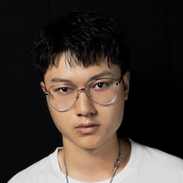

**Ruiyang Ma**

**⮚ (501)410-3990  
⮚ rxma@ualr.edu**

**⮚ 3101 S. Taylor St.**

**⮚ Little Rock, AR 72204**

University of Arkansas at Little Rock

Bachelor of Science in Nursing

Expected Graduation: May 2022

No.1 Middle School of Lu'an

Graduation: June 2017

**Education**

**Employment**

**History**

INDUSTRIAL AND COMMERCIAL BANK OF CHINA, Lu'an, October 2020 -

March 2021

*Programmer*

l Design websites

l Develop application software

l Build WeChat Mini Program

Guangzhou Changjiang Textile City, Guangzhou, May 2021 - September 2021

*Fashion Designer*

l Design fashion clothes independently

l Set up a self-own clothing brand

l Establish an online store and independently promote and sell

**Skills**

l Use multiple programming languages, proficient in JAVA language

l Independent use of code to write programs

l Good at learning the latest technology and discovering new IT technology

l Good teamwork ability

July 2021 - Present

Assistant Coach of Lu'an Badminton Team

**Public**

**Service**