CMPEN271

Ruiyang Qin

11/23/2017

HW#9C

Finite State Machine

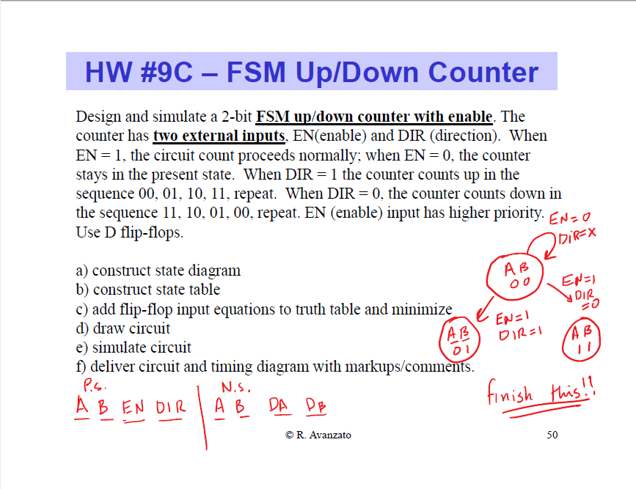

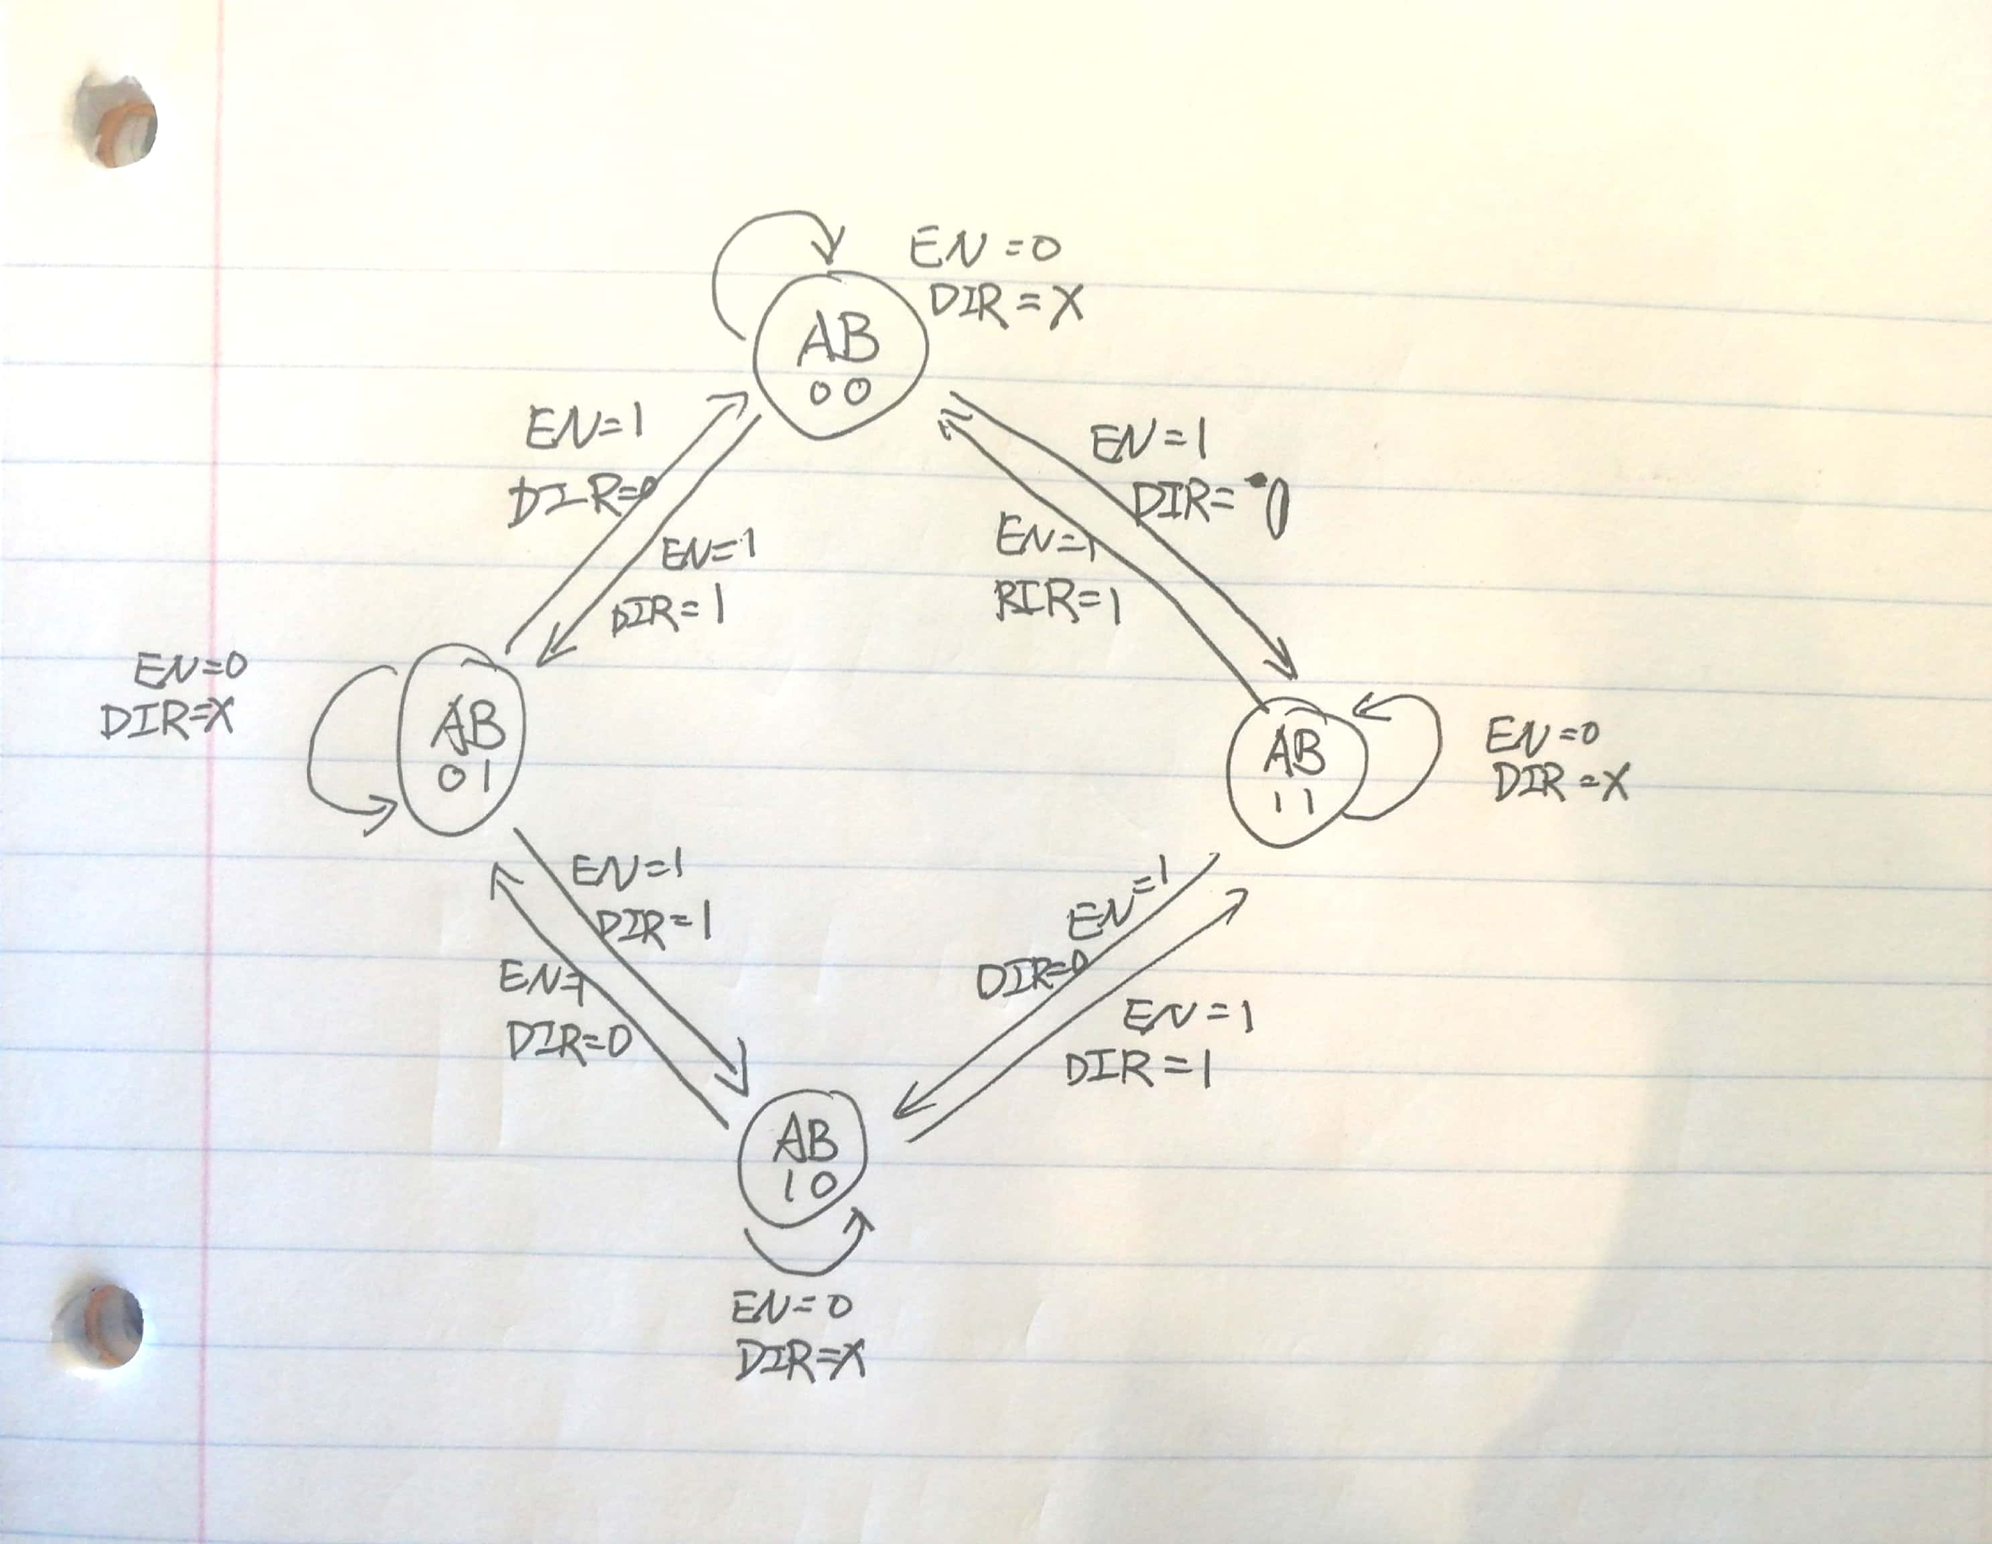

|  |  |  |  |  |  |  |  |
| --- | --- | --- | --- | --- | --- | --- | --- |
| Present State | | | | Next State | | | |
| A | **B** | **E** | **D** | **A** | **B** | **DA** | **DB** |
| 0 | 0 | 0 | 0 | 0 | 0 | 0 | 0 |
| 0 | 0 | 0 | 1 | 0 | 0 | 0 | 0 |
| 0 | 0 | 1 | 0 | 1 | 1 | 1 | 1 |
| 0 | 0 | 1 | 1 | 0 | 1 | 0 | 1 |
| 0 | 1 | 0 | 0 | 0 | 1 | 0 | 1 |
| 0 | 1 | 0 | 1 | 0 | 1 | 0 | 1 |
| 0 | 1 | 1 | 0 | 0 | 0 | 0 | 0 |
| 0 | 1 | 1 | 1 | 1 | 0 | 1 | 0 |
| 1 | 0 | 0 | 0 | 1 | 0 | 1 | 0 |
| 1 | 0 | 0 | 1 | 1 | 0 | 1 | 0 |
| 1 | 0 | 1 | 0 | 0 | 1 | 0 | 1 |
| 1 | 0 | 1 | 1 | 1 | 1 | 1 | 1 |
| 1 | 1 | 0 | 0 | 1 | 1 | 1 | 1 |
| 1 | 1 | 0 | 1 | 1 | 1 | 1 | 1 |
| 1 | 1 | 1 | 0 | 1 | 0 | 1 | 0 |
| 1 | 1 | 1 | 1 | 0 | 0 | 0 | 0 |

DA = Σm(2,7,8,9,11,12,13,14)

DB = Σm(2,3,4,5,10,11,12,13,14)

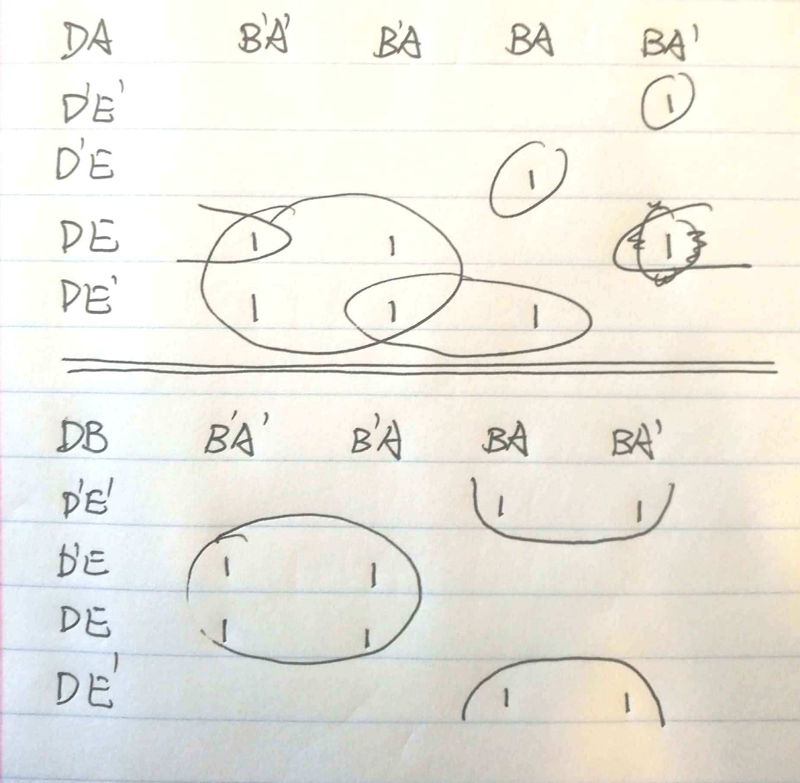

DA=A'B'ED'+A'BED+AB'E'D'+AB'E'D+AB'ED+ABE'D'+ABE'D+ABED'

Simplify: DA=A'B'ED'+A'BED+A(B⊕D)+AE'

DB=A'B'ED'+A'B'ED+A'BE'D'+A'BE'D+AB'ED'+AB'ED+ABE'D'+ABE'D

Simplify: DB=B⊕E

