CMPEN 271

Homework #4

Ruiyang Qin

Sept. 20th, 2017

Homework Description:

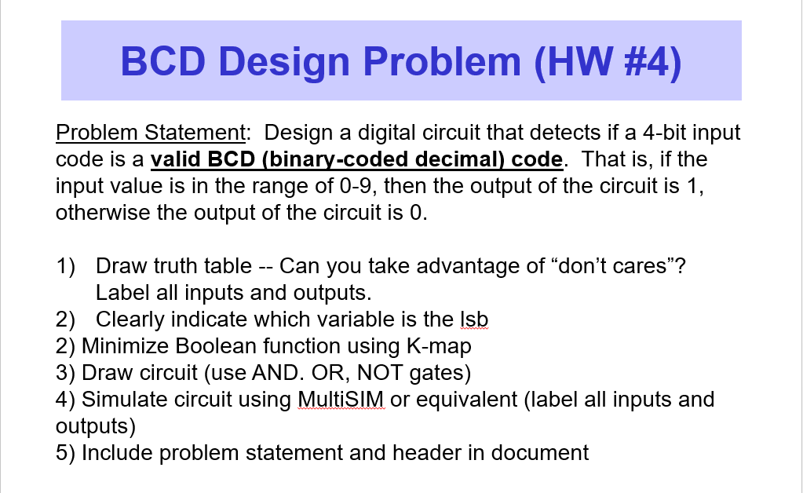

1. Truth Table

Msb lsb

|  |  |  |  |  |
| --- | --- | --- | --- | --- |
| A | B | C | D | Output |
| 0 | 0 | 0 | 0 | 1 |
| 0 | 0 | 0 | 1 | 1 |
| 0 | 0 | 1 | 0 | 1 |
| 0 | 0 | 1 | 1 | 1 |
| 0 | 1 | 0 | 0 | 1 |
| 0 | 1 | 0 | 1 | 1 |
| 0 | 1 | 1 | 0 | 1 |
| 0 | 1 | 1 | 1 | 1 |
| 1 | 0 | 0 | 0 | 1 |
| 1 | 0 | 0 | 1 | 1 |
| 1 | 0 | 1 | 0 | 0 |
| 1 | 0 | 1 | 1 | 0 |
| 1 | 1 | 0 | 0 | 0 |
| 1 | 1 | 0 | 1 | 0 |
| 1 | 1 | 1 | 0 | 0 |
| 1 | 1 | 1 | 1 | 0 |

1. Variable D is lsb.
2. K-map:

|  |  |  |  |  |
| --- | --- | --- | --- | --- |
|  | C’D’ | C’D | CD | CD’ |
| A’B’ | M0  **1** | M1  **1** | M3  **1** | M2  **1** |
| A’B | M4  **1** | M5  **1** | M7  **1** | M6  **1** |
| AB | M12 | M13 | M15 | M14 |
| AB’ | M8  **1** | M9  **1** | M11 | M10 |



**F = A’ + B’C’**

4. By MultiSIM:



