Ruiyang Qin

Sept. 9th 2017

CMPEN 271

HW#3B Majority Voting Circuit

Description: Design a circuit with 3 inputs and 1 output. The output will be high when 2 or more of the inputs are high, otherwise the output will be low.

Simplification:

Inputs: (input high) IPH1, IPH2, IPH3

Output: (output high) OPH

Boolean Function:

F = ( IPH1 * IPH2 ) + ( IPH1 * IPH3 ) + ( IPH2 * IPH3 ) + ( IPH1 * IPH2 * IPH3 )

Truth Table:

|  |  |  |  |
| --- | --- | --- | --- |
| IPH1 | IPH2 | IPH3 | OPH |
| 0 | 0 | 0 | 0 |
| 0 | 0 | 1 | 0 |
| 0 | 1 | 0 | 0 |
| 0 | 1 | 1 | 1 |
| 1 | 0 | 0 | 0 |
| 1 | 0 | 1 | 1 |
| 1 | 1 | 0 | 1 |
| 1 | 1 | 1 | 1 |

Minimize:

F = (IPH1 * IPH2)(1 + IPH3) + (IPH1 * IPH3) + (IPH2 * IPH3)

= (IPH1 * IPH2) + (IPH1 * IPH3) + (IPH2 * IPH3)

= IPH1 * (IPH2 + IPH3) + (IPH2 + IPH3)

= (IPH1 + 1) * (IPH 2 + IPH3)

= IPH2 + IPH3

# of IC: 42/14=3 (all for NAND)

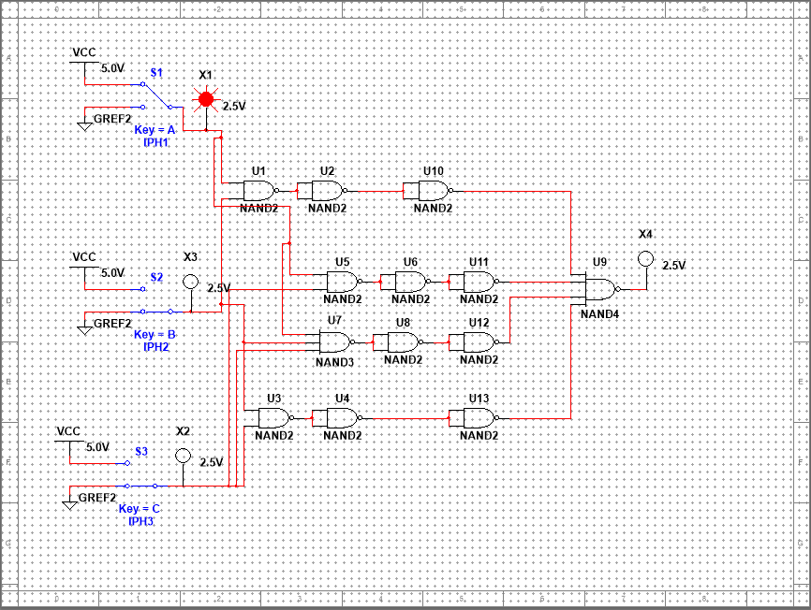

Simplification first: (# of IC: 2)

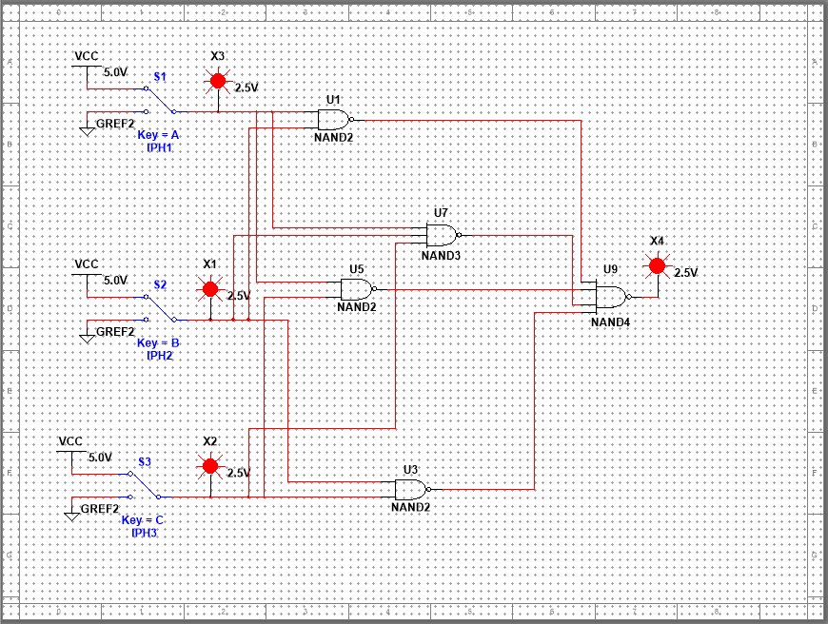

Minimize based on Boolean function: (F = IPH2 + IPH3 )

# of IC 1

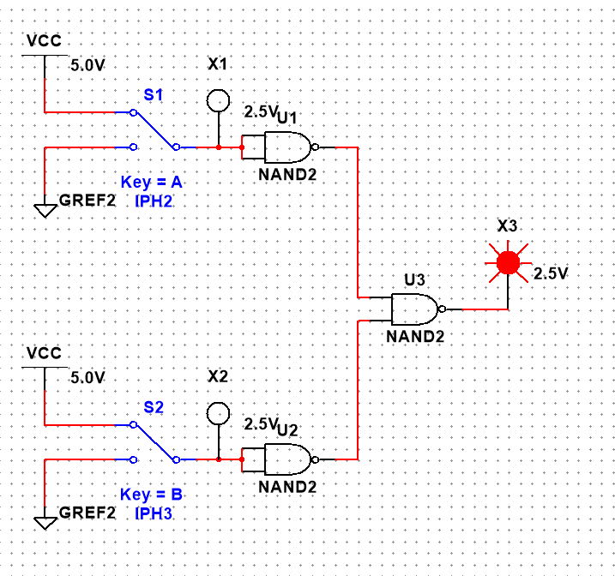

Other version:

