CMPEN271_Homework #7_Question2

Oct. 21st, 2017

Ruiyang Qin

Description:

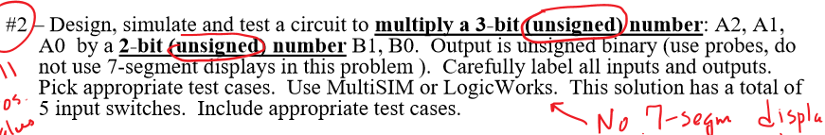

A3(msb) A2 A1(lsb)

B2(msb) B1(lsb)

M4(msb) M3 M2 M1 M0(lsb)

Example case:

111X10:

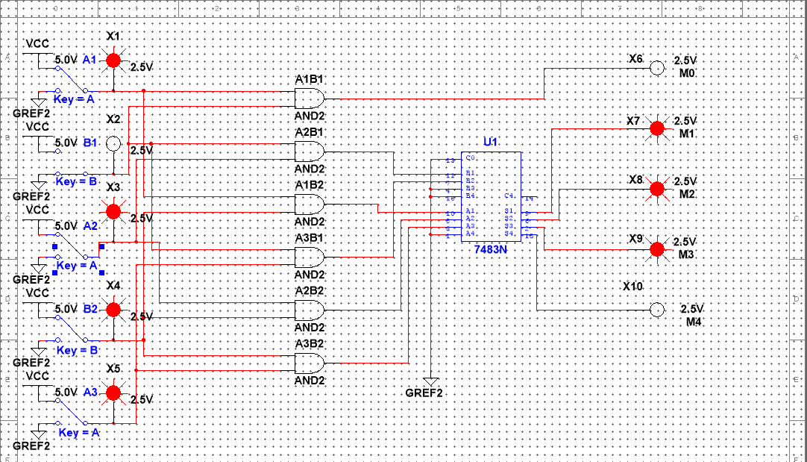

110X11:

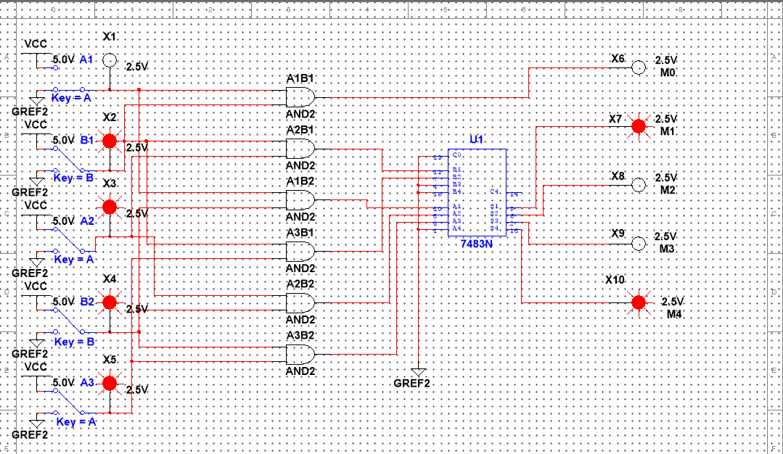

100X01:

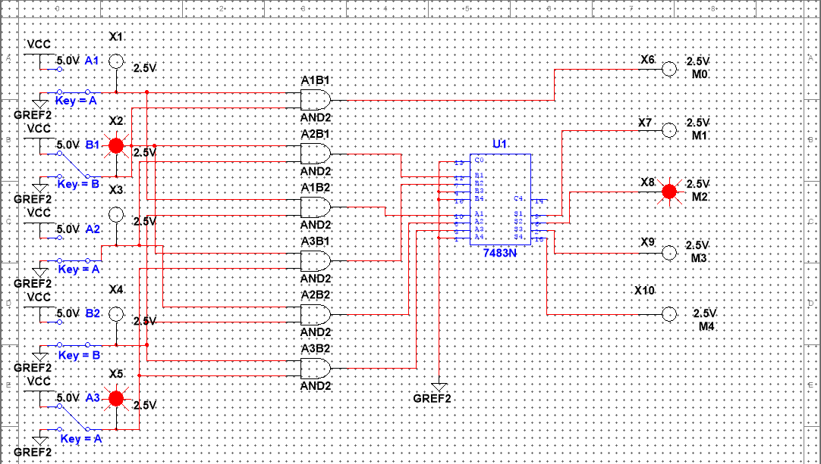

111X00:

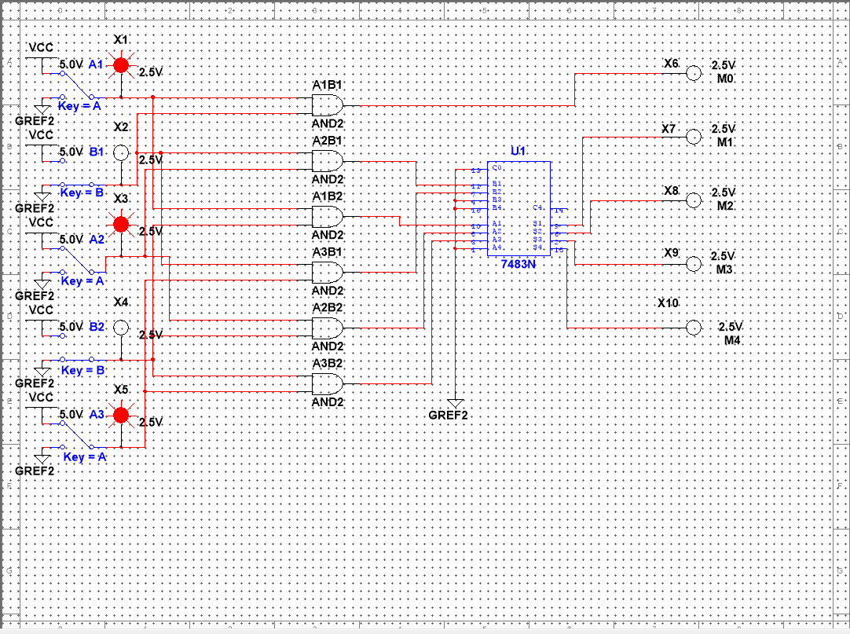

010X11:

