Ruiyang Qin

Sept.9th 2017

CMPEN 271

Design a car alarm Circuit

Design a minimal circuit to implement the door alarm Boolean function

Boolean Function:

Alarm=doorOpen*alarmEnabled

+doorOpen*alarmEnabled*motionSensorActivie

+alarmEnabled*motionSensorActive

Simplification of words:

doopOpen = DO

alarmEnabled = AE

motionSensorActivie = MSA

Truth table

|  |  |  |  |  |  |  |
| --- | --- | --- | --- | --- | --- | --- |
| DO | AE | MSA | DO*AE | DO*AE*MSA | AE*MSA | output |
| 0 | 0 | 0 | 0 | 0 | 0 | 0 |
| 0 | 0 | 1 | 0 | 0 | 0 | 0 |
| 0 | 1 | 0 | 0 | 0 | 0 | 0 |
| 0 | 1 | 1 | 0 | 0 | 1 | 1 |
| 1 | 0 | 0 | 0 | 0 | 0 | 0 |
| 1 | 0 | 1 | 0 | 0 | 0 | 0 |
| 1 | 1 | 0 | 1 | 0 | 0 | 1 |
| 1 | 1 | 1 | 1 | 1 | 1 | 1 |

Minimize:

F = DO * AE + DO * AE * MSA + AE * MSA

= DO * AE + MSA * (DO * AE + AE)

= DO * AE + MSA * AE (DO + 1)

= DO * AE + MSA * AE * 1 = DO * AE + MSA * AE

= AE * (DO + MSA)

# of IC: 2(one for and one for or)

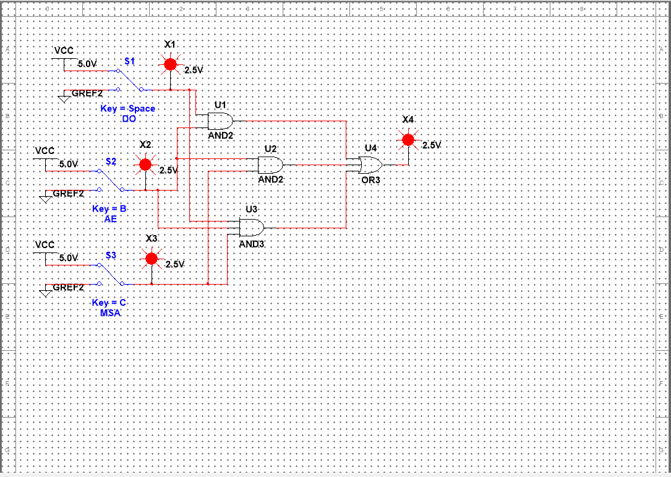

Minimize: (# of IC: 2)

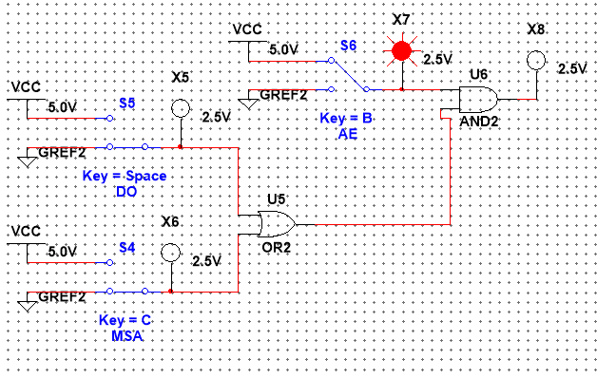

Other version of minimize:

